Project Documentation – PhonePe Transaction Insights

## 1. Decoding Transaction Dynamics on PhonePe

Scenario:  
PhonePe, a leading digital payments platform, has observed fluctuations in transaction behavior across various states, quarters, and payment categories. Certain regions exhibit strong growth while others show stagnation. To formulate data-driven business strategies, a detailed transaction pattern analysis is essential.

Analysis:  
- Used PostgreSQL to aggregate transaction volume and value by state, quarter, and category.  
- Identified high-performing regions and stagnating ones through bar and line charts in Streamlit.

Tools Used: Python, PostgreSQL, Pandas, Streamlit, Plotly.

Business Solution: Prioritize underperforming states for targeted promotions and feature rollouts.

Key Learning: Importance of quarterly trends and regional user behavior.

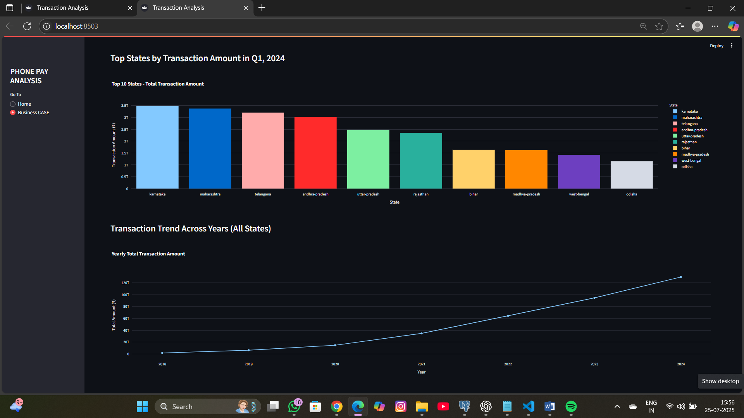

## 2. Device Dominance and User Engagement Analysis

Scenario:  
PhonePe seeks to understand device-wise app engagement across India. Despite high registrations on certain devices, app usage remains low in specific areas.

Analysis:  
- Aggregated registered users and app opens by device brand.  
- Visualized with choropleth maps and bar charts to show usage discrepancies.

Tools Used: PostgreSQL, Python, Streamlit, Plotly.

Business Solution: Improve optimization and support for underperforming device brands.

Key Learning: Device usage patterns vary significantly by region.

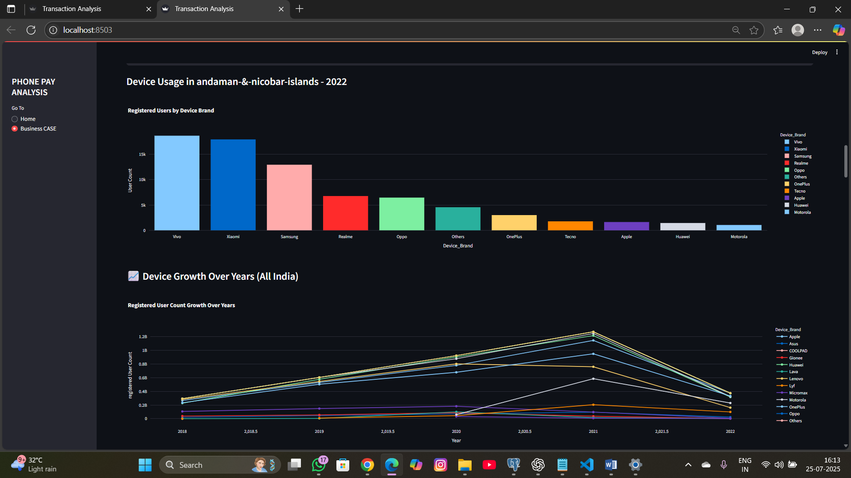

## 3. Insurance Penetration and Growth Potential Analysis

Scenario:  
With increasing adoption of digital insurance, PhonePe wants to understand penetration across states to support insurer partnerships and targeted marketing.

Analysis:  
- Extracted transaction count and amount for insurance by state.  
- Identified top and low-penetration regions.

Tools Used: PostgreSQL, Streamlit, Plotly.

Business Solution: Target underpenetrated states with awareness campaigns.

Key Learning: Insurance growth varies greatly, requiring localized strategy.

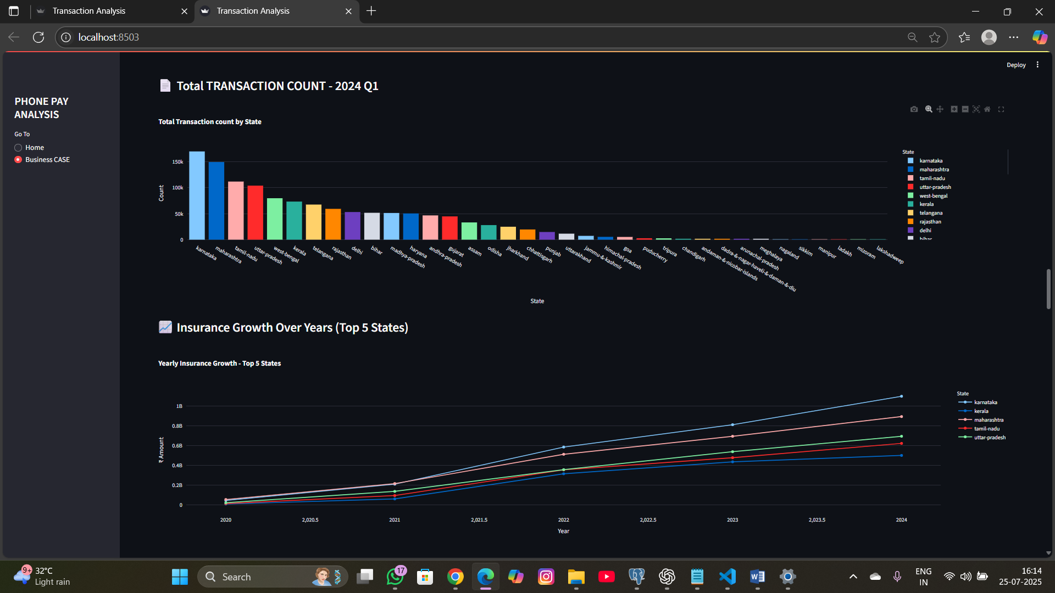

## 4. Transaction Analysis for Market Expansion

Scenario:  
Understanding regional transaction growth helps PhonePe expand strategically into new markets and enhance service in existing ones.

Analysis:  
- Ranked states by transaction value and volume.  
- Detected growth patterns and saturation points.

Tools Used: PostgreSQL, Streamlit, Pandas.

Business Solution: Expand in high-growth but low-competition regions.

Key Learning: State-wise prioritization aids effective expansion.

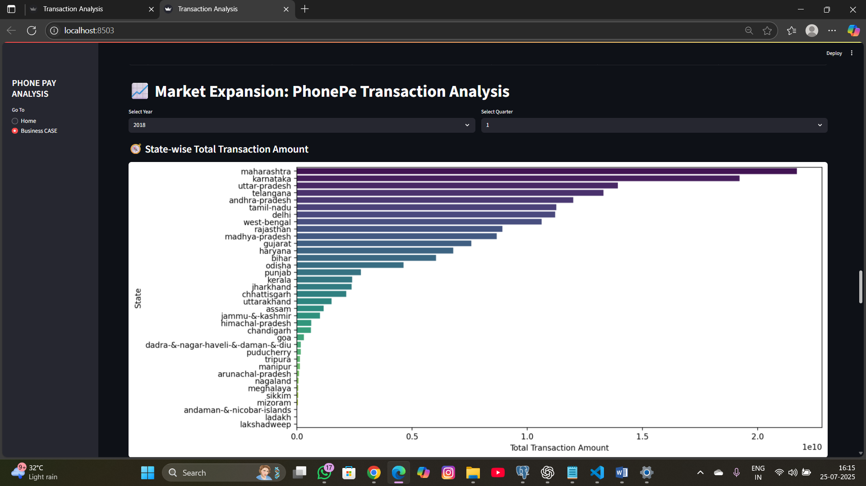

## 5. Transaction Analysis Across States and Districts

Scenario:  
This study aims to identify top-performing districts and pin codes to enhance PhonePe's regional marketing and engagement.

Analysis:  
- Grouped transactions by state, district, and pincode.  
- Created pie and bar charts for visualization of top locations.

Tools Used: PostgreSQL, Python, Streamlit, Plotly.

Business Solution: Launch district-level campaigns and optimize partner networks.

Key Learning: Micro-level analysis helps with granular targeting.

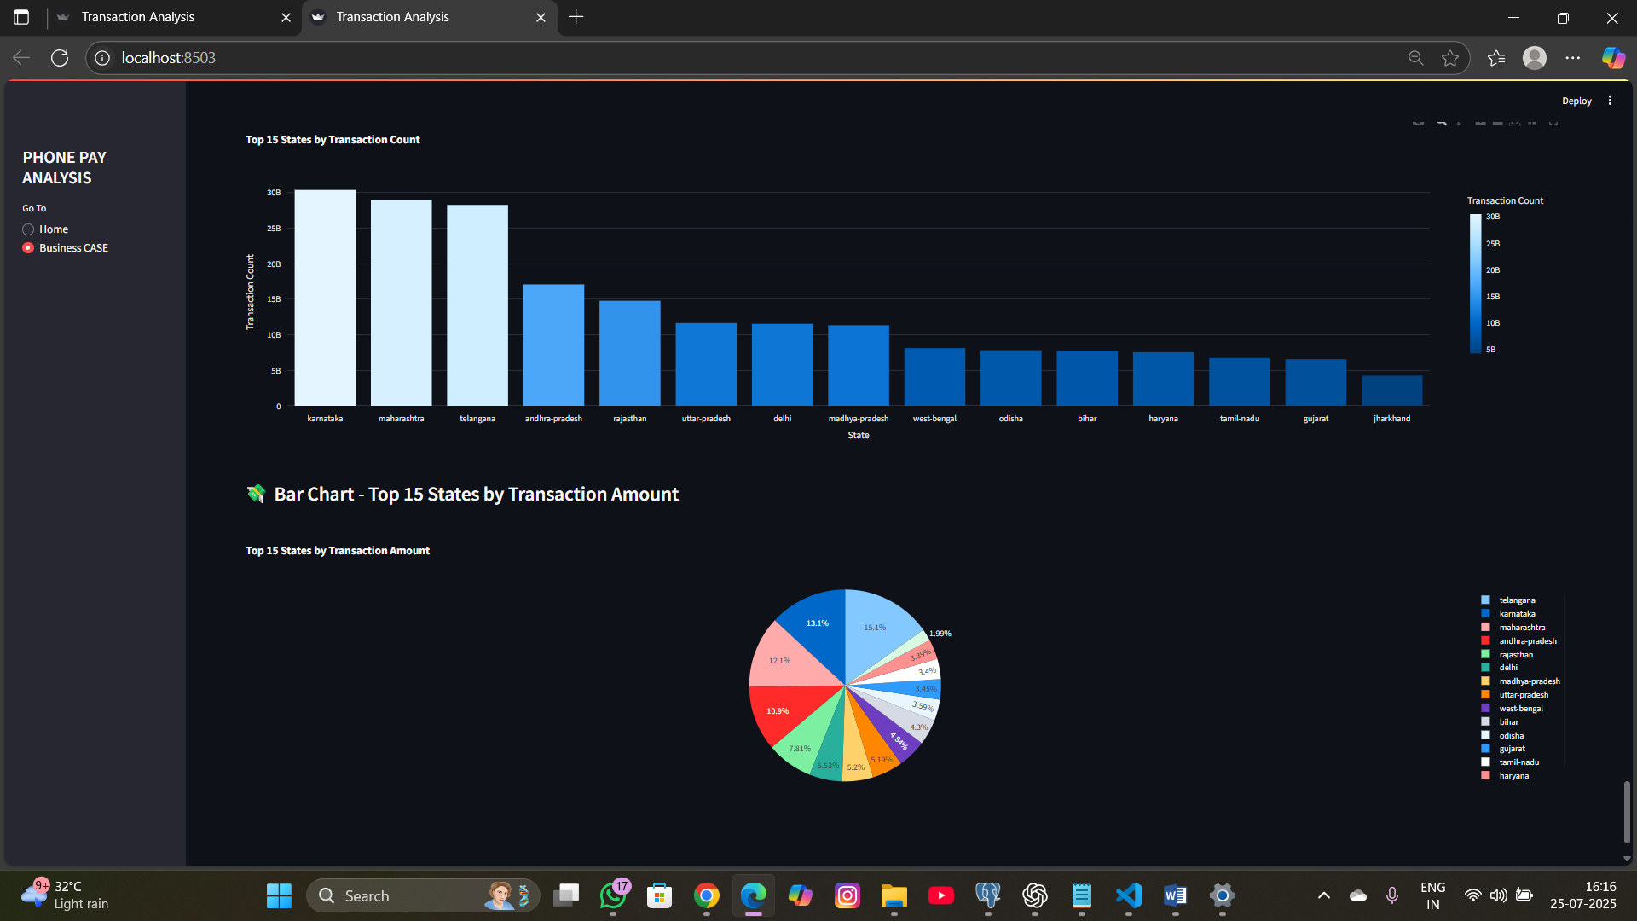

## Tools & Techniques Summary

- Data Source: Phone Pe Pulse (GitHub)  
- Database: PostgreSQL  
- Visualization: Streamlit with Plotly  
- Tech Stack: Python, Pandas, SQLAlchemy

## Python Libraries Used & Why

| **Library** | **Purpose** |
| --- | --- |
| **pandas** | For data manipulation, aggregation, and filtering across all analyses. |
| **sqlalchemy** | To establish a connection between Python and PostgreSQL databases. |
| **plotly** | To create interactive bar, line, and pie charts. |
| **plotly.express** | For quick and easy choropleth map visualizations. |
| **plotly.graph_objects** | For customized and dynamic visualizations. |
| **streamlit** | To develop an interactive web-based dashboard interface. |
| **json** | To load and handle Geo JSON files used in maps. |
| **os** | For working with file paths and reading local folders. |
| **glob** | To list and access multiple files during bulk data extraction. |

## Streamlit Libraries Used & Why

| **Library** | **Purpose** |
| --- | --- |
| **streamlit** | To develop an interactive web-based dashboard interface. |
| **pandas** | For data manipulation, aggregation, and filtering across all analyses. |
| **plotly.express** | For creating quick and easy visualizations like choropleth maps, bar charts, etc. |
| **sqlalchemy** | To establish a connection between Python and PostgreSQL databases. |
| **matplotlib.pyplot** | Used for static data visualization, including line and bar charts. |
| **seaborn** | Built on top of Matplotlib, used for statistical data visualization and attractive charts. |
| **bokeh.plotting** | For creating interactive visualizations and dashboards, often with large datasets. |

## Challenges Faced

- Inconsistent naming conventions in raw data  
- Null or missing values in early quarters  
- Complex joins while aggregating pincode-level data

## Lessons Learned

- Importance of clean and normalized data  
- Designing dynamic dashboards with filters for time and geography  
- Building queries for deep-dive analysis

## Business Solutions

- Use AI to optimize strategies based on real-time regional transaction trends.  
- Run pin-code level marketing with location-based offers and promotions.  
- Improve app performance on low-engagement device brands.   
- 2Designing Launch localized insurance awareness campaigns in regional languages.  
- Build a live dashboard for instant insights and faster decision-making.  
- Personalize user offers based on transaction history and behaviour.  
- Expand into low-competition, high-growth districts with local partnerships.

## Project Output: PhonePe Dashboard Snapshot

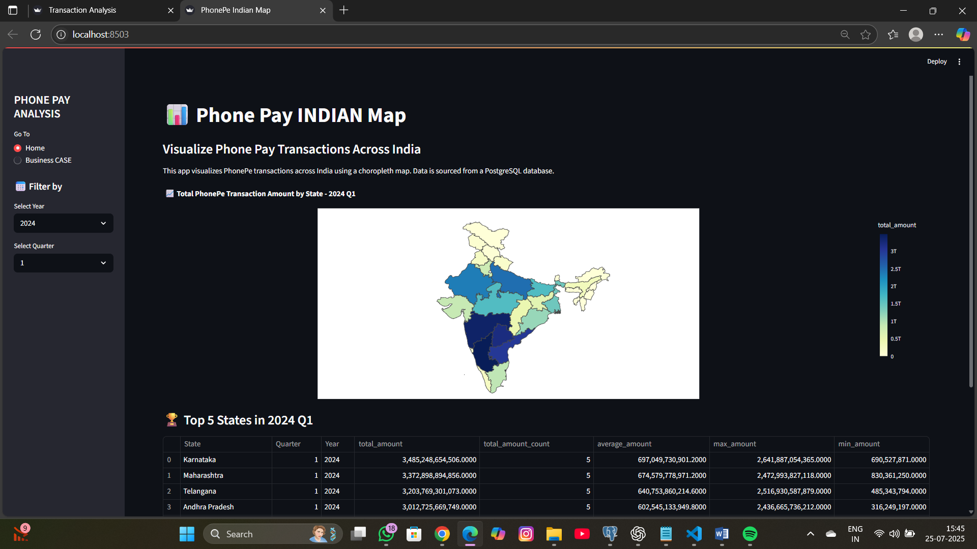

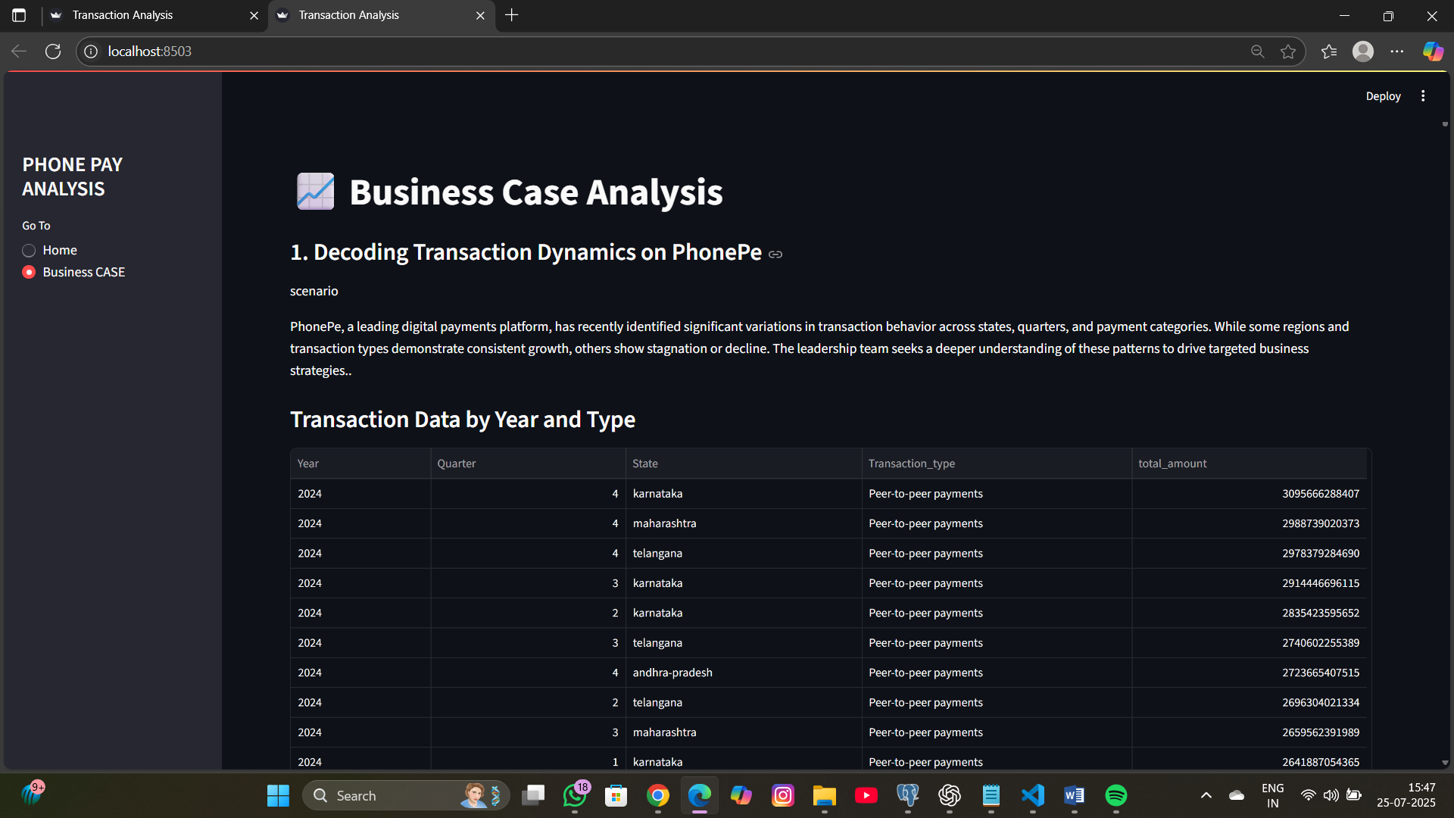

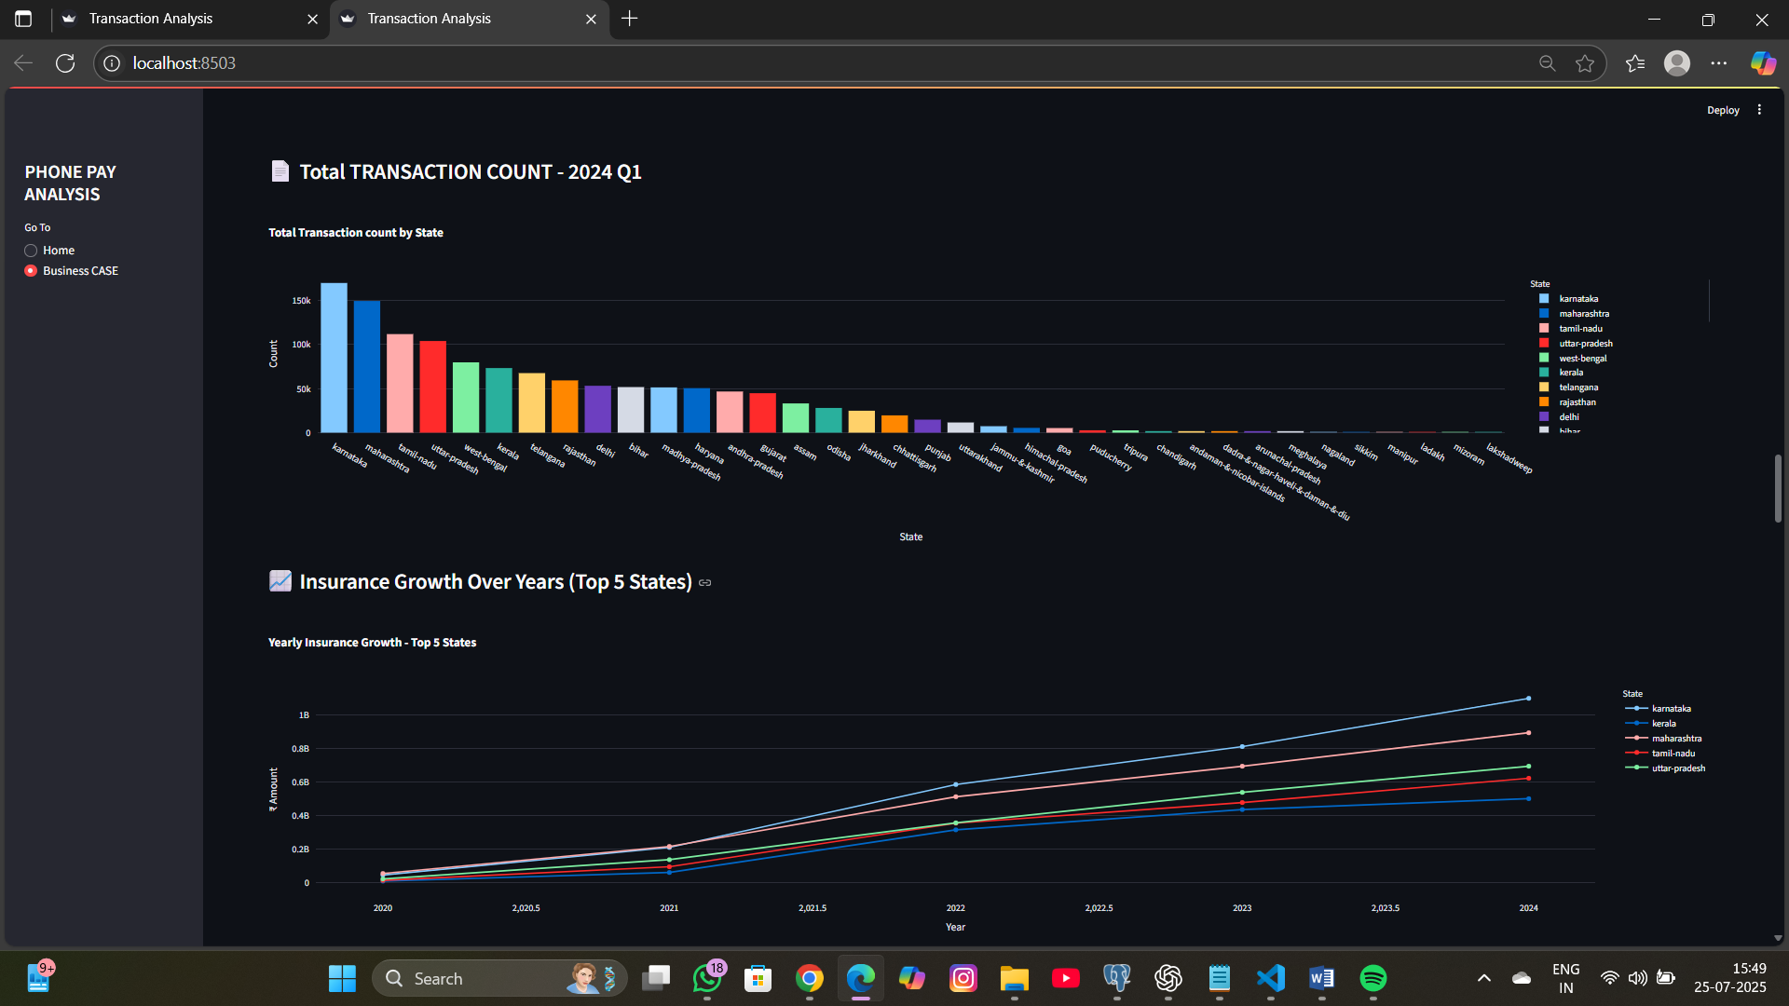

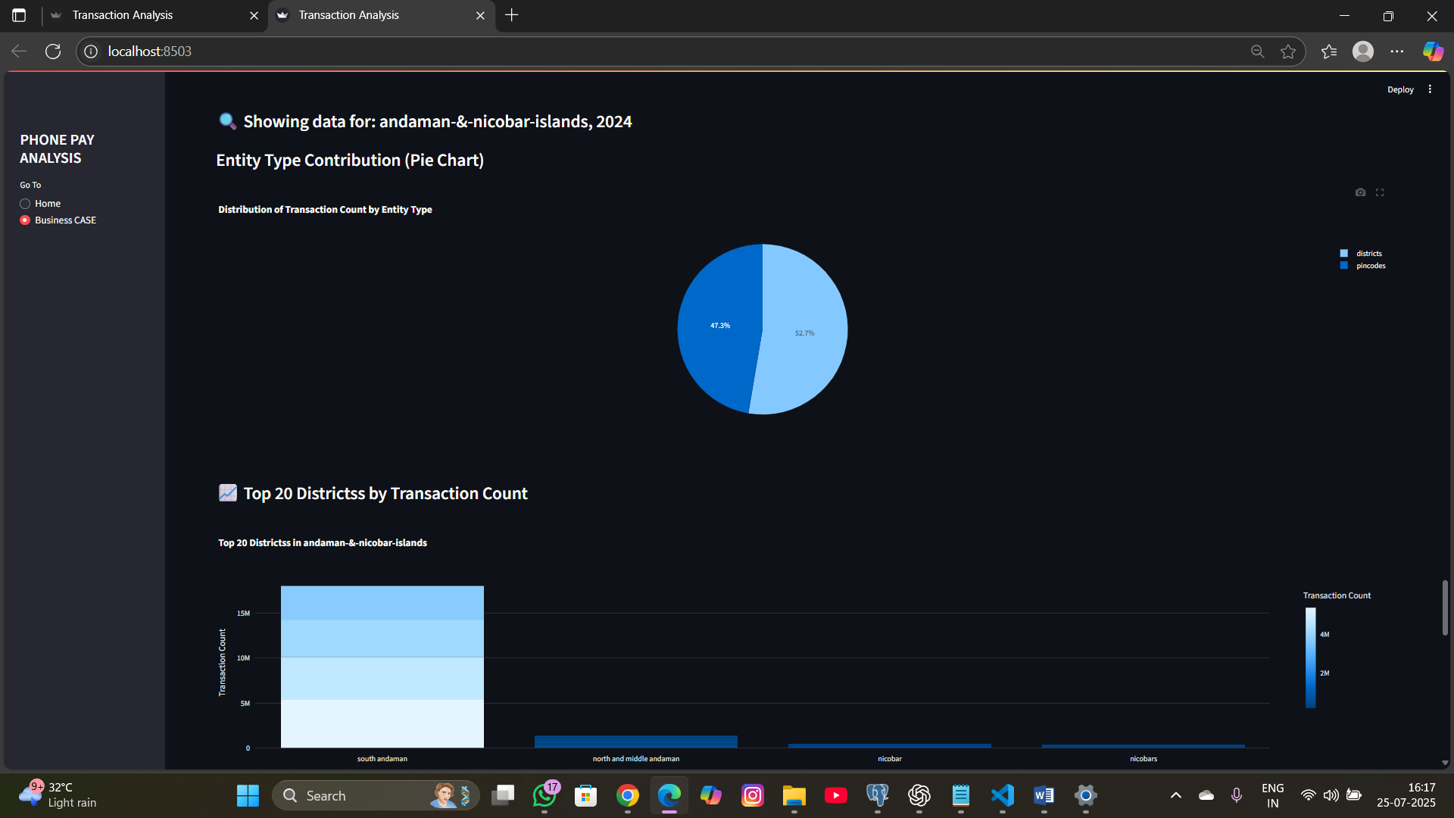

## Prepared by : VINOTHKUMAR S

## Project Duration : [6 DAYS]