Project Documentation – Luxury Housing Sales Analysis Bengaluru

## 1. Understanding Market Trends in Luxury Housing

**Questions:**  
How have luxury housing bookings changed quarter by quarter across micro-markets?

→ (Line Chart with Quarter on X-axis and Booking_Count on Y-axis, segmented by Micro_Market).

**Analysis:**

* Used **Power BI** line charts with **Quarter on X-axis** and **Booking_Count on Y-axis**, segmented by **Micro_Market**.
* Tracked quarter-wise changes to identify rising and falling demand.
* Compared performance of high-demand micro-markets (e.g., Whitefield, Indiranagar) against slower ones.

**Tools Used:** Power BI, SQL, Excel.

**Business Solution:**  
Developers can prioritize projects in **high-demand localities**, while strategizing marketing campaigns or offering incentives in **stagnant markets** to boost sales.

**Key Learning:**  
Quarterly demand patterns are crucial to predict **future buyer preferences** and optimize **inventory allocation** across Bengaluru’s micro-markets.

## 2. Builder Performance

**Question:**  
Which builders have the highest total ticket sales and how do they rank in terms of average ticket size?  
→ (Bar Chart or Table showing Builder, Sum(Ticket_Price_Cr), Avg(Ticket_Price_Cr))

**Analysis:**

* Used Power BI **bar chart/table** to compare total ticket sales and average ticket price per builder.
* Identified **top builders (e.g., Prestige, Sobha, Puravankara)** dominating in both revenue and average ticket size.
* Highlighted gaps where some builders achieve higher volume but lower average price.

**Tools Used:** Power BI, SQL, Excel.

**Business Solution:**  
Developers can benchmark pricing strategies against competitors. Builders with strong volume but lower pricing may **reposition projects** to capture premium segments.

**Key Learning:**  
Ranking builders by **both total sales and average ticket size** helps distinguish between **mass-market leaders and premium-focused developers**.

## 3. Amenity Impact

**Question:**  
Is there a correlation between amenity score and booking success rate?  
→ (Scatter plot: Amenity_Score vs Booking_Conversion_Rate, with bubble size by Project Count)

**Analysis:**

* Created a **scatter plot** with Amenity Score on X-axis and Booking Conversion Rate on Y-axis.
* Bubble size represented project count to highlight **larger vs niche projects**.
* Observed that projects with **higher amenity scores generally show better conversion rates**, but diminishing returns appear beyond a certain level.

**Tools Used:** Power BI, SQL.

**Business Solution:**  
Builders should invest in **critical amenities** (connectivity, security, clubhouse, etc.) to maximize conversions, while avoiding overspending on features with **low buyer impact**.

**Key Learning:**  
**Amenities strongly influence buyer decisions**, but there is an **optimal threshold** beyond which returns plateau.

## 4. Booking Conversion

**Question:**

Which micro-markets have the highest and lowest booking conversion rates?  
**Visualization:** Stacked Column Chart → Micro_Market with % Booking_Status as stacked sections

**Analysis:**

* Used Power BI stacked column chart to compare booking conversion percentages across micro-markets.
* Segmented markets into “High Conversion” vs “Low Conversion” zones.
* Identified markets where buyers are more decisive vs hesitant.

**Tools Used:** Power BI, SQL

**Business Solution:** Builders can focus on low-conversion micro-markets by offering flexible payment plans, discounts, or tailored marketing campaigns to improve sales efficiency.

**Key Learning:** Conversion rate is a stronger metric than raw bookings — it reveals actual buyer intent and market stickiness.

## 5. Configuration Demand

**Question:**

What are the most in-demand housing configurations (e.g., 3BHK, 4BHK)?  
**Visualization:** Pie Chart or Donut Chart → Configuration vs Booking Count

**Analysis:**

* Aggregated booking counts by configuration type.
* Visualized demand share of 2BHK, 3BHK, 4BHK, and luxury penthouses.
* Identified the dominant preference (e.g., 3BHK leading demand).

**Tools Used:** Power BI, Excel

**Business Solution:** Developers can optimize inventory planning — e.g., allocate more 3BHK units if demand is consistently high, and bundle luxury configurations with offers to clear slower-moving inventory.

**Key Learning:** Demand patterns highlight buyer affordability brackets and help align supply with market preference.

## 6. Sales Channel Efficiency

**Question:**

Which sales channels contribute most to successful bookings?  
**Visualization:** 100% Stacked Column Chart → Sales_Channel vs Booking_Status distribution

**Analysis:**

* Used Power BI to analyze sales performance across different channels (Direct Sales, Brokers, Online Portals, NRI Agents).
* Compared success rate of each channel in driving confirmed bookings vs cancellations/dropouts.

**Tools Used:** Power BI, SQL

**Business Solution:** Developers can invest more in high-performing channels (e.g., direct + online portals) while restructuring or training underperforming ones (e.g., brokers).

**Key Learning:** Channel efficiency impacts overall sales velocity — data-driven allocation of sales budgets maximizes ROI.

## 7. Quarterly Builder Contribution

**Question:**

Which builders dominate the market each quarter?  
**Visualization:** Matrix Table → Rows = Builder, Columns = Quarter, Values = Sum(Ticket_Price_Cr*)*

**Analysis:**

* Used Power BI matrix table to track builder-wise revenue contribution across quarters.
* Identified top-performing builders consistently dominating each quarter.
* Highlighted seasonal fluctuations in builder performance.

**Tools Used:** Power BI, SQL

**Business Solution:** Builders can benchmark quarterly sales trends against competitors and plan **timed launches** or **discount campaigns** during weaker quarters.

**Key Learning:** Quarterly builder contribution provides a clear view of **market share dynamics** and **competitive positioning** over time.

## 8. Possession Status Analysis

**Question:**

How does possession status affect buyer type and booking decisions?  
**Visualization:** Clustered Column Chart → Possession_Status vs Booking_Status, colored by Buyer_Type

**Analysis:**

* Compared booking behavior across possession statuses (Ready-to-Move, Under Construction, Pre-Launch).
* Segmented results by **buyer type** (Local vs NRI).
* Observed that NRIs tend to prefer **ready-to-move properties**, while locals show interest in **under-construction projects** for price advantage.

**Tools Used:** Power BI, SQL

**Business Solution:** Developers can market **ready-to-move units** to NRI buyers and **pre-launch offers** to local buyers to maximize conversions.

**Key Learning:** Buyer type strongly influences preference for possession status, impacting **pricing strategy and launch timing**.

## 9. Geographical Insights

**Question:**

Where are most luxury housing projects concentrated within Bangalore?  
**Visualization:** Map Visualization → Micro_Market or Latitude/Longitude

**Analysis:**

* Plotted project concentration using map visual in Power BI.
* Identified high-density zones (e.g., Whitefield, Outer Ring Road, Indiranagar).
* Highlighted areas with **emerging demand clusters**.

**Tools Used:** Power BI, Geo-Mapping, SQL

**Business Solution:** Developers can target **expansion opportunities** in under-served micro-markets and investors can identify **real estate hotspots**.

**Key Learning:** Geographic clustering of projects highlights **supply concentration vs unmet demand**, guiding both expansion and pricing strategies.

## 10. Top Performers

**Question:** Who are the top 5 builders in terms of revenue and booking success?  
**Visualization:** KPI Cards or Card Visuals → Top 5 Builders with drill-through to detailed project list

**Analysis:**

* Ranked builders by **total revenue** and **conversion success rate**.
* Displayed top 5 performers using KPI/summary cards.
* Enabled drill-through to detailed projects for further analysis.

**Tools Used:** Power BI, SQL, Excel

**Business Solution:** Developers can benchmark themselves against **market leaders**, while investors may prioritize **top-performing builders** for safer bets.

**Key Learning:** Identifying top performers gives a quick snapshot of **industry leaders**, guiding **investment, partnerships, and strategic positioning**.

## Tools & Techniques Summary

**Data Source**

* Luxury Housing Sales Dataset (Bengaluru)

**Database**

* SQL & Excel (for data storage and querying)

**Visualization Tool**

* Power BI (interactive dashboards & reports)

**Programming & Libraries**

* Python (Pandas, NumPy, Matplotlib)

**Techniques Applied**

* Data Cleaning & Preprocessing
* Trend & Pattern Analysis
* Buyer Segmentation (Local vs NRI)
* Market Demand Analysis (Configurations, Micro-markets)
* Business Insights & Decision Support

## Python Libraries Used & Why

* **pandas** – Used for cleaning the raw housing sales dataset, handling missing values, and performing aggregation like sum of ticket prices and booking counts.
* **numpy** – Applied for numerical computations such as averages, percentages, and transformations of ticket prices and square feet values.
* **matplotlib / seaborn** – Utilized during Exploratory Data Analysis (EDA) to identify data patterns and relationships before final visualization in Power BI.
* **sqlalchemy** – Helped to connect Python with the SQL database (PostgreSQL/MySQL) for running queries and pulling data into the analysis pipeline.
* **openpyxl** – Supported in reading and writing Excel files for preprocessing and exporting cleaned datasets to be used in Power BI.
* **os** – Used to manage file paths and automate the process of loading multiple raw data files from local folders.

## Power BI - Used & Why

Power BI was the primary visualization tool used in this project. It helped transform the cleaned and processed data into **interactive dashboards** that developers, investors, and business stakeholders can easily interpret. With Power BI, I created **line charts, stacked columns, maps, and KPI cards** to analyze market trends, builder performance, sales channel efficiency, and geographical insights.

The tool allowed me to build **drill-down reports** so users could explore data at both a high level (city-wide trends) and a detailed level (micro-markets, builder-specific performance). Power BI’s **DAX functions** were particularly useful for creating calculated fields like booking conversion rates and ranking builders by revenue.

Overall, Power BI was chosen because it provides an **intuitive, visually rich, and business-friendly interface** that bridges the gap between technical analysis and decision-making.

## Challenges Faced

• **Data Cleaning:** The dataset had inconsistent formats (e.g., different date styles, missing booking details, duplicate project entries), which required careful preprocessing before analysis.

• **Data Integration:** Combining information from multiple sources (Excel sheets, SQL tables) into a single structured dataset was time-consuming.

• **Complex Calculations:** Creating KPIs like booking conversion rate, builder rankings, and quarterly growth required advanced DAX measures in Power BI.

• **Visualization Selection:** Choosing the right chart to represent insights without overcrowding the dashboard was challenging.

## Lessons Learned

• Data preprocessing and cleaning form the backbone of any analysis—spending enough time here saves errors later.

• Power BI’s DAX functions and visualization capabilities are powerful but need logical planning to avoid circular dependencies.

• Business insights are best communicated through **simple, focused visuals** rather than overwhelming dashboards.

• Regular iteration and feedback from a “business-user perspective” make dashboards more decision-friendly.

## Business Solutions

• **Market Strategy:** Developers can prioritize investments in high-demand micro-markets and optimize inventory allocation based on quarterly demand patterns.

• **Builder Benchmarking:** Builders can track their performance against competitors, identifying strengths and weak areas in sales or ticket pricing.

• **Customer Targeting:** Insights into buyer types, possession preferences, and booking conversions help refine marketing strategies and tailor offers.

• **Sales Optimization:** Understanding which channels drive the most bookings allows better allocation of resources to high-performing sales strategies.

## Project Output: Luxury Housing Sales Analysis (Bengaluru)

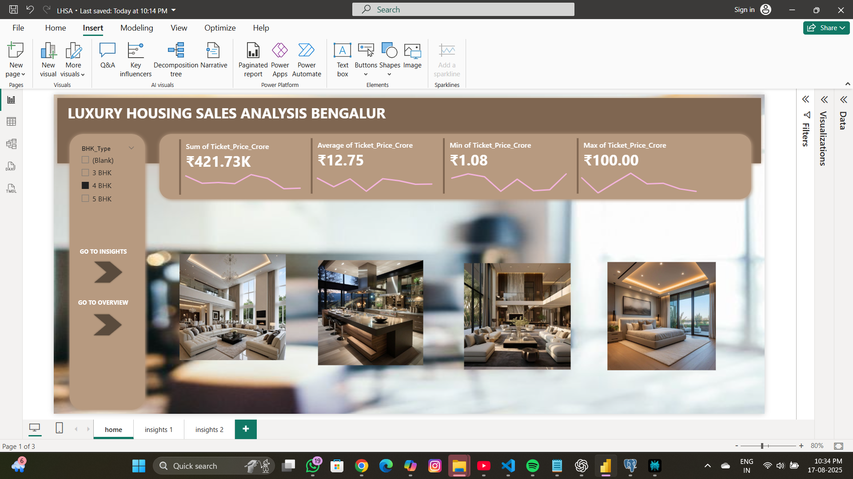

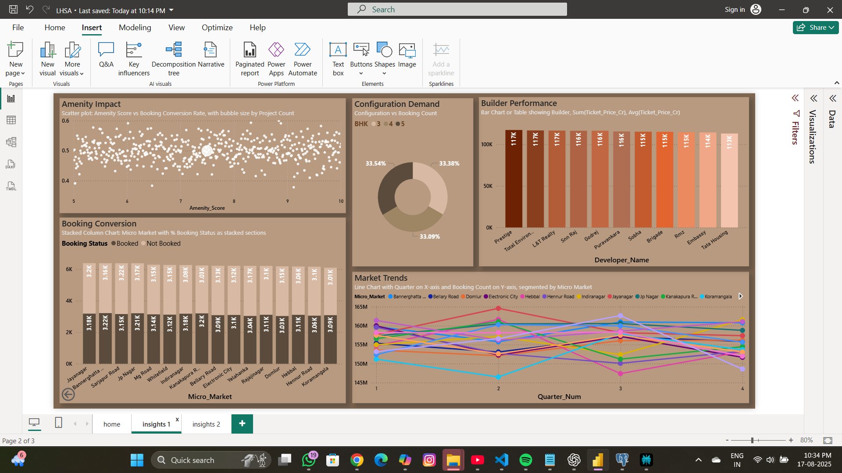

## D:\Studys\GUVI\GUVI Project\Luxury Housing Sales Analysis – Bengaluru\assets\overview.png

## Prepared by : VINOTHKUMAR S

## Project Duration : [10 DAYS]