***Q1) Write a set of test cases covering functional, boundary, and edge cases***

|  |  |
| --- | --- |
| **Title:** Test web application user registration | |
| **Description:** A new feature in a web application allows users to register an account. The registration form includes fields for username, password, email, and a "Subscribe to newsletter" checkbox | |
| **Test Scenario ID** | LOGIN-TEST-01 |
| **Module name** | USER-LOGIN |
| **Creation date** | 2024.12.20 |
| **Author** | Premkumar Vincent |
| **Reviewer** |  |
| **Reviewed date** |  |

|  |  |  |  |  |  |
| --- | --- | --- | --- | --- | --- |
| **Test Case ID** | 1 | **Priority** | High | **Executed by** | Premkumar Vincent |
| **Test case description** | Test valid input for ‘Usern*ame’* section | | | | |
| **Pre-Condition** | * Load http://13.209.85.69/ | | | | |
| **Test data** |  | | | | |
| **Test Steps** | 1. Enter the username. Test the following conditions:    1. A valid username should contain more than 5 characters    2. Can contain alphabet (upper and lower cases), numbers (0-9)    3. Case sensitive    4. No spaces    5. Can contain only ‘. , _ , and -‘ special characters    6. Cannot be an email (since there is a separate section for email) 2. Enter a valid password and email 3. Click *Register* | | | | |
| **Expected Result** | 1. Username is registered successfully without any issues | | | | |
| **Actual Result** | 1. User name is accepted if 5 characters or more – Pass   **Bus reports:**   1. Username is accepted with spaces - Fail 2. User accepts all special characters (can be security risk) - Fail 3. Not able to check Case sensitivity since page refreshes (no output feedback on the registered profile) - Fail 4. Accepts an email - Fail 5. Username doesn’t seem to have a character limit – Under Review | | | | |
| **Comments** |  | | | | |
| **Test Case ID** | 2 | **Priority** | High | **Executed by** | Premkumar Vincent |
| **Test case description** | Test valid input for ‘Password*’* section | | | | |
| **Pre-Condition** | * Load http://13.209.85.69/ | | | | |
| **Test data** |  | | | | |
| **Test Steps** | 1. Enter the password. Test the following cases:    1. A valid password should contain more than 8 characters    2. Can contain any character    3. Case sensitive    4. Should not be available in the weak-passwords (hacked passwords) directory. Eg: password123 2. Enter Username and Email 3. Click *Register* | | | | |
| **Expected Result** | 1. Password is registered successfully without any issues | | | | |
| **Actual Result** | 1. Password is accepted if more than 8 characters – Pass   **Bugs report:**   1. Password from hacked password list directory is allowed - Fail | | | | |
| **Comments** | While there are conflicting interests when it comes to make passwords have an uppercase, a lower case, numbers, and symbols, I believe it would be better to allow the password section to not have those restrictions as it will make brute-force attacks harder to execute.  Moreover, it keeps user-interface simpler and easier for the users | | | | |

|  |  |  |  |  |  |
| --- | --- | --- | --- | --- | --- |
| **Test Case ID** | 3 | **Priority** | High | **Executed by** | Premkumar Vincent |
| **Test case description** | Test valid input for ‘email’ section | | | | |
| **Pre-Condition** | * Load http://13.209.85.69/ | | | | |
| **Test data** |  | | | | |
| **Test Steps** | 1. Enter the email. Test the following cases:    1. A valid email should contain @    2. Cannot have dot ‘.’ as the first character    3. Cannot have 2 consecutive dots ‘..’    4. Top-level-Domain should contain at least 2 characters: eg: .co.kr, .com    5. Top-level-Domain cannot contain special characters 2. Enter valid username and password 3. Click *Register* | | | | |
| **Expected Result** | 1. Email is registered successfully without any issues | | | | |
| **Actual Result** | 1. Valid email is accepted – Pass   **Bug reports:**   1. Email accepted without a domain – Fail 2. Email accepted without top-level-domain like .co.kr - Fail 3. Email accepted with dot as first character – Fail 4. Email accepted with 2 consecutive dots – Fail | | | | |
| **Comments** |  | | | | |

|  |  |  |  |  |  |
| --- | --- | --- | --- | --- | --- |
| **Test Case ID** | 4 | **Priority** | High | **Executed by** | Premkumar Vincent |
| **Test case description** | Test *Subscribe to newsletter* | | | | |
| **Pre-Condition** | * Load <http://13.209.85.69/> * Test 1-3 should pass | | | | |
| **Test data** |  | | | | |
| **Test Steps** | 1. Enter valid details in username, password, and email sections 2. Check ‘*Subscribe to newsletter*’ 3. Click *Register* | | | | |
| **Expected Result** | 1. User profile is made and is subscribed to newsletter | | | | |
| **Actual Result** | **Bug report:**   1. Not able to test if the subscription is successful - Retest | | | | |
| **Comments** |  | | | | |

|  |  |  |  |  |  |
| --- | --- | --- | --- | --- | --- |
| **Test Case ID** | 5 | **Priority** | High | **Executed by** | Premkumar Vincent |
| **Test case description** | Test *Register* button | | | | |
| **Pre-Condition** | * Load <http://13.209.85.69/> * Test 1-3 should pass | | | | |
| **Test data** |  | | | | |
| **Test Steps** | 1. Enter valid details in username, password, and email sections 2. Click *Register* 3. This should make a new user profile | | | | |
| **Expected Result** | 1. User profile is made | | | | |
| **Actual Result** | **Bug report:**   1. Not able to test if the user profile was created - Retest | | | | |
| **Comments** |  | | | | |

**Supplementary**

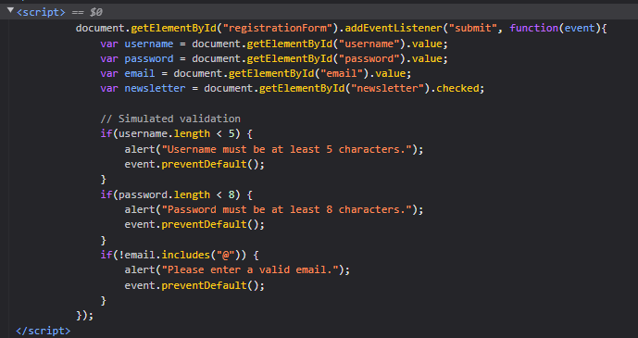

Test cases can be derived from here directly without manual testing to speed up test-case writing process. This is usually done during integration test