The **bullwhip effect** is a distribution channel phenomenon in which demand forecasts yield supply chain inefficiencies. It refers to increasing swings in inventory in response to shifts in consumer demand as one moves further up the supply chain.

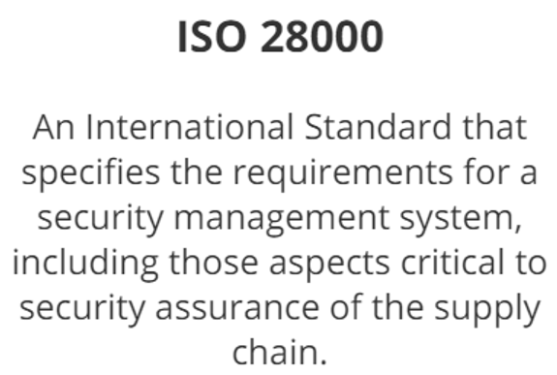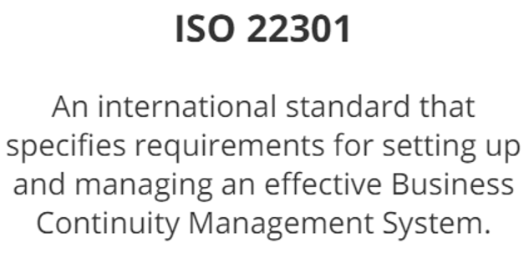

* ISO 9001 – Quality Management system
* ISO 14001 – Environmental Management systems
* ISO 22301 – Business Continuity Management System
* ISO 26000 – Social Responsibility
* ISO 31000 & 31010 – Risk Management
* ISO 73 – Risk management vocabulary
* SA 8000 – Social Accountability

The mission of the global reporting initiative (GRI) is to provide a**:  trusted and credible framework for reports regarding sustainability practices.**

A firm supplies products and services to a wide variety of industries with varying  
requirements for responsiveness and reliability. Many customers across these industries  
are not satisfied with the firms ability to meet the lead time and on time delivery  
requirements. Which of the following tools is most appropriate for the firm to use to improve  
customer service?

**Market Segmentation**

A company manufactures special products for select customers. When demand for these  
products drops, the manufacturer can switch the production line to a commodity-type  
product that can be sold on the open market at reduced terms to generate cash. The  
company is executing a corporate strategy that is based on:

**multiple upstream supply chains.**

The process of gathering data about what customers need and ensuring that desired  
features are included in the design and initial planning phase of a new product or service is  
known as:

**Quality function deployment**

A company's annual cost of goods sold is $350 million, and inventory carrying cost is 18%.  
The company averages four inventory turns. The cost savings resulting from increasing  
inventory turns from four to six would be:

**The value of inventory held up decreases when there is an increase in inventory turnover. The net decrease in inventory = (350/4 - 350/6) . The resulting cost savings from lesser carrying cost (as a result of less held up inventory) = (350/4 - 350/6)*18% = 5,250,000**

Incorporating supplier input into product and process design helps to:

**reduce time to market**

Which of the following factors typically is the most significant impediment to implementing  
collaborative commerce?

**Corporate Culture**

The focus of collaborative supply chain management differs from a transactional approach  
by its emphasis on the:

**flow of demand information and cash up the chain.**

Which of the following forecasting methods relies on the opinions of a panel of experts?

**Delphi technique**

The main benefit of a mass customization product design strategy is to:

**offer more product variety while keeping inventories low.**

Which of the following types of information would be an appropriate basis for a qualitative  
forecast?

**Market research data**

The probability of customer dissatisfaction is highest when which of the following conditions  
exists?

**There is a gap between expected performance and perceived performance.**

Keeping all other factors equal, a company typically will try to maintain higher service levels  
for products with:

**higher profit margins.**

A company that produces standardized products and sells them through retailers via a  
responsive transportation system has decided to expand its sales with an online store for  
customized products. Which of the following distribution strategies would be the most  
appropriate for the business-strategy change?

**A centralized distribution center serving retailers and direct shipment from the factory serving online sales**

A manufacturer uses standard costing, and a potential supplier uses activity-based costing.  
This difference most likely will have implications for which of the following types of future  
decisions?

**Make-or-buy**

Which of the following indicators is most appropriate to use as a measure of supply chain  
utilization?

**Net asset turnover**

A return material authorization (RMA) policy is used in reverse logistics to:

**reduce the cost of returned items by refusing to accept items that should not be returned.**

Compared to a blanket purchase order, a supplier alliance agreement is best differentiated  
by: **a shared vision of added value.**

Which of the following actions typically would be considered part of a reverse logistics  
strategy?

**Offering a discount on new purchases when used products are returned**

A remanufacturer of equipment is most likely to have what type of supply chain?

**Reverse logistics**

Using an independent service provider for logistics would be most appropriate in which of  
the following situations?

**A shoe company that wants to penetrate a foreign market**

A companys decision to charge different prices for the same service sold in different  
market segments is most likely based on which of the following metrics?

**Lifetime customer value (LCV)**

A media company offers a majority of its movies through a specific distributor. The media  
company is beginning to produce content for a new foreign market to which the distributor  
has exclusive access. To maximize savings and gain entry to this new market, the media  
company should: **form a strategic alliance.**

Which of the following benefits of supplier relationship management typically results from  
collaboration with a few critical suppliers? **Reduction in customer and supplier inventories**

Medium-term demand management projections are used primarily to**: aggregate demand for production planning**

Reverse supply chain activity typically peaks nearest the beginning of which of the  
following stages of the product life cycle? **Decline**

Supply chains delivering products or services are most able to respond quickly to changing  
market requirements when: **products have a modular design.**

When designing a supply chain for strategic advantage, a company first should consider: **matching the supply chain to product type.**

Which of the following corporate strategies is most consistent with a flexible supply chain  
strategy? **Providing the highest-quality service**

A firm wants to lose customers that don't value the unique products and services the firm  
offers and to attract and retain customers that want what the firm offers. Engaging in this  
activity should allow the firm to: **create a more loyal customer base.**

A company that sells engineered-to-order products is planning implementation of a supplier  
relationship management system (SRM) for direct materials. Which of the following factors  
is most likely to make the implementation difficult? **Complexity of the purchasing process**

Inventory parameters established using analytic inventory techniques typically are based  
on balancing: **customer service and inventory costs.**

The globalization of a supply chain typically increases uncertainty and: **documentation complexity.**

The strategy to implement supplier relationship management has been developed. The  
most appropriate next step is to**: develop criteria for prospective partners.**

When doing international business, a company's total line-haul costs will vary with the: **distance shipped (not weight or volume)**

Managing supply chain risks includes which of the following activities? **Developing alternatives to key suppliers**

Which of the following distribution approaches for a low-volume, high-variety product line  
typically will result in the highest level of customer service and the lowest total distribution  
costs? **Direct shipment from plant to customers**

When an importer and manufacturer are operating in a free trade zone, payment of a  
customs duty is triggered when products are **distributed**