We’ll use a four-stage model of supply chain management evolution:

Stage 1—multiple dysfunction: reactive supply chain

Stage 2—semifunctional enterprise: reactive efficient supply chain

Stage 3—integrated enterprise: proactive efficient supply chain

Stage 4—extended enterprise : strategic driver supply chain

INTERNAL INPUTS

A business model consists of a

1. Business strategy
2. Organizational strategy
3. Business plan
4. Value proposition
5. Set of core capabilities
6. Cost structure
7. Revenue model.

3 types of Strategies:

1. Business Strategy
2. Organizational Strategy
3. Supply chain Strategy

Types of Business Strategy: Cost, Focus & Differentiation. There are many ways that these generic strategies can be combined or made into hybrids, for example:

1. **Low cost**—Focuses on delivering no-frills basics with low prices that are hard to match; cost is the basis for competition.
2. **Best cost**—Focuses on delivering the best value at a relatively low price; both cost and quality are the bases for competition.
3. **Broad differentiation**—Creates product/service attributes that appeal to many buyers looking for variety of goods; customer experience and/or quality are often the basis for competitive differentiation.
4. **Focused differentiation**—Develops unique strategies for targeted niche markets to meet unique buyer needs; niche marketing and innovation are important examples of this type of competitive basis.
5. **Focused low cost**—Designed to meet well-defined (niche market) buyer needs at a low cost; responsiveness can be the basis for competition.

Ways to create a focus advantage:

1. Niche marketing
2. Responsiveness
3. Innovation.

4 types of organizational strategy:

1. customer focus and alignment
2. forecast-driven enterprise
3. demand-driven enterprise
4. product-type-driven supply chains

Business Plan consists of:

1. Customer Service
2. Sales Channels
3. Value Added
4. Operating Model
5. Asset Footprint

Value Proposition: worth of an item, good or service

Core Capabilities: Can impact:

1. Decision Making: Planning & Enabling
2. Execution: Sourcing, Manufacturing, Delivering & Returning

Core capabilities fall into these categories:

1. Scale Advantages
2. Geographical Advantages
3. Technological Advantages
4. Resource Advantages

Cost Structure:

Operating Models Cost

1. Make-to-stock
   1. It has low manufacturing cost & high inv holding cost
   2. When demands are high, standardized
2. Make-to-order
   1. It has high manufacturing cost & low inv holding cost
   2. When demands are sporadic
3. Assemble-to-order
   1. It has moderate manufacturing cost & low inv holding cost
   2. When demands are moderate-to-high & varying options, like computers
4. Configure-to-order
   1. Short lead time extension of Make to order of mass producing items which can be configured after production
   2. Used when it would take longer to assemble the item than the customer is willing to wait
5. Engineer-to-order
   1. Production & inv costs initiated after payment terms are confirmed
   2. Eg: Construction of a building

Asset Footprint cost

1. Global Footprint
2. Country wise
3. Regional

Revenue Model:

How to earn more than spent? Customer channels, segmentation & profitability are key decisions

EXTERNAL INPUTS

1. Competition
2. Market Conditions
3. Global Perspectives

Supply Chain Management Strategy

Objectives of implementing a sound SCM strategy include:

* Improving market knowledge
* Implementing 3 Vs (Improving Velocity, Increasing Visibility, Reducing Variability)  
  Extra 3 Vs should also be kept in mind:  
  Vocalization – to prevent bullwhip effect & avoid communication gaps rather than assuming consistent order patterns  
  Variety – to have a mix of different products & services in portfolio  
  Volume – to flexibly expand or contract volumes as per changes in customer demand
* Streamlining Operations
* Improving Risk Management
* Improving Sustainability

Supply Chain strategies need some of those same elements as in Organization Strategy:

* Value Proposition
* Core Capabilities
* Cost Structure
* Revenue Model

Supply chains should create 3 types of value:

1. Financial Value
   * Cut Costs to yield net gains
   * Money makes Money (ROI / ROA)
   * Gains should be equitably distributed
2. Customer Value
   * Quality
   * Affordability
   * Availability
   * Service
   * Sustainability
3. Social Value

* Delivering socially useful products & services
* Avoiding or decreasing negative environmental impact
* Integrating sustainability in supply chains

Supply Chain capabilities

General Capabilities

Ideally, each organization in the supply chain would have the following capabilities:

1. Integrated **organizational design** with a process orientation
2. Key supply chain **processes** already in place and functioning at competitive velocity
3. **Systems and technology** sufficiently advanced to tie all processes together and allow the supply network to

operate from the same, simultaneously available data

1. **Human Resources**: Educated and skilled employees who have a process focus, can see the end-to-end supply chain as a single entity, and manage accordingly
2. **Metrics** that are in place to assess performance against a relevant standard and identify strengths to encourage and weaknesses to amend

Core Capabilities

* Excellence in Customer Service
  + Availability
  + Operational Performance
  + Customer Satisfaction
* Effective & Efficient use of Systemwide Resources
  + Effectiveness: Outward facing – on customers needs but by still meeting cost objectives
  + Efficiency: Inward facing – on improving performance (% of actual output / expected output)

Tools & Techniques

Macro & Micro Economic Considerations

**Macroeconomics**

Macroeconomics is the analysis of the behavior of the overall economy (supply and demand in aggregate) in

response to various market forces

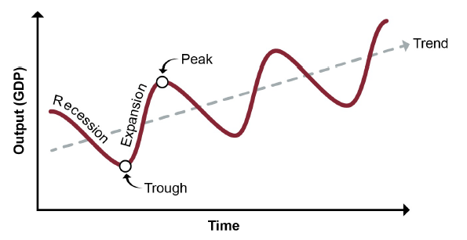

Near the peaks of a cycle, unemployment is low and production is at or near full capacity. Near the troughs,

employment and output are low. Innovation can trigger periods of expansion; economic scarcity, political

events, or financial instability can trigger recessions.

GDP: When overall prices shift higher, people can afford fewer goods and services; when prices are lower, people can afford more. Conversely, and as an opposing force to this effect, when overall prices shift higher, suppliers want to make more; when prices are lower, suppliers will be less motivated to produce and will cut production and idle workers. These two opposing forces work to balance each other out in the long term to a point of equilibrium.

The potential output of the area’s economy at full employment is also called the long range aggregate supply.

Inflation is a sustained increase in the general level of prices for an area, while deflation is a sustained

decrease in prices. One way to detect inflation is with a consumer price index (CPI), which is a sampling of

the actual prices of various consumer goods. Inflation occurs when consumers have more money available

to spend but the supply is scarce. Creditors are harmed by inflation; debtors are helped. Inflation also harms

consumers on fixed incomes.

Inflationary growth in real GDP occurs when demand increases but supply fails to increase

as fast. Deflationary growth in real GDP occurs when demand increases but supply increases faster than

demand.

A recession is when real GDP declines for two consecutive quarters. If the long-range aggregate supply

decreases during that time or if the contraction is severe or prolonged, it becomes a depression.

Metrics help supply chain managers to scan macroeconomic conditions, like:

* CPI: sampling of the actual prices of various consumer goods
* CCI: the consumer confidence index provides leading information on likely future demand because it polls consumers’ feelings about the economy and how likely they are to make purchases.
* PPI: The PPI measures the prices received by domestic producers for their goods and services
* the World Bank provides “Worldwide Governance Indicators” for 215 global economies. These KPIs track fairness of elections, rule of law, control of corruption, and other transparency & effectiveness measures. They also track the growth trends of GDPs.

**Microeconomics**

Microeconomics focuses on specifics such as the price of a product, how sensitive customers are to changes in that price (how much price changes impact demand), cost trends for a business, or employment levels in a given industry.

* Law of Demand: Demand inversely proportional to cost of good
  + Diminishing marginal utility is When consumers purchase units of a good or service, each additional unit purchased will have less utility than the previous one.
* Law of Supply: Supply directly proportional to cost of good as More sellers can sell at a profit.
  + Economies of scale means that as output is increased, the cost per unit of output decreases
  + At a certain level of output, however, an organization may experience diminishing returns, or diseconomies of scale. This occurs when new costs are incurred to increase output, and these new costs can cause the cost per unit of output to slow its decrease until it is no longer valuable to produce additional units.
* Law of Equilibrium (Supply & Demand): states that the price of any good will adjust until the quantity supplied and quantity demanded are in balance.

Price Elasticity is the degree of change in buyer demand in response to changes in product price. It is calculated by dividing the percentage of change in quantity bought by the percentage of change of price. For example, demand for most medical services is relatively inelastic, but demand for automobiles is generally elastic. A coefficient greater than 1.0 is elastic; less than 1.0 is inelastic.

* Low-priced items are generally inelastic and are less impacted by small price changes.
* Necessities are inelastic and luxuries are elastic.
* Demand is more inelastic over the short term and more elastic over the long term (e.g., people pay more for gas for a while but may shift to a more efficient vehicle or the bus if prices stay high for a while).

A simple test is the total revenue test. If you drop the price and demand increases, and if the loss of revenue from the lower price is exceeded by the increase in revenue from more units sold, then demand is elastic. However, if you drop the price and the loss of revenue from the lower price is greater than the gain in revenue from the increase in unit sales, then demand is inelastic.

**Marginal analysis**

Another microeconomic concept is marginal analysis. A marginal analysis focuses only on the marginal utility & marginal cost of the choice. Marginal utility is the extra usefulness or satisfaction gained from purchasing one additional unit of the good or service. Marginal cost is the additional cost incurred for making a given decision or the cost of producing one more unit of a good or service. Costs incurred regardless of what choice is made are ignored. The rule for marginal analysis is that if the marginal utility exceeds the marginal cost, it is a wise economic choice.

The majority of the world uses one set of financial accounting standards, the International Financial

Reporting Standards (IFRS) developed by the International Accounting Standards Board (IASB).

166 countries have adopted IFRS for all or most of their domestic publicly accountable Organizations. Some countries require IFRS for financial institutions but not listed companies, and others permit rather than require it.

IFRS and U.S. GAAP both allow businesses to organize as proprietorships, partnerships, and corporations,

but the most advantageous business form may differ by country, not only due to differences in the country’s

required accounting rules but also to other country-specific legal and tax differences

Differences in IFRS financial systems & US GAAP financial systems:

* A statement of changes in equity for the period is similar to a U.S. GAAP statement of retained earnings
* IFRS report on income is called revenue in U.S. GAAP
* IFRS expenses use simple principle-based definitions. By contrast, U.S. GAAP uses rules-based definitions that are slightly more complex and legalistic.
* under U.S. GAAP a disaster at a plant, that is not expected to recur may be classified as an extraordinary item, which means that gains or losses from the event are not classified as part of normal operating revenue or expenses. Under IFRS all income and expense is considered ordinary; there is no such thing as an extraordinary item

IFRS definitions of the major financial statement components:

**Assets.** A resource controlled by the entity as a result of past events and from which future economic

benefits are expected to flow to the entity.

**Liabilities.** A present obligation of the entity arising from past events, the settlement of which is

expected to result in an outflow from the entity of resources embodying economic benefits.

**Equity.** A residual interest in the assets of the entity after deducting all its liabilities.

**Income.** Increases in economic benefits that result in increases in equity (other than those related to

contributions from shareholders). Income includes both revenues (resulting from ordinary activities)

and gains.

**Expenses.** Decreases in economic benefits that result in decreases in equity (other than those related

to distributions to shareholders). Expenses include losses that are not the result of ordinary activities

The balance sheet is often called a “snapshot” of the company’s financial position,

because it is a static view of financial value or net worth at a point in time, usually the last day of the fiscal or

calendar year. The balance equation is: Assets = Liabilities + Owner’s Equity

Accounts receivable are the value of goods shipped or services rendered to a customer on which payment has not yet been received. Usually includes an allowance for bad debts.

Accounts payable are the value of goods and services acquired for which payment has not yet been made.

These two balance sheet amounts are used to calculate the cash-to-cash cycle time, which measures how many days the organization’s working capital is invested in managing the supply chain.

**Net working capital** is “the current assets of a firm minus its current liabilities.”

In contrast to the balance sheet, the income statement (Net Income over a period of time) is cumulative and dynamic, meaning that the statement covers business results over a period of time, such as a quarter or a year, rather than being a static snapshot. Income = Revenue – Expenses

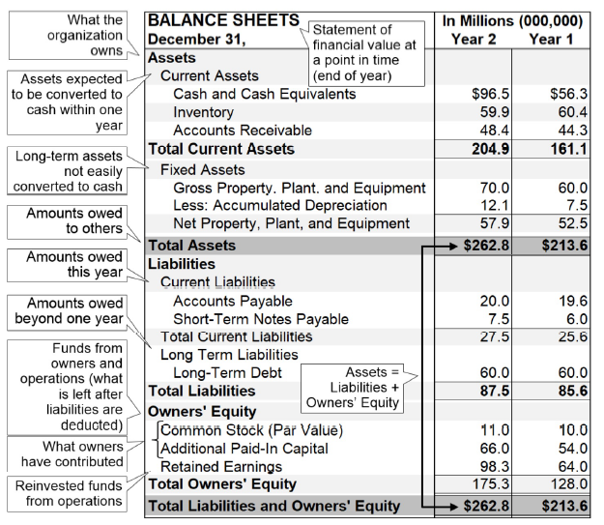

The **gross [profit] margin** measures “the difference between total revenue and the cost of goods sold”

**Net profit** is figured by deducting all expenses, not only the cost of goods sold, from revenues.

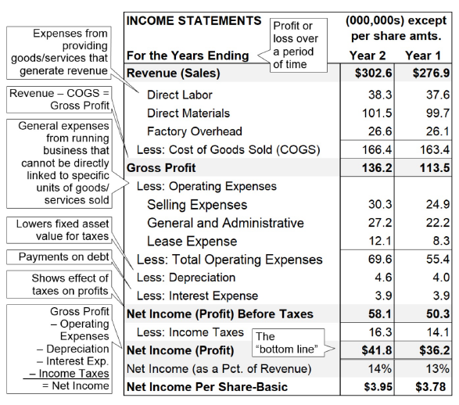

Matching refers to reporting related revenues and expenses together in the period in which they were incurred. For example, sales expenses incurred to make a sale should fall in the period in which the sale was made. When they do not, accountants use adjustments called accruals to account for the period differences.

The “bottom line” refers to the line at the bottom of the income statement that shows a net profit or loss.

**statement of cash flows (funds flow statement)** as “a financial statement showing the flow of cash and its timing into and out of an organization or project [over a given period of time].” three sections of cash flows: operating, investing, and financing.

In the indirect method (most popular way of calculating cash flow), the operating activities section will show net income from the income statement followed by a number of necessary adjustments to convert the total net

income to the cash impact of all business activities for the period.

There are three factors that determine cash flows: sales, after-tax operating profit margins, and capital requirements.

The purpose of a statement of cash flows is to show lenders, investors, and creditors whether the organization has sufficient cash to pay debts, bills, and dividends to owners, because cash, not net income, is needed to make these payments.

A cash flow statement is important:

1. In order to keep the cash flow turning over, the supply chain professional must efficiently manage the company’s inventory level and cost while maintaining and improving customer satisfaction.
2. It shows if the company is generating enough cash to fulfill its minimum obligations to lenders, investors, and governments (taxes).
3. Generating extra cash can be used to repay debt, purchase additional assets for growth, or invest in new products.

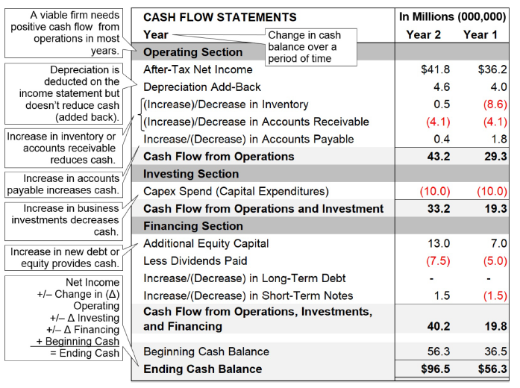

Strategic Analysis Tools

SWOT

|  |  |  |
| --- | --- | --- |
| Strengths | Weaknesses | -> Internal Focus |
| Opportunities | Threats | -> External Focus |
| Positive | Negative |  |

Market Plan includes:

* the current market position
* opportunity and issue analysis [SWOT results]
* marketing objectives and strategies,
* action plans
* programs & projects
* budgets
* pro forma profit and loss statement (pro forma means based on forecasted info rather than historical info)
* management controls.

Marketing translates the external perspective for internal audiences (What does the market need?), while

sales translates the internal perspective for external audiences (Why do you need what we have to offer?)

**four Ps** as a set of marketing tools to direct the business offering to the customer. The four Ps are product, price,

place, and promotion. **demand shaping** is definedas the practice of using the four Ps…and other market variables to influence the demand of a product or service so that the demand better matches the available supply.

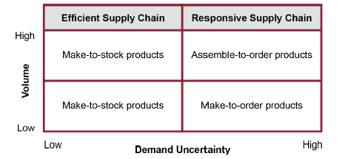

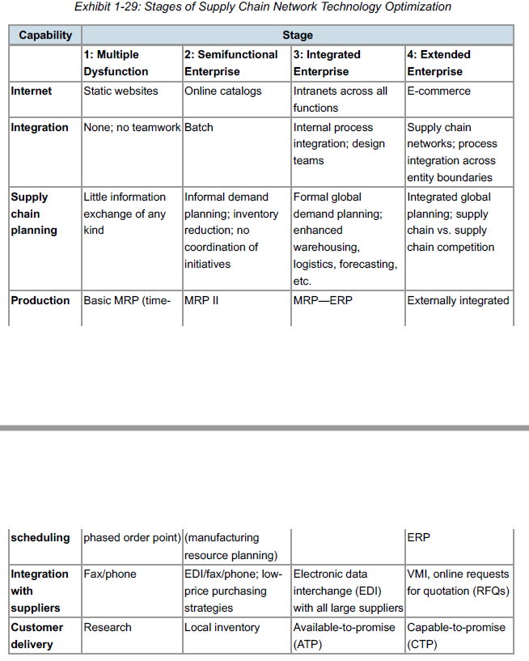



1. Traditional Over-the-wall design vs Collaborative Design

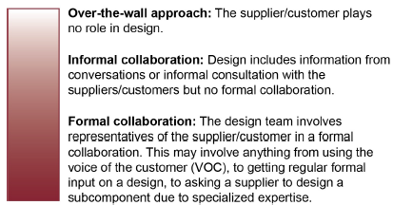

1. Broad Based Methods of Design

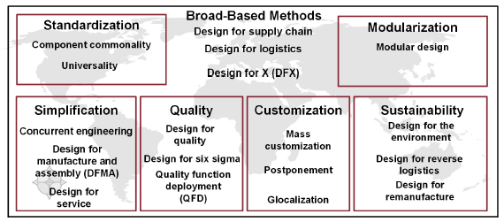

**Design for the supply chain** refers to “enhancement of a firm’s product design in consideration of the

issues that will arise in the supply chain, from raw materials to the final stage of the product’s life cycle”

Design for Logistics (Transportation & Storage):

Benefits

Lowering transportation and warehousing costs increases profit margins.

Warehouses can store more goods, relieving capacity pressures.

Recognizable master carton design helps retailers when looking for a particular item to restock from

storerooms.

Packaging design can allow some retailers to sell directly from a pallet.

Tradeoffs

Maximizing items on a pallet needs to be balanced against the needs of retailers; slow-moving goods

may not be desired in larger quantities.

Product requirements may make standard box sizes problematic.

The density of items may need to be altered to balance between maximum vehicle volume (“cube out”)

and vehicle weight restrictions (“weigh out”).

DFX (Design for X) is referred as design for excellence, a design process that ensures the outcome is manufacturable,

maintainable, cost effective, and high quality. It is also called design for everything to describe a need to design a product or service with all of the design considerations that an organization determines are of strategic importance

1. Standardization

**A standardized product,** which is “a product that can be made in large quantities, or continuously, because of very few product designs”

Component Commonality:

Benefits

Lower purchasing costs because less variety allows economies of scale

More streamlined production because of fewer shifts between different processes and tools

Simpler, cheaper storage

Tradeoffs

Cost of product modifications required to accept the new part

Less flexibility for designers, who may prefer a variety of similar parts

Reductions in quality if the greater variety of parts would, for example, allow closer tolerances or more

attractive design

a **modular design strategy** is planning and designing products so that components or subassemblies can be used in current and future products or assembled to produce multiple configurations of a product. The opposite of modularity is integral design, in which all components are designed to work together in one specific product. Apple computers focus on integral design, while PCs are modular. Clothing can also illustrate the two types. Trousers, shirts, ties, and sport coats can be mixed and matched because they are modular. A uniform, on the other hand, is an example of integral design.

Benefits

Reduced cost of design and manufacturing when using modules to create a family of products,

possibly leveraging postponement strategies (described later in Topic 7)

Increased efficiency and decreased cost of production, since multiple products can be created

simultaneously from the standard components

Expanded customer base, because products can be customized closer to the end user (and

sometimes by the end user)

Easier, more cost-effective shipping, warehousing, and display of the product if it is designed with

packaging in mind (e.g., boxed furniture kits)

Tradeoffs

There are potential tradeoffs involved in taking a modular approach to design:

While modular design may reduce logistics costs, the cost of each product in a family may go up.

Errors in module assembly can create a poor end user experience.

Integral design generally allows more emphasis on style, beauty, quality, “fit and finish,” user

experience, and customization. Costs can be higher.

**Universality** is “the strategy of designing a product initially intended for one market in such a way that it can

also be sold in other markets”

Benefits

Increased sales volume

Reduced design and manufacturing cost compared to market-specific items.

Tradeoffs

On the debit side, universal designs may be less suited to any given market than a specialized product

would be. And this can translate to a shorter product life cycle and less customer loyalty.

1. Simplification

**Simplification** is “improving quality and cutting costs by removing complexity from a product or service”

Types of Simplification:

* Concurrent Engineering
* Design for Manufacture & Assembly
* Design for Service

One of the first steps along the path toward supply-chain-oriented design is sometimes called concurrent

engineering (CE). Originating in the 1980s, CE has also been called simultaneous engineering or

participative design. Whatever the name or particular tactics, concurrent engineering starts from the premise

that the product design processes can be shortened and simplified when stakeholders other than the

engineers contribute. Variations on that theme are known as early manufacturing involvement and early

supplier involvement (ESI).

Benefits

Emphasizes design collaboration

Shortens the design cycle when events are parallel rather than sequential

Can make use of newer collaborative design tools for interactive design participation in virtual meetings

Tradeoffs

Concurrent engineering has been replaced by more complete methodologies such as design for

manufacture and assembly.

**design for manufacture and assembly (DFMA)** is a product development approach that involves the manufacturing function in the initial stages of product design to ensure ease of manufacturing and assembly.

DFMA is essentially a further development of concurrent engineering. A related term in the *Dictionary* is

**design for manufacturability,** which is the “simplification of parts, products, and processes to improve

quality and reduce manufacturing costs.”

Benefits

Confusion, complexity, and variability are reduced, in turn reducing production delays, long setup

times, and extensive training requirements.

Standards and policies, such as requiring evaluation of existing equipment before resorting to a new

production line, can enforce DFMA.

DFMA makes use of standardization, such as common parts for product families or off-the-shelf parts,

whenever possible.

It assists lean philosophies, modular design, and mass customization.

Software automates many features of DFMA.

Tradeoffs

The main tradeoff of DFMA is that it could be at odds with customer demand and marketing desires if

simplifications result in some demanded features being omitted. (Usually these are features that fail to

increase marginal profits.)

**Design for service** is the “simplification of parts and processes to improve the after-sale service of a

product” (*APICS Dictionary,* 16th edition). It is also called design for maintainability.

Benefits

Design for service lowers the total cost of ownership. For example, if a facility manager can replace all

air filters in a building in a day rather than two days, it saves the organization a great deal of money

over the life of the building.

Design for service also extends to logistics, since a ready supply of replacement parts must be

available. Replacement parts can be a significant source of profit. If the ordering experience is easy, it

can be a source of customer satisfaction.

Tradeoffs

Design for service may compete with other design goals such as aesthetics or minimizing development cost.

1. Quality

Quality is defined as Conformance to requirements or fitness for use.

Quality can be defined through five principal approaches:

(1) Transcendent quality is an ideal, a condition of excellence

(2) Product-based quality is based on a product attribute

(3) User-based quality is fitness for use

(4) Manufacturing-based quality is conformance to requirements

(5) Value-based quality is the degree of excellence at an acceptable price.

Also, quality has two major components:

(1) quality of conformance—quality is defined by the absence of defects

(2) quality of design—quality is measured by the degree of customer satisfaction with a product’s characteristics & features.

**design for quality** is defined as a product design approach that uses quality measures to capture the extent to which the design meets the needs of the target market (customer attributes), as well as its actual performance, aesthetics & cost.

Benefits

Fewer defects reduces waste and increases customer satisfaction.

High quality can move the product from an order qualifier to an order winner if the organization’s strategy is to compete on quality.

Tradeoffs

Quality may involve significant initial expense.

Over time it usually lowers total costs, but these savings may be hard to trace back to the quality program.

Design for Six Sigma is an approach to designing products and processes that attempts to ensure the firm can provide products or services that meet six sigma quality levels. These quality levels correspond to approximately 3.4

defects per million opportunities.

Design for Quality function Deployment (QFD) is a methodology designed to ensure that all the major requirements of the customer are identified & subsequently met or exceeded through the resulting product design process and the design & operation of the supporting production management system.

Benefits

Provides all of the benefits of design for quality

Improves customer service

Shows relative levels of interactions between desired product characteristics so they can be prioritized

when in conflict with one another (e.g., light and sturdy or fast acceleration and low gas mileage)

Tradeoffs

One issue with QFD is that, like any complex methodology, it requires the organization to wholeheartedly

champion, adopt, and maintain it.

1. Customization

It is a design goal that allows products or product families to be adapted to changing customer demand over time.

* Customization that requires engineering-to-order has a very high product cost and long lead times.
* While this is appropriate for some markets, it cannot be profitable for many products & services.
* Therefore, methods of customization have been developed to harness mass production as much as possible, like:
  + Mass Customization
  + Postponement:
  + Glocalization

Mass Customization (or delayed differentiation)  
It is a practice of moving final product configuration closer to the customer  
The use of mass production techniques to create large volume of products in a wide variety keeping production costs low while enabling customized output primarily utilizing postponement or delayed differentiation.

Benefits

Benefits of mass customization include the following:

Savings due to economies of scale

Increased efficiency and expertise of workers who create assembled-to-order modules

Increased sales volume because of the appeal of differentiated products to different market segments

Reduced inventory costs, because aggregation of demand increases the accuracy of forecasts and

allows each region to reduce its inventory

Creation of semiskilled jobs to benefit local communities

Tradeoffs

Tradeoffs of mass customization include the following:

Costs of investing in equipment and training to enable distributors to assemble the product

Potential friction with distributors who don’t want the added tasks

Potential for quality issues if assemblers are poorly trained or designs fail to make assembly foolproof

**Postponement** is very similar to mass customization. It is a product design or supply chain strategy that deliberately delays final differentiation (i.e., assembly, production, packaging, tagging, etc.) until the latest possible time in the process. This shifts product differentiation closer to the consumer to reduce the anticipatory risk, eliminating excess inventory in the form of finished goods in the supply chain.

**Product differentiation** is a strategy of making a product distinct from the competition on a nonprice basis such as availability, durability, quality, or reliability.

Benefits

Postponement is useful as a countermeasure against the bullwhip effect because it reduces the need

for safety stock in multiple varieties.

The amount of in-transit (pipeline or transportation) inventory is reduced, lowering insurance and

handling costs and increasing cash flow.

Materials needed only locally can be locally sourced and produced to assist with corporate social

responsibility initiatives.

Tradeoffs

Requires process, equipment, product, and packaging redesign capital expenditures

Can actually increase costs if there are few varieties of the end product

Glocalization

It is a form of postponement where a product or service is developed for distribution globally but is modified to meet the needs of a local market. The modifications are made to conform with local laws, customs, cultures or preferences.

1. Sustainability

**Design for the environment (DFE)** requires “considering health, safety, and environmental aspects of a product during the design and development phase of product development”. Design for env includes considerations like:

* Adoption of Recycle & Reuse
* Reduced Energy Consumption
* Avoidance of danger or hazardous material
* Use of Lighter Material & Components

Benefits

Consistent with supply chain management’s attention to all phases of the product life cycle

Enhanced corporate reputation and resulting goodwill

Limits on corporate liability and legal costs that can result from harm to the environment or violation of regulations

Increased marketability among ecology-minded consumer segments (ads can emphasize a product’s benefits for health, clean air, etc.)

Tradeoffs

Increased manufacturing expenses and higher price to the consumer

Reduced safety and convenience when some products are small and light

Reduced longevity of natural, less-processed products

Design for Reverse Logistics

Benefits

Potential benefits of design for reverse logistics include the following:

Enhanced customer loyalty resulting from ease of repair, replacement, return, and recycling

Lower cost of returns

Improved product designs through attention to reasons for returns

Tradeoffs

An issue in design for reverse logistics is that this is a complex system that can often be underestimated. It

may not be able to use the forward supply chain logistics infrastructure and has added costs such as

warranty expenses and restocking fees.

**Design for remanufacture** is defined as products developed in a manner that allows components to be used in other products. This process is associated with green manufacturing.

Benefits

Proven characteristics of design for remanufacturing include lower cost to the customer, lower impact on the

environment, and lower product development costs. Also, the increasing costs associated with materials and

resources and impending environmental laws make remanufacturing an attractive option for various

companies.

Tradeoffs

The primary tradeoff of remanufacturing is that rather than receiving full cash, the manufacturer receives

parts as partial payment, so cash can be tied up in inventory longer. Note also that in the U.S. and possibly

elsewhere a remanufactured product cannot be sold or marketed as a new product.

1. Product Life Cycle Stages

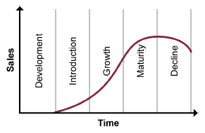

**life cycle analysis** is a quantitative forecasting technique based on applying past patterns of demand data covering

introduction, growth, maturity, saturation, and decline of similar products to a new product family.

**product life cycle management** is the process of facilitating the development, use, and support of products that customers want and need. PLM helps professionals envision the creation and preservation of product information, both to the customer and along the reverse-logistics portion of the supply chain.

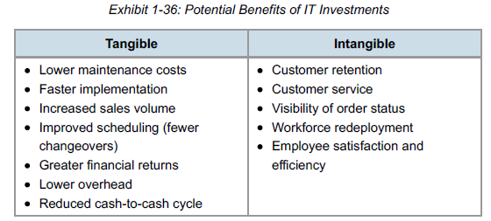

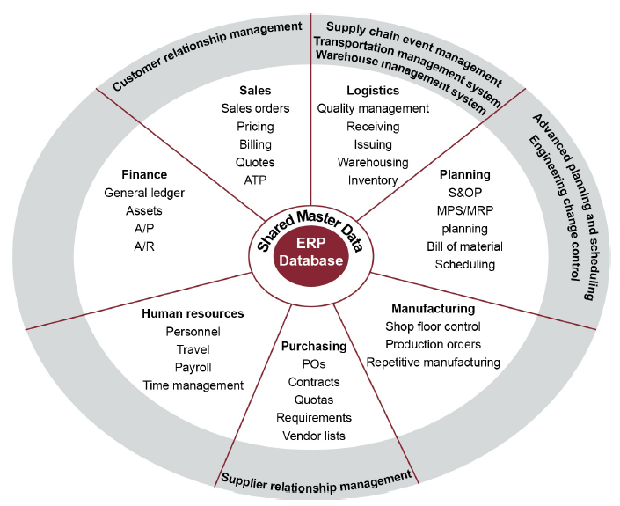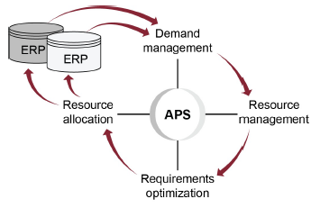

*Available-to-promise (ATP)* is defined as the uncommitted portion of a company’s inventory and planned production maintained in the master schedule to support customer-order promising. The ATP quantity is the uncommitted inventory balance in the first period and is normally calculated for each period in which an MPS receipt is scheduled.

*Capable-to-promise (CTP) is defined* as the process of committing orders against available capacity as well as inventory. This process may involve multiple manufacturing or distribution sites. Capable-to-promise is used to determine when a new or unscheduled customer order can be delivered.

*Profitable-to-promise (PTP).* This combines CTP with a profitability analysis to determine how profitable a particular order would be after all costs are considered.

SCEM provides active visibility, meaning it can perform the following functions:

* **Monitor** events such as demand, shipments, orders, production, fulfillment, and inventory and distribute the information throughout the supply chain.
* **Measure** events against key performance indicators to improve forecasts and decision making.
* **Notify** decision makers when exceptions occur, such as a shortage, so they can make alternate plans in time to avoid costly consequences.
* **Simulate** real or projected exceptions to gauge their impact and recommend solutions.
* Help **control** events by providing timely and simple methods for reversing previous system choices when an exception indicates that a change could prevent a problem or be less costly (e.g., ship from an alternate source).

Specific WMS functions include the following:

* Receiving—automatically matches and routes POs with advanced shipment notifications (ASNs) and blind or traditional receipts; notifies staff of incoming ASNs and upgrades backorders or rush orders
* Storage location management and optimization—creates put-away algorithms and determines location by type, size, volatility, and velocity
* Cross-docking—allows for opportunistic or planned truck-to-truck transfers, including timed merging of items for a customer’s order
* Inventory control—performs cycle counting and creates audit trails to track the time, person, and place of movements, inventory levels, and lead times
* Quality control—tracks items by batch or lot, notifies management of quality issues, places rejects on hold, and ensures quality compliance
* Order selection and task management—forms a pick plan by picking type, allocates items for specific orders, and shows order status
* Automated replenishment—automatically creates a shipment order when an internal or external partner’s system signals the demand
* Security—interfaces with security by requiring WMS records for all releases at controlled points, rotates work assignments, etc.
* Returns—manages reverse logistics for repairs, returns, and recycling

**Automatic identification system (AIS) is defined** as “a system that can use various means, including bar code scanning and radio frequencies, to sense and load data in a computer.” Devices used for an AIS are sometimes called automatic identification and data capture (AIDC) devices. These devices identify items and track the movement of goods across the supply chain automatically, leaving employees to handle just the physical movement of goods.

Unlike just having a serial number on an object, an AIDC device can communicate the object’s presence.

AIDC devices have two key features: automatic classification and automatic identification.

The following content looks at types of AIS and related AIDC devices, including warehouse automation

systems, bar codes and bar-code scanners, RFID, smart cards, magnetic stripes, and vision systems.:

* Warehouse Automation System
  + **Wireless radio data terminal (RDT):** The RDT receives commands from a WMS and directs the actions of the employee for picking or put-away
  + **Synthesized Voice:** A WMS directs this hands-free synthesized voice system to tell an operator what to do. The operator may wear a microphone to indicate when a job is finished
  + **Pick to Light:** These systems highlight a path through the warehouse and/or an item to be picked using physical indicator lights or lit alphanumeric displays installed at each inventory location or on a carousel.
  + **Heads Up Displays:** Heads-up displays present a virtual image of the warehouse over the employee’s actual view for hands-free direction.
* Bar Codes & Scanners: A machine-readable code that identifies, at a minimum, the product manufacturer & the stock keeping unit (SKU). Some bar codes also contain lot & batch information & a serial number. It will continue to coexist with RFID because bar-code labels are very inexpensive. Most RFID labels have a bar code on the outside of the tag for use with either system. RFID and bar codes can be complementary; when RFID experiences interference, the bar-code tag can be scanned.  
    
  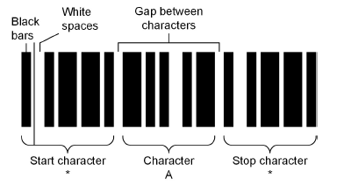

Components of a bar-code system include

Bar-code printers

Bar-code labels

Bar-code readers (portable or stationary)

Hard-wired or radio frequency (RF) communications links between the bar-code readers and an application (ERP, TMS, WMS, or POS capture)

Applications to process the data collected.

A very common bar-code standard is the Universal Product Code (UPC) with a 12-digit number. It is the maximum information for this type. This number is typically used to identify the manufacturer and SKU only;

One type of bar code gaining in popularity is the 2D code. A 2D bar code can be scanned by mobile devices for automatic redirection to mobile-friendly websites. 2D bar codes include standards such as the QR (quick response) code and PDF417, a code found on the back of every U.S. driver’s license.

**Batch processing** relates to computer processing is “a computer technique in which transactions are accumulated & processed together.” In a warehouse, the operator will be given a series of tasks to perform, and, when these tasks are finished, the operator will send the information to the system in a batch before receiving a new set of commands. While batch processing is low in cost, the advantages of a real-time barcode system include better data for salespersons quoting availability, on-the-fly correction of operator errors, & systems that can add or change tasks during a job.

* RFID **radio frequency identification**: a system using electronic tags to store data about items.  
  electronic product code (EPC) is the most widely accepted set of standards for RFID tag data and has been mandated by numerous retailers. The *APICS Dictionary,* 16th edition, defines **EPC** as “codes that are used with RFID tags to carry information on the product that will support warranty programs.

**EPCglobal’s EPC Generation 2 (Gen 2)** interface protocols specify how information is communicated between tags and readers. EPC Gen 2 is recognized by the International Organization for Standardization (ISO) as the ISO 18000-6 class of standards.

Simple and cheap tags are used to record an EPC, while more sophisticated tags are used as a mobile database (e.g., recording temperature, pressure). A chip can also control a process on an assembly line. Some tags are for single use only, while others can be updated and reused. Tag types include active, passive, and semipassive:

An **active tag** is “a radio frequency identification tag that broadcasts information and contains its own power source” (*APICS Dictionary,* 16th edition). Such tags can transmit data to a reader at long ranges and are the most expensive type of tag. They are often used to tag containers or pallets.  
A **passive tag** is “a RFID tag which does not send out data and is not self-powered”. The radio frequency energy from the reader temporarily powers the tag. Passive tags can transmit data at short range and are cheap if purchased in bulk. Readers must typically be installed at gateway entry and exit points, on equipment such as a forklift, or be handheld.  
A **semipassive tag** is “an RFID tag that sends out data, is self-powered, and widens its range by

harnessing power from the reader”

Interference (a distorted radio signal) can be a problem with RFID. A signal can be affected by variables such as antenna size, reader power level, frequency used, and other radio frequency emissions (e.g., machinery white noise). Some liquids absorb reader/tag signals, and some metals reflect signals. Reading multiple boxes on a pallet is not foolproof; reading singular cases on a conveyor system is very reliable. Common adjustments to improve read rates include Placing readers in locations with less interference Placing a buffer or shield between the tag and the interfering object Adjusting the position and angle of the RFID antennae on readers Changing reader or tag type/manufacturer to suit the facility or product.

It will provide a strategic advantage, such as collaborative product life cycle management, continuous demand management, reduction of stockouts, asset management, fulfilment and distribution, aftermarket sales, or reducing counterfeiting or theft.

* Other AIDC devices like:

**Smart cards.** A smart card has an embedded microchip with a unique identifier. Companies give

employees smart cards to regulate physical and computer access and create an automatic time log.

Smart cards are also used for vehicle identification at tollbooths or in warehousing for a picking tour.

**Magnetic stripes.** Magnetic stripes are used for credit and ID cards to automate number entry. Data

on the magnetic stripe can be changed. Because the stripe must be read by contact, it can’t be used

for high-speed sorting.

**Vision systems.** Vision systems use cameras and computers to interpret the images. These systems

are relatively expensive and can distinguish changes at moderate speeds with great accuracy in a

controlled environment. A vision system may be used to identify incoming items that have only text labels

A **decision support system (DSS)** is “a computer system designed to assist managers in selecting and

evaluating courses of action by providing a logical, usually quantitative, analysis of the relevant factors”

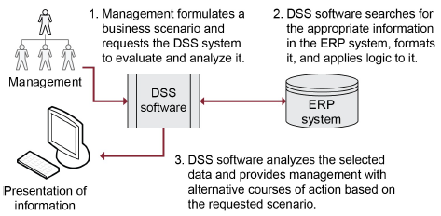

**Data mining** is “the process of studying data to search for previously unknown relationships. This

knowledge is then applied to achieving specific business goals”

HTML, which is not a programming language but a way to format text, permits a user to create

text, hypertext links, and multimedia elements within a web page.

Amazon net sales $400 billion and average of 200+ million monthly unique visitors.

Sell Side E-Commerce

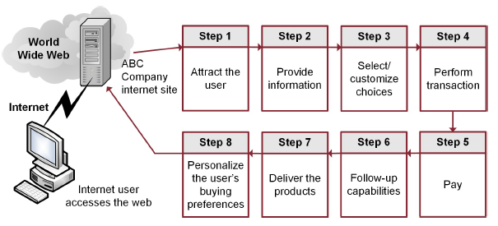

Analyzing **RACI (responsible, accountable, consult, and inform)** and organizational charts can also provide

information on how to structure your communications. RACI charts spell out who needs to do each task

(responsible), which one person will answer to its success or failure (accountable), who needs to be given a

chance to review (consult), and who simply needs to be told about what’s going on (inform).

Enterprise Environmental Factors (EEFs)

EEFs refer to conditions outside the control of the project team that influence or constrain the project. It is

vital to think about EEFs right from the start of a project, because they can influence whether the project is

even feasible at the given time given things such as the economy, demand, or organizational readiness.

Organizational Process Assets (OPAs)

OPAs are the policies, procedures, processes, plans, and organizational knowledge base of the

organization. OPAs are common inputs to planning processes and are created during some processes and

so also may become outputs. OPAs include:

* Policies, procedures, and processes: rules, standards, templates, and methodologies (e.g., best practices)
* Organizational knowledge base: historical information from organizational activities and lessons learned from prior projects.

work breakdown structure (WBS) is “a hierarchical decomposition of the total scope of work to be carried out by the project team to accomplish the project objectives and create the required deliverables.”

Earned value measurement (EVM) is a technique that allows project managers to measure scope, schedule, and cost variances. EVM uses 3 input measurements to produce a large number of variance measurements & ratios:

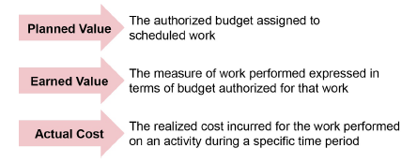

PV = Planned Value = Schedule Completed / Total * Budget = ¾ * 2000$ = 1500$

EV = Earned Value = Budget * Actual % completed = 2000$ * 50% = 1000 $

AC = Actual Cost (expenses incurred till now)

SV = Scheduled Variance, SPI = Schedule Performance Index

CV = Cost Variance, CPI = Cost Performance Index

Negative values are bad (e.g., behind schedule or over budget); positive values are good.

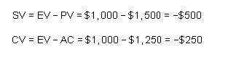

An SPI or CPI of less than 1.0 or 100 percent shows that a project is off schedule or budget; values greater

than 1.0 or 100 percent mean that the project is ahead of schedule or under budget.

