Aside from assessing import duties, Customs also inspects shipments with the following intentions:

* To confirm that the goods actually have the value stated on the shipment’s documentation, since that

value partly determines the amount of the import duties

* To determine that the items have all the correct markings, including safety labels, instructions,

identification of country of origin, and any special marks required

* To weed out any forbidden items, such as illegal drugs and goods judged not to meet certain national

standards

* To enforce quotas
* To ensure that the invoice is correct and that the shipment contains the number of items claimed in the

documentation

* To discourage dumping of products by imposing a high percentage duty (Dumping is when a company

exports a product at a price lower than what the product normally sells for in the country where the

company operates. There is a link for additional anti-dumping information online in the Resource

Center.)

While any company owning a patent can do this, a special class of organization called a Patent Assertion Entity (PAE), or “patent troll” has come to exist. According to a U.S. White House report titled Patent Assertion and U.S. Innovation, PAEs “focus on aggressive litigation [...] asserting that their patents cover inventions not imagined at the time they were granted.” These companies form shell companies to hide their identities and threaten or sue both large and small organizations.

An AMR Research study ranked China and India as problem countries related to IP infringement and

other risks such as security breaches. In China, for example, the first entity to use a trademark in that

country owns that trademark, even if it is a trademark that is already registered in a different country.

Therefore, it is imperative to file trademarks in China at the same time as in other countries even if the

organization does not plan to do business there right away. However, many countries require active use of a

trademark in that country for the protection to be maintained.

IP resources exist. In the U.S., the Patent Cooperation Treaty allows organizations to file an international

patent application and seek patent protection in 115 countries with one application to the U.S. Patent and

Trademark Office (USPTO) if the applicant has filed a foreign filing license. In another example, the U.S. and

the European Union have partnered to provide a set of resources for small and mid-sized organizations to

manage IP rights (IPR) in foreign markets. They have developed the TransAtlantic IPR Portal that includes

toolkits for specific countries, how to manage IP rights, training, and links to enforcement authorities.

Licensees, not licensers, usually have the responsibility to

* Periodically check for changes in licensing policy.
* Understand the complex methods of counting per user or device metrics.
* Select the most cost-effective licensing method. License per user may be better if each user has
* multiple devices while license per device may be better if each person has only one device or multiple
* persons use that device on occasion. A mix of both might be allowed but is hard to administer.
* Discover when they have unused licenses that can be granted to another user or device.
* Discover authorized users using software on an unauthorized devices.
* Maintain records of purchases and licenses.
* Determine when licenses are expiring and renew them.

A tax aligned supply chain (TASC) is one that weighs taxation amongst other supply chain costs and challenges.

Various types of taxes might be used as incentives including property, income, and value-added taxes (VAT).

The taxes might be lowered for an area for an indefinite period through a change in tax policy. For example,

Ireland was granted a tax advantage for VAT. The tax on the value added in that country is 10 to 12 percent

rather than the 20 percent assessed in the rest of the European Union. The decision to save a net of 5 to 10

percent in total taxes by moving to Ireland then needs to be weighed against other costs including labor and

transportation infrastructure.

**International labor considerations**

A number of international organizations support labor rights. For example, the United Nations has a large

number of declarations that support human rights, labor organization, economic rights, and prevention of

discrimination against women. The Organisation for Economic Co-operation and Development (OECD) has

Guidelines for Multinational Enterprises, and the International Labour Organization (ILO) has a Tripartite

Declaration of Principles Concerning Multinational Enterprises and Social Policy. The United Nations Global

Reporting Initiative (GRI), which is discussed in greater detail in the next topic, draws upon information in

these standards. Its categories of information on the social impact of organizations help illustrate some

prominent international labor considerations. For each of the following, organizations need to consider their

impact in each significant region of operations:

* How entry-level wages compare to local minimum wage laws and any gender disparity
* How average wages compare to market rates and any gender disparity
* The proportion of senior management positions filled by local community persons
* Local infrastructure or job base investments
* Diversity of new hires and retention for age, gender, ethnicity, and so on
* Benefit differential between full- and part-time employees and if the proportion of the two groups is

reasonably allocated

* Parental leave time support and post-leave retention
* How layoffs and plant closings are communicated with/without unions and whether support services for

career transitioning is offered

* Whether employees are represented on health and safety committees
* Worker injuries or health issues by region or gender
* How well health and safety is handled in union/nonunion shops
* Proper and sufficient worker training by gender or employee category
* Existence and efficacy of grievance mechanisms

The labor practices regarding suppliers by region is also of concern:

* The proportion of local suppliers that are used
* Whether suppliers are screened for labor practices
* The proportion of suppliers with negative impact labor incidents, and their significance
* Whether supplier labor ethical policies exist and their degree of enforcement, including any contract
* terminations for poor labor practices
* A special international labor consideration is a deemed export.

**sustainability** involves the “activities that provide present benefit without compromising the needs of future generations.”

The **triple bottom line (TBL)** concept has three components that create a sustainable business model as:

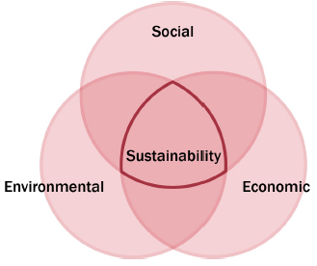

According to the U.S. Department of Transportation (DOT), items or goods are called hazardous materials

(hazmat) or dangerous goods (DG) internationally when they are, “capable of posing an unreasonable risk

when transported in commerce to health, to safety, and to property.” Many governments require

organizations to have contingency and disaster preparation plans in place to mitigate both the environmental

and economic consequences of a disaster. Contingency planning is discussed in the section on “Manage

Risk in the Supply Chain.”

The U.S. DOT identifies ignitability, corrosivity, reactivity, and toxicity as four characteristics of concern due to

health and U.S. Environmental Protection Agency (EPA) requirements. The level of danger is also rated.

Ships that transport dangerous or hazardous materials or goods are governed by the International Maritime

Dangerous Goods (IMDG) Code. The code covers such matters as packing, container traffic, and stowage,

with particular reference to the segregation of incompatible substances. Since its adoption in 1965, the IMDG

Code has undergone many changes to keep pace with the ever-changing needs of industry. Amendments

are made on a two year cycle and are adopted by all authorities responsible for regulating the different

modes of transport. With some exceptions, the Code became mandatory in 2002.

In the United States, the laws regarding dangerous goods are known as “Hazardous Materials Regulations.”

Canada has its own laws governing “Transportation of Dangerous Goods.” In Great Britain, the Health and

Safety Commission (HSC) regulates all work-related health and safety risks. A book titled *Recommendations*

*on Dangerous Goods* is published and updated every other year by the International Civil Aviation

Organization (ICAO). The ICAO and the International Air Transport Authority (IATA) also publish special

instructions on transporting dangerous goods. Air transport is most strictly regulated.

***European Union efforts***

The European Union is also contributing to the sustainability movement with legislation relating to material

content disclosure, reuse of materials, recycling, and related issues. The EU Waste Electrical and Electronic

Equipment (WEEE) directive mandates that suppliers take back equipment at the end of its economic life,

and it also sets targets for recycling and recovery of material used in electronics. The directive arises from

concerns about specific materials used in electronics products, such as mercury, cadmium, lead, chromium

VI, and other heavy metals and flame retardants.

In 2002 the EU issued a Restriction of Hazardous Substances (RoHs) directive for electrical and electronic

equipment; this is discussed more in the section on “Manage Risk in the Supply Chain.”

You can also use the environmental SCOR model component called Green SCOR. ® Its performance

attributes focus on environmental concerns. The research sponsored by the U.S. Office of the Deputy Under

Secretary of Defense (Installations and Environment) cited in the discussion of SCOR established the

following parallel environmental definitions:

**Reliability.** Reliability is the ability to deliver the correct product to the customer. Reliability reduces

waste from product discards and reduces air emissions and fuel use from extra transportation for

returned products. Proper documentation enables all players in the supply chain to keep better track of

hazardous materials or toxins that are embedded in certain products, thus allowing them to arrange for

proper storage, handling, and disposal.

**Responsiveness.** The environmental definition of responsiveness relates to measuring the changes in material movement velocity from processes intended to mitigate environmental impacts, such as pollution control or other regulatory steps in a process.

**Flexibility.** Flexibility is the degree to which a company can meet the environmental demands of its customers. This pertains to the company’s products and their production, transportation, recyclability, etc.

**Costs.** These expenses include the costs of environmental compliance and cleanup as well as energy costs.

**Asset management.** Sustainable asset management practices take governance, environmental, and

social aspects into consideration when making asset and investment decisions.

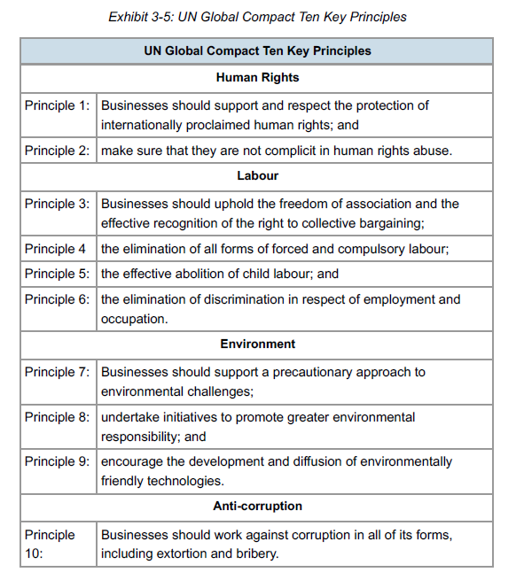

the **Global Reporting Initiative (GRI)** is “a network-based organization that has pioneered the development of the world’s most widely used sustainability reporting framework.” the **GRI reporting framework** is the framework that sets out the principles and performance indicators organizations can use to measure and report their human rights, labor, environment, and anticorruption practices and outcomes.

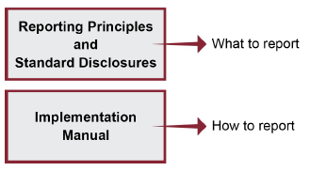

The G4 Sustainability Reporting Guidelines

The GRI’s Sustainability Reporting Guidelines are now in their fourth generation. Launched in May 2013, the

G4 Sustainability Reporting Guidelines are the latest and most complete version, which replaces the content

of the third generation G3.1 Guidelines released in 2011.

The system uses specific terms for the levels in its hierarchy:

**Categories:** Economic, environmental, and social.

**Social has subcategories:** Labor practices and decent work, human rights, society, and product

responsibility.

**Aspects:** The economic and environmental categories and four social subcategories each have a

list of subjects to be covered, which are called aspects. Only those aspects that are material

(defined below) need to be included in the report.

**Indicators:** Each aspect has one or more indicators, which are the lowest level of information

in the report. For example, the water aspect includes three indicators: total water withdrawal

by source, water sources significantly affected by withdrawal of water, and percentage and

total volume of water recycled and reused.

For many indicators, there are linkages to the UN Global Compact’s Ten Principles and/or to the

Organization for Economic Co-operation and Development’s Guidelines for Multinational Enterprises, which

is discussed later.

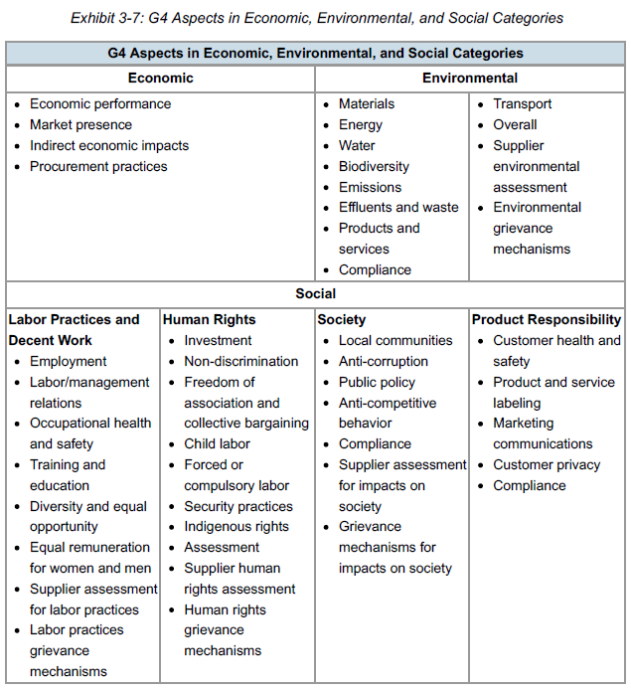

**Organization for Economic Cooperation and Development (OECD)**

**Guidelines for Multinational Enterprises**

Another sustainability entity is the Organization for Economic Co-operation and Development (OECD).

Established in 1961, OECD was created to promote policies that will improve the economic and social wellbeing

of people around the world. It provides a forum in which governments can work together to share

experiences and seek solutions to common problems and identify factors that drive economic, social, and

environmental change. OECD measures productivity and global flows of trade and investment and

establishes international standards ranging from agriculture, to taxes, to the safety of chemicals. The OECD

is located in Paris, France, and, as of mid-2015, has 34 member countries.

In 2000, the OECD developed the **Organization for Economic Co-operation and Development (OECD)**

**Guidelines for Multinational Enterprises,** defines as a set of recommendations on responsible business conduct addressed by governments to Multinational Enterprises (MNEs) operating in or from adhering countries that encourage and maximize the positive impact MNEs can make to sustainable development and enduring social progress.

**conflict minerals** are “minerals mined in conditions of armed conflict and human rights abuses, and are sold or traded by armed groups.”

**accreditation** is certification by a recognized body of the facilities, capability, objectivity, competence, and integrity of an agency, service, operational group, or individual to provide the specific service or operation needed. For example, the Registrar Accreditation Board accredits those organizations that register companies to the ISO 9000 Series Standards.

ISO 9000 Series Standards on quality and ISO 9001 certification

ISO 14000 Series Standards on environmental management and ISO 14001 certification

ISO 26000 Guidance for Social Responsibility (not applicable for certification)

SA8000 Social Accountability certification

ANSI Z.10 Occupational Health and Safety Management Systems certification

an international standard that specifies requirements for a Quality Management System (QMS) where an organization: a) Needs to demonstrate its ability to consistently provide product that meets customer and applicable statutory and regulatory requirements and b) Aims to enhance customer satisfaction through the effective application of the system, including processes for continual improvement of the system and the assurance of conformity to customer and applicable statutory and regulatory requirements.

**SA8000** is a widely recognized international standard for managing human rights in the workplace. It provides an

auditable framework for assuring that social accountability is being stewarded by an organization.

The ANSI-ASQ National Accreditation Board (ANAB) is the U.S. accreditation body that accredits third-party

certification bodies to provide certifications for this standard as well as for ISO 14001 and ISO 28000.

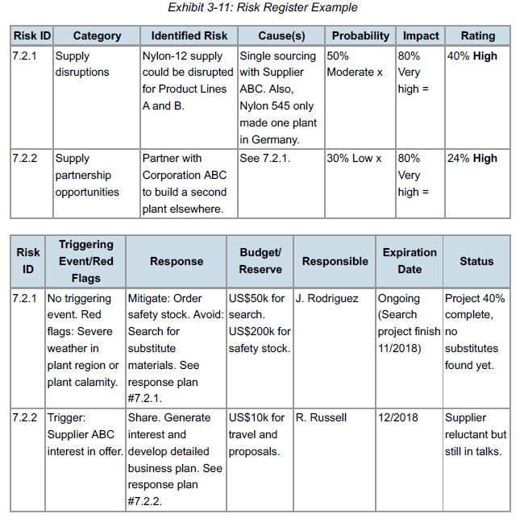

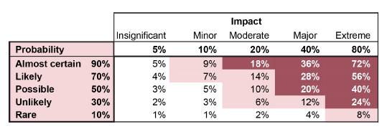

**PERT (program evaluation and review technique)**

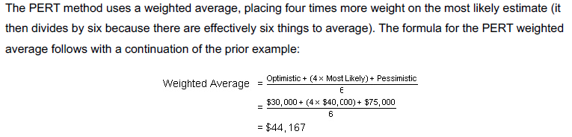

**Expected Monetary Value (EMV)**

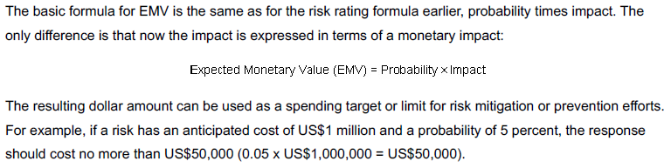

EMV makes the simplifying assumption that the options being considered are the only possible outcomes

and so these outcomes sum to 100 percent of the possibilities. Therefore, if these are the only two options

being considered, if there is a 75 percent chance that the partnership will bring in US$10 million, then there

is a 25 percent chance of the US$1 million result.

EMV is calculated separately for each option and then the options are summed to find the expected value of

that decision. The calculations for this example follow:



Net Impact EMV

When a risk has a response cost or an opportunity has an up-front cost, this can be factored in to the

analysis. To continue the previous example, say that there is a US$5 million up-front investment. This cost is

deducted from the impact prior to multiplying it by the probability. If the net result is positive, it is then an

opportunity. If the net result is negative, then it is a threat (negative risk). The formula for calculating a EMV

when there is an initial cost follows along with a continuation of the prior example:



a **Monte Carlo simulation** is “a subset of digital simulation models based on random or stochastic processes.” Monte Carlo simulations use specialized tools or spreadsheet add-ons to allow developers to enter a range for each input variable rather than just one value. Then the simulation is run thousands of times using different random values from each input range at each pass. The result is an averaged set of results along with statistics such as probability distributions.

Hedging

Hedging is a risk transfer tool for commodities, currency exchange, and financial instruments. Hedging is

often used to lock in a price now for something that needs to be purchased in the future, such as a

commodity or a foreign exchange transaction. By locking in the price now, the organization is transferring the

risk of the price going in an unwanted direction to the party offering the hedging instrument. The organization

is also sacrificing the benefit it would receive if the price of the underlying asset being hedged goes in a

favorable direction. In this sense, a long term contract with a supplier that fixes prices is a form of hedging,

since the supplier bears the risk of its raw materials going up but cannot pass on those costs. For this

reason, many fixed-price contracts have escape clauses in the event of severe commodity or foreign

exchange rate changes.

The opposite of hedging is speculation. The hedger is working to reduce risk (uncertainty), not to increase

profits. The speculator is the other party to a hedging transaction, who is betting in the opposite direction.

The incentive of a speculator is to make a profit.

Three types of hedging instruments are forwards, futures, and options. Forwards and futures are very similar,

with the key difference being that forwards are customized deals between two parties (the other is often a

bank) while futures are standardized deals offered by large financial exchanges in standard amounts and for

a limited number of currencies and commodities. Otherwise the two instruments serve the same purpose:

lock in a price now for something needed in the future. Both are mandatory, meaning that you need to settle

them regardless of what the market does. Forwards are often used for things not on the organized

exchanges or when another party offers customized terms that fit very well. A risk is that the other party will

default. This risk is very low when working with an exchange, but it can be significant with other parties.

An option is like a forward or a future, only you have the option to use it or not. You pay the writer a premium

(fee) to gain this flexibility. The fees can be sizable and must be taken into account when calculating the

overall savings or loss from the hedge. For example, if oil options are offered at €65 per barrel and you

purchase an option to buy 100,000 barrels of oil next year for a premium of €5 per barrel, then you are

effectively paying €70 per barrel, so at least you have some budget certainty. If the price were €66 per barrel,

you would exercise the option and pay €65 + €5 per barrel. The market price would need to be higher than

€70 per barrel to be a real savings. If the price was €$50 per barrel however, you would not use the option

and buy on the open market. The effective price for you would be €50 + €5 per barrel since the fee is paid

either way.

**ISO 28000** is an International Standard that specifies the requirements for a security management system, including

those aspects critical to security assurance of the supply chain.

a **business continuity management system (BCMS)** is Part of the overall management systems that establishes, implements, operates, monitors, reviews, maintains and improves the organizational capability of continuing to deliver products or services at acceptable predefined levels following a disruptive incident.

**ISO 22301** as “an international standard that specifies requirements for setting up and

managing an effective business continuity management system.”

Examples of security partnerships follow:

* C-TPAT for imports (defined below)—U.S.
* Authorized Economic Operator (AEO) program—EU
* Partners in Protection (PIP)—Canada
* Secure Trade Partnership (STP)—Singapore
* AA rating for customs—China

COSO ERM is a process that the board of directors, management, and staff enact to set risk strategy, identify risk events, and manage risk within the organizations risk appetite, with the goal of ensuring organizational objectives can be met. The COSO ERM framework has eight components that need to be tightly integrated:

1. **Internal environment.** Perspective from which risk is viewed including risk management philosophy, appetite, ethics, and integrity.
2. **Objective setting.** A formal objective-setting process aligns with organizational mission and risk appetite.
3. **Event identification.** Identify threats and opportunities to objectives. Opportunities loop back to strategy/objective setting.
4. **Risk assessment.** Risk likelihood and impact determine response.
5. **Risk response.** Select a type of response that aligns with appetite.
6. **Control activities.** Policy and procedure reinforce responses.
7. **Information and communication.** Timely information is shared down, up, and across the organization.
8. **Monitoring.** Management and audit continuously improves ERM.

**ISO 31000** is a standard adopted by the International Standards Organization that outlines principles and a set of

guidelines to manage risk in any endeavor. The standard outlines guidelines for understanding risk, developing a risk management policy, integrating risk management into organizational processes (including accountability and responsibility), and establishing internal and external risk communication processes.



Benefits for organizations of implementing ISO 31000, ISO 31010, and Guide 73 include the following:

Implementation increases organizational risk awareness and identification.

* It increases the probability of meeting or exceeding organizational objectives due to better operational resilience, efficiency, and effectiveness.
* It reduces the probability of identified risks and reduces losses from risk events.
* It allows more accurate assessment of internal strengths and weaknesses and external opportunities and threats (i.e., SWOT analysis).
* It helps with compliance with regulations, laws, and international standards.
* It enhances internal controls and corporate governance.
* It enhances external controls such as for financial reporting.
* It reduces uncertainty, improving stakeholder trust and confidence.
* Managers can proactively prepare for problems instead of just reacting.
* Managers can plan, decide, and budget based on reliable and custom tailored risk assessments.
* It assists with organizational learning.