E-sat Report

The EMPLOYEE SECURITY AWARENESS TESTING TOOL is a security testing tool aimed at testing the security awareness of employees in an organization. The tool is designed to run on a local network and tests the security of the employees devices connected to the network, without their knowl

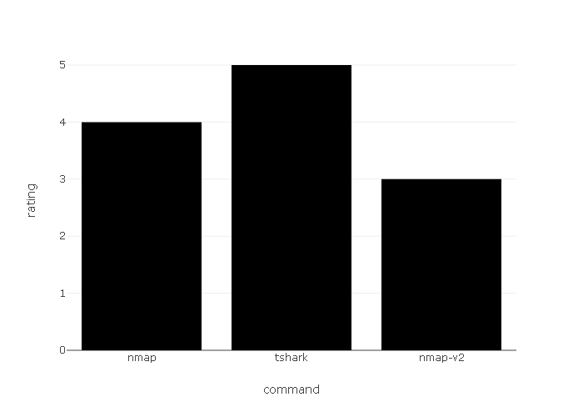

### IP :- 10.76.15.153

### MAC :- 94:08:53:9b:37:d7

### RATING : 4

### VULNERABILITY

|  |  |  |
| --- | --- | --- |
| RISK LEVEL | VULNERABILITY NAME | CV |
| 2 | Remote code execution (RCE) | CVE-2020-1472 |

### TRAFFIC

example.com

google.com

facebook.com

stackoverflow.com

### suspicious domains

|  |  |
| --- | --- |
| SOURCES | STATUS |
| ecil.com1 | Unrated |

### PORTS

|  |  |  |
| --- | --- | --- |
| NUMBER | SERVICES | INFO |
| 80211 | http | alternat https proxy port |