automated-backup_script

The original script was

#!/bin/bash

backup_dir="/path/to/backup"

source_dir="/path/to/source"

timestamp=$(date +"%Y%m%d%H%M%S")

tar -czf "$backup_dir/backup_$timestamp.tar.gz" "$source_dir"

I change it to

#!/bin/bash

backup_dir="/home/vinod/apt_log_backup "

source_dir="/var/log/apt"

timestamp=$(date +"%Y%m%d%H%M%S")

tar -czf "$backup_dir/backup_$timestamp.tar.gz" "$source_dir"

After executing the above script getting get below error

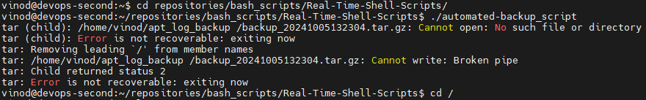

I was getting this error because i have given space between **backup** and **"** in below line in the above script

backup_dir="/home/vinod/apt_log_**backup "**

**So after removing the** space between **backup** and **"** in the script it worked but giving below error



Now for resolving the above I got solution at <https://unix.stackexchange.com/questions/59243/tar-removing-leading-from-member-names>

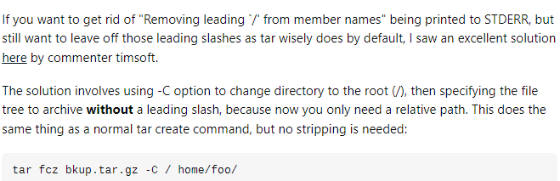

So now i changed my script as below and it worked now

#!/bin/bash

backup_dir="/home/vinod/apt_log_backup"

source_dir="var/log/apt"

timestamp=$(date +"%Y%m%d%H%M%S")

tar -czf "$backup_dir/backup_$timestamp.tar.gz" -C / "$source_dir"

