log_rotation_script\

Write a script to rotate log files to prevent them from growing too large.

The original script was

#!/bin/bash

log_file="/path/to/logfile.log"

max_size=1000000 # 1MB

if [ $(wc -c < "$log_file") -gt $max_size ]; then

mv "$log_file" "$log_file.old"

touch "$log_file"

fi

Then I changed it to below

#!/bin/bash

log_file="/var/log/syslog"

max_size=1000000 # 1MB

if [ $(wc -c < "$log_file") -gt $max_size ]; then

mv "$log_file" "$log_file.old"

touch "$log_file"

fi

When I executed it with non privileged user vinod it gave me below error

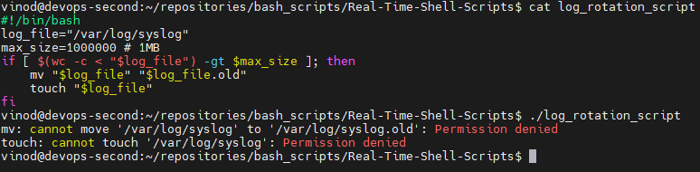

So now when i executed it with root it worked



After the execution of above script syslog file has been moved to syslog.old as its size is more than 1 mb and a new 0 byte file syslog has been created we can see tis in the below picture

