**Member mapping on WWA Portal**

Member mapping always done on WWA. WWA will have only one entry for each member.

* To create new user we need to insert entries in **gen_User** and **sei_Member** tables

INSERT INTO gen_User SET cCompanyname='Team Global',cAddress='Kurla Road, near Saki Naka, Andheri (East)', cCity='Mumbai', cUsername='edi_teamglobal_prod', cPassword=sha1('xxxxxxxxx'), tEntered=now();

SET @iUserID = (SELECT iUserID FROM gen_User WHERE

cUsername = 'edi_teamglobal_prod' limit 1);

* Create respective directories.

**Member Mapping**

**Example,** Member name: TeamGlobal UN-Code: INSGO01

Member need to map on **WWA** Portal

**1) Fetch the required data from database**

SET @iMemberID=(SELECT iMemberID FROM sei_Member WHERE cCompanycode='edi_teamglobal_prod' limit 1);

SET @iCountryID=(SELECT iCountryID FROM gen_Country WHERE cCode='IN' limit 1 );

SET @iCurrencyID=(SELECT iCurrencyID FROM gen_Currency WHERE cCode='INR' limit 1);

SET @iBranchID=(SELECT iBranchID FROM web_Branch WHERE cCode='SGO' and cEmail='insgo01@wwalliance.com' limit 1);

**2) Map the new office to requested member.**

INSERT INTO sei_Office_map SET

cCmscode=' ', // Not applicable in Member mapping case

iBranchID=@iBranchID,

iMemberID=@iMemberID,

iCountryID=@iCountryID,

iCurrencyID=@iCurrencyID,

cExternalcode='INSGO01',

cCity='Sagar',

cCountry='India',

tEntered=now();

**Buzzword with tables : sei –Shipco, wei-WWA**

**In sei_Office_map** table we are having many column out of which iStatus, iEnteredby, tEntered, iUpdated, tUpdated uses for identification.

iStatus : 0 indicates active /Valid Transaction

-1 indicates inactive

1 indicates Current Status

In case of office mapping only 0 and -1 will be used. Here 0 indicated Office is mapped and -1 indicates office is deactivated.

To map office to new member we need to fetch data from various tables;

**Field Table Name Condition**

MemberID sei_Member Based on Company Name

CountryID gen_Country Based on Country Code

CurrencyID gen_Currency Based on Currency Code

BranchID web_Branch Based on city code and cEmail

Here BranchID is very essential because office which we are inserting need to link with which branch.

cCmscode = It will be blank in Member case because UNLocation and Office code is same , and in customer mapping if code is not same we are going to set Customer name and address in cCmscode field.

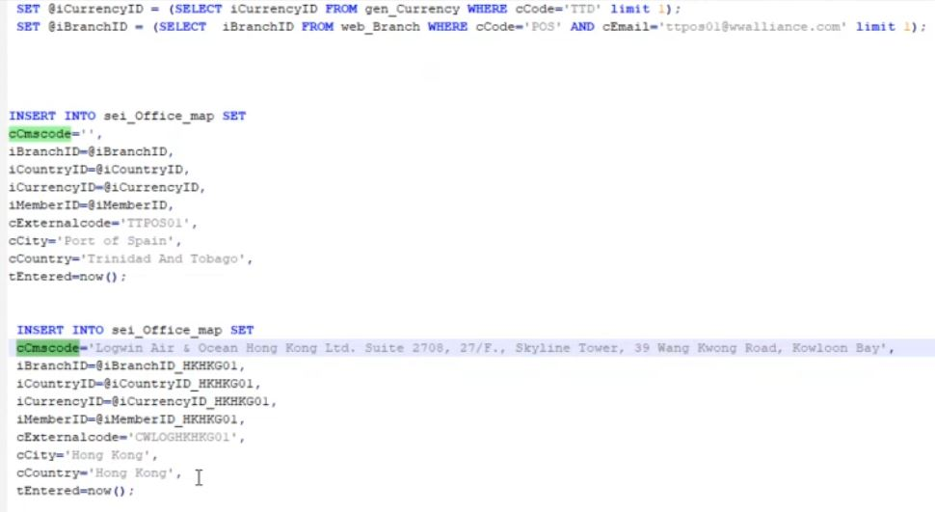

First insert query is for Member where cCmscode is blank.

Second insert query is for Customer where cCmscode is having customer name and address. This will reflect in customer report.

**Customer Mapping with Member**

**Example :** Member name: TeamGlobal UN-Code: INSGO01

Customer name: DHL, Code: DDAOSGO

DDAOSGO ---> Sagar ---> INSGO01

Here DHL Sagar customer code need to map with Sagar

**MySQL Script for the above mapping**

SET @iMemberID_DDAOSGO =

(SELECT iMemberID FROM sei_Office_map WHERE cExternalcode='INSGO01' limit 1);

SET @iCountryID_DDAOSGO =

(SELECT iCountryID FROM sei_Office_map WHERE cExternalcode='INSGO01' limit 1);

SET @iCurrencyID_DDAOSGO =

(SELECT iCurrencyID FROM sei_Office_map WHERE cExternalcode='INSGO01' limit 1);

SET @iBranchID_DDAOSGO=

(SELECT iBranchID FROM web_Branch WHERE cCode='SGO' AND cEmail='insgo01@wwalliance.com' limit 1);

* In Customer Mapping we are referring sei_Office_map table to find MemberID, CountryID, CurrencyID and BranchID

**Now we are going to map Customer office with Member office by executing following query.**

INSERT INTO sei_Office_map SET

cCmscode='DHL & Sagar State: MP, Pin Code: 470001',

iBranchID=@iBranchID_DDAOSGO,

iCountryID=@iCountryID_DDAOSGO,

iCurrencyID=@iCurrencyID_DDAOSGO,

iMemberID=@iMemberID_DDAOSGO,

cExternalcode='DDAOSGO',

cCity='Sagar',

cCountry='India',

tEntered=now();

CExternalcode is: WWA requester ID i.e Customer Code

* **Customer office is always Link or Map with Member Office.**
* **Importance of Office : Transmit the booking or BL to right Member.**

**Cargowise:**

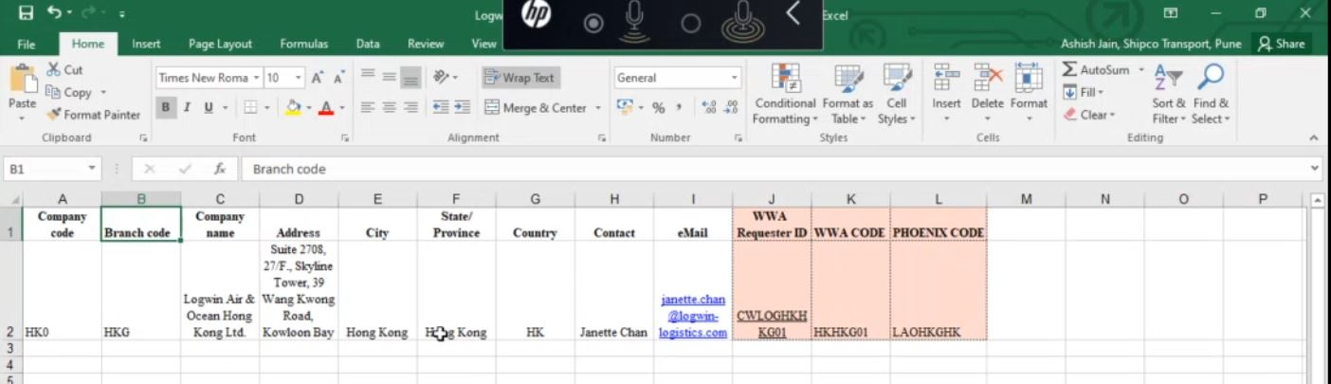

**Office mapping request for customer Logwin Air & Ocean Hong Kong Ltd via CargoWise.**

**Cargowise:** Cargowise is a portal for multiple customers. It also provides required software’s for shipping companies.When any customer wants to do booking he need to raise ticket on Cargowise portal then cargowise will open gate for that customer to do booking. Once booking is done by customer that will flows to WWA and WWA to respective Member. In backend data will exchange with EDI. Cargowise will always send mapping request in Excel format.

Cargowise send WWA request ID either in any of two formats

1. Office code : CWLOGHKHKG01
2. Customer name with code : edi_logwin_prod # CWLOGHKHKG01

At the time of mapping we need only office code.

**Customer office booking:**

Customer when prepare booking or BL he informs to member via EDI channel- EDI includes booking or BL information based on which to which member booking will go.

**Customer 🡪 WWA 🡪Member**

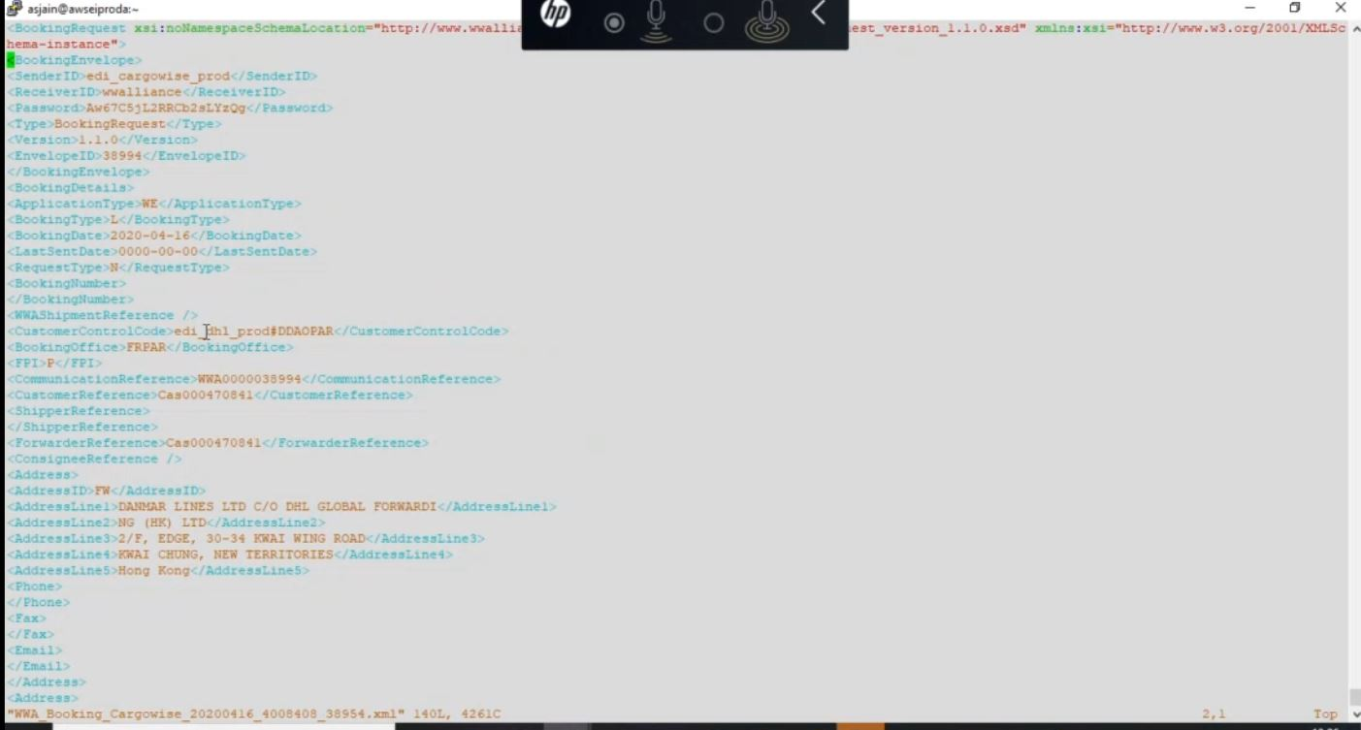

In the above snap customer DHL uses cargowise portal to do booking refer CustomerControlTag and this booking flows from Cargowise to WWA portal so SenderID is edi_cargowise_prod.

**Mapping Scenarios**

Case 1:

Customer office code != Member Office code (Mapping need to Prepare)

Case 2:

Customer office code = Member Office code (Already Mapped) due to system loop hole

Case 3:

Customer office code = Member Office code but requested for different code

Ex: (KN) USEHX01 : (Shipco) USEHX01 but Ops KN requested to map with USNYC01

WWA Portal

M1

M2

M3

* **Shipco Mapping**

Offices which are already mapped in WWA portal only those offices will map with Shipco.

* Difference lies in below criteria

|  |  |  |
| --- | --- | --- |
| **Criteria / DBTable** | **WWA** | **Shipco** |
| gen_Office_intinfo | --- | iOfficeID( Citycode) |
| web_Branch | iBranchID (cityCode & Email) |  |
| Branch | 90 % Same 10 % Differ | |

**WWA -> Validate file-> Process -> Route**

**Member**

**Shipco -> Validate file-> Process Booking File**

SET @iMemberid =

(select iMemberID from sei_Member where cCompanycode='edi_hko_prod' limit 1);

SET @iOfficeID_HKHKG01 = (select iOfficeID from gen_Office_intinfo where cCode='HKG' limit 1);

INSERT INTO sei_Office_map SET

iMemberID=@iMemberID,

iOfficeID=@iOfficeID_HKHKG01,

cExternalcode='CWLOGHKG01',

cCmscode='LAOHKGHK',

cAlias='LOGWIN',

cCity='Hong Kong',

cCountry='HK ',

tEntered=now();

**CVS: Concurrent Versioning System**

This system we are using for checkout and checkin.It is centralized system normally we are using when we are done with MySQL script that needs to commit here and after committing need to checkout and deploy it on Production server.