DEVELOPMENT OF A WEB-BASED COMPUTER HARDWARE AND SERVICE MANAGEMENT SYSTEM

GROUP L (3B)
MEMBERS
- LISA SIFA MAYABI - HDB212-0314/2023
- JESSICA NGUMBAU - HDB212-2325/2023
- DAN OLING'A - HDB212-0346/2023
- JESSE NJUGUNA - HDB212-0335/2023
- JIRMO BORU - HDB212-0350/2023

BACHELOR OF BUSINESS INFORMATION TECHNOLOGY
YEAR 3 SEM 1
HBT2308: SYSTEM DEVELOPMENT PROJECT

JOMO KENYATTA UNIVERSITY OF AGRICULTURE AND TECHNOLOGY

2026

Table of Contents
LIST OF TABLES v
LIST OF FIGURES vi
ABSTRACT vii
CHAPTER ONE 1
INTRODUCTION 1
1.1 Background Information 1
1.2 Statement of the Problem 2
1.3 Objectives 3
General Objective 3
1.3.1 Specific Objectives 4
1.4 System Research Questions 4
1.5 Significance of the System 4
1.5.1 Customers 4
1.5.2 Owners 5
1.5.3 Government 5
1.6 Scope of the System 5
CHAPTER TWO 8
LITERATURE REVIEW 8
2.1 Introduction 8
2.2 Empirical Review 8
2.2.1 Existing Systems 8
2.2.2 System Architectures 9
2.2.3 Illustrations (Description of System Flow) 10
2.2.4 Illustrations (Diagrams) 10
2.3 Proposed System Architecture 11
2.3.1 Functionalities of the Proposed System 13
2.3.2 Illustration of Proposed System 13
2.4 System Design Requirements 15
2.4.1 Hardware Requirements 15
2.4.2 Software Requirements 15
2.4.3 Functional Requirements 15
2.4.4 Non-Functional Requirements 16
CHAPTER THREE 18
METHODOLOGY 18
3.1 Introduction 18
3.2 System Design Methodologies 18
3.2.1 Waterfall Development Methodology 18
3.2.2 Iterative Development Methodology 20
3.2.3 Incremental Development Methodology 21
3.3 Fact-Finding Techniques 22
3.3.1 Interviews 22
3.3.2 Observation 22
3.3.3 Questionnaires 23
3.3.4 Document Analysis 24
3.4 Feasibility Studies 25
3.4.1 Technical Feasibility 25
3.4.2 Economic Feasibility 25
3.4.3 Operational Feasibility 26
3.4.4 Schedule Feasibility 26
CHAPTER FOUR 28
SYSTEM ANALYSIS AND DESIGN 28
4.1 Introduction 28
4.2 Data Entity Analysis 28
4.2.1 User Tables 29
4.2.2 Data Flow Diagrams 31
4.3 Design 33
4.3.1 Use Case Diagram 33
4.3.2 Flowcharts 35
4.3.3 Activity Diagram 37
4.3 Code 41
4.4 Conclusion 46
CHAPTER FIVE 48
SYSTEM IMPLEMENTATION 48
5.1 Introduction 48
5.2 Implementation Techniques 48
Tools and Technologies Used 49
Training 49
The system includes demo accounts for customers, staff and admin. 49
User Manuals 50
5.3 System Testing 53
Test Cases and Results 54
5.4 Conclusion 57
Challenges and Recommendations 57

LIST OF TABLES
Table 1: Three Tier Architecture 11
Table 2: Use Case Diagram 33
Table 3: Tools and Technologies 49
Table 4: User Manual System Structure 51
Table 5: Test Cases and Results 55
Table 6: System Summary 57
Table 7: Challenges & Recommendations 58

LIST OF FIGURES
Figure 1: Three Tier Architecture 10
Figure 2: Level 0(DFD) 13
Figure 3: System Flowchart 15
Figure 4: Waterfall Model 19
Figure 5: Entity Relationship Diagram(ERD) 30
Figure 6: Level 0 - The big picture 32
Figure 7: Level 1 - Detailed System 32
Figure 8: Use Case Diagram 34
Figure 9: Sales Process Flowchart 36
Figure 10: Activity Diagram - User Registration & Login 37
Figure 11:Activity Diagram - Checkout via Mpesa(Daraja API) 38
Figure 12: Activity Diagram — Admin Manages Inventory & Order 39
Figure 13: Activity Diagram — Staff Service Request Workflow 40
Figure 14: Login Page Structure(index.html) 42
Figure 15: Login JavaScript Logic (js/login.js) 43
Figure 16: 3. Backend Login Script (php/login.php) 44

ABSTRACT
The rapid growth in demand for computers, accessories and technical services has exposed major weaknesses in traditional manual operations of computer hardware stores. Sales, inventory tracking, service requests and record keeping are still done using books, spreadsheets and paper forms. These methods cause stock-outs, overstocking, lost records, data inconsistencies, delays in service delivery and poor coordination between in-store and online activities.
This study aims to develop a web-based Computer Hardware and Service Management System that will automate and integrate inventory, sales, customer orders and repair/service records for a single computer hardware store. The main objective is to build a more effective and efficient computerized system than the existing manual processes.
The specific objectives are to:
- determine current stock levels of computers and accessories to avoid shortages or overstocking.
- establish an efficient system for managing sales, customer orders and repair/service records.
- estimate the revenue generated from product sales and services within a given period.
- determine demand trends for different computer products and services to support better business decision-making.
The research questions address the extent to which an automated inventory module can prevent stock problems, how integration of sales and repair records improves operational efficiency, the accuracy of revenue estimation and reporting, and how demand trends influence long-term business decisions.
The system will be developed using the Waterfall methodology. Fact-finding techniques will include interviews with store owners, staff and customers, direct observation of daily operations, questionnaires and analysis of existing sales and inventory documents. Technical, economic, operational and schedule feasibility studies have already confirmed that the project is viable.

The scope of the system is limited to one store. It will cover product and inventory management, sales transactions (in-store and online), service/repair request tracking, customer management, and basic reporting. The system will be web-based, using HTML/CSS/JavaScript for the front end and PHP with MySQL for the back end. It targets three user groups: customers, store staff and management. Advanced features such as artificial intelligence, mobile apps or multi-branch support are excluded.
Once implemented, the system is expected to provide real-time stock monitoring, accurate record keeping, faster service delivery, improved data security and data-driven decision support, thereby reducing operational costs and increasing customer satisfaction.

CHAPTER ONE

INTRODUCTION

1.1 Background Information
Computer hardware stores have increasingly become important due to the rising demand for computers, accessories and technical support services in businesses, schools and homes. A typical computer hardware store deals with the sale of products such as laptops, desktops, keyboards, mice and storage devices, while also offering services like software installation, troubleshooting, maintenance and repair of computer systems.

In many stores, operations are still carried out using traditional manual systems. Sales transactions are recorded in books, stock levels are tracked manually, and service requests are written down on paper. Customers are required to physically visit the store to make purchases, follow up on orders or request for technical services. This makes the process slow and inconvenient, especially for customers who are far from the store.

These manual methods pose several challenges such as loss or damage of records, poor data security, difficulty in tracking inventory and inefficiency in handling customer requests. It also becomes difficult to coordinate sales and service activities effectively. In addition, the lack of an online platform limits customer accessibility and reduces business reach.

A Computer Hardware and Service Management System will address these challenges by automating the operations of the store and integrating both physical and online services. The system will enable better management of inventory, sales and service records while also allowing customers to interact with the store remotely. This will improve efficiency, accuracy and overall service delivery.

The system will assist in the management of activities within a computer hardware store. It will provide both in-store and online services to customers such as purchasing computer hardware and accessories, placing orders, and requesting technical services like software installation, troubleshooting, maintenance and repair. The system will also help in proper keeping of records within the store. This will ensure availability of the right information, improved data security, easy storage, access and retrieval of information. The study aims at building a computerized computer hardware and service management system that is more effective and efficient than the existing manual system.

1.2 Statement of the Problem

Many small computer hardware stores in Kenya still operate using manual methods or separate unconnected tools for daily activities. Sales are recorded in paper books or basic spreadsheets, stock levels are counted by hand, service requests for repairs or software installation are noted on loose sheets, and any online orders are handled apart from in-store work. This creates a clear gap between what currently happens and what it should be: a single, unified web-based system that links inventory, sales, customer orders, and repair records in real time. The lack of such integration leads to slow processes, errors, and missed chances for better service.

The problem exists as Kenya’s ICT market continues to grow fast. The sector is valued at approximately KES 1.55 trillion in 2026 and is expected to reach KES 2.03 trillion by 2031. Computer hardware makes up about 70 % of the IT market, yet most small and medium enterprises (SMEs) cannot afford modern digital tools. These businesses face a KES 2.3 trillion financing gap that stops them from moving beyond manual records. As a result, shops experience frequent stock-outs or overstocking of laptops, keyboards, and accessories, inconsistent data between sales and inventory, and delays when handling repair jobs alongside walk-in customers. During peak periods, staff waste time reconciling paper records instead of serving clients quickly.

The main groups affected are store owners and managers of Computer Hardware Stores and similar small hardware shops, sales and technical staff, and both walk-in and online customers. Suppliers are also indirectly impacted when orders are delayed or incorrect. The problem occurs every day in the sales floor, service workshop, and back office of Kenya hardware stores. It becomes worse when online orders and physical sales happen at the same time without automatic stock updates. The way it happens is simple: separate tools such as manual ledgers for sales, spreadsheets for stock, and notebooks for repair requests do not talk to each other. An online sale may not reduce physical stock immediately, forcing staff to do extra manual checks that often contain mistakes.

The extent of the problem is serious for small businesses. Manual record-keeping causes revenue losses through stock theft, wrong ordering, poor tracking of service income, and inability to spot demand trends quickly. Many shops lose customers because items are out of stock or repair status is unclear. In a competitive market where e-commerce is growing, these inefficiencies limit scalability and place small stores at a disadvantage compared to better-organised rivals. Without a unified system, owners continue to rely on guesswork for buying stock and setting prices, leading to wasted money and lower profits.

In summary, the absence of an integrated Computer Hardware and Service Management System creates ongoing operational weaknesses that stop small Kenya stores from meeting the rising demand for computers and technical services. This study therefore seeks to develop a practical web-based solution that closes the gap between current manual practices and the efficient, data-driven operations needed for sustainable growth.

1.3 Objectives

General Objective
To develop a web-based Computer Hardware and Service Management System for a computer hardware store in the Kenyan market that integrates inventory management, sales processing, customer orders, and repair/service records to improve operational efficiency and support data-driven decision making.

1.3.1 Specific Objectives
- To find out the current stock levels of computers and accessories in the shop to avoid shortages or overstocking.
- To establish an efficient system for managing sales, customer orders, and repair/service records.
- To estimate the revenue generated from product sales and services offered within a given period.
- To determine the demand trends for different computer products and services to support better business decision-making.

1.4 System Research Questions
- To what extent can the implementation of an automated inventory module prevent stock-outs and overstocking of computer accessories?
- How does the integration of sales and repair records into a centralized system improve the operational efficiency of the shop?
- To what extent does the system accurately estimate and report the revenue generated from diverse service and product streams?
- How do the identified demand trends for specific computer products influence the long-term business decision-making process for the owners?

1.5 Significance of the System
The proposed web-based Computer Hardware and Service Management System hold important value for different stakeholders by addressing the inefficiencies of manual operations in small computer hardware stores in Nairobi. The system will transform record-keeping, inventory tracking, sales processing, and service management into a centralized, digital platform. This change is expected to bring measurable improvements in efficiency, accuracy, and profitability while supporting compliance and customer satisfaction.

1.5.1 Customers
The system will enhance service delivery by ensuring that high-demand computers and accessories are consistently available through better stock tracking. Furthermore, the management of repair and service records ensures that customers receive accurate feedback on their device status, reducing wait times and improving trust in the shop’s technical expertise.

1.5.2 Owners
For the management of ABC Ltd., the system is a vital decision-making tool. By providing real-time data on revenue and demand trends, the owners can move away from "guesswork" and toward data-driven inventory procurement. This reduces financial waste tied up in slow-moving stock and maximizes profitability by focusing on the products and services that generate the highest returns.

1.5.3 Government
By maintaining organized and accurate records of sales and service revenue, the system ensures that the business complies with national tax regulations. It provides a transparent audit trail that simplifies the process of filing returns and adhering to trade standards, contributing to the formalization of the local retail economy.

Overall, the significance of this system lies in its ability to bridge the gap between traditional manual practices and modern digital requirements. By providing efficiency gains, better data security, reduced operational costs, and support for informed decisions, the Computer Hardware and Service Management System will contribute to the sustainable growth of small computer retail businesses in Nairobi while aligning with Kenya’s broader digital economy goals.

1.6 Scope of the System
The Computer Hardware and Service Management System is designed to cover the core operational activities of a computer hardware retail and service store. The system will support inventory management by tracking stock levels of computer products and accessories such as laptops, desktops, keyboards, mice, and storage devices, ensuring that the store maintains optimal stock at all times. It will also handle sales management by recording customer purchases, generating receipts, and maintaining a history of transactions. Additionally, the system will manage service and repair requests, allowing the store to log, track, and update the status of technical jobs including software installation, troubleshooting, maintenance, and device repair. Customers will be able to interact with the system both in-store and online, enabling them to place orders, request services, and follow up on their requests remotely. The system will further provide revenue reporting and demand trend analysis to support data-driven decision-making by store management.
The system will, however, be limited to the operations of a single store only and will not extend to other branches or third-party hardware suppliers. It will not incorporate advanced features such as artificial intelligence-based predictive analytics, integration with external government tax systems, or hardware diagnostics tools. The system targets three primary user groups — customers, store staff, and the store owner/management — each with defined access rights and roles within the system. It will be developed as a web-based application, meaning it will not include a dedicated mobile application. All data generated and stored within the system, including sales records, inventory data, and customer information, will remain within the system's internal database and will not be shared with any external platforms unless explicitly required for compliance purposes.

REFERENCES
Laudon, K. C., & Laudon, J. P. (2018). Management information systems: Managing the digital firm (16th ed.). Pearson Education.
Mordor Intelligence. (2026). Kenya ICT market size & share analysis - Growth trends & forecasts (2026 - 2031). https://www.mordorintelligence.com/industry-reports/kenya-ict-market
Kenya National Bureau of Statistics. (2025). Economic survey 2025. https://www.knbs.or.ke/wp-content/uploads/2025/05/2025-Economic-Survey.pdf

CHAPTER TWO

LITERATURE REVIEW

2.1 Introduction
This chapter reviews existing knowledge and systems related to computer hardware shop management systems and online retail platforms. It examines current systems, their architectures, and functionalities, and identifies gaps that justify the proposed system. This literature review presents the proposed system architecture and outlines the system design requirements, including hardware, software, and functional specifications.

2.2 Empirical Review
Empirical studies reveal that many small retail businesses, including computer hardware stores in Kenya and similar developing markets, still rely on manual or fragmented systems for managing inventory, sales, and services. These traditional approaches often lead to inaccuracies in stock records, delays in service delivery, and difficulties in coordinating in-store and online activities, as noted in the project work document.

2.2.1 Existing Systems
- Management Information Systems (MIS), e.g. Point of Sale (POS) systems, have been widely adopted in retail to integrate inventory, sales records, and basic reporting. Studies show that POS implementation in small to mid-sized retailers can increase sales by an average of 10-20% and reduce operational expenses by 8-15%, mainly through faster transaction processing and reduced manual errors. However, most POS systems in Kenyan small businesses focus primarily on sales and basic inventory without strong integration for technical service tracking such as repairs or maintenance.

- Inventory management systems in Kenyan retail contexts, especially in supermarkets and small enterprises, demonstrate that automated or electronic systems significantly reduce stock-outs and overstocking. For instance, research on e-inventory systems in Nairobi County supermarkets found positive impacts on performance through better stock visibility and reduced wastage. Similar patterns appear in hardware and small retail settings where manual tracking leads to financial losses, while basic database or barcode-enabled systems improve accuracy and profitability. Yet, few studies address combined product sales and repair service management in computer hardware shops.

- E-commerce platforms have expanded reach for hardware retailers by enabling online orders. Case studies in Africa show that e-commerce adoption in hardware SMEs improves customer access and sales growth while lowering some operational costs. However, many small stores use separate e-commerce tools that do not synchronize in real time with physical inventory or service records, resulting in data inconsistencies.

- Web-based systems for retail hardware management remain limited for small businesses. Most existing solutions target larger operations or focus mainly on product sales, with weak support for service modules like software installation, troubleshooting, and repair tracking. This gap leaves small Nairobi computer hardware stores struggling with uncoordinated operations, as highlighted in the project work document.

Some systems integrate both physical shop operations and online stores, allowing centralized management of products, orders, and customers. However, many small and medium-sized businesses use separate systems for inventory, sales, and services, leading to inefficiencies and data inconsistency. Most existing systems focus mainly on product sales and do not effectively incorporate service management such as repairs, troubleshooting, and maintenance tracking, which are critical in a computer hardware business. The proposed web-based Computer Hardware and Service Management System address this by integrating all core functions in one platform.

2.2.2 System Architectures
Most existing systems use client-server architecture, where the client (user interface- HTML, CSS, and JavaScript for the front-end (customer and staff interface)) interacts with a central server (PHP with MySQL for the back-end database) that processes requests and manages the database. In online stores, three-tier architecture is commonly used, consisting of:
Presentation layer (user interface)
Application layer (business logic)
Data layer (database)

Cloud-based architecture is also increasingly used, allowing remote access, scalability, and data backup. These architectures support real-time updates, enabling synchronization between physical shop operations and online platforms.

2.2.3 Illustrations (Description of System Flow)
In existing systems, the general flow involves:
- User inputs data (sales, orders, or service requests)
- System processes the request
- Data is stored in a database
- Output is generated (receipt, report, or confirmation)
For example:
A customer purchases a laptop → system records sale → stock is updated → receipt is generated
A repair request is logged → technician updates status → customer is notified

2.2.4 Illustrations (Diagrams)

System Architecture Diagram (Three-Tier)
Figure 1: Three Tier Architecture
Database
Client
Server
Presentation Layer
-Web Interface
-Admin Dashboard
-Customer Interface

Application Layer
- Sales Processing
- Inventory Control
- Service Management
- Order Handling

Data Layer
- Products Database
- Sales Records
- Customer Data
- Service Logs

Table 1: Three Tier Architecture
Tier | Technology Stack | Responsibility
Presentation Layer | HTML5, CSS3, JavaScript (Vanilla) | User interface for customers, staff, and admin portals; responsive design
Application Layer | PHP 8.0+ | Business logic: authentication, order processing, inventory updates, M-Pesa integration, report generation
Data Layer | MySQL 8.0, relational schema | Persistent storage of all system data: users, products, orders, service requests, transactions

2.3 Proposed System Architecture
The proposed system will adopt a three-tier architecture consisting of:
  - Presentation Layer
This is the user interface layer that customers, store staff, and management interact with. It includes:
A web-based online store for customers to browse products, place orders, and request services.
An admin dashboard for shop staff and owners to manage inventory, sales, repairs, and reports.
Responsive interfaces built using HTML, CSS, and JavaScript.
The layer ensures the system is user-friendly and accessible via any web browser, supporting both walk-in and remote users as described in the project work document.

  - Application Layer (Business Logic Layer)
This middle layer processes all requests and contains the core business rules. It handles:
Sales processing and receipt generation.
Automatic inventory updates after every sale or order.
Service/repair request management, including logging, status tracking, and notifications.
Order processing and customer management.
Revenue calculations and demand trend analysis.
The logic will be implemented using PHP, ensuring that data from the presentation layer is validated, processed according to business rules, and passed securely to the data layer.
  - Data Layer
This layer is responsible for storing and retrieving all system data. It uses a MySQL relational database to manage:
Product details and inventory levels.
Customer information.
Sales and order records.
Service/repair logs.
Revenue and trend reports.
The central database ensures real-time synchronization between in-store activities and online operations, eliminating the data inconsistencies common in manual systems.
The three-tier design improves scalability, maintainability, security, and performance, which are essential for a small computer hardware store in Nairobi that handles both in-store and online operations.

2.3.1 Functionalities of the Proposed System
The system will provide the following functionalities:
Product management (add, update, delete products)
Inventory tracking (real-time stock levels monitoring)
Sales management (record and track transactions - orders, receipts, online/in-store )
Online ordering system
Service management (repairs, maintenance, troubleshooting, status updates)
Customer management
Report generation (sales, stock, services)

2.3.2 Illustration of Proposed System
The system will work as follows:
- Customer accesses system (shop or online)
- Selects product or requests service
- System processes request
- Database updates records
- Output is generated (receipt, order confirmation, or service status)

Context Diagram (Level 0 DFD)
Figure 2: Level 0(DFD)
Customer
Computer Shop Store
Admin/staff

System Flowchart
End
Start
Customer visits system
Select
Place Order
Request Service
Product
Service
Process Payment
Assign Technician
Generate Output (Receipt/Status)

Figure 3: System Flowchart

2.4 System Design Requirements

2.4.1 Hardware Requirements
The system will require the following minimum hardware to run effectively:
A standard desktop or laptop computer (Intel Core i5 or equivalent processor, 8 GB RAM, 500 GB storage) for the server and admin operations.
Reliable internet connection (minimum 10 Mbps) to support online ordering and remote access.
A thermal printer for generating customer receipts and service invoices.
Basic networking equipment (router and LAN cables) for connecting point-of-sale devices in the store.

2.4.2 Software Requirements
The development and deployment of the system will be based on open-source and widely used technologies to minimize licensing costs:
Operating System: Windows 10/11 or Linux (Ubuntu) for the server environment.
Web Technologies:
Front-end: HTML5, CSS3, and JavaScript for user interfaces.
Back-end: PHP (version 8.0 or above) for business logic.
Database Management System: MySQL for storing all data (products, inventory, sales, services, and customers).
Web Server: Apache (via XAMPP or WAMP for local development and testing).
Web Browser: Google Chrome or Mozilla Firefox for accessing the system.

2.4.3 Functional Requirements
The system should:
Allow customers to view products, check stock availability, place orders, and request services online or in-store.
Enable staff to record sales transactions, generate receipts, and update inventory automatically after every sale.
Support logging, tracking, and updating of repair/service requests (software installation, troubleshooting, maintenance, and repairs) with status notifications.
Provide real-time inventory monitoring with low-stock alerts to prevent shortages or overstocking.
Maintain customer records and purchase/service history.
Generate reports on sales, services, revenue, and demand trends for a given period.
Allow the store owner to add, update, or delete product information and manage user access rights.
All functionalities will be role-based: customers have limited access, staff handle daily operations, and the owner has full administrative control.

2.4.4 Non-Functional Requirements
The system should satisfy the following non-functional requirements to ensure usability and reliability:
User-friendliness: The interface must be simple and easy to navigate, even for users with basic computer skills.
Performance: Response time should not exceed 2 seconds for most operations to avoid delays during peak hours.
Security: Data must be protected with password authentication, role-based access control, and basic input validation to prevent unauthorized access or data loss.
Reliability: The system should be available during store operating hours with automatic backup of the database.
Scalability: The design should allow future expansion (e.g., adding more users or features) without major restructuring.
Maintainability: The code should be well-structured and documented for easy updates by local developer

REFERENCES
1.Kenneth C. Laudon and Jane P. Laudon (2018). Management Information Systems: Managing the Digital Firm. Pearson Education.
Ralph M. Stair and George W. Reynolds (2017). Principles of Information Systems. Cengage Learning.
Ian Sommerville (2016). Software Engineering (10th Edition). Pearson.
International Business Machines Corporation (2020). Introduction to Client-Server Architecture.
Oracle Corporation (2021). Database Design and Implementation Guide.
Microsoft Corporation (2021). System Design Fundamentals and Best Practices

CHAPTER THREE

METHODOLOGY

3.1 Introduction
This chapter describes the methods and approaches that will be used in the development of the Computer Hardware and Service Management System. It outlines the procedures that will be followed to ensure that the system is developed in an effective and efficient manner.
It also highlights the system design methodologies that will be used, the fact-finding techniques for gathering information about the current system and the feasibility studies carried out to determine whether the proposed system can be successfully implemented.

3.2 System Design Methodologies
System design methodologies are structured approaches used in the development of information systems. They provide guidelines on how system development activities such as planning, analysis, design, implementation and testing should be carried out. The choice of methodology depends on the nature of the system and the requirements involved. In the development of the Computer Hardware and Service Management System, the following methodologies are considered.
"Adopting structured methodologies ensures that system requirements, design, and implementation are clearly defined, reducing errors and enhancing system reliability" (Pressman, 2019).

3.2.1 Waterfall Development Methodology
The Waterfall methodology is a linear, sequential approach where each phase—requirements, design, implementation, testing, and maintenance—is completed before the next begins. For the computer hardware store system, requirements for inventory management, online product ordering, and service scheduling are gathered first. The design phase creates the database structure, user interface, and workflow diagrams. Implementation then builds the system based on these designs, followed by testing to ensure that inventory, service, and order functionalities work as intended. Maintenance supports future updates or modifications. Waterfall is particularly suitable for this system because its predictable operations and clearly defined requirements allow for stable, reliable deployment, ensuring that inventory alerts, online ordering, and service management are operational from day one.

Illustration
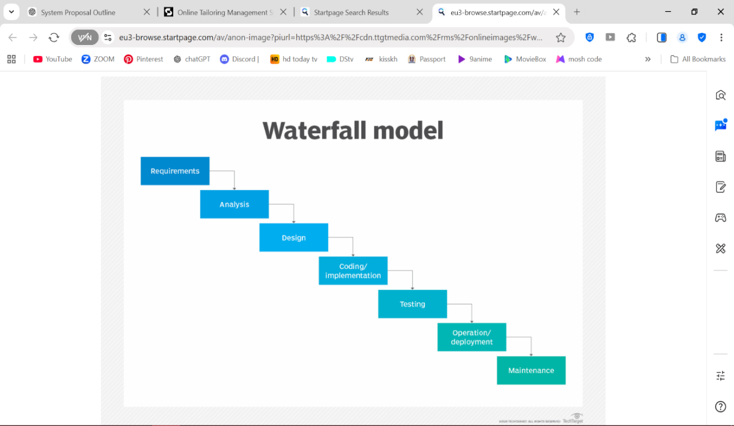
Figure 4: Waterfall Model

"Waterfall methodology provides a structured approach that validates requirements and design before implementation, minimizing operational risks" (Pressman, 2019).
Advantages:
- Improves quality by identifying errors during design rather than after implementation.
- Simple and easy to understand for all team members.
- Easy to manage with clearly defined deliverables and review checkpoints.
- Phases are processed one at a time, reducing the chance of skipping critical functionality.
- Produces clear documentation for future system maintenance.
Disadvantages:
- Inflexible to changes after the design phase.
- Assumes perfect requirement gathering, which may not reflect evolving business needs.
- Late testing may uncover critical bugs.
- High risk for complex systems integrating multiple modules.
- Limited stakeholder involvement after initial phases may lead to unmet expectations.

3.2.2 Iterative Development Methodology
Iterative Development involves building the system in repeated cycles, refining and expanding features based on feedback. For the hardware store, the first iteration might implement basic inventory tracking and service scheduling, followed by later iterations introducing online ordering, notifications, and repair request management. This approach allows developers to test core features early, incorporate user feedback, and adapt to changing requirements such as new service offerings or inventory processes. By gradually evolving the system, the store reduces the risk of failure and ensures that both customers and staff find the system functional and user-friendly from the early stages.
"Iterative Development allows early testing of core features and adaptability to evolving business needs" (Pressman, 2019).
Advantages:
- Early feedback from stakeholders ensures system meets real business needs.
- Flexible adaptation to new requirements.
- Continuous testing improves overall quality.
- Engages users through regular demonstrations and reviews.
- Reduces risks by identifying issues early.
Disadvantages:
- Higher overhead due to repeated planning and design cycles.
- Scope may remain unclear if requirements change significantly.
- Rework may be necessary if early iterations are significantly revised.
- Difficult to predict timelines for final delivery.
- Risk of scope creep without strict iteration control.

3.2.3 Incremental Development Methodology
Incremental Development delivers the system as a series of functional modules. For example, Version 1 might implement core inventory management, Version 2 adds online ordering, and Version 3 integrates repair and service request tracking. This allows the hardware store to deploy essential functionality quickly while gradually introducing additional features. Each increment is tested individually, reducing integration risks and providing immediate business value to staff and customers. Incremental development also enables gradual adoption, allowing employees to learn and adapt to each new feature.
"Incremental Development provides immediate business value while allowing phased adoption of new features" (Sommerville, 2020).
Advantages:
- Early ROI with core features deployed quickly.
- Easier testing as increments is isolated.
- Clear progress tracking through versioned releases.
- Lower risk because failures affect only one increment.
- Gradual user adoption and training.
Disadvantages:
- Integration challenges if increments are not aligned.
- Early design may constrain future architecture.
- Potential redundancy between modules.
- Advanced features may be delayed.
- Dependencies between modules require careful management.

3.3 Fact-Finding Techniques

3.3.1 Interviews
Interviews are essential for understanding the unique challenges of the hardware store from owners, staff, and customers. Speaking directly with stakeholders helps identify issues like frequent stockouts, delays in service requests, and difficulties with online order tracking. Interviews allow the development team to gather detailed requirements for inventory alerts, service scheduling, and online ordering workflows. They also foster closer contact between users and developers, reducing the probability of system rejection.
"Interviews help identify crucial features needed in the system, such as automated inventory alerts and service scheduling" (Babbie, 2021).
Advantages:
- Provides first-hand insights into inventory, order, and service workflows.
- Clarifies complex processes through follow-up questions.
- Helps prioritize system features based on real needs.
- Builds stakeholder trust by involving them in design.
- Reveals hidden challenges not evident in documentation.
Disadvantages:
- Time-consuming to conduct multiple interviews.
- Responses may be biased or idealized.
- Conflicting opinions may emerge between staff and management.
- May overlook habitual but unspoken practices.
- Findings may not generalize across all store locations.

3.3.2 Observation
Observation allows developers to see actual workflows, revealing inefficiencies that interviews may miss. By shadowing staff during inventory checks, sales, and service handling, bottlenecks, redundant tasks, or workflow gaps can be identified. Observation ensures that the system reflects real-world operations, including peak sales periods and high service demand, rather than assumptions.
"Observation provides an unfiltered view of actual workflows, revealing inefficiencies like time-consuming manual stock counts" (Robson & McCartan, 2016).
Advantages:
- Reveals actual workflows.
- Identifies inefficiencies and bottlenecks.
- Captures interactions with customers.
- Highlights seasonal or peak-period trends.
- Provides objective measurements of task durations.
Disadvantages:
- Staff may alter behaviours when observed (Hawthorne effect).
- Limited to visible tasks; behind-the-scenes activities may be missed.
- Time-intensive to cover all operations.
- Rare but critical events may be overlooked.
- Ethical concerns regarding privacy.

3.3.3 Questionnaires
Questionnaires gather standardized data from staff and customers, such as preferred delivery times, frequently requested products, or common service needs. This method helps quantify trends and validate assumptions, ensuring that the system aligns with actual business operations and customer expectations.
"Questionnaires efficiently gather standardized data, helping prioritize features like online ordering and service request tracking" (Dillman et al., 2014).

Advantages:
- Scalable for large groups.
- Quantifies trends and preferences.
- Anonymous responses encourage honesty.
- Cost-effective and efficient.
- Standardized data simplifies analysis.

Disadvantages:
- Low response rates can bias results.
- Superficial answers if poorly designed.
- No follow-up for ambiguous responses.
- Sampling bias may over-represent certain demographics.
- Risk of misinterpretation of vague questions.

3.3.4 Document Analysis
Document analysis involves reviewing sales records, inventory logs, and service request reports. This provides concrete evidence of current operations, ensures the new system aligns with existing structures, and helps forecast inventory and service trends.
"Reviewing existing documents ensures the system integrates seamlessly with current operations and data structures" (Bowen, 2009).
Advantages:
- Provides objective evidence of current operations.
- Reveals data structures for integration.
- Identifies compliance requirements.
- Tracks historical trends.
- Non-intrusive; does not disrupt operations.
Disadvantages:
- Records may be outdated or incomplete.
- Gaps in documentation may require assumptions.
- Confidentiality issues may arise.
- Time-consuming for large volumes.
- May miss unwritten practices.

3.4 Feasibility Studies
Feasibility studies are assessments carried out to determine whether a proposed system can be successfully developed and implemented given the available resources, time and technical capabilities. They help in identifying potential risks and challenges before development begins, ensuring that time and resources are not wasted on a system that cannot be practically implemented. In the development of the Computer Hardware and Service Management System, the following feasibility studies were considered.

3.4.1 Technical Feasibility
Technical feasibility examines whether the technology required to develop and run the proposed system is available and accessible. This involves assessing whether the hardware, software, and technical expertise needed to build the Computer Hardware and Service Management System can be obtained. The proposed system will be developed as a web-based application using widely available programming technologies and database management tools. The store is expected to have access to basic computer hardware such as a server or desktop computer capable of running the system, as well as a stable internet connection to support online functionalities. Technically skilled developers are available to design, build and maintain the system. Therefore, the proposed system is technically feasible as all the required tools and expertise are accessible within the current technological environment.

3.4.2 Economic Feasibility
Economic feasibility, also referred to as cost-benefit analysis, evaluates whether the financial benefits of developing the proposed system outweigh the costs involved. The costs associated with developing the Computer Hardware and Service Management System include software development costs, hardware acquisition, system installation and staff training. However, these costs are justified by the long-term benefits the system will bring, including reduced operational costs from eliminating manual record keeping, minimized losses due to better inventory control, improved sales tracking and increased customer satisfaction leading to greater revenue. The system is expected to improve efficiency and reduce the time spent on manual processes, which translates to cost savings for the store. Based on this analysis, the proposed system is economically feasible as the benefits it provides are expected to far exceed the initial and ongoing costs of development and maintenance.

3.4.3 Operational Feasibility
Operational feasibility determines whether the proposed system will be accepted and effectively used by the people it is intended to serve once it is implemented. This includes assessing whether the store staff, management and customers are willing and able to use the new system in their day-to-day operations. The Computer Hardware and Service Management System has been designed with a user-friendly interface to ensure that users with varying levels of computer literacy can operate it with ease. The store owner and staff will be provided with adequate training to familiarize themselves with the system before it is fully deployed. Customers will also be able to interact with the system online without requiring technical knowledge. Since the system directly addresses the challenges faced with the current manual operations, it is expected to be welcomed by all stakeholders. Therefore, the proposed system is operationally feasible.

3.4.4 Schedule Feasibility
Schedule feasibility assesses whether the proposed system can be developed and delivered within a realistic and acceptable timeframe. This involves evaluating whether the development team has sufficient time to complete all phases of system development, including analysis, design, implementation, testing and deployment, without compromising the quality of the final product. The development of the Computer Hardware and Service Management System has been planned to use the Waterfall methodology, which provides a clear and structured timeline for each phase of development. Each stage has been allocated adequate time to ensure thorough completion before proceeding to the next. The development process is expected to be completed within the stipulated academic project period. Based on this assessment, the proposed system is scheduled feasible as the development timeline is realistic and achievable within the available time frame.

REFERENCES
Babbie, E. (2021). The practice of social research (15th ed.). Cengage Learning.
Bowen, G. A. (2009). Document analysis as a qualitative research method. Qualitative Research Journal, 9(2), 27–40. https://doi.org/10.3316/QRJ0902027
Dillman, D. A., Smyth, J. D., & Christian, L. M. (2014). Internet, phone, mail, and mixed-mode surveys: The tailored design method (4th ed.). John Wiley & Sons.
Kenya National Bureau of Statistics. (2025). Economic survey 2025. https://www.knbs.or.ke/wp-content/uploads/2025/05/2025-Economic-Survey.pdf
Mordor Intelligence. (2026). Kenya ICT market size & share analysis - Growth trends & forecasts (2026 - 2031). https://www.mordorintelligence.com/industry-reports/kenya-ict-market
Pressman, R. S. (2019). Software engineering: A practitioner's approach (9th ed.). McGraw-Hill Education.
Pressman, R. S., & Maxim, B. R. (2019). Software engineering: A practitioner's approach (9th ed.). McGraw-Hill Education.
Robson, C., & McCartan, K. (2016). Real world research (4th ed.). John Wiley & Sons.
Sommerville, I. (2016). Software engineering (10th ed.). Pearson Education Limited.
Sommerville, I. (2020). Software engineering (11th ed.). Pearson.

CHAPTER FOUR

SYSTEM ANALYSIS AND DESIGN

4.1 Introduction
This chapter presents the complete design of the web-based Computer Hardware and Service Management System (CompuStore HMS). System design translates the requirements identified in the earlier chapters into a blueprint for constructing the system. The design covers data entity analysis, modeling of data flows and processes using Data Flow Diagrams (DFD), Entity-Relationship Diagrams (ERD), Use Case diagrams, and system flowcharts. The design follows the three-tier architecture outlined in Chapter Two (Presentation Layer, Application Layer, and Data Layer) and adheres to the functional and non-functional requirements. This design provides the blueprint for the coding and implementation of the system.
The CompuStore HMS is designed as a three-tier web application targeting three user groups: customers, store staff, and administrators(admin). The system handles inventory management, sales and order processing, service and repair request tracking, M-Pesa payment integration, and management reporting.

Data Entity Analysis
In the dynamic environment of a computer hardware store, efficient data entry is essential for accurate inventory management, smooth service delivery, and effective customer interactions. A well-designed system that integrates both physical and online operations transforms raw data into meaningful insights, ensuring that products are available, services are efficiently scheduled, and customer needs are promptly met. The effectiveness of the system depends on clearly understanding who inputs data, how the data flows through the system, and how it is processed into useful information for decision-making.
"Efficient data entry serves as the backbone of seamless inventory control" (Laudon & Laudon, 2020, p. 215).

User Tables
In the computer hardware store system, different users play key roles in data entry, each contributing to the smooth operation of the system. Store managers and staff are responsible for entering and managing core data such as product details, including hardware specifications, pricing, supplier information, and stock levels. They also perform manual stock adjustments in cases of damaged goods, returns, or delayed deliveries, ensuring that the inventory database remains accurate and up to date. Additionally, managers define reorder levels to trigger alerts when stock falls below a certain threshold, helping maintain product availability.

Customers and sales personnel contribute to data entry through order placement, whether online or in-store. Customers input product selections, delivery details, and payment information, while sales staff assist in processing transactions and confirming orders. For service-related operations such as software installation, troubleshooting, and repair, technicians enter service requests, update progress, and record completion details, ensuring proper tracking of all service activities.

The system supports automation by updating inventory levels automatically after each sale and analyzing sales data to predict demand trends, helping the store prepare for future stock requirements.
Entity Relationship Diagram (ERD)
The core entities and their relationships:
users: Central entity storing customers, staff, and admins. Differentiated by a role ENUM column and an optional access_level column for sub-roles such as technician or super_admin.
products: Stores all inventory items with stock quantity, reorder threshold, and category association via a foreign key to categories.
categories: Lookup table for product grouping (Laptops, Accessories, Storage, etc.).
orders: Records for each sales transaction. Links to users via customer_id. Supports both in_store and online order types. Stores M-Pesa receipt codes.
order_items: Line items for each order. Contains a GENERATED ALWAYS computed column subtotal = quantity * unit_price, ensuring calculation consistency at the database level.
service_requests: Tracks each repair/maintenance job from open through in_progress to completed. Links to users for both the customer and the assigned technician.

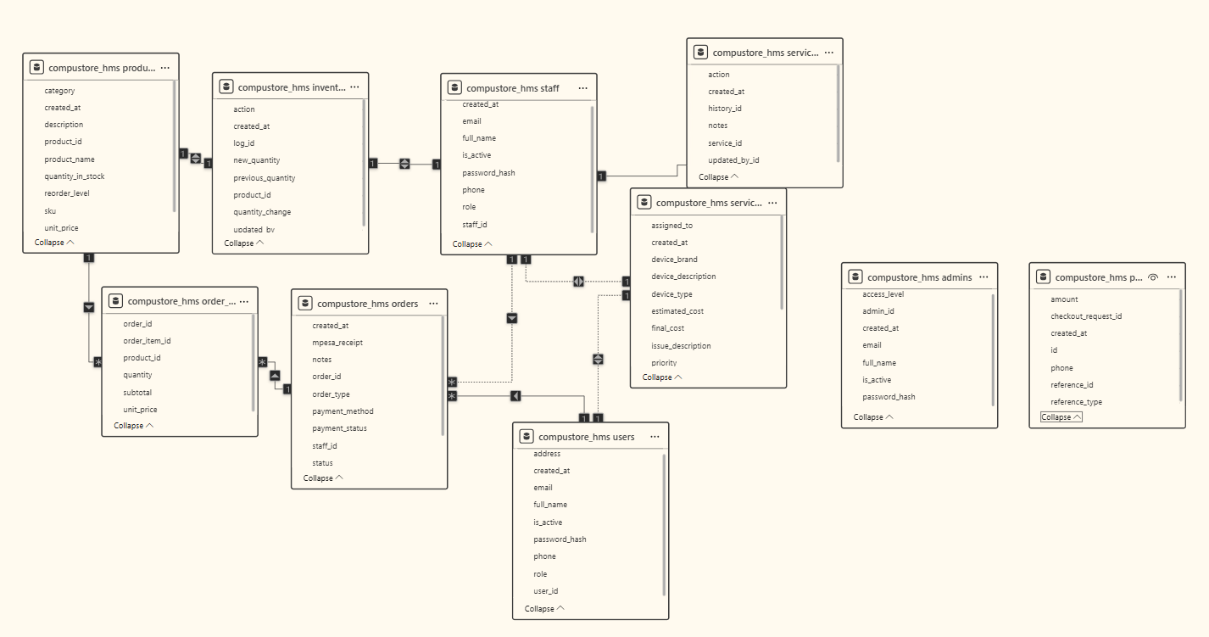
Figure 5: Entity Relationship Diagram(ERD)

Data Flow Diagrams
The Data Flow Diagrams (DFDs) illustrates the data flow from input, processing to storage and output. At a high level, the system interacts with several key external entities: customers who place orders and request services, and delivery personnel who manage product distribution.
The main processes in the system include inventory management, order processing, and service management. Inventory management handles the tracking of stock levels, updating records after sales or restocking, and generating alerts when stock is low. Order processing manages customer orders by validating payment details, confirming availability of products, and preparing items for delivery or pickup. Service management processes handle requests for installation, maintenance, and repair, ensuring that tasks are assigned and completed efficiently.
At a more detailed level, inventory control receives inputs such as product details from staff, sales data from transactions, and delivery updates from suppliers. It produces outputs such as updated stock levels, low-stock alerts, and purchase orders to suppliers. Order process takes customer order details and generates confirmations and real-time tracking updates. Service-related processes handle customer requests and technician updates, producing service status reports and completion records.
The impact of this structured data flow is significant. Real-time inventory updates reduce the chances of stock shortages, ensuring that high-demand computer hardware is always available. Automated data processing improves efficiency and reduces manual errors. Integrated service tracking enhances customer satisfaction by providing transparency and timely updates. Furthermore, data-driven insights support better decision-making, enabling the store to optimize inventory levels and improve overall performance.
"Built-in age verification and reporting features prevent costly regulatory fines" (NABCA, 2022, p. 34).
"Data Flow Diagrams map how information moves from input to storage, processing, and output" (Kendall & Kendall, 2019, p. 142).

LEVEL 0
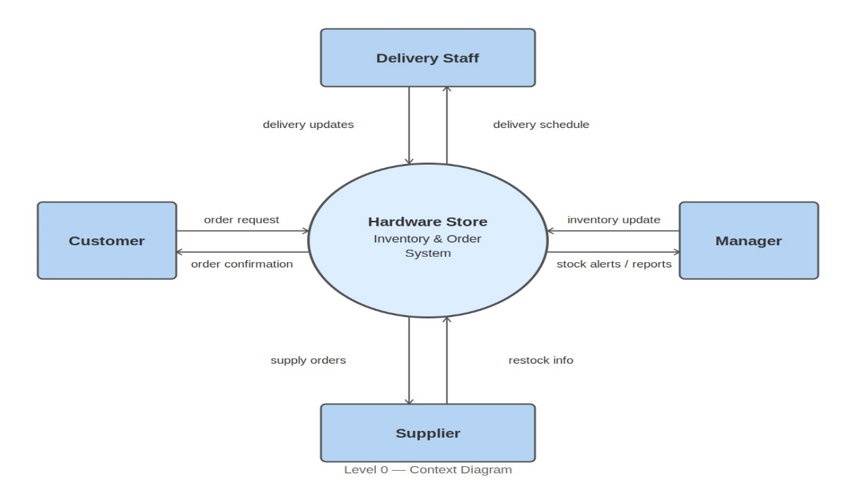
Figure 6: Level 0 - The big picture
LEVEL 1
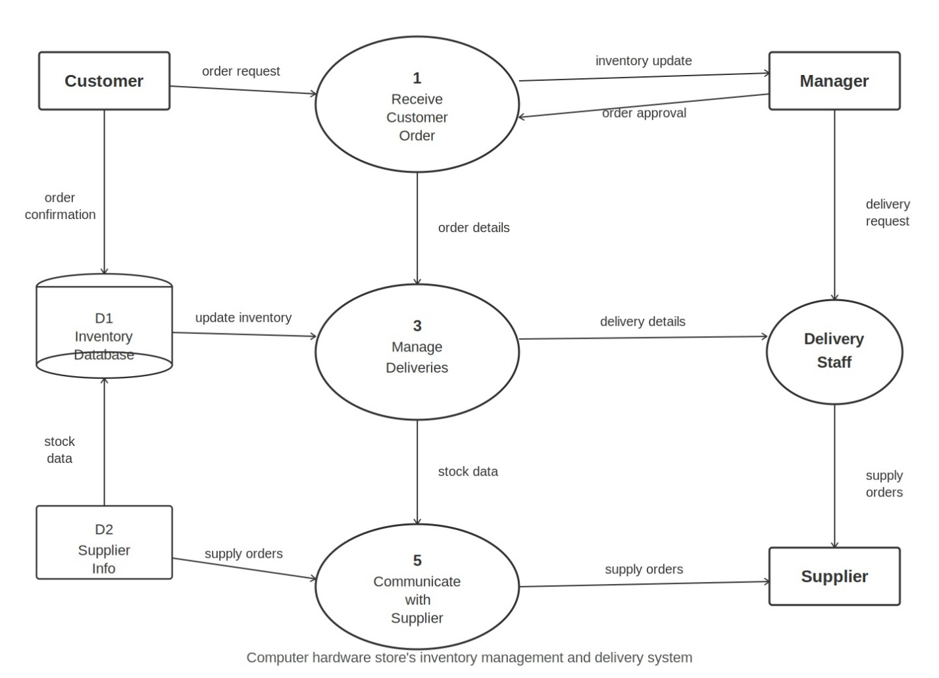
Figure 7: Level 1 - Detailed System

4.3 Design

4.3.1 Use Case Diagram
The system has three main actors:
Actor | Use Cases | Description
Customer | Browse Products  Place Order  Request Service  Track Order | Access online or in-store catalog, view stock levels, purchase items, request technical services, monitor order status in real-time
Staff | Record Sales  Manage Inventory  Handle Service Requests | Process customer transactions, update stock levels, log and track repair/service requests, generate receipts
Admin | Manage Users  Configure System  Generate Reports | Create/manage user accounts, set pricing and permissions, access comprehensive analytics and reports
Guest User | Browse Products  View Services | Browse catalog without registration, view available services and pricing
Table 2: Use Case Diagram

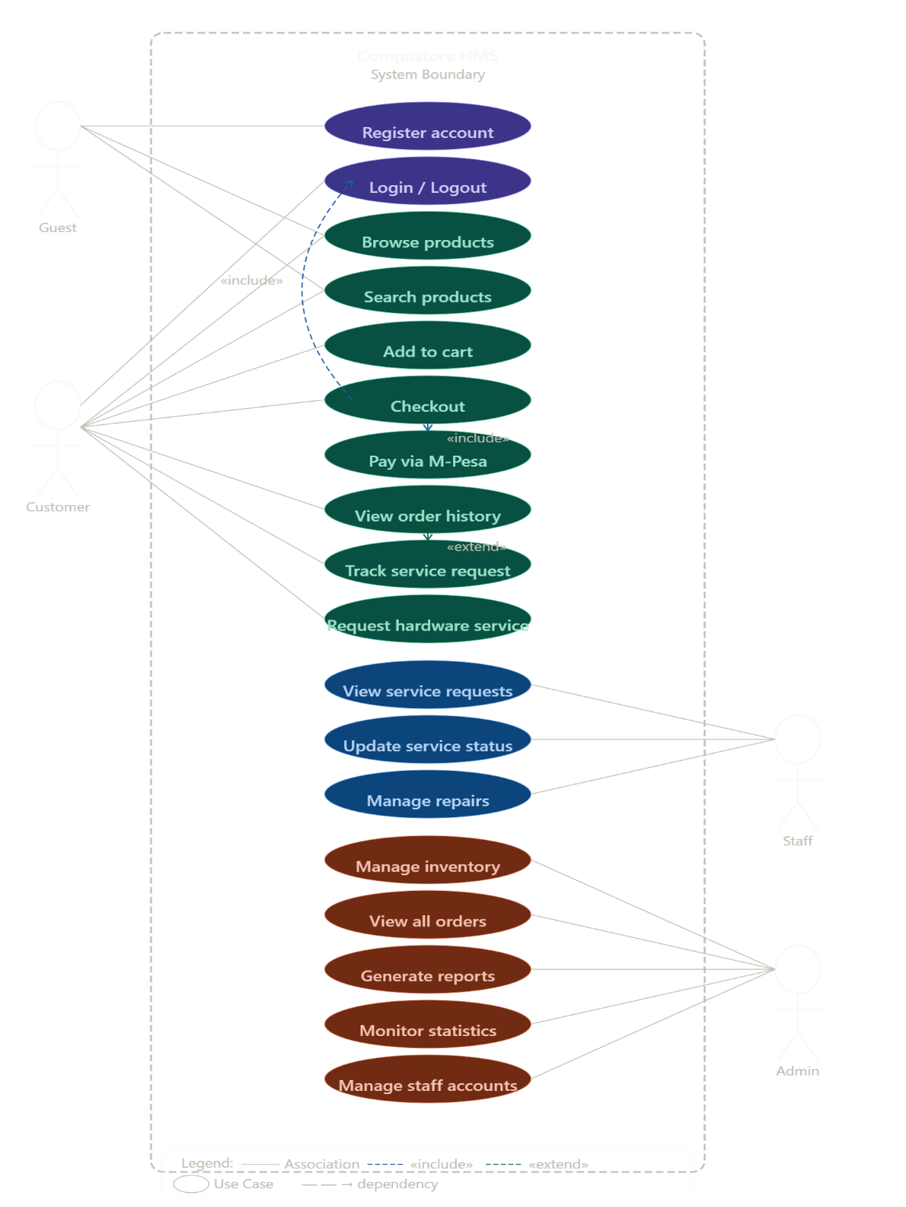
Figure 8: Use Case Diagram

4.3.2 Flowcharts
Sales Process Flowchart
- Start → Customer searches product(s)
- Selects Product(s)
- System checks stock availability
- If stock sufficient → Add to cart → Calculate total (in KES)
- Customer makes payment(checkout)
- Record sale → Reduce stock quantity
- Update inventory log
- End

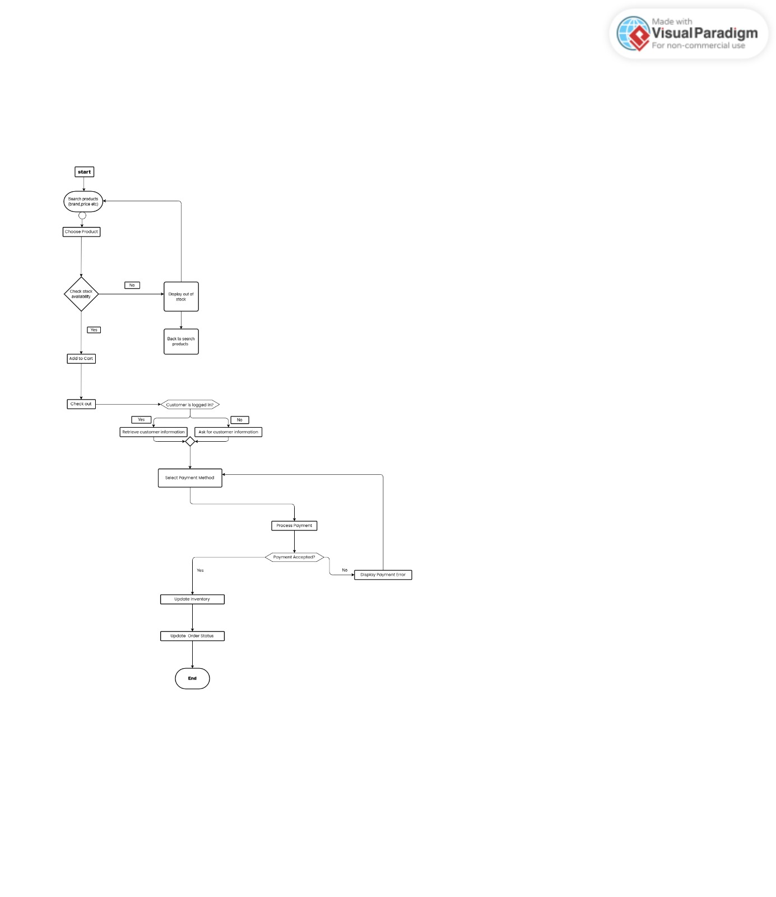
Figure 9: Sales Process Flowchart

4.3.3 Activity Diagram
An activity diagram for “Online Order Placement”:
- Validate stock
- Calculate total amount
- Process payment
- Send confirmation email/SMS
- Update database (sales and inventory)
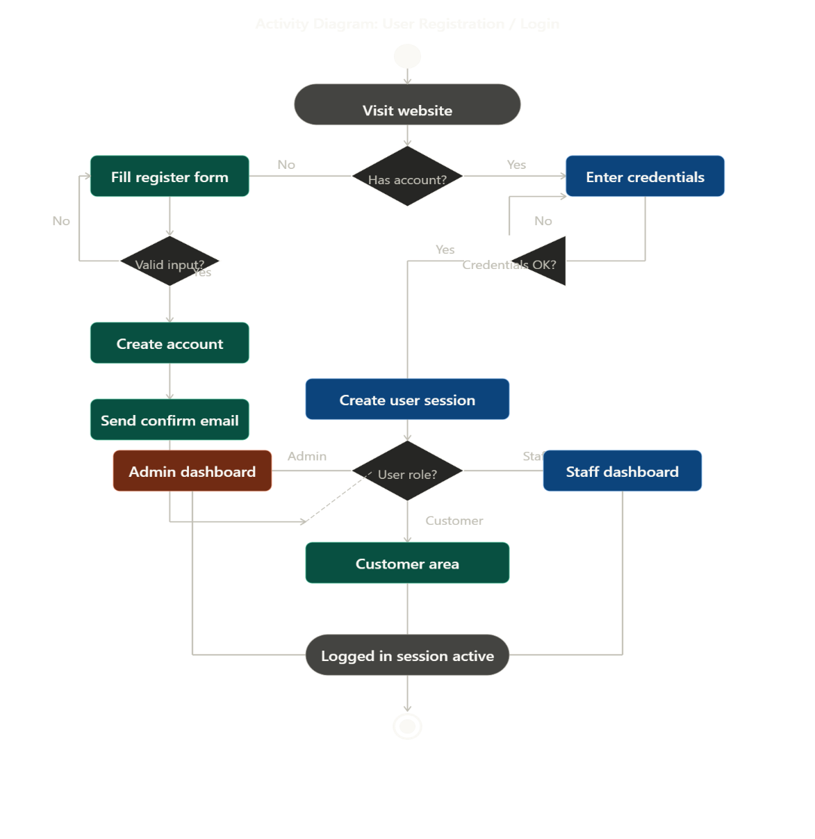
Figure 10: Activity Diagram - User Registration & Login

Activity Diagram — Browse, Cart & M-Pesa Checkout
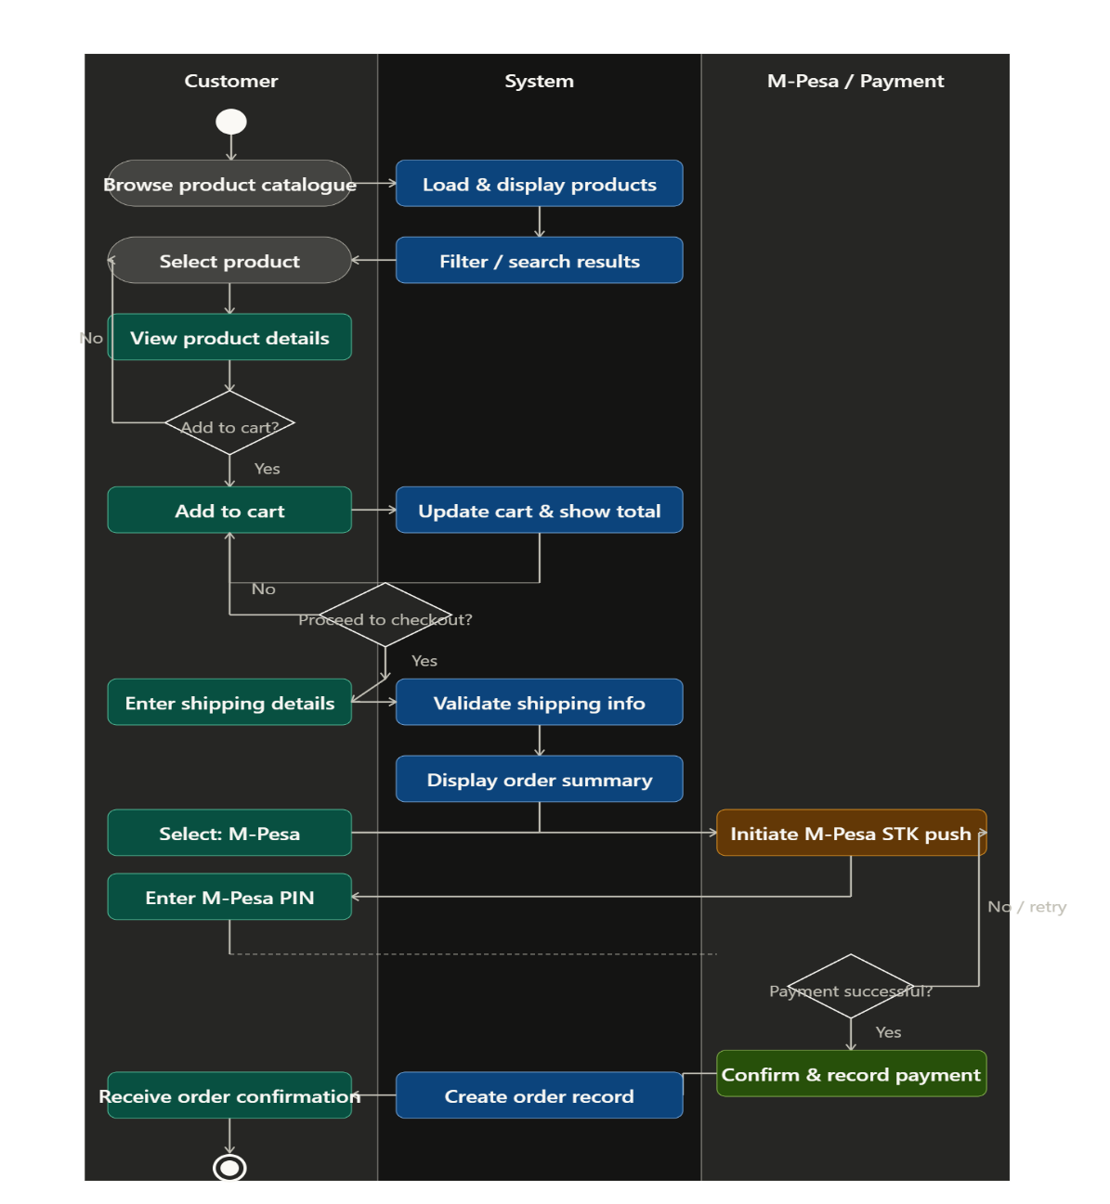
Figure 11:Activity Diagram - Checkout via Mpesa(Daraja API)

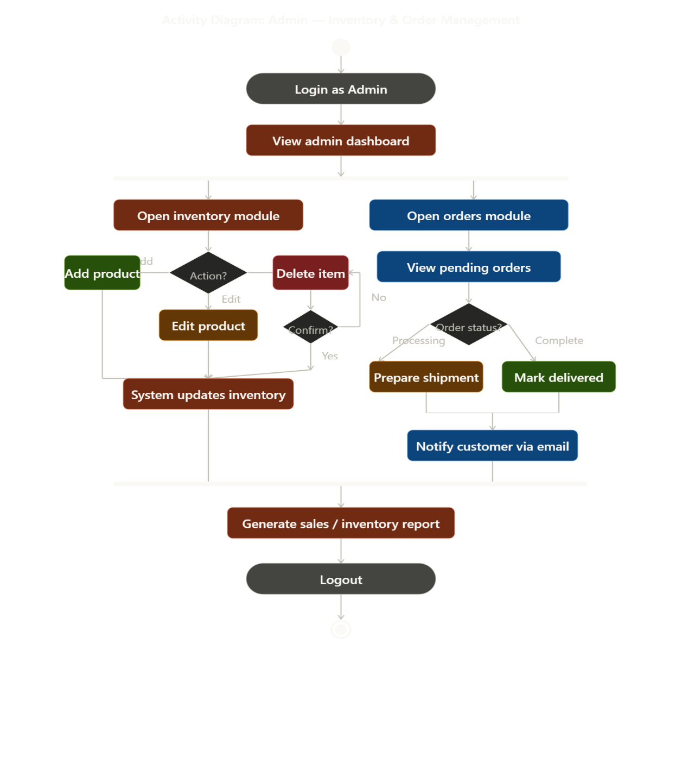
Figure 12: Activity Diagram — Admin Manages Inventory & Order

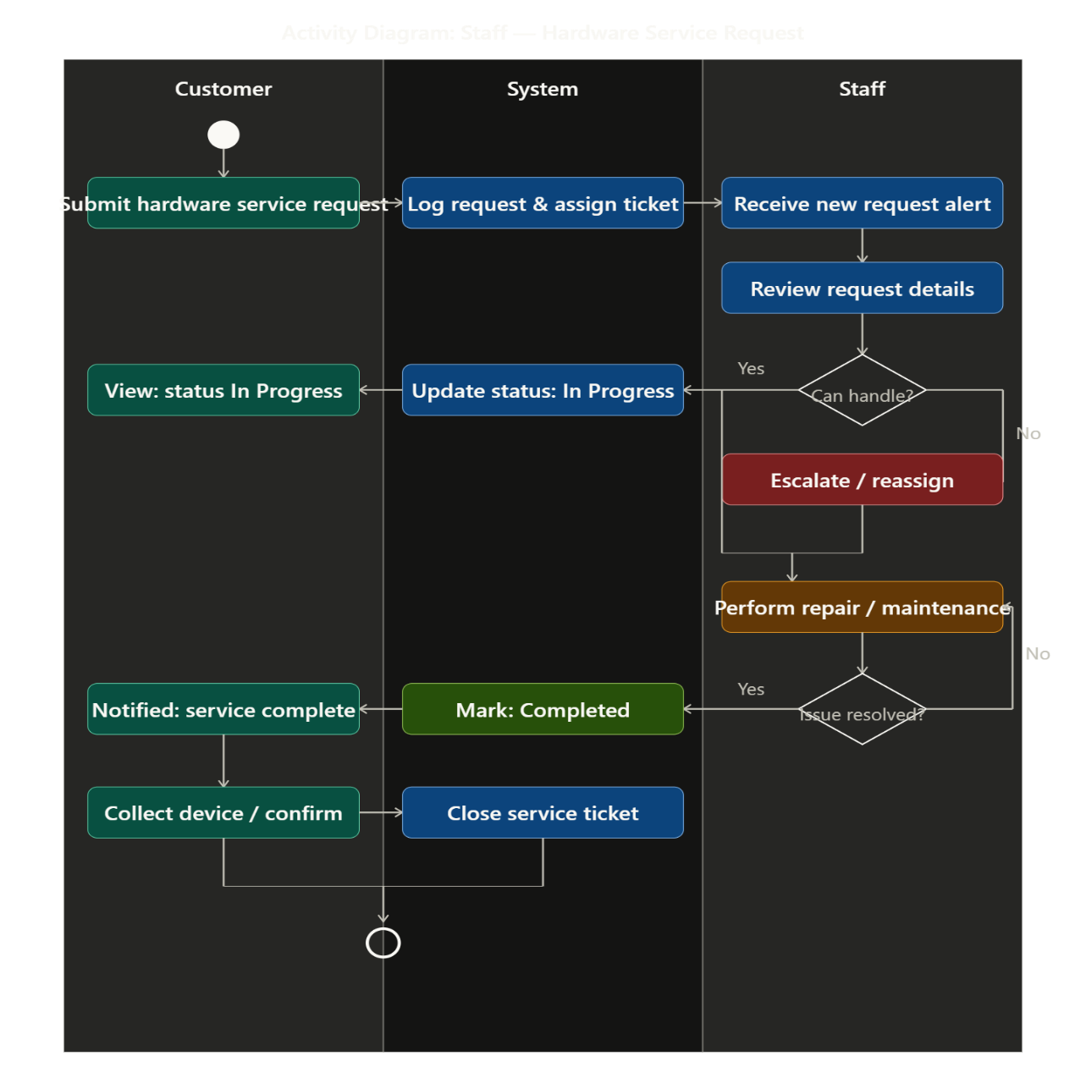
Figure 13: Activity Diagram — Staff Service Request Workflow

Code
The hardware management system was built using HTML, CSS and JavaScript for the frontend.
PHP and MySQL for the backend.
 | Technology | Type | Where it runs | Purpose
 | HyperText Markup Language (HTML) | Markup | Browser (Client) | Structure & content
 | Cascading Style Sheets (CSS) | Style sheet | Browser (Client) | Visual presentation & layout
 | JavaScript (JS) | Programming | Browser (Client) | Interactivity
 | Hypertext Preprocessor (PHP) | Scripting | Web Server (Server) | Server-side logic & dynamic content
 | Structured Query Language (SQL) | Query language | Database server | Data storage & retrieval

How these technologies have been used in the creating of our system
Sample login
    - Login Page Structure (index.html)
Figure 14: Login Page Structure(index.html)
<div class="role-selector">
<button type="button" class="role-btn active" data-role="customer">Customer</button>
<button type="button" class="role-btn" data-role="staff">Staff</button>
<button type="button" class="role-btn" data-role="admin">Admin</button>
</div>

<form id="loginForm" onsubmit="handleLogin(event)">
<div class="form-group">
<label>Email</label>
<input type="email" id="email" placeholder="user@example.com" required>
</div>
<div class="form-group">
<label>Password</label>
<input type="password" id="password" placeholder="Password" required>
</div>
<button type="submit" class="btn-primary btn-full">Login</button>
</form>

    - Login JavaScript Logic (js/login.js)
Figure 15: Login JavaScript Logic (js/login.js)
let selectedRole = 'customer';
async function handleLogin(event) {event.preventDefault();
const email = document.getElementById('email').value.trim();
const password = document.getElementById('password').value;
if (!email || !password) {
showAlert('Please enter email and password', 'error');
return; }
try { const res = await fetch('php/login.php', {
method: 'POST',
headers: { 'Content-Type': 'application/json' },
body: JSON.stringify({ email, password, role: selectedRole }) });
const data = await res.json();
if (data.success) {
showAlert('Login successful!', 'success');
setTimeout(() => {
window.location.href = data.redirect; }, 1000);
} else {showAlert(data.error || 'Login failed', 'error'); }
} catch (err) { showAlert('Network error', 'error'); }}

    - Backend Login Script (php/login.php)

Figure 16: 3. Backend Login Script (php/login.php)
<?php
require_once '../includes/db.php';
requireMethod('POST');
$data = requestJson();
$email = trim($data['email'] ?? '');
$pass = trim($data['password'] ?? '');
$role = trim($data['role'] ?? 'customer');
if (!$email || !$pass) { jsonResponse(['error' => 'Email and password are required'], 400);}
$db = getDB();
if ($role === 'customer') {
$sql = "SELECT user_id AS id, full_name, email, password_hash FROM users WHERE email =?";
$table_name = 'users';
} elseif ($role === 'staff' || $role === 'technician') {
$sql = "SELECT staff_id AS id, full_name, email, password_hash, role FROM staff WHERE email = ?";
$table_name = 'staff';
} else {
$role = 'admin';
$sql = "SELECT admin_id AS id, full_name, email, password_hash FROM admins WHERE email = ?";
$table_name = 'admins';}
$stmt = $db->prepare($sql);
$stmt->bind_param('s', $email);
$stmt->execute();
$result = $stmt->get_result();
$user = $result->fetch_assoc();
if (!$user) {
jsonResponse(['error' => 'Invalid email or password'], 401);}
if (!password_verify($pass, $user['password_hash'])) {
jsonResponse(['error' => 'Invalid email or password'], 401);}$_SESSION['user_id'] = $user['id'];
$_SESSION['full_name'] = $user['full_name'];
$_SESSION['email'] = $user['email'];
$_SESSION['role'] = isset($user['role']) ? $user['role'] : $role;
$redirect = match($_SESSION['role']) {
'admin', 'staff', 'manager', 'technician' => 'staff/dashboard.html',
default => 'customer/dashboard.html',

Key Security Features
Uses prepared statements to prevent SQL injection.
Stores passwords using password_hash and verifies with password_verify.
Role-based redirection after login.
Demo accounts (password: password) are available in the database for testing.

User requests a page (types URL or clicks a link)
Web server receives the request
PHP (server-side) runs:
Processes logic (authentication, form data, business rules)
Queries the database using SQL
Generates HTML dynamically (inserts user data, posts, products, etc.)
Server sends the HTML + CSS + JS back to the user's browser
HTML → builds the skeleton
CSS → applies styles and layout
JS → makes the page interactive (clicks, animations, real-time updates, form validation, etc.)
Implementation of Daraja API
Customer initiates payment (Frontend) via the checkout button on cart after selecting products and adding them to cart.
System sends STK Push to customer’s phone via Daraja API.
Customer enters PIN and confirms payment.
Safaricom calls callback URL with transaction result which will be updated to the stores website when we go into production.
System updates order/service status and reduces stock if applicable.

Conclusion
The data entities, diagrams, and code structure support the objectives of real-time inventory tracking, efficient sales/service management, revenue reporting, and demand analysis. The design of the web-based system is scalable for one store and for implementation of the system. It directly addresses the manual process problems identified earlier in the responses we collected from targeted actors in the use case that is the customers and administrators.

REFERENCES
Laudon, K. C., & Laudon, J. P. (2018). Management information systems: Managing the digital firm (16th ed.). Pearson Education.
Pressman, R. S. (2019). Software engineering: A practitioner's approach (9th ed.). McGraw-Hill Education.
Sommerville, I. (2020). Software engineering (11th ed.). Pearson Education Limited.
Safaricom. (2026). Daraja API Documentation. https://developer.safaricom.co.ke

CHAPTER FIVE

SYSTEM IMPLEMENTATION

5.1 Introduction
This chapter describes the development, deployment and implementation of the CompuStore HMS as designed the design chapter and it uses Waterfall Methodology. The system automates inventory tracking, sales, customer orders, and repair/service records for a single computer hardware store in a Kenyan market. The system is built for business owners, that is the administrators and their staff in the store. It can also enable customers to purchase products online without the hustle of having to visit the store.
This chapter, system implementation and testing, covers the development environment setup, the implementation of each system module, the M-Pesa Daraja API (Sandbox for testing before going into production) integration, system testing, and deployment considerations. The system was built using HTML5, CSS3, JavaScript, PHP 8.0, and MySQL 8.0, in line with the software requirements.

5.2 Implementation Techniques
The system was implemented using a three-tier architecture (Presentation, Application, and Data layers).
SQL for creating tables (users, products, orders, etc)
Manually updating data in the database such us updating user credentials who have trouble in accessing the system on the frontend.
PHP provides the backend logic.
HTML for structure.
CSS for responsive design and layout.
JavaScript for interactive features such as real-time stock updates and form handling.

Tools and Technologies Used

Component | Technology / Tool | Purpose
Back-end Language | PHP 8.0+ | API endpoints, business logic, database queries
Database | MySQL 8.0 | Relational data storage, views for reporting
Front-end | HTML5, CSS3, JavaScript | All three user portals; customers, staff and admin
Charts | Chart.js v4.4 (CDN) | Revenue trend and demand charts on admin dashboard and reports page
Payment API | Safaricom Daraja (Sandbox) | M-Pesa STK Push for order and service fee payments
Version Control | Git | Source code management
Code Editor | Visual Studio Code | Development IDE
Table 3: Tools and Technologies

Training

The system includes demo accounts for customers, staff and admin.
The users e.g. the customers login and get a feel of the system’s dashboard before having to register in the system.
Customers browse products, add to cart and checkout.
The checkout button sends a stkPush to the customers where they enter their pin and the system updates the payment system to paid and the inventory quantity in the store when the transaction is completed.
The staff and admin: Add and products, checks stock levels.
Update the quantity, and names of the products.
Recording sales and managing service requests.

User Manuals
The system is organized into a clearly separated directory structure that maps directly to the three-tier architecture:
Directory / File | Description
/index.html | Unified login page with role selector tabs and customer registration modal
/css/style.css | Global design system: CSS variables, layout components, tables, modals, badges
/css/login.css | Split-panel login page layout styles
/js/utils.js | Shared JavaScript utilities: apiFetch(), auth helpers, formatMoney(), statusBadge(), modals
/js/login.js | Login form submission, role selector, register modal logic
/php/includes/db.php | Database connection singleton, JSON response helper, input sanitisation, requireLogin()
/php/auth.php | Authentication endpoints: login, logout, register, me (session check)
/php/products.php | Products and inventory CRUD API with filtering, pagination, low-stock query
/php/orders.php | Order placement (transactional), order listing and filtering, status update
/php/services.php | Service request submission, listing, technician assignment, status updates
/php/mpesa.php | Daraja OAuth token retrieval, STK Push initiation, transaction status query
/php/mpesa_callback.php | Safaricom callback receiver; updates payment_status on successful payment
/php/reports.php | Report data endpoints: summary stats, revenue, trends, inventory, services
/php/users.php | User management CRUD (admin only)
/staff/ | Staff portal: dashboard, orders, services, inventory pages
/customer/ | Customer portal: dashboard, shop, my-orders, request-service, my-services pages
Table 4: User Manual System Structure

Authentication Module
The authentication system uses PHP sessions with bcrypt password hashing. When a user submits the login form, the front-end JavaScript posts the email, password, and selected role to login.php. The PHP endpoint queries the users table with a prepared statement matching both email and role, then calls password_verify() to compare the submitted password against the stored bcrypt hash.
On success, the user_id, role, full_name, and email are stored in the PHP session. Every subsequent API request calls the requireLogin() helper, which checks for a valid session and optionally enforces a specific role. HTTP 401 is returned for unauthenticated requests, causing the JavaScript apiFetch() wrapper to redirect to the login page.
Customer registration is handled by register.php. It checks duplicate email addresses before inserting a new user record with role=customer.
Inventory Management Module
The inventory module (products.php) implements a RESTful API supporting GET, POST, PUT, and DELETE operations. GET requests support multiple optional query parameters for flexible searching:
search: Full-text search across name, Stock Keeping Unit(SKU), and description fields using LIKE queries with prepared statements.
category: Filter by category name using an inner join with the categories table.
status: Filter to low stock (quantity <= reorder_level) or out_of_stock (quantity = 0) items.
low_stock=1: Returns all products at or below their reorder threshold for dashboard alerts.
page and limit: Pagination parameters. The API returns both the data array and total count, enabling front-end page controls.
When a new product is added (POST) or updated (PUT), the PHP validates required fields and uses a prepared INSERT or UPDATE statement. Admin delete is implemented as a soft delete (is_active = 0) to preserve historical order data referencing deleted products.
Order Processing Module
Order placement is the most critical transaction in the system. The PHP endpoint wraps the entire operation in a database transaction (begin_transaction / commit / rollback) to ensure atomicity. The sequence within the transaction is:
- Validate that every requested product exists and has sufficient stock.
- Insert the order record into the orders table.
- For each line item, insert a row into order_items and decrement the product quantity using UPDATE products SET quantity = quantity - ? WHERE product_id = ?.
- Commit the transaction. If any step fails, rollback restores the database to its pre-order state.
This transactional approach prevents stock inconsistencies that are common in the manual systems identified in Chapter One, where simultaneous sales could result in negative stock levels.
Service Request Module
The service request module (services.php) tracks the lifecycle of repair and maintenance jobs. Customers submit requests through request-service.html, selecting the service type (repair, maintenance, software_install, troubleshooting, other), device type, brand, issue description, and priority level.
Administrators assign technicians by updating the assigned_to field with a staff user_id. Staff members can filter their services portal to show only their assigned jobs. When a job is marked completed, the PHP endpoint automatically sets the completed_at timestamp using NOW(), which is displayed to the customer on their tracking page with a visual three-stage progress indicator (Open -> In Progress -> Completed)
Reporting Module
The reports module (reports.php) serves five report types through a single endpoint differentiated by the type query parameter:
summary: Returns aggregate statistics for the admin dashboard including total products, low-stock count, total orders, pending orders, monthly revenue, open service requests, and total customers. Seven separate COUNT/SUM queries are executed against the database.
revenue: Queries the v_revenue_report view for monthly breakdowns of order revenue, collected amounts, and service revenue over a configurable number of months. The admin Reports page renders this as a Chart.js line chart and a formatted table with column totals.
demand: Aggregates order_items joined to products and categories to rank products by units sold. An optional period parameter filters to the last month, last quarter, or all time. Displayed as a horizontal bar chart and tabular breakdown.
inventory: Returns all active products with their computed stock_status (ok, low, out_of_stock) and stock_value (quantity * unit_price), enabling a full inventory valuation report.
services: Groups service_requests by service_type, counting total, completed, and in-progress jobs and summing collected service fees.

5.3 System Testing
Unit Testing: Individual PHP functions (e.g., stock update after sale) and JavaScript features were tested.
Integration Testing: Ensured that sales automatically reduce stock and service requests update correctly.
System Testing: End-to-end processes such as customer order → payment (including M-Pesa simulation)
User Acceptance Testing: Demoed to group members and simulated store staff.

Test Cases and Results
# | Test Case | Expected Result | Status | Notes
1 | Customer login with valid credentials | Redirected to customer/dashboard.html; session established | Pass | —
2 | Login with wrong password | HTTP 401 returned; "Invalid email or password" alert shown | Pass | —
3 | Customer registers new account | Record created in users table; confirmation shown | Pass | Duplicate email returns 409
4 | Add product (admin) | Product inserted; appears in inventory table | Pass | Duplicate SKU returns error
5 | Place order with sufficient stock | Order created; product quantity decremented; receipt generated | Pass | Atomic transaction confirmed
6 | Place order exceeding stock | HTTP 422 returned; "Insufficient stock" error shown; no decrement | Pass | Rollback verified
7 | Submit service request | Record created with status=open; ref number shown | Pass | —
8 | Admin assigns technician | assigned_to updated; staff sees job in their queue | Pass | —
9 | M-Pesa STK Push (sandbox) | STK prompt received on test phone; callback updates payment_status | Pass | ngrok used for callback URL
10 | Low stock alert on dashboard | Products at/below reorder_level appear in alert table | Pass | —
11 | Revenue report chart renders | Chart.js bar/line charts display with correct KES values | Pass | Requires orders with paid status
12 | Customer portal role isolation | Customer accessing admin/dashboard.html redirected to login | Pass | requireAuth() on all pages
13 | Demand trends (all time) | Products ranked by units_sold; zero sales shown as empty state | Pass | —
14 | Staff updates order status | Status change persisted; customer sees updated status | Pass | —
15 | Service progress tracker | Customer sees correct stage highlighted based on status | Pass | Cancelled shows as open
Table 5: Test Cases and Results
Deployment Instructions
Local Development Setup
Local Development Environment: Web server, PHP interpreter and a database management system(MYSQL)
Core Server Stack: PHP, APACHE2, MYSQL-SERVER.
Essential Development Tools: Visual Studio Code(vsCode) as the Intergrated Development Editor(IDE) with the essential extensions for (HTML, CSS, JS) writing and updates.
Essential extensions such as MySql for database management.
Version Control: Git to track changes and save progress.
Production Deployment Checklist
Upload project files to a PHP 8.0+ web hosting provider (e.g., HostAfrica, Truehost Kenya).
Create a MySQL database.
Set environment variables for DB credentials and Daraja live credentials.
Update MPESA_BASE_URL to https://api.safaricom.co.ke and change shortcode to live value.
Ensure HTTPS is enabled on the domain (required by Daraja callback).
Change the demo account passwords immediately after first login.
Configure automated daily MySQL database backups.
System Summary
Screen | User Role | Key Features Visible
Login Page (index.html) | All | Role selector tabs, branded landing panel with store metrics, customer registration modal
Admin Dashboard | Admin | 7 KPI stat cards, revenue trend chart, demand chart, low-stock alert table, recent orders
Inventory Management | Admin/Staff | Searchable/filterable product table, add/edit modal, low stock badges, pagination
Order Management | Admin/Staff | Full order list with status filters, order detail modal with items, inline status update
Service Management | Admin/Staff | Service queue with priority badges, technician assignment dropdown, diagnosis text area
Reports Page | Admin | Revenue line chart with table totals, demand horizontal bar chart, inventory valuation, services summary
Customer Shop | Customer | Product grid with add-to-cart, sticky cart sidebar, M-Pesa checkout modal with STK polling
My Orders | Customer | Order history with Pay button for unpaid orders, order detail modal with items
Request Service | Customer | Service type/device/priority form, process explanation panel
My Services | Customer | Service history, 3-stage visual progress tracker, technician diagnosis reveals, M-Pesa payment
Table 6: System Summary

5.4 Conclusion

Challenges and Recommendations
The current implementation addresses all objectives stated in Chapter One. However, the following limitations were identified during implementation, along with recommended enhancements for future development cycles:
Current Limitation | Recommended Enhancement
Single-store scope only | Multi-branch support with branch_id foreign key across all tables and a branch manager role
M-Pesa callback matching uses amount heuristic | Store CheckoutRequestID in a pending_payments table for exact callback-to-transaction mapping
No dedicated mobile application | React Native or Flutter mobile app consuming the same PHP JSON API
No email or SMS notifications | Integrate Africa's Talking SMS API for order/service status notifications to customers
No automated reorder workflow | Automatic purchase order generation to suppliers when stock reaches reorder_level
No AI-based demand forecasting | Machine learning model trained on v_demand_trends data to predict future stock needs
Table 7: Challenges & Recommendations

REFERENCES
Babbie, E. (2021). The practice of social research (15th ed.). Cengage Learning.
Bowen, G. A. (2009). Document analysis as a qualitative research method. Qualitative Research Journal, 9(2), 27-40. https://doi.org/10.3316/QRJ0902027
Dillman, D. A., Smyth, J. D., & Christian, L. M. (2014). Internet, phone, mail, and mixed-mode surveys: The tailored design method (4th ed.). John Wiley & Sons.
Kenya National Bureau of Statistics. (2025). Economic survey 2025. https://www.knbs.or.ke/
Laudon, K. C., & Laudon, J. P. (2018). Management information systems: Managing the digital firm. Pearson Education.
Mordor Intelligence. (2026). Kenya ICT market size & share analysis - Growth trends & forecasts (2026-2031). https://www.mordorintelligence.com/industry-reports/kenya-ict-market
Oracle Corporation. (2021). MySQL 8.0 reference manual. https://dev.mysql.com/doc/refman/8.0/en/
Pressman, R. S., & Maxim, B. R. (2019). Software engineering: A practitioner's approach (9th ed.). McGraw-Hill Education.
Safaricom PLC. (2024). Daraja API documentation. https://developer.safaricom.co.ke/
Sommerville, I. (2020). Software engineering (11th ed.). Pearson.
Stair, R. M., & Reynolds, G. W. (2017). Principles of information systems. Cengage Learning.

