TASK – Bootcamp – Pandas & Venv

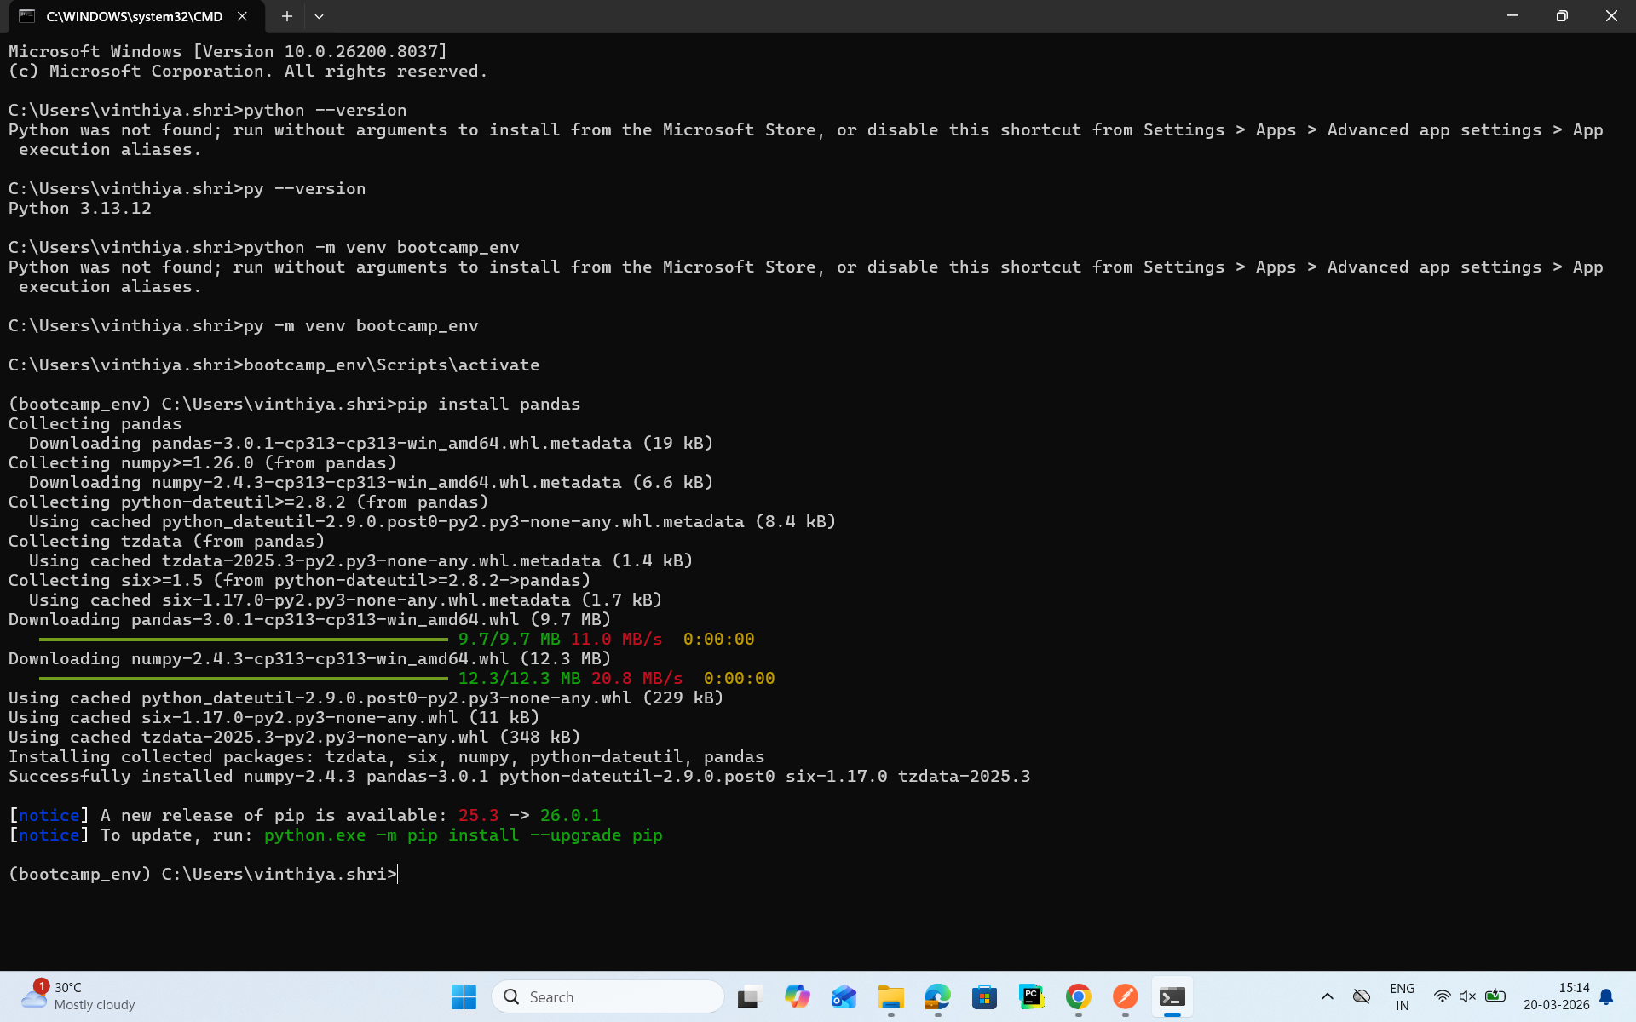

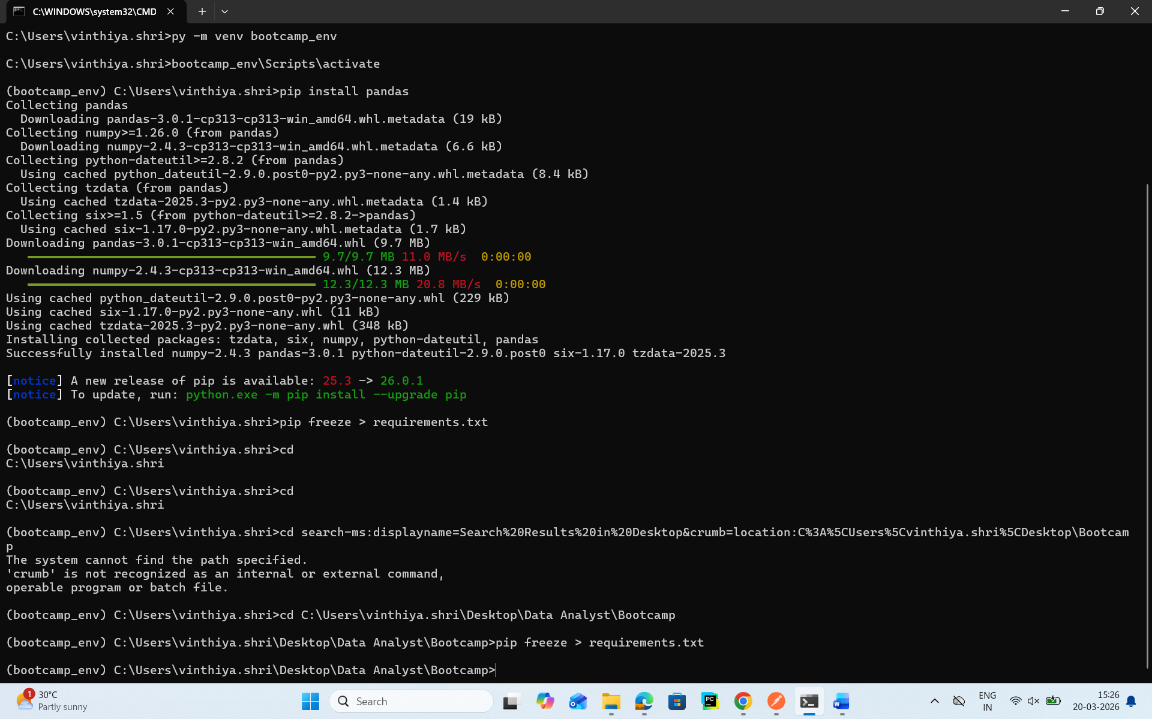
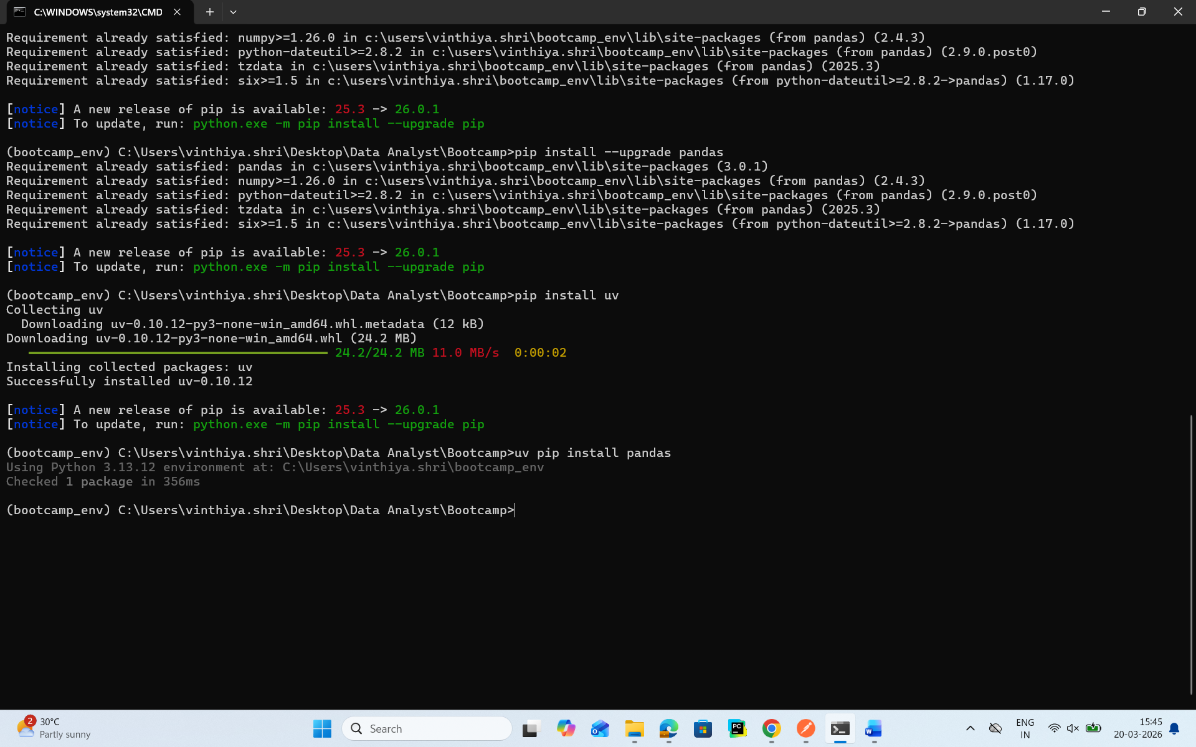

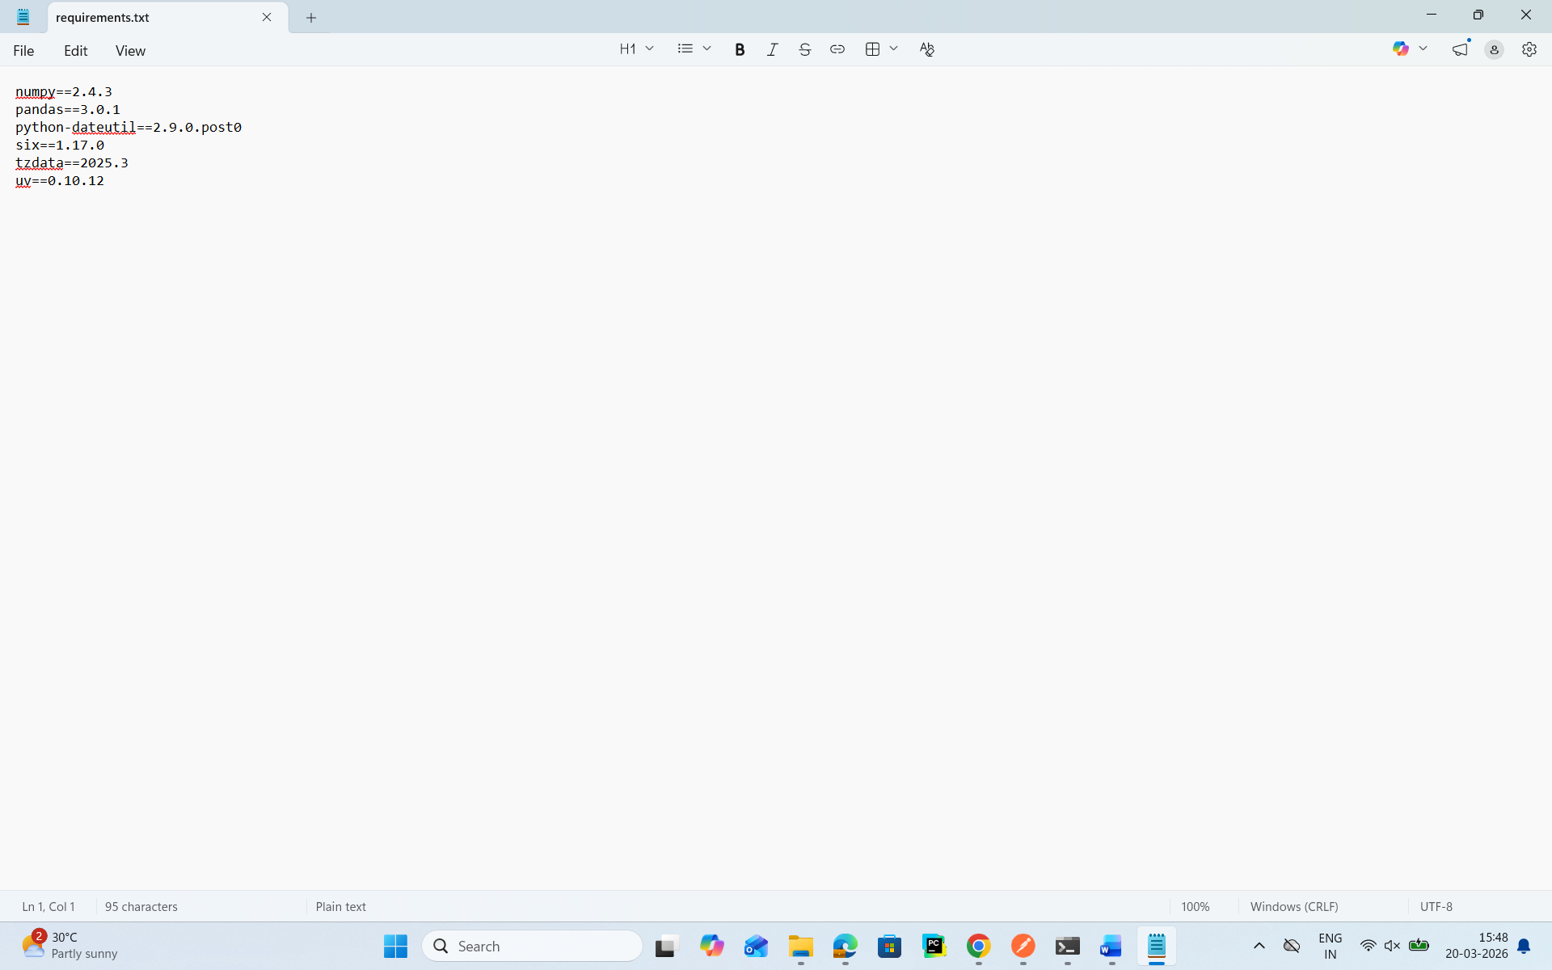

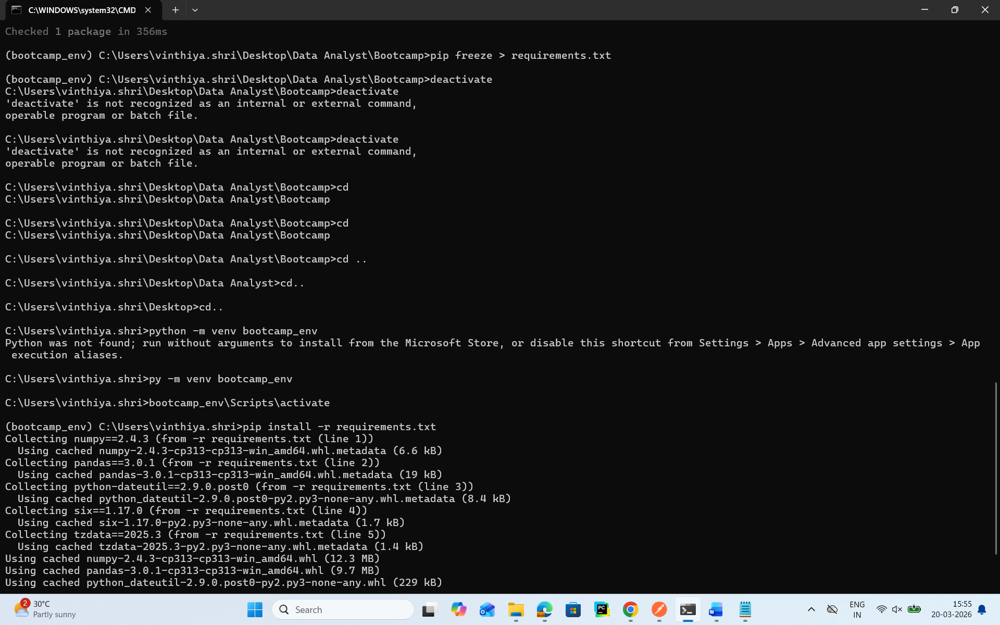

Pandas Task

- Load the dataset using pd.read_csv()

df = pd.read_csv("Sample - Superstore.csv")
print("Dataset Loaded")

- Display the top 5 rows with .head()

print(df.head(5))

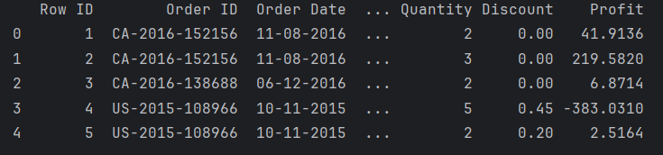

- Check for missing Values using .isnull().sum()

print("Missing Values\n", df.isnull().sum())

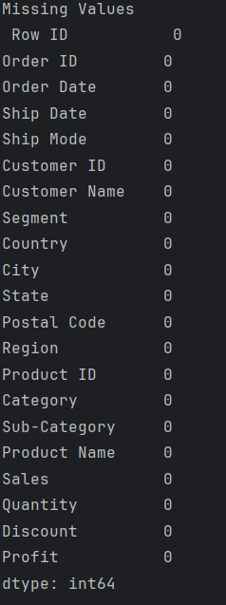

- Filter rows where sales >1000

print(df[df['Sales']>1000])

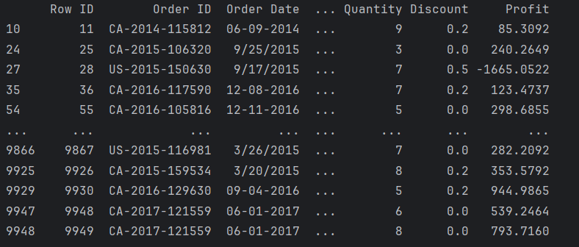

- Group by Category and Calculate total sales

print(df.groupby(‘Category’)[‘Sales’].sum()

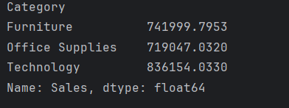

- Create a new column : Profit = sales – cost

df[‘Cost’] = df[‘Sales’] – df[‘Profit’]
df[‘New_Profit’] = df[‘Sales’] – df[‘Cost’]
print(“New_Profit:\n”, df[[‘Sales’,’Cost’,’Profit’]].head())

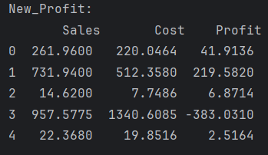

- Sort by highest sales using sort_values()

df_sorted = df.sort_values(by = ‘Sales’, ascending = False)
print(“sorted values\n”, df_sorted.head())

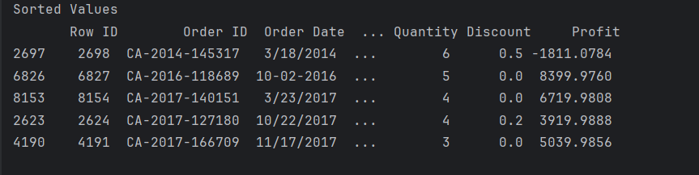

- Save the cleaned dataset to a new CSV
df.to_csv(“cleaned_data.csv”, index=False)
print(“File Saved”)

