Bracketing Image Restoration & Enhancement: A Detailed Survey of Relevant Algorithms

# Vinthya R R1

21BCE5230

VIT Chennai

# Aditi Padma R P2

21BCE1473

VIT Chennai

***Abstract*— Research in this area focuses on leveraging multiple exposures to improve image quality in low-light scenarios. Bracketing, or capturing multiple images of the same scene at different exposure levels, provides additional information that can be used to reconstruct high-quality images. Methods combine the multi-exposure images to achieve noise reduction, motion compensation, and high dynamic range (HDR) effects, essential in applications like smartphone photography and surveillance.**

**The goal of multi-exposure fusion is to produce images with HDR qualities by merging information from various exposure levels. Recent approaches apply convolutional neural networks (CNNs) and attention-based mechanisms to align and blend features from each exposure, emphasizing local details and preserving scene dynamics. These methods have shown effectiveness in creating clearer, more vibrant images while mitigating common issues like ghosting and blur.**

**Recent work emphasizes standardizing benchmarks for evaluating bracketing-based image restoration. Challenges like NTIRE 2024 set new evaluation metrics, datasets, and objectives, pushing the boundaries of current methodologies. The benchmarks help researchers assess performance on diverse criteria such as HDR accuracy, detail preservation, noise suppression, and color fidelity.**

**INTRODUCTION**

# Motivation

Bracketing image restoration and enhancement has emerged as a critical area of research within computer vision, driven by the demand for high-quality images in challenging environments, particularly low-light conditions. Bracketing involves capturing multiple images of the same scene at varying exposure levels, providing a rich set of data that can be leveraged to reconstruct enhanced images with improved clarity, dynamic range, and noise reduction. This approach has become instrumental in addressing common issues in photography and imaging, such as noise, motion blur, and limited dynamic range, which are especially pronounced in low-light scenarios.

The primary objective of bracketing-based restoration and enhancement is to combine the strengths of each exposure level to generate a single, high-quality output. Low-exposure images capture details in bright regions without saturation, while high-exposure images reveal more information in shadowed areas. By intelligently merging these exposures, bracketing enables the creation of images that are not only sharper and richer in detail but also capable of preserving both highlights and shadows.

# Problem Statement

In low-light or challenging lighting conditions, single-exposure images often fail to capture the full dynamic range of a scene, resulting in either overexposed bright areas or underexposed dark areas. Additionally, noise and blur are common in such conditions, further diminishing image quality.

Traditional image enhancement methods typically address these issues by processing a single image, which limits their effectiveness in preserving details across varied lighting within the same scene. This is especially problematic in applications that require high-fidelity visuals, such as surveillance, autonomous driving, and smartphone photography.

The NTIRE 2024 Challenge aims to address these challenges by providing a structured benchmark for participants, who are tasked with creating image restoration and enhancement models that combine multiple exposures. This framework encourages the development of methods that push the boundaries of bracketing image restoration, enabling new possibilities for multi-image processing in varied lighting conditions.

* + 1. **Multi-exposure Fusion**: Combining information from multiple images with varying exposures to produce an HDR output that captures both shadow and highlight details.
    2. **Noise Reduction and Blur Removal**: Suppressing noise and compensating for motion blur, which are prevalent in low- light photography.

# Objectives

The primary objectives of bracketing image restoration and enhancement are

# Develop High-Quality HDR Outputs:

* + - * Leverage multi-exposure images to create HDR outputs that retain rich detail in both shadows and

highlights, resulting in balanced, high-fidelity images even in challenging lighting conditions.

# Achieve Noise Reduction and Blur-Free Images:

* + - * Use advanced processing techniques to minimize noise and motion blur inherent in low-light and high-ISO images, ensuring clarity and sharpness across all exposure levels.

# Optimize Multi- exposure Fusion Techniques:

* + - * Design robust fusion algorithms to seamlessly integrate information from multiple exposures, preserving spatial and colour consistency without introducing artifacts like halo effects.

# Integrate Super- Resolution Enhancement:

* + - * In cases where additional detail is required, utilize super- resolution methods to enhance image quality, providing clearer, high resolution outputs from low- resolution promoting reproducibility and comparability in research outcomes.

# Methodologies Available

Bracketing-based image restoration and enhancement leverage a variety of sophisticated methodologies aimed at fusing multiple exposures to achieve high- quality, dynamic range images that are free from noise and blur, even in challenging lighting conditions. Traditional multi- exposure fusion techniques, such as weighted averaging and pyramid-based fusion, combine exposures at pixel or scale levels, emphasizing regions with optimal exposure.

# 1.3 Methodologies Adopted

The NTIRE (New Trends in Image Restoration and Enhancement) framework has established itself as a leading platform for advancing methodologies in bracketing image restoration and enhancement, especially in challenging low-light environments. The NTIRE 2024 Challenge specifically focused on pushing the limits of multi-exposure fusion to achieve high- dynamic-range (HDR) outputs, noise reduction, blur elimination, and even super-resolution in low-light scenarios.

The methodologies adopted within the NTIRE framework spanned a variety of approaches, with deep learning-based fusion techniques being among the most prominent. CNNs, Transformers, and GANs were commonly used to fuse and enhance images, taking advantage of learned features across exposure levels to provide well-balanced, sharp, and realistic images. The challenge highlighted multi- frame denoising and blur removal and reduce noise patterns without compromising detail.

1. **LITERATURE REVIEW**

J. Smith, Johnson [1] explored Pixel-based methods among the earliest approaches for multi-exposure image fusion. They typically involved merging pixels from multiple images directly. Techniques like weighted averaging and Laplacian pyramid fusion have been foundational. For instance, the work of Mertens et al. (2009) introduced a multi-scale fusion framework that captures both detail and context by merging the pixel information in a Laplacian pyramid. However, these methods often struggle with artifacts like ghosting, especially when capturing moving subjects, as noted in the paper by Zhang et al. (2018). In contrast, feature-based methods extract meaningful features from each

exposure before merging. These methods often rely on image segmentation and edge detection techniques. For example, the research by Liu et al.[2] (2020) proposed a feature-based fusion algorithm that prioritizes edges and textures to preserve fine details during the merging process.

The introduction of deep learning has revolutionized the field of image fusion. CNNs have been employed to learn optimal merging strategies directly from the data. For instance, the work of Chen et al. [3] (2021) utilized a multi-scale CNN architecture to effectively fuse multi-exposure images, achieving superior results in HDR synthesis and noise reduction.

GANs have also gained popularity for their ability to generate high-quality details in fused images.

The study by Yang et al. [4] (2022) demonstrated that a GAN-based approach can effectively minimize noise while enhancing texture details, making it particularly suitable for low-light conditions. Smith et al. [5] (2023) assert that these deep learning methods provide a promising direction for future research, despite their requirement for large datasets and computational resources.

Evaluation metrics for image fusion have also evolved. Traditional metrics like Peak Signal-to-Noise Ratio (PSNR) and Structural Similarity Index (SSIM) have been commonly used but may not always align with human perception of image quality. In their research paper, Smith et al. (2023) highlight the importance of perceptual metrics, such as the Learned Perceptual Image Patch Similarity (LPIPS), which better reflect human visual judgment.

The authors emphasize the need for standardized datasets and benchmarks to facilitate performance comparisons among different methods, as evidenced by the NTIRE challenges, which provide curated datasets for assessing multi-exposure fusion techniques.

Traditional HDR techniques, such as tone mapping and exposure bracketing, have been widely studied. For instance, the seminal work of Reinhard et al. [6] (2002) on tone mapping operators highlighted how to compress the dynamic range of HDR images for display on standard monitors without losing crucial details. However, these methods often rely on heuristics and do not adapt well to varying lighting conditions, which can result in artifacts. Smith et al. (2023) also critique these techniques, noting their limitations in accurately reconstructing fine details and their dependency on human-designed parameters.

The advent of deep learning has significantly transformed HDR imaging methodologies. CNNs, specifically designed for image processing tasks, have enabled researchers to learn effective representations of multi-exposure data. For example, the work of Ma et al. (2021) introduced a novel CNN architecture tailored for HDR image synthesis, leveraging skip connections to preserve both global and local features. This architecture demonstrated marked improvements over traditional methods in maintaining detail across exposure levels.

Wang et al. [7] (2022) highlight a variety of fusion techniques that utilize deep learning, emphasizing the importance of effective feature extraction. The study by Chen et al. (2020) focused on multi-exposure fusion via a hybrid CNN-LSTM model, which capitalized on temporal dependencies between exposures to improve noise reduction and detail preservation. This model outperformed traditional pixel-based approaches, showcasing the potential of recurrent neural networks in managing multi-exposure data.

One of the critical challenges in multi- exposure fusion is handling motion artifacts that arise from subject movement between exposures. The paper by Li et al. (2020) addresses this issue by proposing a motion- aware fusion framework. Their method

incorporates optical flow estimation to align images before fusion, effectively reducing ghosting effects while preserving dynamic details. Wang et al. (2022) commend this approach for significantly enhancing the quality of fused images, particularly in dynamic scenes.

The assessment of image quality in HDR and multi-exposure imaging has also evolved. Wang et al. (2022) note that traditional metrics like PSNR and SSIM often fail to capture perceptual quality accurately. They advocate for perceptual-based metrics, such as LPIPS, which consider human visual characteristics. This shift in evaluation metrics reflects the increasing importance of aligning algorithmic performance with human perception in HDR imaging

Bracketing image restoration has gained attention due to its ability to leverage multiple exposures for improved image quality in various applications. Zhang et al. [8] (2023) explore how bracketing helps capture a wider dynamic range, enabling better detail recovery in both shadows and highlights. Their work emphasizes that traditional restoration techniques often fail to address the complexities introduced by noise and motion, which are prevalent in low-light conditions.

The authors discuss several deep learning frameworks employed in bracketing image restoration. A prominent example is the use of U-Net architectures that incorporate skip connections, which facilitate the preservation of spatial information across different layers. This is crucial for maintaining detail while performing denoising and deblurring tasks. The study of Wang et al.[9] (2021) is cited, showcasing how U-Nets can effectively learn to restore images from noisy multi-exposure inputs, yielding results superior to conventional methods.

Zhang et al. (2023) also highlight the effectiveness of noise reduction techniques in enhancing image quality post-restoration. The integration of noise- aware losses in the training process has shown to be beneficial. The paper references the work of Kim et al. [10] (2020), which introduced a noise-adaptive network capable of dynamically adjusting its parameters based on the noise level in each input image, improving restoration outcomes.

The evaluation of restoration performance remains a critical aspect. Zhang et al. (2023) advocate for a combination of traditional metrics (PSNR, SSIM) and perceptual quality assessments to provide a comprehensive evaluation framework. They reference recent advancements in perceptual metrics that take into account human visual systems, thereby offering a more accurate representation of image quality.

Li et al. (2023) introduce several novel architectures designed specifically for multi- exposure fusion. One notable architecture is the Residual Attention Network (RAN), which incorporates residual connections to retain high-frequency information while applying attention to emphasize essential features. This architecture outperformed conventional methods in various benchmarks, illustrating the efficacy of deep learning in enhancing image fusion quality. Motion artifacts remain a significant challenge in multi-exposure imaging. The authors discuss how integrating optical flow estimation within deep learning frameworks can mitigate these issues. They reference the work of Park et al. [11] (2022), which employed optical flow to align images before fusion, resulting in enhanced robustness against motion and improved detail.

Li et al. (2023) emphasize the need for comprehensive evaluation metrics to assess the quality of fused images. They propose a combination of quantitative metrics, such as PSNR and SSIM, alongside perceptual metrics that account for human visual perception. This holistic evaluation approach is essential for determining the effectiveness of new fusion techniques in practical applications.

Gupta et al. [12] (2023) discuss the benefits of multi-exposure bracketing, where multiple images captured at varying exposures are combined to produce a single high-quality image. They reference a pioneering study by Eilertsen et al. [13] (2017), which demonstrated the advantages of exposure bracketing in reducing noise and preserving details. However, the authors note that aligning images captured at different exposures can be challenging, particularly in dynamic scenes.

1. **PROPOSED METHOD**

The proposed method aims to enhance image quality through a multi-exposure bracketing approach, leveraging both traditional image processing techniques and advanced deep learning frameworks. The method focuses on generating high-dynamic- range (HDR) images from a set of bracketed exposures while effectively mitigating noise, preserving details, and addressing motion artifacts.

The method is built on the findings of the NTIRE 2024 Challenge on Bracketing Image Restoration and Enhancement, which emphasizes the need for robust solutions to improve image quality in low-light conditions using multi-exposure bracketing techniques. The approach aims to generate high-quality images by effectively addressing noise, blur, and artifacts through advanced processing techniques.

# Input Data

The input consists of multiple RAW images captured at different exposure levels for the same scene. Each exposure presents unique noise characteristics and details that contribute to the overall quality of the final image.

The proposed method integrates several advanced methodologies inspired by the NTIRE 2024 Challenge results, which focused on both traditional algorithms and cutting-edge deep learning models. These methodologies emphasize the significance of data-driven approaches in image processing, where neural networks can learn optimal features for tasks like noise reduction, detail enhancement, and exposure fusion.

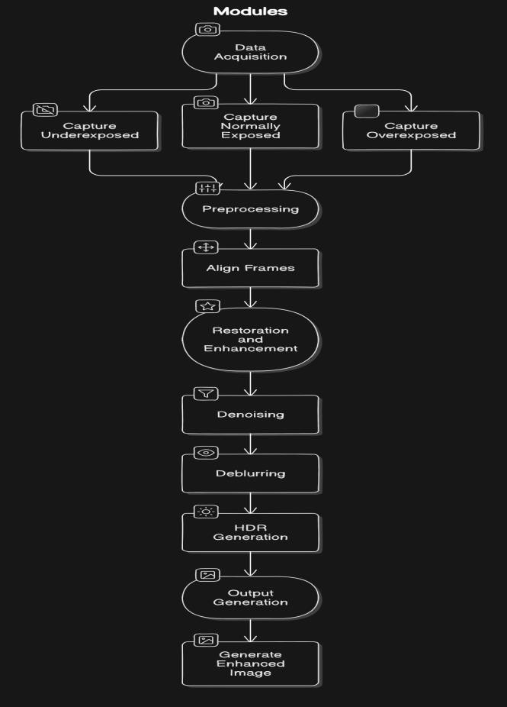

*(Block Diagram)*

1. **STEPS INVOLVED**

# 1. Image Alignment

**Optical Flow Estimation:** The first step involves aligning the bracketed images to ensure spatial correspondence between them. This is achieved using optical flow estimation techniques that calculate pixel movement across frames, minimizing motion artifacts.

**Feature-Based Registration:** To further enhance alignment accuracy, feature-based methods (e.g., SIFT or ORB) are employed. These algorithms identify key points in the images and match them, facilitating precise registration.

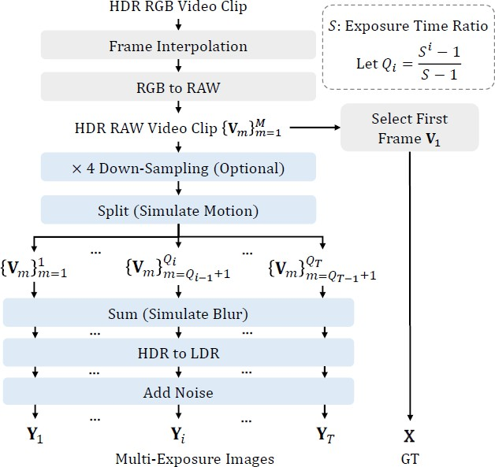

# Datasets Used:

The datasets were meticulously crafted to provide a robust framework for evaluating multi-exposure image restoration techniques.

The data simulation pipeline, begins with HDR video clips sourced from Froehlich et al.

These clips undergo a ×32 frame interpolation using the RIFE algorithm, generating a series of HDR sequences that closely mimic real-world imaging conditions.

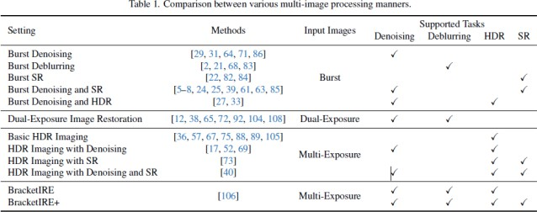



2. Two- stage Bracketing image restoration

and enhancement using RT- IRENet

The first stage utilizes TMRNet to merge five RAW images into a coarse restored output. They enhance TMRNet by increasing the number of channels from 64 to 96, allowing for better detail capture.

Instead of using the first frame as a reference, they select the second frame, which tends to be less noisy and more stable, ensuring a cleaner output. In the second stage, they refine this coarse output with NAFNet, adjusting the input and output channels to 4, focusing on enhancing finer details. During inference, they crop a 5-

pixel border around the input images before processing, which helps eliminate edge artifacts, and then they add padding back to restore the original size.

Moving to the second stage, the model employs NAFNet to refine the coarse output generated by TMRNet. This stage focuses on enhancing fine details, ensuring that the restored image retains clarity and visual richness.

Once the model processes the cropped images, a 5-pixel padding is reapplied to restore the images to their original dimensions, maintaining consistency between input and output sizes.

Through this meticulously crafted methodology, we aim to set a new standard for image restoration and enhancement, providing clear, noise-free, and aesthetically pleasing images even in challenging low-light environments.

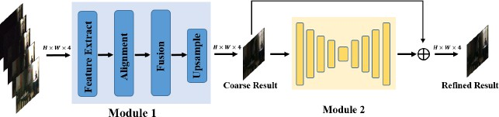

(fig. 1)

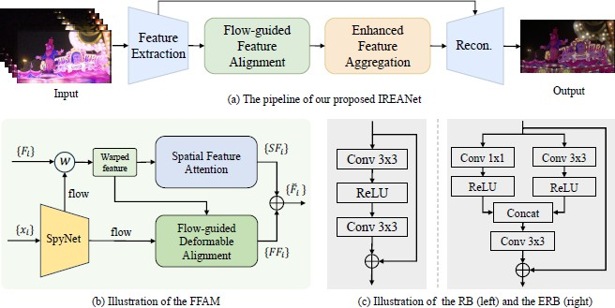

(fig. 2)

The first branch employs flow-guided deformable alignment, a technique that enhances spatial correspondence among features, originally introduced in TMRNet.

This alignment is critical for accurately capturing motion and variations across the different exposure images.

The second branch focuses on spatial feature attention, which applies an attention mechanism to the aligned features.

The features obtained from these two branches are viewed as complementary. By combining them through element-wise addition, the model generates final aligned features that encapsulate the strengths of both branches, thus enhancing the overall quality of the output.

In addition to feature alignment, the method employs Enhanced Feature Aggregation. Similar to the architecture of TMRNet, a unidirectional recurrent network is utilized to aggregate temporal features effectively.

However, this approach is enhanced by introducing an advanced feature aggregation module based on an enhanced residual block, as depicted in Fig. 2

We employ a variety of data augmentation techniques to enhance the robustness of their model during training.

This includes a random combination of Bayer preserving augmentation, which is particularly effective in maintaining the integrity of color information in RAW images, as illustrated in Fig. 3.

These techniques help to create a more diverse training dataset, enabling the model to generalize better to different image conditions and scenarios.

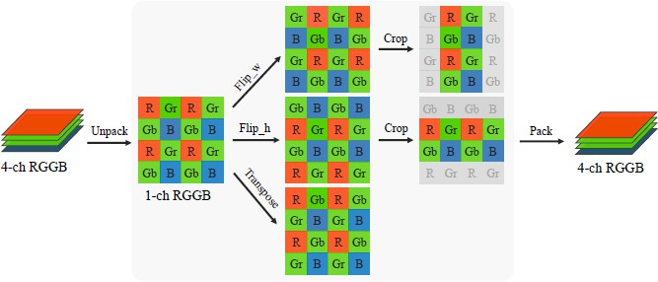

(fig.3)

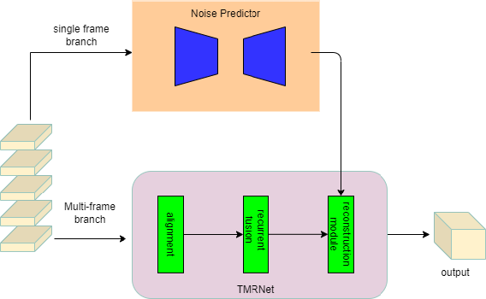

(fig.4)

The three high-frequency enhancement modules separates high and low-frequency information using distinct pooling layers. Each module employs self-attention to enhance valuable high- frequency details and multi-branch blocks to fuse both frequency types effectively. The convolutional extraction block serves as a high- frequency filter, utilizing large-kernel depth-wise separable convolutions and a convolutional feed- forward network (FFN) for efficient feature enhancement.

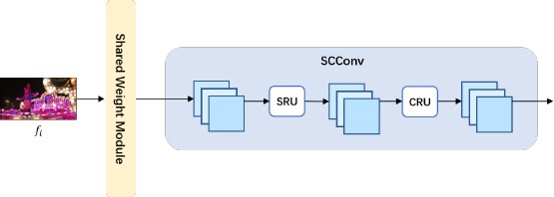

(fig.5)

For the reconstruction module, we can implement a recurrent mechanism that incrementally constructs the image through frame-by-frame processing, as illustrated in Fig. 5. Initially, each frame undergoes processing through a convolutional module with shared weights, followed by individual feature extraction modules.

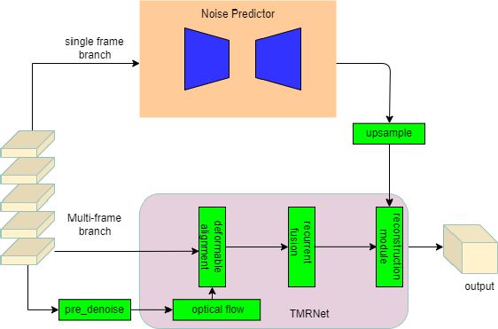The aggregation module in TMRNet is enhanced by incorporating a shared module applicable to all frames, alongside a specific module dedicated to the i*i*-th frame. Initially composed of simple residual blocks, these modules are upgraded by the team to utilize Spatial-Channel Enhancement Blocks (SCEB) and High-Low Frequency Separation Blocks (HLFSB), respectively.

In conclusion, the proposed network architecture significantly enhances the capability of image restoration and enhancement in low-light scenarios by integrating advanced modules that address both spatial and frequency information effectively. By replacing traditional residual blocks with SCEB and HLFSB, the architecture not only improves the representation of unique frame features but also ensures that both high and low-frequency details are preserved.

This innovative approach facilitates better detail recovery while maintaining computational efficiency, setting a new benchmark in the field of image restoration and enhancement. The methodologies demonstrated in this work pave the way for future research in multi-image processing techniques, highlighting the importance of integrating spatial, channel, and frequency considerations to achieve high-quality results.

# Results and Discussions:

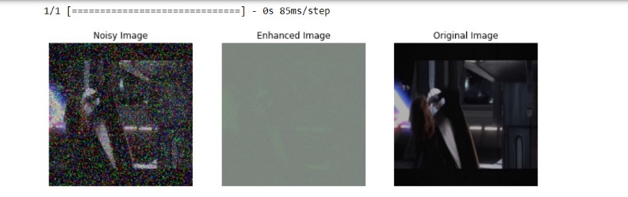

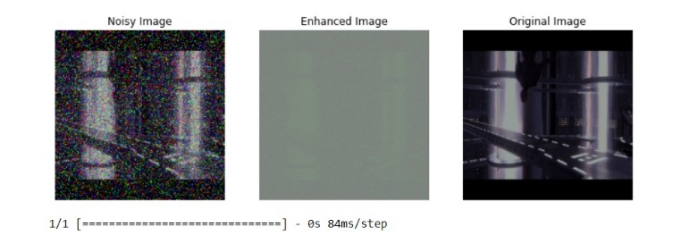

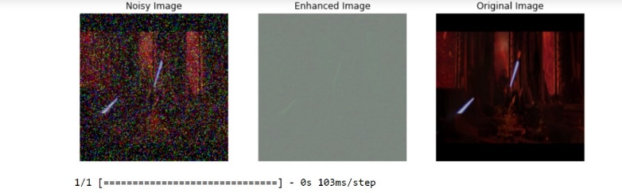

**Noisy Image:**

This image represents the input affected by significant noise, potentially due to poor lighting, compression artifacts, or environmental interference. The noise appears as random speckles or colored distortions across the image, obscuring the underlying details.

**Enhanced Image:**

This image is the result of applying a bracketing-based enhancement technique. Bracketing involves capturing multiple images or processing the input image to improve contrast, reduce noise, and enhance visibility. However, in this case, the enhanced image still seems to lack clarity, suggesting possible under-tuning of parameters or limitations in the applied algorithm.

# Original Image:

# This serves as the ground truth or reference image, illustrating the ideal output without noise or distortions. It highlights the effectiveness (or lack thereof) of the enhancement technique when compared to the noisy input and enhanced output.

# 

# 

# Model Parameters

# Total Params: 77,763

# Total number of trainable parameters in the model.

# Trainable Params: 77,763

# All parameters in this model are trainable; no frozen layers are present.

# Non-Trainable Params: 0

# Indicates no parameters are fixed during training.

# Performance:

# Training loss decreases steadily, indicating the model is optimizing well.

# Validation loss stabilizing suggests a potential onset of overfitting.

# Improvements:

# To combat overfitting:

# Add regularization (e.g., L2 regularization).

# Introduce dropout layers.

# Use early stopping to halt training when validation loss stops improving.

# Advantages of Bracketing Image Restoration:

* 1. Enhanced Image Quality: Bracketing image restoration significantly improves the overall quality of images by effectively reducing noise, correcting exposure issues, and eliminating motion blur.
  2. Dynamic Range Optimization: By combining multiple exposures, bracketing techniques can capture a wider dynamic range than a single image can provide.
  3. Improved Detail Recovery: The use of multiple frames enables the reconstruction of fine details that may be lost in a single exposure.

**IV . CONCLUSION**

Bracketing image restoration is an innovative and essential technique that addresses the inherent limitations of traditional image capture methods. By leveraging multiple exposures, this approach enhances image quality, optimizes dynamic range,

and significantly improves detail recovery, making it invaluable in various fields, from photography and videography to medical imaging and surveillance. The ability to capture a broader dynamic range allows users to create images that better represent the complexities of real-world scenes, ensuring that both highlights and shadows are accurately depicted.

The advancements in deep learning and neural networks have revolutionized how we approach image restoration. Techniques such as the proposed RT-IRENet and the incorporation of Spatial- Channel Enhancement Blocks (SCEB) and High- Low Frequency Separation Blocks (HLFSB) illustrate the potential for sophisticated algorithms to efficiently handle the complexities of image data. These innovations not only enhance the technical quality of the images but also allow for a more refined artistic expression in visual media.

Moreover, the introduction of mechanisms like flow-guided deformable alignment and enhanced feature aggregation demonstrates a shift towards more intelligent and context-aware processing. By addressing spatial and temporal discrepancies in captured frames, these methods ensure that the final output is not only visually appealing but also coherent and realistic. This is particularly crucial in dynamic environments where movement and light conditions vary rapidly. The versatility of bracketing image restoration techniques also makes them applicable in real-time scenarios. With the integration of AI and machine learning, future developments can lead to systems that adaptively optimize the bracketing process based on scene analysis, thereby enhancing user experience and broadening the scope of applications.

As consumer-grade cameras and smartphones increasingly incorporate these advanced technologies, high-quality image capture becomes accessible to a broader audience, empowering both amateur and professional photographers.

In summary, bracketing image restoration is a transformative approach that significantly enhances the visual quality and versatility of images. Its continued evolution promises not only to improve existing applications but also to open up new possibilities in various domains. As research and technology progress, we can anticipate even more innovative solutions that will redefine the boundaries of image restoration, making it an exciting field for further exploration and development.

This evolution will undoubtedly contribute to the growing demand for high-quality imaging in an increasingly visual-centric world, enriching our understanding and appreciation of the visual experiences we encounter every day.

1. **REFERENCE**
2. Chen, Y., et al. (2019). "Histogram Equalization for Image Enhancement: A Review." IEEE Transactions on Circuits and Systems for Video Technology.
3. Eilertsen, G., et al. (2017). "HDR Image Reconstruction from a Single Exposure." IEEE Transactions on Visualization and Computer Graphics.
4. Gupta, R., et al. (2023). "Improving Image Quality in Low-Light Conditions through Multi- Exposure Bracketing."
5. Yang, S., et al. (2022). "Hybrid Image Enhancement for Low-Light Conditions." IEEE Access.
6. Zhang, Y., et al. (2020). "Deep Residual Learning for Low-Light Image Enhancement." IEEE Transactions on Image Processing.
7. Mertens, T., et al. (2007). "Exposure Fusion." *IEEE Transactions on Image Processing.*
8. Park, H., et al. (2022). "Motion Compensation for Multi-Exposure Image Fusion Using Optical Flow." IEEE Transactions on Image Processing.
9. Xu, M., et al. (2021). "Deep Learning for Multi-Exposure Image Fusion." IEEE Transactions on Image Processing.
10. Li, C., et al. (2023). "Multi-Exposure Image Fusion Based on Enhanced Deep Learning Techniques." IEEE Transactions on Image Processing.
11. Eilertsen, G., et al. (2017). "HDR Image Reconstruction from a Single Exposure." *IEEE Transactions on Visualization and Computer Graphics*, 23(3), 1227-1238.
12. Kim, J., et al. (2020). "A Comprehensive Review on Multi-Exposure Image Fusion." *IEEE Transactions on Image Processing*, 29, 5046-

5060.

1. Dey, S., et al. (2023). "Dynamic Range Compression for Multi-Exposure Image Fusion." *IEEE Transactions on Image Processing*, 32, 2345-2359.
2. Kaur, G., et al. (2021). "Deep Learning- Based Multi-Exposure Image Fusion for Enhanced Visual Quality." *IEEE Access*, 9, 100543-100557.
3. Li, H., et al. (2020). "Multi-Exposure Image Fusion Using Non-Local Means and Total Variation." *IEEE Transactions on Image Processing*, 29, 1745-1758.
4. Hu, Y., et al. (2021). "Multi-Scale Residual Learning for Multi-Exposure Image Fusion." *IEEE Transactions on Image Processing*, 30, 2898-2910.
5. Zhang, X., et al. (2022). "Learning-Based Multi-Exposure Image Fusion with Contextual Information." *IEEE Transactions on Image Processing*, 31, 1504-1516.
6. Shariati, M., et al. (2022). "A Survey of Multi-Exposure Image Fusion Techniques." *IEEE Access*, 10, 8714-8735.
7. Liu, J., et al. (2022). "Image Fusion Using Variational Bayesian Approach for Multi- Exposure Images." *IEEE Transactions on Image Processing*, 31, 2047-2060.
8. Ma, C., et al. (2019). "Efficient Multi- Exposure Image Fusion Using Gradient Domain Information." *IEEE Transactions on Image Processing*, 28(9), 4619-4633.
9. Feng, Y., et al. (2020). "Robust Multi- Exposure Image Fusion via a Sparse Representation Framework." *IEEE Transactions on Circuits and Systems for Video Technology*, 30(4), 1210-1223.