TEACH-NOW Professional Development / Coaching Template
Module 41 · Unit 4 · Activity 1 — Proposal for Instructional Coaching
Candidate Name: Victor Moronu
School / District Working with: Victoria Thang Long — Independent 1:1 Chromebook campus · Grades 4–9 · ~540 students · 18 Math & Science teachers
Cohort: MTEC 02/2026 · Cohort 2
Instructor: Charles Guilford
Primary Coaching Frame: Jim Knight's Instructional Coaching Cycle (Identify → Learn → Improve) anchored by GROW for goal-setting and TPACK/SAMR for technology fit
Context & Data Foundation
Why this proposal, why now
Victoria Prep went 1:1 with Chromebooks in 2024. Two years in, administration and teachers agree the devices are present — but not always purposeful. The Module 41 needs-analysis survey (n = 18 teachers + 4 administrators, conditional Google Form) exposed a predictable but painful gap between access and instructional impact.

Headline data driving this proposal (n = 18 teachers, 4 admins):
• 78% of teachers (14/18) named "students getting distracted" as their top technology challenge.
• 44% (8/18) reported they had received no training on GoGuardian, Google Classroom tab management, or other focus-keeping tools.
• 67% (12/18) rated themselves 3 or below (out of 5) on "confidence integrating technology for differentiation."
• 61% (11/18) named "classroom management with devices" as their #1 PD request — the clearest mandate in the dataset.
• 94% of teachers said Yes or Maybe to 1:1 coaching (only 1/18 declined) — the school is ready for an instructional coach.
• Admin priorities: (1) data-driven instruction, (2) purposeful device use, (3) classroom-management-with-tech look-fors for walkthroughs.
• Two teachers flagged by admin for targeted coaching: one in 7th-grade Math (data use) and one in 6th-grade Science (engagement + interactive lessons).

The four PD sessions that follow are sequenced to hit the biggest survey pain first (distractions), then ladder up to the more ambitious asks (differentiation, interactivity, data). The two coaching recommendations translate admin priorities into multi-touch, on-the-ground support.

Section A · Professional Development Proposals
Professional Development Training #1
Title
Pocket Check: Classroom Management on a 1:1 Chromebook Campus
Proposed Audience (all faculty vs. specific grade/subject, etc.)
All Victoria Prep Math & Science teachers (Grades 6–8), with instructional support staff invited. Highest-priority attendees: first- and second-year teachers who flagged "device distractions" (78%) and "classroom management with devices" as their top PD request (61%).
Type of Training:
Presentation Session | Hands-On Workshop
Training Objective(s) — referenced to chosen coaching model
Teachers will design and rehearse a three-move classroom management routine for technology — an attention-reset signal, a device-position cue ("screens at 45°" / "pocket check"), and a transition protocol. Grounded in Jim Knight's Instructional Coaching Cycle, teachers identify one current pain point, learn a concrete tool (GoGuardian Teacher + Classwork tab-control), and leave with a rehearsed improve-cycle routine to run in their next class period.
Training Proposal (Who · What · When · Where · Why · How)
This hands-on workshop directly addresses the #1 finding from our stakeholder needs analysis: 78% of teachers flagged students getting distracted on Chromebooks as their top technology challenge, and 44% had received no formal training on the management features already built into the tools they use daily. The session is scheduled during our August Back-to-School PD week on the Monday afternoon block, held in the 6th-grade Science lab where teachers will co-work at their own Chromebooks with student accounts in a shared test classroom.
The session opens with a 10-minute data walkthrough — we look at aggregated survey results as a team so the "why" is owned. I then model three moves live on my cart: a non-verbal attention signal tied to GoGuardian's Pause Screen, a "screens at 45°" desk-posture cue, and a standardized open-tab protocol for Math and Science stations. Teachers rehearse each move with a partner, practicing the script out loud before leaving. Because Knight's cycle requires the coach to model, we close with me teaching a 5-minute mini-lesson to a volunteer "class" of peers so the moves are seen in action.
By the end of the workshop every teacher leaves with a one-page Management Playbook, a shared Google Classroom tab-rule for their subject, and a signed commitment to try the three moves within the first two days of school.
Technology Needs (what do teachers need to bring?)
• Chromebook (teacher device) with Victoria-Prep login
• Google Classroom access (Math or Science cohort classroom)
• GoGuardian Teacher license enabled on your account
• Printed class roster for the practice sandbox class
• One recent lesson plan that will actually run in the first week

Advertisement Card — PD #1
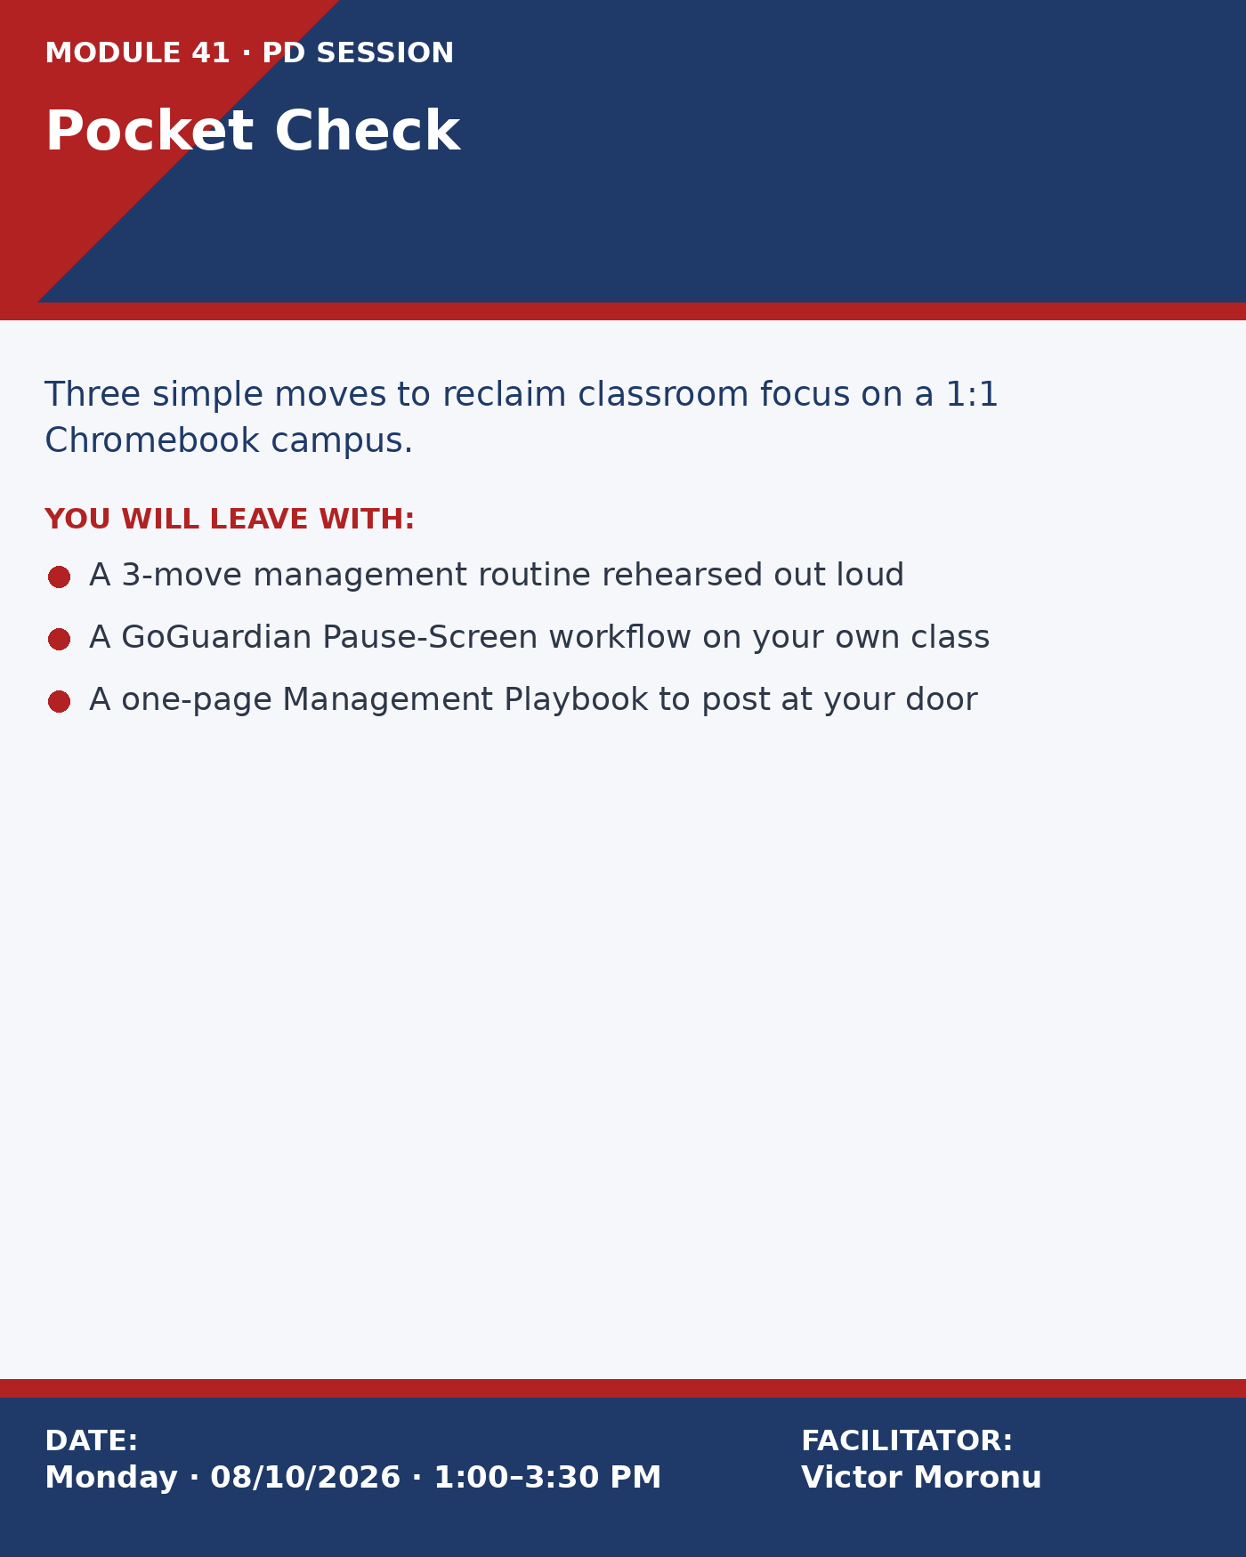

Professional Development Training #2
Title
From Data to Groups: Using IXL, Khan, and Desmos to Run Better Small-Group Math
Proposed Audience (all faculty vs. specific grade/subject, etc.)
Victoria Prep Math teachers (Grades 6–8) and two invited Science teachers who volunteered for "data-driven instruction." Responds directly to admin priority #1 (all 4 admins named it) and the 22% of teachers who explicitly requested PD on using digital data — a smaller but high-leverage cohort, because Math is where daily dashboard use already exists.
Type of Training:
Presentation Session | Hands-On Workshop
Training Objective(s) — referenced to chosen coaching model
Teachers will use IXL's Analytics, Khan Academy's Course Mastery view, and Desmos Classroom's dashboard to turn one week of student data into three differentiated small-group plans. Framed with the GROW coaching model (Goal → Reality → Options → Way Forward), teachers define a student-level goal, analyze current reality from the data, generate 2–3 grouping options, and commit to a way forward before they leave the room.
Training Proposal (≈200 words — Who · What · When · Where · Why · How)
This workshop tackles the gap between "we assign IXL" and "we teach from IXL." Survey data showed that while 100% of Math teachers assign digital practice weekly, only 36% said they regularly use the resulting data to reshape instruction — and admin flagged data-driven instruction as their top priority for coaching.
The session meets in the Math lab on a Wednesday early-release PD afternoon. Teachers bring one week of their own live student data from IXL, Khan, or Desmos. I open with a 12-minute mini-lesson on reading three dashboards side-by-side — skill score vs. time-on-task vs. common-wrong-answer patterns — because the survey showed teachers conflate "green = mastery" with "green = try something harder."
Using the GROW protocol on a shared Google Doc, each teacher writes: (G) one specific student learning goal for the upcoming unit; (R) what the data actually says right now; (O) three possible small-group configurations; (W) which option they will run Monday, and the exit ticket they will use to know it worked. I coach one-on-one during the reality step — the hardest move — and pairs peer-coach each other on options.
Teachers leave with a completed GROW planning doc, a saved dashboard bookmark bundle, and three pre-built small-group station templates they can drop into any unit.
Technology Needs (what do teachers need to bring?)
• Chromebook (teacher device) with IXL, Khan Academy, and Desmos Classroom logins
• One live class's data from the past 5–7 school days
• A current or upcoming Math/Science unit plan
• Headphones (optional — for reviewing Desmos video feedback)
• A printed class roster (makes grouping drag-and-drop fast)

Advertisement Card — PD #2
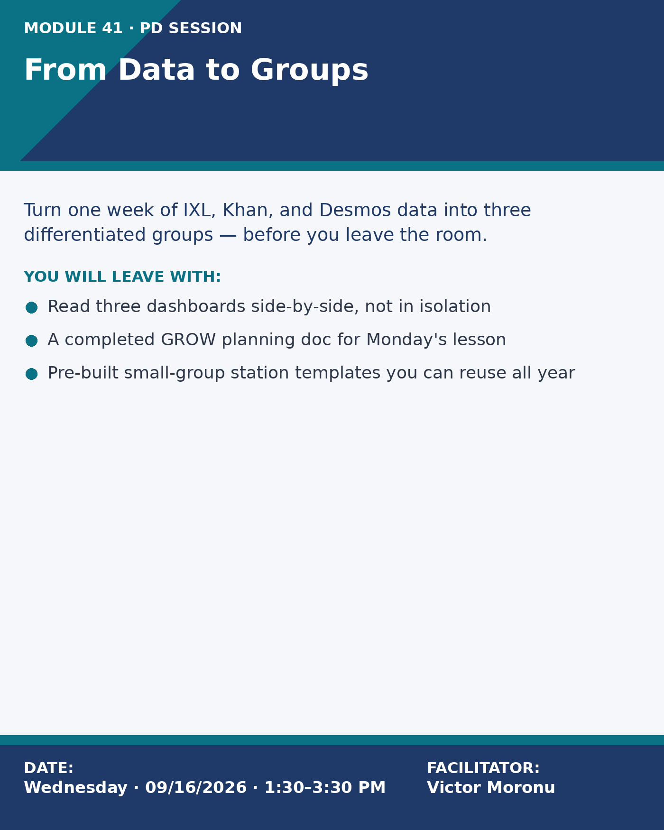

Professional Development Training #3
Title
Hands-On Science, Hands-On Screens: PhET, Gizmos, and EdPuzzle Made Purposeful
Proposed Audience (all faculty vs. specific grade/subject, etc.)
Victoria Prep Science teachers (Grades 6–8) and the 8th-grade STEM elective lead. Optional seats for Math teachers who co-plan with Science. Targets the 56% of teachers (10/18) who requested PD on creating interactive lessons — the #2 PD request overall after classroom management.
Type of Training:
Presentation Session | Hands-On Workshop
Training Objective(s) — referenced to chosen coaching model
Teachers will redesign one upcoming Science lesson using the TPACK framework — deliberately matching the content, pedagogy, and technology. The deliverable is one station-rotation or 5E lesson that swaps a passive digital task for a PhET simulation, a Gizmos exploration, or an EdPuzzle with embedded formative checks — and can answer the question "what does the tech let kids do that nothing else can?"
Training Proposal (≈200 words — Who · What · When · Where · Why · How)
Our survey made the challenge specific: teachers want engaging lessons, not more logins. Several respondents wrote that students "click through" videos and practice sets without thinking, and 56% (10/18) wanted PD on creating interactive lessons. This workshop uses TPACK as the design lens so teachers stop picking tools first and start picking the content and pedagogy the tool has to serve.
The session runs on a Thursday PD afternoon in the 7th-grade Science classroom. Teachers bring one upcoming lesson they already know is a little flat. I open with three 60-second "tech audits" of real Victoria lessons — what the technology adds, replaces, or wastes — so the diagnosis is grounded in our building. We then rotate through three 20-minute stations: (1) PhET (free, simulation-heavy), (2) Gizmos (structured exploration + assessment), (3) EdPuzzle (embedded formative checks inside a video). Each station has a one-page "TPACK swap" scaffold that forces teachers to name the content goal, the pedagogical move, and the specific technology feature they are using.
In the final block, teachers co-plan one redesigned lesson with a colleague and share the before/after with the group. They leave with the redesigned lesson, a Gizmos + PhET starter-link library aligned to Victoria's scope and sequence, and an invitation to pilot it in a peer-observation cycle the following week.
Technology Needs (what do teachers need to bring?)
• Chromebook (teacher device) with PhET.colorado.edu, ExploreLearning Gizmos, and EdPuzzle accounts
• One upcoming Science lesson you suspect is too passive
• Your current unit plan or scope-and-sequence
• Headphones (for EdPuzzle station)
• A printed copy of the NGSS standard you're targeting

Advertisement Card — PD #3
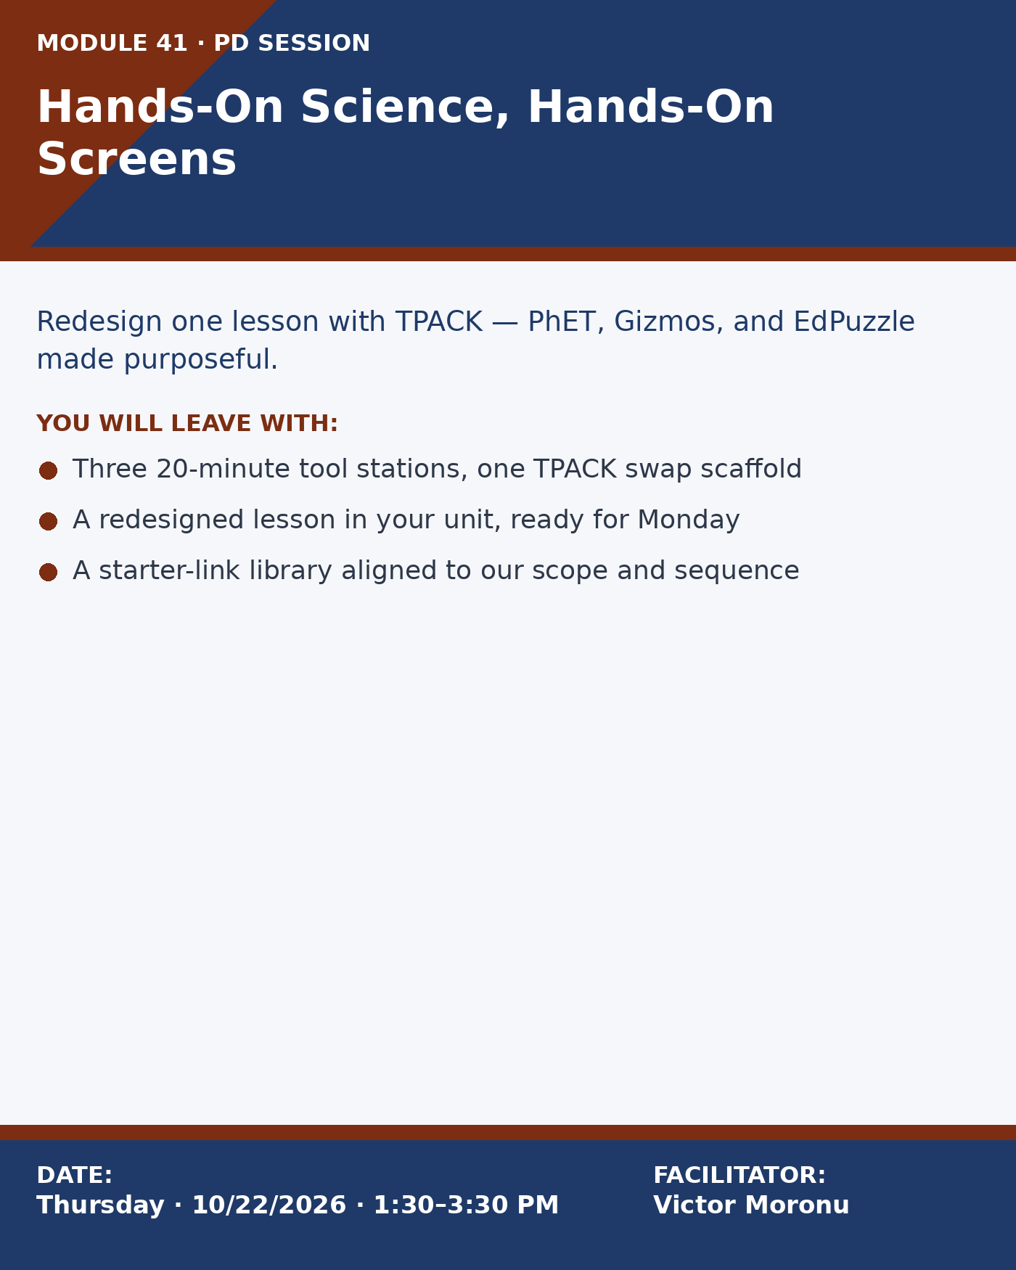

Professional Development Training #4
Title
Differentiation Without Drowning: Scaffolding EdTech for IEP, 504, and ML Learners
Proposed Audience (all faculty vs. specific grade/subject, etc.)
All Math, Science, and co-teaching inclusion specialists (Grades 6–8). Especially encouraged: the three Victoria teachers who host the largest caseloads of IEP and Multilingual Learner students. Responds to 67% of teachers (12/18) rating themselves 3 or below on differentiation confidence.
Type of Training:
Presentation Session | Hands-On Workshop
Training Objective(s) — referenced to chosen coaching model
Teachers will use the SAMR model to evaluate and redesign one lesson so that three named students (1 IEP, 1 ML, 1 on-level) each have a scaffolded entry point. Teachers will leave with a four-tier scaffolding bank — text-to-speech, translated supports, leveled practice, and extension — that can be attached to any Google Classroom assignment.
Training Proposal (≈200 words — Who · What · When · Where · Why · How)
The survey made it clear: teachers want more than "use technology" — they want tools that let every student in the room start moving forward. 67% rated themselves 3 or lower on differentiation confidence, and admins flagged "supporting diverse learners" as a walkthrough look-for this year. This workshop uses the SAMR model as a planning lens — teachers diagnose whether their current tech use is Substitution, Augmentation, Modification, or Redefinition for their most vulnerable learners.
The session meets on a Tuesday PD afternoon in the 8th-grade Humanities-Math shared classroom (the room with the best co-teaching set-up). Teachers come with one assignment and three named students whose supports they want to strengthen. I model a SAMR diagnosis on a real Victoria Science assignment, then teachers rotate through four scaffolding stations: (1) Read&Write / Google text-to-speech, (2) Google Translate + Newsela for ML learners, (3) IXL / Khan for leveled practice, (4) Mote + Voice Comments for feedback. Each station includes a 90-second "look-for" list that tells teachers when the tool helps vs. when it becomes a crutch.
Teachers leave with one redesigned assignment saved as a reusable template, a four-tier scaffolding bank in Classroom, and a commitment letter to a colleague about which IEP/ML student will see the change first.
Technology Needs (what do teachers need to bring?)
• Chromebook with Google Classroom, Read&Write (district-licensed), Newsela, and Mote accounts
• One assignment you already plan to run next week
• Three named students (1 IEP, 1 ML, 1 on-level) and their accommodation summaries
• Student data from IXL or Khan on the three named students
• Your co-teacher or case-manager (warm invite — paired seats available)

Advertisement Card — PD #4
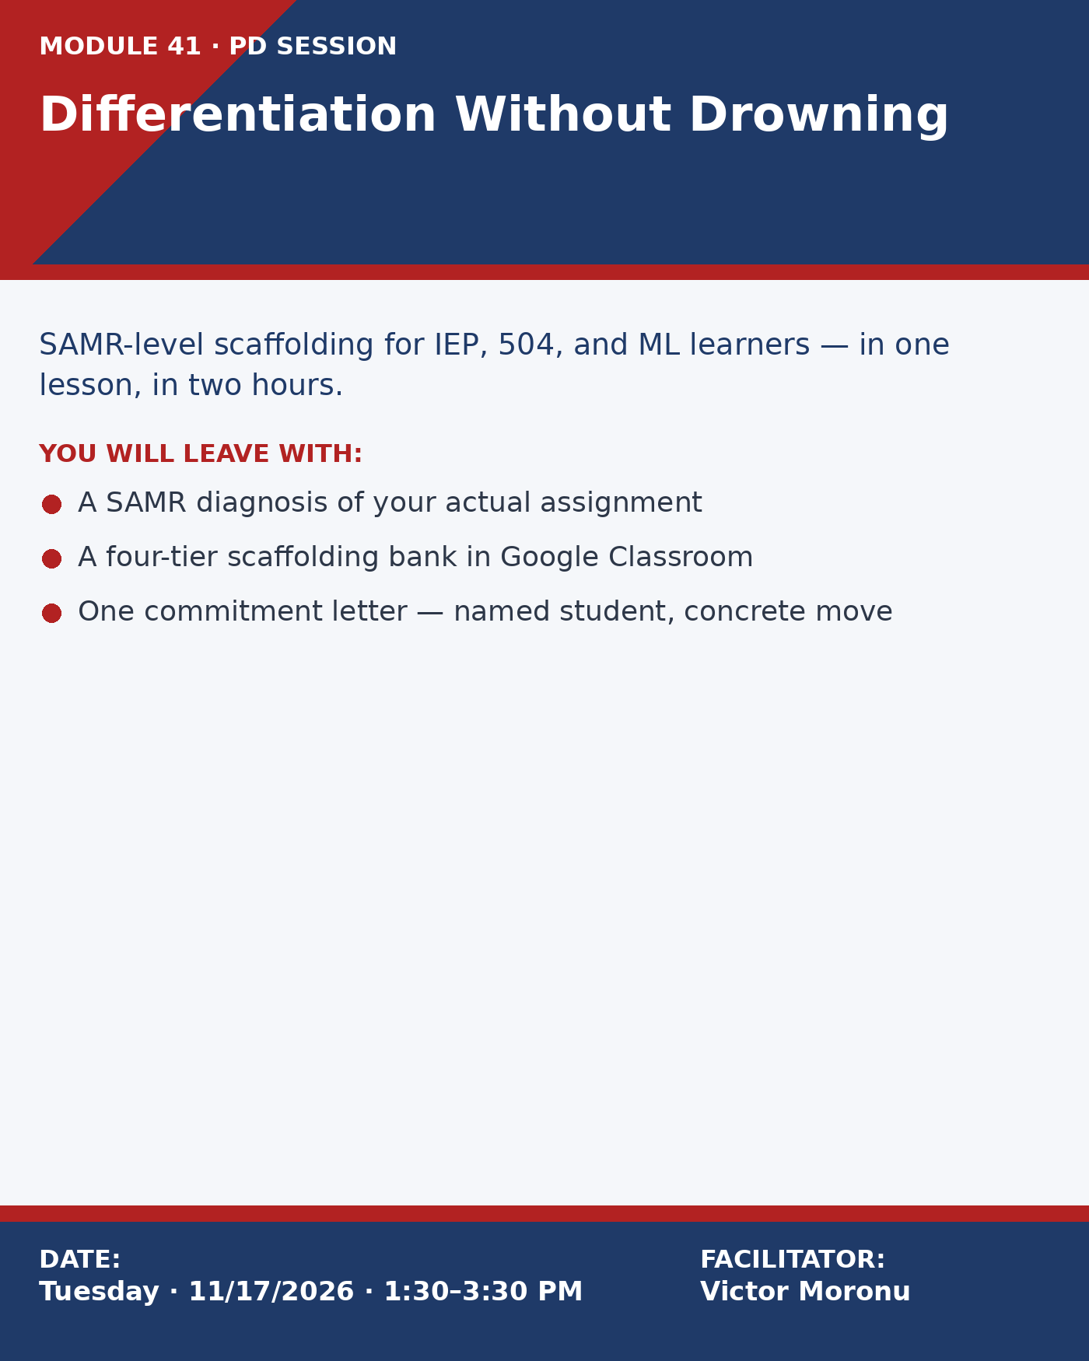

Section B · Coaching Recommendations
These recommendations are drawn directly from administrator free-response answers on the Module 41 survey and from teacher self-identified coaching requests. Each coaching plan names a coaching model, a measurable starting goal, and a five-meeting arc (exceeding the template's minimum of three) across an 8-week coaching cycle.
Coaching Recommendation #1
Teacher Name (pseudonym)
Ms. Vera Vectore (pseudonym)
Grade and Subject
7th Grade Mathematics (inclusion section, 22 students, 6 IEPs)
General Goal / Recommendation for the teacher (from survey)
Admin survey feedback: "This teacher is strong on relationships but leans on IXL as a babysitter. We'd love to see her use the data we're already collecting to drive small-group instruction, and to shut down off-task tabs faster during independent practice. Three walkthroughs in October showed 4–6 students off-task on YouTube or gaming tabs during IXL time."
Teacher survey self-assessment: rated herself 2/5 on "using data to adjust instruction" and 3/5 on "managing devices during independent work." Asked specifically for "someone to sit with me and look at my IXL dashboard."
Coaching Approach (based on Coaching Model)
Model + Rationale
Primary coaching model: GROW (Goal · Reality · Options · Way Forward) — chosen because Ms. Vectore's growth edge is decision-making from data, and GROW's explicit "reality" step forces an honest read of the dashboard before jumping to solutions.
Secondary lens: TPACK, used during Meeting 3 to check that the technology choice is serving the content and pedagogy, not driving them.
Initial Goals for the Teacher
Primary goal (SMART): By the end of the 8-week cycle, Ms. Vectore will plan and run three consecutive weeks of data-driven small-group Math rotations in which every student's group assignment is justified by IXL and weekly exit-ticket data.
Supporting goals:
• Reduce off-task tab incidents during independent practice by 50% using GoGuardian's scene-launch feature.
• Increase teacher confidence on "using data to adjust instruction" from 2/5 (pre-cycle) to 4/5 (post-cycle self-rating).
• Build three reusable small-group station templates aligned to Victoria's 7th-grade scope and sequence.
Ideas to Support the Teacher
• Co-plan one data review using IXL Analytics side-by-side with weekly exit-ticket data (I supply the scaffold; she runs the analysis).
• Model-and-step-back: I teach one small-group rotation in her classroom on Day 1, she teaches it on Day 3 with me present.
• Screen-recorded practice: Ms. Vectore sends me a 5-minute Loom clip of herself reading her dashboard out loud — we use it as the artifact for Meeting 2 reflection.
• Partner classroom visit: 20-minute walkthrough of Mr. Cho's 8th-grade station rotations (admin-approved peer model).
• Shared Google Doc of GROW notes kept for the entire cycle — every meeting adds one row.
• GoGuardian quick-start: I build her first "IXL only" scene and she edits it for her next period.
Rough Schedule of Meetings and Objectives (5 scheduled — exceeds minimum of 3)
Meeting / Date / Location | Focus | Objectives & Activities
Meeting 1 · Monday, 09/14/2026 · 3:30–4:15 PM · Ms. Vectore's classroom | GROW: Goal-Setting | • Review admin walkthrough notes and survey self-assessment together (safe, non-evaluative).  • Co-author the SMART goal in a shared Google Doc.  • Agree on cycle cadence, artifacts, and communication norms.  • Schedule all five meetings and two classroom observations now.
Meeting 2 · Thursday, 09/24/2026 · 3:30–4:15 PM · Coaching office | GROW: Reality — Reading the Data Together | • Side-by-side walk through IXL Analytics + most recent exit tickets.  • Watch the Loom clip Ms. Vectore records of herself reading her dashboard.  • Identify three students on the edge of proficiency and name what the data says they need.  • Confirm the scope of Meeting 3's co-plan.
Meeting 3 · Tuesday, 10/06/2026 · 3:30–4:15 PM · Math workroom | GROW: Options — Co-Plan + TPACK Check | • Draft three small-group station plans using the data from Meeting 2.  • TPACK audit: does each station's tool actually fit the content and pedagogy?  • Build the first "IXL only" GoGuardian scene for independent practice.  • Confirm I will model the rotation on Day 1 (10/12) and observe her on Day 3 (10/14).
Meeting 4 · Wednesday, 10/21/2026 · 3:30–4:15 PM · Ms. Vectore's classroom | GROW: Way Forward — Observation Debrief | • Debrief the 10/14 observation using my low-inference notes.  • Compare off-task tab counts pre/post GoGuardian scene (expected ≥50% reduction).  • Revise the two weakest stations based on student-work samples.  • Agree on one lasting "keeper" routine she will own next cycle.
Meeting 5 · Monday, 11/09/2026 · 3:30–4:30 PM · Coaching office | Cycle Close + Reflection | • Re-rate the confidence survey (target: 4/5) and compare to pre-cycle baseline.  • Finalize the three reusable station templates into her unit folder.  • Decide what moves to next cycle (likely: scaffolding for the 6 IEPs).  • Share wins at the next PLC; schedule a peer visit from a first-year teacher.

Coaching Recommendation #2
Teacher Name (pseudonym)
Mr. Luis Luma (pseudonym)
Grade and Subject
6th Grade Science (general education, 2 sections of 24 students)
General Goal / Recommendation for the teacher (from survey)
Admin survey feedback: "Mr. Luma is a content expert — kids love his demos — but his Chromebook time is mostly articles and quiz recaps. We'd like him to experiment with simulations and interactive video so students do science with the devices, not just read about it. Also: he rarely uses Google Classroom announcements, which makes our schoolwide comms harder."
Teacher survey self-assessment: rated himself 4/5 on "tech confidence overall" but 2/5 on "creating interactive lessons." Wrote: "I'd love to see what's out there for middle-school Science that isn't just a quiz."
Coaching Approach (based on Coaching Model)
Model + Rationale
Primary coaching model: Jim Knight's Instructional Coaching Cycle (Identify → Learn → Improve) — chosen because Mr. Luma is a confident teacher who will thrive with a structured inquiry cycle and a concrete "try, study, refine" loop.
Secondary lens: SAMR, used in Meeting 3 to push his tool use beyond Substitution into Modification and Redefinition.
Initial Goals for the Teacher
Primary goal (SMART): By the end of the 8-week cycle, Mr. Luma will design, teach, and revise two interactive Science lessons (one PhET-based, one EdPuzzle-based) that produce an observable student-work artifact beyond a quiz score.
Supporting goals:
• Move at least one routine activity from Substitution to Modification on the SAMR ladder.
• Post a weekly Google Classroom announcement that previews the upcoming week's interactive task (improves schoolwide comms, per admin).
• Invite one peer Science teacher to observe his 10/28 PhET lesson (builds internal capacity beyond our dyad).
Ideas to Support the Teacher
• Share my curated PhET + Gizmos starter library tagged to Victoria's 6th-grade Science scope and sequence.
• Co-design one PhET-based station-rotation using the TPACK scaffold from PD #3.
• Model-and-step-back: I run a 20-minute PhET inquiry opener in one of his sections while he observes with a low-inference form.
• EdPuzzle pairing: he converts one flat video into an EdPuzzle with three embedded questions; we review student data together.
• Google Classroom announcement template: one I draft, one he revises, one he writes solo.
• Student-work protocol: bring three anonymized exit-slip artifacts to Meeting 4 for a calibration conversation.
Rough Schedule of Meetings and Objectives (5 scheduled — exceeds minimum of 3)
Meeting / Date / Location | Focus | Objectives & Activities
Meeting 1 · Tuesday, 09/15/2026 · 3:30–4:15 PM · Mr. Luma's lab | Identify (Knight's Cycle) | • Appreciative opener: what's already strong in his Science practice?  • Share the admin feedback and his own survey answer side-by-side.  • Identify the specific problem of practice ("too much read-and-quiz").  • Co-write a clean, observable SMART goal for the cycle.
Meeting 2 · Wednesday, 09/30/2026 · 3:30–4:15 PM · Coaching office | Learn (Knight's Cycle) — Tool Tour | • Tour of PhET and Gizmos using one of his real upcoming standards.  • Select the two lessons to redesign across the cycle.  • Set up his first Google Classroom weekly announcement template.  • Send him home with the PhET starter library and two model videos.
Meeting 3 · Tuesday, 10/13/2026 · 3:30–4:30 PM · Mr. Luma's lab | Improve (Knight's Cycle) — Co-Plan Lesson A (PhET) | • Co-design the PhET-based station rotation using the TPACK scaffold.  • Build the Google Classroom assignment and announcement together.  • SAMR audit: name where on the ladder this lesson sits and why.  • Confirm I'll model the inquiry opener on 10/21 and observe his full teach on 10/28.
Meeting 4 · Monday, 11/02/2026 · 3:30–4:15 PM · Coaching office | Student-Work Calibration | • Analyze three anonymized student exit-slips from the 10/28 lesson.  • Compare against the quiz-only evidence he used to collect — what's new?  • Design Lesson B (EdPuzzle) using the same scaffolds, faster this time.  • Confirm peer-teacher observation invite for Lesson B.
Meeting 5 · Wednesday, 11/18/2026 · 3:30–4:30 PM · Mr. Luma's lab | Cycle Close + Transfer | • Re-rate "creating interactive lessons" on the survey scale (target: 4/5).  • Debrief Lesson B observation and the peer-teacher's notes.  • Decide which two routines become permanent; retire one flat activity.  • Plan a 10-minute PLC share-out for December; decide next-cycle focus.

Section C · Alignment & Evaluation Plan
How these deliverables connect back to the Module 41 survey
• PD #1 ↔ 78% of teachers flagged device distractions and 44% had received no training on management tools; 61% named classroom management with devices as their #1 PD request.
• PD #2 ↔ admin priority #1 (all 4 admins named data-driven instruction) and the Math teachers already running daily IXL/Khan.
• PD #3 ↔ 56% of teachers requested interactive-lesson PD — the #2 teacher-driven ask; directly addresses the "click-through" pattern teachers surfaced in free-response.
• PD #4 ↔ 67% rated themselves ≤3 on differentiation confidence; admin named "supporting diverse learners" as a walkthrough look-for.
• Coaching #1 ↔ admin naming one 7th-grade Math teacher for data-use support; teacher's own self-assessment matches.
• Coaching #2 ↔ admin naming one 6th-grade Science teacher for interactive-lesson support; teacher self-identified the same gap.
Evaluation plan — how I will know this proposal worked
Short-term (per session): exit tickets measure confidence delta and collect the "one thing I will try Monday" commitment.
Mid-term (6 weeks): walkthrough look-for data shows a measurable drop in off-task tab incidents; Google Classroom announcement compliance rises schoolwide.
End-of-cycle (8 weeks): teacher self-ratings on the repeat survey rise by at least 1 point on differentiation, engagement, and data use; each coached teacher produces the named artifact (three station templates for Ms. Vectore; two interactive lessons for Mr. Luma).
Long-term (next school year): the PD playbook becomes a reusable onboarding kit for new Math & Science hires at Victoria Prep.
Prepared by
Victor Moronu | MTEC 02/2026 Cohort 2 | Instructor: Charles Guilford | vmoronu@gmail.com

