A6B2_EXPT-8: BLACK BOX TESTING
Test Case Document - Unified Student Placement System (Website)
Particular | Details
Course | Software Engineering Lab (24CS01PR0502)
Experiment | 8 - Black Box Testing
Name | Vineet Shah
Class / Batch | 5S CSE / A6 - B2
Roll No. | 28
Date of test execution | 26-10-2026
Application under test | Unified Student Placement System (USPS) - placement portal (4 form interfaces)
Faculty | D A Borikar

Aim
To compile a test case document for a website having at least three form interfaces (excluding Login/Register forms) in a prescribed template, indicating the inputs and the outputs of every test case.

Problem Statement / Application Under Test
The Unified Student Placement System (USPS) is the case study of my SE lab work (SRS, use cases, class, sequence, statechart and activity diagrams). It brings the campus placement process onto one website: recruiters post jobs with eligibility criteria, the placement officer approves them, the system checks each student against the criteria automatically, and students apply and track their applications. The website under test is the USPS prototype built for my SE PBL; its page has a Student, a Recruiter and a Placement Officer view and four form interfaces, none of which is a Login or Register form:
- Form 1 - Post a Job (Recruiter view): A recruiter of an approved company posts a job with its package, deadline and eligibility criteria; it is stored as Pending for the placement cell (SRS FR-09, FR-10, FR-13).
- Form 2 - Record Job Decision (Placement Officer view): The placement officer approves, rejects or returns a pending job posting; on approval the eligible students are notified (SRS FR-11, BR-02).
- Form 3 - Apply for a Job (Student view): A student applies to a published job with one of their resumes and an optional cover note and receives a tracking id (SRS FR-15, UC-1, BR-03, BR-04, BR-05).
- Form 4 - Job Search (Student view (Job board)): A student searches the published jobs by keyword, location and minimum package and can show only the jobs they are eligible for (SRS FR-12, FR-14).

Black Box Testing - Techniques Used
Black box testing checks the software against its specification without looking at the internal code. The tester supplies inputs through the user interface and compares the output shown with the expected output.
- Equivalence Partitioning (EP): each input is divided into valid and invalid classes, and one representative value from each class is tested.
- Boundary Value Analysis (BVA): values at and just outside the limits (min-1, min, max, max+1) are tested, because errors are most likely at the edges of a range.

Test Environment
Item | Details
Website | Unified Student Placement System (HTML, CSS, JavaScript page; Python 3.11 REST server with SQLite), served locally from ../PBL_Student_Placement
Browser | Microsoft Edge 156.0.0.0 (headless) on Windows 11
Execution | Each test case was executed through the user interface: the page is opened as the user of the test case, the input data is entered in the fields, the button is clicked and the message displayed on the page is recorded as the actual output (harness/case.html, run_tests.py).
Test data | The server is started afresh with the pre-loaded data of Tables 1-3 for every test case, with its date and time fixed at 26-10-2026 10:00 so the job deadlines are fixed.
Executed on | 26-10-2026 12:54:48

Test Data (Pre-loaded Records)
Table 1 - Students and their resumes
ID | Name | Branch | Batch | CGPA | Backlogs | Placed | Resumes
101 | Aarav Kulkarni | CSE | 2023-2027 | 8.60 | 0 | No | Aarav_Resume_v2.pdf (active), Aarav_Resume_v1.pdf (inactive)
102 | Diya Joshi | IT | 2023-2027 | 7.40 | 0 | No | Diya_Resume.pdf
103 | Kabir Deshmukh | ECE | 2023-2027 | 6.80 | 1 | No | Kabir_Resume.pdf
104 | Meera Patil | CSE | 2023-2027 | 9.10 | 0 | Yes | Meera_Resume.pdf
105 | Rohan Wankhede | ME | 2022-2026 | 7.90 | 2 | No | Rohan_Resume.pdf

Table 2 - Recruiters and companies; placement officer
Recruiter | Company | Company approved
Ritika Menon | Nimbus Analytics Pvt Ltd | Yes
Sameer Khan | Orbit Systems | Yes
Anil Rao | Vertex Labs | No
Placement officer: Dr. N. Bhagat | - | -

Table 3 - Jobs
Job | Title | Company | Package | Location | Deadline | Status | Eligibility criteria
J-1 | Software Engineer | Nimbus | 8.5 LPA | Pune | 25-11-2026 10:00 | Published | CGPA >= 7.0, CSE/IT, 0 backlogs, batch 2023-2027
J-2 | Embedded Systems Engineer | Orbit | 6.0 LPA | Bengaluru | 15-11-2026 10:00 | Published | CGPA >= 6.5, CSE/ECE/EE, <= 1 backlog
J-3 | Data Analyst | Nimbus | 7.0 LPA | Hyderabad | 20-11-2026 10:00 | Pending | CGPA >= 7.5, 0 backlogs
J-4 | Firmware Intern | Orbit | 3.6 LPA | Nagpur | 25-10-2026 10:00 (passed) | Published | CGPA >= 6.0, ECE/EE

Form Interfaces - Inputs and Outputs

Form 1: Post a Job (Recruiter view)
Input field | Control | Valid input | Output (message) for invalid input
Job title | Text box | 3 to 120 characters | Title must be 3 to 120 characters.
Description | Text area | 20 to 2000 characters | Description must be 20 to 2000 characters.
Package (LPA) | Text box | A number, more than 0 and at most 100 | Package (CTC) must be a positive number up to 100 LPA. / Package (CTC) must be a number.
Location | Text box | 2 to 80 characters | Location is required (2 to 80 characters).
Application deadline | Date and time | Later than the current date and time | Deadline must be a future date and time.
Minimum CGPA | Text box | Optional; 0 to 10 | Minimum CGPA must be between 0 and 10.
Maximum active backlogs | Text box | Optional; whole number 0 to 10 | Maximum backlogs must be a whole number from 0 to 10.
Allowed branches | Check boxes | Optional; CSE, IT, ECE, EE, ME, CE | -
Batch | Text box | Optional; YYYY-YYYY spanning 4 years (e.g. 2023-2027) | Batch must look like 2023-2027.
Eligibility criteria (as a group) | Rule | At least one of the four criteria | At least one eligibility criterion is required.
Company of the recruiter | Rule | Approved by the placement cell | Your company is not yet approved by the placement cell.
Output for valid input: Job J-<id> submitted for approval (status: Pending). The job appears in My job postings as Pending.

Form 2: Record Job Decision (Placement Officer view)
Input field | Control | Valid input | Output (message) for invalid input
Job | Drop-down | A pending job posting | Select a pending job posting.
Decision | Radio buttons | Approve, Reject or Return for changes | Decision must be approve, reject or return.
Remarks | Text box | Reject / Return: 5 to 200 characters; Approve: optional, at most 200 | Remarks (5 to 200 characters) are required to reject or return a posting. / Remarks cannot exceed 200 characters.
Output for valid input: Job J-<id> published. <n> eligible student(s) notified. / Job J-<id> rejected. Recruiter notified. / Job J-<id> returned to the recruiter for changes.

Form 3: Apply for a Job (Student view)
Input field | Control | Valid input | Output (message) for invalid input
Job | Drop-down | A published job the student is eligible for, before its deadline | Select a job to apply for. / Not eligible: <unmet criteria> (Submit disabled) / The application deadline for J-<id> has passed. (Submit disabled) / You are already placed; the placement policy blocks further applications. / You have already applied to J-<id> (tracking id <tid>).
Resume | Drop-down | One of the student's active resumes (the active one is pre-selected) | Select one of your active resumes.
Cover note | Text area | Optional; at most 500 characters (counter shown) | Cover note cannot exceed 500 characters.
Output for valid input: Application submitted for J-<id>. Tracking id USPS-26-<nnnn>.

Form 4: Job Search (Student view (Job board))
Input field | Control | Valid input | Output (message) for invalid input
Keyword | Text box | Any text; matches job title, description or company, ignoring case | -
Location | Text box | Any text; part of the job location, ignoring case | -
Min package (LPA) | Text box | Optional; a number | Minimum package must be a number.
Eligible only | Check box | Ticked or not | -
Output for valid input: Job count and the matching jobs, open jobs first: '<n> jobs' followed by the job titles; when nothing matches: 'No jobs match the filters.'

Test Case Document
Template: TC ID | Test scenario (technique) | Pre-condition | Test steps | Input (test data) | Expected output | Actual output | Status. Dates are shown as dd-mm-yyyy; the test cases were executed on 26-10-2026.

Form 1: Post a Job
TC ID | Test scenario (technique) | Pre-condition | Test steps | Input (test data) | Expected output | Actual output | Status
TC_PJ_01 | All fields valid  [EP (valid class)] | Recruiter view open as Ritika Menon (Nimbus Analytics, approved) unless stated; data of Tables 1-3; server date 26-10-2026 10:00. | 1. Open the Recruiter view as Recruiter Ritika Menon - Nimbus Analytics  2. Enter the input data  3. Click 'Submit for approval' | Job title: Backend Developer  Description: Design REST APIs and database schemas for the analytics platform. (65 chars)  Package (LPA): 9  Location: Pune  Deadline: 05-11-2026 17:00  Minimum CGPA: 7  Maximum backlogs: 0  Branches: CSE, IT  Batch: (blank) | Job J-5 submitted for approval (status: Pending). | Job J-5 submitted for approval (status: Pending). | PASS
TC_PJ_02 | Job title of 2 characters  [BVA (min - 1)] | Recruiter view open as Ritika Menon (Nimbus Analytics, approved) unless stated; data of Tables 1-3; server date 26-10-2026 10:00. | 1. Open the Recruiter view as Recruiter Ritika Menon - Nimbus Analytics  2. Enter the input data  3. Click 'Submit for approval' | Job title: QA (2 chars)  Other fields: as in TC_PJ_01 | Title must be 3 to 120 characters. | Title must be 3 to 120 characters. | PASS
TC_PJ_03 | Job title of 3 characters  [BVA (min)] | Recruiter view open as Ritika Menon (Nimbus Analytics, approved) unless stated; data of Tables 1-3; server date 26-10-2026 10:00. | 1. Open the Recruiter view as Recruiter Ritika Menon - Nimbus Analytics  2. Enter the input data  3. Click 'Submit for approval' | Job title: SDE (3 chars)  Other fields: as in TC_PJ_01 | Job J-5 submitted for approval (status: Pending). | Job J-5 submitted for approval (status: Pending). | PASS
TC_PJ_04 | Job title of 120 characters  [BVA (max)] | Recruiter view open as Ritika Menon (Nimbus Analytics, approved) unless stated; data of Tables 1-3; server date 26-10-2026 10:00. | 1. Open the Recruiter view as Recruiter Ritika Menon - Nimbus Analytics  2. Enter the input data  3. Click 'Submit for approval' | Job title: 'A' x 120  Other fields: as in TC_PJ_01 | Job J-5 submitted for approval (status: Pending). | Job J-5 submitted for approval (status: Pending). | PASS
TC_PJ_05 | Job title of 121 characters  [BVA (max + 1)] | Recruiter view open as Ritika Menon (Nimbus Analytics, approved) unless stated; data of Tables 1-3; server date 26-10-2026 10:00. | 1. Open the Recruiter view as Recruiter Ritika Menon - Nimbus Analytics  2. Enter the input data  3. Click 'Submit for approval' | Job title: 'A' x 121  Other fields: as in TC_PJ_01 | Title must be 3 to 120 characters. | Title must be 3 to 120 characters. | PASS
TC_PJ_06 | Description of 19 characters  [BVA (min - 1)] | Recruiter view open as Ritika Menon (Nimbus Analytics, approved) unless stated; data of Tables 1-3; server date 26-10-2026 10:00. | 1. Open the Recruiter view as Recruiter Ritika Menon - Nimbus Analytics  2. Enter the input data  3. Click 'Submit for approval' | Description: Write code for APIs (19 chars)  Other fields: as in TC_PJ_01 | Description must be 20 to 2000 characters. | Description must be 20 to 2000 characters. | PASS
TC_PJ_07 | Description of 20 characters  [BVA (min)] | Recruiter view open as Ritika Menon (Nimbus Analytics, approved) unless stated; data of Tables 1-3; server date 26-10-2026 10:00. | 1. Open the Recruiter view as Recruiter Ritika Menon - Nimbus Analytics  2. Enter the input data  3. Click 'Submit for approval' | Description: Write code for APIs. (20 chars)  Other fields: as in TC_PJ_01 | Job J-5 submitted for approval (status: Pending). | Job J-5 submitted for approval (status: Pending). | PASS
TC_PJ_08 | Package of 0 LPA  [BVA (min - 1)] | Recruiter view open as Ritika Menon (Nimbus Analytics, approved) unless stated; data of Tables 1-3; server date 26-10-2026 10:00. | 1. Open the Recruiter view as Recruiter Ritika Menon - Nimbus Analytics  2. Enter the input data  3. Click 'Submit for approval' | Package (LPA): 0  Other fields: as in TC_PJ_01 | Package (CTC) must be a positive number up to 100 LPA. | Package (CTC) must be a positive number up to 100 LPA. | PASS
TC_PJ_09 | Package just above 0  [BVA (min)] | Recruiter view open as Ritika Menon (Nimbus Analytics, approved) unless stated; data of Tables 1-3; server date 26-10-2026 10:00. | 1. Open the Recruiter view as Recruiter Ritika Menon - Nimbus Analytics  2. Enter the input data  3. Click 'Submit for approval' | Package (LPA): 0.1  Other fields: as in TC_PJ_01 | Job J-5 submitted for approval (status: Pending). | Job J-5 submitted for approval (status: Pending). | PASS
TC_PJ_10 | Package of 100 LPA  [BVA (max)] | Recruiter view open as Ritika Menon (Nimbus Analytics, approved) unless stated; data of Tables 1-3; server date 26-10-2026 10:00. | 1. Open the Recruiter view as Recruiter Ritika Menon - Nimbus Analytics  2. Enter the input data  3. Click 'Submit for approval' | Package (LPA): 100  Other fields: as in TC_PJ_01 | Job J-5 submitted for approval (status: Pending). | Job J-5 submitted for approval (status: Pending). | PASS
TC_PJ_11 | Package above 100 LPA  [BVA (max + 0.5)] | Recruiter view open as Ritika Menon (Nimbus Analytics, approved) unless stated; data of Tables 1-3; server date 26-10-2026 10:00. | 1. Open the Recruiter view as Recruiter Ritika Menon - Nimbus Analytics  2. Enter the input data  3. Click 'Submit for approval' | Package (LPA): 100.5  Other fields: as in TC_PJ_01 | Package (CTC) must be a positive number up to 100 LPA. | Package (CTC) must be a positive number up to 100 LPA. | PASS
TC_PJ_12 | Package typed in words  [EP (invalid class)] | Recruiter view open as Ritika Menon (Nimbus Analytics, approved) unless stated; data of Tables 1-3; server date 26-10-2026 10:00. | 1. Open the Recruiter view as Recruiter Ritika Menon - Nimbus Analytics  2. Enter the input data  3. Click 'Submit for approval' | Package (LPA): nine  Other fields: as in TC_PJ_01 | Package (CTC) must be a number. | Package (CTC) must be a number. | PASS
TC_PJ_13 | Location left blank  [EP (invalid class)] | Recruiter view open as Ritika Menon (Nimbus Analytics, approved) unless stated; data of Tables 1-3; server date 26-10-2026 10:00. | 1. Open the Recruiter view as Recruiter Ritika Menon - Nimbus Analytics  2. Enter the input data  3. Click 'Submit for approval' | Location: (blank)  Other fields: as in TC_PJ_01 | Location is required (2 to 80 characters). | Location is required (2 to 80 characters). | PASS
TC_PJ_14 | Deadline equal to the current date and time  [BVA (equal to now)] | Recruiter view open as Ritika Menon (Nimbus Analytics, approved) unless stated; data of Tables 1-3; server date 26-10-2026 10:00. | 1. Open the Recruiter view as Recruiter Ritika Menon - Nimbus Analytics  2. Enter the input data  3. Click 'Submit for approval' | Deadline: 26-10-2026 10:00 (= now)  Other fields: as in TC_PJ_01 | Deadline must be a future date and time. | Deadline must be a future date and time. | PASS
TC_PJ_15 | Deadline one minute in the future  [BVA (now + 1 min)] | Recruiter view open as Ritika Menon (Nimbus Analytics, approved) unless stated; data of Tables 1-3; server date 26-10-2026 10:00. | 1. Open the Recruiter view as Recruiter Ritika Menon - Nimbus Analytics  2. Enter the input data  3. Click 'Submit for approval' | Deadline: 26-10-2026 10:01  Other fields: as in TC_PJ_01 | Job J-5 submitted for approval (status: Pending). | Job J-5 submitted for approval (status: Pending). | PASS
TC_PJ_16 | Deadline not entered  [EP (invalid class)] | Recruiter view open as Ritika Menon (Nimbus Analytics, approved) unless stated; data of Tables 1-3; server date 26-10-2026 10:00. | 1. Open the Recruiter view as Recruiter Ritika Menon - Nimbus Analytics  2. Enter the input data  3. Click 'Submit for approval' | Deadline: (blank)  Other fields: as in TC_PJ_01 | Deadline must be a future date and time. | Deadline must be a future date and time. | PASS
TC_PJ_17 | Minimum CGPA above 10  [BVA (max + 0.01)] | Recruiter view open as Ritika Menon (Nimbus Analytics, approved) unless stated; data of Tables 1-3; server date 26-10-2026 10:00. | 1. Open the Recruiter view as Recruiter Ritika Menon - Nimbus Analytics  2. Enter the input data  3. Click 'Submit for approval' | Minimum CGPA: 10.01  Other fields: as in TC_PJ_01 | Minimum CGPA must be between 0 and 10. | Minimum CGPA must be between 0 and 10. | PASS
TC_PJ_18 | Maximum backlogs above 10  [BVA (max + 1)] | Recruiter view open as Ritika Menon (Nimbus Analytics, approved) unless stated; data of Tables 1-3; server date 26-10-2026 10:00. | 1. Open the Recruiter view as Recruiter Ritika Menon - Nimbus Analytics  2. Enter the input data  3. Click 'Submit for approval' | Maximum backlogs: 11  Other fields: as in TC_PJ_01 | Maximum backlogs must be a whole number from 0 to 10. | Maximum backlogs must be a whole number from 0 to 10. | PASS
TC_PJ_19 | Batch that does not span 4 years  [EP (invalid class)] | Recruiter view open as Ritika Menon (Nimbus Analytics, approved) unless stated; data of Tables 1-3; server date 26-10-2026 10:00. | 1. Open the Recruiter view as Recruiter Ritika Menon - Nimbus Analytics  2. Enter the input data  3. Click 'Submit for approval' | Batch: 2023-2026  Other fields: as in TC_PJ_01 | Batch must look like 2023-2027. | Batch must look like 2023-2027. | PASS
TC_PJ_20 | No eligibility criterion given  [EP (invalid class)] | Recruiter view open as Ritika Menon (Nimbus Analytics, approved) unless stated; data of Tables 1-3; server date 26-10-2026 10:00. | 1. Open the Recruiter view as Recruiter Ritika Menon - Nimbus Analytics  2. Enter the input data  3. Click 'Submit for approval' | Minimum CGPA, Maximum backlogs, Batch: (blank)  Branches: none ticked  Other fields: as in TC_PJ_01 | At least one eligibility criterion is required. | At least one eligibility criterion is required. | PASS
TC_PJ_21 | Recruiter of a company not approved by the placement cell  [EP (invalid class)] | Recruiter view open as Ritika Menon (Nimbus Analytics, approved) unless stated; data of Tables 1-3; server date 26-10-2026 10:00. | 1. Open the Recruiter view as Recruiter Anil Rao - Vertex Labs  2. Enter the input data  3. Click 'Submit for approval' | All fields: as in TC_PJ_01 | Your company is not yet approved by the placement cell. | Your company is not yet approved by the placement cell. | PASS

Form 2: Record Job Decision
TC ID | Test scenario (technique) | Pre-condition | Test steps | Input (test data) | Expected output | Actual output | Status
TC_JD_01 | Approve the pending posting without remarks  [EP (valid class)] | Placement Officer view open as Dr. N. Bhagat; J-3 Data Analyst is the pending posting (Table 3). A confirmation dialog for Reject is answered OK. | 1. Open the Placement Officer view as Placement Officer Dr. N. Bhagat  2. Enter the input data  3. Click 'Record decision' | Job: J-3 Data Analyst - Nimbus Analytics  Decision: Approve  Remarks: (blank) | Job J-3 published. 1 eligible student(s) notified. | Job J-3 published. 1 eligible student(s) notified. | PASS
TC_JD_02 | Reject with remarks  [EP (valid class)] | Placement Officer view open as Dr. N. Bhagat; J-3 Data Analyst is the pending posting (Table 3). A confirmation dialog for Reject is answered OK. | 1. Open the Placement Officer view as Placement Officer Dr. N. Bhagat  2. Enter the input data  3. Click 'Record decision' | Job: J-3  Decision: Reject  Remarks: Package below the campus minimum. (33 chars) | Job J-3 rejected. Recruiter notified. | Job J-3 rejected. Recruiter notified. | PASS
TC_JD_03 | Return for changes with remarks  [EP (valid class)] | Placement Officer view open as Dr. N. Bhagat; J-3 Data Analyst is the pending posting (Table 3). A confirmation dialog for Reject is answered OK. | 1. Open the Placement Officer view as Placement Officer Dr. N. Bhagat  2. Enter the input data  3. Click 'Record decision' | Job: J-3  Decision: Return for changes  Remarks: Please add the batch criterion. (31 chars) | Job J-3 returned to the recruiter for changes. | Job J-3 returned to the recruiter for changes. | PASS
TC_JD_04 | No job selected  [EP (invalid class)] | Placement Officer view open as Dr. N. Bhagat; J-3 Data Analyst is the pending posting (Table 3). A confirmation dialog for Reject is answered OK. | 1. Open the Placement Officer view as Placement Officer Dr. N. Bhagat  2. Enter the input data  3. Click 'Record decision' | Job: -- Select --  Decision: Approve  Remarks: (blank) | Select a pending job posting. | Select a pending job posting. | PASS
TC_JD_05 | No decision selected  [EP (invalid class)] | Placement Officer view open as Dr. N. Bhagat; J-3 Data Analyst is the pending posting (Table 3). A confirmation dialog for Reject is answered OK. | 1. Open the Placement Officer view as Placement Officer Dr. N. Bhagat  2. Enter the input data  3. Click 'Record decision' | Job: J-3  Decision: (none)  Remarks: (blank) | Decision must be approve, reject or return. | Decision must be approve, reject or return. | PASS
TC_JD_06 | Reject without remarks  [EP (invalid class)] | Placement Officer view open as Dr. N. Bhagat; J-3 Data Analyst is the pending posting (Table 3). A confirmation dialog for Reject is answered OK. | 1. Open the Placement Officer view as Placement Officer Dr. N. Bhagat  2. Enter the input data  3. Click 'Record decision' | Job: J-3  Decision: Reject  Remarks: (blank) | Remarks (5 to 200 characters) are required to reject or return a posting. | Remarks (5 to 200 characters) are required to reject or return a posting. | PASS
TC_JD_07 | Reject with remarks of 4 characters  [BVA (min - 1)] | Placement Officer view open as Dr. N. Bhagat; J-3 Data Analyst is the pending posting (Table 3). A confirmation dialog for Reject is answered OK. | 1. Open the Placement Officer view as Placement Officer Dr. N. Bhagat  2. Enter the input data  3. Click 'Record decision' | Job: J-3  Decision: Reject  Remarks: Late (4 chars) | Remarks (5 to 200 characters) are required to reject or return a posting. | Remarks (5 to 200 characters) are required to reject or return a posting. | PASS
TC_JD_08 | Reject with remarks of 5 characters  [BVA (min)] | Placement Officer view open as Dr. N. Bhagat; J-3 Data Analyst is the pending posting (Table 3). A confirmation dialog for Reject is answered OK. | 1. Open the Placement Officer view as Placement Officer Dr. N. Bhagat  2. Enter the input data  3. Click 'Record decision' | Job: J-3  Decision: Reject  Remarks: Spam. (5 chars) | Job J-3 rejected. Recruiter notified. | Job J-3 rejected. Recruiter notified. | PASS
TC_JD_09 | Return with remarks of 200 characters  [BVA (max)] | Placement Officer view open as Dr. N. Bhagat; J-3 Data Analyst is the pending posting (Table 3). A confirmation dialog for Reject is answered OK. | 1. Open the Placement Officer view as Placement Officer Dr. N. Bhagat  2. Enter the input data  3. Click 'Record decision' | Job: J-3  Decision: Return for changes  Remarks: 'R' x 200 | Job J-3 returned to the recruiter for changes. | Job J-3 returned to the recruiter for changes. | PASS
TC_JD_10 | Return with remarks of 201 characters  [BVA (max + 1)] | Placement Officer view open as Dr. N. Bhagat; J-3 Data Analyst is the pending posting (Table 3). A confirmation dialog for Reject is answered OK. | 1. Open the Placement Officer view as Placement Officer Dr. N. Bhagat  2. Enter the input data  3. Click 'Record decision' | Job: J-3  Decision: Return for changes  Remarks: 'R' x 201 | Remarks (5 to 200 characters) are required to reject or return a posting. | Remarks (5 to 200 characters) are required to reject or return a posting. | PASS
TC_JD_11 | Approve with remarks of 200 characters  [BVA (max)] | Placement Officer view open as Dr. N. Bhagat; J-3 Data Analyst is the pending posting (Table 3). A confirmation dialog for Reject is answered OK. | 1. Open the Placement Officer view as Placement Officer Dr. N. Bhagat  2. Enter the input data  3. Click 'Record decision' | Job: J-3  Decision: Approve  Remarks: 'R' x 200 | Job J-3 published. 1 eligible student(s) notified. | Job J-3 published. 1 eligible student(s) notified. | PASS
TC_JD_12 | Approve with remarks of 201 characters  [BVA (max + 1)] | Placement Officer view open as Dr. N. Bhagat; J-3 Data Analyst is the pending posting (Table 3). A confirmation dialog for Reject is answered OK. | 1. Open the Placement Officer view as Placement Officer Dr. N. Bhagat  2. Enter the input data  3. Click 'Record decision' | Job: J-3  Decision: Approve  Remarks: 'R' x 201 | Remarks cannot exceed 200 characters. | Remarks cannot exceed 200 characters. | PASS

Form 3: Apply for a Job
TC ID | Test scenario (technique) | Pre-condition | Test steps | Input (test data) | Expected output | Actual output | Status
TC_AJ_01 | Eligible student applies with the pre-selected active resume  [EP (valid class)] | Student view open as the student named in the test case; data of Tables 1-3. | 1. Open the Student view as Student Aarav Kulkarni  2. Enter the input data  3. Click 'Submit application' | Job: J-1 Software Engineer - Nimbus Analytics  Resume: Aarav_Resume_v2.pdf (pre-selected)  Cover note: Keen on backend work. (21 chars) | Application submitted for J-1. Tracking id USPS-26-0001. | Application submitted for J-1. Tracking id USPS-26-0001. | PASS
TC_AJ_02 | Cover note left blank (optional)  [EP (valid class)] | Student view open as the student named in the test case; data of Tables 1-3. | 1. Open the Student view as Student Diya Joshi  2. Enter the input data  3. Click 'Submit application' | Job: J-1  Resume: Diya_Resume.pdf (pre-selected)  Cover note: (blank) | Application submitted for J-1. Tracking id USPS-26-0001. | Application submitted for J-1. Tracking id USPS-26-0001. | PASS
TC_AJ_03 | No job selected  [EP (invalid class)] | Student view open as the student named in the test case; data of Tables 1-3. | 1. Open the Student view as Student Aarav Kulkarni  2. Enter the input data  3. Click 'Submit application' | Job: -- Select a job --  Resume: Aarav_Resume_v2.pdf  Cover note: (blank) | Select a job to apply for. | Select a job to apply for. | PASS
TC_AJ_04 | Student not eligible for the job  [EP (invalid class)] | Student view open as the student named in the test case; data of Tables 1-3. | 1. Open the Student view as Student Kabir Deshmukh  2. Enter the input data  3. Click 'Submit application' | Job: J-1 Software Engineer (CGPA >= 7.0, CSE/IT, 0 backlogs)  Resume: Kabir_Resume.pdf  Cover note: (blank) | Not eligible: CGPA 6.80 is below the minimum 7.00. Branch ECE is not in the allowed branches (CSE, IT). Active backlogs 1 exceed the maximum 0. | Submit application button disabled | Not eligible: CGPA 6.80 is below the minimum 7.00. Branch ECE is not in the allowed branches (CSE, IT). Active backlogs 1 exceed the maximum 0. | Submit application button disabled | PASS
TC_AJ_05 | Job whose deadline has passed  [EP (invalid class)] | Student view open as the student named in the test case; data of Tables 1-3. | 1. Open the Student view as Student Kabir Deshmukh  2. Enter the input data  3. Click 'Submit application' | Job: J-4 Firmware Intern (deadline 25-10-2026 10:00)  Resume: Kabir_Resume.pdf  Cover note: (blank) | The application deadline for J-4 has passed. | Submit application button disabled | The application deadline for J-4 has passed. | Submit application button disabled | PASS
TC_AJ_06 | Student who is already placed  [EP (invalid class)] | Student view open as the student named in the test case; data of Tables 1-3. | 1. Open the Student view as Student Meera Patil  2. Enter the input data  3. Click 'Submit application' | Job: J-1  Resume: Meera_Resume.pdf  Cover note: (blank) | You are already placed; the placement policy blocks further applications. | You are already placed; the placement policy blocks further applications. | PASS
TC_AJ_07 | Inactive resume selected  [EP (invalid class)] | Student view open as the student named in the test case; data of Tables 1-3. | 1. Open the Student view as Student Aarav Kulkarni  2. Enter the input data  3. Click 'Submit application' | Job: J-1  Resume: Aarav_Resume_v1.pdf (inactive)  Cover note: (blank) | Select one of your active resumes. | Select one of your active resumes. | PASS
TC_AJ_08 | No resume selected  [EP (invalid class)] | Student view open as the student named in the test case; data of Tables 1-3. | 1. Open the Student view as Student Aarav Kulkarni  2. Enter the input data  3. Click 'Submit application' | Job: J-1  Resume: -- Select a resume --  Cover note: (blank) | Select one of your active resumes. | Select one of your active resumes. | PASS
TC_AJ_09 | Cover note of 500 characters  [BVA (max)] | Student view open as the student named in the test case; data of Tables 1-3. | 1. Open the Student view as Student Aarav Kulkarni  2. Enter the input data  3. Click 'Submit application' | Job: J-1  Resume: Aarav_Resume_v2.pdf  Cover note: 'a' x 500 | Application submitted for J-1. Tracking id USPS-26-0001. | Application submitted for J-1. Tracking id USPS-26-0001. | PASS
TC_AJ_10 | Cover note of 501 characters  [BVA (max + 1)] | Student view open as the student named in the test case; data of Tables 1-3. | 1. Open the Student view as Student Aarav Kulkarni  2. Enter the input data  3. Click 'Submit application' | Job: J-1  Resume: Aarav_Resume_v2.pdf  Cover note: 'a' x 501 | Cover note cannot exceed 500 characters. | Cover note cannot exceed 500 characters. | PASS
TC_AJ_11 | Applying to the same job a second time  [EP (invalid class)] | Student view open as the student named in the test case; data of Tables 1-3. | 1. Open the Student view as Student Aarav Kulkarni  2. Enter the input data  3. Click 'Submit application' | Job: J-1 (Submit pressed twice)  Resume: Aarav_Resume_v2.pdf  Cover note: (blank) | You have already applied to J-1 (tracking id USPS-26-0001). | You have already applied to J-1 (tracking id USPS-26-0001). | PASS

Form 4: Job Search
TC ID | Test scenario (technique) | Pre-condition | Test steps | Input (test data) | Expected output | Actual output | Status
TC_JS_01 | No filter: all published jobs, open ones first  [EP (valid class)] | Student view open as the student named in the test case; data of Tables 1-3. | 1. Open the Student view (Job board) as Student Aarav Kulkarni  2. Enter the input data  3. Click 'Search' | Keyword, Location, Min package: (blank)  Eligible only: unticked | 3 jobs: Embedded Systems Engineer, Software Engineer, Firmware Intern | 3 jobs: Embedded Systems Engineer, Software Engineer, Firmware Intern | PASS
TC_JS_02 | Keyword in the job title  [EP (valid class)] | Student view open as the student named in the test case; data of Tables 1-3. | 1. Open the Student view (Job board) as Student Aarav Kulkarni  2. Enter the input data  3. Click 'Search' | Keyword: software | 1 job: Software Engineer | 1 job: Software Engineer | PASS
TC_JS_03 | Keyword in the company name, upper case  [EP (valid class)] | Student view open as the student named in the test case; data of Tables 1-3. | 1. Open the Student view (Job board) as Student Aarav Kulkarni  2. Enter the input data  3. Click 'Search' | Keyword: ORBIT | 2 jobs: Embedded Systems Engineer, Firmware Intern | 2 jobs: Embedded Systems Engineer, Firmware Intern | PASS
TC_JS_04 | Keyword that matches no job  [EP (invalid class)] | Student view open as the student named in the test case; data of Tables 1-3. | 1. Open the Student view (Job board) as Student Aarav Kulkarni  2. Enter the input data  3. Click 'Search' | Keyword: doctor | 0 jobs: No jobs match the filters. | 0 jobs: No jobs match the filters. | PASS
TC_JS_05 | Location filter  [EP (valid class)] | Student view open as the student named in the test case; data of Tables 1-3. | 1. Open the Student view (Job board) as Student Aarav Kulkarni  2. Enter the input data  3. Click 'Search' | Location: pune | 1 job: Software Engineer | 1 job: Software Engineer | PASS
TC_JS_06 | Minimum package equal to a job's package (6 LPA)  [BVA (equal)] | Student view open as the student named in the test case; data of Tables 1-3. | 1. Open the Student view (Job board) as Student Aarav Kulkarni  2. Enter the input data  3. Click 'Search' | Min package: 6 | 2 jobs: Embedded Systems Engineer, Software Engineer | 2 jobs: Embedded Systems Engineer, Software Engineer | PASS
TC_JS_07 | Minimum package just above 6 LPA  [BVA (equal + 0.1)] | Student view open as the student named in the test case; data of Tables 1-3. | 1. Open the Student view (Job board) as Student Aarav Kulkarni  2. Enter the input data  3. Click 'Search' | Min package: 6.1 | 1 job: Software Engineer | 1 job: Software Engineer | PASS
TC_JS_08 | Minimum package above the highest package (8.5 LPA)  [BVA (max + 0.1)] | Student view open as the student named in the test case; data of Tables 1-3. | 1. Open the Student view (Job board) as Student Aarav Kulkarni  2. Enter the input data  3. Click 'Search' | Min package: 8.6 | 0 jobs: No jobs match the filters. | 0 jobs: No jobs match the filters. | PASS
TC_JS_09 | Minimum package typed in words  [EP (invalid class)] | Student view open as the student named in the test case; data of Tables 1-3. | 1. Open the Student view (Job board) as Student Aarav Kulkarni  2. Enter the input data  3. Click 'Search' | Min package: abc | Minimum package must be a number. | Minimum package must be a number. | PASS
TC_JS_10 | Eligible only - ECE student  [EP (valid class)] | Student view open as the student named in the test case; data of Tables 1-3. | 1. Open the Student view (Job board) as Student Kabir Deshmukh  2. Enter the input data  3. Click 'Search' | Eligible only: ticked | 2 jobs: Embedded Systems Engineer, Firmware Intern | 2 jobs: Embedded Systems Engineer, Firmware Intern | PASS
TC_JS_11 | Eligible only - student eligible for no job  [EP (valid class)] | Student view open as the student named in the test case; data of Tables 1-3. | 1. Open the Student view (Job board) as Student Rohan Wankhede  2. Enter the input data  3. Click 'Search' | Eligible only: ticked | 0 jobs: No jobs match the filters. | 0 jobs: No jobs match the filters. | PASS
TC_JS_12 | Keyword and location together  [EP (valid class)] | Student view open as the student named in the test case; data of Tables 1-3. | 1. Open the Student view (Job board) as Student Aarav Kulkarni  2. Enter the input data  3. Click 'Search' | Keyword: engineer  Location: Bengaluru | 1 job: Embedded Systems Engineer | 1 job: Embedded Systems Engineer | PASS

Test Execution Summary
Form | Test cases executed | EP / BVA cases | Passed | Failed
Form 1: Post a Job | 21 | 7 / 14 | 21 | 0
Form 2: Record Job Decision | 12 | 6 / 6 | 12 | 0
Form 3: Apply for a Job | 11 | 9 / 2 | 11 | 0
Form 4: Job Search | 12 | 9 / 3 | 12 | 0
Total | 56 | 31 / 25 | 56 | 0

Execution Screenshots
Screenshots were captured in Microsoft Edge after each test case was executed. The dark bar at the top is added by the test harness and shows the test case ID, the time of execution, the actual output and the result.
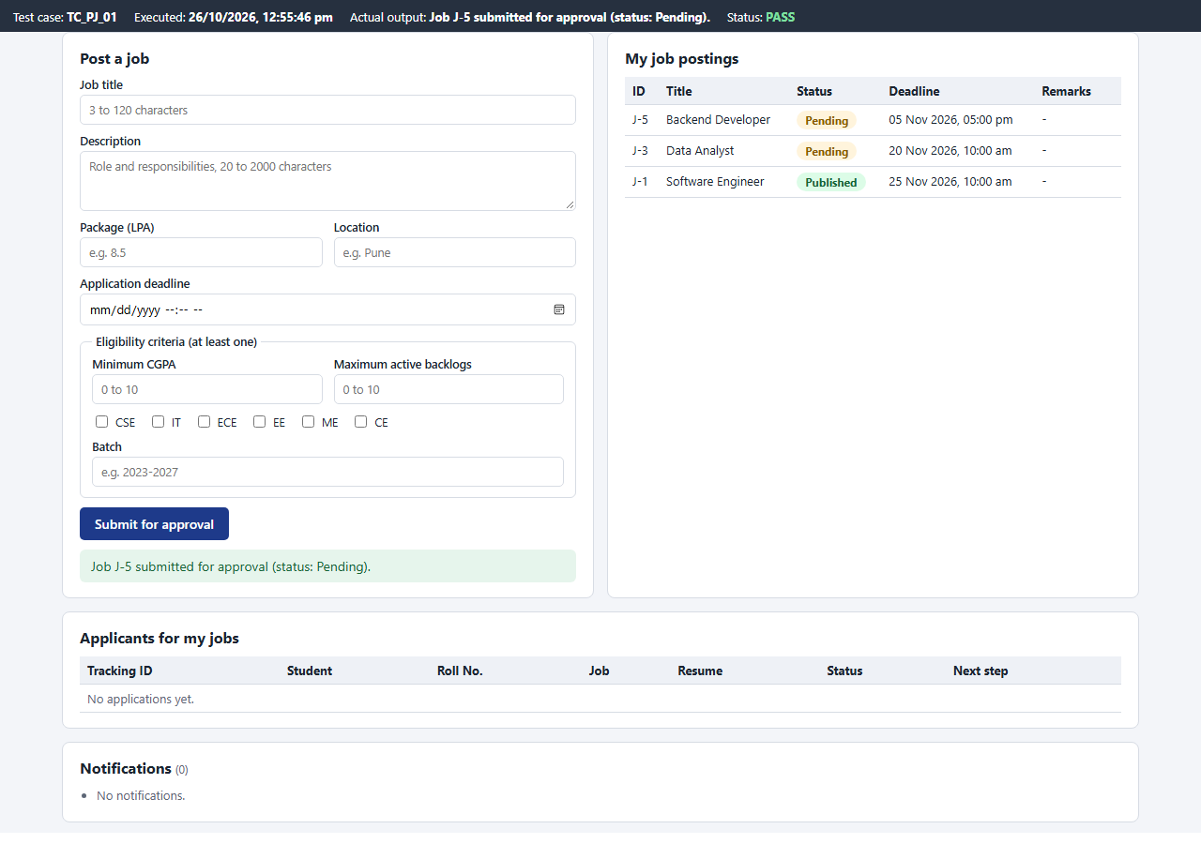
Figure 1: TC_PJ_01 - Form 1 - valid job posting submitted for approval
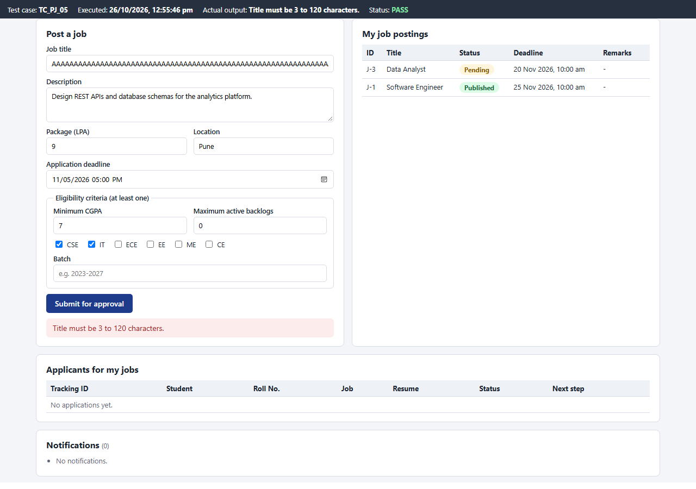
Figure 2: TC_PJ_05 - Form 1 - job title of 121 characters rejected (BVA, max + 1)
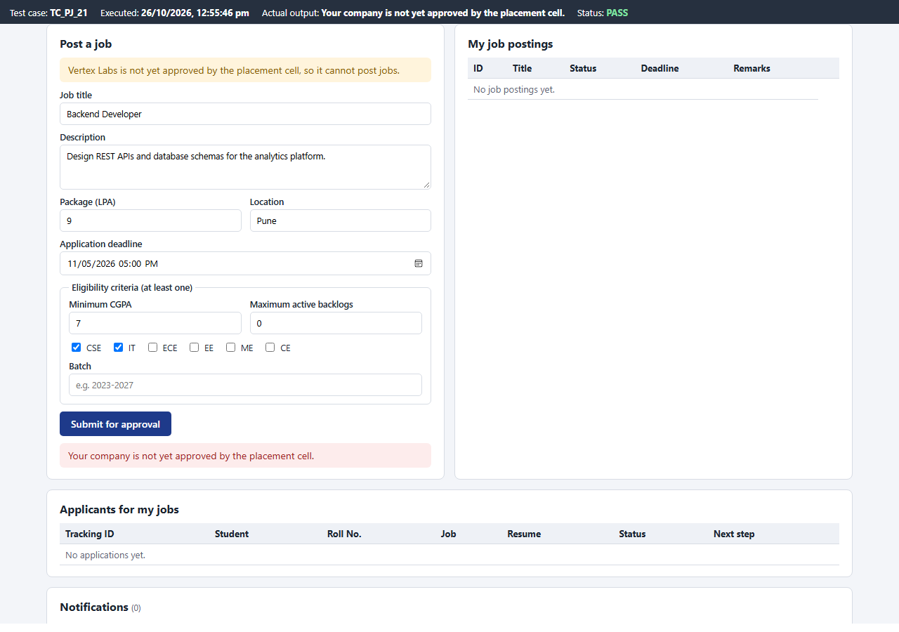
Figure 3: TC_PJ_21 - Form 1 - recruiter of a company that is not approved
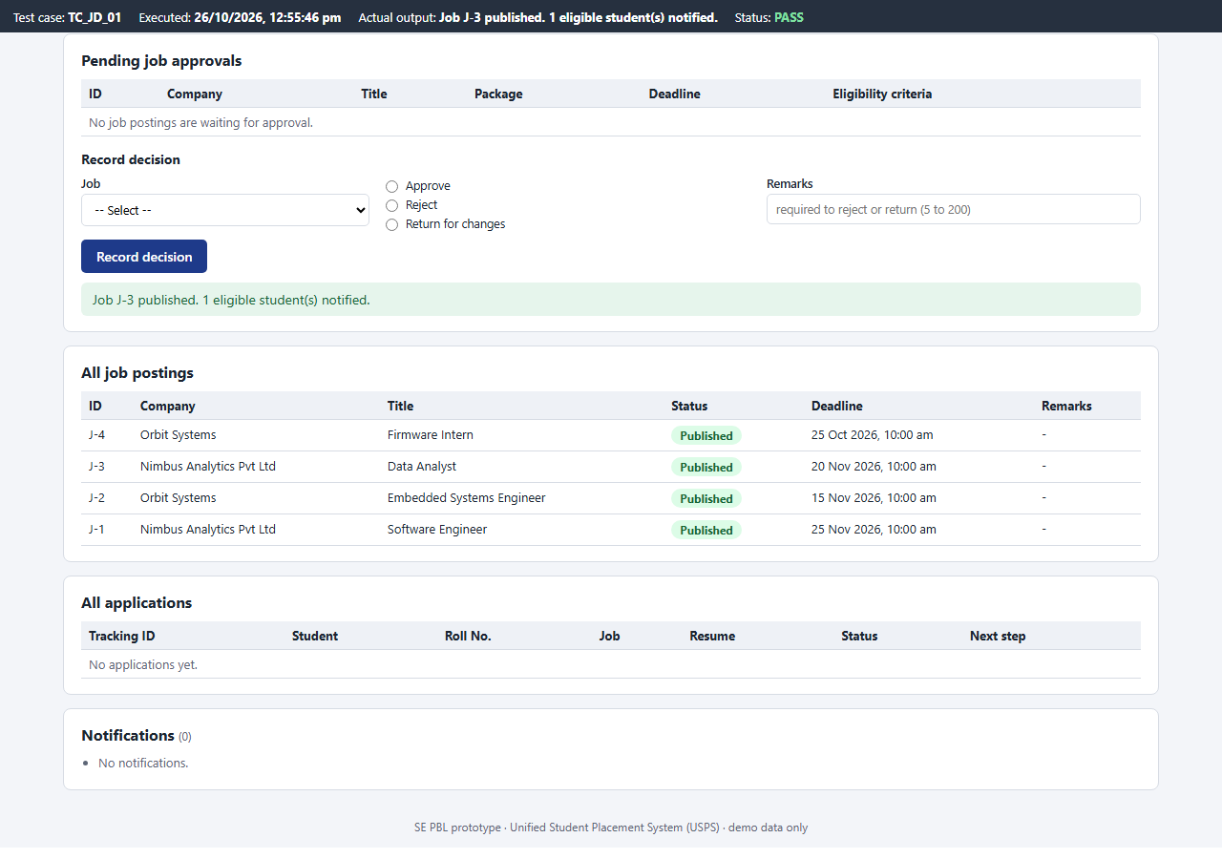
Figure 4: TC_JD_01 - Form 2 - pending job J-3 approved, eligible student notified
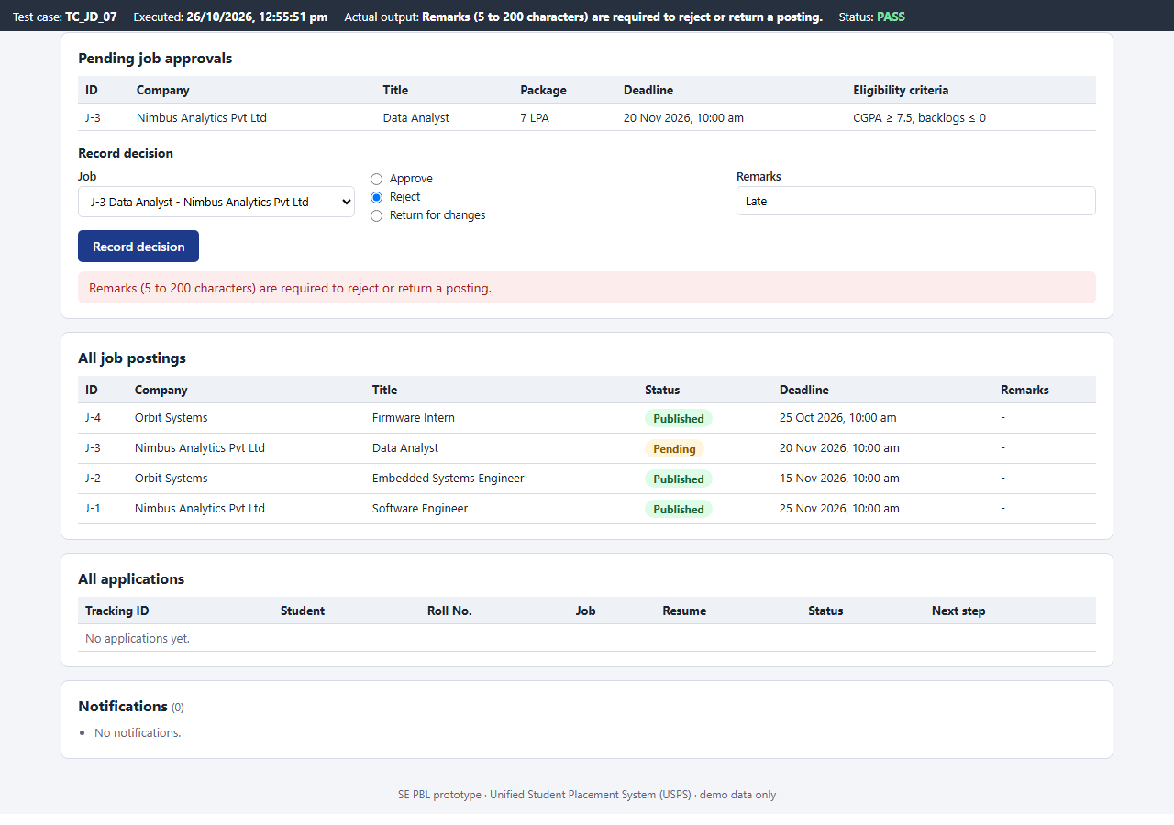
Figure 5: TC_JD_07 - Form 2 - reject with 4-character remarks refused (BVA, min - 1)
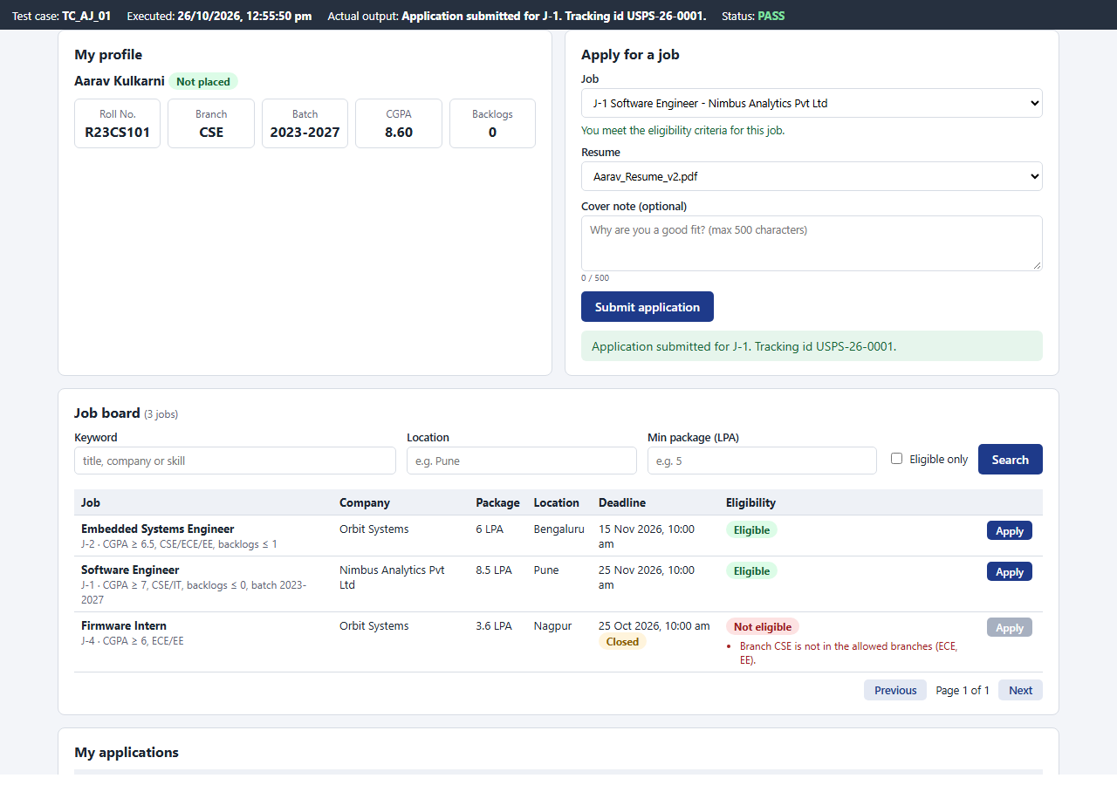
Figure 6: TC_AJ_01 - Form 3 - application submitted with a tracking id
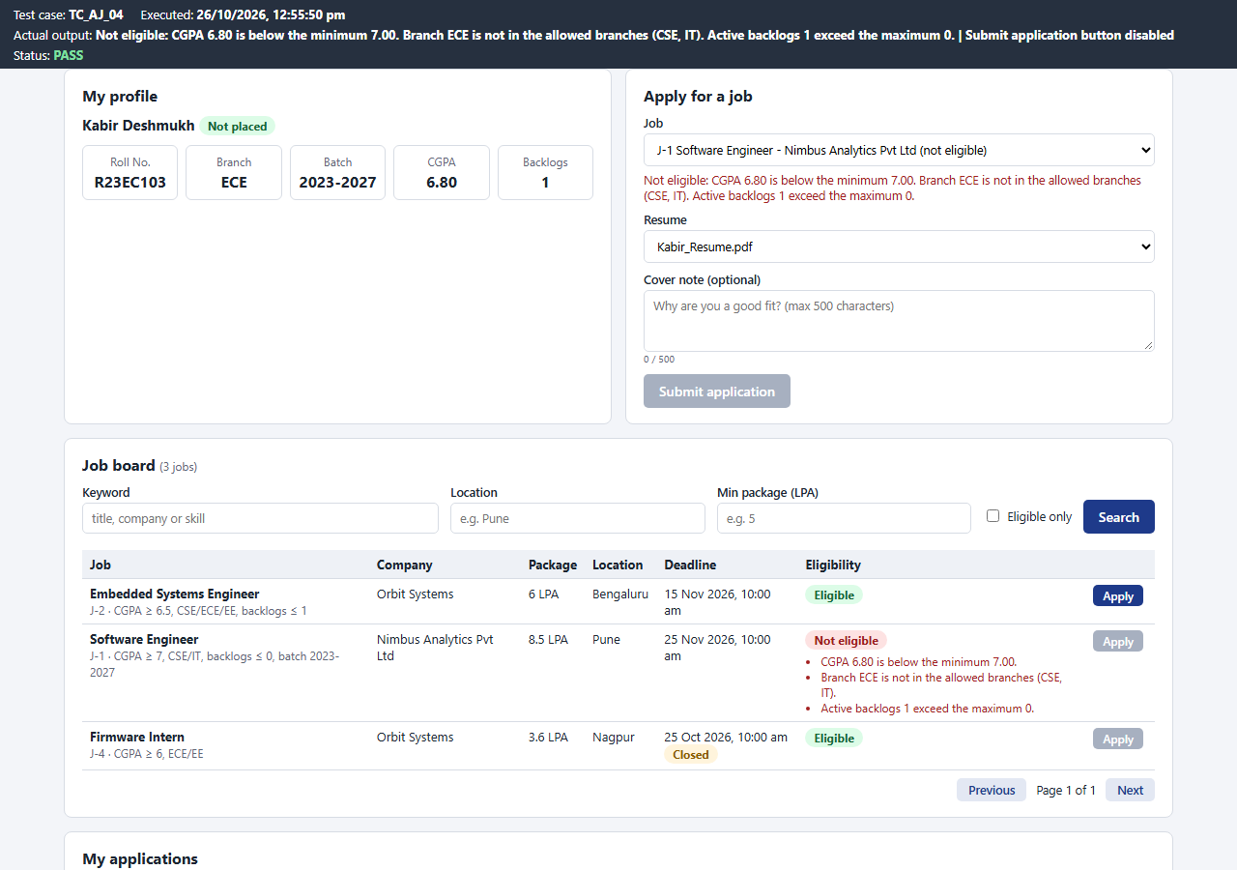
Figure 7: TC_AJ_04 - Form 3 - ineligible student: unmet criteria listed, Submit disabled
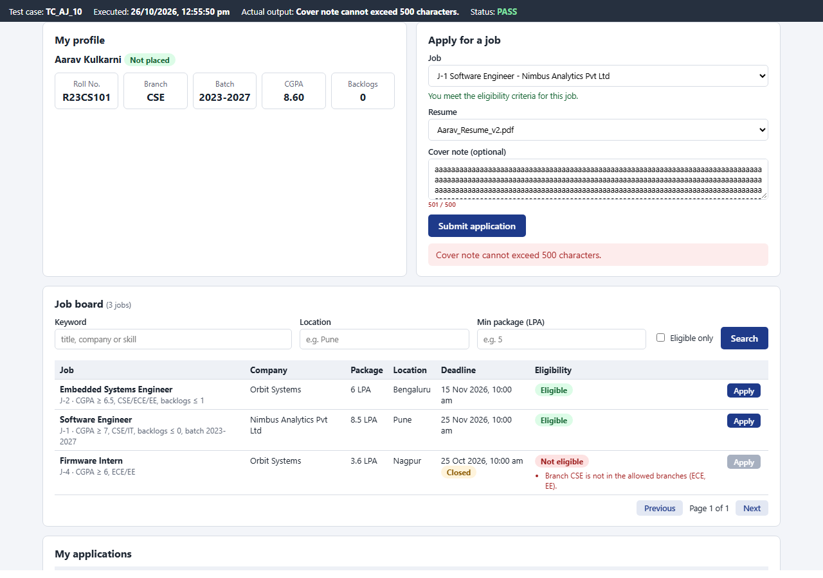
Figure 8: TC_AJ_10 - Form 3 - cover note of 501 characters refused (BVA, max + 1)
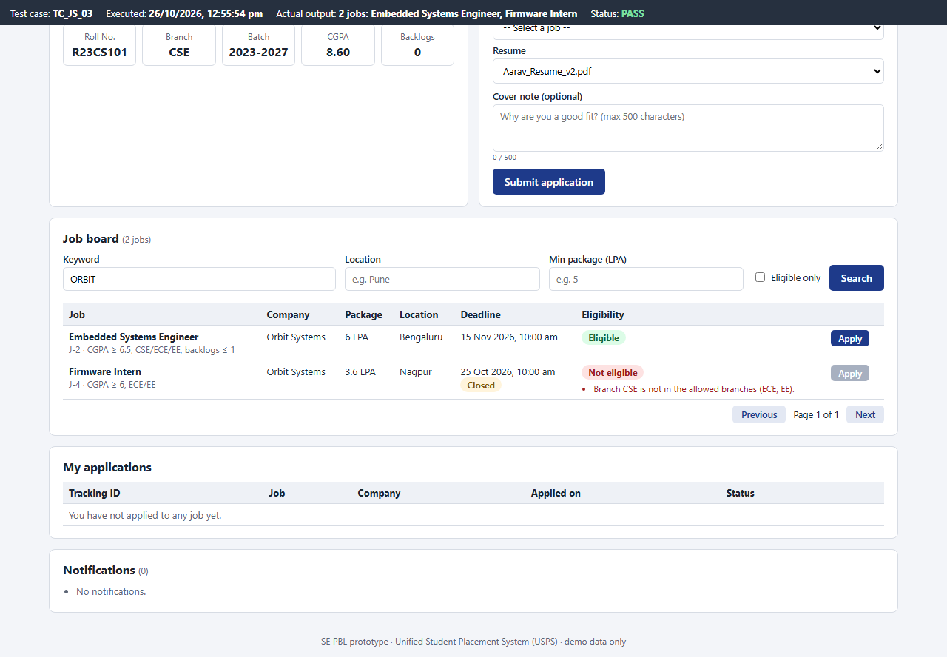
Figure 9: TC_JS_03 - Form 4 - keyword search on the company name
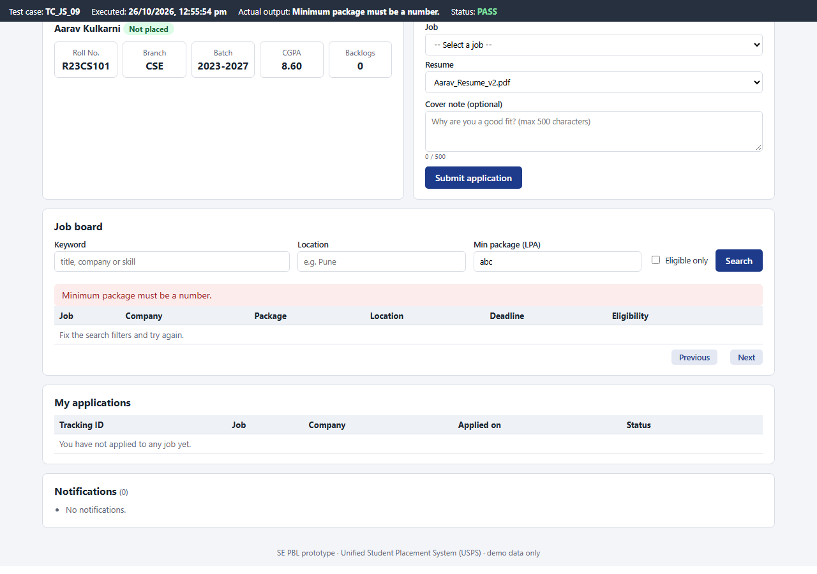
Figure 10: TC_JS_09 - Form 4 - minimum package typed in words
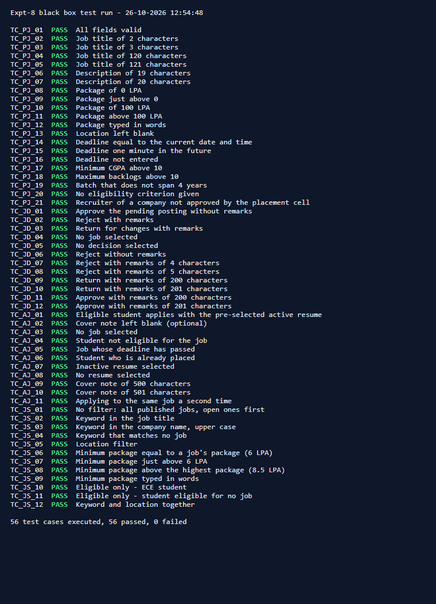
Figure 11: Complete test run (run_tests.py) - 56 test cases executed, 56 passed, 0 failed

Conclusion
A test case document was prepared for four form interfaces of the Unified Student Placement System website: Post a Job, Record Job Decision, Apply for a Job and Job Search. Using Equivalence Partitioning and Boundary Value Analysis, 56 test cases were designed with their inputs and expected outputs. All test cases were executed through the user interface and the actual outputs were recorded: 56 passed and 0 failed.

