A6B2_EXPT-9: WHITE BOX TESTING
Basis Path Testing with JUnit - Java
Particular | Details
Course | Software Engineering Lab (24CS01PR0502)
Experiment | 9 - White Box Testing
Name | Vineet Shah
Class / Batch | 5S CSE / A6 - B2
Roll No. | 28
Date of execution | 26-10-2026
Case study | Unified Student Placement System (USPS)
Faculty | D A Borikar

Problem Statement [in Java]
[1] Implement a Class as mentioned during the lab instructions. Create a JUnit Test Suite incorporating all possible test cases covering independent paths.
[2] Choose any class from your Class Diagram (one which involves substantial computational logic) and implement it. Now create JUnit suite to test this class appropriately.

Aim
To implement Java classes, draw the control flow graph of each method under test, compute its cyclomatic complexity, identify the independent paths, and create a JUnit test suite with one test case for every independent path.

Theory
White box testing designs test cases from the internal structure of the code. In basis path testing the code is converted into a control flow graph (CFG): every node is a statement or a condition and every edge is a possible transfer of control. A compound condition such as (a <= 0 || b <= 0) is split into one node per simple condition, because Java evaluates it with short-circuiting.
- Cyclomatic complexity V(G) = E - N + 2P, where E = edges, N = nodes and P = connected components (P = 1 for one method).
- Equivalently, V(G) = number of predicate (decision) nodes + 1.
- V(G) is the number of linearly independent paths; each independent path adds at least one edge not covered by the earlier paths. Testing all of them executes every statement and every branch.
- JUnit 5: @Test marks a test method, assertEquals(expected, actual) checks the result, @DisplayName names the test, and @Suite with @SelectClasses groups test classes into a test suite.

Tools Used
Tool | Version / use
Java | Eclipse Temurin JDK 21.0.12 (javac / java)
JUnit | JUnit 5.11.4 (Jupiter) with JUnit Platform 1.11.4 Suite engine, run through the junit-platform-console-standalone launcher
JaCoCo | 0.8.12 - records which lines and branches were executed by the test suite
Run script | run_tests.ps1 - compiles src/ and test/, runs WhiteBoxTestSuite, writes reports/

Part 1: Triangle Class
Triangle.classify(a, b, c) takes the three sides of a triangle and returns INVALID (a side is zero or negative), NOT A TRIANGLE (triangle inequality fails), EQUILATERAL, ISOSCELES or SCALENE.

1.1 Source code - Triangle.java
1 /**
2 * Part 1: classifies a triangle from the lengths of its three sides.
3 */
4 public class Triangle {
5
6 public static String classify(int a, int b, int c) {
7 if (a <= 0 || b <= 0 || c <= 0) {
8 return "INVALID";
9 }
10 if (a + b <= c || b + c <= a || a + c <= b) {
11 return "NOT A TRIANGLE";
12 }
13 if (a == b) {
14 if (b == c) {
15 return "EQUILATERAL";
16 }
17 return "ISOSCELES";
18 }
19 if (b == c || a == c) {
20 return "ISOSCELES";
21 }
22 return "SCALENE";
23 }
24 }

1.2 Control Flow Graph
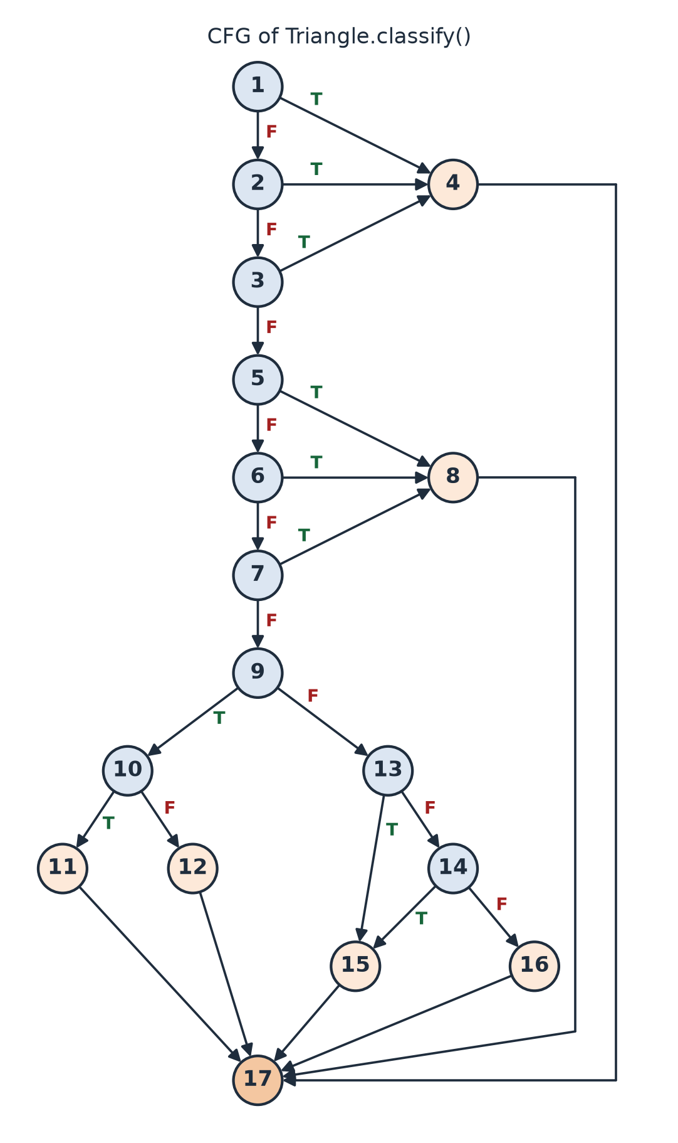
Figure 1: CFG of Triangle.classify() (blue = decision node, orange = return / exit node)
Node | Line | Statement / condition
1 | 7 | a <= 0
2 | 7 | b <= 0
3 | 7 | c <= 0
4 | 8 | return "INVALID"
5 | 10 | a + b <= c
6 | 10 | b + c <= a
7 | 10 | a + c <= b
8 | 11 | return "NOT A TRIANGLE"
9 | 13 | a == b
10 | 14 | b == c
11 | 15 | return "EQUILATERAL"
12 | 17 | return "ISOSCELES"
13 | 19 | b == c
14 | 19 | a == c
15 | 20 | return "ISOSCELES"
16 | 22 | return "SCALENE"
17 | 23 | end of method (exit)

1.3 Cyclomatic Complexity
Method | Calculation | V(G)
E - N + 2P | E = 26 edges, N = 17 nodes, P = 1 -> 26 - 17 + 2 | 11
Predicate nodes + 1 | Decision nodes 1, 2, 3, 5, 6, 7, 9, 10, 13, 14 = 10 -> 10 + 1 | 11
JaCoCo report | Complexity reported for classify(int, int, int) | 11

Hence there are 11 independent paths and at least 11 test cases are required.

1.4 Independent Paths and Test Cases
Path | Node sequence | Input (a, b, c) | Expected output | Actual output | Result
P1 | 1-4-17 | (0, 5, 5) | INVALID | INVALID | PASS
P2 | 1-2-4-17 | (4, 0, 3) | INVALID | INVALID | PASS
P3 | 1-2-3-4-17 | (4, 3, -2) | INVALID | INVALID | PASS
P4 | 1-2-3-5-8-17 | (1, 2, 3) | NOT A TRIANGLE | NOT A TRIANGLE | PASS
P5 | 1-2-3-5-6-8-17 | (7, 2, 3) | NOT A TRIANGLE | NOT A TRIANGLE | PASS
P6 | 1-2-3-5-6-7-8-17 | (2, 8, 3) | NOT A TRIANGLE | NOT A TRIANGLE | PASS
P7 | 1-2-3-5-6-7-9-10-11-17 | (5, 5, 5) | EQUILATERAL | EQUILATERAL | PASS
P8 | 1-2-3-5-6-7-9-10-12-17 | (5, 5, 8) | ISOSCELES | ISOSCELES | PASS
P9 | 1-2-3-5-6-7-9-13-15-17 | (4, 6, 6) | ISOSCELES | ISOSCELES | PASS
P10 | 1-2-3-5-6-7-9-13-14-15-17 | (6, 4, 6) | ISOSCELES | ISOSCELES | PASS
P11 | 1-2-3-5-6-7-9-13-14-16-17 | (3, 4, 5) | SCALENE | SCALENE | PASS

Actual output is the value returned by classify() during the JUnit run; assertEquals passed for every path (see the console output in Section 3).

1.5 JUnit test class - TriangleTest.java
1 import static org.junit.jupiter.api.Assertions.assertEquals;
2
3 import org.junit.jupiter.api.DisplayName;
4 import org.junit.jupiter.api.MethodOrderer;
5 import org.junit.jupiter.api.Order;
6 import org.junit.jupiter.api.Test;
7 import org.junit.jupiter.api.TestMethodOrder;
8
9 /**
10 * Basis-path tests for Triangle.classify(): one test per independent path
11 * of the control flow graph (V(G) = 11). Node numbers refer to the CFG.
12 */
13 @DisplayName("Part 1 - Triangle.classify() independent paths")
14 @TestMethodOrder(MethodOrderer.OrderAnnotation.class)
15 class TriangleTest {
16
17 @Test
18 @Order(1)
19 @DisplayName("P1: 1-4-17 side a <= 0")
20 void path1SideANotPositive() {
21 assertEquals("INVALID", Triangle.classify(0, 5, 5));
22 }
23
24 @Test
25 @Order(2)
26 @DisplayName("P2: 1-2-4-17 side b <= 0")
27 void path2SideBNotPositive() {
28 assertEquals("INVALID", Triangle.classify(4, 0, 3));
29 }
30
31 @Test
32 @Order(3)
33 @DisplayName("P3: 1-2-3-4-17 side c <= 0")
34 void path3SideCNotPositive() {
35 assertEquals("INVALID", Triangle.classify(4, 3, -2));
36 }
37
38 @Test
39 @Order(4)
40 @DisplayName("P4: 1-2-3-5-8-17 a + b <= c")
41 void path4FirstInequalityFails() {
42 assertEquals("NOT A TRIANGLE", Triangle.classify(1, 2, 3));
43 }
44
45 @Test
46 @Order(5)
47 @DisplayName("P5: 1-2-3-5-6-8-17 b + c <= a")
48 void path5SecondInequalityFails() {
49 assertEquals("NOT A TRIANGLE", Triangle.classify(7, 2, 3));
50 }
51
52 @Test
53 @Order(6)
54 @DisplayName("P6: 1-2-3-5-6-7-8-17 a + c <= b")
55 void path6ThirdInequalityFails() {
56 assertEquals("NOT A TRIANGLE", Triangle.classify(2, 8, 3));
57 }
58
59 @Test
60 @Order(7)
61 @DisplayName("P7: 1-2-3-5-6-7-9-10-11-17 a == b == c")
62 void path7Equilateral() {
63 assertEquals("EQUILATERAL", Triangle.classify(5, 5, 5));
64 }
65
66 @Test
67 @Order(8)
68 @DisplayName("P8: 1-2-3-5-6-7-9-10-12-17 a == b, b != c")
69 void path8IsoscelesAEqualsB() {
70 assertEquals("ISOSCELES", Triangle.classify(5, 5, 8));
71 }
72
73 @Test
74 @Order(9)
75 @DisplayName("P9: 1-2-3-5-6-7-9-13-15-17 b == c")
76 void path9IsoscelesBEqualsC() {
77 assertEquals("ISOSCELES", Triangle.classify(4, 6, 6));
78 }
79
80 @Test
81 @Order(10)
82 @DisplayName("P10: 1-2-3-5-6-7-9-13-14-15-17 a == c")
83 void path10IsoscelesAEqualsC() {
84 assertEquals("ISOSCELES", Triangle.classify(6, 4, 6));
85 }
86
87 @Test
88 @Order(11)
89 @DisplayName("P11: 1-2-3-5-6-7-9-13-14-16-17 all sides different")
90 void path11Scalene() {
91 assertEquals("SCALENE", Triangle.classify(3, 4, 5));
92 }
93 }

Part 2: EligibilityCriteria Class (from the Class Diagram)
From the class diagram of the Unified Student Placement System (Expt-3), the EligibilityCriteria class is chosen because it holds the main computational logic of the placement process (SRS FR-13, FR-14, BR-03): it turns the allowed-branches text of a job (attribute allowedBranches : String) into a checked list, and for a student it works out every criterion that is not met - minimum CGPA, allowed branch, maximum active backlogs and batch - with a reason for each (operations evaluate() and getReasons() of the diagram). A criterion that is not set is not checked. It uses the Student class, which holds the academic data of a student. The same rules run in the USPS web prototype of the PBL (app/rules.py, in Python); here the class is implemented in Java for JUnit.
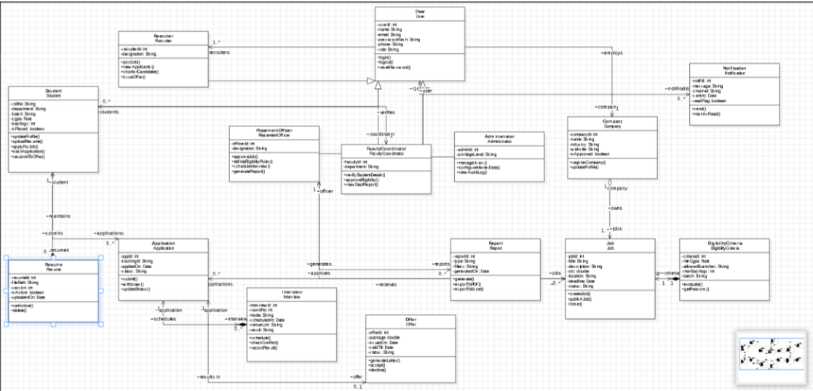
Figure 2: Class diagram from my Expt-3 submission - EligibilityCriteria is linked to Job

2.1 Source code - Student.java
1 /**
2 * A student of the Unified Student Placement System (class Student of the Expt-3 class diagram),
3 * with the academic data used by the eligibility check.
4 */
5 public class Student {
6
7 private final String rollNo;
8 private final String department;
9 private final String batch;
10 private final double cgpa;
11 private final int backlogs;
12
13 public Student(String rollNo, String department, String batch, double cgpa, int backlogs) {
14 this.rollNo = rollNo;
15 this.department = department;
16 this.batch = batch;
17 this.cgpa = cgpa;
18 this.backlogs = backlogs;
19 }
20
21 public String getRollNo() {
22 return rollNo;
23 }
24
25 public String getDepartment() {
26 return department;
27 }
28
29 public String getBatch() {
30 return batch;
31 }
32
33 public double getCgpa() {
34 return cgpa;
35 }
36
37 public int getBacklogs() {
38 return backlogs;
39 }
40 }

2.2 Source code - EligibilityCriteria.java
1 import java.util.ArrayList;
2 import java.util.List;
3 import java.util.Locale;
4
5 /**
6 * Part 2: eligibility rule-set of a job (class EligibilityCriteria of the Expt-3 class diagram of the
7 * Unified Student Placement System, SRS FR-13 / FR-14, BR-03). A criterion that is not set (null or
8 * no branches) is not checked. The PBL prototype applies the same rules in Python (app/rules.py).
9 */
10 public class EligibilityCriteria {
11
12 public static final List<String> BRANCHES = List.of("CSE", "IT", "ECE", "EE", "ME", "CE");
13
14 private final int criteriaId;
15 private final Double minCgpa;
16 private final List<String> allowedBranches;
17 private final Integer maxBacklogs;
18 private final String batch;
19
20 public EligibilityCriteria(int criteriaId, Double minCgpa, String allowedBranches, Integer maxBacklogs,
21 String batch) {
22 this.criteriaId = criteriaId;
23 this.minCgpa = minCgpa;
24 this.allowedBranches = parseBranches(allowedBranches);
25 this.maxBacklogs = maxBacklogs;
26 this.batch = (batch == null || batch.isBlank()) ? null : batch.trim();
27 }
28
29 /** Turns "cse, IT" into [CSE, IT]: blanks are skipped, duplicates kept once, unknown branches refused. */
30 public static List<String> parseBranches(String text) {
31 List<String> branches = new ArrayList<>();
32 if (text == null) {
33 return branches;
34 }
35 for (String part : text.split(",")) {
36 String branch = part.trim().toUpperCase(Locale.ROOT);
37 if (branch.isEmpty()) {
38 continue;
39 }
40 if (!BRANCHES.contains(branch)) {
41 throw new IllegalArgumentException("Unknown branch " + branch + ".");
42 }
43 if (!branches.contains(branch)) {
44 branches.add(branch);
45 }
46 }
47 return branches;
48 }
49
50 /** getReasons(): every criterion the student does not meet, in the order CGPA, branch, backlogs, batch. */
51 public List<String> getReasons(Student s) {
52 List<String> reasons = new ArrayList<>();
53 if (minCgpa != null) {
54 if (s.getCgpa() < minCgpa) {
55 reasons.add(String.format(Locale.ROOT, "CGPA %.2f is below the minimum %.2f.", s.getCgpa(), minCgpa));
56 }
57 }
58 if (!allowedBranches.isEmpty()) {
59 if (!allowedBranches.contains(s.getDepartment())) {
60 reasons.add("Branch " + s.getDepartment() + " is not in the allowed branches ("
61 + String.join(", ", allowedBranches) + ").");
62 }
63 }
64 if (maxBacklogs != null) {
65 if (s.getBacklogs() > maxBacklogs) {
66 reasons.add("Active backlogs " + s.getBacklogs() + " exceed the maximum " + maxBacklogs + ".");
67 }
68 }
69 if (batch != null) {
70 if (!batch.equals(s.getBatch())) {
71 reasons.add("Batch " + s.getBatch() + " does not match the required batch " + batch + ".");
72 }
73 }
74 return reasons;
75 }
76
77 /** evaluate(): the student is eligible when no criterion is unmet. */
78 public boolean evaluate(Student s) {
79 return getReasons(s).isEmpty();
80 }
81
82 public int getCriteriaId() {
83 return criteriaId;
84 }
85
86 public List<String> getAllowedBranches() {
87 return allowedBranches;
88 }
89 }

2.3 Method parseBranches(text)
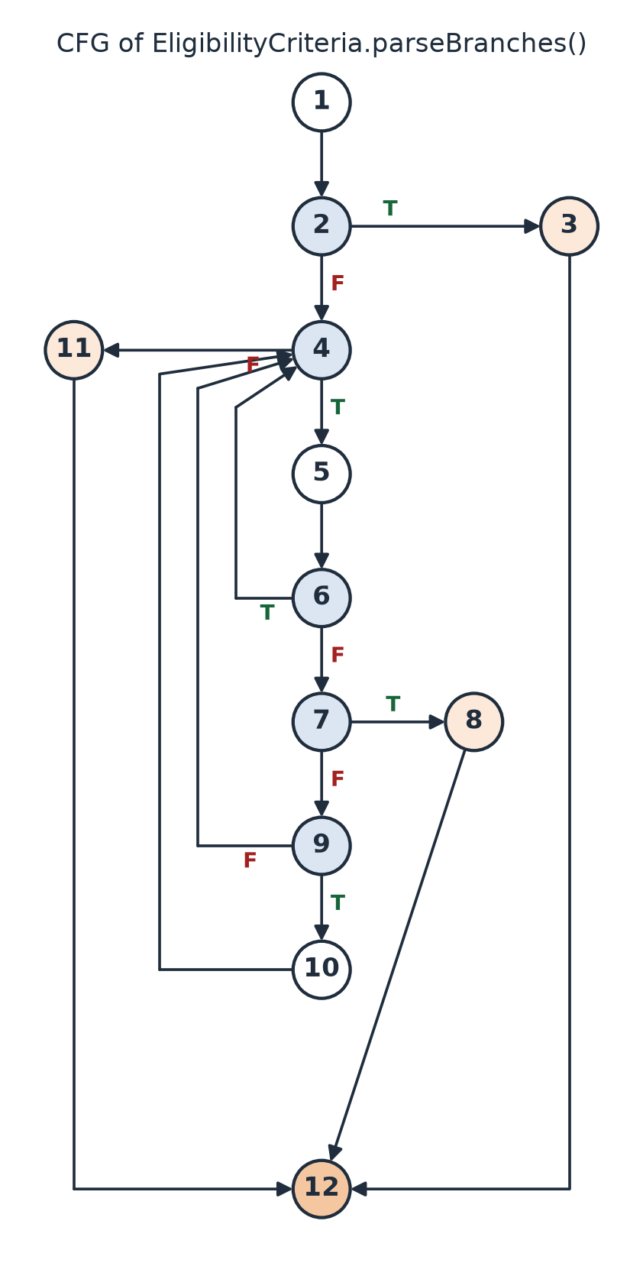
Figure 3: CFG of EligibilityCriteria.parseBranches()
Node | Line | Statement / condition
1 | 31 | branches = new ArrayList<>()
2 | 32 | text == null
3 | 33 | return branches (empty list)
4 | 35 | for (part : text.split(",")) - another part?
5 | 36 | branch = part.trim().toUpperCase()
6 | 37 | branch.isEmpty() (true: continue, line 38)
7 | 40 | !BRANCHES.contains(branch)
8 | 41 | throw IllegalArgumentException("Unknown branch ...")
9 | 43 | !branches.contains(branch)
10 | 44 | branches.add(branch)
11 | 47 | return branches
12 | 48 | end of method (exit)

Method | Calculation | V(G)
E - N + 2P | E = 16, N = 12, P = 1 -> 16 - 12 + 2 | 6
Predicate nodes + 1 | Decision nodes 2, 4, 6, 7, 9 = 5 -> 5 + 1 | 6
JaCoCo report | Complexity reported for parseBranches(String) | 6

Of the 6 basis paths, 1-2-4-11-12 (loop condition false on the first check) is infeasible: String.split() always returns at least one element, so when text is not null the loop body runs at least once. The 5 feasible paths R1-R5 still execute every node and every edge of the graph (edge 4-11 is taken at the end of R2, R4 and R5), and JaCoCo shows 10 of 10 branches covered.
Path | Node sequence | Input text | Expected | Actual | Result
R1 | 1-2-3-12 | null | [] (empty list) | [] (empty list) | PASS
R2 | 1-2-4-5-6-4-11-12 | " " (only a blank) | [] (blank skipped) | [] (blank skipped) | PASS
R3 | 1-2-4-5-6-7-8-12 | "AI" | IllegalArgumentException: Unknown branch AI. | IllegalArgumentException: Unknown branch AI. | PASS
R4 | 1-2-4-5-6-7-9-10-4-11-12 | "CSE" | [CSE] | [CSE] | PASS
R5 | 1-2-4-5-6-7-9-10-4-5-6-7-9-4-11-12 | "CSE, cse" | [CSE] (duplicate kept once) | [CSE] (duplicate kept once) | PASS
Extra | loop body 5 times | " it , CSE,,ece " | [IT, CSE, ECE] | [IT, CSE, ECE] | PASS

2.4 Method getReasons(student)
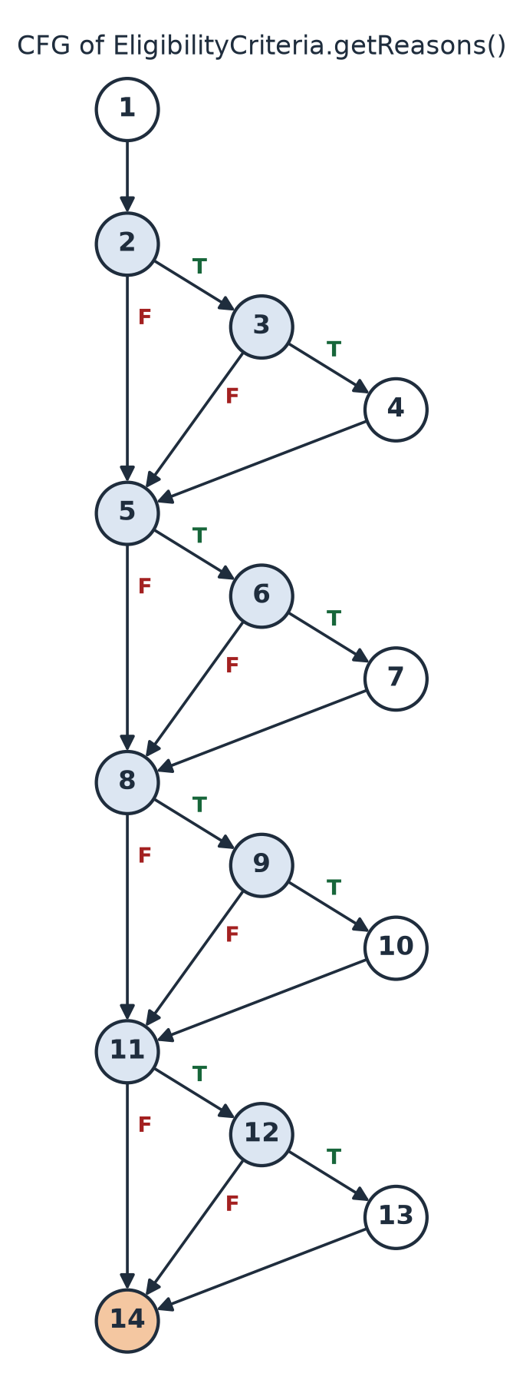
Figure 4: CFG of EligibilityCriteria.getReasons()
Node | Line | Statement / condition
1 | 52 | reasons = new ArrayList<>()
2 | 53 | minCgpa != null
3 | 54 | s.getCgpa() < minCgpa
4 | 55 | add "CGPA x is below the minimum y."
5 | 58 | !allowedBranches.isEmpty()
6 | 59 | !allowedBranches.contains(s.getDepartment())
7 | 60-61 | add "Branch b is not in the allowed branches (...)."
8 | 64 | maxBacklogs != null
9 | 65 | s.getBacklogs() > maxBacklogs
10 | 66 | add "Active backlogs n exceed the maximum m."
11 | 69 | batch != null
12 | 70 | !batch.equals(s.getBatch())
13 | 71 | add "Batch b does not match the required batch r."
14 | 74 | return reasons (exit)

Method | Calculation | V(G)
E - N + 2P | E = 21, N = 14, P = 1 -> 21 - 14 + 2 | 9
Predicate nodes + 1 | Decision nodes 2, 3, 5, 6, 8, 9, 11, 12 = 8 -> 8 + 1 | 9
JaCoCo report | Complexity reported for getReasons(Student) | 9

Test data (demo students of USPS): Aarav - CSE, 2023-2027, CGPA 8.60, 0 backlogs; Kabir - ECE, 2023-2027, CGPA 6.80, 1 backlog; Rohan - ME, 2022-2026, CGPA 7.90, 2 backlogs; Diya - IT, 2023-2027, CGPA 7.00, 0 backlogs. Each test builds its own EligibilityCriteria with only the criteria it needs.
Path | Node sequence | Input (criteria; student) | Expected output | Actual output | Result
A1 | 1-2-5-8-11-14 | no criterion set; Kabir | [] (eligible) | [] (eligible) | PASS
A2 | 1-2-3-5-8-11-14 | min CGPA 7.0; Aarav (8.60) | [] (eligible) | [] (eligible) | PASS
A3 | 1-2-3-4-5-8-11-14 | min CGPA 7.0; Kabir (6.80) | [CGPA 6.80 is below the minimum 7.00.] | [CGPA 6.80 is below the minimum 7.00.] | PASS
A4 | 1-2-5-6-8-11-14 | branches "CSE, IT"; Aarav (CSE) | [] (eligible) | [] (eligible) | PASS
A5 | 1-2-5-6-7-8-11-14 | branches "CSE, IT"; Kabir (ECE) | [Branch ECE is not in the allowed branches (CSE, IT).] | [Branch ECE is not in the allowed branches (CSE, IT).] | PASS
A6 | 1-2-5-8-9-11-14 | max backlogs 1; Kabir (1) | [] (eligible) | [] (eligible) | PASS
A7 | 1-2-5-8-9-10-11-14 | max backlogs 0; Kabir (1) | [Active backlogs 1 exceed the maximum 0.] | [Active backlogs 1 exceed the maximum 0.] | PASS
A8 | 1-2-5-8-11-12-14 | batch 2023-2027; Aarav (2023-2027) | [] (eligible) | [] (eligible) | PASS
A9 | 1-2-5-8-11-12-13-14 | batch 2023-2027; Rohan (2022-2026) | [Batch 2022-2026 does not match the required batch 2023-2027.] | [Batch 2022-2026 does not match the required batch 2023-2027.] | PASS
Extra | 1-2-3-4-5-6-7-8-9-10-11-12-13-14 | min 8.0, CSE/IT, max 0, 2023-2027; Rohan | 4 reasons in the order CGPA, branch, backlogs, batch | 4 reasons in the order CGPA, branch, backlogs, batch | PASS
Extra | 1-2-3-5-8-11-14 | min CGPA 7.0; Diya (7.00) - boundary | [] (eligible, CGPA equal to minimum) | [] (eligible, CGPA equal to minimum) | PASS

A1-A9 are the 9 independent paths. The extra tests check that all reasons are collected in order when every criterion fails, and the CGPA boundary (equal to the minimum is eligible). evaluate() has V(G) = 1 and is tested with one eligible and one ineligible student; two constructor tests check the parsed branch list and that a blank batch means no batch criterion.

2.5 JUnit test class - EligibilityCriteriaTest.java
1 import static org.junit.jupiter.api.Assertions.assertEquals;
2 import static org.junit.jupiter.api.Assertions.assertFalse;
3 import static org.junit.jupiter.api.Assertions.assertThrows;
4 import static org.junit.jupiter.api.Assertions.assertTrue;
5
6 import java.util.List;
7
8 import org.junit.jupiter.api.DisplayName;
9 import org.junit.jupiter.api.MethodOrderer;
10 import org.junit.jupiter.api.Nested;
11 import org.junit.jupiter.api.Order;
12 import org.junit.jupiter.api.Test;
13 import org.junit.jupiter.api.TestMethodOrder;
14
15 /**
16 * Basis-path tests for EligibilityCriteria. Node numbers refer to the control flow graphs:
17 * parseBranches() has V(G) = 6 and getReasons() has V(G) = 9.
18 * Students are the demo students of the USPS prototype.
19 */
20 @DisplayName("Part 2 - EligibilityCriteria independent paths")
21 class EligibilityCriteriaTest {
22
23 private static final Student AARAV = new Student("R23CS101", "CSE", "2023-2027", 8.60, 0);
24 private static final Student KABIR = new Student("R23EC103", "ECE", "2023-2027", 6.80, 1);
25 private static final Student ROHAN = new Student("R22ME105", "ME", "2022-2026", 7.90, 2);
26
27 private static EligibilityCriteria rule(Double minCgpa, String branches, Integer maxBacklogs, String batch) {
28 return new EligibilityCriteria(1, minCgpa, branches, maxBacklogs, batch);
29 }
30
31 @Nested
32 @DisplayName("parseBranches() V(G) = 6")
33 @TestMethodOrder(MethodOrderer.OrderAnnotation.class)
34 class ParseBranches {
35
36 @Test
37 @Order(1)
38 @DisplayName("R1: 1-2-3-12 no branches given (null)")
39 void pathR1Null() {
40 assertEquals(List.of(), EligibilityCriteria.parseBranches(null));
41 }
42
43 @Test
44 @Order(2)
45 @DisplayName("R2: 1-2-4-5-6-4-11-12 only a blank entry is skipped")
46 void pathR2BlankSkipped() {
47 assertEquals(List.of(), EligibilityCriteria.parseBranches(" "));
48 }
49
50 @Test
51 @Order(3)
52 @DisplayName("R3: 1-2-4-5-6-7-8-12 unknown branch refused")
53 void pathR3UnknownBranch() {
54 IllegalArgumentException e = assertThrows(IllegalArgumentException.class,
55 () -> EligibilityCriteria.parseBranches("AI"));
56 assertEquals("Unknown branch AI.", e.getMessage());
57 }
58
59 @Test
60 @Order(4)
61 @DisplayName("R4: 1-2-4-5-6-7-9-10-4-11-12 one valid branch added")
62 void pathR4OneBranch() {
63 assertEquals(List.of("CSE"), EligibilityCriteria.parseBranches("CSE"));
64 }
65
66 @Test
67 @Order(5)
68 @DisplayName("R5: 1-2-4-...-9-10-4-5-6-7-9-4-11-12 duplicate kept once")
69 void pathR5Duplicate() {
70 assertEquals(List.of("CSE"), EligibilityCriteria.parseBranches("CSE, cse"));
71 }
72
73 @Test
74 @Order(6)
75 @DisplayName("Loop many times: ' it , CSE,,ece ' gives IT, CSE, ECE")
76 void loopManyTimes() {
77 assertEquals(List.of("IT", "CSE", "ECE"), EligibilityCriteria.parseBranches(" it , CSE,,ece "));
78 }
79 }
80
81 @Nested
82 @DisplayName("getReasons() V(G) = 9")
83 @TestMethodOrder(MethodOrderer.OrderAnnotation.class)
84 class GetReasons {
85
86 @Test
87 @Order(1)
88 @DisplayName("A1: 1-2-5-8-11-14 no criterion set")
89 void pathA1NoCriteria() {
90 assertEquals(List.of(), rule(null, null, null, null).getReasons(KABIR));
91 }
92
93 @Test
94 @Order(2)
95 @DisplayName("A2: 1-2-3-5-8-11-14 CGPA 8.60 meets minimum 7.0")
96 void pathA2CgpaMet() {
97 assertEquals(List.of(), rule(7.0, null, null, null).getReasons(AARAV));
98 }
99
100 @Test
101 @Order(3)
102 @DisplayName("A3: 1-2-3-4-5-8-11-14 CGPA 6.80 below minimum 7.0")
103 void pathA3CgpaBelow() {
104 assertEquals(List.of("CGPA 6.80 is below the minimum 7.00."), rule(7.0, null, null, null).getReasons(KABIR));
105 }
106
107 @Test
108 @Order(4)
109 @DisplayName("A4: 1-2-5-6-8-11-14 branch CSE allowed")
110 void pathA4BranchAllowed() {
111 assertEquals(List.of(), rule(null, "CSE, IT", null, null).getReasons(AARAV));
112 }
113
114 @Test
115 @Order(5)
116 @DisplayName("A5: 1-2-5-6-7-8-11-14 branch ECE not allowed")
117 void pathA5BranchNotAllowed() {
118 assertEquals(List.of("Branch ECE is not in the allowed branches (CSE, IT)."),
119 rule(null, "CSE, IT", null, null).getReasons(KABIR));
120 }
121
122 @Test
123 @Order(6)
124 @DisplayName("A6: 1-2-5-8-9-11-14 1 backlog equals maximum 1")
125 void pathA6BacklogsEqual() {
126 assertEquals(List.of(), rule(null, null, 1, null).getReasons(KABIR));
127 }
128
129 @Test
130 @Order(7)
131 @DisplayName("A7: 1-2-5-8-9-10-11-14 1 backlog exceeds maximum 0")
132 void pathA7BacklogsExceed() {
133 assertEquals(List.of("Active backlogs 1 exceed the maximum 0."), rule(null, null, 0, null).getReasons(KABIR));
134 }
135
136 @Test
137 @Order(8)
138 @DisplayName("A8: 1-2-5-8-11-12-14 batch 2023-2027 matches")
139 void pathA8BatchMatches() {
140 assertEquals(List.of(), rule(null, null, null, "2023-2027").getReasons(AARAV));
141 }
142
143 @Test
144 @Order(9)
145 @DisplayName("A9: 1-2-5-8-11-12-13-14 batch 2022-2026 does not match")
146 void pathA9BatchDiffers() {
147 assertEquals(List.of("Batch 2022-2026 does not match the required batch 2023-2027."),
148 rule(null, null, null, "2023-2027").getReasons(ROHAN));
149 }
150
151 @Test
152 @Order(10)
153 @DisplayName("All four criteria fail together (job J-1 rules, student Rohan): reasons in order")
154 void allCriteriaFail() {
155 assertEquals(List.of("CGPA 7.90 is below the minimum 8.00.",
156 "Branch ME is not in the allowed branches (CSE, IT).",
157 "Active backlogs 2 exceed the maximum 0.",
158 "Batch 2022-2026 does not match the required batch 2023-2027."),
159 rule(8.0, "CSE, IT", 0, "2023-2027").getReasons(ROHAN));
160 }
161
162 @Test
163 @Order(11)
164 @DisplayName("Boundary: CGPA exactly equal to the minimum (7.00 vs 7.0) is eligible")
165 void cgpaEqualsMinimum() {
166 Student diya = new Student("R23IT102", "IT", "2023-2027", 7.00, 0);
167 assertEquals(List.of(), rule(7.0, null, null, null).getReasons(diya));
168 }
169 }
170
171 @Nested
172 @DisplayName("Constructor")
173 class Constructor {
174
175 @Test
176 @DisplayName("Branches text is parsed and the id kept: id 7, ' it, cse ' gives IT, CSE")
177 void branchesParsed() {
178 EligibilityCriteria c = new EligibilityCriteria(7, null, " it, cse ", null, null);
179 assertEquals(7, c.getCriteriaId());
180 assertEquals(List.of("IT", "CSE"), c.getAllowedBranches());
181 }
182
183 @Test
184 @DisplayName("Blank batch ' ' means no batch criterion: Rohan (2022-2026) has no reason")
185 void blankBatchIgnored() {
186 assertEquals(List.of(), rule(null, null, null, " ").getReasons(ROHAN));
187 }
188 }
189
190 @Nested
191 @DisplayName("evaluate() V(G) = 1")
192 class Evaluate {
193
194 @Test
195 @DisplayName("Eligible student: Aarav for J-1 (CGPA >= 7.0, CSE/IT, 0 backlogs, 2023-2027)")
196 void eligible() {
197 assertTrue(rule(7.0, "CSE, IT", 0, "2023-2027").evaluate(AARAV));
198 }
199
200 @Test
201 @DisplayName("Ineligible student: Kabir for J-1")
202 void ineligible() {
203 assertFalse(rule(7.0, "CSE, IT", 0, "2023-2027").evaluate(KABIR));
204 }
205 }
206 }

3. JUnit Test Suite and Execution

3.1 Test suite - WhiteBoxTestSuite.java
1 import org.junit.platform.suite.api.SelectClasses;
2 import org.junit.platform.suite.api.Suite;
3 import org.junit.platform.suite.api.SuiteDisplayName;
4
5 /**
6 * JUnit test suite for Expt-9: runs the independent-path tests of both parts together.
7 */
8 @Suite
9 @SuiteDisplayName("Expt-9 White Box Testing Suite")
10 @SelectClasses({ TriangleTest.class, EligibilityCriteriaTest.class })
11 public class WhiteBoxTestSuite {
12 }

3.2 Command used
powershell -ExecutionPolicy Bypass -File run_tests.ps1
# inside run_tests.ps1 (test run):
java -javaagent:lib\jacoco-0.8.12\lib\jacocoagent.jar=destfile=out\jacoco.exec \
-jar lib\junit-platform-console-standalone-1.11.4.jar execute \
--class-path "out\classes;out\test-classes" --select-class WhiteBoxTestSuite \
--details=tree

3.3 Console output (captured from the run on 26-10-2026)
╷
├─ JUnit Platform Suite ✔
│ └─ Expt-9 White Box Testing Suite ✔
│ └─ JUnit Jupiter ✔
│ ├─ Part 1 - Triangle.classify() independent paths ✔
│ │ ├─ P1: 1-4-17 side a <= 0 ✔
│ │ ├─ P2: 1-2-4-17 side b <= 0 ✔
│ │ ├─ P3: 1-2-3-4-17 side c <= 0 ✔
│ │ ├─ P4: 1-2-3-5-8-17 a + b <= c ✔
│ │ ├─ P5: 1-2-3-5-6-8-17 b + c <= a ✔
│ │ ├─ P6: 1-2-3-5-6-7-8-17 a + c <= b ✔
│ │ ├─ P7: 1-2-3-5-6-7-9-10-11-17 a == b == c ✔
│ │ ├─ P8: 1-2-3-5-6-7-9-10-12-17 a == b, b != c ✔
│ │ ├─ P9: 1-2-3-5-6-7-9-13-15-17 b == c ✔
│ │ ├─ P10: 1-2-3-5-6-7-9-13-14-15-17 a == c ✔
│ │ └─ P11: 1-2-3-5-6-7-9-13-14-16-17 all sides different ✔
│ └─ Part 2 - EligibilityCriteria independent paths ✔
│ ├─ evaluate() V(G) = 1 ✔
│ │ ├─ Ineligible student: Kabir for J-1 ✔
│ │ └─ Eligible student: Aarav for J-1 (CGPA >= 7.0, CSE/IT, 0 backlogs, 2023-2027) ✔
│ ├─ Constructor ✔
│ │ ├─ Branches text is parsed and the id kept: id 7, ' it, cse ' gives IT, CSE ✔
│ │ └─ Blank batch ' ' means no batch criterion: Rohan (2022-2026) has no reason ✔
│ ├─ getReasons() V(G) = 9 ✔
│ │ ├─ A1: 1-2-5-8-11-14 no criterion set ✔
│ │ ├─ A2: 1-2-3-5-8-11-14 CGPA 8.60 meets minimum 7.0 ✔
│ │ ├─ A3: 1-2-3-4-5-8-11-14 CGPA 6.80 below minimum 7.0 ✔
│ │ ├─ A4: 1-2-5-6-8-11-14 branch CSE allowed ✔
│ │ ├─ A5: 1-2-5-6-7-8-11-14 branch ECE not allowed ✔
│ │ ├─ A6: 1-2-5-8-9-11-14 1 backlog equals maximum 1 ✔
│ │ ├─ A7: 1-2-5-8-9-10-11-14 1 backlog exceeds maximum 0 ✔
│ │ ├─ A8: 1-2-5-8-11-12-14 batch 2023-2027 matches ✔
│ │ ├─ A9: 1-2-5-8-11-12-13-14 batch 2022-2026 does not match ✔
│ │ ├─ All four criteria fail together (job J-1 rules, student Rohan): reasons in order ✔
│ │ └─ Boundary: CGPA exactly equal to the minimum (7.00 vs 7.0) is eligible ✔
│ └─ parseBranches() V(G) = 6 ✔
│ ├─ R1: 1-2-3-12 no branches given (null) ✔
│ ├─ R2: 1-2-4-5-6-4-11-12 only a blank entry is skipped ✔
│ ├─ R3: 1-2-4-5-6-7-8-12 unknown branch refused ✔
│ ├─ R4: 1-2-4-5-6-7-9-10-4-11-12 one valid branch added ✔
│ ├─ R5: 1-2-4-...-9-10-4-5-6-7-9-4-11-12 duplicate kept once ✔
│ └─ Loop many times: ' it , CSE,,ece ' gives IT, CSE, ECE ✔
├─ JUnit Jupiter ✔
└─ JUnit Vintage ✔
Test run finished after 381 ms
[ 11 containers found ]
[ 0 containers skipped ]
[ 11 containers started ]
[ 0 containers aborted ]
[ 11 containers successful ]
[ 0 containers failed ]
[ 32 tests found ]
[ 0 tests skipped ]
[ 32 tests started ]
[ 0 tests aborted ]
[ 32 tests successful ]
[ 0 tests failed ]

Tests found | Tests successful | Tests failed
32 | 32 | 0

3.4 Code Coverage (JaCoCo)
Class | Lines covered | Branches covered | Complexity covered
Triangle | 11 / 12 | 20 / 20 | 11 / 12
EligibilityCriteria | 38 / 38 | 30 / 30 | 22 / 22
Student | 11 / 12 | no branches | 5 / 6

Every line and every branch of EligibilityCriteria is executed by the suite (100%), and every branch of Triangle. The only lines not executed are the implicit default constructor of Triangle (classify() is static, so no object is created) and Student.getRollNo(), which the eligibility check does not use.
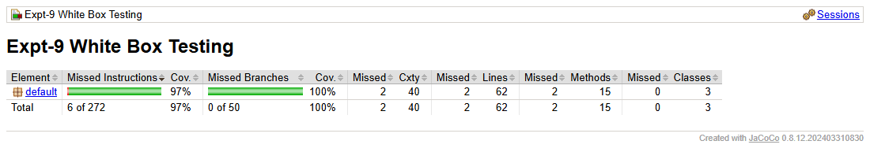
Figure 5: JaCoCo coverage summary for all classes
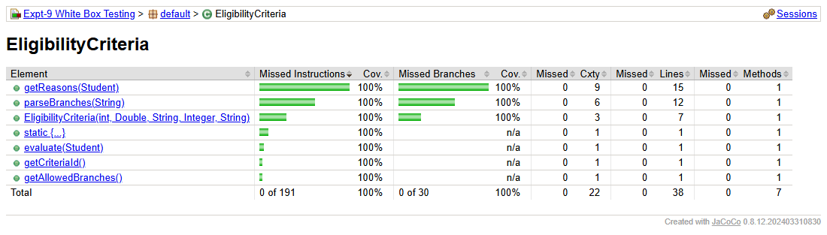
Figure 6: EligibilityCriteria - complexity (Cxty) and coverage per method
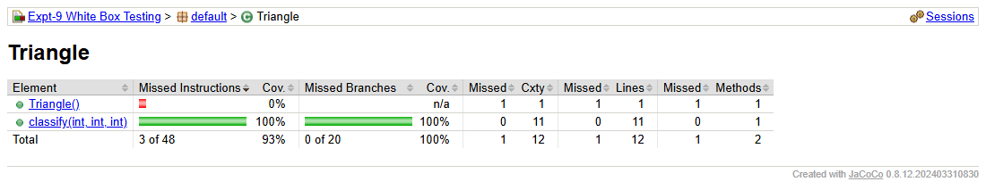
Figure 7: Triangle - complexity (Cxty) and coverage per method
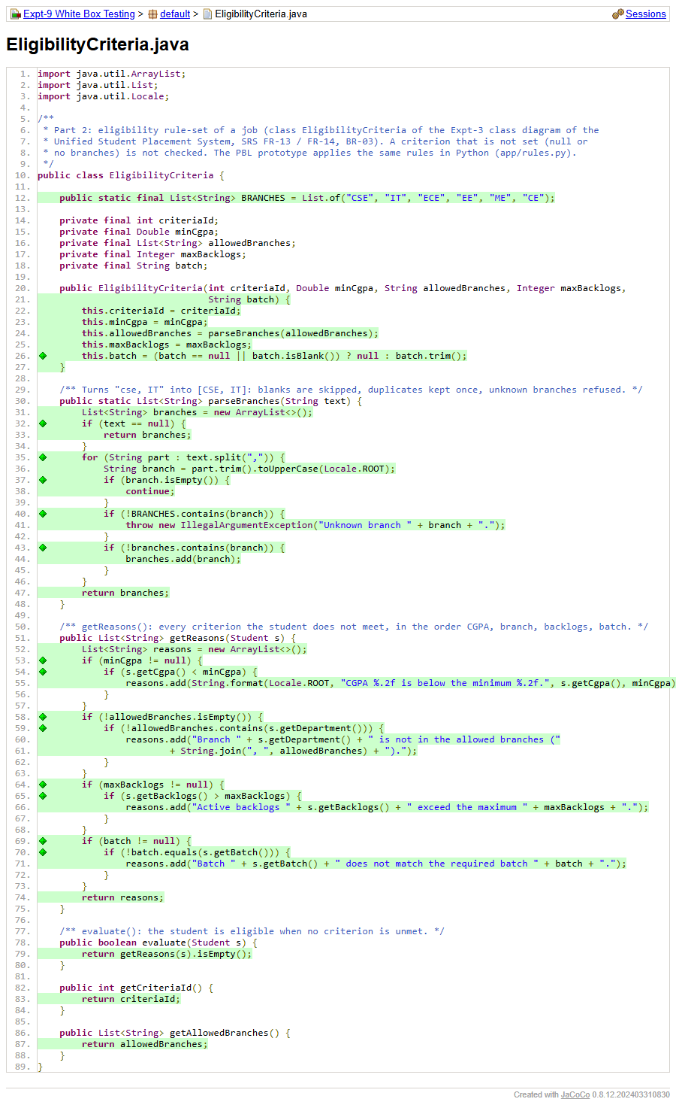
Figure 8: EligibilityCriteria.java in the JaCoCo report - green lines and diamonds show executed code and fully covered branches
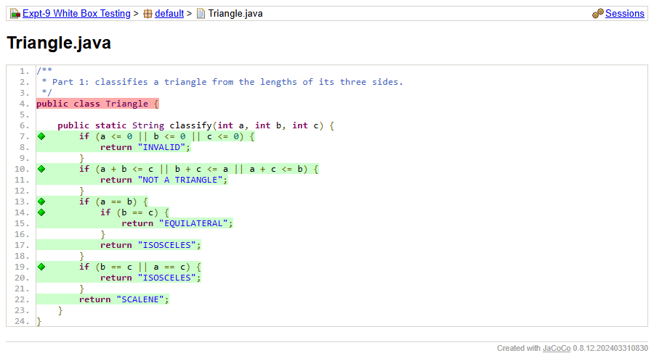
Figure 9: Triangle.java in the JaCoCo report

Conclusion
Basis path testing was applied to Triangle.classify() (V(G) = 11) and to the EligibilityCriteria class of the Unified Student Placement System - parseBranches() (V(G) = 6, one infeasible path) and getReasons() (V(G) = 9). One JUnit test was written for every feasible independent path, plus extra tests for repeated loop execution, the CGPA boundary, evaluate() and the constructor, and all tests were grouped in WhiteBoxTestSuite. The suite ran 32 tests: 32 passed and 0 failed, and JaCoCo confirmed that every branch of both classes was executed.

