Software Engineering Lab - Project-Based Learning (PBL)
Smart Classroom Electricity Management System
Vacancy detection, AC-state inference and appliance control
Individual Project Report

Particular | Details
Name | Vineet Shah
Class / Batch | 5S CSE / A6 - B2
Roll No. | 28
Course | Software Engineering Lab (24CS01PR0502)
Academic year | 2026-27
Implemented modules | Module 1: Vacancy and AC-State Detection Engine  Module 2: Monitoring Dashboard and Control
Project management | Jira (epics, user stories, tasks, sub-tasks, sprints, bugs)
Date | 25-10-2026

1. Project Title and Problem Statement
Title: Smart Classroom Electricity Management System
Lights, fans and air conditioners stay on in classrooms and laboratories after people leave. Manual switching and fixed timers cannot follow irregular lecture schedules, which raises utility bills and wastes energy. PIR sensors cannot recognise appliances and miss people who sit still, and a single temperature sensor cannot tell whether the AC is still running.
The proposed system watches the room with a CCTV camera and a YOLOv8 detector (people, fans and lights), measures the temperature of four room regions with DHT11 sensors, confirms that the room is vacant, raises alerts for appliances left on, infers whether the AC is still running from the temperature drop (Delta T) across the four regions, and lets an operator switch fans and lights through an ESP32 relay controller from a web dashboard.
The problem statement comes from my Idea Lab project "Electricity Management through Computer Vision & Temperature Sensing". For this individual SE PBL, two software modules of that system were selected, implemented, managed in Jira and tested.

2. System and Module Description
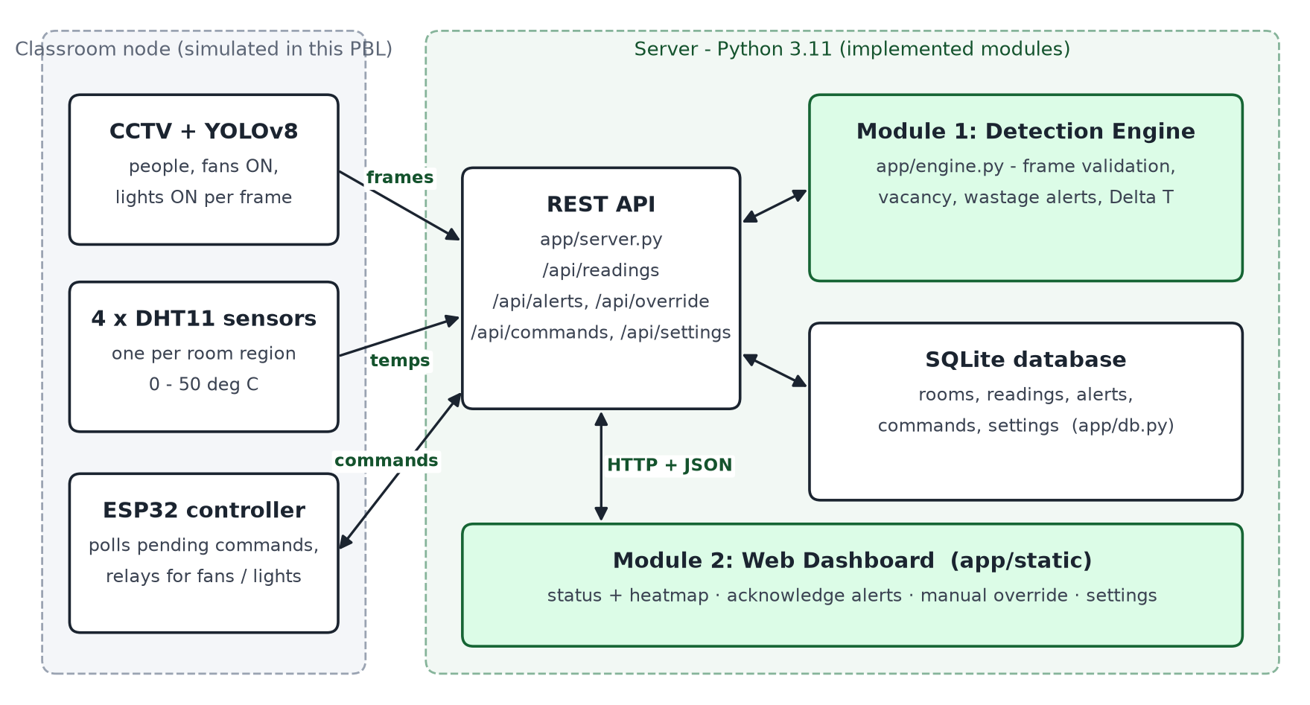
Figure 1: Architecture of the prototype (green boxes are the two implemented modules)
Part | Role in this prototype
Module 1 - Vacancy and AC-State Detection Engine (app/engine.py) | Validates each frame, confirms vacancy over consecutive empty frames, raises fan/light wastage alerts and infers the AC state from the 4-region Delta T.
Module 2 - Monitoring Dashboard and Control (app/server.py, app/db.py, app/static) | REST API and SQLite database; web dashboard with room status, heatmap, alert acknowledgement, manual relay override and detection settings.
Classroom node (app/simulator.py) | The CCTV + YOLOv8 detector, the four DHT11 sensors and the ESP32 controller were not available for this prototype. The simulator sends the same frames to the API and executes relay commands exactly as the ESP32 would.

Item | Technology
Language / runtime | Python 3.11 (standard library only: http.server, sqlite3, json, unittest)
Database | SQLite (tables: rooms, readings, alerts, commands, settings)
User interface | HTML, CSS, JavaScript (fetch API), served by the Python server
Testing | Python test runner and unittest; dashboard UI tests in headless Microsoft Edge
Project management | Jira - backlog, sprints, board, bug tracking

3. Jira Project
Item | Details
Jira space (project) | Smart Classroom Electricity Management - key SCEM (Scrum, team-managed)
Site | rbunagpur-team-zhx8jd75.atlassian.net
Work items | 4 epics, 9 user stories, 10 tasks, 18 subtasks, 4 bugs = 45
Hierarchy | Epic -> Story / Task / Bug -> Subtask (SCEM-1 to SCEM-4 are the epics)
Workflow | To Do -> In Progress -> Done
Status on 26-10-2026 | 43 Done, 2 In Progress (SCEM-23 report and presentation, and its epic SCEM-4)

The backlog was written in jira/backlog.py and imported into Jira with the CSV importer (jira/jira_import.csv). Work items were then planned into three sprints and moved through the workflow as the work was completed; each bug was moved to In Progress, given a fix and retest comment, and closed.
Epic | Jira key | Description | Label
Module 1: Vacancy and AC-State Detection Engine | SCEM-1 | Edge decision engine: validates camera/sensor frames, confirms vacancy over consecutive frames, raises fan/light wastage alerts and infers the AC state from the 4-region temperature drop (FR-1.1 to FR-1.8). | module-1
Module 2: Monitoring Dashboard and Control | SCEM-2 | REST API + SQLite database + web dashboard: room status and heatmap, alert acknowledgement, manual ESP32 relay override and detection settings (FR-2.1 to FR-2.7). | module-2
Testing and Quality Assurance | SCEM-3 | Test case design (EP, BVA, validation), unit, integration and UI test automation, test execution, bug tracking and retesting. | testing
Project Setup and Documentation | SCEM-4 | Requirements, project structure, simulator for the hardware, report and presentation. | docs

Sprint and goal | Dates | Work items | Points | State
SCEM Sprint 1  Detection engine (Module 1) and requirements | 25-10-2026 19:30 - 19:50 | SCEM-5, SCEM-6, SCEM-7, SCEM-8, SCEM-9, SCEM-10 | 16 | Completed
SCEM Sprint 2  Dashboard, API, database and simulator (Module 2) | 25-10-2026 19:50 - 20:00 | SCEM-11, SCEM-12, SCEM-13, SCEM-14, SCEM-15, SCEM-16 | 22 | Completed
SCEM Sprint 3  Testing, bug fixing and documentation | 25-10-2026 20:00 - 01-11-2026 | SCEM-17, SCEM-18, SCEM-19, SCEM-20, SCEM-21, SCEM-22, SCEM-23, SCEM-24 to SCEM-27 (bugs) | 16 | Active

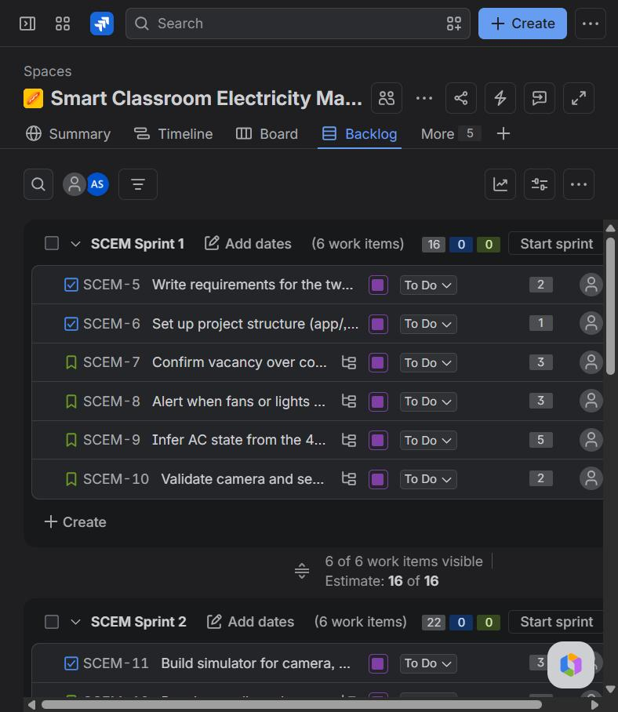 | 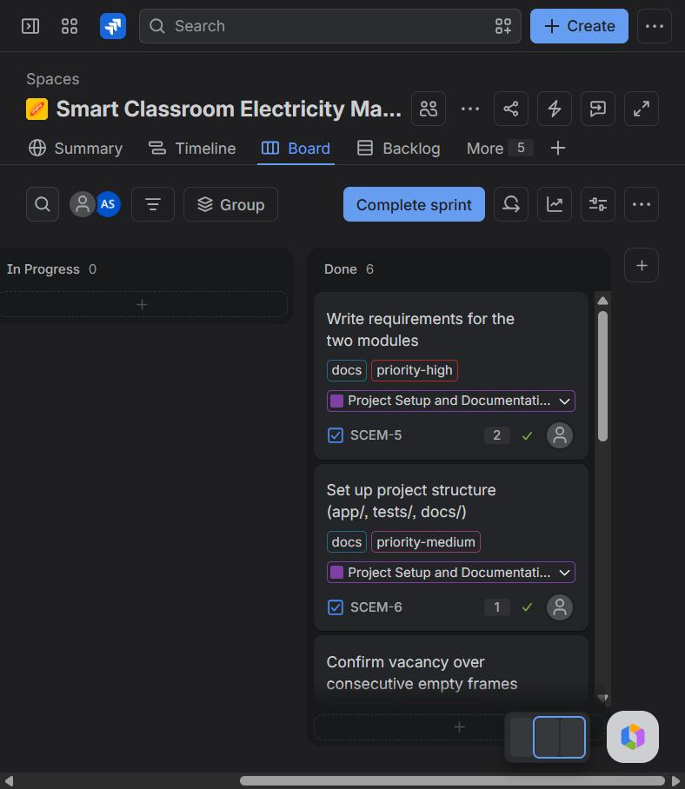
Figure 2: Sprint planning - backlog items placed in SCEM Sprint 1 and Sprint 2 | Figure 3: SCEM Sprint 1 board - all work items moved to Done

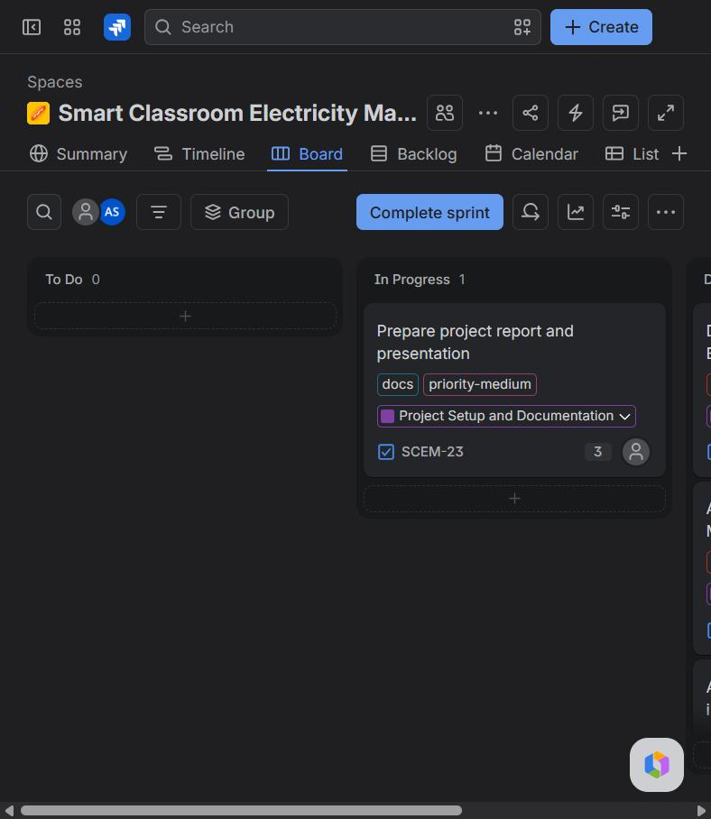 | 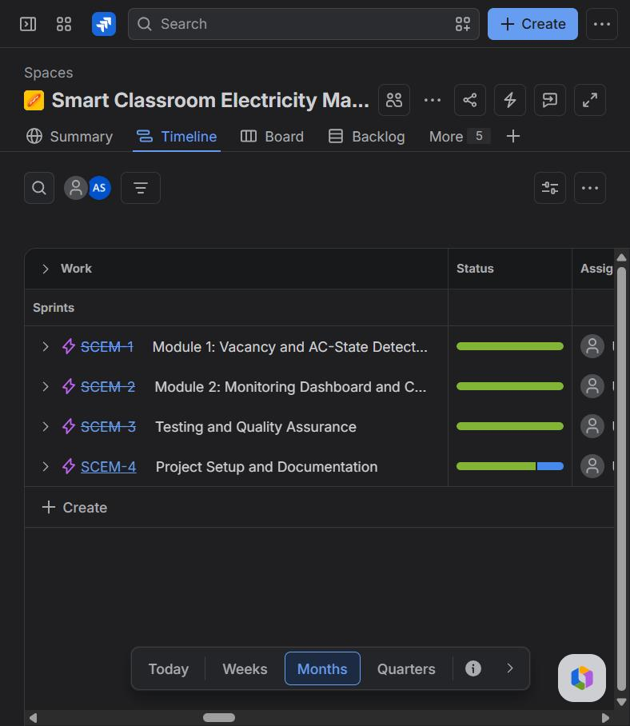
Figure 4: Active SCEM Sprint 3 board - report task In Progress | Figure 5: Timeline - progress of the four epics

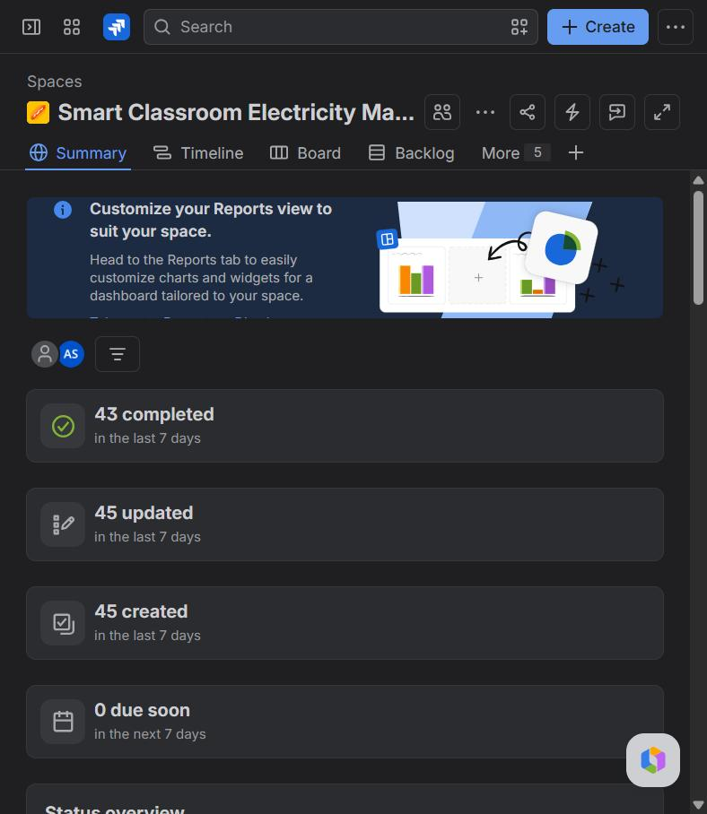 | 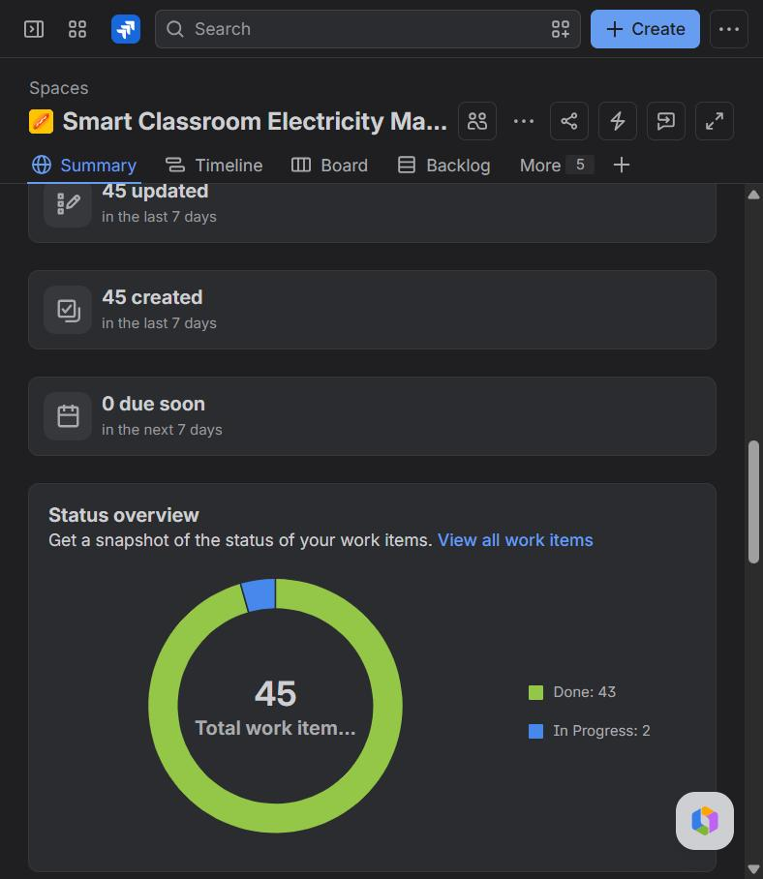
Figure 6: Project summary - 45 work items created, 43 completed | Figure 7: Status overview - Done 43, In Progress 2

4. Product Backlog
Jira key | Type | Summary | Epic | Priority | Points | Sprint
SCEM-5 | Task | Write requirements for the two modules | SCEM-4 | High | 2 | S1
SCEM-6 | Task | Set up project structure (app/, tests/, docs/) | SCEM-4 | Medium | 1 | S1
SCEM-7 | Story | Confirm vacancy over consecutive empty frames | SCEM-1 | High | 3 | S1
SCEM-8 | Story | Alert when fans or lights are left ON in a vacant room | SCEM-1 | High | 3 | S1
SCEM-9 | Story | Infer AC state from the 4-region temperature drop | SCEM-1 | Highest | 5 | S1
SCEM-10 | Story | Validate camera and sensor frames | SCEM-1 | Medium | 2 | S1
SCEM-11 | Task | Build simulator for camera, DHT11 sensors and ESP32 | SCEM-4 | Medium | 3 | S2
SCEM-12 | Story | Receive readings through a REST API and store them | SCEM-2 | High | 3 | S2
SCEM-13 | Story | Show room status and region heatmap on the dashboard | SCEM-2 | High | 5 | S2
SCEM-14 | Story | List and acknowledge open alerts | SCEM-2 | High | 3 | S2
SCEM-15 | Story | Manual fan/light override through the ESP32 | SCEM-2 | High | 5 | S2
SCEM-16 | Story | Edit detection settings from the dashboard | SCEM-2 | Medium | 3 | S2
SCEM-17 | Task | Design test cases (EP, BVA, validation, integration) | SCEM-3 | High | 3 | S3
SCEM-18 | Task | Automate unit tests for Module 1 | SCEM-3 | High | 2 | S3
SCEM-19 | Task | Automate API and integration tests | SCEM-3 | High | 3 | S3
SCEM-20 | Task | Automate dashboard UI tests in Microsoft Edge | SCEM-3 | Medium | 3 | S3
SCEM-21 | Task | Execute test run 1 and log defects in Jira | SCEM-3 | High | 1 | S3
SCEM-22 | Task | Retest after bug fixes (run 2) | SCEM-3 | High | 1 | S3
SCEM-23 | Task | Prepare project report and presentation | SCEM-4 | Medium | 3 | S3

Sub-tasks (18): US1 - Implement vacancy counter in RoomMonitor; US1 - Unit tests TC_M1_11 to TC_M1_13; US2 - Implement fan/light wastage alerts; US2 - Unit tests TC_M1_14 to TC_M1_18; US3 - Implement Delta T calculation and AC inference; US3 - Unit tests TC_M1_19 to TC_M1_26; US4 - Implement Frame.from_dict validation; US4 - Unit tests TC_M1_01 to TC_M1_10; US5 - Create SQLite schema (rooms, readings, alerts, commands, settings); US5 - Implement POST /api/readings; US6 - Build status card and heatmap UI; US6 - UI tests TC_UI_01 to TC_UI_04; US7 - Implement alert list and acknowledge API; US7 - Build acknowledge form; US8 - Implement override and command API; US8 - Build override form and command list; US9 - Implement settings API with persistence; US9 - Build settings form.

5. User Stories
Key | User story and acceptance criteria | Points
US1 | Confirm vacancy over consecutive empty frames  As a facility manager I want a room to be marked vacant only after N consecutive frames without people, so that short absences do not raise alerts.  Acceptance: FR-1.3, FR-1.4; settings limit FR-1.8. | 3
US2 | Alert when fans or lights are left ON in a vacant room  As a facility manager I want an alert when a fan or light stays ON after everyone leaves.  Acceptance: FR-1.5 (once per occurrence, again if switched off and on). | 3
US3 | Infer AC state from the 4-region temperature drop  As a facility manager I want to know if the AC is still running in a vacant room without a power meter.  Acceptance: FR-1.6 (mean drop >= threshold after wait_seconds), FR-1.7 (cancel if someone enters). | 5
US4 | Validate camera and sensor frames  As the system I want invalid frames rejected with a clear message.  Acceptance: FR-1.1, FR-1.2. | 2
US5 | Receive readings through a REST API and store them  As the sensor node I want to post readings to /api/readings so that they are processed and stored.  Acceptance: FR-2.1. | 3
US6 | Show room status and region heatmap on the dashboard  As an operator I want to see the state, counts, AC check and a 2x2 temperature heatmap of a room.  Acceptance: FR-2.2. | 5
US7 | List and acknowledge open alerts  As an operator I want to acknowledge alerts with my name and remarks.  Acceptance: FR-2.3. | 3
US8 | Manual fan/light override through the ESP32  As an operator I want to switch fans or lights ON/OFF from the dashboard.  Acceptance: FR-2.4, FR-2.5. | 5
US9 | Edit detection settings from the dashboard  As an administrator I want to change the vacancy, wait and threshold settings and keep them after a restart.  Acceptance: FR-2.6, FR-2.7. | 3

6. Implementation of the Two Modules

6.1 Module 1: Vacancy and AC-State Detection Engine
The engine (app/engine.py, class RoomMonitor) receives one frame at a time. A frame carries the YOLOv8 counts (people, fans ON, lights ON) and the four DHT11 temperatures. The room becomes vacant only after N consecutive empty frames; the four temperatures are then recorded and, after wait_seconds, compared with the current ones. A mean drop of at least delta_t_threshold means the AC is still cooling an empty room.
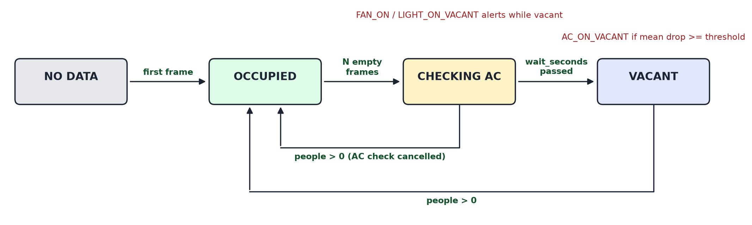
Figure 8: Room states maintained by Module 1
ID | Functional requirement (Module 1)
FR-1.1 | Accept frames: timestamp, people, fans_on, lights_on and exactly 4 region temperatures.
FR-1.2 | Input validation: counts are whole numbers 0-50, temperatures 0-50 deg C (DHT11 range), timestamps strictly increasing.
FR-1.3 | Vacancy is confirmed after at least vacancy_frames consecutive frames with people = 0; any person resets the count.
FR-1.4 | On vacancy the four temperatures are recorded and the state becomes CHECKING_AC.
FR-1.5 | FAN_ON_VACANT / LIGHT_ON_VACANT alerts while vacant, once per occurrence.
FR-1.6 | After wait_seconds: mean drop >= delta_t_threshold -> AC inferred ON and AC_ON_VACANT.
FR-1.7 | A person entering during the check cancels it; the room is OCCUPIED again.
FR-1.8 | Settings: vacancy_frames 1-300, wait_seconds 30-600, delta_t_threshold 0.1-5.0.

Core of the engine - RoomMonitor.process() (complete file in Appendix A):
def process(self, frame):
if self.last_timestamp is not None and frame.timestamp <= self.last_timestamp:
raise ValidationError("timestamp must be later than the previous frame.")
self.last_timestamp = frame.timestamp
self.last_frame = frame
alerts = []
if frame.people > 0:
self._reset_to_occupied()
return alerts
self.empty_frames += 1
if self.state == OCCUPIED and self.empty_frames >= self.settings.vacancy_frames:
self.state = CHECKING_AC
self.initial_temps = list(frame.temps)
self.check_started = frame.timestamp
if self.state == OCCUPIED:
return alerts
alerts += self._appliance_alerts(frame)
if self.state == CHECKING_AC and frame.timestamp - self.check_started >= self.settings.wait_seconds:
drops = [start - end for start, end in zip(self.initial_temps, frame.temps)]
# Compare at full precision (6 decimals only removes float noise); rounding to 2 decimals
# before comparing turned a 0.499 deg C drop into 0.50 and raised a false AC alert (BUG-02).
mean_drop = round(sum(drops) / REGIONS, 6)
self.last_mean_drop = round(mean_drop, 3)
self.ac_inferred_on = mean_drop >= self.settings.delta_t_threshold
self.state = VACANT
if self.ac_inferred_on:
alerts.append(self._alert(AC_ON_VACANT, frame.timestamp,
"AC appears to be ON in vacant room %s (mean temperature drop %.2f deg C "
"in %d s)." % (self.room_id, self.last_mean_drop, self.settings.wait_seconds),
self.last_mean_drop))
return alerts

6.2 Module 2: Monitoring Dashboard and Control
The server (app/server.py) exposes a REST API, passes readings to Module 1, stores readings, alerts, relay commands and settings in SQLite (app/db.py) and serves the dashboard (app/static). The dashboard refreshes every 2 seconds.
Method and path | Purpose | Validation / errors
POST /api/readings | Frame from the classroom node -> Module 1 -> stored with any alerts | 400 room_id is required / frame errors (FR-1.2); 404 unknown room; 400 invalid JSON
GET /api/rooms, /api/rooms/<id> | Room details, engine status and open alert count | 404 unknown room
GET /api/alerts?room=&status= | Alerts, newest first | -
POST /api/alerts/<id>/ack | Acknowledge an alert | operator 3-40 letters; remarks <= 200; 404; 409
POST /api/override | Queue a fan/light ON/OFF command for the ESP32 | appliance fan/light; action ON/OFF; operator; reason 5-100
GET /api/commands, POST /api/commands/<id>/done | ESP32 reads and completes commands | 404; 409
GET / PUT /api/settings | Detection settings, stored in the database | limits of FR-1.8

Table | Columns
rooms | id, name, fans, lights, acs
readings | id, room_id, ts, people, fans_on, lights_on, t1, t2, t3, t4, state
alerts | id, room_id, ts, type, message, value, status, ack_by, ack_remarks, ack_at
commands | id, room_id, appliance, action, operator, reason, status, created_at, done_at
settings | key, value

ID | Functional requirement (Module 2)
FR-2.1 | Receive readings through the API, pass them to Module 1, store readings and alerts.
FR-2.2 | Show state, counts, AC check, last reading and a 2x2 heatmap; NO DATA for rooms without readings.
FR-2.3 | List open alerts and acknowledge one (operator name and optional remarks).
FR-2.4 | Manual override of fans/lights with operator name and reason.
FR-2.5 | ESP32 picks up pending commands and marks them done.
FR-2.6 | Edit settings on the dashboard; stored, applied at once, kept after restart.
FR-2.7 | Dashboard validation messages use the field labels shown on the form.

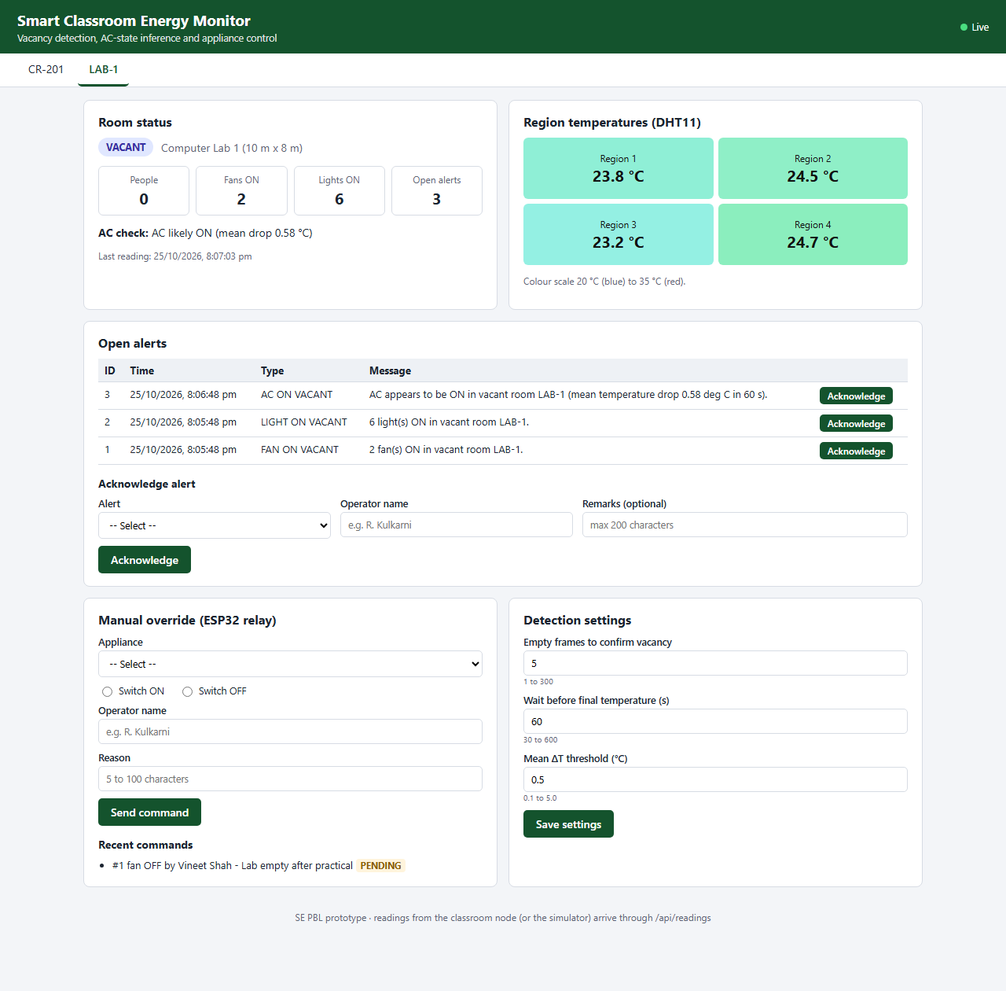
Figure 9: Dashboard - LAB-1 after the class left with 2 fans, 6 lights and the AC on (simulator run on 25-10-2026); a fan OFF command is pending for the ESP32
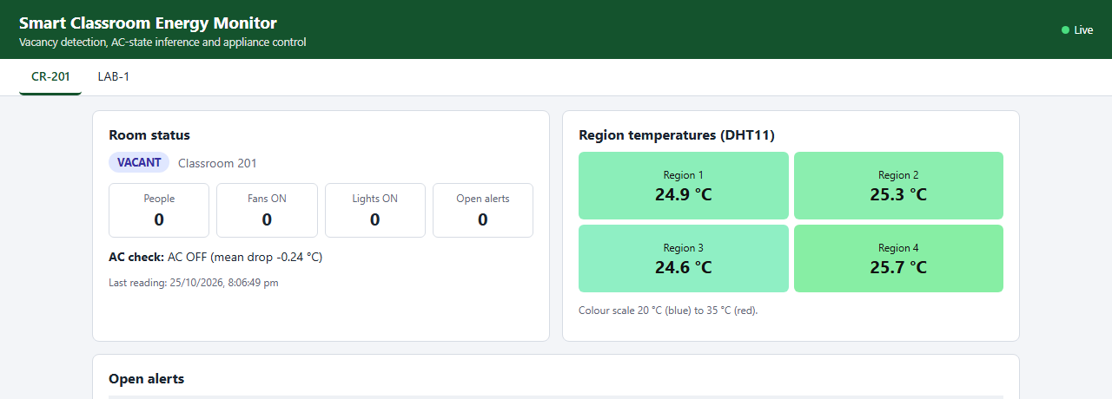
Figure 10: Dashboard - CR-201 after everything was switched off: AC inferred OFF (room warmed by 0.24 deg C)
Integration: readings flow from the classroom node through the API into Module 1; the alerts it returns are written to the database and shown by the dashboard. Commands sent from the dashboard are stored as PENDING, executed by the ESP32 (simulated) and marked DONE; the next readings then show the appliance switched off. Settings saved on the dashboard are applied to the running engine.

7. Source Code
File | Lines | Contents
app/engine.py | 187 | Module 1 - frame validation, RoomMonitor state machine, settings
app/server.py | 252 | Module 2 - REST API, request validation, static file server
app/db.py | 147 | Module 2 - SQLite schema and data access
app/simulator.py | 82 | Simulated camera + DHT11 + ESP32 node
app/static/index.html | 103 | Dashboard page
app/static/app.js | 205 | Dashboard logic (polling, forms)
app/static/style.css | 68 | Dashboard styles
tests/helpers.py | 87 | Test helpers: frame builders, throw-away server, HTTP client
tests/engine_cases.py | 186 | 32 Module 1 test cases
tests/api_cases.py | 269 | 24 Module 2 API cases and 7 integration cases
tests/ui/ui_cases.js | 136 | 15 dashboard UI test cases
tests/run_tests.py | 80 | Executes all cases and records actual results
tests/test_unit.py | 29 | unittest entry point
jira/backlog.py | 161 | Jira backlog and CSV export

python -m app.server --port 8090 --db data/energy.db # start server + dashboard
python -m app.simulator --room LAB-1 --scenario ac_left_on # simulated classroom node
python -m tests.run_tests run2-retest # execute all 78 test cases
python -m unittest -v tests.test_unit # unit + API + integration via unittest

8. Test Cases and Test Results
Technique | How it was applied
Unit testing | Module 1 engine methods tested directly (TC_M1_xx)
Functional testing | Every functional requirement checked through its output
Integration testing | Engine + API + database + ESP32 command loop (TC_INT_xx, TC_UI_08)
Boundary Value Analysis | min-1 / min / max / max+1 for temperatures, counts, frames, wait, threshold, name, remarks and reason lengths
Equivalence Partitioning | valid and invalid classes for every input field
Validation testing | every error message of the API and of the dashboard forms

Test cases were designed from the requirements (docs/requirements.md) before execution. They are automated: Python cases call the engine or the running server; UI cases fill the dashboard forms in Microsoft Edge and read the displayed result. Actual results below are from the final run (run2-retest, 2026-10-25 20:04:31); the first run is compared in Section 10.

M1 Detection Engine
Test Case ID | Module | Test Scenario | Test Data | Expected Result | Actual Result | Status
TC_M1_01 | M1 Detection Engine | Valid frame from camera and sensors  [Validation / EP (valid)] | people=3, fans_on=2, lights_on=4, temps=[24.5, 25.0, 24.8, 25.2] | accepted | accepted | PASS
TC_M1_02 | M1 Detection Engine | Only 3 region temperatures sent  [Validation / EP (invalid)] | temps=[24.5, 25.0, 24.8] | temps must list exactly 4 region temperatures. | temps must list exactly 4 region temperatures. | PASS
TC_M1_03 | M1 Detection Engine | Region temperature at DHT11 upper limit  [BVA (max)] | temps=[24.5, 50.0, 24.8, 25.2] | accepted | accepted | PASS
TC_M1_04 | M1 Detection Engine | Region temperature above DHT11 range  [BVA (max + 0.1)] | temps=[24.5, 50.1, 24.8, 25.2] | temperature of region 2 must be between 0 and 50 deg C. | temperature of region 2 must be between 0 and 50 deg C. | PASS
TC_M1_05 | M1 Detection Engine | Region temperature at DHT11 lower limit  [BVA (min)] | temps=[0.0, 25.0, 24.8, 25.2] | accepted | accepted | PASS
TC_M1_06 | M1 Detection Engine | Region temperature below DHT11 range  [BVA (min - 0.1)] | temps=[-0.1, 25.0, 24.8, 25.2] | temperature of region 1 must be between 0 and 50 deg C. | temperature of region 1 must be between 0 and 50 deg C. | PASS
TC_M1_07 | M1 Detection Engine | Negative people count  [EP (invalid)] | people=-1 | people must be between 0 and 50. | people must be between 0 and 50. | PASS
TC_M1_08 | M1 Detection Engine | People count sent as text  [EP (invalid)] | people="3" | people must be a whole number. | people must be a whole number. | PASS
TC_M1_09 | M1 Detection Engine | Fractional fan count  [EP (invalid)] | fans_on=1.5 | fans_on must be a whole number. | fans_on must be a whole number. | PASS
TC_M1_10 | M1 Detection Engine | Frame with the same timestamp as the previous frame  [Validation] | frames at t=10 and t=10 | timestamp must be later than the previous frame. | timestamp must be later than the previous frame. | PASS
TC_M1_11 | M1 Detection Engine | 4 consecutive empty frames  [BVA (frames - 1)] | vacancy_frames=5; 2 occupied + 4 empty frames | state=OCCUPIED, alerts=[] | state=OCCUPIED, alerts=[] | PASS
TC_M1_12 | M1 Detection Engine | 5 consecutive empty frames confirm vacancy  [BVA (frames)] | vacancy_frames=5; 2 occupied + 5 empty frames | state=CHECKING_AC, alerts=[] | state=CHECKING_AC, alerts=[] | PASS
TC_M1_13 | M1 Detection Engine | Person re-enters after 4 empty frames  [Unit (path)] | 4 empty, 1 frame with people=1, 4 empty | state=OCCUPIED, alerts=[] | state=OCCUPIED, alerts=[] | PASS
TC_M1_14 | M1 Detection Engine | Fans left ON after everyone leaves  [Functional / EP] | 5 empty frames + 5 more with fans_on=2 | state=CHECKING_AC, alerts=[FAN_ON_VACANT] | state=CHECKING_AC, alerts=[FAN_ON_VACANT] | PASS
TC_M1_15 | M1 Detection Engine | Lights left ON after everyone leaves  [Functional / EP] | 10 empty frames with lights_on=6 | state=CHECKING_AC, alerts=[LIGHT_ON_VACANT] | state=CHECKING_AC, alerts=[LIGHT_ON_VACANT] | PASS
TC_M1_16 | M1 Detection Engine | Fans and lights switched off when leaving  [Functional / EP] | 10 empty frames, fans_on=0, lights_on=0 | state=CHECKING_AC, alerts=[] | state=CHECKING_AC, alerts=[] | PASS
TC_M1_17 | M1 Detection Engine | Fans and lights ON while room is occupied  [EP (occupied)] | 10 frames with people=4, fans_on=4, lights_on=6 | state=OCCUPIED, alerts=[] | state=OCCUPIED, alerts=[] | PASS
TC_M1_18 | M1 Detection Engine | Fan switched OFF and ON again during vacancy  [Functional] | vacant: fans_on 2, 2, 0, 2 | state=CHECKING_AC, alerts=[FAN_ON_VACANT, FAN_ON_VACANT] | state=CHECKING_AC, alerts=[FAN_ON_VACANT, FAN_ON_VACANT] | PASS
TC_M1_19 | M1 Detection Engine | Mean temperature drop exactly 0.5 deg C  [BVA (threshold)] | start 25.0 in all regions, after 60 s 24.5 in all regions | state=VACANT, ac_inferred_on=True, alerts=[AC_ON_VACANT] | state=VACANT, ac_inferred_on=True, alerts=[AC_ON_VACANT] | PASS
TC_M1_20 | M1 Detection Engine | Mean temperature drop 0.49 deg C  [BVA (threshold - 0.01)] | start 25.0, after 60 s 24.51 in all regions | state=VACANT, ac_inferred_on=False, alerts=[] | state=VACANT, ac_inferred_on=False, alerts=[] | PASS
TC_M1_21 | M1 Detection Engine | Mean temperature drop 0.499 deg C  [BVA (threshold - 0.001)] | start 25.0, after 60 s regions 24.501, 24.501, 24.501, 24.501 | state=VACANT, ac_inferred_on=False, alerts=[] | state=VACANT, ac_inferred_on=False, alerts=[] | PASS
TC_M1_22 | M1 Detection Engine | Different drop in each region (mean above threshold)  [Functional] | start 25.0; after 60 s 24.0, 24.8, 24.2, 25.0 (mean drop 0.5) | state=VACANT, ac_inferred_on=True, alerts=[AC_ON_VACANT] | state=VACANT, ac_inferred_on=True, alerts=[AC_ON_VACANT] | PASS
TC_M1_23 | M1 Detection Engine | Room warms up after vacancy (AC off)  [EP (AC off)] | start 25.0, after 60 s 25.3 in all regions | state=VACANT, ac_inferred_on=False, alerts=[] | state=VACANT, ac_inferred_on=False, alerts=[] | PASS
TC_M1_24 | M1 Detection Engine | Final reading 59 s after vacancy confirmed  [BVA (wait - 1 s)] | drop 1.0 deg C at 59 s | state=CHECKING_AC, ac_inferred_on=None, alerts=[] | state=CHECKING_AC, ac_inferred_on=None, alerts=[] | PASS
TC_M1_25 | M1 Detection Engine | Final reading exactly 60 s after vacancy confirmed  [BVA (wait)] | drop 1.0 deg C at 60 s | state=VACANT, ac_inferred_on=True, alerts=[AC_ON_VACANT] | state=VACANT, ac_inferred_on=True, alerts=[AC_ON_VACANT] | PASS
TC_M1_26 | M1 Detection Engine | Person enters during the AC check  [Unit (path)] | vacancy at t=7, people=2 at t=30, empty again at t=67 with drop 1.0 | state=OCCUPIED, ac_inferred_on=None, alerts=[] | state=OCCUPIED, ac_inferred_on=None, alerts=[] | PASS
TC_M1_27 | M1 Detection Engine | vacancy_frames = 0  [BVA (min - 1)] | vacancy_frames=0, wait_seconds=120, delta_t_threshold=0.5 | vacancy_frames must be between 1 and 300. | vacancy_frames must be between 1 and 300. | PASS
TC_M1_28 | M1 Detection Engine | vacancy_frames = 1 and 300  [BVA (min / max)] | vacancy_frames=1, then 300 | accepted / accepted | accepted / accepted | PASS
TC_M1_29 | M1 Detection Engine | vacancy_frames = 301  [BVA (max + 1)] | vacancy_frames=301 | vacancy_frames must be between 1 and 300. | vacancy_frames must be between 1 and 300. | PASS
TC_M1_30 | M1 Detection Engine | wait_seconds = 29 and 601  [BVA] | wait_seconds=29, then 601 | wait_seconds must be between 30 and 600. / wait_seconds must be between 30 and 600. | wait_seconds must be between 30 and 600. / wait_seconds must be between 30 and 600. | PASS
TC_M1_31 | M1 Detection Engine | delta_t_threshold = 0.09 and 5.1  [BVA] | delta_t_threshold=0.09, then 5.1 | delta_t_threshold must be between 0.1 and 5.0. / delta_t_threshold must be between 0.1 and 5.0. | delta_t_threshold must be between 0.1 and 5.0. / delta_t_threshold must be between 0.1 and 5.0. | PASS
TC_M1_32 | M1 Detection Engine | Non-numeric and fractional settings  [EP (invalid)] | delta_t_threshold="abc"; vacancy_frames=10.5 | delta_t_threshold must be a number. / vacancy_frames must be a whole number. | delta_t_threshold must be a number. / vacancy_frames must be a whole number. | PASS

M2 Dashboard & Control
Test Case ID | Module | Test Scenario | Test Data | Expected Result | Actual Result | Status
TC_M2_01 | M2 Dashboard & Control | List monitored rooms  [Functional] | GET /api/rooms | 200: 2 rooms (CR-201, LAB-1) | 200: 2 rooms (CR-201, LAB-1) | PASS
TC_M2_02 | M2 Dashboard & Control | Post a valid reading  [Functional / EP (valid)] | LAB-1, t=1, people=5, fans_on=4, lights_on=6, temps 25.0 x 4 | 200: state=OCCUPIED | 200: state=OCCUPIED | PASS
TC_M2_03 | M2 Dashboard & Control | Reading for a room that does not exist  [EP (invalid)] | room_id=LAB-9 | 404: Room LAB-9 not found. | 404: Room LAB-9 not found. | PASS
TC_M2_04 | M2 Dashboard & Control | Reading without room_id  [Validation] | body without room_id | 400: room_id is required. | 400: room_id is required. | PASS
TC_M2_05 | M2 Dashboard & Control | Body is not valid JSON  [Validation] | body = {people: 3 | 400: Request body must be valid JSON. | 400: Request body must be valid JSON. | PASS
TC_M2_06 | M2 Dashboard & Control | Region 3 temperature 50.5 deg C  [Validation / BVA] | temps=[25, 25, 50.5, 25] | 400: temperature of region 3 must be between 0 and 50 deg C. | 400: temperature of region 3 must be between 0 and 50 deg C. | PASS
TC_M2_07 | M2 Dashboard & Control | Acknowledge an open alert  [Functional] | alert 1, operator='R. Kulkarni', remarks='' | 200: Alert 1 acknowledged by R. Kulkarni. | 200: Alert 1 acknowledged by R. Kulkarni. | PASS
TC_M2_08 | M2 Dashboard & Control | Acknowledge the same alert twice  [EP (invalid)] | alert 1 acknowledged, then again | 409: Alert 1 is already acknowledged. | 409: Alert 1 is already acknowledged. | PASS
TC_M2_09 | M2 Dashboard & Control | Acknowledge an alert that does not exist  [EP (invalid)] | alert 999 | 404: Alert 999 not found. | 404: Alert 999 not found. | PASS
TC_M2_10 | M2 Dashboard & Control | Operator name of 2 characters  [BVA (min - 1)] | operator='Ra' | 400: Operator name must be 3 to 40 characters (letters, spaces and dots only). | 400: Operator name must be 3 to 40 characters (letters, spaces and dots only). | PASS
TC_M2_11 | M2 Dashboard & Control | Operator name of 3 characters  [BVA (min)] | operator='Ram' | 200: Alert 1 acknowledged by Ram. | 200: Alert 1 acknowledged by Ram. | PASS
TC_M2_12 | M2 Dashboard & Control | Remarks of 201 characters  [BVA (max + 1)] | remarks = 'A' x 201 | 400: Remarks cannot exceed 200 characters. | 400: Remarks cannot exceed 200 characters. | PASS
TC_M2_13 | M2 Dashboard & Control | Remarks of 200 characters  [BVA (max)] | remarks = 'A' x 200 | 200: Alert 1 acknowledged by R. Kulkarni. | 200: Alert 1 acknowledged by R. Kulkarni. | PASS
TC_M2_14 | M2 Dashboard & Control | Manual override: switch fans OFF  [Functional] | LAB-1, fan, OFF, 'R. Kulkarni', 'Room empty after lecture' | 200: Command 1 queued: switch fan OFF in LAB-1. | 200: Command 1 queued: switch fan OFF in LAB-1. | PASS
TC_M2_15 | M2 Dashboard & Control | Override for an unsupported appliance  [EP (invalid)] | appliance='ac' | 400: Appliance must be fan or light. | 400: Appliance must be fan or light. | PASS
TC_M2_16 | M2 Dashboard & Control | Action in lower case  [EP (invalid)] | action='on' | 400: Action must be ON or OFF. | 400: Action must be ON or OFF. | PASS
TC_M2_17 | M2 Dashboard & Control | Reason of 4 characters  [BVA (min - 1)] | reason='Idle' | 400: Reason must be 5 to 100 characters. | 400: Reason must be 5 to 100 characters. | PASS
TC_M2_18 | M2 Dashboard & Control | Reason of 5 characters  [BVA (min)] | reason='Empty' | 200: Command 1 queued: switch fan OFF in LAB-1. | 200: Command 1 queued: switch fan OFF in LAB-1. | PASS
TC_M2_19 | M2 Dashboard & Control | Reason of 100 characters  [BVA (max)] | reason = 'R' x 100 | 200: Command 1 queued: switch fan OFF in LAB-1. | 200: Command 1 queued: switch fan OFF in LAB-1. | PASS
TC_M2_20 | M2 Dashboard & Control | Reason of 101 characters  [BVA (max + 1)] | reason = 'R' x 101 | 400: Reason must be 5 to 100 characters. | 400: Reason must be 5 to 100 characters. | PASS
TC_M2_21 | M2 Dashboard & Control | ESP32 marks a command as done  [Functional] | POST /api/commands/1/done | 200: status=DONE | 200: status=DONE | PASS
TC_M2_22 | M2 Dashboard & Control | Command marked done twice  [EP (invalid)] | POST /api/commands/1/done twice | 409: Command 1 is already DONE. | 409: Command 1 is already DONE. | PASS
TC_M2_23 | M2 Dashboard & Control | Save valid detection settings  [Functional] | vacancy_frames=8, wait_seconds=90, delta_t_threshold=0.8 | 200: Settings saved. | 200: Settings saved. | PASS
TC_M2_24 | M2 Dashboard & Control | Settings kept after server restart  [Functional (database)] | save 8 / 90 / 0.8, restart server on the same database, GET /api/settings | vacancy_frames=8, wait_seconds=90, delta_t_threshold=0.8 | vacancy_frames=8, wait_seconds=90, delta_t_threshold=0.8 | PASS

Integration (M1 + M2)
Test Case ID | Module | Test Scenario | Test Data | Expected Result | Actual Result | Status
TC_INT_01 | Integration | Engine alerts are stored and listed  [Integration] | 2 occupied frames, 5 vacant frames with 2 fans + 6 lights ON, drop 1.0 deg C after 60 s | AC_ON_VACANT, FAN_ON_VACANT, LIGHT_ON_VACANT | AC_ON_VACANT, FAN_ON_VACANT, LIGHT_ON_VACANT | PASS
TC_INT_02 | Integration | Room status combines engine and database  [Integration] | same readings as TC_INT_01; GET /api/rooms/LAB-1 | state=VACANT, open_alerts=3, ac_inferred_on=True | state=VACANT, open_alerts=3, ac_inferred_on=True | PASS
TC_INT_03 | Integration | Acknowledging an alert updates the room  [Integration] | TC_INT_01 readings, acknowledge alert 1 | open_alerts=2, alert 1 status=ACKNOWLEDGED | open_alerts=2, alert 1 status=ACKNOWLEDGED | PASS
TC_INT_04 | Integration | Override reaches the ESP32 and stops alerts  [Integration] | vacant with 2 fans ON; send fan OFF; ESP32 executes; 3 more frames with fans_on=0 | pending=1, command status=DONE, FAN_ON_VACANT alerts=1 | pending=1, command status=DONE, FAN_ON_VACANT alerts=1 | PASS
TC_INT_05 | Integration | New settings apply to the running engine  [Integration] | vacancy_frames=3; 2 occupied + 3 empty frames | state=CHECKING_AC | state=CHECKING_AC | PASS
TC_INT_06 | Integration | Every reading is stored  [Integration (database)] | 7 readings for LAB-1 | readings stored=7 | readings stored=7 | PASS
TC_INT_07 | Integration | Simulator scenario ac_left_on  [Integration (end to end)] | simulator: people leave at 10 s, 2 fans + 6 lights + AC left on, 80 s | AC_ON_VACANT, FAN_ON_VACANT, LIGHT_ON_VACANT | AC_ON_VACANT, FAN_ON_VACANT, LIGHT_ON_VACANT | PASS

M2 Dashboard & Control (UI)
Test Case ID | Module | Test Scenario | Test Data | Expected Result | Actual Result | Status
TC_UI_01 | M2 Dashboard & Control | Room that has sent no readings yet  [Functional (UI)] | Open dashboard, room CR-201 (no readings) | NO DATA | NO DATA | PASS
TC_UI_02 | M2 Dashboard & Control | Status card after the room becomes vacant  [Functional (UI)] | Open room LAB-1 | VACANT | people 0 | fans 2 | lights 6 | AC likely ON (mean drop 1.00 °C) | VACANT | people 0 | fans 2 | lights 6 | AC likely ON (mean drop 1.00 °C) | PASS
TC_UI_03 | M2 Dashboard & Control | Heatmap shows the four region temperatures  [Functional (UI)] | Open room LAB-1 | 24.0 °C, 24.0 °C, 24.0 °C, 24.0 °C | 24.0 °C, 24.0 °C, 24.0 °C, 24.0 °C | PASS
TC_UI_04 | M2 Dashboard & Control | Open alerts table  [Functional (UI)] | Open room LAB-1 | 3 rows: AC ON VACANT, LIGHT ON VACANT, FAN ON VACANT | 3 rows: AC ON VACANT, LIGHT ON VACANT, FAN ON VACANT | PASS
TC_UI_05 | M2 Dashboard & Control | Acknowledge without selecting an alert  [Validation (UI)] | Alert: -- Select --, operator 'R. Kulkarni' | Please select an alert. | Please select an alert. | PASS
TC_UI_06 | M2 Dashboard & Control | Operator name of 1 character  [Validation / BVA (UI)] | Alert #1, operator 'R' | Operator name must be 3 to 40 characters (letters, spaces and dots only). | Operator name must be 3 to 40 characters (letters, spaces and dots only). | PASS
TC_UI_07 | M2 Dashboard & Control | Acknowledge alert #1  [Functional (UI)] | Alert #1, operator 'R. Kulkarni', remarks 'Fans switched off' | Alert 1 acknowledged by R. Kulkarni. | Alert 1 acknowledged by R. Kulkarni. | PASS
TC_UI_08 | M2 Dashboard & Control | Acknowledged alert leaves the open list  [Integration (UI)] | Reload dashboard, room LAB-1 | 2 rows; open alerts card shows 2 | 2 rows; open alerts card shows 2 | PASS
TC_UI_09 | M2 Dashboard & Control | Send manual override fan OFF  [Functional (UI)] | Fan, Switch OFF, 'R. Kulkarni', 'Room empty after lecture' | Command 1 queued: switch fan OFF in LAB-1. | Command 1 queued: switch fan OFF in LAB-1. | PASS
TC_UI_10 | M2 Dashboard & Control | Override without choosing an appliance  [Validation (UI)] | Appliance: -- Select --, Switch OFF | Appliance must be fan or light. | Appliance must be fan or light. | PASS
TC_UI_11 | M2 Dashboard & Control | Override without choosing ON or OFF  [Validation (UI)] | Light, no action selected | Action must be ON or OFF. | Action must be ON or OFF. | PASS
TC_UI_12 | M2 Dashboard & Control | Override reason of 3 characters  [Validation / BVA (UI)] | Light, Switch OFF, reason 'abc' | Reason must be 5 to 100 characters. | Reason must be 5 to 100 characters. | PASS
TC_UI_13 | M2 Dashboard & Control | Save valid settings  [Functional (UI)] | frames 5, wait 60, threshold 0.5 | Settings saved. | Settings saved. | PASS
TC_UI_14 | M2 Dashboard & Control | Empty frames = 301  [Validation / BVA (UI)] | frames 301, wait 60, threshold 0.5 | Empty frames to confirm vacancy must be between 1 and 300. | Empty frames to confirm vacancy must be between 1 and 300. | PASS
TC_UI_15 | M2 Dashboard & Control | Threshold is not a number  [Validation (UI)] | frames 5, wait 60, threshold 'abc' | Mean ΔT threshold must be a number. | Mean ΔT threshold must be a number. | PASS

Test execution summary
Module | Test cases | Run 1 passed | Run 1 failed | Run 2 (retest) passed | Run 2 (retest) failed
M1 Detection Engine | 32 | 31 | 1 | 32 | 0
M2 Dashboard & Control | 24 | 23 | 1 | 24 | 0
Integration (M1 + M2) | 7 | 7 | 0 | 7 | 0
M2 Dashboard & Control (UI) | 15 | 12 | 3 | 15 | 0
Total | 78 | 73 | 5 | 78 | 0

9. Bugs Recorded in Jira
Every failure of run 1 was analysed and recorded as a Bug in Jira (SCEM Sprint 3). BUG-01 was first noticed while exploring the dashboard and is reproduced by TC_UI_01.
Bug ID | Bug description | Steps to reproduce | Severity / Priority | Status | Resolution
BUG-01  (SCEM-24) | Dashboard shows OCCUPIED for a room that has not sent any reading  Expected: State badge shows NO DATA (FR-2.2)  Actual: State badge shows OCCUPIED  Found by: Exploratory testing of the dashboard; reproduced by TC_UI_01 in run1-initial | 1. Start the server with a new database: python -m app.server --db data/new.db  2. Open http://127.0.0.1:8090 in the browser  3. Select room CR-201 (no reading has been posted for it) | Minor / Medium | Closed | Fixed - RoomMonitor.status() now reports NO_DATA until the first frame is received; the dashboard shows the NO DATA badge (app/engine.py).  Retest: TC_UI_01 PASS in run2-retest
BUG-02  (SCEM-25) | False AC_ON_VACANT alert when the mean temperature drop is just below the threshold  Expected: ac_inferred_on=False, no alert (mean drop 0.499 < 0.5, FR-1.6)  Actual: ac_inferred_on=True and AC_ON_VACANT alert raised  Found by: TC_M1_21 (BVA: threshold - 0.001) in run1-initial | 1. Settings: vacancy_frames=5, wait_seconds=60, delta_t_threshold=0.5  2. Send 2 occupied frames, then 5 empty frames with all regions at 25.0 deg C  3. 60 s after vacancy is confirmed, send an empty frame with all regions at 24.501 deg C | Major / High | Closed | Fixed - the comparison uses the unrounded mean (rounded to 6 decimals only to remove floating-point noise); 2-3 decimal rounding is kept only for display (app/engine.py).  Retest: TC_M1_19, TC_M1_20, TC_M1_21, TC_M1_22 PASS in run2-retest
BUG-03  (SCEM-26) | API returns 404 'Room None not found.' when room_id is missing  Expected: 400: room_id is required. (FR-2.1)  Actual: 404: Room None not found.  Found by: TC_M2_04 in run1-initial | 1. Start the server  2. POST /api/readings with a valid frame body that has no room_id field | Minor / Low | Closed | Fixed - a missing or empty room_id is rejected with 400 'room_id is required.' before the room lookup (app/server.py).  Retest: TC_M2_04 PASS, TC_M2_03 still PASS in run2-retest
BUG-04  (SCEM-27) | Settings validation messages on the dashboard show internal field names  Expected: Empty frames to confirm vacancy must be between 1 and 300. (FR-2.7)  Actual: vacancy_frames must be between 1 and 300.  Found by: TC_UI_14 and TC_UI_15 in run1-initial | 1. Open the dashboard  2. In Detection settings enter Empty frames = 301, Wait = 60, Threshold = 0.5  3. Click Save settings | Trivial / Low | Closed | Fixed - the dashboard replaces the API field name with the form label before showing the message (app/static/app.js).  Retest: TC_UI_14, TC_UI_15 PASS in run2-retest

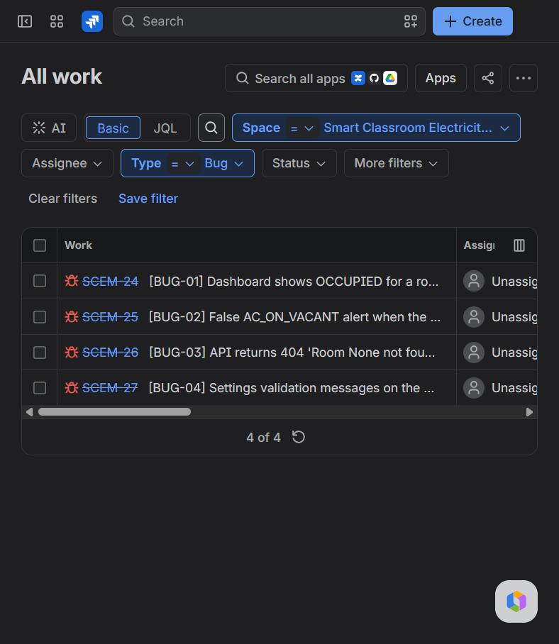 | 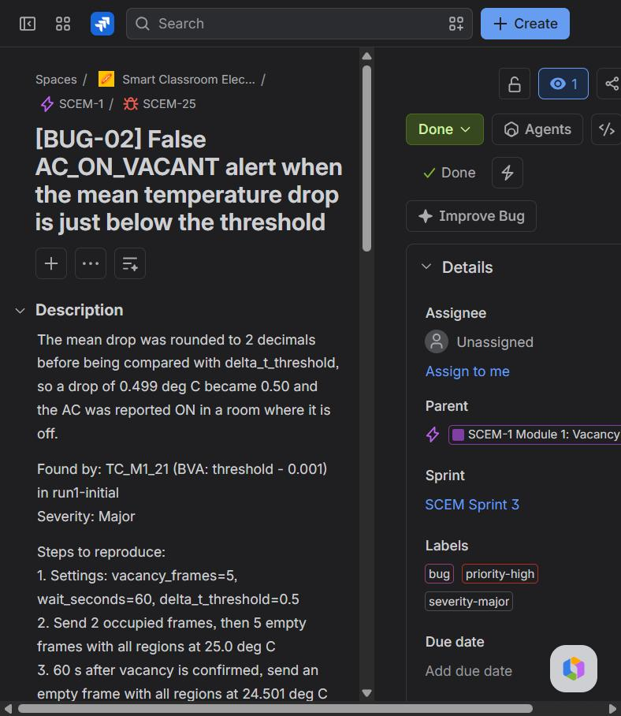
Figure 11: The four bugs in Jira (resolved keys are struck through) | Figure 12: SCEM-25 (BUG-02): description, found by, severity, steps, sprint, labels

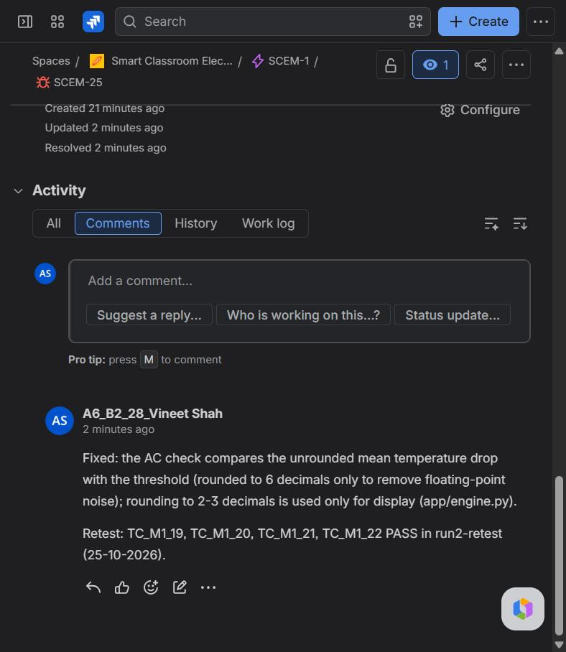
Figure 13: SCEM-25: fix and retest comment, resolved

10. Bug Fixing and Retesting Evidence
Test case | Bug | Run 1 (before fix) - actual | Run 1 | Run 2 (after fix) - actual | Run 2
TC_UI_01 | BUG-01 | OCCUPIED | FAIL | NO DATA | PASS
TC_M1_21 | BUG-02 | state=VACANT, ac_inferred_on=True, alerts=[AC_ON_VACANT] | FAIL | state=VACANT, ac_inferred_on=False, alerts=[] | PASS
TC_M2_04 | BUG-03 | 404: Room None not found. | FAIL | 400: room_id is required. | PASS
TC_UI_14 | BUG-04 | vacancy_frames must be between 1 and 300. | FAIL | Empty frames to confirm vacancy must be between 1 and 300. | PASS
TC_UI_15 | BUG-04 | delta_t_threshold must be a number. | FAIL | Mean ΔT threshold must be a number. | PASS

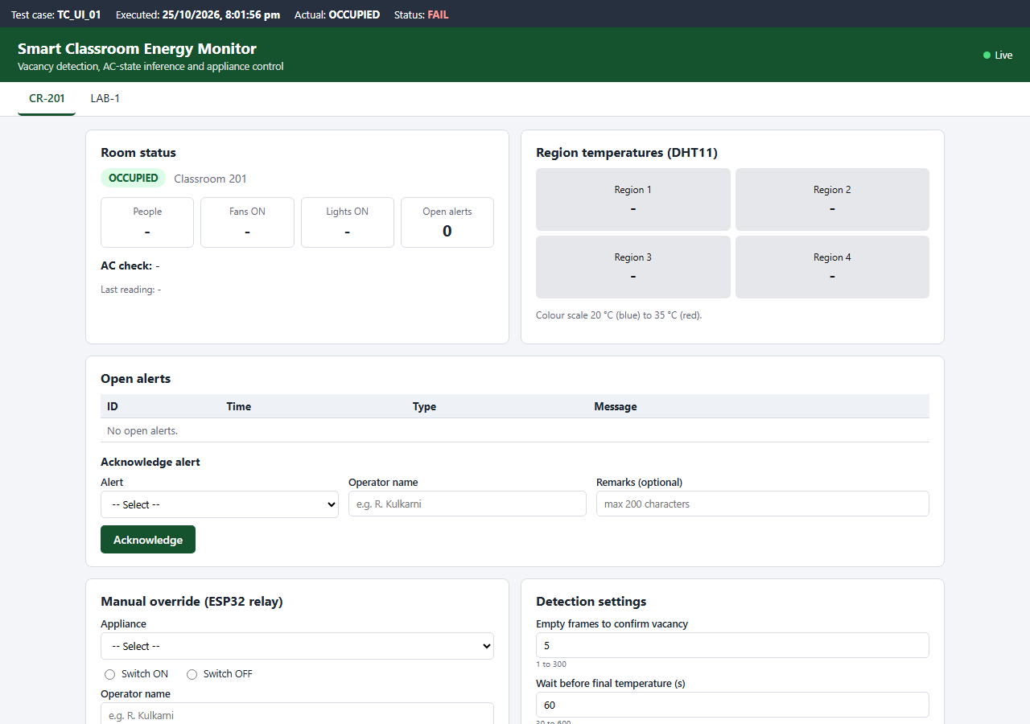
Figure 14: BUG-01 before the fix: CR-201 has no readings but is shown as OCCUPIED (TC_UI_01 FAIL)
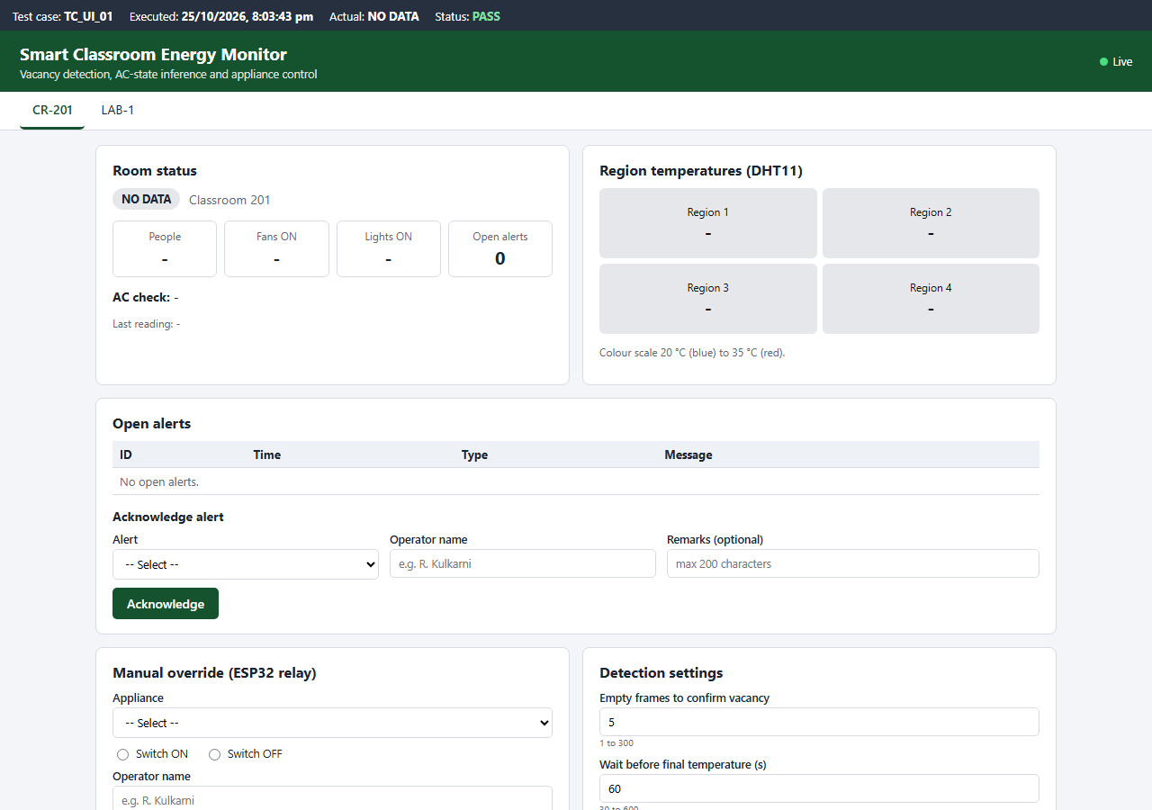
Figure 15: BUG-01 after the fix: NO DATA (TC_UI_01 PASS)
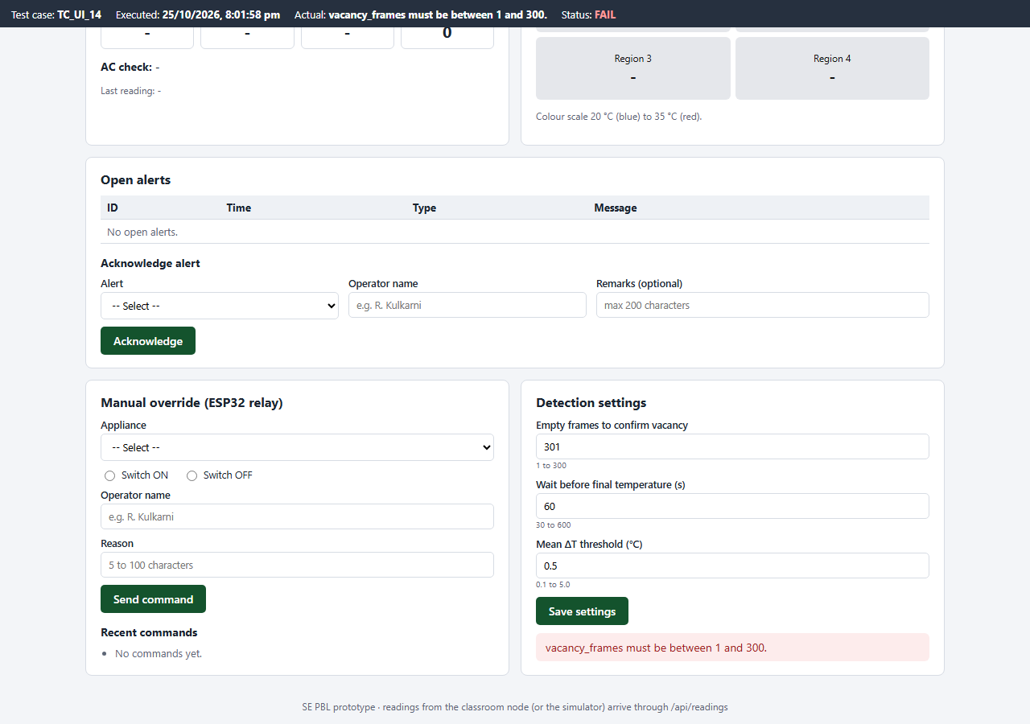
Figure 16: BUG-04 before the fix: internal field name in the message (TC_UI_14 FAIL)
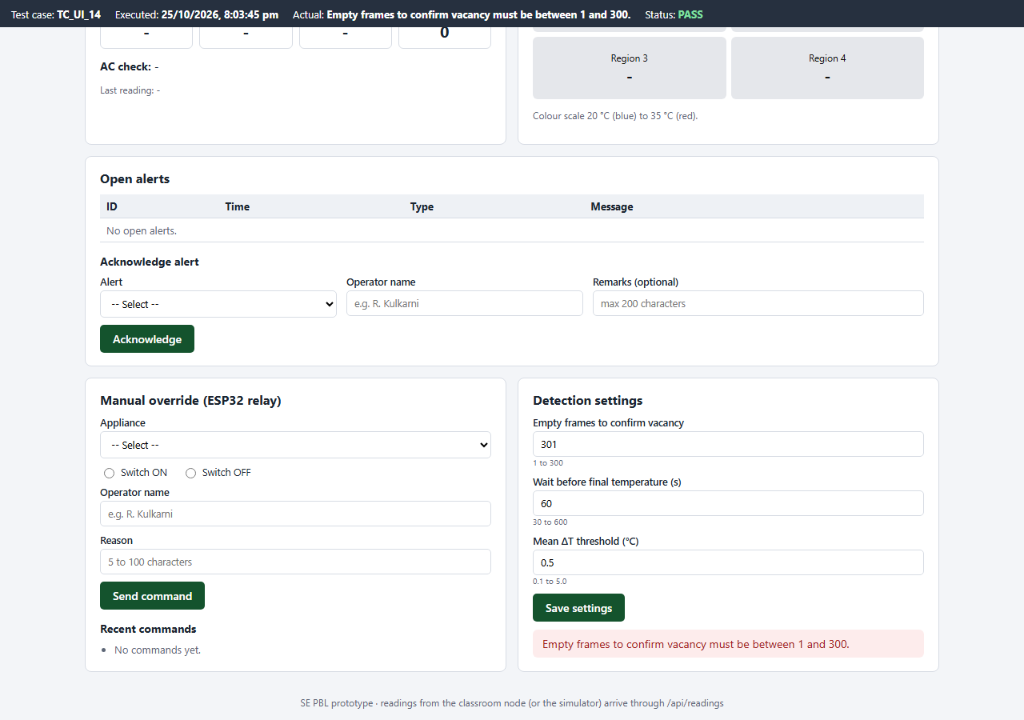
Figure 17: BUG-04 after the fix: message uses the form label (TC_UI_14 PASS)
Run 1 console output (failures only):
TC_M1_21 FAIL Mean temperature drop 0.499 deg C
expected: state=VACANT, ac_inferred_on=False, alerts=[]
actual : state=VACANT, ac_inferred_on=True, alerts=[AC_ON_VACANT]
TC_M2_04 FAIL Reading without room_id
expected: 400: room_id is required.
actual : 404: Room None not found.
TC_UI_01 FAIL Room that has sent no readings yet
expected: NO DATA
actual : OCCUPIED
TC_UI_14 FAIL Empty frames = 301
expected: Empty frames to confirm vacancy must be between 1 and 300.
actual : vacancy_frames must be between 1 and 300.
TC_UI_15 FAIL Threshold is not a number
expected: Mean ΔT threshold must be a number.
actual : delta_t_threshold must be a number.
78 test cases executed, 73 passed, 5 failed (23.9 s)

Run 2 console output (last lines):
TC_UI_12 PASS Override reason of 3 characters
TC_UI_13 PASS Save valid settings
TC_UI_14 PASS Empty frames = 301
TC_UI_15 PASS Threshold is not a number
78 test cases executed, 78 passed, 0 failed (21.5 s)

11. Final Working Demonstration
- Start the server: python -m app.server --port 8090 --db data/demo.db and open http://127.0.0.1:8090.
- Run the classroom simulator: python -m app.simulator --room LAB-1 --scenario ac_left_on.
- Watch LAB-1 change from OCCUPIED to CHECKING AC to VACANT; fan, light and AC alerts appear.
- Acknowledge an alert, send a fan OFF override, change a setting; run the all_off scenario for CR-201 to show the AC OFF result.
- Run python -m tests.run_tests to execute all 78 test cases.
Simulator log of the demonstration run (25-10-2026):
t= 0s state=OCCUPIED people=12 fans=4 lights=6 temps=[24.6, 25.1, 24.2, 25.4]
t= 15s state=CHECKING_AC people=0 fans=0 lights=0 temps=[24.62, 25.12, 24.23, 25.42]
t= 30s state=CHECKING_AC people=0 fans=0 lights=0 temps=[24.68, 25.16, 24.3, 25.48]
t= 45s state=CHECKING_AC people=0 fans=0 lights=0 temps=[24.74, 25.21, 24.38, 25.54]
t= 60s state=CHECKING_AC people=0 fans=0 lights=0 temps=[24.8, 25.25, 24.45, 25.6]
t= 75s state=VACANT people=0 fans=0 lights=0 temps=[24.86, 25.3, 24.53, 25.66]
-----
t= 0s state=OCCUPIED people=12 fans=4 lights=6 temps=[24.6, 25.1, 24.2, 25.4]
t= 14s ALERT FAN_ON_VACANT: 2 fan(s) ON in vacant room LAB-1.
t= 14s ALERT LIGHT_ON_VACANT: 6 light(s) ON in vacant room LAB-1.
t= 15s state=CHECKING_AC people=0 fans=2 lights=6 temps=[24.54, 25.05, 24.13, 25.35]
t= 30s state=CHECKING_AC people=0 fans=2 lights=6 temps=[24.39, 24.93, 23.95, 25.21]
t= 45s state=CHECKING_AC people=0 fans=2 lights=6 temps=[24.24, 24.81, 23.77, 25.08]
t= 60s state=CHECKING_AC people=0 fans=2 lights=6 temps=[24.09, 24.69, 23.59, 24.94]
t= 74s ALERT AC_ON_VACANT: AC appears to be ON in vacant room LAB-1 (mean temperature drop 0.58 deg C in 60 s).
t= 75s state=VACANT people=0 fans=2 lights=6 temps=[23.94, 24.57, 23.41, 24.81]

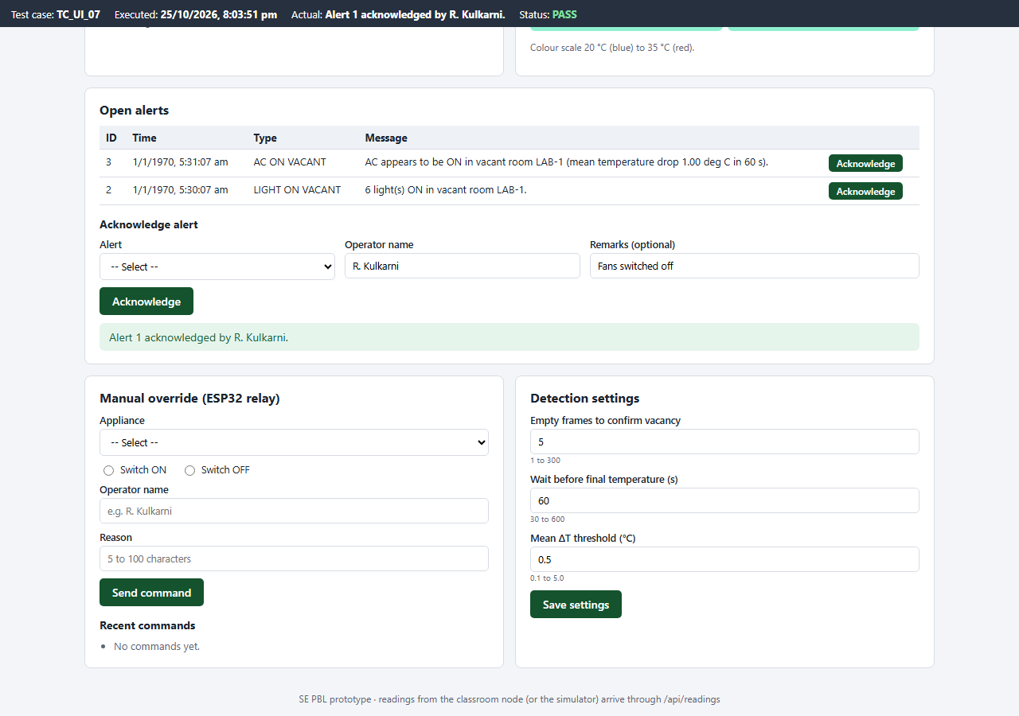
Figure 18: Alert acknowledged from the dashboard (TC_UI_07)
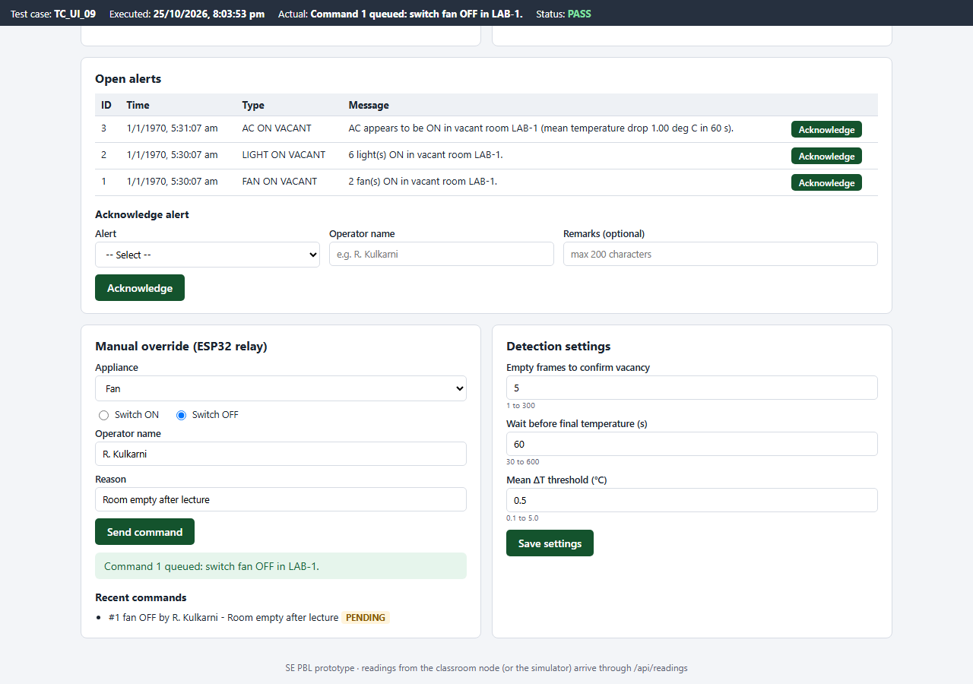
Figure 19: Manual override command queued (TC_UI_09)

12. Conclusion and Future Scope
Two modules of the Smart Classroom Electricity Management System were implemented individually: the vacancy and AC-state detection engine, and the monitoring dashboard with database, alerts, manual ESP32 override and settings. The work was planned and tracked in Jira as epics, user stories, tasks, sub-tasks and three sprints. 78 test cases using functional, unit, integration, boundary value, equivalence partitioning and validation testing were executed. The first run found 4 defects (5 failing test cases); all were recorded in Jira, fixed and retested, and the final run passed all 78 test cases.
- Connect the real CCTV + YOLOv8 detector, DHT11 sensors and ESP32 in place of the simulator.
- MQTT between the classroom node and the server, as in the original architecture.
- Daily energy report (hours of wasted appliance runtime per room) and mobile notifications.

Appendix A: app/engine.py (Module 1)
1 """Module 1: Vacancy and AC-state detection engine (edge decision engine).
2
3 Every frame from the classroom carries the YOLO detection counts (people, fans that are on, lights
4 that are on) and the temperatures of the four regions (one DHT11 sensor per region). The engine
5 confirms that the room is vacant over consecutive frames, raises an alert when a fan or light is left
6 on in a vacant room, and infers whether the AC is still running from the temperature drop (Delta T)
7 measured across the four regions after a waiting period.
8 """
9 from dataclasses import dataclass
10
11 REGIONS = 4
12 TEMP_MIN, TEMP_MAX = 0.0, 50.0 # DHT11 measuring range in deg C
13 COUNT_MAX = 50 # upper bound accepted for any detection count
14
15 OCCUPIED = "OCCUPIED"
16 CHECKING_AC = "CHECKING_AC" # vacancy confirmed, waiting for the final temperatures
17 VACANT = "VACANT" # vacancy confirmed and AC check finished
18 NO_DATA = "NO_DATA" # reported until the room sends its first frame
19
20 FAN_ON_VACANT = "FAN_ON_VACANT"
21 LIGHT_ON_VACANT = "LIGHT_ON_VACANT"
22 AC_ON_VACANT = "AC_ON_VACANT"
23
24
25 class ValidationError(ValueError):
26 """Raised when a frame or a setting is outside its allowed range."""
27
28
29 @dataclass
30 class Settings:
31 vacancy_frames: int = 10 # consecutive empty frames needed to confirm vacancy
32 wait_seconds: int = 120 # wait between the initial and final temperature readings
33 delta_t_threshold: float = 0.5 # mean temperature drop (deg C) that means the AC is still on
34
35 LIMITS = {"vacancy_frames": (1, 300), "wait_seconds": (30, 600), "delta_t_threshold": (0.1, 5.0)}
36
37 @classmethod
38 def from_dict(cls, data):
39 """Builds validated settings; raises ValidationError naming the first bad field."""
40 values = {}
41 for name, (low, high) in cls.LIMITS.items():
42 if name not in data:
43 raise ValidationError("%s is required." % name)
44 value = data[name]
45 is_int_field = name != "delta_t_threshold"
46 if isinstance(value, bool) or not isinstance(value, (int, float)):
47 raise ValidationError("%s must be a number." % name)
48 if is_int_field and value != int(value):
49 raise ValidationError("%s must be a whole number." % name)
50 if not low <= value <= high:
51 raise ValidationError("%s must be between %s and %s." % (name, low, high))
52 values[name] = int(value) if is_int_field else float(value)
53 return cls(**values)
54
55 def to_dict(self):
56 return {"vacancy_frames": self.vacancy_frames, "wait_seconds": self.wait_seconds,
57 "delta_t_threshold": self.delta_t_threshold}
58
59
60 @dataclass
61 class Frame:
62 timestamp: float
63 people: int
64 fans_on: int
65 lights_on: int
66 temps: list
67
68 @classmethod
69 def from_dict(cls, data):
70 """Validates one reading from the camera/sensor node."""
71 ts = data.get("timestamp")
72 if isinstance(ts, bool) or not isinstance(ts, (int, float)) or ts < 0:
73 raise ValidationError("timestamp must be a non-negative number.")
74 counts = {}
75 for name in ("people", "fans_on", "lights_on"):
76 value = data.get(name)
77 if isinstance(value, bool) or not isinstance(value, int):
78 raise ValidationError("%s must be a whole number." % name)
79 if not 0 <= value <= COUNT_MAX:
80 raise ValidationError("%s must be between 0 and %d." % (name, COUNT_MAX))
81 counts[name] = value
82 temps = data.get("temps")
83 if not isinstance(temps, list) or len(temps) != REGIONS:
84 raise ValidationError("temps must list exactly %d region temperatures." % REGIONS)
85 for i, t in enumerate(temps):
86 if isinstance(t, bool) or not isinstance(t, (int, float)):
87 raise ValidationError("temperature of region %d must be a number." % (i + 1))
88 if not TEMP_MIN <= t <= TEMP_MAX:
89 raise ValidationError("temperature of region %d must be between 0 and 50 deg C." % (i + 1))
90 return cls(float(ts), counts["people"], counts["fans_on"], counts["lights_on"], [float(t) for t in temps])
91
92
93 class RoomMonitor:
94 """Tracks one room frame by frame and returns the alerts each frame produces."""
95
96 def __init__(self, room_id, settings=None):
97 self.room_id = room_id
98 self.settings = settings or Settings()
99 self.state = OCCUPIED
100 self.empty_frames = 0
101 self.last_timestamp = None
102 self.initial_temps = None
103 self.check_started = None
104 self.fan_alerted = False
105 self.light_alerted = False
106 self.last_mean_drop = None
107 self.ac_inferred_on = None
108 self.last_frame = None
109
110 def process(self, frame):
111 if self.last_timestamp is not None and frame.timestamp <= self.last_timestamp:
112 raise ValidationError("timestamp must be later than the previous frame.")
113 self.last_timestamp = frame.timestamp
114 self.last_frame = frame
115 alerts = []
116
117 if frame.people > 0:
118 self._reset_to_occupied()
119 return alerts
120
121 self.empty_frames += 1
122 if self.state == OCCUPIED and self.empty_frames >= self.settings.vacancy_frames:
123 self.state = CHECKING_AC
124 self.initial_temps = list(frame.temps)
125 self.check_started = frame.timestamp
126
127 if self.state == OCCUPIED:
128 return alerts
129
130 alerts += self._appliance_alerts(frame)
131
132 if self.state == CHECKING_AC and frame.timestamp - self.check_started >= self.settings.wait_seconds:
133 drops = [start - end for start, end in zip(self.initial_temps, frame.temps)]
134 # Compare at full precision (6 decimals only removes float noise); rounding to 2 decimals
135 # before comparing turned a 0.499 deg C drop into 0.50 and raised a false AC alert (BUG-02).
136 mean_drop = round(sum(drops) / REGIONS, 6)
137 self.last_mean_drop = round(mean_drop, 3)
138 self.ac_inferred_on = mean_drop >= self.settings.delta_t_threshold
139 self.state = VACANT
140 if self.ac_inferred_on:
141 alerts.append(self._alert(AC_ON_VACANT, frame.timestamp,
142 "AC appears to be ON in vacant room %s (mean temperature drop %.2f deg C "
143 "in %d s)." % (self.room_id, self.last_mean_drop, self.settings.wait_seconds),
144 self.last_mean_drop))
145 return alerts
146
147 def _appliance_alerts(self, frame):
148 alerts = []
149 if frame.fans_on > 0 and not self.fan_alerted:
150 alerts.append(self._alert(FAN_ON_VACANT, frame.timestamp,
151 "%d fan(s) ON in vacant room %s." % (frame.fans_on, self.room_id), frame.fans_on))
152 if frame.lights_on > 0 and not self.light_alerted:
153 alerts.append(self._alert(LIGHT_ON_VACANT, frame.timestamp,
154 "%d light(s) ON in vacant room %s." % (frame.lights_on, self.room_id),
155 frame.lights_on))
156 # An appliance switched off and on again during the same vacancy is reported again.
157 self.fan_alerted = frame.fans_on > 0
158 self.light_alerted = frame.lights_on > 0
159 return alerts
160
161 def _reset_to_occupied(self):
162 self.state = OCCUPIED
163 self.empty_frames = 0
164 self.initial_temps = None
165 self.check_started = None
166 self.fan_alerted = False
167 self.light_alerted = False
168
169 def _alert(self, kind, timestamp, message, value):
170 return {"room_id": self.room_id, "type": kind, "timestamp": timestamp, "message": message, "value": value}
171
172 def status(self):
173 f = self.last_frame
174 return {
175 "room_id": self.room_id,
176 "state": self.state if f else NO_DATA,
177 "empty_frames": self.empty_frames,
178 "people": f.people if f else None,
179 "fans_on": f.fans_on if f else None,
180 "lights_on": f.lights_on if f else None,
181 "temps": f.temps if f else None,
182 "last_timestamp": self.last_timestamp,
183 "ac_check_seconds_left": (max(0, round(self.settings.wait_seconds - (self.last_timestamp - self.check_started)))
184 if self.state == CHECKING_AC else None),
185 "mean_temp_drop": self.last_mean_drop,
186 "ac_inferred_on": self.ac_inferred_on,
187 }

