Software Engineering Lab - Project-Based Learning (PBL)
Unified Student Placement System (USPS)
Job Posting & Eligibility Verification | Job Application & Tracking
Project Report

Particular | Details
Name | Vineet Shah
Class / Batch | 5S CSE / A6 - B2
Roll No. | 28
Course | Software Engineering Lab (24CS01PR0502)
Faculty | Prof. D. A. Borikar
Case study | Unified System for Student Placement in Academic Institutions (IEEE SRS, Expt-1 to Expt-5)
Implemented modules | Module 1: Job Posting and Eligibility Verification (SRS 4.3, 4.4)  Module 2: Job Application and Tracking (SRS 4.5)
Project management | Jira space USPS - epics, user stories, tasks, sub-tasks, sprints, bugs
Date | 26-10-2026

1. Project Title and Problem Statement
Title: Unified Student Placement System (USPS)
Campus placement drives are run today with spreadsheets, e-mail threads and notice-board announcements. Placement officers check every student's eligibility for every company by hand, students apply to jobs they are not eligible for or miss deadlines, the same data is copied many times and goes stale, and nobody has a live view of where an application stands.
USPS replaces this with one web platform: recruiters post jobs with eligibility criteria, the placement cell approves them, the system checks every student against the criteria automatically and with reasons, eligible students apply with a resume before the deadline, and every application moves through review, shortlisting, interview and offer with a timeline and notifications that everyone can see in real time.
This report covers the two modules implemented for the PBL out of the full system specified in my SE lab SRS: Module 1 - Job Posting and Eligibility Verification, and Module 2 - Job Application and Tracking. Registration and login, interview scheduling, offer documents and reports are other modules of the SRS and are outside this PBL.

2. System and Module Description
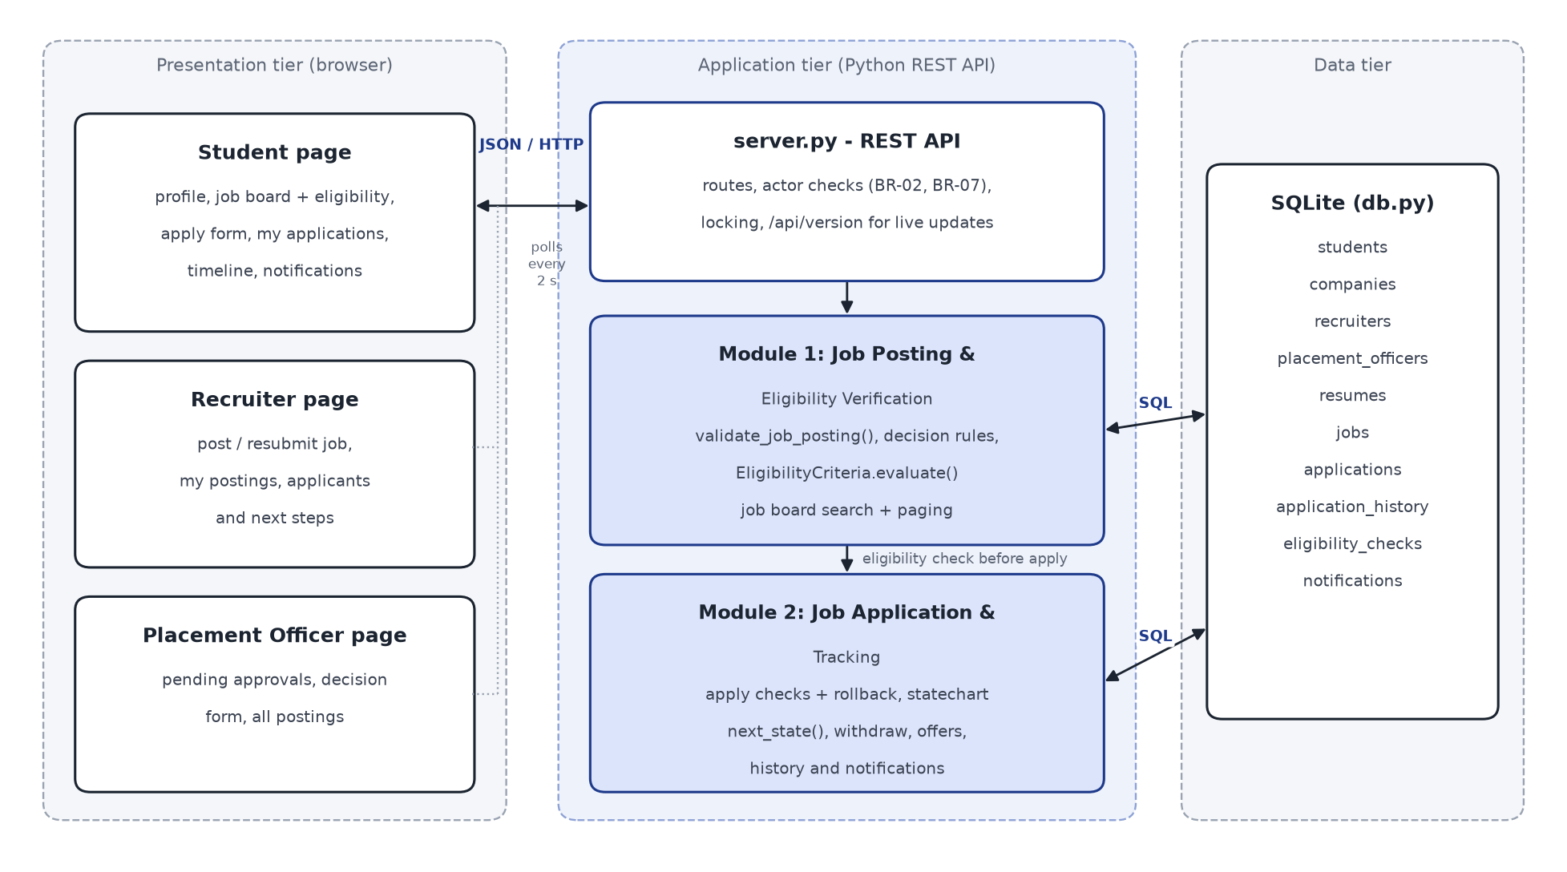
Figure 1: Three-tier architecture of the prototype (SRS 2.1); the two implemented modules are shaded
Module | What it does | SRS
Module 1 - Job Posting and Eligibility Verification | Recruiter posts a job with package, deadline and an eligibility rule-set; placement officer approves, rejects or returns it; returned postings are fixed and resubmitted; students search published jobs; every student is checked against each job automatically with the list of unmet criteria. | 4.3, 4.4; FR-09 to FR-14; UC-2; BR-02, BR-03
Module 2 - Job Application and Tracking | Eligible student applies with an active resume and cover note and gets a tracking id; recruiter / officer move the application through the Expt-5 statechart; student withdraws, accepts or declines an offer; timeline, notifications and live page updates. | 4.5; FR-15 to FR-17, FR-25; UC-1; BR-01, BR-04, BR-05, BR-07, BR-08

Earlier SE lab work | Used in the implementation as
Expt-1/2: IEEE SRS, use cases UC-1 and UC-2 | Requirements FR-1.x / FR-2.x (docs/requirements.md) with the exception flows E1-E4 and validation rules
Expt-3: class diagram | EligibilityCriteria.evaluate() / getReasons(), Application.updateStatus() -> next_state(), tracking id; tables follow the classes Student, Company, Job, Resume, Application, Notification
Expt-4: sequence diagram | Apply flow: select job -> verify eligibility -> store application -> notify
Expt-5: statechart and activity diagram | APPLICATION_TRANSITIONS in app/rules.py is the statechart transition table; the activity diagram's eligible / not eligible branch is the apply check
SRS 6.1 database design | SQLite tables in app/db.py

Item | Technology
Language / runtime | Python 3.11, standard library only (http.server, sqlite3, json, threading, unittest)
Database | SQLite - 10 tables (students, companies, recruiters, placement_officers, resumes, jobs, applications, application_history, eligibility_checks, notifications)
User interface | HTML, CSS, JavaScript (fetch API); one page with Student / Recruiter / Placement Officer views; polls /api/version every 2 s for live updates
Testing | Python test runner + unittest; user-interface tests in headless Microsoft Edge
Project management | Jira Cloud (team-managed Scrum space USPS)

3. Jira Project
Item | Details
Jira space | Unified Student Placement System - key USPS (Scrum, team-managed), board USPS board
Site | rbunagpur-team-zhx8jd75.atlassian.net
Work items | 4 epics, 11 user stories, 11 tasks, 19 sub-tasks, 4 bugs = 49 (USPS-1 to USPS-49)
Hierarchy | Epic -> Story / Task / Bug -> Sub-task; USPS-1 to USPS-4 are the epics
Workflow | To Do -> In Progress -> In Review -> Done
Members | A6_B2_28_Vineet Shah (24shahv@rbunagpur.in) - administrator; Vineet Shah (my second, personal account, invited by e-mail) - member with 14 work items assigned, including the open USPS-26
Status on 26-10-2026 | 47 Done; 2 In Progress (USPS-26 report and presentation, and its epic USPS-4)

The backlog is kept in jira/backlog.py (also exported as jira/jira_import.csv). The work items were created in the USPS space with parent links, story points, priorities and sprints, then moved through the workflow as the work was done. Each bug went To Do -> In Progress -> In Review -> Done and has a fix-and-retest comment. Issue keys are listed in jira/jira_keys.json.
Epic | Jira key | Description | Label
Module 1: Job Posting and Eligibility Verification | USPS-1 | Recruiters post jobs with eligibility criteria, placement officers approve / reject / return them, students search published jobs and the system checks eligibility automatically with reasons (SRS 4.3-4.4, FR-09 to FR-14, UC-2; requirements FR-1.1 to FR-1.8). | module-1
Module 2: Job Application and Tracking | USPS-2 | Students apply with a resume, recruiters move applications through the Expt-5 statechart, students withdraw, accept or decline offers and track a timeline; notifications and live page updates (SRS 4.5, FR-15 to FR-17, UC-1; requirements FR-2.1 to FR-2.12). | module-2
Testing and Quality Assurance | USPS-3 | Test case design (Functional, Unit, Integration, BVA, EP, Validation), automation of unit, API, integration and Edge UI tests, test runs, defect logging and retesting. | testing
Project Setup and Documentation | USPS-4 | Requirements from the SRS, project structure and database, report and presentation. | docs

Sprint and goal | Dates | Work items | Points | State
USPS Sprint 1  Requirements and Module 1: job posting, approval, search and eligibility check | 26-10-2026 10:30 - 10:50 | USPS-5, USPS-6, USPS-7, USPS-8, USPS-9, USPS-10, USPS-11 | 22 | Completed
USPS Sprint 2  Module 2: application, statechart workflow, tracking, notifications and live updates | 26-10-2026 10:50 - 11:05 | USPS-12, USPS-13, USPS-14, USPS-15, USPS-16, USPS-17 | 21 | Completed
USPS Sprint 3  Testing (155 cases), bug fixing, retesting, report and presentation | 26-10-2026 11:05 - 02-11-2026 | USPS-18, USPS-19, USPS-20, USPS-21, USPS-22, USPS-23, USPS-24, USPS-25, USPS-26, USPS-46 to USPS-49 (bugs) | 21 | Active

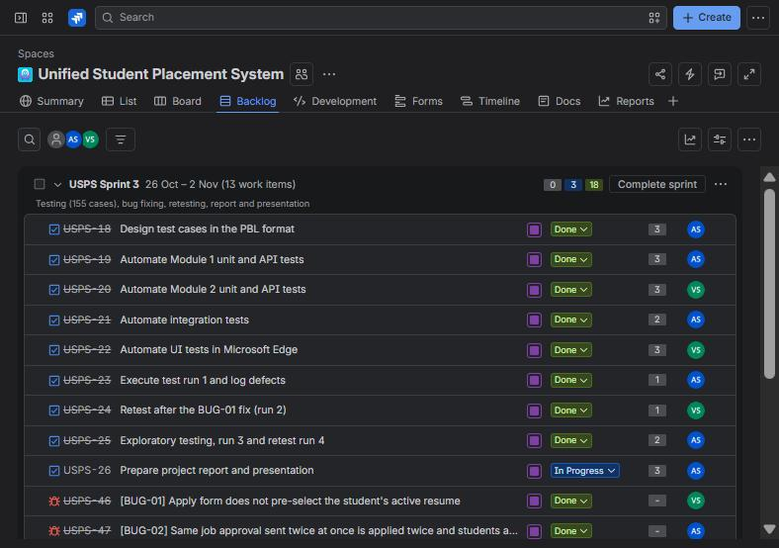 | 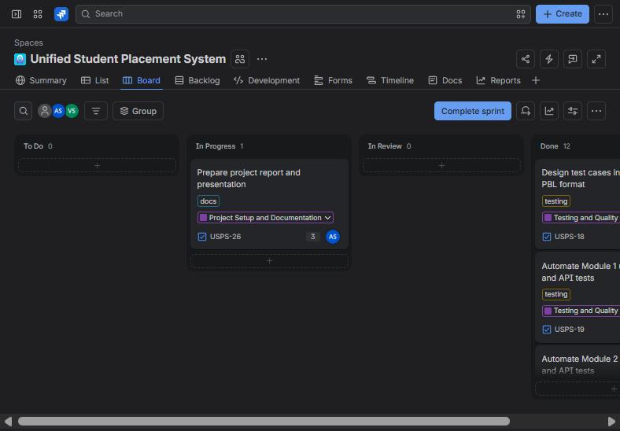
Figure 2: Backlog - active USPS Sprint 3 with goal, points and assignees | Figure 3: Board of USPS Sprint 3 - report task In Progress, the rest Done

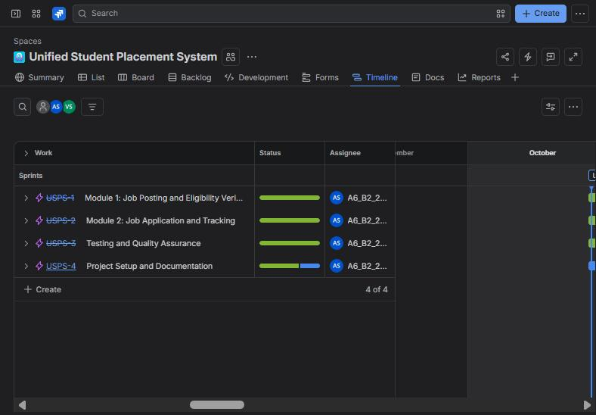 | 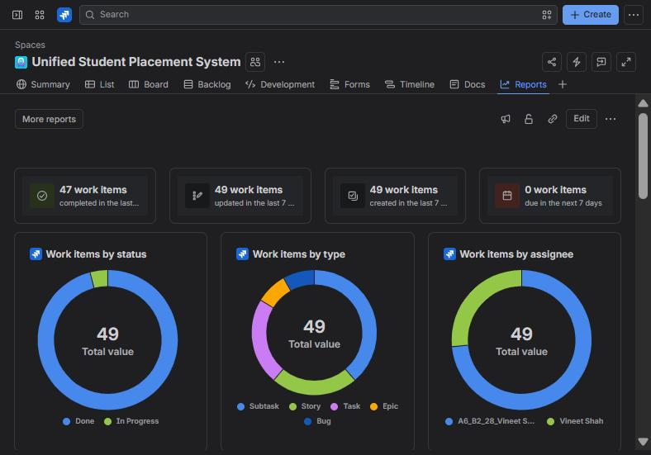
Figure 4: Timeline - progress of the four epics | Figure 5: Reports - 49 work items by status, type and assignee

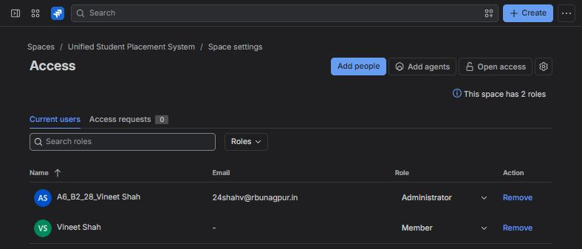 | 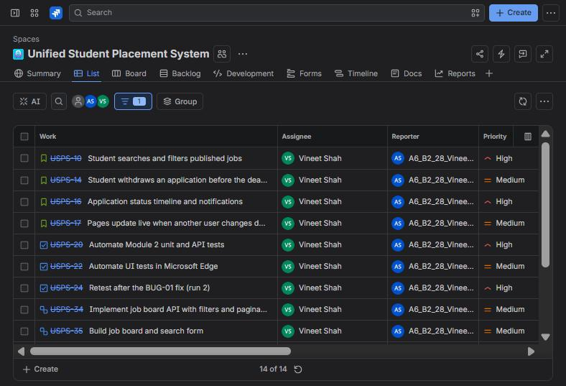
Figure 6: Space access - administrator and the invited member | Figure 7: The 14 work items assigned to the second member (USPS-26 still In Progress)

4. Product Backlog
Jira key | Type | Summary | Epic | Priority | Points | Sprint | Assignee
USPS-5 | Task | Derive the requirements of the two modules from the SRS | USPS-4 | High | 2 | S1 | AS
USPS-6 | Task | Set up project structure and SQLite schema (SRS 6.1) | USPS-4 | Medium | 2 | S1 | AS
USPS-7 | Story | Recruiter posts a job with eligibility criteria | USPS-1 | Highest | 5 | S1 | AS
USPS-8 | Story | Placement officer approves, rejects or returns a posting | USPS-1 | High | 3 | S1 | AS
USPS-9 | Story | Recruiter edits and resubmits a returned posting | USPS-1 | Medium | 2 | S1 | AS
USPS-10 | Story | Student searches and filters published jobs | USPS-1 | High | 3 | S1 | VS
USPS-11 | Story | Automatic eligibility check with reasons | USPS-1 | Highest | 5 | S1 | AS
USPS-12 | Story | Student applies to a job with a resume and cover note | USPS-2 | Highest | 5 | S2 | AS
USPS-13 | Story | Recruiter moves applications through the selection stages | USPS-2 | High | 5 | S2 | AS
USPS-14 | Story | Student withdraws an application before the deadline | USPS-2 | Medium | 2 | S2 | VS
USPS-15 | Story | Student accepts or declines an offer | USPS-2 | High | 3 | S2 | AS
USPS-16 | Story | Application status timeline and notifications | USPS-2 | High | 3 | S2 | VS
USPS-17 | Story | Pages update live when another user changes data | USPS-2 | Medium | 3 | S2 | VS
USPS-18 | Task | Design test cases in the PBL format | USPS-3 | High | 3 | S3 | AS
USPS-19 | Task | Automate Module 1 unit and API tests | USPS-3 | High | 3 | S3 | AS
USPS-20 | Task | Automate Module 2 unit and API tests | USPS-3 | High | 3 | S3 | VS
USPS-21 | Task | Automate integration tests | USPS-3 | High | 2 | S3 | AS
USPS-22 | Task | Automate UI tests in Microsoft Edge | USPS-3 | Medium | 3 | S3 | VS
USPS-23 | Task | Execute test run 1 and log defects | USPS-3 | High | 1 | S3 | AS
USPS-24 | Task | Retest after the BUG-01 fix (run 2) | USPS-3 | High | 1 | S3 | VS
USPS-25 | Task | Exploratory testing, run 3 and retest run 4 | USPS-3 | High | 2 | S3 | AS
USPS-26 | Task | Prepare project report and presentation | USPS-4 | Medium | 3 | S3 | VS

AS = A6_B2_28_Vineet Shah, VS = Vineet Shah (second account). Sub-tasks (19): USPS-27 Implement validate_job_posting() and EligibilityCriteria (USPS-7); USPS-28 Build Post a job form (USPS-7); USPS-29 Unit tests TC_M1_01 to TC_M1_23 (USPS-7); USPS-30 Implement decision API with remarks rules (USPS-8); USPS-31 Build officer approval screen (USPS-8); USPS-32 Implement PUT /api/jobs/<id> resubmission (USPS-9); USPS-33 Add Edit & resubmit to My job postings (USPS-9); USPS-34 Implement job board API with filters and pagination (USPS-10); USPS-35 Build job board and search form (USPS-10); USPS-36 Implement eligibility check with reasons and logging (USPS-11); USPS-37 Show eligibility badges and reasons (USPS-11); USPS-38 Implement apply API with ordered checks and rollback (USPS-12); USPS-39 Build apply form (USPS-12); USPS-40 Implement statechart transitions and authorisation (USPS-13); USPS-41 Build applicant list with next steps (USPS-13); USPS-42 Implement withdraw API (USPS-14); USPS-43 Implement offer response and placement lock (USPS-15); USPS-44 Build My applications, timeline and notifications (USPS-16); USPS-45 Add /api/version and page polling with notification pop-up (USPS-17).

5. User Stories
Key | User story and acceptance criteria | Points
USPS-7 | Recruiter posts a job with eligibility criteria  As a recruiter of an approved company I want to post a job with package, deadline and eligibility criteria so that the placement cell can publish it.  Acceptance: FR-1.1, FR-1.2, FR-1.3 (FR-09, FR-10, FR-13). | 5
USPS-8 | Placement officer approves, rejects or returns a posting  As a placement officer I want to approve, reject or return postings with remarks so that only checked jobs reach students.  Acceptance: FR-1.4 (FR-11, BR-02). | 3
USPS-9 | Recruiter edits and resubmits a returned posting  As a recruiter I want to fix a posting the officer returned and submit it again.  Acceptance: FR-1.5 (UC-2 A1). | 2
USPS-10 | Student searches and filters published jobs  As a student I want to search jobs by keyword, location, package and eligibility.  Acceptance: FR-1.6 (FR-12). | 3
USPS-11 | Automatic eligibility check with reasons  As a student I want to see whether I am eligible for a job and which criteria I do not meet.  Acceptance: FR-1.7, FR-1.8 (FR-14, BR-03). | 5
USPS-12 | Student applies to a job with a resume and cover note  As an eligible student I want to apply before the deadline and get a tracking id.  Acceptance: FR-2.1 to FR-2.4 (FR-15, UC-1, BR-04, BR-05). | 5
USPS-13 | Recruiter moves applications through the selection stages  As a recruiter I want to review, shortlist, schedule, select and make offers to my own applicants.  Acceptance: FR-2.5, FR-2.6 (Expt-5 statechart, BR-07, BR-08). | 5
USPS-14 | Student withdraws an application before the deadline  As a student I want to withdraw an application I no longer want.  Acceptance: FR-2.7 (FR-16). | 2
USPS-15 | Student accepts or declines an offer  As a student I want to respond to an offer; accepting marks me placed.  Acceptance: FR-2.8 (BR-01, BR-05). | 3
USPS-16 | Application status timeline and notifications  As a student I want a timeline of each application and notifications of every change.  Acceptance: FR-2.9 to FR-2.11 (FR-17, FR-25). | 3
USPS-17 | Pages update live when another user changes data  As any user I want my open page to show new jobs, approvals and status changes without reloading.  Acceptance: FR-2.12. | 3

6. Implementation of the Two Modules

6.1 Module 1: Job Posting and Eligibility Verification
The rules of the module are in app/rules.py and have no HTTP or SQL code, so they are unit-tested directly. validate_job_posting() checks a posting field by field and returns the first problem; EligibilityCriteria (class of the Expt-3 diagram) evaluates a student and returns every unmet criterion as a reason. app/server.py adds the actor checks, stores the job as Pending, handles the officer's decision and notifies the officers, the recruiter and the eligible students.
ID | Functional requirement (Module 1)
FR-1.1 | Job posting (FR-10, UC-2). A recruiter submits title (3–120 characters), description (20–2000), package/CTC in LPA (0 < CTC ≤ 100), location (2–80), application deadline (a date-time later than now) and eligibility criteria. Messages, checked in this order: Title must be 3 to 120 characters., Description must be 20 to 2000 characters., Package (CTC) must be a positive number up to 100 LPA. (a value that is not a number: Package (CTC) must be a number.), Location is required (2 to 80 characters)., Deadline must be a future date and time. A valid posting is stored as Pending, the placement officers are notified and the recruiter sees Job J-<id> submitted for approval (status: Pending).
FR-1.2 | Eligibility rule-set (FR-13). Each criterion is optional but at least one is required (At least one eligibility criterion is required.): minimum CGPA 0–10 (Minimum CGPA must be between 0 and 10.), allowed branches from CSE, IT, ECE, EE, ME, CE (Allowed branches must be chosen from CSE, IT, ECE, EE, ME, CE.), maximum active backlogs a whole number 0–10 (Maximum backlogs must be a whole number from 0 to 10.), batch in the form YYYY-YYYY spanning 4 years (Batch must look like 2023-2027.). A non-numeric CGPA/backlog value gives <field> must be a number.
FR-1.3 | Company approval (FR-09). A recruiter whose company is not approved by the placement cell cannot post: 403: Your company is not yet approved by the placement cell.
FR-1.4 | Job approval (FR-11, BR-02). Only a placement officer may decide a posting (403: Only a Placement Officer can approve or reject job postings.). Decisions: approve → Published, reject → Rejected, return → Returned (Decision must be approve, reject or return.). Remarks of 5–200 characters are required to reject or return (Remarks (5 to 200 characters) are required to reject or return a posting.); remarks are optional on approval but at most 200 characters (Remarks cannot exceed 200 characters.). Only a Pending posting can be decided (409: This job is not pending approval (status: <status>).). A posting whose deadline has already passed cannot be approved (409: The deadline of J-<id> has passed; return the posting so the recruiter can change it.); it can still be rejected or returned. A posting is decided only once even when the same decision arrives several times at the same moment (double click, two officers). The recruiter is notified of every decision. On approval every eligible student who is not yet placed is notified and the officer sees Job J-<id> published. <n> eligible student(s) notified.; otherwise Job J-<id> rejected. Recruiter notified. / Job J-<id> returned to the recruiter for changes.
FR-1.5 | Resubmission of a returned posting (UC-2 A1). The recruiter who posted a Returned job can edit it (same validation as FR-1.1/1.2) and resubmit it; it becomes Pending again and the officers are notified: Job J-<id> resubmitted for approval (status: Pending). Other recruiters: 403: You can edit only your own job postings.; a job that is not Returned: 409: Only a posting returned for changes can be edited (status: <status>).
FR-1.6 | Job search and filter (FR-12). Students see only Published jobs. Filters: keyword (case-insensitive, in title, description or company), location (case-insensitive, contains), minimum package (400: Minimum package must be a number.) and "eligible only". Open jobs are listed first (earliest deadline first), then jobs whose deadline has passed, which are marked Closed. Results are paginated, 10 per page by default (Page must be a whole number of at least 1.).
FR-1.7 | Automatic eligibility check (FR-14, BR-03). A student is eligible for a job when CGPA ≥ minimum, branch is allowed, active backlogs ≤ maximum and batch matches; criteria not set are not checked. Each unmet criterion gives a reason: CGPA <x> is below the minimum <y>., Branch <b> is not in the allowed branches (<list>)., Active backlogs <n> exceed the maximum <m>., Batch <b> does not match the required batch <r>. (CGPA shown with 2 decimals). Every check is recorded in the eligibility table.
FR-1.8 | Job board UI (SRS 4.4.2). For a job the student is not eligible for, the board shows Not eligible with the unmet criteria and the Apply action is disabled; it is also disabled for a Closed job.

EligibilityCriteria - automatic eligibility check with reasons (FR-1.7):
class EligibilityCriteria:
"""Rule-set attached to a job (FR-13). Any criterion left as None is not checked."""
def __init__(self, min_cgpa=None, allowed_branches=None, max_backlogs=None, batch=None):
self.min_cgpa = min_cgpa
self.allowed_branches = list(allowed_branches) if allowed_branches else []
self.max_backlogs = max_backlogs
self.batch = batch
def is_empty(self):
return self.min_cgpa is None and not self.allowed_branches and self.max_backlogs is None and not self.batch
def get_reasons(self, student):
"""Reasons why `student` (dict with cgpa, department, backlogs, batch) is not eligible (BR-03)."""
reasons = []
if self.min_cgpa is not None and student["cgpa"] < self.min_cgpa:
reasons.append("CGPA %.2f is below the minimum %.2f." % (student["cgpa"], self.min_cgpa))
if self.allowed_branches and student["department"] not in self.allowed_branches:
reasons.append("Branch %s is not in the allowed branches (%s)."
% (student["department"], ", ".join(self.allowed_branches)))
if self.max_backlogs is not None and student["backlogs"] > self.max_backlogs:
reasons.append("Active backlogs %d exceed the maximum %d." % (student["backlogs"], self.max_backlogs))
if self.batch and student["batch"] != self.batch:
reasons.append("Batch %s does not match the required batch %s." % (student["batch"], self.batch))
return reasons
def evaluate(self, student):
"""FR-14: (is_eligible, reasons)."""
reasons = self.get_reasons(student)
return (len(reasons) == 0, reasons)

6.2 Module 2: Job Application and Tracking
An application follows the statechart drawn in Expt-5. The statechart is coded as a transition table (APPLICATION_TRANSITIONS) and every status change goes through next_state(), so a step that the diagram does not allow (for example an offer before selection, BR-08) is refused. apply() makes the UC-1 checks in order and saves the application, its history and the notifications in one transaction; state-changing requests run under one lock so a double click is applied once.
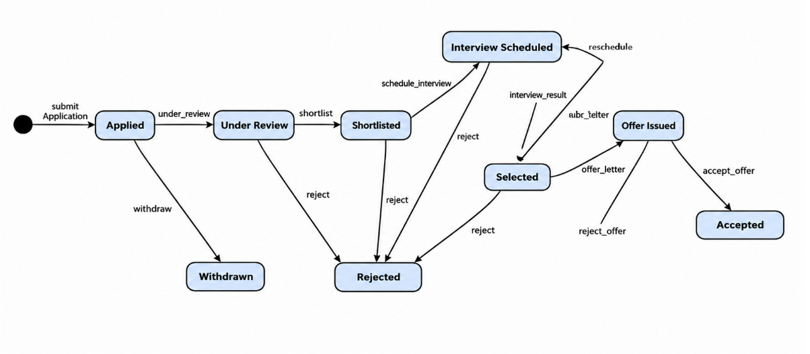
Figure 8: Application statechart from my Expt-5 submission - implemented as APPLICATION_TRANSITIONS
ID | Functional requirement (Module 2)
FR-2.1 | Application submission (FR-15, UC-1). The checks are made in this order: the job is Published (409: Job J-<id> is not open for applications.), the deadline has not passed (BR-04, 409: The application deadline for J-<id> has passed.), the student is not already placed (BR-05 single-offer policy, 409: You are already placed; the placement policy blocks further applications.), the student is eligible (E1, 409: You are not eligible for J-<id>: <reasons>), no earlier application to the same job (E3, 409: You have already applied to J-<id> (tracking id <tid>).), the resume belongs to the student and is active (400: Select one of your active resumes.), the optional cover note is at most 500 characters (400: Cover note cannot exceed 500 characters.).
FR-2.2 | On success (UC-1 step 6–7) the application is stored with status Applied and a unique tracking id USPS-<YY>-<NNNN> (2-digit year, 4-digit application number), the recruiter is notified, a confirmation notification goes to the student and the page shows Application submitted for J-<id>. Tracking id <tid>.
FR-2.3 | Apply form (UC-1 step 4, E1, E2). The student's active resume is pre-selected; inactive resumes are labelled (inactive). When the selected job is one the student is not eligible for, the unmet criteria are listed and Submit is disabled; for a Closed job the form shows The application deadline for J-<id> has passed. and Submit is disabled.
FR-2.4 | Persistence error (UC-1 E4). If saving fails, the whole transaction is rolled back (no application, history or notification row remains) and the student sees 500: Your application could not be saved and nothing was stored. Please try again.
FR-2.5 | Status workflow (Expt-5 statechart, BR-08). Applied –under_review→ Under Review –shortlist→ Shortlisted –schedule_interview→ Interview Scheduled (–reschedule→ itself) –interview_result→ Selected –offer_letter→ Offer Issued –accept_offer→ Accepted; reject from Under Review, Shortlisted, Interview Scheduled or Selected → Rejected; reject_offer from Offer Issued → Rejected; withdraw from Applied → Withdrawn. Any other event: 409: Event '<event>' is not allowed when the application is <state>. (so an offer can only follow selection, BR-08); an event name that does not exist: 400: Unknown event '<event>'. Each change is stored in the history with the actor and time, the student is notified, and the page shows Application <tid> is now <state>. A step is applied only once even when the same request arrives several times at the same moment; the extra requests get the 409 message of the new state.
FR-2.6 | Who may change an application (BR-07). Recruiter steps can be done only by the recruiter who posted the job or by a placement officer (403: Only the recruiter who posted this job or a Placement Officer can update this application.); accepting or declining an offer only by the student who applied (403: Only the student who applied can respond to the offer.). A recruiter's applicant list contains only applications to that recruiter's own jobs.
FR-2.7 | Withdrawal (FR-16). Only the student who applied (403: Only the student who applied can withdraw this application.), only while the application is Applied (409: Only an application in the Applied state can be withdrawn (current: <state>).) and only before the job deadline (409: The deadline has passed; the application can no longer be withdrawn.).
FR-2.8 | Offer acceptance (BR-01, BR-05). Accepting an offer marks the student Placed. A student who already holds an accepted offer cannot accept another (409: You already hold an accepted offer; the placement policy allows only one.) and cannot apply to further jobs (FR-2.1).
FR-2.9 | Tracking (FR-17). The student sees all own applications (newest first) with status, and a timeline of each: the main path Applied → … → Accepted with the reached and current states highlighted, Rejected/Withdrawn shown as an end state, and the full history (time, from → to, step, actor).
FR-2.10 | Confirmation (SRS 3.1, destructive actions). Withdraw, decline offer, reject an applicant and reject a posting ask for confirmation; cancelling leaves the record unchanged.
FR-2.11 | Notifications (FR-25). Each user sees own notifications, newest first, with time.
FR-2.12 | Real-time updates (FR-17 "real-time", SRS 4.3.2). Every open page shows changes made by any other user within about 2 seconds without reloading: a posted job appears in the officers' pending list, an approved job on the students' job board, a new application in the recruiter's applicant list and a status change in the student's applications. A notification that arrives this way also pops up on the page. A half-filled form is not cleared by such an update.

PlacementApp.apply() - UC-1 checks, tracking id and rollback (FR-2.1 to FR-2.4):
def apply(self, body):
if not body.get("job_id"):
raise ApiError(400, "Select a job to apply for.")
with self.lock:
student = self._student(body.get("student_id"))
job = self._job(body.get("job_id"))
key = job_key(job["job_id"])
now = self.clock()
if job["status"] != "published":
raise ApiError(409, "Job %s is not open for applications." % key)
if job["deadline"] <= now.isoformat(timespec="minutes"):
raise ApiError(409, "The application deadline for %s has passed." % key)
if student["is_placed"]:
raise ApiError(409, "You are already placed; the placement policy blocks further applications.")
eligible, reasons = self._criteria(job).evaluate(student)
self._record_check(job, student, eligible, reasons)
if not eligible:
raise ApiError(409, "You are not eligible for %s: %s" % (key, " ".join(reasons)))
dup = self.db.one("SELECT tracking_id FROM applications WHERE student_id = ? AND job_id = ?",
(student["student_id"], job["job_id"]))
if dup:
raise ApiError(409, "You have already applied to %s (tracking id %s)." % (key, dup["tracking_id"]))
resume = self.db.one("SELECT * FROM resumes WHERE resume_id = ? AND student_id = ? AND is_active = 1",
(body.get("resume_id"), student["student_id"]))
if not resume:
raise ApiError(400, "Select one of your active resumes.")
note = (body.get("cover_note") or "").strip()
if len(note) > 500:
raise ApiError(400, "Cover note cannot exceed 500 characters.")
stamp = now.isoformat(timespec="seconds")
try:
with self.db.transaction() as tx:
app_id = tx.execute("INSERT INTO applications (student_id, job_id, resume_id, cover_note, "
"applied_on, status) VALUES (?, ?, ?, ?, ?, ?)",
(student["student_id"], job["job_id"], resume["resume_id"], note, stamp,
rules.APPLIED)).lastrowid
tid = rules.tracking_id(app_id, now.year)
tx.execute("UPDATE applications SET tracking_id = ? WHERE app_id = ?", (tid, app_id))
tx.execute(HISTORY_SQL, (app_id, None, rules.APPLIED, "submit",
"student %d" % student["student_id"], stamp))
tx.execute(NOTIFY_SQL, ("recruiter", job["posted_by"], "New application %s from %s for %s."
% (tid, student["name"], job["title"]), stamp))
tx.execute(NOTIFY_SQL, ("student", student["student_id"], "Your application %s for %s at %s "
"was received." % (tid, job["title"], job["company"]), stamp))
except sqlite3.Error:
raise ApiError(500, "Your application could not be saved and nothing was stored. Please try again.")
return {"ok": True, "app_id": app_id, "tracking_id": tid,
"message": "Application submitted for %s. Tracking id %s." % (key, tid)}

6.3 REST API, database and pages
Method and path | Purpose
GET /api/meta, /api/version | Demo users, resumes, statechart; data version polled by every page
POST /api/jobs, PUT /api/jobs/<id> | Post a job / resubmit a returned job (Module 1)
POST /api/jobs/<id>/decision | Officer approves, rejects or returns a posting (Module 1)
GET /api/jobs?q=&location=&min_ctc=&eligible_only=&page= | Job board with eligibility (Module 1)
GET /api/jobs/<id>/eligibility?student_id= | Eligibility check with reasons, recorded (Module 1)
GET /api/jobs/manage?recruiter_id= | status= | Recruiter's postings / officer's pending list
POST /api/applications | Apply (Module 2)
POST /api/applications/<id>/events, /withdraw | Statechart step, offer response, withdrawal (Module 2)
GET /api/applications?student_id= | recruiter_id=, /api/applications/<id> | My applications / applicants of own jobs (BR-07) / timeline
GET /api/notifications?recipient_type=&recipient_id= | Notifications, newest first

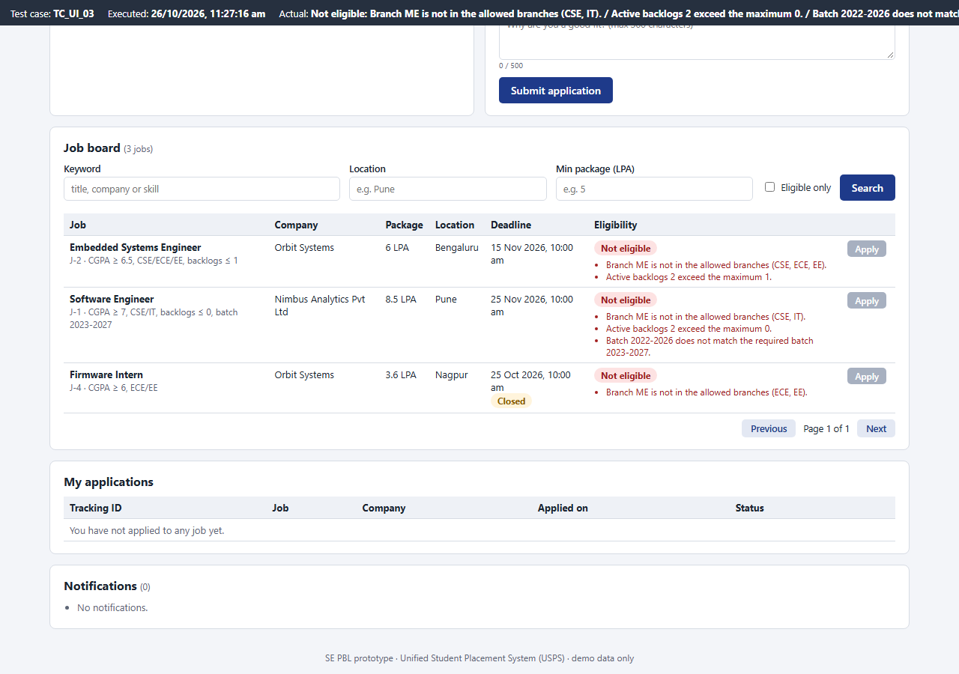 | 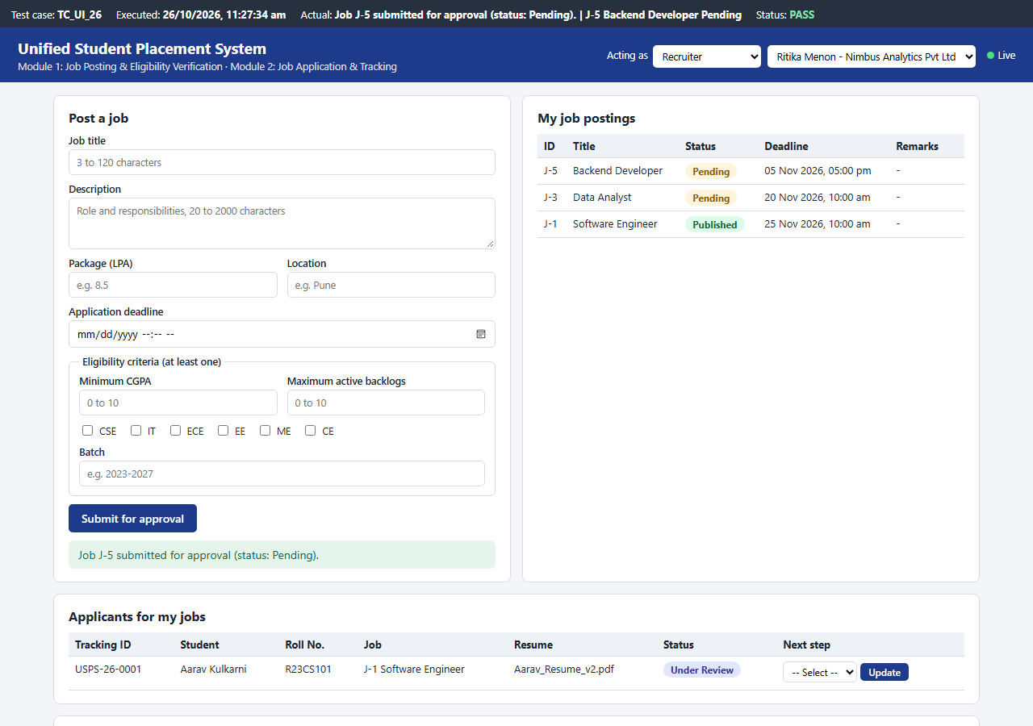
Figure 9: Student 105: unmet criteria listed, Apply disabled | Figure 10: Recruiter posts J-5; it is stored as Pending

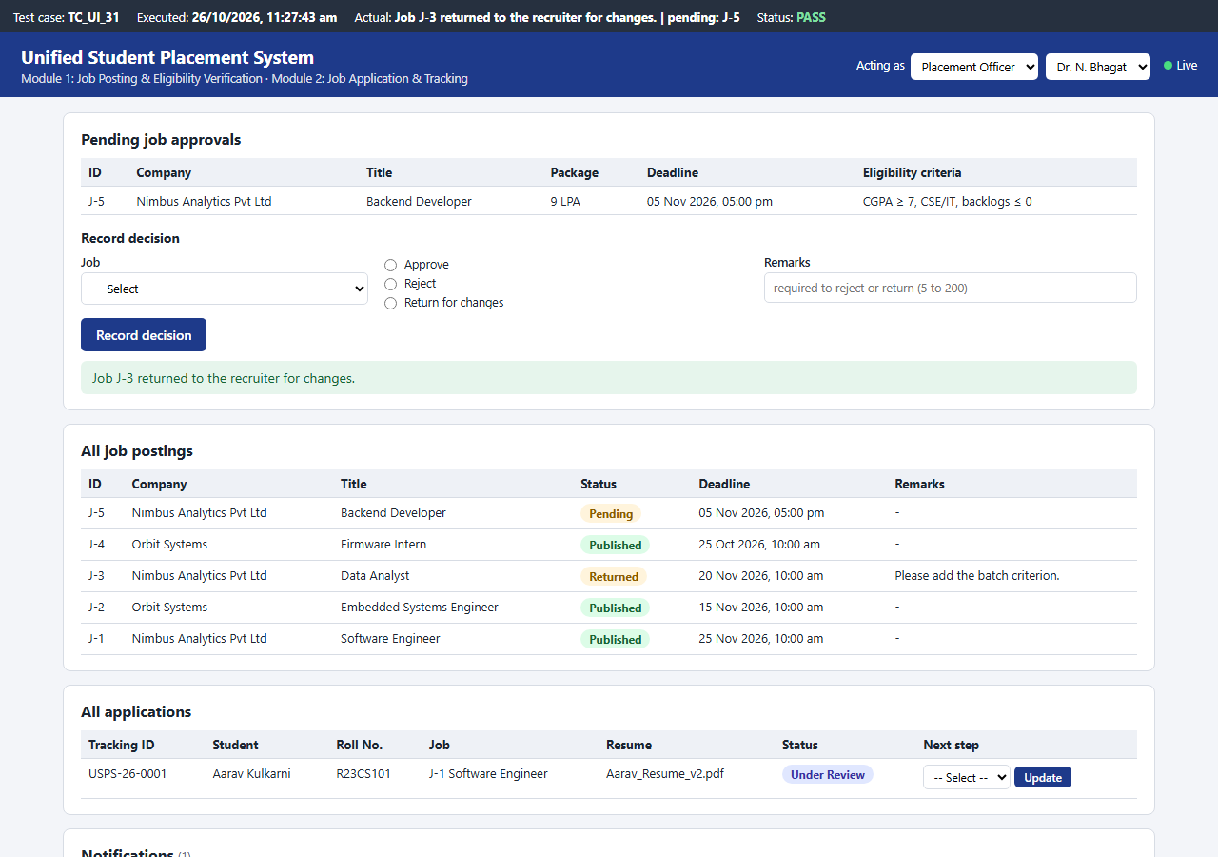 | 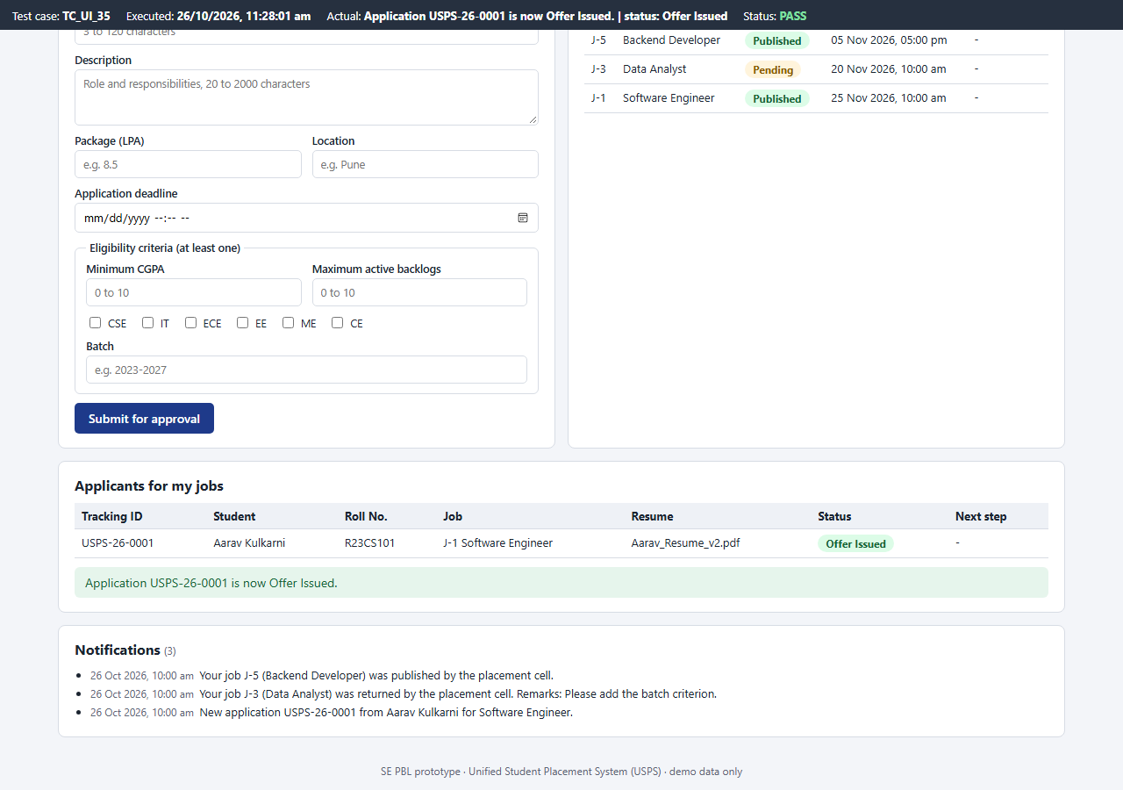
Figure 11: Officer returns J-3 with remarks | Figure 12: Recruiter moves USPS-26-0001 to Offer Issued

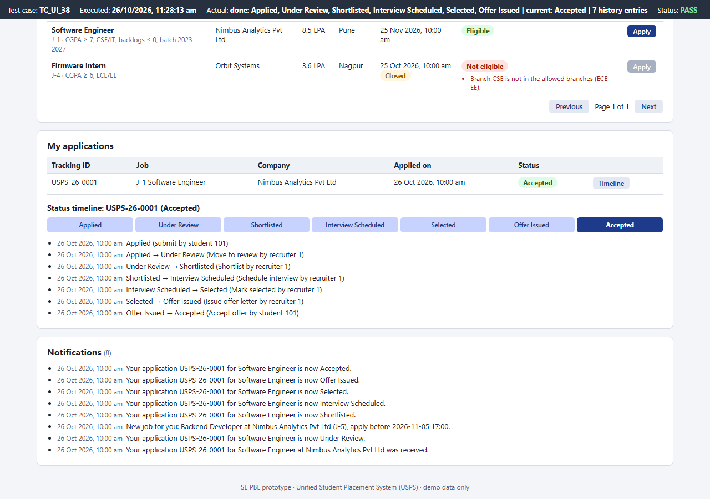 | 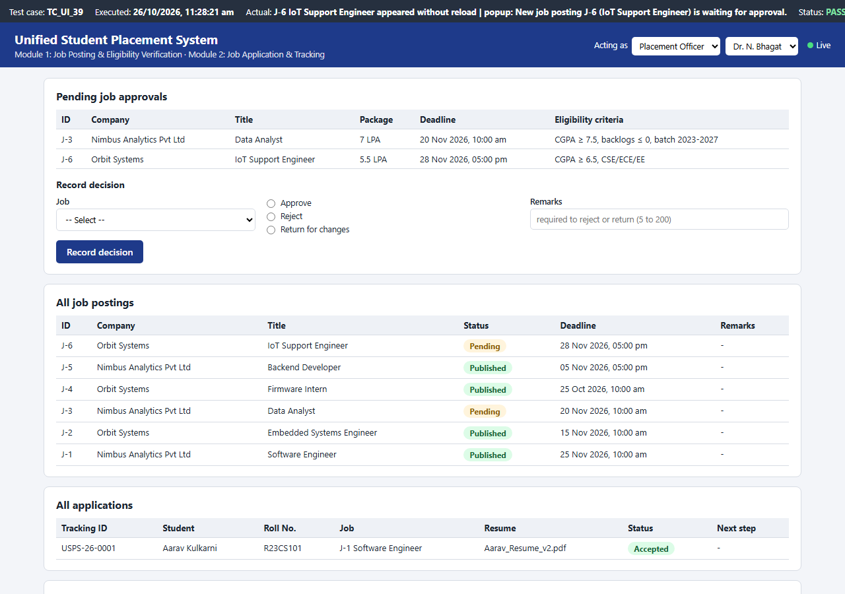
Figure 13: Student timeline after accepting the offer | Figure 14: Live update: a job posted elsewhere appears on the officer's open page with a pop-up

Integration: a posting made on the recruiter page goes through the API into Module 1, is stored as Pending and appears on the officer page within 2 seconds; after approval Module 1 evaluates every student and notifies the eligible ones, whose job boards update by themselves; applying runs the Module 1 eligibility check again inside Module 2 before the application is stored.

7. Source Code
File | Lines | Contents
app/rules.py | 163 | Business rules of both modules: posting validation, EligibilityCriteria, decisions, statechart, tracking id
app/server.py | 517 | REST API, actor checks, Module 1 and Module 2 services, live-update version
app/db.py | 134 | SQLite schema (SRS 6.1), demo data, transactions
app/static/index.html | 175 | Page with student, recruiter and officer views
app/static/app.js | 644 | Page logic: forms, tables, timeline, live polling
app/static/style.css | 95 | Styles, responsive layout
run.py | 10 | Starts the portal
tests/helpers.py | 112 | Test clock, throw-away server, HTTP client
tests/m1_cases.py | 278 | 61 Module 1 cases
tests/m2_cases.py | 267 | 42 Module 2 cases
tests/integration_cases.py | 214 | 11 integration cases
tests/ui/ui_cases.js | 356 | 41 UI cases
tests/run_tests.py | 83 | Executes all cases and records actual results
tests/capture_evidence.py | 36 | Screenshots of UI cases for the report
jira/backlog.py | 173 | Jira backlog and CSV export

python run.py # start the portal: http://127.0.0.1:8091
python -m tests.run_tests run4 # execute all 155 test cases
python -m unittest -v tests.test_all # Python cases through unittest

8. Test Cases and Test Results
Technique | How it was applied
Unit testing | app/rules.py tested directly: posting validation, eligibility, decisions, statechart (TC_M1_01-37, TC_M2_01-08)
Functional testing | Every functional requirement checked through the API and the page
Integration testing | Module 1 + Module 2 + database + notifications: full placement flow, rollback, concurrency, restart, live updates (TC_INT_01-11, TC_UI_39-40)
Boundary Value Analysis | title 2/3/120/121, package 0/0.1/100/100.5, CGPA 6.99/7.00/10/10.01, backlogs, remarks 4/5/201, cover note 500/501, deadline = now / now+1 min, apply 1 min before and at the deadline, page 0
Equivalence Partitioning | valid and invalid classes of every input: numbers as words, unknown branch, wrong batch, inactive / other student's resume, unknown decision or event
Validation testing | every error message of the API and of the page forms

Test cases were designed from docs/requirements.md before execution and are automated: Python cases call app/rules.py or a fresh server with the demo data and a fixed test clock (26-10-2026 10:00); UI cases fill the page in Microsoft Edge and read what it shows. Actual results below are from the final run (run4, 2026-10-26 11:25:19). Earlier runs are compared in Section 10.

M1 Job Posting & Eligibility
Test Case ID | Module | Test Scenario | Test Data | Expected Result | Actual Result | Status
TC_M1_01 | M1 Job Posting & Eligibility | Valid job posting with all criteria  [Unit / EP (valid)] | Backend Developer, 9 LPA, Pune, deadline 05-11-2026 17:00, CGPA>=7, CSE, 0 backlogs, 2023-2027 | accepted | accepted | PASS
TC_M1_02 | M1 Job Posting & Eligibility | Title of 2 characters  [Unit / BVA (min-1)] | title='QA' | Title must be 3 to 120 characters. | Title must be 3 to 120 characters. | PASS
TC_M1_03 | M1 Job Posting & Eligibility | Title of 3 characters  [Unit / BVA (min)] | title='SDE' | accepted | accepted | PASS
TC_M1_04 | M1 Job Posting & Eligibility | Title of 120 characters  [Unit / BVA (max)] | title='A'*120 | accepted | accepted | PASS
TC_M1_05 | M1 Job Posting & Eligibility | Title of 121 characters  [Unit / BVA (max+1)] | title='A'*121 | Title must be 3 to 120 characters. | Title must be 3 to 120 characters. | PASS
TC_M1_06 | M1 Job Posting & Eligibility | Description of 19 characters  [Unit / BVA (min-1)] | description='Write code for APIs' (19) | Description must be 20 to 2000 characters. | Description must be 20 to 2000 characters. | PASS
TC_M1_07 | M1 Job Posting & Eligibility | Package of 0 LPA  [Unit / BVA (min-1)] | ctc=0 | Package (CTC) must be a positive number up to 100 LPA. | Package (CTC) must be a positive number up to 100 LPA. | PASS
TC_M1_08 | M1 Job Posting & Eligibility | Package just above 0  [Unit / BVA (min)] | ctc=0.1 | accepted | accepted | PASS
TC_M1_09 | M1 Job Posting & Eligibility | Package of 100 LPA  [Unit / BVA (max)] | ctc=100 | accepted | accepted | PASS
TC_M1_10 | M1 Job Posting & Eligibility | Package above 100 LPA  [Unit / BVA (max+)] | ctc=100.5 | Package (CTC) must be a positive number up to 100 LPA. | Package (CTC) must be a positive number up to 100 LPA. | PASS
TC_M1_11 | M1 Job Posting & Eligibility | Package typed as words  [Unit / EP (invalid)] | ctc='eight' | Package (CTC) must be a number. | Package (CTC) must be a number. | PASS
TC_M1_12 | M1 Job Posting & Eligibility | Location left empty  [Unit / Validation] | location='' | Location is required (2 to 80 characters). | Location is required (2 to 80 characters). | PASS
TC_M1_13 | M1 Job Posting & Eligibility | Deadline equal to the current time  [Unit / BVA (equal)] | deadline=26-10-2026 10:00 (= now) | Deadline must be a future date and time. | Deadline must be a future date and time. | PASS
TC_M1_14 | M1 Job Posting & Eligibility | Deadline one minute in the future  [Unit / BVA (now+1 min)] | deadline=26-10-2026 10:01 | accepted | accepted | PASS
TC_M1_15 | M1 Job Posting & Eligibility | Deadline that is not a date  [Unit / EP (invalid)] | deadline='next friday' | Deadline must be a future date and time. | Deadline must be a future date and time. | PASS
TC_M1_16 | M1 Job Posting & Eligibility | No eligibility criterion given (UC-2 E1)  [Unit / Validation] | all four criteria blank | At least one eligibility criterion is required. | At least one eligibility criterion is required. | PASS
TC_M1_17 | M1 Job Posting & Eligibility | Minimum CGPA of 10  [Unit / BVA (max)] | min_cgpa=10 | accepted | accepted | PASS
TC_M1_18 | M1 Job Posting & Eligibility | Minimum CGPA above 10  [Unit / BVA (max+)] | min_cgpa=10.01 | Minimum CGPA must be between 0 and 10. | Minimum CGPA must be between 0 and 10. | PASS
TC_M1_19 | M1 Job Posting & Eligibility | Maximum backlogs of -1  [Unit / BVA (min-1)] | max_backlogs=-1 | Maximum backlogs must be a whole number from 0 to 10. | Maximum backlogs must be a whole number from 0 to 10. | PASS
TC_M1_20 | M1 Job Posting & Eligibility | Maximum backlogs not a whole number  [Unit / EP (invalid)] | max_backlogs=1.5 | Maximum backlogs must be a whole number from 0 to 10. | Maximum backlogs must be a whole number from 0 to 10. | PASS
TC_M1_21 | M1 Job Posting & Eligibility | Branch that does not exist  [Unit / EP (invalid)] | allowed_branches=['CSE', 'AI'] | Allowed branches must be chosen from CSE, IT, ECE, EE, ME, CE. | Allowed branches must be chosen from CSE, IT, ECE, EE, ME, CE. | PASS
TC_M1_22 | M1 Job Posting & Eligibility | Batch spanning 3 years  [Unit / EP (invalid)] | batch='2023-2026' | Batch must look like 2023-2027. | Batch must look like 2023-2027. | PASS
TC_M1_23 | M1 Job Posting & Eligibility | Only one criterion (batch) given  [Unit / EP (valid)] | batch='2024-2028', others blank | accepted | accepted | PASS
TC_M1_24 | M1 Job Posting & Eligibility | Student meeting every criterion of J-1  [Unit / EP (eligible)] | Aarav: CSE, CGPA 8.60, 0 backlogs, 2023-2027 vs J-1 | eligible | eligible | PASS
TC_M1_25 | M1 Job Posting & Eligibility | CGPA exactly equal to the minimum  [Unit / BVA (equal)] | CGPA 7.00 vs min 7.0 | eligible | eligible | PASS
TC_M1_26 | M1 Job Posting & Eligibility | CGPA just below the minimum  [Unit / BVA (min-0.01)] | CGPA 6.99 vs min 7.0 | CGPA 6.99 is below the minimum 7.00. | CGPA 6.99 is below the minimum 7.00. | PASS
TC_M1_27 | M1 Job Posting & Eligibility | Branch not in the allowed list  [Unit / EP (invalid class)] | Diya as ME student vs CSE/IT | Branch ME is not in the allowed branches (CSE, IT). | Branch ME is not in the allowed branches (CSE, IT). | PASS
TC_M1_28 | M1 Job Posting & Eligibility | Backlogs equal to and one above the maximum  [Unit / BVA (equal, max+1)] | max 1 backlog: student with 1, then with 2 | eligible / Active backlogs 2 exceed the maximum 1. | eligible / Active backlogs 2 exceed the maximum 1. | PASS
TC_M1_29 | M1 Job Posting & Eligibility | Several unmet criteria are all reported  [Unit / Functional] | Kabir (ECE, 6.80, 1) vs J-1 | CGPA 6.80 is below the minimum 7.00. | Branch ECE is not in the allowed branches (CSE, IT). | Active backlogs 1 exceed the maximum 0. | CGPA 6.80 is below the minimum 7.00. | Branch ECE is not in the allowed branches (CSE, IT). | Active backlogs 1 exceed the maximum 0. | PASS
TC_M1_30 | M1 Job Posting & Eligibility | Batch does not match  [Unit / Functional] | Rohan (ME, 2 backlogs, 2022-2026) vs J-1 | Branch ME is not in the allowed branches (CSE, IT). | Active backlogs 2 exceed the maximum 0. | Batch 2022-2026 does not match the required batch 2023-2027. | Branch ME is not in the allowed branches (CSE, IT). | Active backlogs 2 exceed the maximum 0. | Batch 2022-2026 does not match the required batch 2023-2027. | PASS
TC_M1_31 | M1 Job Posting & Eligibility | Criteria that are not set are not checked  [Unit / EP] | rule: only CGPA >= 6.0; Rohan | eligible | eligible | PASS
TC_M1_32 | M1 Job Posting & Eligibility | Approve without remarks  [Unit / EP (valid)] | pending, approve, remarks='' | published | published | PASS
TC_M1_33 | M1 Job Posting & Eligibility | Reject with 4-character remarks  [Unit / BVA (min-1)] | reject, remarks='Late' | Remarks (5 to 200 characters) are required to reject or return a posting. | Remarks (5 to 200 characters) are required to reject or return a posting. | PASS
TC_M1_34 | M1 Job Posting & Eligibility | Reject with 5-character remarks  [Unit / BVA (min)] | reject, remarks='Spam.' | rejected | rejected | PASS
TC_M1_35 | M1 Job Posting & Eligibility | Approve with 201-character remarks  [Unit / BVA (max+1)] | approve, remarks='x'*201 | Remarks cannot exceed 200 characters. | Remarks cannot exceed 200 characters. | PASS
TC_M1_36 | M1 Job Posting & Eligibility | Unknown decision  [Unit / EP (invalid)] | decision='hold' | Decision must be approve, reject or return. | Decision must be approve, reject or return. | PASS
TC_M1_37 | M1 Job Posting & Eligibility | Deciding a job that is already published  [Unit / Validation] | status=published, approve | This job is not pending approval (status: published). | This job is not pending approval (status: published). | PASS
TC_M1_38 | M1 Job Posting & Eligibility | Recruiter of an approved company posts a job (UC-2 step 1-2)  [Functional (API)] | POST /api/jobs as recruiter 1 (Nimbus) with the valid posting | 200: Job J-5 submitted for approval (status: Pending). | status=pending | officer notified=True | 200: Job J-5 submitted for approval (status: Pending). | status=pending | officer notified=True | PASS
TC_M1_39 | M1 Job Posting & Eligibility | Recruiter of a company that is not approved  [Functional (API) / FR-09] | POST /api/jobs as recruiter 3 (Vertex Labs, not approved) | 403: Your company is not yet approved by the placement cell. | 403: Your company is not yet approved by the placement cell. | PASS
TC_M1_40 | M1 Job Posting & Eligibility | Server validates the posting, not only the page  [Validation (API)] | title='' | 400: Title must be 3 to 120 characters. | 400: Title must be 3 to 120 characters. | PASS
TC_M1_41 | M1 Job Posting & Eligibility | Recruiter tries to approve a posting  [Functional (API) / BR-02] | POST /api/jobs/3/decision approve as recruiter 1 | 403: Only a Placement Officer can approve or reject job postings. | 403: Only a Placement Officer can approve or reject job postings. | PASS
TC_M1_42 | M1 Job Posting & Eligibility | Officer approves J-3; eligible unplaced students notified  [Functional (API) / FR-25] | J-3 needs CGPA>=7.5, 0 backlogs; students 101-105 | 200: Job J-3 published. 1 eligible student(s) notified. | students notified: [101] | 200: Job J-3 published. 1 eligible student(s) notified. | students notified: [101] | PASS
TC_M1_43 | M1 Job Posting & Eligibility | Officer rejects without remarks  [Validation (API)] | decision=reject, remarks='' | 400: Remarks (5 to 200 characters) are required to reject or return a posting. | 400: Remarks (5 to 200 characters) are required to reject or return a posting. | PASS
TC_M1_44 | M1 Job Posting & Eligibility | Officer returns J-3 with remarks (UC-2 A1)  [Functional (API)] | decision=return, remarks='Add the batch criterion.' | 200: Job J-3 returned to the recruiter for changes. | recruiter 1 told with remarks=True | 200: Job J-3 returned to the recruiter for changes. | recruiter 1 told with remarks=True | PASS
TC_M1_45 | M1 Job Posting & Eligibility | Deciding a job that is already published  [Validation (API)] | approve J-1 (published) | 409: This job is not pending approval (status: published). | 409: This job is not pending approval (status: published). | PASS
TC_M1_46 | M1 Job Posting & Eligibility | Recruiter edits and resubmits the returned posting  [Functional (API)] | PUT /api/jobs/3 by recruiter 1 after it was returned | 200: Job J-3 resubmitted for approval (status: Pending). | status=pending | 200: Job J-3 resubmitted for approval (status: Pending). | status=pending | PASS
TC_M1_47 | M1 Job Posting & Eligibility | Another recruiter tries to edit the returned posting  [Functional (API)] | PUT /api/jobs/3 by recruiter 2 | 403: You can edit only your own job postings. | status=returned | 403: You can edit only your own job postings. | status=returned | PASS
TC_M1_48 | M1 Job Posting & Eligibility | Editing a posting that was not returned  [Validation (API)] | PUT /api/jobs/3 while pending | 409: Only a posting returned for changes can be edited (status: pending). | status=pending | 409: Only a posting returned for changes can be edited (status: pending). | status=pending | PASS
TC_M1_49 | M1 Job Posting & Eligibility | Students see only published jobs, open ones first  [Functional (API) / FR-12] | GET /api/jobs (J-3 is pending, J-4 deadline passed) | J-2, J-1, J-4 | J-2, J-1, J-4 | PASS
TC_M1_50 | M1 Job Posting & Eligibility | Jobs whose deadline passed are marked closed  [Functional (API)] | GET /api/jobs?student_id=101 | J-2 open, J-1 open, J-4 closed | J-2 open, J-1 open, J-4 closed | PASS
TC_M1_51 | M1 Job Posting & Eligibility | Keyword search ignores case and looks in the description  [EP (API)] | q=FIRMWARE | J-2, J-4 | J-2, J-4 | PASS
TC_M1_52 | M1 Job Posting & Eligibility | Keyword search on company name  [EP (API)] | q=nimbus | J-1 | J-1 | PASS
TC_M1_53 | M1 Job Posting & Eligibility | Location filter  [EP (API)] | location=pune | J-1 | J-1 | PASS
TC_M1_54 | M1 Job Posting & Eligibility | Minimum package equal to a job's package  [BVA (API)] | min_ctc=6 (J-2 is 6.0 LPA) | J-2, J-1 | J-2, J-1 | PASS
TC_M1_55 | M1 Job Posting & Eligibility | Minimum package that is not a number  [EP (API, invalid)] | min_ctc=abc | 400: Minimum package must be a number. | 400: Minimum package must be a number. | PASS
TC_M1_56 | M1 Job Posting & Eligibility | Eligible-only filter  [Functional (API)] | student 103 (ECE, 6.80, 1 backlog), eligible_only=1 | J-2, J-4 | J-2, J-4 | PASS
TC_M1_57 | M1 Job Posting & Eligibility | Pagination of the job list  [Functional (API)] | per_page=2&page=2 | page 2 of 2 (3 jobs): J-4 | page 2 of 2 (3 jobs): J-4 | PASS
TC_M1_58 | M1 Job Posting & Eligibility | Page number 0  [BVA (API, min-1)] | page=0 | 400: Page must be a whole number of at least 1. | 400: Page must be a whole number of at least 1. | PASS
TC_M1_59 | M1 Job Posting & Eligibility | Eligibility check with reasons is recorded  [Functional (API) / FR-14] | GET /api/jobs/1/eligibility?student_id=105 | 200: eligible=False; Branch ME is not in the allowed branches (CSE, IT). Active backlogs 2 exceed the maximum 0. Batch 2022-2026 does not match the required batch 2023-2027.; recorded=1 | 200: eligible=False; Branch ME is not in the allowed branches (CSE, IT). Active backlogs 2 exceed the maximum 0. Batch 2022-2026 does not match the required batch 2023-2027.; recorded=1 | PASS
TC_M1_60 | M1 Job Posting & Eligibility | Approving a posting after its deadline has passed  [BVA (API)] | clock 20-11-2026 10:00 (= J-3 deadline), officer approves J-3 | 409: The deadline of J-3 has passed; return the posting so the recruiter can change it. | status=pending | 409: The deadline of J-3 has passed; return the posting so the recruiter can change it. | status=pending | PASS
TC_M1_61 | M1 Job Posting & Eligibility | An expired posting can still be returned to the recruiter  [Functional (API)] | clock 20-11-2026 10:00, officer returns J-3 with remarks | 200: Job J-3 returned to the recruiter for changes. | status=returned | 200: Job J-3 returned to the recruiter for changes. | status=returned | PASS

M2 Application & Tracking
Test Case ID | Module | Test Scenario | Test Data | Expected Result | Actual Result | Status
TC_M2_01 | M2 Application & Tracking | First recruiter step from Applied  [Unit / Functional] | Applied + under_review | Under Review | Under Review | PASS
TC_M2_02 | M2 Application & Tracking | Main success path of the statechart  [Unit / Functional] | Applied + under_review, shortlist, schedule_interview, interview_result, offer_letter, accept_offer | Applied -> Under Review -> Shortlisted -> Interview Scheduled -> Selected -> Offer Issued -> Accepted | Applied -> Under Review -> Shortlisted -> Interview Scheduled -> Selected -> Offer Issued -> Accepted | PASS
TC_M2_03 | M2 Application & Tracking | Rescheduling keeps the interview state  [Unit / Functional] | Interview Scheduled + reschedule | Interview Scheduled | Interview Scheduled | PASS
TC_M2_04 | M2 Application & Tracking | Reject from each state that allows it  [Unit / EP] | reject from Under Review, Shortlisted, Interview Scheduled, Selected | Rejected, Rejected, Rejected, Rejected | Rejected, Rejected, Rejected, Rejected | PASS
TC_M2_05 | M2 Application & Tracking | Offer letter before the candidate is selected  [Unit / Validation / BR-08] | Shortlisted + offer_letter | Event 'offer_letter' is not allowed when the application is Shortlisted. | Event 'offer_letter' is not allowed when the application is Shortlisted. | PASS
TC_M2_06 | M2 Application & Tracking | Withdraw after the review has started  [Unit / Validation] | Under Review + withdraw | Event 'withdraw' is not allowed when the application is Under Review. | Event 'withdraw' is not allowed when the application is Under Review. | PASS
TC_M2_07 | M2 Application & Tracking | Any step from a final state  [Unit / Validation] | Accepted + reject | Event 'reject' is not allowed when the application is Accepted. | Event 'reject' is not allowed when the application is Accepted. | PASS
TC_M2_08 | M2 Application & Tracking | Tracking id format at the smallest and largest 4-digit numbers  [Unit / BVA] | tracking_id(1, 2026), tracking_id(9999, 2026) | USPS-26-0001, USPS-26-9999 | USPS-26-0001, USPS-26-9999 | PASS
TC_M2_09 | M2 Application & Tracking | Eligible student applies with the active resume  [Functional (API) / UC-1] | student 101 -> J-1, resume 1, cover note '' | 200: Application submitted for J-1. Tracking id USPS-26-0001. | 200: Application submitted for J-1. Tracking id USPS-26-0001. | PASS
TC_M2_10 | M2 Application & Tracking | Stored status and notifications after applying  [Functional (API)] | student 101 -> J-1 | status=Applied | recruiter notified=True | student confirmation=True | status=Applied | recruiter notified=True | student confirmation=True | PASS
TC_M2_11 | M2 Application & Tracking | Applying to a job that is not published  [Validation (API)] | student 101 -> J-3 (pending) | 409: Job J-3 is not open for applications. | 409: Job J-3 is not open for applications. | PASS
TC_M2_12 | M2 Application & Tracking | Applying after the deadline (UC-1 E2)  [Validation (API) / BR-04] | student 103 -> J-4 (deadline 25-10-2026 10:00) | 409: The application deadline for J-4 has passed. | 409: The application deadline for J-4 has passed. | PASS
TC_M2_13 | M2 Application & Tracking | Applying one minute before the deadline  [BVA (API)] | clock 15-11-2026 09:59, J-2 | 200: Application submitted for J-2. Tracking id USPS-26-0001. | 200: Application submitted for J-2. Tracking id USPS-26-0001. | PASS
TC_M2_14 | M2 Application & Tracking | Applying exactly at the deadline  [BVA (API)] | clock 15-11-2026 10:00, J-2 | 409: The application deadline for J-2 has passed. | 409: The application deadline for J-2 has passed. | PASS
TC_M2_15 | M2 Application & Tracking | Already placed student applies  [Validation (API) / BR-05] | student 104 (placed) -> J-1 | 409: You are already placed; the placement policy blocks further applications. | 409: You are already placed; the placement policy blocks further applications. | PASS
TC_M2_16 | M2 Application & Tracking | Ineligible student applies (UC-1 E1)  [Validation (API) / BR-03] | student 103 -> J-1 | 409: You are not eligible for J-1: CGPA 6.80 is below the minimum 7.00. Branch ECE is not in the allowed branches (CSE, IT). Active backlogs 1 exceed the maximum 0. | 409: You are not eligible for J-1: CGPA 6.80 is below the minimum 7.00. Branch ECE is not in the allowed branches (CSE, IT). Active backlogs 1 exceed the maximum 0. | PASS
TC_M2_17 | M2 Application & Tracking | Second application to the same job (UC-1 E3)  [Validation (API)] | student 101 -> J-1 twice | 409: You have already applied to J-1 (tracking id USPS-26-0001). | 409: You have already applied to J-1 (tracking id USPS-26-0001). | PASS
TC_M2_18 | M2 Application & Tracking | Inactive resume selected  [EP (API, invalid)] | resume 2 (Aarav v1, inactive) | 400: Select one of your active resumes. | 400: Select one of your active resumes. | PASS
TC_M2_19 | M2 Application & Tracking | Another student's resume selected  [EP (API, invalid)] | resume 3 (Diya's) | 400: Select one of your active resumes. | 400: Select one of your active resumes. | PASS
TC_M2_20 | M2 Application & Tracking | No resume selected  [Validation (API)] | resume_id=null | 400: Select one of your active resumes. | 400: Select one of your active resumes. | PASS
TC_M2_21 | M2 Application & Tracking | Cover note of 500 characters  [BVA (API, max)] | cover_note='a'*500 | 200: Application submitted for J-1. Tracking id USPS-26-0001. | 200: Application submitted for J-1. Tracking id USPS-26-0001. | PASS
TC_M2_22 | M2 Application & Tracking | Cover note of 501 characters  [BVA (API, max+1)] | cover_note='a'*501 | 400: Cover note cannot exceed 500 characters. | 400: Cover note cannot exceed 500 characters. | PASS
TC_M2_23 | M2 Application & Tracking | Rejected submissions leave no record (UC-1 postcondition)  [Functional (API)] | ineligible, pending job, inactive resume | applications=0, history=0 | applications=0, history=0 | PASS
TC_M2_24 | M2 Application & Tracking | Recruiter moves the application to review  [Functional (API)] | recruiter 1: under_review | 200: Application USPS-26-0001 is now Under Review. | 200: Application USPS-26-0001 is now Under Review. | PASS
TC_M2_25 | M2 Application & Tracking | Status change is stored in the history and the student is notified  [Functional (API)] | apply, then under_review by recruiter 1 | history: submit by student 101, under_review by recruiter 1 | student notified=True | history: submit by student 101, under_review by recruiter 1 | student notified=True | PASS
TC_M2_26 | M2 Application & Tracking | Offer letter straight from Applied  [Validation (API) / BR-08] | recruiter 1: offer_letter | 409: Event 'offer_letter' is not allowed when the application is Applied. | 409: Event 'offer_letter' is not allowed when the application is Applied. | PASS
TC_M2_27 | M2 Application & Tracking | Recruiter of another company changes the application  [Functional (API) / BR-07] | recruiter 2 (Orbit): under_review on a J-1 application | 403: Only the recruiter who posted this job or a Placement Officer can update this application. | 403: Only the recruiter who posted this job or a Placement Officer can update this application. | PASS
TC_M2_28 | M2 Application & Tracking | Placement officer changes the application  [Functional (API)] | officer 1: under_review | 200: Application USPS-26-0001 is now Under Review. | 200: Application USPS-26-0001 is now Under Review. | PASS
TC_M2_29 | M2 Application & Tracking | Recruiter sees only applicants of own jobs  [Functional (API) / BR-07] | 101 -> J-1 (recruiter 1), 103 -> J-2 (recruiter 2) | recruiter 1: ['USPS-26-0001'] | recruiter 2: ['USPS-26-0002'] | recruiter 1: ['USPS-26-0001'] | recruiter 2: ['USPS-26-0002'] | PASS
TC_M2_30 | M2 Application & Tracking | Student tries a recruiter step on own application  [Functional (API)] | student 101: shortlist | 403: Only the recruiter who posted this job or a Placement Officer can update this application. | 403: Only the recruiter who posted this job or a Placement Officer can update this application. | PASS
TC_M2_31 | M2 Application & Tracking | Recruiter tries to accept the offer for the student  [Functional (API)] | Offer Issued, recruiter 1: accept_offer | 403: Only the student who applied can respond to the offer. | 403: Only the student who applied can respond to the offer. | PASS
TC_M2_32 | M2 Application & Tracking | Event name that does not exist  [EP (API, invalid)] | event='hire' | 400: Unknown event 'hire'. | 400: Unknown event 'hire'. | PASS
TC_M2_33 | M2 Application & Tracking | Student withdraws before the deadline  [Functional (API) / FR-16] | student 101, Applied | 200: Application USPS-26-0001 is now Withdrawn. | 200: Application USPS-26-0001 is now Withdrawn. | PASS
TC_M2_34 | M2 Application & Tracking | Another student tries to withdraw it  [Functional (API)] | student 102 withdraws app 1 | 403: Only the student who applied can withdraw this application. | 403: Only the student who applied can withdraw this application. | PASS
TC_M2_35 | M2 Application & Tracking | Withdraw after the review has started  [Validation (API)] | status Under Review | 409: Only an application in the Applied state can be withdrawn (current: Under Review). | 409: Only an application in the Applied state can be withdrawn (current: Under Review). | PASS
TC_M2_36 | M2 Application & Tracking | Withdraw after the deadline  [BVA (API)] | clock moved to 25-11-2026 10:00 (J-1 deadline) | 409: The deadline has passed; the application can no longer be withdrawn. | 409: The deadline has passed; the application can no longer be withdrawn. | PASS
TC_M2_37 | M2 Application & Tracking | Applying again after withdrawing (UC-1 E3)  [Validation (API)] | withdraw, then apply to J-1 | 409: You have already applied to J-1 (tracking id USPS-26-0001). | 409: You have already applied to J-1 (tracking id USPS-26-0001). | PASS
TC_M2_38 | M2 Application & Tracking | Student accepts the offer and becomes placed  [Functional (API) / BR-01] | Offer Issued, student 101: accept_offer | 200: Application USPS-26-0001 is now Accepted. | is_placed=1 | 200: Application USPS-26-0001 is now Accepted. | is_placed=1 | PASS
TC_M2_39 | M2 Application & Tracking | Accepting a second offer  [Functional (API) / BR-01] | offers for J-1 and J-2, accept J-1 then J-2 | 409: You already hold an accepted offer; the placement policy allows only one. | 409: You already hold an accepted offer; the placement policy allows only one. | PASS
TC_M2_40 | M2 Application & Tracking | Student declines the offer  [Functional (API)] | Offer Issued, student 101: reject_offer | 200: Application USPS-26-0001 is now Rejected. | 200: Application USPS-26-0001 is now Rejected. | PASS
TC_M2_41 | M2 Application & Tracking | Timeline holds every step with its actor  [Functional (API) / FR-17] | full path to Accepted, GET /api/applications/1 | 7 entries: submit, under_review, shortlist, schedule_interview, interview_result, offer_letter, accept_offer | 7 entries: submit, under_review, shortlist, schedule_interview, interview_result, offer_letter, accept_offer | PASS
TC_M2_42 | M2 Application & Tracking | Notifications and applications are listed newest first  [Functional (API)] | apply J-1, under_review, shortlist; apply J-2 | 3 notifications, newest is about Shortlisted=True | USPS-26-0002, USPS-26-0001 | 3 notifications, newest is about Shortlisted=True | USPS-26-0002, USPS-26-0001 | PASS

Integration (M1 + M2)
Test Case ID | Module | Test Scenario | Test Data | Expected Result | Actual Result | Status
TC_INT_01 | Integration | Complete placement flow across both modules  [Integration / Functional] | recruiter 1 posts J-5 (CGPA>=7, CSE/IT, 0 backlogs, 2023-2027) -> officer approves -> student 102 applies -> recruiter takes it to Offer Issued -> student accepts -> student applies to J-1 | 200: Job J-5 submitted for approval (status: Pending). | 200: Job J-5 published. 2 eligible student(s) notified. | notified [101, 102] | 200: Application submitted for J-5. Tracking id USPS-26-0001. | 200: Application USPS-26-0001 is now Accepted. | 409: You are already placed; the placement policy blocks further applications. | 200: Job J-5 submitted for approval (status: Pending). | 200: Job J-5 published. 2 eligible student(s) notified. | notified [101, 102] | 200: Application submitted for J-5. Tracking id USPS-26-0001. | 200: Application USPS-26-0001 is now Accepted. | 409: You are already placed; the placement policy blocks further applications. | PASS
TC_INT_02 | Integration | Returned posting is fixed, resubmitted and published (UC-2 A1)  [Integration / Functional] | officer returns J-3 -> recruiter 1 resubmits -> officer approves | returned -> pending -> published | on student board=True | returned -> pending -> published | on student board=True | PASS
TC_INT_03 | Integration | Rejected posting is never visible or open (UC-2 E2)  [Integration / Functional] | post J-5 -> officer rejects -> student 101 applies to J-5 | on board=False | 409: Job J-5 is not open for applications. | on board=False | 409: Job J-5 is not open for applications. | PASS
TC_INT_04 | Integration | Database error while saving rolls everything back  [Integration / Exception (UC-1 E4)] | tracking-id step fails with 'disk I/O error' during student 101 -> J-1 | 500: Your application could not be saved and nothing was stored. Please try again. | applications=0, history=0, new notifications=0 | 500: Your application could not be saved and nothing was stored. Please try again. | applications=0, history=0, new notifications=0 | PASS
TC_INT_05 | Integration | Crossing the deadline closes the job for apply and withdraw  [Integration / BVA] | 101 applies to J-2, clock moves to J-2 deadline, 102 applies, 101 withdraws | 200: Application submitted for J-2. Tracking id USPS-26-0001. | J-2 open=False | 409: The application deadline for J-2 has passed. | 409: The deadline has passed; the application can no longer be withdrawn. | 200: Application submitted for J-2. Tracking id USPS-26-0001. | J-2 open=False | 409: The application deadline for J-2 has passed. | 409: The deadline has passed; the application can no longer be withdrawn. | PASS
TC_INT_06 | Integration | Eligibility on the job board matches the apply check (BR-03)  [Integration / Functional] | students 101, 102, 103, 105 vs J-1 | 101:eligible/200, 102:eligible/200, 103:ineligible/409, 105:ineligible/409 | 101:eligible/200, 102:eligible/200, 103:ineligible/409, 105:ineligible/409 | PASS
TC_INT_07 | Integration | Five simultaneous identical applications  [Integration / Concurrency] | 5 parallel POSTs student 101 -> J-1 | responses [200, 409, 409, 409, 409] | applications stored=1 | responses [200, 409, 409, 409, 409] | applications stored=1 | PASS
TC_INT_08 | Integration | Data is kept after a server restart and not re-seeded  [Integration / Persistence] | apply, stop server, start a new server on the same database file | students=5, jobs=4, applications=1, status=Applied | students=5, jobs=4, applications=1, status=Applied | PASS
TC_INT_09 | Integration | Data version that open pages poll for live updates (FR-2.12)  [Integration / Functional] | GET /api/version before and after reads, a rejected apply and a job posting | after reads: same | after rejected request: same | after job posted: changed | after reads: same | after rejected request: same | after job posted: changed | PASS
TC_INT_10 | Integration | Same approval sent several times at once (FR-1.4)  [Integration / Concurrency] | 10 trials of 6 simultaneous 'approve J-3' requests | trials with a double decision: 0 of 10 | trials with a double decision: 0 of 10 | PASS
TC_INT_11 | Integration | Same status change sent several times at once (FR-2.5)  [Integration / Concurrency] | 10 trials of 8 simultaneous 'under_review' requests | trials with a double status change: 0 of 10 | trials with a double status change: 0 of 10 | PASS

M1 Job Posting & Eligibility (UI)
Test Case ID | Module | Test Scenario | Test Data | Expected Result | Actual Result | Status
TC_UI_01 | M1 Job Posting & Eligibility | Student profile used for the eligibility check  [Functional (UI)] | Acting as student 101 | Aarav Kulkarni | Not placed | R23CS101 | CSE | 2023-2027 | 8.60 | 0 | Aarav Kulkarni | Not placed | R23CS101 | CSE | 2023-2027 | 8.60 | 0 | PASS
TC_UI_02 | M1 Job Posting & Eligibility | Job board lists published jobs, open first, with eligibility  [Functional (UI)] | Acting as student 101 | (3 jobs) J-2: Eligible | J-1: Eligible | J-4: Closed, Not eligible | (3 jobs) J-2: Eligible | J-1: Eligible | J-4: Closed, Not eligible | PASS
TC_UI_03 | M1 Job Posting & Eligibility | Ineligible job shows the unmet criteria and Apply is disabled  [Functional (UI) / FR-1.8] | Student 105 (ME, 2 backlogs, 2022-2026), row J-1 | Not eligible: Branch ME is not in the allowed branches (CSE, IT). / Active backlogs 2 exceed the maximum 0. / Batch 2022-2026 does not match the required batch 2023-2027. | Apply disabled=true | Not eligible: Branch ME is not in the allowed branches (CSE, IT). / Active backlogs 2 exceed the maximum 0. / Batch 2022-2026 does not match the required batch 2023-2027. | Apply disabled=true | PASS
TC_UI_04 | M1 Job Posting & Eligibility | Keyword search ignores case  [EP (UI)] | Keyword 'FIRMWARE' | (2 jobs) Embedded Systems Engineer, Firmware Intern | (2 jobs) Embedded Systems Engineer, Firmware Intern | PASS
TC_UI_05 | M1 Job Posting & Eligibility | Minimum package that is not a number  [EP (UI, invalid)] | Min package 'abc' | Minimum package must be a number. | Minimum package must be a number. | PASS
TC_UI_06 | M1 Job Posting & Eligibility | 'Eligible only' filter  [Functional (UI)] | Student 103 (ECE, 6.80, 1 backlog), Eligible only ticked | (2 jobs) Embedded Systems Engineer, Firmware Intern | (2 jobs) Embedded Systems Engineer, Firmware Intern | PASS
TC_UI_10 | M1 Job Posting & Eligibility | Apply button on the board opens the job in the apply form  [Functional (UI)] | Click Apply on J-1 | J-1 Software Engineer - Nimbus Analytics Pvt Ltd | You meet the eligibility criteria for this job. | J-1 Software Engineer - Nimbus Analytics Pvt Ltd | You meet the eligibility criteria for this job. | PASS
TC_UI_23 | M1 Job Posting & Eligibility | Job form submitted empty  [Validation (UI)] | All fields blank | Title must be 3 to 120 characters. | Title must be 3 to 120 characters. | PASS
TC_UI_24 | M1 Job Posting & Eligibility | Deadline in the past  [Validation (UI)] | Valid job, deadline 20-10-2026 10:00 | Deadline must be a future date and time. | Deadline must be a future date and time. | PASS
TC_UI_25 | M1 Job Posting & Eligibility | No eligibility criterion given  [Validation (UI) / UC-2 E1] | Valid job, criteria all blank | At least one eligibility criterion is required. | At least one eligibility criterion is required. | PASS
TC_UI_26 | M1 Job Posting & Eligibility | Recruiter posts a valid job  [Functional (UI) / UC-2] | Backend Developer, 9 LPA, Pune, 05-11-2026 17:00, CGPA>=7, CSE/IT, 0 backlogs | Job J-5 submitted for approval (status: Pending). | J-5 Backend Developer Pending | Job J-5 submitted for approval (status: Pending). | J-5 Backend Developer Pending | PASS
TC_UI_27 | M1 Job Posting & Eligibility | Recruiter of an unapproved company  [Functional (UI) / FR-09] | Recruiter 3 (Vertex Labs) submits a valid job | note shown=true | Your company is not yet approved by the placement cell. | note shown=true | Your company is not yet approved by the placement cell. | PASS
TC_UI_28 | M1 Job Posting & Eligibility | Officer sees the pending postings  [Functional (UI)] | Officer 1 | J-3 Data Analyst, J-5 Backend Developer | J-3 Data Analyst, J-5 Backend Developer | PASS
TC_UI_29 | M1 Job Posting & Eligibility | Decision not chosen  [Validation (UI)] | J-3, no decision | Decision must be approve, reject or return. | Decision must be approve, reject or return. | PASS
TC_UI_30 | M1 Job Posting & Eligibility | Reject without remarks (after confirming)  [Validation (UI)] | J-3, Reject, remarks blank | confirmation asked=true | Remarks (5 to 200 characters) are required to reject or return a posting. | confirmation asked=true | Remarks (5 to 200 characters) are required to reject or return a posting. | PASS
TC_UI_31 | M1 Job Posting & Eligibility | Officer returns a posting with remarks  [Functional (UI) / UC-2 A1] | J-3, Return, 'Please add the batch criterion.' | Job J-3 returned to the recruiter for changes. | pending: J-5 | Job J-3 returned to the recruiter for changes. | pending: J-5 | PASS
TC_UI_32 | M1 Job Posting & Eligibility | Recruiter edits and resubmits the returned posting  [Functional (UI) / FR-1.5] | J-3, Edit & resubmit, batch 2023-2027 | Returned: Please add the batch criterion. | form: Data Analyst, 7.5 | Job J-3 resubmitted for approval (status: Pending). | Returned: Please add the batch criterion. | form: Data Analyst, 7.5 | Job J-3 resubmitted for approval (status: Pending). | PASS
TC_UI_33 | M1 Job Posting & Eligibility | Officer approves J-5; eligible students are notified  [Functional (UI) / FR-1.4] | J-5, Approve | Job J-5 published. 2 eligible student(s) notified. | Job J-5 published. 2 eligible student(s) notified. | PASS
TC_UI_34 | M1 Job Posting & Eligibility | Approved job reaches an eligible student  [Functional (UI)] | Student 102 (IT, 7.40, 0 backlogs) | J-5: Eligible | notified about J-5=true | J-5: Eligible | notified about J-5=true | PASS
TC_UI_39 | M1 Job Posting & Eligibility | Job posted by a recruiter elsewhere appears on the officer's open page  [Integration (UI) / FR-2.12] | Recruiter 2 posts 'IoT Support Engineer' from another browser | J-6 IoT Support Engineer appeared without reload | popup: New job posting J-6 (IoT Support Engineer) is waiting for approval. | J-6 IoT Support Engineer appeared without reload | popup: New job posting J-6 (IoT Support Engineer) is waiting for approval. | PASS

M2 Application & Tracking (UI)
Test Case ID | Module | Test Scenario | Test Data | Expected Result | Actual Result | Status
TC_UI_07 | M2 Application & Tracking | Active resume is pre-selected, inactive one is labelled  [Functional (UI) / FR-2.3] | Student 101 has v2 (active) and v1 (inactive) | selected: Aarav_Resume_v2.pdf | options: Aarav_Resume_v2.pdf, Aarav_Resume_v1.pdf (inactive) | selected: Aarav_Resume_v2.pdf | options: Aarav_Resume_v2.pdf, Aarav_Resume_v1.pdf (inactive) | PASS
TC_UI_08 | M2 Application & Tracking | Choosing a job the student is not eligible for  [Validation (UI) / UC-1 E1] | Student 103 chooses J-1 | Not eligible: CGPA 6.80 is below the minimum 7.00. Branch ECE is not in the allowed branches (CSE, IT). Active backlogs 1 exceed the maximum 0. | Submit disabled=true | Not eligible: CGPA 6.80 is below the minimum 7.00. Branch ECE is not in the allowed branches (CSE, IT). Active backlogs 1 exceed the maximum 0. | Submit disabled=true | PASS
TC_UI_09 | M2 Application & Tracking | Choosing a job whose deadline has passed  [Validation (UI) / UC-1 E2] | Student 103 chooses J-4 (closed) | The application deadline for J-4 has passed. | Submit disabled=true | The application deadline for J-4 has passed. | Submit disabled=true | PASS
TC_UI_11 | M2 Application & Tracking | Eligible student submits an application  [Functional (UI) / UC-1] | J-1, resume pre-selected, cover note 'Keen on backend work.' | Application submitted for J-1. Tracking id USPS-26-0001. | Application submitted for J-1. Tracking id USPS-26-0001. | PASS
TC_UI_12 | M2 Application & Tracking | Application appears in My applications with its timeline  [Functional (UI) / FR-2.9] | Click Timeline on USPS-26-0001 | USPS-26-0001 | J-1 Software Engineer | Applied | done: | current: Applied | 1 history entries | USPS-26-0001 | J-1 Software Engineer | Applied | done: | current: Applied | 1 history entries | PASS
TC_UI_13 | M2 Application & Tracking | Confirmation notification shown to the student  [Functional (UI) / FR-2.11] | Notifications of student 101 | (1) mentions USPS-26-0001=true | (1) mentions USPS-26-0001=true | PASS
TC_UI_14 | M2 Application & Tracking | Applying to the same job again  [Validation (UI) / UC-1 E3] | Student 101, J-1 again | You have already applied to J-1 (tracking id USPS-26-0001). | You have already applied to J-1 (tracking id USPS-26-0001). | PASS
TC_UI_15 | M2 Application & Tracking | Cover note of 501 characters  [BVA (UI, max+1)] | Student 102, J-1, cover note 'a'*501 | 501 / 500 (over) | Cover note cannot exceed 500 characters. | 501 / 500 (over) | Cover note cannot exceed 500 characters. | PASS
TC_UI_16 | M2 Application & Tracking | Inactive resume chosen  [EP (UI, invalid)] | Student 101, J-2, resume Aarav_Resume_v1.pdf (inactive) | Select one of your active resumes. | Select one of your active resumes. | PASS
TC_UI_17 | M2 Application & Tracking | Withdraw asks for confirmation; cancelling keeps the application  [Functional (UI) / FR-2.10] | Withdraw USPS-26-0001, answer Cancel | confirmation asked=true | status: Applied | confirmation asked=true | status: Applied | PASS
TC_UI_18 | M2 Application & Tracking | Recruiter of another company does not see the applicant  [Functional (UI) / BR-07] | Recruiter 2 (Orbit Systems) | No applications yet. | No applications yet. | PASS
TC_UI_19 | M2 Application & Tracking | Next steps offered for an Applied application follow the statechart  [Functional (UI)] | Recruiter 1, USPS-26-0001 (Applied) | Aarav Kulkarni | R23CS101 | Aarav_Resume_v2.pdf | Applied | next: Move to review | Aarav Kulkarni | R23CS101 | Aarav_Resume_v2.pdf | Applied | next: Move to review | PASS
TC_UI_20 | M2 Application & Tracking | Update without choosing a next step  [Validation (UI)] | Recruiter 1, USPS-26-0001, -- Select -- | Select the next step for USPS-26-0001. | Select the next step for USPS-26-0001. | PASS
TC_UI_21 | M2 Application & Tracking | Recruiter moves the application to review  [Functional (UI)] | Recruiter 1, USPS-26-0001, Move to review | Application USPS-26-0001 is now Under Review. | next: Shortlist, Reject | Application USPS-26-0001 is now Under Review. | next: Shortlist, Reject | PASS
TC_UI_22 | M2 Application & Tracking | Student timeline after the review started  [Functional (UI) / FR-2.9] | Student 101, Timeline of USPS-26-0001 | done: Applied | current: Under Review | 2 history entries | done: Applied | current: Under Review | 2 history entries | PASS
TC_UI_35 | M2 Application & Tracking | Recruiter takes the application to Offer Issued  [Functional (UI)] | Shortlist, Schedule interview, Mark selected, Issue offer letter | Application USPS-26-0001 is now Offer Issued. | status: Offer Issued | Application USPS-26-0001 is now Offer Issued. | status: Offer Issued | PASS
TC_UI_36 | M2 Application & Tracking | Student accepts the offer and becomes placed  [Functional (UI) / BR-01] | Accept offer on USPS-26-0001, confirm | Application USPS-26-0001 is now Accepted. | profile: Placed | Application USPS-26-0001 is now Accepted. | profile: Placed | PASS
TC_UI_37 | M2 Application & Tracking | Placed student applies to another job  [Validation (UI) / BR-05] | Student 101 (placed), J-5 | You are already placed; the placement policy blocks further applications. | You are already placed; the placement policy blocks further applications. | PASS
TC_UI_38 | M2 Application & Tracking | Timeline after acceptance  [Functional (UI) / FR-2.9] | Timeline of USPS-26-0001 | done: Applied, Under Review, Shortlisted, Interview Scheduled, Selected, Offer Issued | current: Accepted | 7 history entries | done: Applied, Under Review, Shortlisted, Interview Scheduled, Selected, Offer Issued | current: Accepted | 7 history entries | PASS
TC_UI_40 | M2 Application & Tracking | Job approved elsewhere appears on the student's open job board  [Integration (UI) / FR-2.12] | Officer approves J-6 from another browser; student 103 (ECE) is eligible | J-6: Eligible appeared without reload | J-6: Eligible appeared without reload | PASS
TC_UI_41 | M2 Application & Tracking | Page fits a phone screen  [Functional (UI) / NFR-18] | Frame width 390 px | horizontal page scroll=false | horizontal page scroll=false | PASS

Test execution summary
Module | Cases | Run 1 passed | Run 2 passed (retest) | Run 3 passed (+4 new cases) | Run 4 passed (retest)
M1 Job Posting & Eligibility | 61 | 59 / 59 | 59 / 59 | 60 / 61 | 61 / 61
M2 Application & Tracking | 42 | 42 / 42 | 42 / 42 | 42 / 42 | 42 / 42
Integration (M1 + M2) | 11 | 9 / 9 | 9 / 9 | 9 / 11 | 11 / 11
M1 Job Posting & Eligibility (UI) | 20 | 20 / 20 | 20 / 20 | 20 / 20 | 20 / 20
M2 Application & Tracking (UI) | 21 | 6 / 21 | 21 / 21 | 21 / 21 | 21 / 21
Total | 155 | 136 / 151 | 151 / 151 | 152 / 155 | 155 / 155

9. Bugs Recorded in Jira
Run 1 failed 15 UI cases; they all trace to one defect (BUG-01) because the later UI cases build on the application that could not be submitted. After the retest, an exploratory session (two officers, double clicks, an approval after the deadline) found BUG-02 to BUG-04; new test cases TC_INT_10, TC_INT_11, TC_M1_60 and TC_M1_61 were written for them and failed in run 3. All four bugs were recorded in Jira (USPS Sprint 3), fixed and retested.
Bug ID | Bug description | Steps to reproduce | Severity / Priority | Status | Resolution
BUG-01  (USPS-46) | Apply form does not pre-select the student's active resume  Expected: Resume shows Aarav_Resume_v2.pdf (the active one) and the application is submitted: 'Application submitted for J-1. Tracking id USPS-26-0001.' (FR-2.3, UC-1 step 4)  Actual: Resume shows '-- Select a resume --'; Submit gives 'Select one of your active resumes.'  Found by: Test execution run1: TC_UI_07 failed directly; TC_UI_11, 14, 15 and 37 failed with 'Select one of your active resumes.' and 10 later UI cases that depend on the application (TC_UI_12, 13, 17, 19-22, 35, 36, 38) could not run | 1. Start the portal: python run.py and open http://127.0.0.1:8091/?role=student&id=101  2. In 'Apply for a job' choose J-1 Software Engineer  3. Look at the Resume field and press Submit application | Major / High | Closed | Fixed - fillApplyForm() keeps the previous resume only when one was actually chosen, otherwise it selects the student's active resume (app/static/app.js).  Retest: TC_UI_07, TC_UI_11 and the 13 dependent UI cases PASS in run2 (151/151)
BUG-02  (USPS-47) | Same job approval sent twice at once is applied twice and students are notified twice  Expected: Exactly one request succeeds, the others get '409: This job is not pending approval (status: published).'; each eligible student is notified once (FR-1.4)  Actual: Two requests return 200 and each eligible student is notified twice (4 of 10 trials)  Found by: Exploratory testing after run2 (double click / two officers); reproduced by new case TC_INT_10 in run3 (4 of 10 trials failed) | 1. Start the portal with the demo data  2. Send 6 identical requests at the same time: POST /api/jobs/3/decision {decision: approve, actor_role: officer, actor_id: 1} (or double-click Record decision on a slow network)  3. Count the 200 responses and the student notifications about J-3 | Major / High | Closed | Fixed - decide_job() and resubmit_job() run under the application lock (threading.RLock), so check-and-update is atomic (app/server.py).  Retest: TC_INT_10 PASS in run4: double decisions in 0 of 10 trials
BUG-03  (USPS-48) | Same application status change sent twice at once is recorded twice  Expected: One request succeeds; the others get '409: Event 'under_review' is not allowed when the application is Under Review.'; history has 2 entries (submit, under_review) (FR-2.5)  Actual: Two or more requests return 200 and the history contains duplicate Under Review entries  Found by: Exploratory testing after run2 (9 of 15 manual trials); reproduced by new case TC_INT_11 in run3 (3 of 10 trials failed) | 1. Student 101 applies to J-1 (USPS-26-0001)  2. Send 8 identical requests at the same time: POST /api/applications/1/events {event: under_review, actor_role: recruiter, actor_id: 1}  3. Open GET /api/applications/1 and count the history entries | Major / High | Closed | Fixed - withdraw() and event() run under the same application lock as apply(); the lock is re-entrant because event() calls withdraw() (app/server.py).  Retest: TC_INT_11 PASS in run4: double status changes in 0 of 10 trials
BUG-04  (USPS-49) | Officer can approve a posting whose deadline has already passed  Expected: '409: The deadline of J-3 has passed; return the posting so the recruiter can change it.' and J-3 stays pending (FR-1.4)  Actual: '200: Job J-3 published. 1 eligible student(s) notified.'; J-3 shows as Closed on the board  Found by: Exploratory testing after run2; reproduced by new case TC_M1_60 in run3 | 1. Leave J-3 (deadline 20-11-2026 10:00) pending until the deadline  2. As Placement Officer choose J-3, Approve, Record decision  3. Look at the response, the student board and the student notifications | Minor / Medium | Closed | Fixed - decide_job() refuses 'approve' when the deadline is not in the future; reject and return are still allowed (TC_M1_61) (app/server.py). Requirement FR-1.4 updated.  Retest: TC_M1_60 and TC_M1_61 PASS in run4

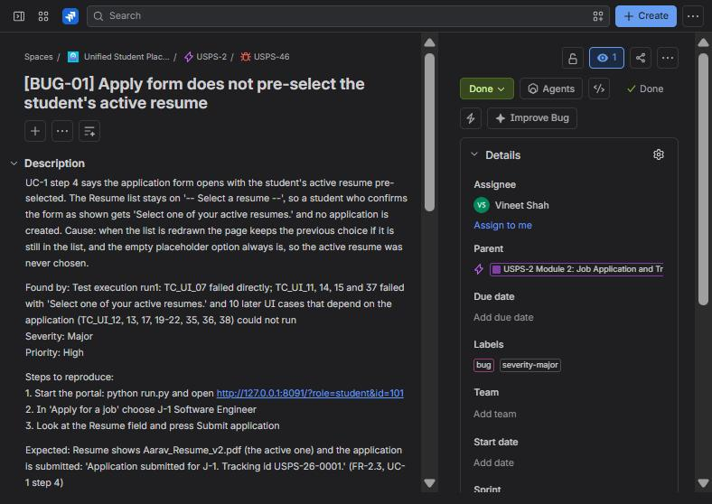 | 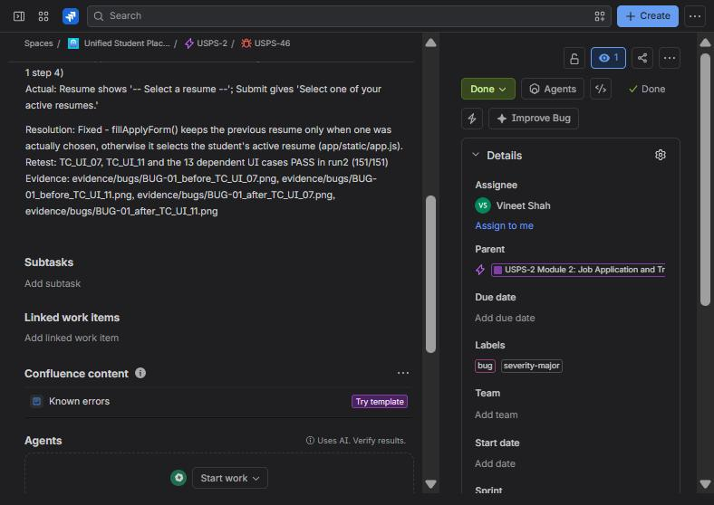
Figure 15: USPS-46 (BUG-01): description, found by, severity, steps, assignee, labels | Figure 16: USPS-46: expected / actual, resolution, retest and evidence

10. Bug Fixing and Retesting Evidence
Test case | Bug | Before the fix - actual | Status | After the fix - actual | Status
TC_UI_07 | BUG-01  (USPS-46) | run1: selected: -- Select a resume -- | options: Aarav_Resume_v2.pdf, Aarav_Resume_v1.pdf (inactive) | FAIL | run2: selected: Aarav_Resume_v2.pdf | options: Aarav_Resume_v2.pdf, Aarav_Resume_v1.pdf (inactive) | PASS
TC_UI_11 | BUG-01  (USPS-46) | run1: Select one of your active resumes. | FAIL | run2: Application submitted for J-1. Tracking id USPS-26-0001. | PASS
TC_UI_15 | BUG-01  (USPS-46) | run1: 501 / 500 (over) | Select one of your active resumes. | FAIL | run2: 501 / 500 (over) | Cover note cannot exceed 500 characters. | PASS
TC_UI_37 | BUG-01  (USPS-46) | run1: Select one of your active resumes. | FAIL | run2: You are already placed; the placement policy blocks further applications. | PASS
TC_INT_10 | BUG-02  (USPS-47) | run3: trials with a double decision: 4 of 10 | FAIL | run4: trials with a double decision: 0 of 10 | PASS
TC_INT_11 | BUG-03  (USPS-48) | run3: trials with a double status change: 3 of 10 | FAIL | run4: trials with a double status change: 0 of 10 | PASS
TC_M1_60 | BUG-04  (USPS-49) | run3: 200: Job J-3 published. 1 eligible student(s) notified. | status=published | FAIL | run4: 409: The deadline of J-3 has passed; return the posting so the recruiter can change it. | status=pending | PASS

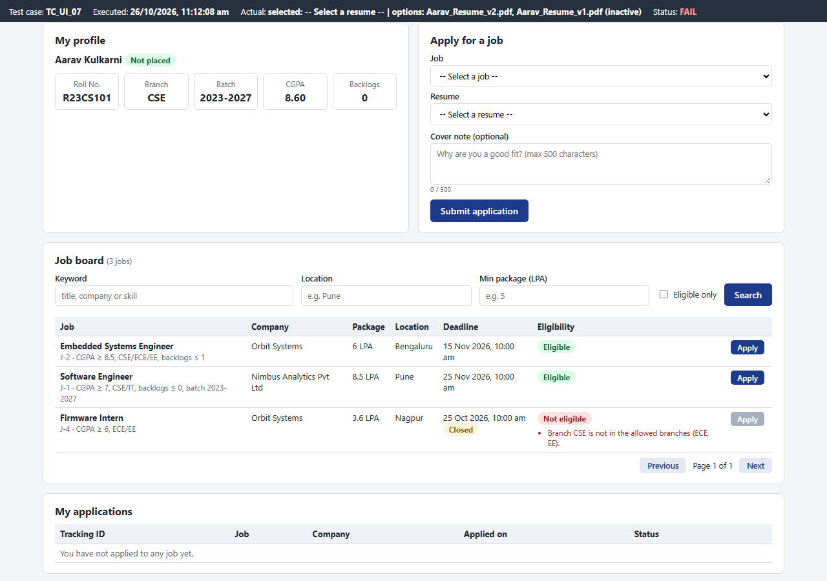 | 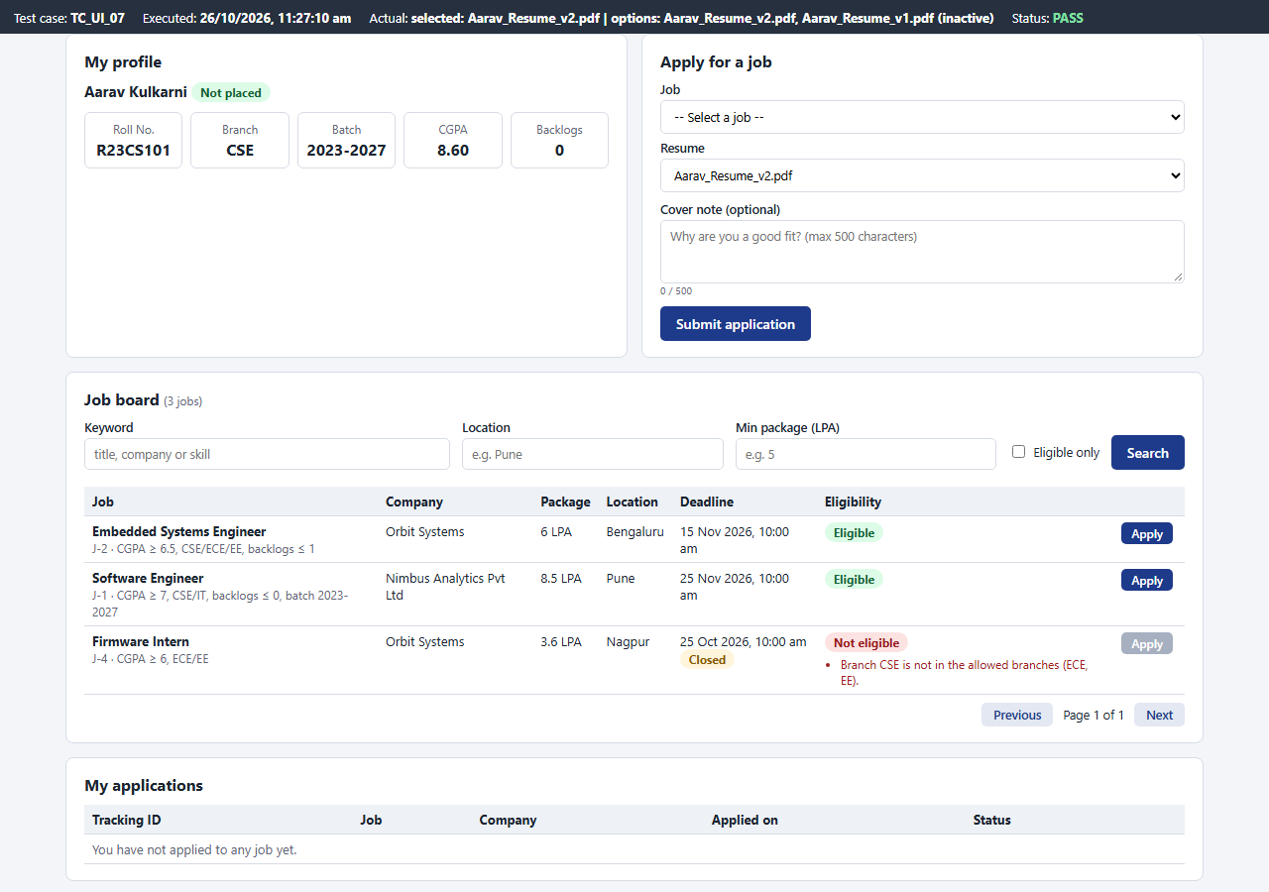
Figure 17: BUG-01 before: no resume pre-selected (TC_UI_07 FAIL, run 1) | Figure 18: BUG-01 after: active resume pre-selected (TC_UI_07 PASS)

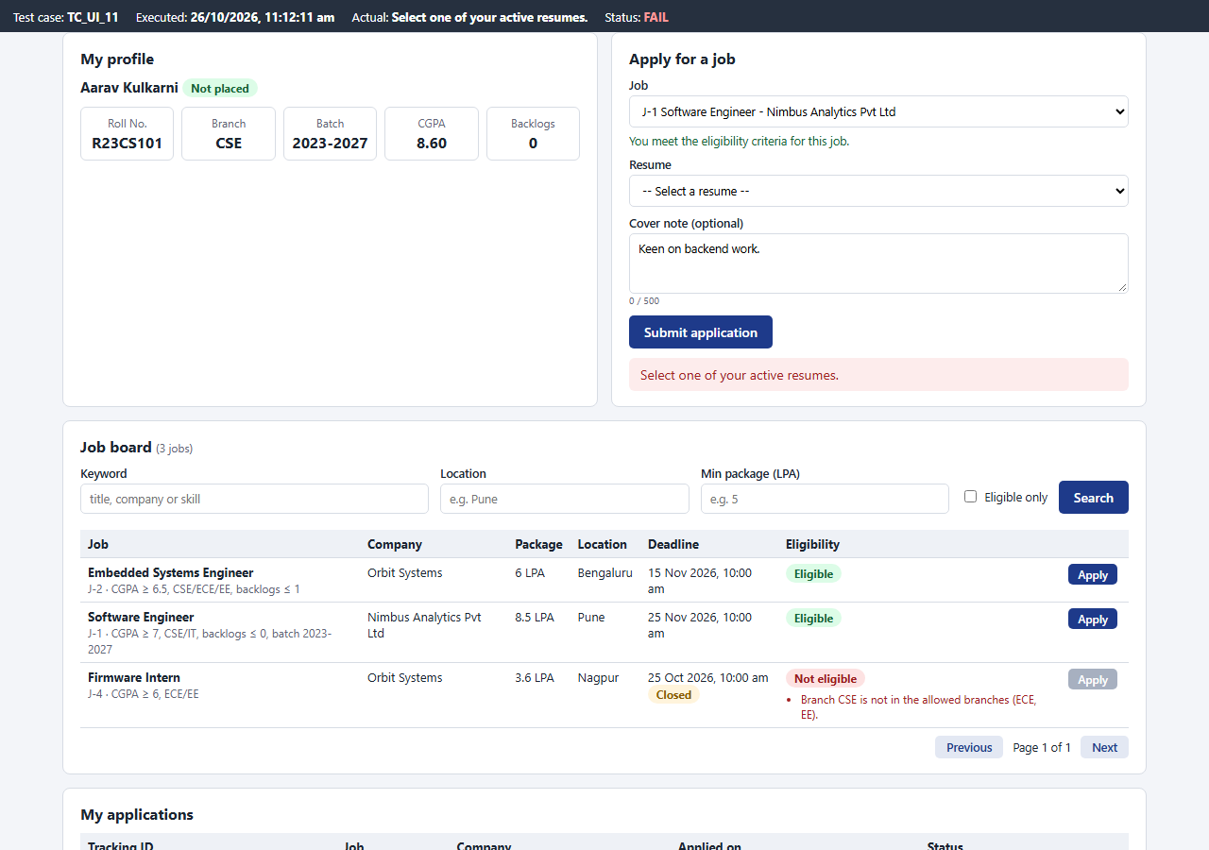 | 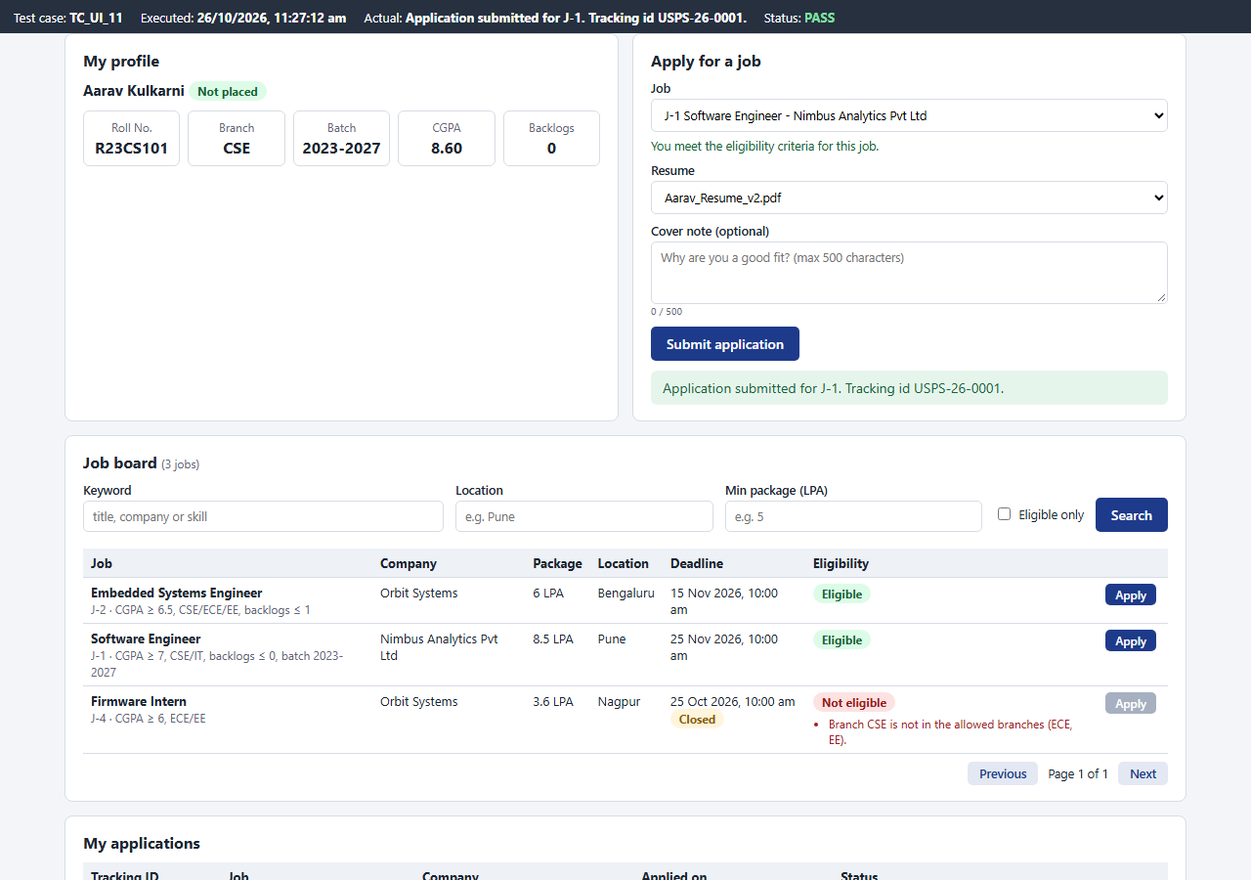
Figure 19: BUG-01 before: submit refused (TC_UI_11 FAIL, run 1) | Figure 20: BUG-01 after: application submitted (TC_UI_11 PASS)

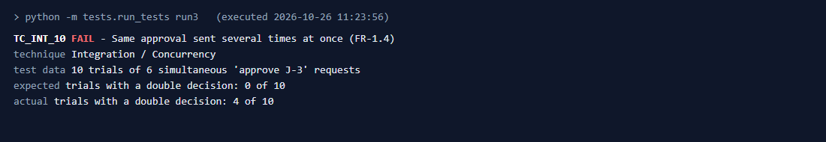
Figure 21: BUG-02 (double approval) before the fix - run 3
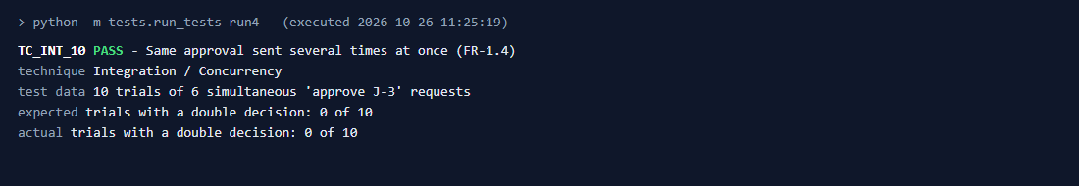
Figure 22: BUG-02 after the fix - run 4
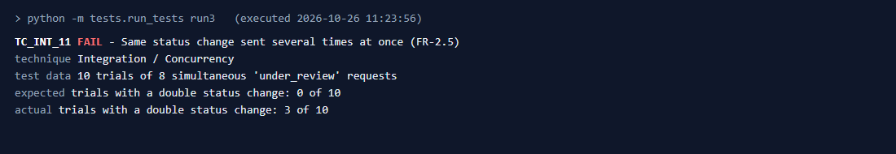
Figure 23: BUG-03 (double status change) before the fix - run 3
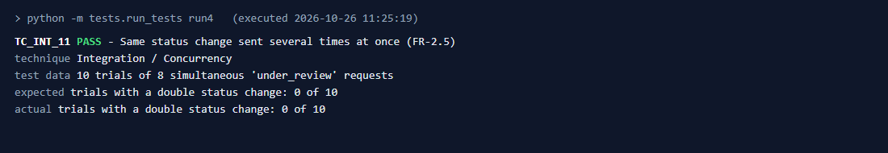
Figure 24: BUG-03 after the fix - run 4
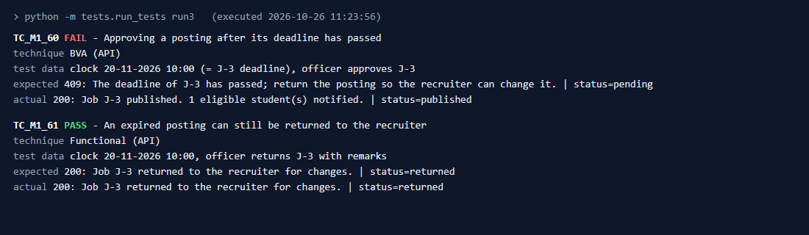
Figure 25: BUG-04 (approval after the deadline) before the fix - run 3
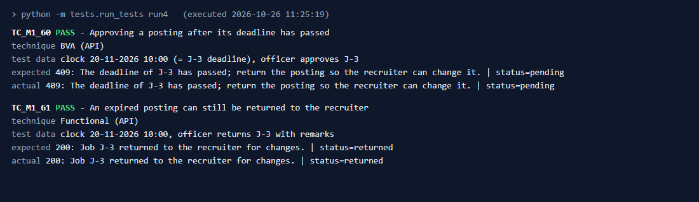
Figure 26: BUG-04 after the fix - run 4
Console summary of the four runs:
151 test cases executed, 136 passed, 15 failed (44.8 s) (run1)
151 test cases executed, 151 passed, 0 failed (118.5 s) (run2)
155 test cases executed, 152 passed, 3 failed (62.4 s) (run3)
155 test cases executed, 155 passed, 0 failed (60.9 s) (run4)

11. Final Working Demonstration
- Start the portal: python run.py and open http://127.0.0.1:8091 in two browser windows.
- Window 1 as Recruiter (Ritika Menon - Nimbus): post a job. Window 2 as Placement Officer: the job appears in Pending job approvals within 2 seconds with a pop-up; approve it.
- Switch window 2 to Student Diya Joshi: the new job is on the job board as Eligible and a 'New job for you' notification has arrived; apply with the pre-selected resume and get a tracking id.
- Window 1: the applicant appears; move it through Move to review, Shortlist, Schedule interview, Mark selected and Issue offer letter while the student's timeline updates by itself.
- Student accepts the offer, becomes Placed, and a further application is refused (BR-05).
- Show an ineligible student (Rohan, ME) with the unmet criteria and the disabled Apply button.
- Run python -m tests.run_tests to execute all 155 test cases (about 1 minute).
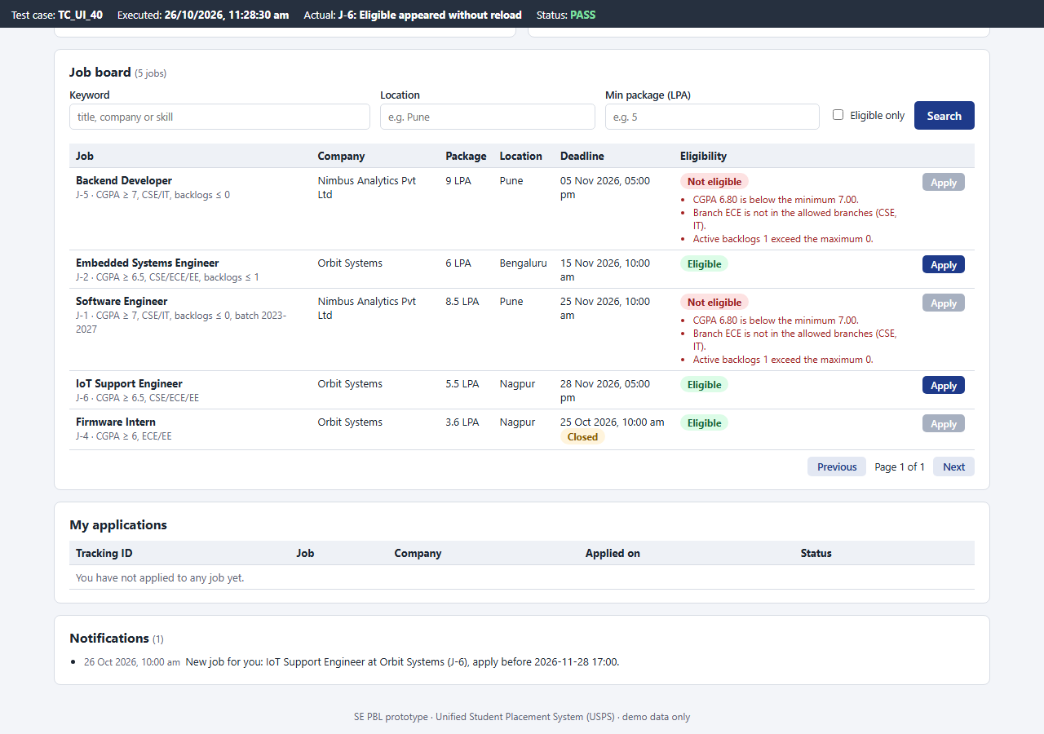 | 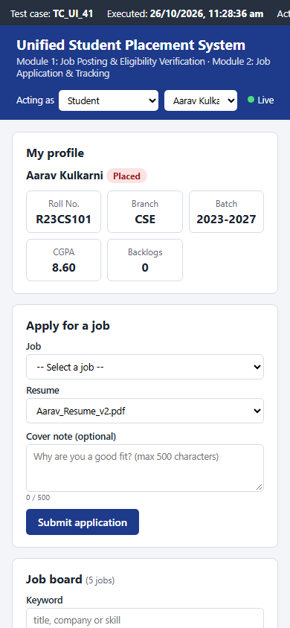
Figure 27: Approved job appears on the student's open board | Figure 28: Same page on a 390 px phone screen

12. Conclusion and Future Scope
Two modules of the Unified Student Placement System from my SE lab SRS were implemented: job posting and eligibility verification, and job application and tracking, as one web application with a REST API, an SQLite database and live-updating pages for students, recruiters and placement officers. The design follows the earlier lab work - the use cases, the class diagram and the application statechart. The work was planned and tracked in Jira as 4 epics, 11 user stories, 11 tasks, 19 sub-tasks and 3 sprints. 155 test cases using functional, unit, integration, boundary value, equivalence partitioning and validation testing were executed: run 1 passed 136 of 151, the defects were logged in Jira, fixed and retested, and the final run passed all 155.
- Login and role-based access (SRS 4.1) so the acting user comes from the session, not a selector.
- Interview scheduling with rounds and slots, and offer letters as documents (SRS 4.6, 4.7).
- E-mail notifications and server-sent events instead of polling for live updates.
- Reports and analytics of placement statistics for the placement cell.

Appendix A: app/rules.py (business rules of both modules)
1 """Core business logic of the two PBL modules, kept free of HTTP and SQL so it can be unit tested.
2
3 Module 1 - Job Posting and Eligibility Verification (SRS 4.3, 4.4): validate_job_posting(), EligibilityCriteria
4 Module 2 - Job Application and Tracking (SRS 4.5): APPLICATION_TRANSITIONS, next_state(), tracking_id()
5
6 Class names follow the Class Diagram of Expt-3 (EligibilityCriteria.evaluate / getReasons, Application.updateStatus)
7 and the states follow the Application statechart of Expt-5.
8 """
9 import re
10 from datetime import datetime
11
12 BRANCHES = ("CSE", "IT", "ECE", "EE", "ME", "CE")
13 BATCH_RE = re.compile(r"^(\d{4})-(\d{4})$")
14
15
16 class RuleError(ValueError):
17 """A business-rule or validation failure; the message is shown to the user."""
18
19
20 # ---------------------------------------------------------------- Module 1
21
22 class EligibilityCriteria:
23 """Rule-set attached to a job (FR-13). Any criterion left as None is not checked."""
24
25 def __init__(self, min_cgpa=None, allowed_branches=None, max_backlogs=None, batch=None):
26 self.min_cgpa = min_cgpa
27 self.allowed_branches = list(allowed_branches) if allowed_branches else []
28 self.max_backlogs = max_backlogs
29 self.batch = batch
30
31 def is_empty(self):
32 return self.min_cgpa is None and not self.allowed_branches and self.max_backlogs is None and not self.batch
33
34 def get_reasons(self, student):
35 """Reasons why `student` (dict with cgpa, department, backlogs, batch) is not eligible (BR-03)."""
36 reasons = []
37 if self.min_cgpa is not None and student["cgpa"] < self.min_cgpa:
38 reasons.append("CGPA %.2f is below the minimum %.2f." % (student["cgpa"], self.min_cgpa))
39 if self.allowed_branches and student["department"] not in self.allowed_branches:
40 reasons.append("Branch %s is not in the allowed branches (%s)."
41 % (student["department"], ", ".join(self.allowed_branches)))
42 if self.max_backlogs is not None and student["backlogs"] > self.max_backlogs:
43 reasons.append("Active backlogs %d exceed the maximum %d." % (student["backlogs"], self.max_backlogs))
44 if self.batch and student["batch"] != self.batch:
45 reasons.append("Batch %s does not match the required batch %s." % (student["batch"], self.batch))
46 return reasons
47
48 def evaluate(self, student):
49 """FR-14: (is_eligible, reasons)."""
50 reasons = self.get_reasons(student)
51 return (len(reasons) == 0, reasons)
52
53 def to_dict(self):
54 return {"min_cgpa": self.min_cgpa, "allowed_branches": self.allowed_branches,
55 "max_backlogs": self.max_backlogs, "batch": self.batch}
56
57
58 def _number(value, field):
59 if isinstance(value, bool) or value is None or value == "":
60 return None
61 try:
62 return float(value)
63 except (TypeError, ValueError):
64 raise RuleError("%s must be a number." % field)
65
66
67 def validate_job_posting(data, now):
68 """FR-10 / UC-2 validation rules. Returns cleaned fields; raises RuleError with the first problem."""
69 title = (data.get("title") or "").strip()
70 if not 3 <= len(title) <= 120:
71 raise RuleError("Title must be 3 to 120 characters.")
72 description = (data.get("description") or "").strip()
73 if not 20 <= len(description) <= 2000:
74 raise RuleError("Description must be 20 to 2000 characters.")
75 ctc = _number(data.get("ctc"), "Package (CTC)")
76 if ctc is None or not 0 < ctc <= 100:
77 raise RuleError("Package (CTC) must be a positive number up to 100 LPA.")
78 location = (data.get("location") or "").strip()
79 if not 2 <= len(location) <= 80:
80 raise RuleError("Location is required (2 to 80 characters).")
81 try:
82 deadline = datetime.fromisoformat(str(data.get("deadline") or ""))
83 except ValueError:
84 raise RuleError("Deadline must be a future date and time.")
85 if deadline <= now:
86 raise RuleError("Deadline must be a future date and time.")
87
88 min_cgpa = _number(data.get("min_cgpa"), "Minimum CGPA")
89 if min_cgpa is not None and not 0 <= min_cgpa <= 10:
90 raise RuleError("Minimum CGPA must be between 0 and 10.")
91 max_backlogs = _number(data.get("max_backlogs"), "Maximum backlogs")
92 if max_backlogs is not None and (max_backlogs != int(max_backlogs) or not 0 <= max_backlogs <= 10):
93 raise RuleError("Maximum backlogs must be a whole number from 0 to 10.")
94 branches = data.get("allowed_branches") or []
95 if not isinstance(branches, list) or any(b not in BRANCHES for b in branches):
96 raise RuleError("Allowed branches must be chosen from %s." % ", ".join(BRANCHES))
97 batch = (data.get("batch") or "").strip()
98 if batch:
99 m = BATCH_RE.match(batch)
100 if not m or int(m.group(2)) - int(m.group(1)) != 4:
101 raise RuleError("Batch must look like 2023-2027.")
102 criteria = EligibilityCriteria(min_cgpa, branches, None if max_backlogs is None else int(max_backlogs),
103 batch or None)
104 if criteria.is_empty():
105 raise RuleError("At least one eligibility criterion is required.")
106 return {"title": title, "description": description, "ctc": ctc, "location": location,
107 "deadline": deadline, "criteria": criteria}
108
109
110 JOB_DECISIONS = {"approve": "published", "reject": "rejected", "return": "returned"}
111
112
113 def validate_job_decision(job_status, decision, remarks):
114 """FR-11 / BR-02: officer decision on a pending posting. Returns the new job status."""
115 if job_status != "pending":
116 raise RuleError("This job is not pending approval (status: %s)." % job_status)
117 if decision not in JOB_DECISIONS:
118 raise RuleError("Decision must be approve, reject or return.")
119 remarks = (remarks or "").strip()
120 if decision != "approve" and not 5 <= len(remarks) <= 200:
121 raise RuleError("Remarks (5 to 200 characters) are required to reject or return a posting.")
122 if len(remarks) > 200:
123 raise RuleError("Remarks cannot exceed 200 characters.")
124 return JOB_DECISIONS[decision]
125
126
127 # ---------------------------------------------------------------- Module 2
128
129 APPLIED, UNDER_REVIEW, SHORTLISTED = "Applied", "Under Review", "Shortlisted"
130 INTERVIEW, SELECTED, OFFER_ISSUED = "Interview Scheduled", "Selected", "Offer Issued"
131 ACCEPTED, REJECTED, WITHDRAWN = "Accepted", "Rejected", "Withdrawn"
132 FINAL_STATES = (ACCEPTED, REJECTED, WITHDRAWN)
133
134 # (event, from state) -> to state, exactly as in the Expt-5 statechart.
135 APPLICATION_TRANSITIONS = {
136 ("under_review", APPLIED): UNDER_REVIEW,
137 ("withdraw", APPLIED): WITHDRAWN,
138 ("shortlist", UNDER_REVIEW): SHORTLISTED,
139 ("reject", UNDER_REVIEW): REJECTED,
140 ("schedule_interview", SHORTLISTED): INTERVIEW,
141 ("reject", SHORTLISTED): REJECTED,
142 ("reschedule", INTERVIEW): INTERVIEW,
143 ("interview_result", INTERVIEW): SELECTED,
144 ("reject", INTERVIEW): REJECTED,
145 ("offer_letter", SELECTED): OFFER_ISSUED,
146 ("reject", SELECTED): REJECTED,
147 ("accept_offer", OFFER_ISSUED): ACCEPTED,
148 ("reject_offer", OFFER_ISSUED): REJECTED,
149 }
150 STUDENT_EVENTS = ("withdraw", "accept_offer", "reject_offer")
151 STAFF_EVENTS = tuple(sorted({e for e, _ in APPLICATION_TRANSITIONS} - set(STUDENT_EVENTS)))
152
153
154 def next_state(state, event):
155 """Application.updateStatus(): the state after `event`, or RuleError if the statechart forbids it."""
156 if (event, state) not in APPLICATION_TRANSITIONS:
157 raise RuleError("Event '%s' is not allowed when the application is %s." % (event, state))
158 return APPLICATION_TRANSITIONS[(event, state)]
159
160
161 def tracking_id(app_id, year):
162 """Unique tracking id issued on submission (FR-15), e.g. USPS-26-0007."""
163 return "USPS-%02d-%04d" % (year % 100, app_id)

