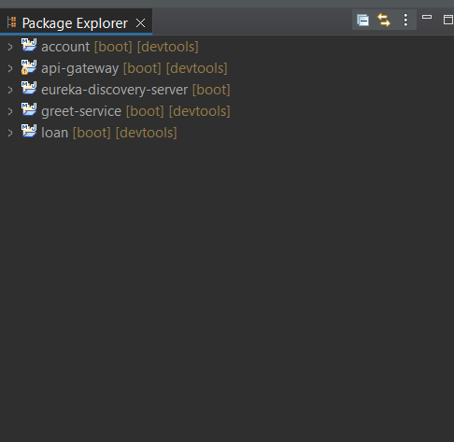

package com.cognizant.account;

public class Account {

private String number;

private String type;

private double balance;

public Account() {}

public Account(String number, String type, double balance) {

this.number = number;

this.type = type;

this.balance = balance;

}

public String getNumber() {

return number;

}

public void setNumber(String number) {

this.number = number;

}

public String getType() {

return type;

}

public void setType(String type) {

this.type = type;

}

public double getBalance() {

return balance;

}

public void setBalance(double balance) {

this.balance = balance;

}

}

Controller:

package com.cognizant.account;

import org.springframework.web.bind.annotation.*;

*@RestController*

*@RequestMapping*("/accounts")

public class AccountController {

*@GetMapping*("/{number}")

public Account getAccountByNumber(*@PathVariable* String number) {

// Dummy account data

return new Account(number, "savings", 234343);

}

}

Account Application:

package com.cognizant.account;

import org.springframework.boot.SpringApplication;

import org.springframework.boot.autoconfigure.SpringBootApplication;

import org.springframework.cloud.client.discovery.EnableDiscoveryClient;

*@SpringBootApplication*

*@EnableDiscoveryClient*

public class AccountApplication {

public static void main(String[] args) {

SpringApplication.*run*(AccountApplication.class, args);

}

}

ApiGateway:

package com.cognizant.api_gateway;

import org.springframework.boot.SpringApplication;

import org.springframework.boot.autoconfigure.SpringBootApplication;

@SpringBootApplication

public class ApiGatewayApplication {

public static void main(String[] args) {

SpringApplication.run(ApiGatewayApplication.class, args);

}

}

LogFilter:

package com.cognizant.api_gateway;

import org.slf4j.Logger;

import org.slf4j.LoggerFactory;

import org.springframework.cloud.gateway.filter.GatewayFilterChain;

import org.springframework.cloud.gateway.filter.GlobalFilter;

import org.springframework.stereotype.Component;

import org.springframework.web.server.ServerWebExchange;

import reactor.core.publisher.Mono;

*@Component*

public class LogFilter implements GlobalFilter {

private static final Logger ***logger*** = LoggerFactory.*getLogger*(LogFilter.class);

*@Override*

public Mono<Void> filter(ServerWebExchange exchange, GatewayFilterChain chain) {

***logger***.info("=====> Request URL: {}", exchange.getRequest().getURI());

return chain.filter(exchange);

}

}

Application properties:

Eureka-discover-server:

package com.cognizant.eureka_discovery_server;

import org.springframework.boot.SpringApplication;

import org.springframework.boot.autoconfigure.SpringBootApplication;

import org.springframework.cloud.netflix.eureka.server.EnableEurekaServer;

@SpringBootApplication

@EnableEurekaServer

public class EurekaDiscoveryServerApplication {

public static void main(String[] args) {

SpringApplication.run(EurekaDiscoveryServerApplication.class, args);

}

}

Application Properties:

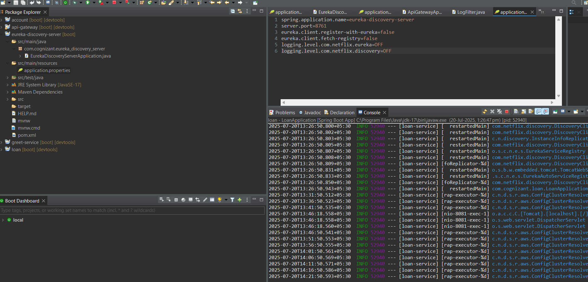

Ouptut:

Logging URI request

