Emergency Resource Coordination System
Mini Web Application — Project Documentation Report
A Full-Stack CRUD Web Application for Resource, Request, and Shelter Coordination
Submitted by: Vinushika M
Class : CSE – C Sec
Roll No.:922525104181
Department: Computer Science and Engineering

1. Project Overview
The Emergency Resource Coordination System is a full-stack CRUD web application designed to help emergency response coordinators track supplies, manage requests for those supplies, and let the public check shelter availability during disaster response operations. The system was built in three incremental phases, each fully functional and tested before moving to the next, ensuring the project was never in an unfinished state.

2. Problem Statement
During emergencies, resource visibility — what supplies are available, where, and how much — is often scattered across spreadsheets, phone calls, or manual logs. This causes delays in relief distribution and makes it hard for coordinators to know when to reallocate or request more supplies. Similarly, information about shelter capacity is often unavailable to the public until they arrive in person. This system centralizes resource tracking, request fulfillment, and shelter status into a single, validated, real-time platform.

3. Objectives
- Provide full CRUD (Create, Read, Update, Delete) management for emergency resources.
- Allow requests to be raised against a specific resource, with server-side validation preventing over-fulfillment.
- Automatically decrement resource stock and update its status when a request is fulfilled.
- Track shelter capacity and occupancy, preventing occupancy from exceeding capacity.
- Provide a public, no-login page for checking shelter availability, separate from the admin interface.
- Enforce validation and error handling on every operation, with clear HTTP status codes and messages.

4. Technology Stack
Layer | Technology | Purpose
Frontend | HTML, CSS, JavaScript | Admin dashboard and public availability page
Backend | Java, Spring Boot, Spring Data JPA | REST API, business logic, validation
Database | MySQL | Persistent storage of Resources, Requests, and Shelters
API Testing | Postman | Manual verification of all endpoints and edge cases
Version Control | Git & GitHub | Source control and submission repository
Dev Environment | Visual Studio Code, Maven, MySQL Workbench | Coding, build management, database administration

5. System Architecture
The application follows a standard layered (N-tier) architecture, cleanly separating concerns between the presentation, business logic, and data layers:
User → HTML/CSS/JS Frontend → REST API (Spring Boot Controller) → Service Layer → Repository (Spring Data JPA) → MySQL Database
Backend layer responsibilities:
- Controller — receives HTTP requests, maps them to service calls, returns JSON responses.
- Service — contains business logic and validation rules (e.g. stock checks, occupancy limits).
- Repository — interfaces extending Spring Data JPA's JpaRepository, providing database access with no manual SQL.
- Entity — Java classes mapped to database tables via JPA annotations.
The frontend is a separate, independent HTML/CSS/JavaScript application that communicates with the backend exclusively through the REST API using fetch() calls, with CORS enabled on the backend to allow cross-origin requests during local development.

6. Entity & Database Design
The system is built around three related entities.

6.1 Resource
Represents a category of emergency supplies and its current stock level.
Field | Type | Constraints
id | Long | Primary key, auto-generated
resourceType | String | Required (not blank)
quantityAvailable | Integer | Must be positive
unit | String | Required (not blank)
location | String | Required (not blank)
status | Enum | AVAILABLE / LOW / DEPLETED
lastUpdated | DateTime | Auto-set on create/update

6.3 Shelter
Represents a physical shelter location and its current occupancy.
Field | Type | Constraints
id | Long | Primary key, auto-generated
name | String | Required (not blank)
location | String | Required (not blank)
capacity | Integer | Must be positive
occupancy | Integer | Zero or positive, default 0
status | Enum | OPEN / FULL / CLOSED (auto-derived)

6.4 Entity Relationship Summary
Resource (1) ——— (Many) Request | Shelter is an independent entity

7. Validation Rules
- All quantity fields (quantityAvailable, quantityNeeded, capacity) must be positive numbers.
- Status, urgency, and other categorical fields are restricted to fixed enum value sets — invalid values are rejected at the JSON parsing level.
- A request cannot be fulfilled if its quantityNeeded exceeds the linked resource's current quantityAvailable.
- A shelter's occupancy cannot exceed its capacity.
- All required text fields (name, location, resourceType, requestedBy) must not be blank.
- All validation is enforced server-side via Bean Validation annotations and custom service-layer checks, regardless of what the client sends.
A centralized GlobalExceptionHandler intercepts three categories of failure and returns clean, structured JSON error responses:
Failure Type | HTTP Status | Example
Record not found | 404 Not Found | GET /api/resources/999 → "Resource not found with id: 999"
Invalid JSON / bad enum value | 400 Bad Request | "status": "BROKEN" → not one of AVAILABLE, LOW, DEPLETED
Business rule violation | 400 Bad Request | Occupancy (200) cannot exceed capacity (100)

8. Screenshots

8.1 API Testing — Postman
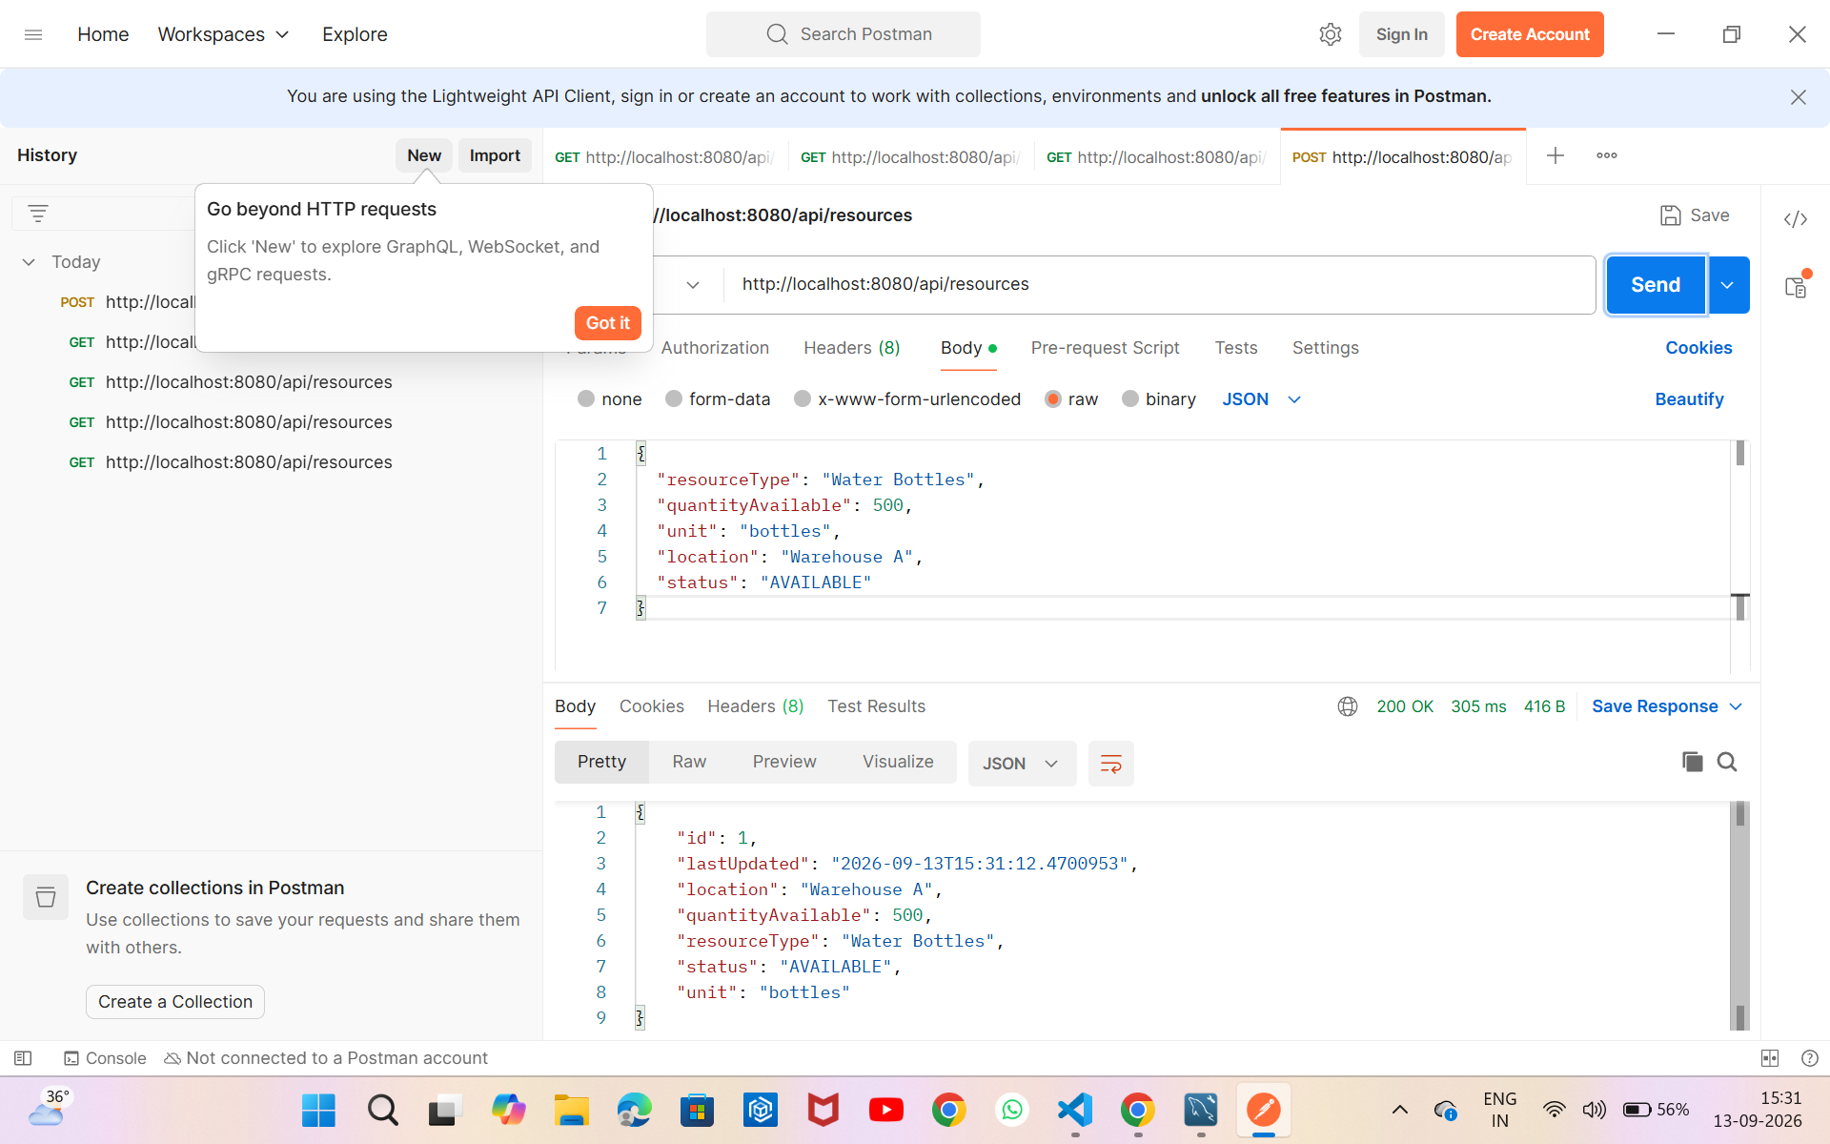
Figure 1: Successful POST request creating a new Resource (200 OK).
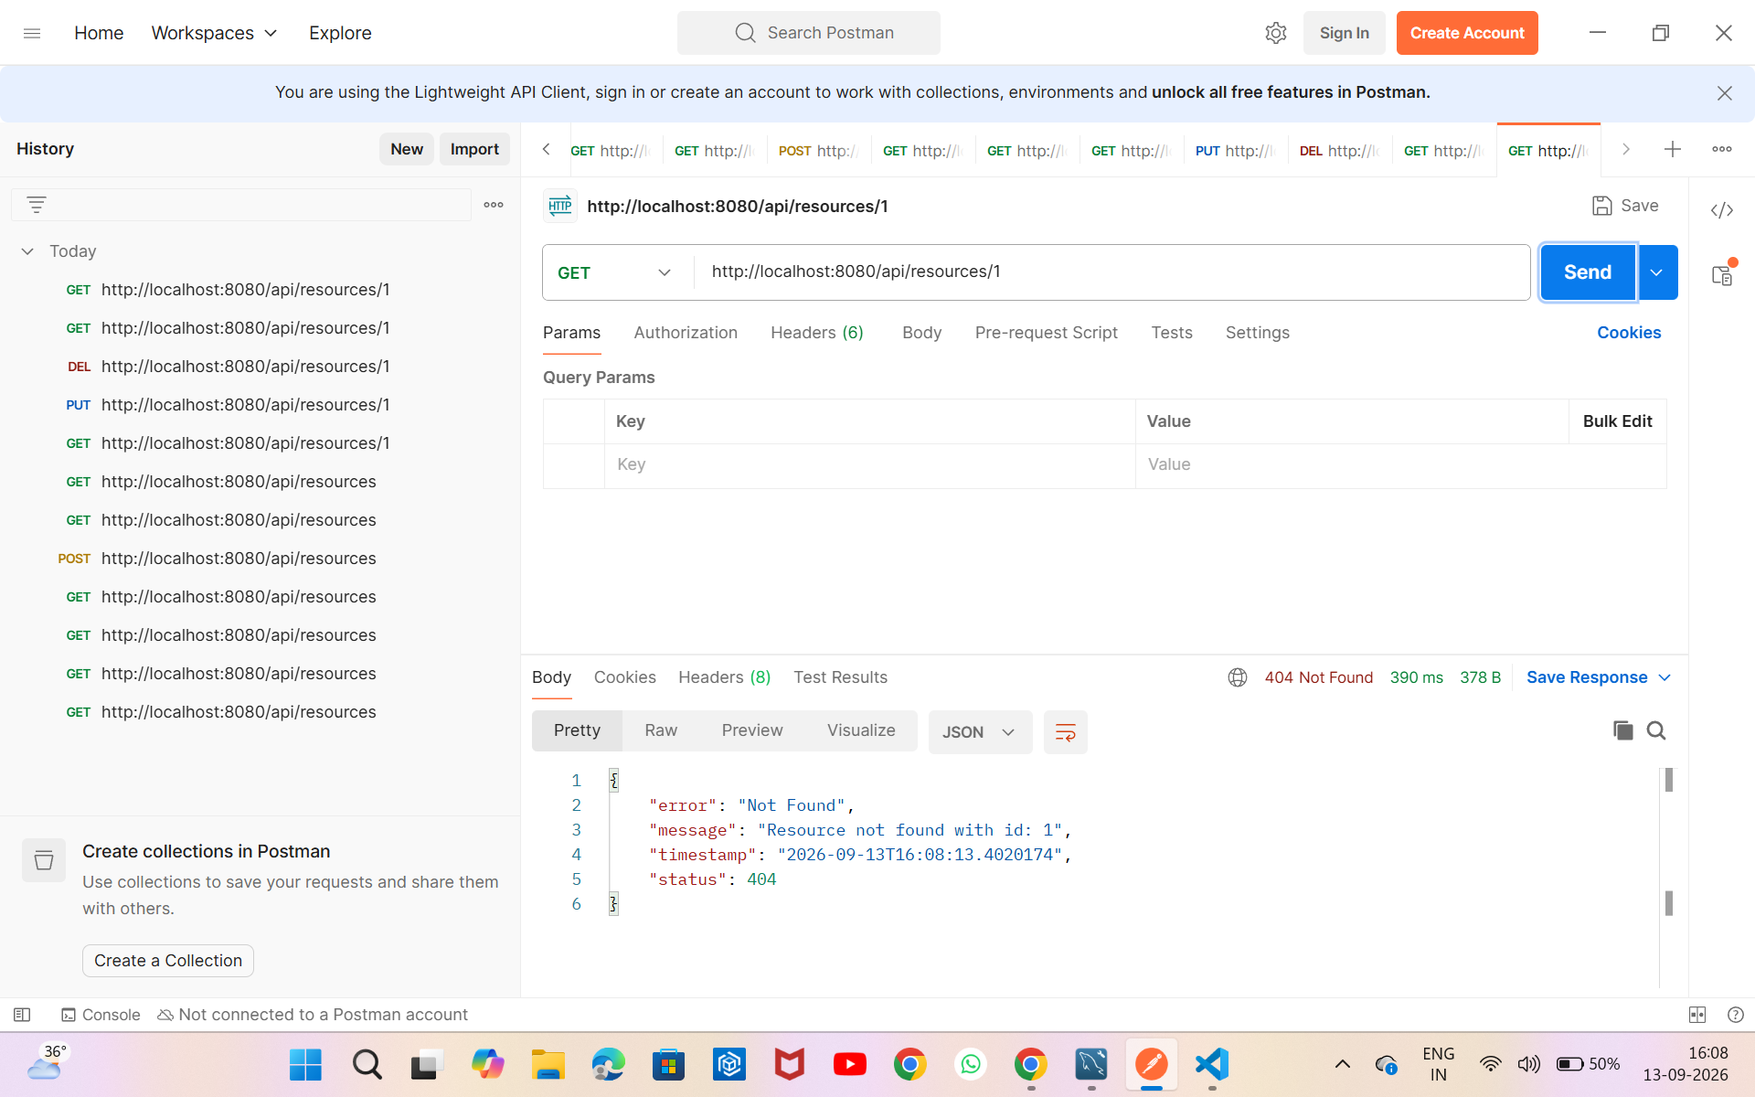
Figure 2: Requesting a deleted resource correctly returns 404 Not Found with a clear JSON error message.

8.2 Adding Resources Page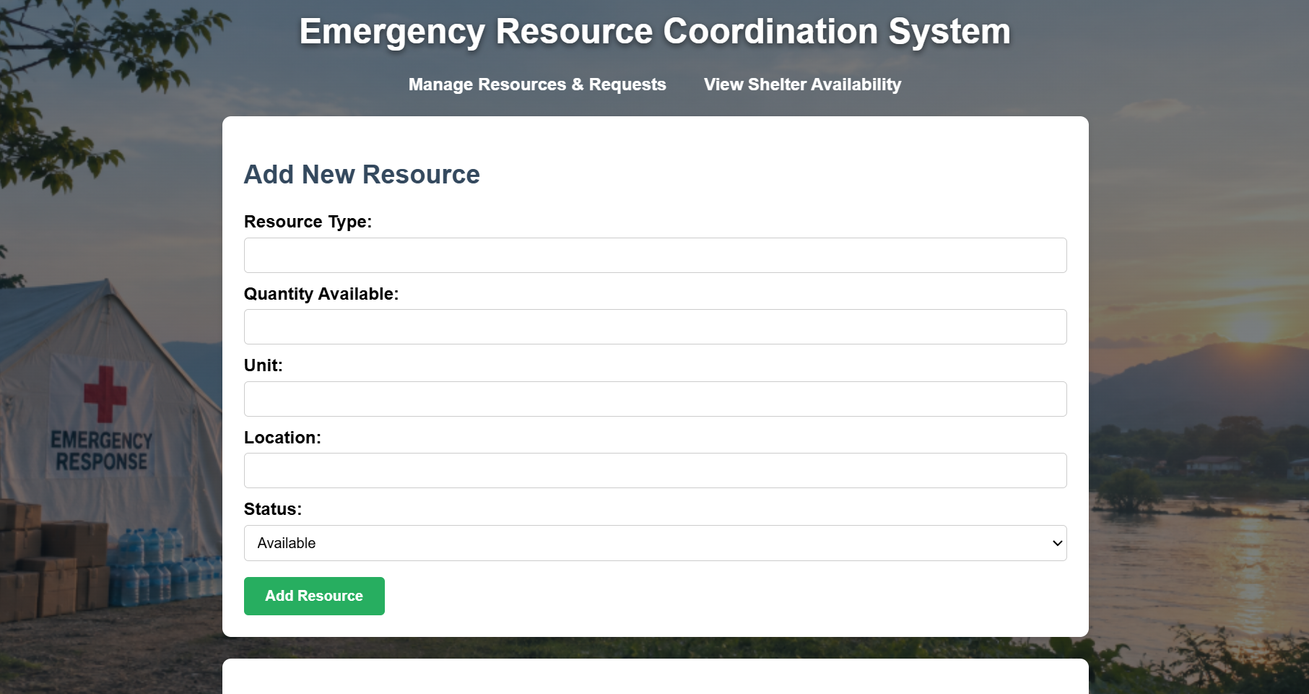
Figure 3: Adding Resources
Available Resources
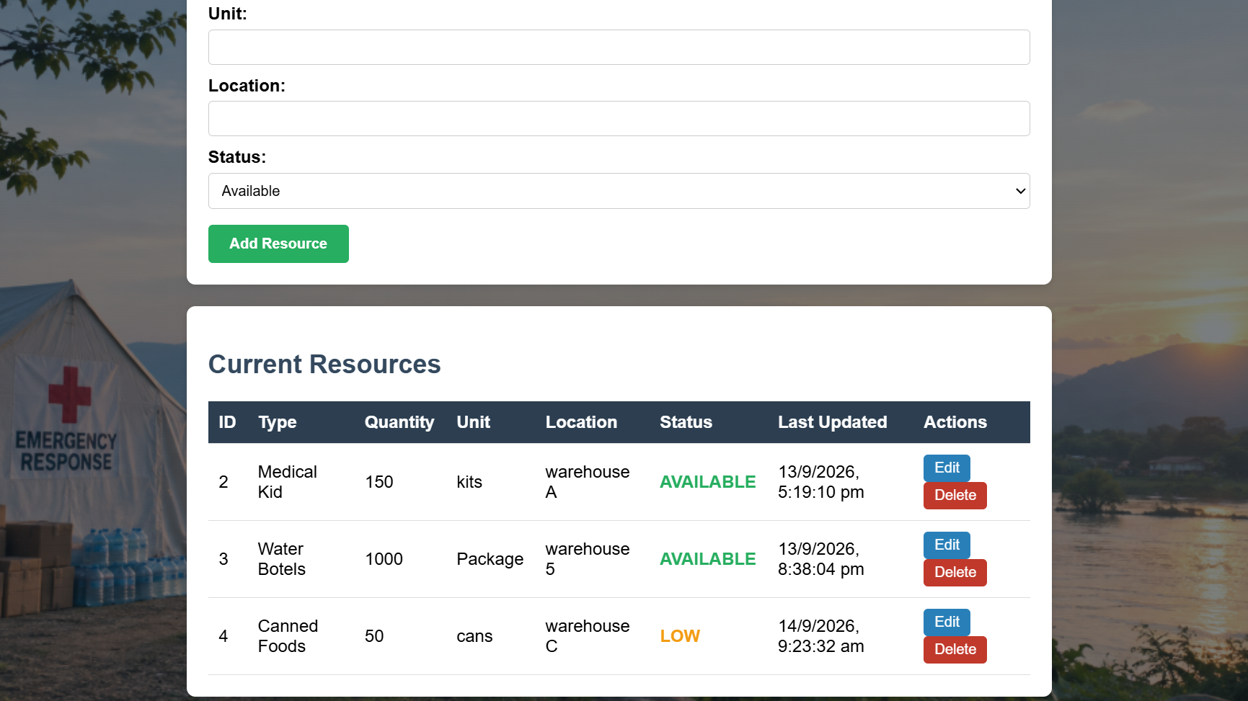
Figure 5:Current Resourcse
Adding Request
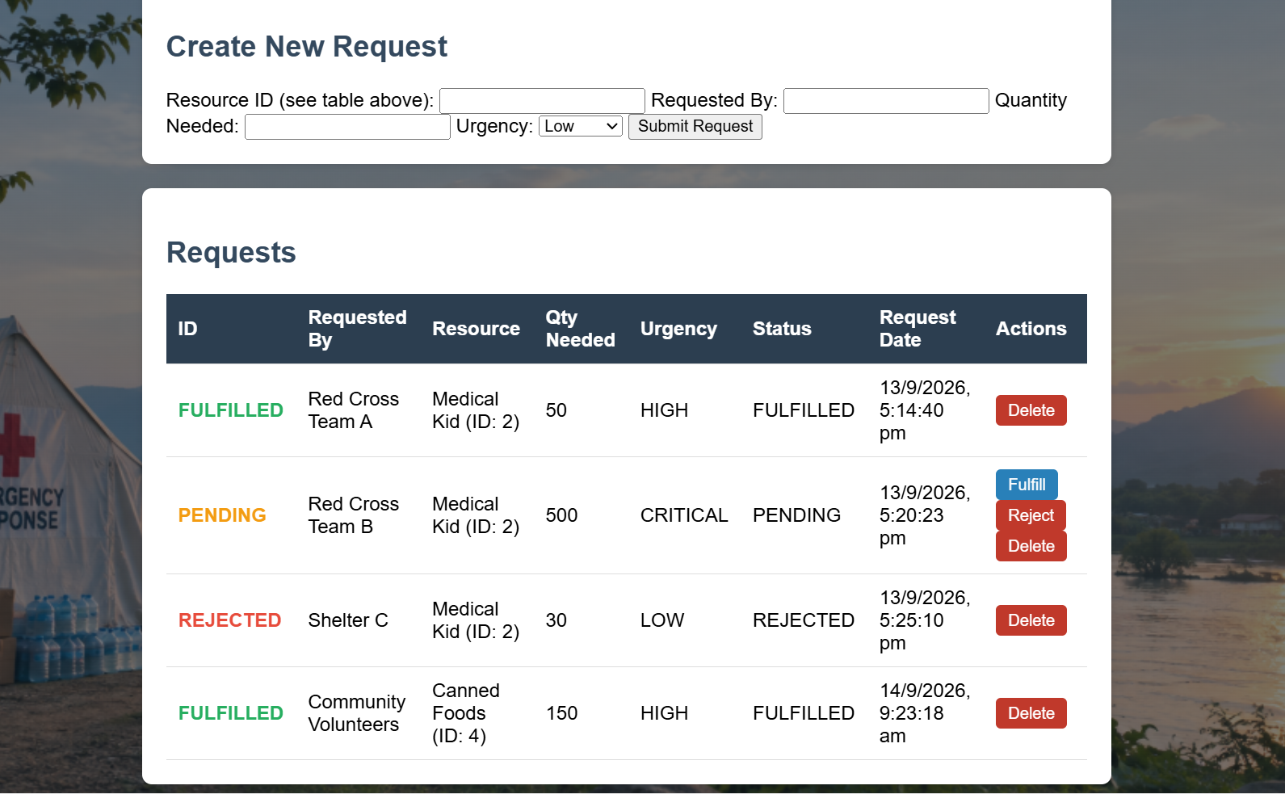

9.3 Public Shelter Availability Page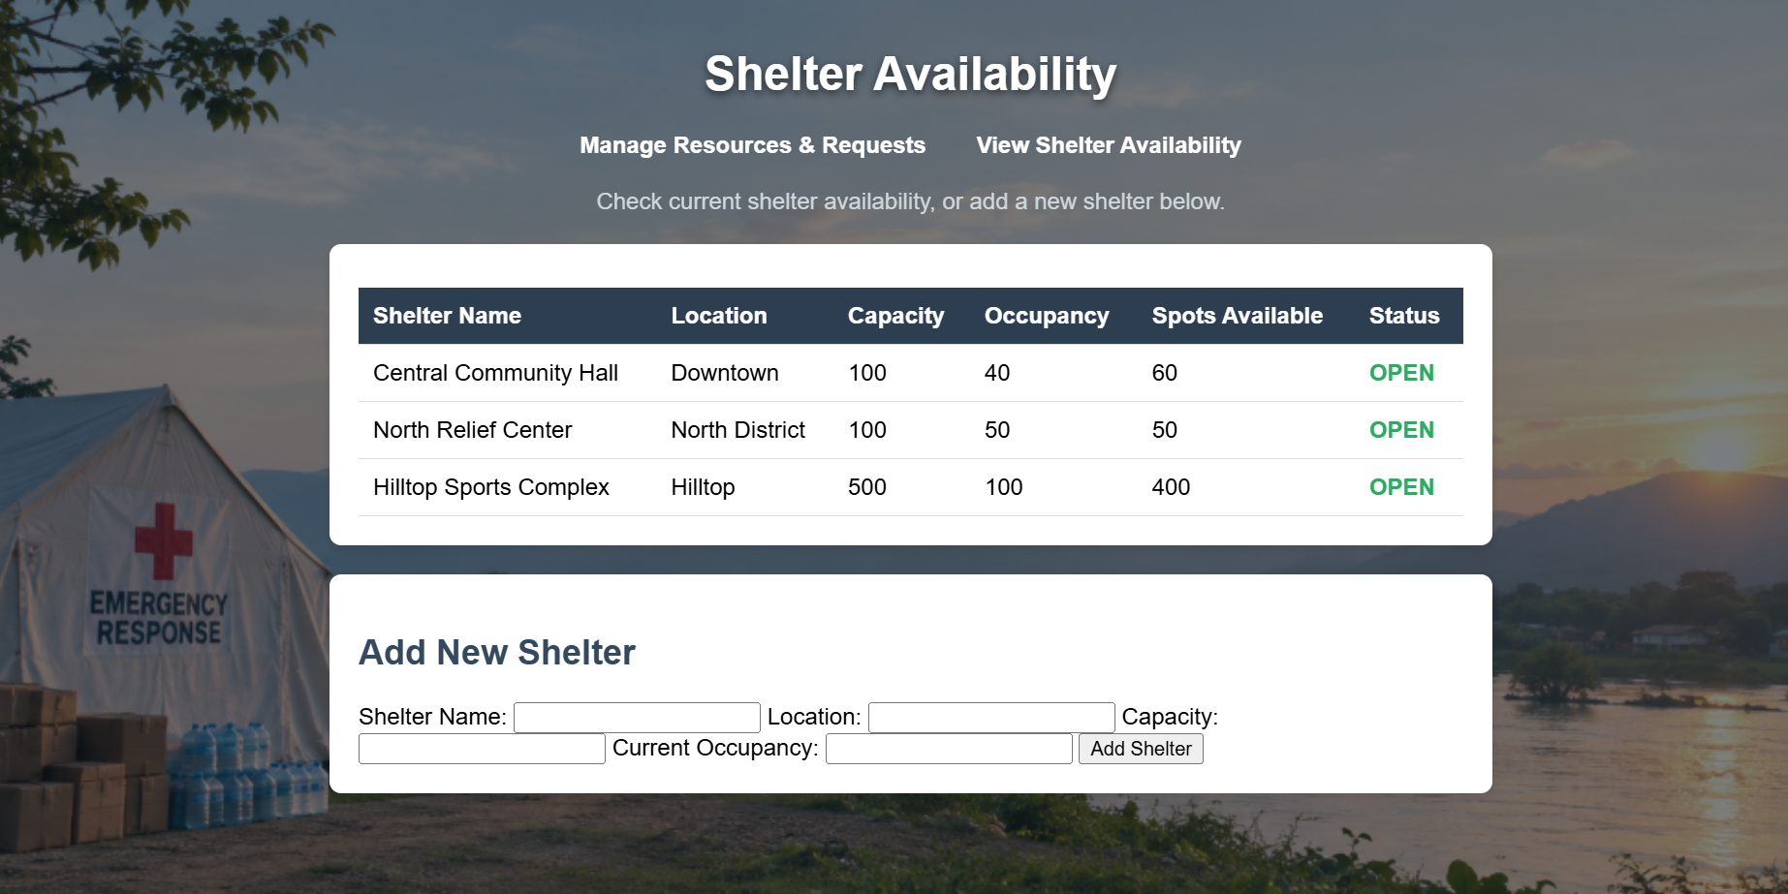 Figure 5 Shelter Availability page (availability.html).

10. Testing Summary
All endpoints were manually tested using Postman, covering both successful operations and edge cases. A summary of the key test cases and results:
Test Case | Expected Result | Actual Result
Create resource with valid data | 200 OK, resource returned with generated id | Pass
Get all resources | 200 OK, JSON array returned | Pass
Get resource by valid id | 200 OK, single resource object | Pass
Update resource | 200 OK, updated fields reflected | Pass
Delete resource | 200 OK, confirmation message | Pass
Create resource with negative quantity | 400 Bad Request | Pass
Create resource with missing required field | 400 Bad Request | Pass
Create resource with invalid status enum | 400 Bad Request | Pass
Get/Update/Delete with invalid id | 404 Not Found | Pass
Create request linked to a resource | 200 OK, nested resource object returned | Pass
Fulfill request within available stock | 200 OK, stock decremented, status FULFILLED | Pass
Fulfill request exceeding available stock | 400 Bad Request, stock unchanged | Pass
Reject request | 200 OK, status REJECTED, stock unchanged | Pass
Create shelter with occupancy ≤ capacity | 200 OK, status OPEN | Pass
Create shelter with occupancy > capacity | 400 Bad Request | Pass

11. Setup & Installation

11.1 Prerequisites
- JDK 17 or higher
- Apache Maven
- MySQL Server 8.x
- A modern web browser
- VS Code (or any IDE) with the Live Server extension for the frontend

11.2 Backend Setup
- Create the database: CREATE DATABASE resource_coordination;
- Navigate to the backend project folder (resource-coordination).
- Configure src/main/resources/application.properties with your MySQL username and password.
- Run the application: mvn spring-boot:run — the server starts on http://localhost:8080.
- Hibernate automatically creates the resource, request, and shelter tables on first run.

11.3 Frontend Setup
- Navigate to the frontend folder.
- Open index.html using a local development server (e.g. VS Code's Live Server extension) to avoid CORS/file-protocol issues.
- index.html — Admin dashboard for managing Resources and Requests.
- availability.html — Public, no-login Shelter Availability page.

12. Challenges & Solutions
Challenge | Solution
Java package/folder mismatches causing compilation errors | Verified exact file paths using "Copy Path" in VS Code and corrected folder nesting to match package declarations.
Generic exceptions returning incorrect HTTP status codes (e.g. 404 instead of 400) | Implemented a centralized GlobalExceptionHandler with specific handlers for RuntimeException, IllegalArgumentException, and malformed JSON/enum errors.
Frontend JavaScript failing silently (elements not found) | Diagnosed via browser DevTools Console; corrected HTML element ordering so <script> tags load after all referenced elements exist in the DOM.
CORS / "Failed to fetch" errors between frontend and backend | Ensured the backend was running before frontend requests, added @CrossOrigin(origins = "*") to all controllers, and served the frontend via Live Server rather than the file:// protocol.

13. Future Enhancements
- Add authentication and role-based access control for the admin dashboard.
- Add search and filter functionality across Resources, Requests, and Shelters.
- Deploy the application live — frontend on Vercel/Netlify, backend and database on Render/Railway.
- Add automated unit and integration tests using JUnit and Mockito.
- Send notifications when a resource becomes LOW/DEPLETED or a shelter becomes FULL.

14. Conclusion
The Emergency Resource Coordination System successfully demonstrates a complete, full-stack CRUD web application built in three well-tested phases. It implements a proper layered backend architecture, enforces meaningful server-side validation and business rules (including a real one-to-many relational link between Resources and Requests), and provides both an administrative interface and a genuinely separate public-facing page. All core operations were verified through systematic API testing in Postman as well as end-to-end testing through the browser interface.

