***Software Requirements***

***Specification***

(Online E-commerce Website)

**Author** - M. Vinuja

1. Abstract 3

2. Objective 3

3. Introduction  3

3.1 Purpose 3

3.2 Scope……………………………………………………………………………………………4

4. Functional Requirement 4

5. Non-Functional Requirement 5

6. Design 6

7. Use Case Diagram 7

8. Class Diagram 8

9. Sequence Diagram 8

10. Testcase 9

**1.Abstract**

The online e-commerce website under development aims to provide users with a seamless and secure platform for purchasing products. Users will have the ability to register accounts, log in securely, and recover passwords if needed. They can browse products by category, utilizing a robust search function to find specific items. Shopping cart management enables users to add, edit, and review their selected items, with the system calculating the total price for added convenience. Streamlined order processing allows users to proceed to checkout, providing shipping and billing information, and receiving confirmation emails upon order placement. Payment integration ensures support for multiple secure payment methods, while user account management empowers users to update profiles, view order history, and track orders effortlessly.

**2.Objective**

The objective of the online e-commerce website is to provide users with a convenient and secure platform for purchasing products. It aims to streamline the shopping experience by offering features such as user authentication, product browsing, and search functionality. The website will facilitate efficient shopping cart management, order processing, and payment integration to ensure smooth transactions. Additionally, user account management features will empower users to update profiles, track orders, and view order history effortlessly. Overall, the objective is to create a reliable, user-friendly, and accessible platform that meets the diverse needs of online shoppers.

**3.Introduction**

**3.1 Purpose**

The purpose of this document is to outline the requirements for the development of an online e-commerce website. This website aims to provide a platform for users to browse, search, and purchase a variety of products conveniently.

**3.2 Scope**

The online e-commerce website will include features such as user authentication, product browsing, product search, shopping cart management, order processing, payment integration, and user account management.

**4.Functional Requirement**

**4.1 User Authentication**

Users will have the capability to create accounts for accessing the platform. Once registered, they can securely log in to their accounts. Additionally, the system will facilitate password recovery mechanisms for users who may forget their login credentials, ensuring a seamless and secure authentication process.

**4.2 Product Browsing**

Users will navigate products through categorized and subcategorized listings. Each product will feature comprehensive details encompassing price, images, and specifications, facilitating informed decision-making during browsing sessions.

**4.3 Product Search**

Users can easily find products by typing keywords into the search bar. The search function will then display relevant results, making it simple for users to locate what they're looking for.

**4.4 Shopping Cart Management**

Users can easily add products to their shopping cart and view/edit its contents. The system will automatically calculate the total price of items in the cart, simplifying the shopping experience.

**4.5 Payment**

The website supports various payment methods like credit/debit cards and PayPal, ensuring flexibility for users.

**4.6 User Account Management**

Users have the flexibility to update their profile information as needed. They can also conveniently view their order history and track the status of their orders, empowering them with control over their shopping experience

**5.Non-Functional Requirement**

**5.1 Performance**

The website will load quickly and respond efficiently on various devices and internet connections, ensuring a smooth user experience. It will also handle a large number of users simultaneously without slowing down, maintaining optimal performance during peak times.

**5.2 Security**

All user authentication processes and data transmissions will be encrypted using HTTPS, guaranteeing the security and privacy of user information. The system will also incorporate measures to thwart common security threats like SQL injection and cross-site scripting, safeguarding against potential vulnerabilities.

**5.3 Usability**

The user interface will be designed to be intuitive and user-friendly, making it easy for users to navigate the website and find what they're looking for. Additionally, the website will adhere to accessibility standards, ensuring that all users, including those with disabilities, can use it effectively.

**5.4 Reliability**

The website will be available 24/7 with minimal downtime for maintenance, ensuring continuous access for users. Regular backups of the database will be performed to prevent data loss and maintain the integrity of user information, providing peace of mind to both users and administrators.

**6.Design**

**6.1 High Level Design**

**6.1.1 System Architecture**

Modules like user authentication, product management, and payment processing interact cohesively within a client-server architecture, enabling efficient communication between clients and servers. The system's architecture may follow microservices or monolithic patterns, optimizing scalability and maintainability based on project requirements.

**6.1.2 Database Design**

The database schema outlines tables, columns, and relationships, organized to accommodate user profiles, product details, and order information as per the SRS requirements. Data will be stored efficiently with normalization to minimize redundancy and optimize query performance, ensuring scalability, reliability, and high performance under varying loads.

**6.1.3 User Interface Design**

User interface components like navigation menus and forms will be designed for intuitive navigation and interaction. The layout will feature a harmonious color scheme and visual elements, promoting user engagement and ease of use. Responsive design principles will ensure that the interface adapts seamlessly to various devices and screen sizes, enhancing accessibility and user experience.

**6.2 Low Level Design**

**6.2.1 Module Design**

Each module's specifications will outline its purpose, inputs, and outputs, ensuring clarity in functionality and interaction. Input interfaces will define how data is received and processed, while output interfaces will detail the format and delivery of results. Additionally, functions or methods within each module will be identified, specifying the actions they perform to achieve the module's objectives.

**6.2.2 User Interface Components**

UI components like buttons and forms will feature consistent design elements across the website, facilitating intuitive navigation and interaction. User interactions will be processed dynamically, providing real-time feedback and seamless transitions between pages. Accessibility guidelines will be adhered to, ensuring compatibility with assistive technologies and optimizing usability for all users.

**6.2.3 Security Mechanism**

Authentication and authorization will utilize secure encryption algorithms and robust key management procedures to safeguard user credentials and access privileges. Security controls like input validation and parameterized queries will be implemented to thwart common threats such as SQL injection and cross-site scripting, with comprehensive error handling and logging mechanisms in place to promptly detect and respond to security incidents.

**7.Use Case Diagram**

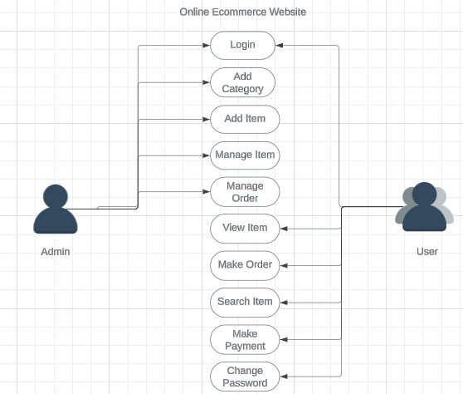

**8.Class Diagram**

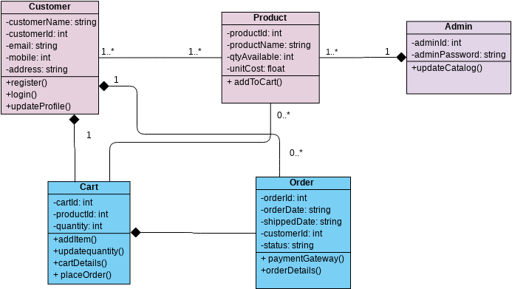

**9. Sequence Diagram**

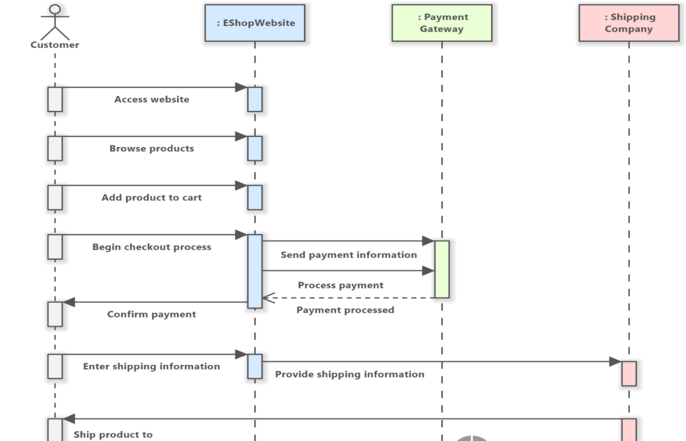

**10.Test Case**

Test Case 1: Adding Product to Shopping Cart

Objective: To verify that users can add products to their shopping cart successfully.

Test Case 2: Placing an Order

Objective: To verify that users can successfully place an order for products in the shopping cart.

Test Case 3: Product Search Functionality

Objective: To verify that the product search functionality returns accurate results based on user queries.

Test Case 4: Updating User Profile Information

Objective: To verify that users can successfully update their profile information.

Test Case 5: Viewing Order History

Objective: To verify that users can view their order history and track the status of their orders.

Test Case 6: Applying Filter Options

Objective: To verify that users can successfully apply filter options to refine product search results.