**Exercise 0:**

=== Output for 2 processes ===

Just a normal process From rank 1 machine ip-172-31-47-241.ec2.internal

Hello World! From rank 0 machine ip-172-31-47-241.ec2.internal

=== Output for 4 processes ===

Just a normal process From rank 2 machine ip-172-31-47-241.ec2.internal

Just a normal process From rank 3 machine ip-172-31-47-241.ec2.internal

Just a normal process From rank 1 machine ip-172-31-47-241.ec2.internal

Hello World! From rank 0 machine ip-172-31-47-241.ec2.internal

msg1_output

Just a normal process From rank 2 machine ip-172-31-47-241.ec2.internal

SEnding message to computer 3 from computer 1

in computer 3 the value of y is 30

Just a normal process From rank 0 machine ip-172-31-47-241.ec2.internal

msg2_output

Just a normal process From rank 2 machine ip-172-31-47-241.ec2.internal

SEnding message to computer 3 from computer 1

Just a normal process From rank 0 machine ip-172-31-47-241.ec2.internal

in computer 3 the value of y is printed

0 10 20 30 40 50 60 70 80 90

**Exercise 2:**

Fib(30) = 832040

Time taken: 0.997294 seconds

**Exercise 3:**

Sum = 50000005000000

**Exercise 4:**

Estimated Pi = 3.141305

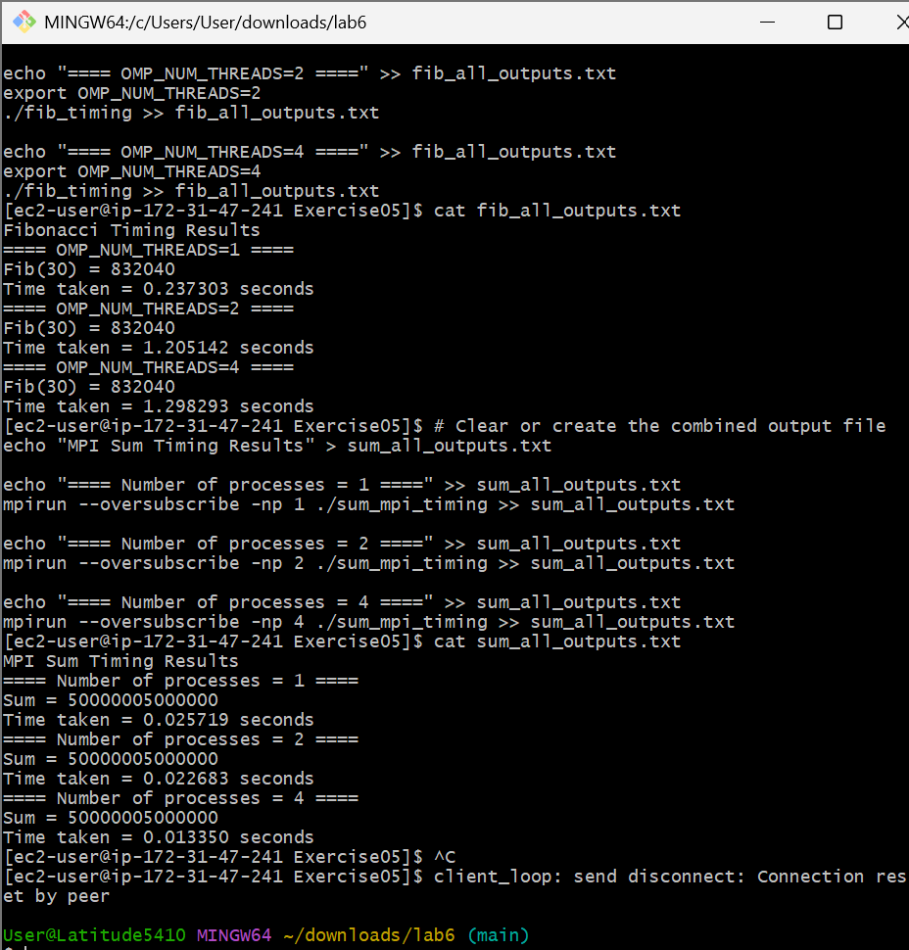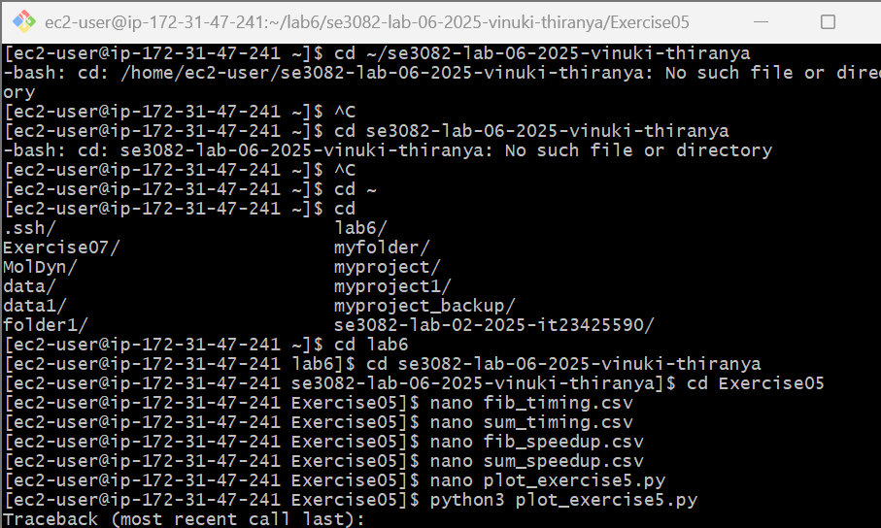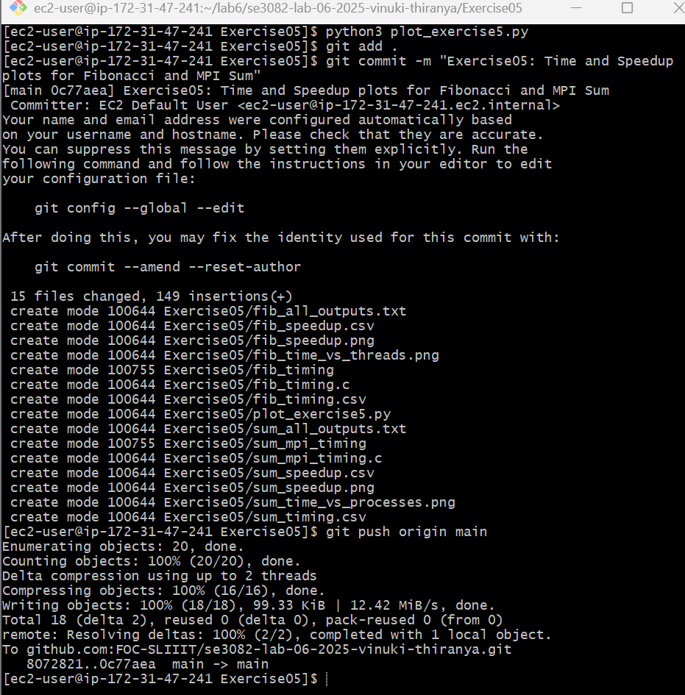 **Fibonacci Timing Results**

==== OMP_NUM_THREADS=1 ====

Fib(30) = 832040

Time taken = 0.237303 seconds

==== OMP_NUM_THREADS=2 ====

Fib(30) = 832040

Time taken = 1.205142 seconds

==== OMP_NUM_THREADS=4 ====

Fib(30) = 832040

Time taken = 1.298293 seconds

**MPI Sum Timing Results**

==== Number of processes = 1 ====

Sum = 50000005000000

Time taken = 0.025719 seconds

==== Number of processes = 2 ====

Sum = 50000005000000

Time taken = 0.022683 seconds

==== Number of processes = 4 ====

Sum = 50000005000000

Time taken = 0.013350 seconds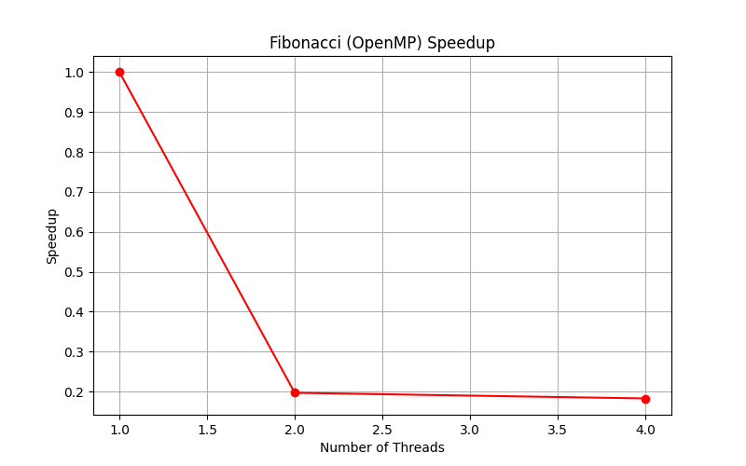

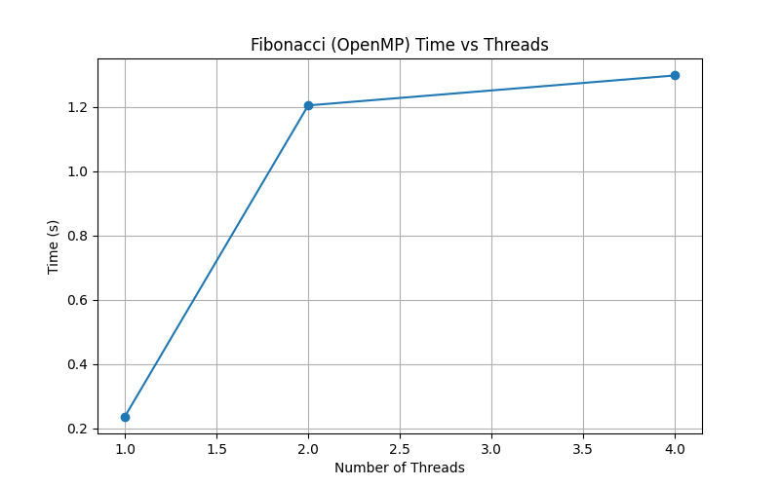

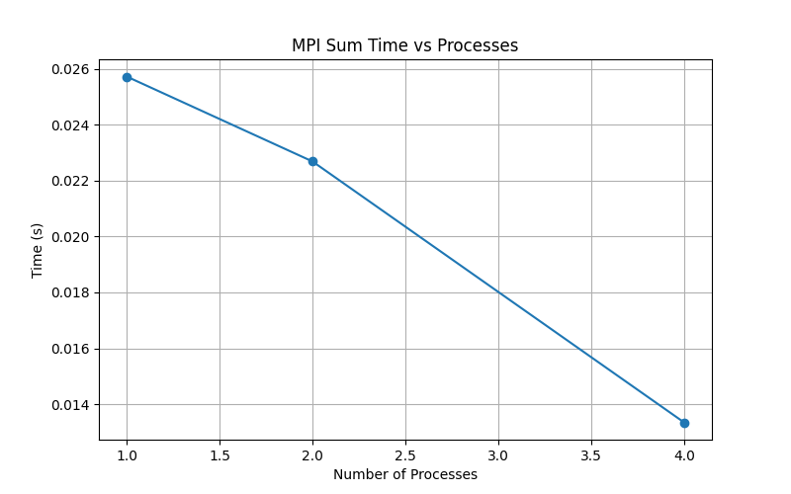

**Exercise 6:**

Exercise 6: MPI Outputs

==== Output of wrong_message.c ====

Sending message to rank 2 from rank 0

Rank 1 is idle, not receiving anything

Rank 2 received data = 100

==== Output of buffered_send.c ====

Process 0 sending buffered message to process 1

Process 0 sent message

Process 1 received: 0 10 20 30 40 50 60 70 80 90

If the source and destination don’t match in MPI:

* The program will hang (deadlock) because the receiver is waiting for a message that will never arrive.
* Sometimes MPI may throw an error (depending on implementation).
* This demonstrates why matching source, destination, and tags in MPI communication is very important.

**Exercise 07**

Received sum 9375001250000 from rank 1

Received sum 15625001250000 from rank 2

Received sum 21875001250000 from rank 3

Total Sum = 50000005000000

* **Exercise 3:** Uses MPI_Reduce → all local sums are automatically collected and added, only the **final result** is shown.
* **Exercise 7:** Uses MPI_Send/MPI_Recv with MPI_ANY_SOURCE → rank 0 manually receives sums from other ranks, shows **partial sums** and then the total.

**Exercise 8:**

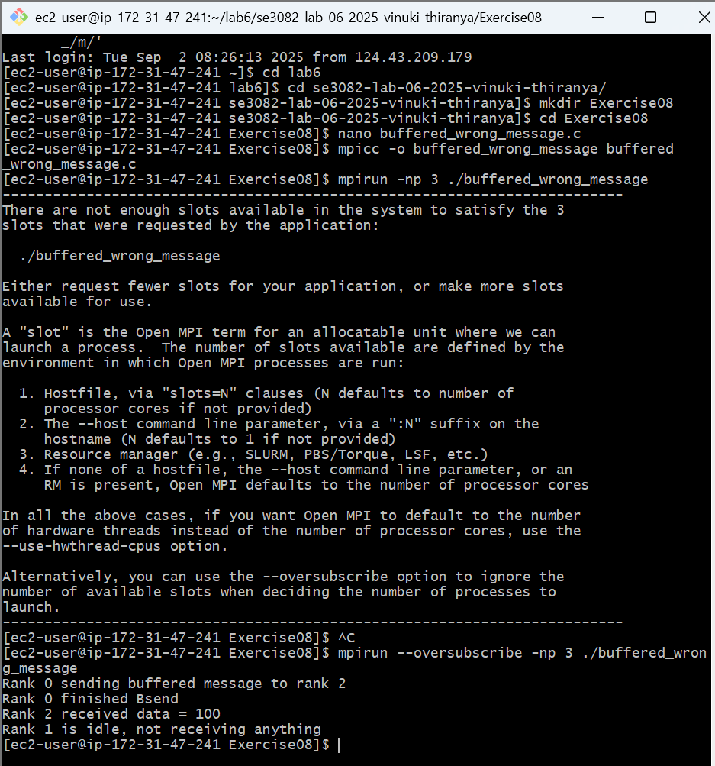

Rank 0 sending buffered message to rank 2

Rank 0 finished Bsend

Rank 1 is idle, not receiving anything

Rank 2 received data = 100