Architecture Document
Triage MVP — Data Ingestion, Correlation & AI Root-Cause Assistant
A Streamlit-based Minimum Viable Product for Embedded Video & Broadband Devices

Version 2.0
Document Owner: Engineering / QA Tools

Table of Contents

1. Introduction

1.1 Purpose
This document describes the software architecture of the Minimum Viable Product (MVP): a single Streamlit application that takes an engineer end-to-end from raw source code, logs, and documents to an AI-proposed, cited root cause for a triage investigation. It covers what has been built (the data ingestion and tracking layer), what remains to complete the MVP (indexing, retrieval, and the AI agent), and what is explicitly deferred beyond the MVP to a later, fleet-scale production system. Every component is traced back to the requirement IDs it implements in the Consolidated Requirements Specification.

1.2 What "MVP" Means Here
The MVP is the smallest version of the system that delivers the core value proposition end-to-end for a real user, not merely a technical demo of one layer in isolation. Concretely, the MVP is complete when:
- An engineer can provision source code, logs, and documents for a single investigation through the Streamlit UI, from either local paths or the remote sources described in Section 3.1 — with no manual data wrangling outside the app.
- That data is automatically templated (logs), chunked and embedded (code and documents), and linked through a lightweight knowledge graph — without the engineer needing to run separate scripts.
- An AI agent can query across all three data types and propose a root cause with citations back to the specific log signature, commit, and document that support it — matching the tool contract in AI-FR-061.
- A second engineer, unfamiliar with the codebase, can pick up the tool, ingest a new investigation's data, and get a usable answer without help from whoever built it.
This is a meaningfully larger scope than the proof-of-concept this document previously described: a POC exists to test whether an idea is feasible; this MVP exists to be genuinely usable by a team on a real investigation, even though it still runs as a single local process without fleet-scale infrastructure.

1.3 Scope
In scope for the MVP:
- The ingestion layer: provisioning source code, logs, and documents from local paths or remote sources (git, Jira, URLs) — implemented.
- The tracking/storage layer: a single DuckDB table recording every ingested artifact with a consistent schema regardless of source — implemented.
- The indexing layer: log templating, code chunking, and document embedding — required to complete the MVP, not yet built.
- The retrieval layer: hybrid (vector + keyword + graph) search across all indexed data — required to complete the MVP, not yet built.
- The agent layer: a Claude-based tool-calling loop that investigates an issue and proposes a cited root cause — required to complete the MVP, not yet built.
Out of scope, deferred to post-MVP:
- Fleet-scale infrastructure — ClickHouse, a hosted vector database, Neo4j, streaming telemetry ingestion (Kafka/MQTT).
- SCIP-based precise code indexing (the MVP uses tree-sitter-based chunking instead).
- CI-triggered automatic re-indexing (the MVP is manually triggered from the UI).
- Multi-user support, RBAC, and any encryption-at-rest beyond what the underlying tools provide by default.
- The full Part C triage workflow from the Requirements Specification (intake forms, dashboards, SLA timers) — the MVP focuses on proving the correlation and agent loop, not replacing a ticketing system.

1.4 Relationship to the Requirements Specification
The MVP implements the majority of Section 4 (AI-Powered Correlation & Root Cause Analysis) of the Consolidated Requirements Specification, substituting embedded/local technology for the production-scale technology named there (see Section 4.1 of this document for the specific mapping). Where an MVP component maps to a specific requirement ID, that ID is noted inline. Requirements this MVP does not attempt are called out explicitly in Section 1.3 above, rather than left ambiguous.

1.5 Definitions
Term | Definition
Artifact | Any single piece of ingested data tracked by the system — one code file, one log file, or one document.
Ingestion layer | The set of modules responsible for bringing external data (code, logs, docs) into local storage. Implemented.
Tracking layer | The DuckDB table recording metadata about every ingested artifact, regardless of source. Implemented.
Indexing layer | Processes that transform raw artifacts into searchable/queryable structures: log templates, code chunks, document embeddings. MVP scope — not yet built.
Retrieval layer | The hybrid search capability (vector + keyword + graph) that answers queries across indexed artifacts. MVP scope — not yet built.
Agent layer | The Claude-based tool-calling loop that investigates an issue across the retrieval layer and proposes a cited root cause. MVP scope — not yet built.
Post-MVP | Capability explicitly deferred beyond this MVP — fleet-scale infrastructure, multi-user support, and production-hardening (Section 1.3).

2. Architecture Overview

2.1 Guiding Principles
- Local-first, but complete: the MVP runs as a single Python process on one machine (or Streamlit Community Cloud) — no external infrastructure beyond the Claude API and the optional Jira API — while still closing the full loop from raw data to a cited answer, not stopping at ingestion.
- Decoupled ingestion from indexing: provisioning data and processing it are separate stages, connected only through the tracking layer's artifact records. Either stage can be re-run or replaced independently, which is what allows indexing/retrieval/agent to be added without reworking ingestion.
- One tracking schema, many sources: whether an artifact arrives via a local folder, a git clone, a Jira attachment, or a URL fetch, it is recorded identically — this is the MVP-scale analog of the shared identifier schema (Requirements Specification, Section 8.2).
- Hybrid/scale-agnostic by design: the same ingestion and templating logic that works against a handful of local files is intended to be the same logic that would run against a production-scale pipeline later, per AI-FR-007/008/018 — MVP scope is a deployment-mode choice, not a different architecture from the eventual production system.

2.2 Component Architecture
The diagram below shows the full MVP architecture. Teal components are implemented; amber components are in scope for the MVP but not yet built; the dashed gray box is explicitly deferred to a post-MVP, fleet-scale production system.
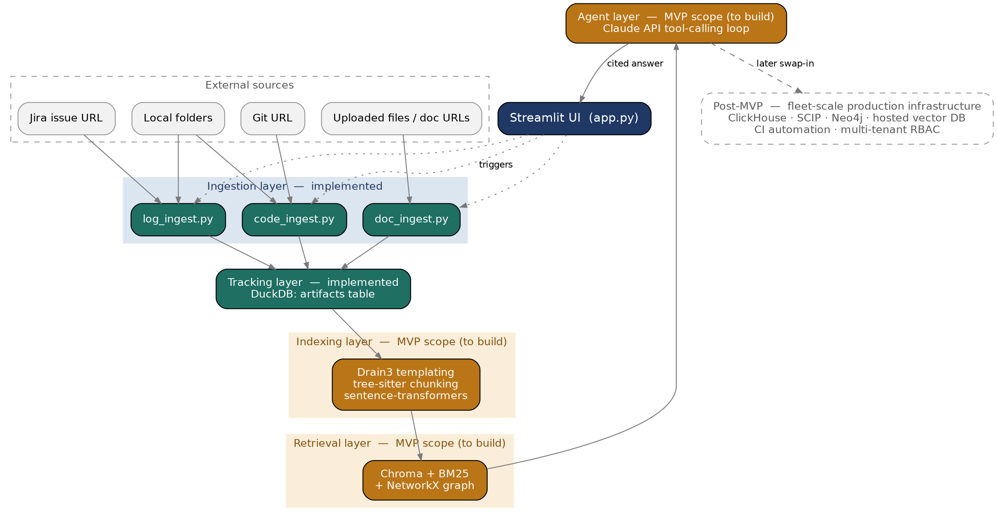
Figure 1 — Component architecture: implemented ingestion/tracking layers (teal), MVP-scope indexing/retrieval/agent layers still to build (amber), and deferred post-MVP production infrastructure (dashed gray).

2.3 Deployment View
The MVP deploys as a single Streamlit process. All state lives on local disk: raw artifacts under data/code, data/logs, data/docs, and tracking/indexing metadata in a single DuckDB file at data/poc.duckdb, plus an embedded Chroma store for vectors once the indexing layer is built. There is no separate application server, message queue, or database server to provision. The only external network dependencies are: the Claude API (for the agent layer), the Jira Cloud REST API (only when a user chooses Jira as a log source), and whatever git remote or document URL a user points the tool at.
This can run on a developer's laptop via `streamlit run app.py`, or be hosted on Streamlit Community Cloud for a shared team pilot — both use the identical codebase, since there is no environment-specific configuration beyond secrets (API keys/tokens). A shared team pilot is the realistic MVP deployment target — this is a meaningfully different bar than a POC that only ever needs to run on one developer's machine.

3. Component Detail

3.1 Ingestion Layer — Implemented
Three independent modules, one per data type, each supporting a local and a remote provisioning path:
Module | Local path | Remote path | Requirement ref.
code_ingest.py | Walk a local folder; register recognized source files (.c, .h, .cpp, .py, ...) | Shallow git clone into data/code/<repo>; then walk and register the same way | AI-FR-010 (precise indexing is a later phase; this stage only provisions files)
log_ingest.py | Walk a local folder; register every file as-is | Parse a Jira issue URL, call the Jira Cloud REST API, download matching attachments | AI-FR-007 (standalone mode — no fleet telemetry pipeline assumed)
doc_ingest.py | Accept uploaded PDF/Markdown files via the Streamlit file uploader; extract text | Fetch a URL, detect PDF/Markdown/HTML by content type, extract text accordingly | AI-FR-020 (chunking/embedding is a later phase; this stage extracts clean text)

Each module is independent of the others and has no shared state beyond calling the same record_artifact() function in the tracking layer — a module can be modified, tested, or replaced without touching the other two.

3.2 Tracking Layer — Implemented
A single DuckDB table (artifacts) is the system of record for everything ingested. DuckDB was chosen for the MVP because it is embedded (no server process), columnar (consistent with the production ClickHouse-class choice in the Requirements Specification for logs), and queryable directly with SQL from within the same Python process.
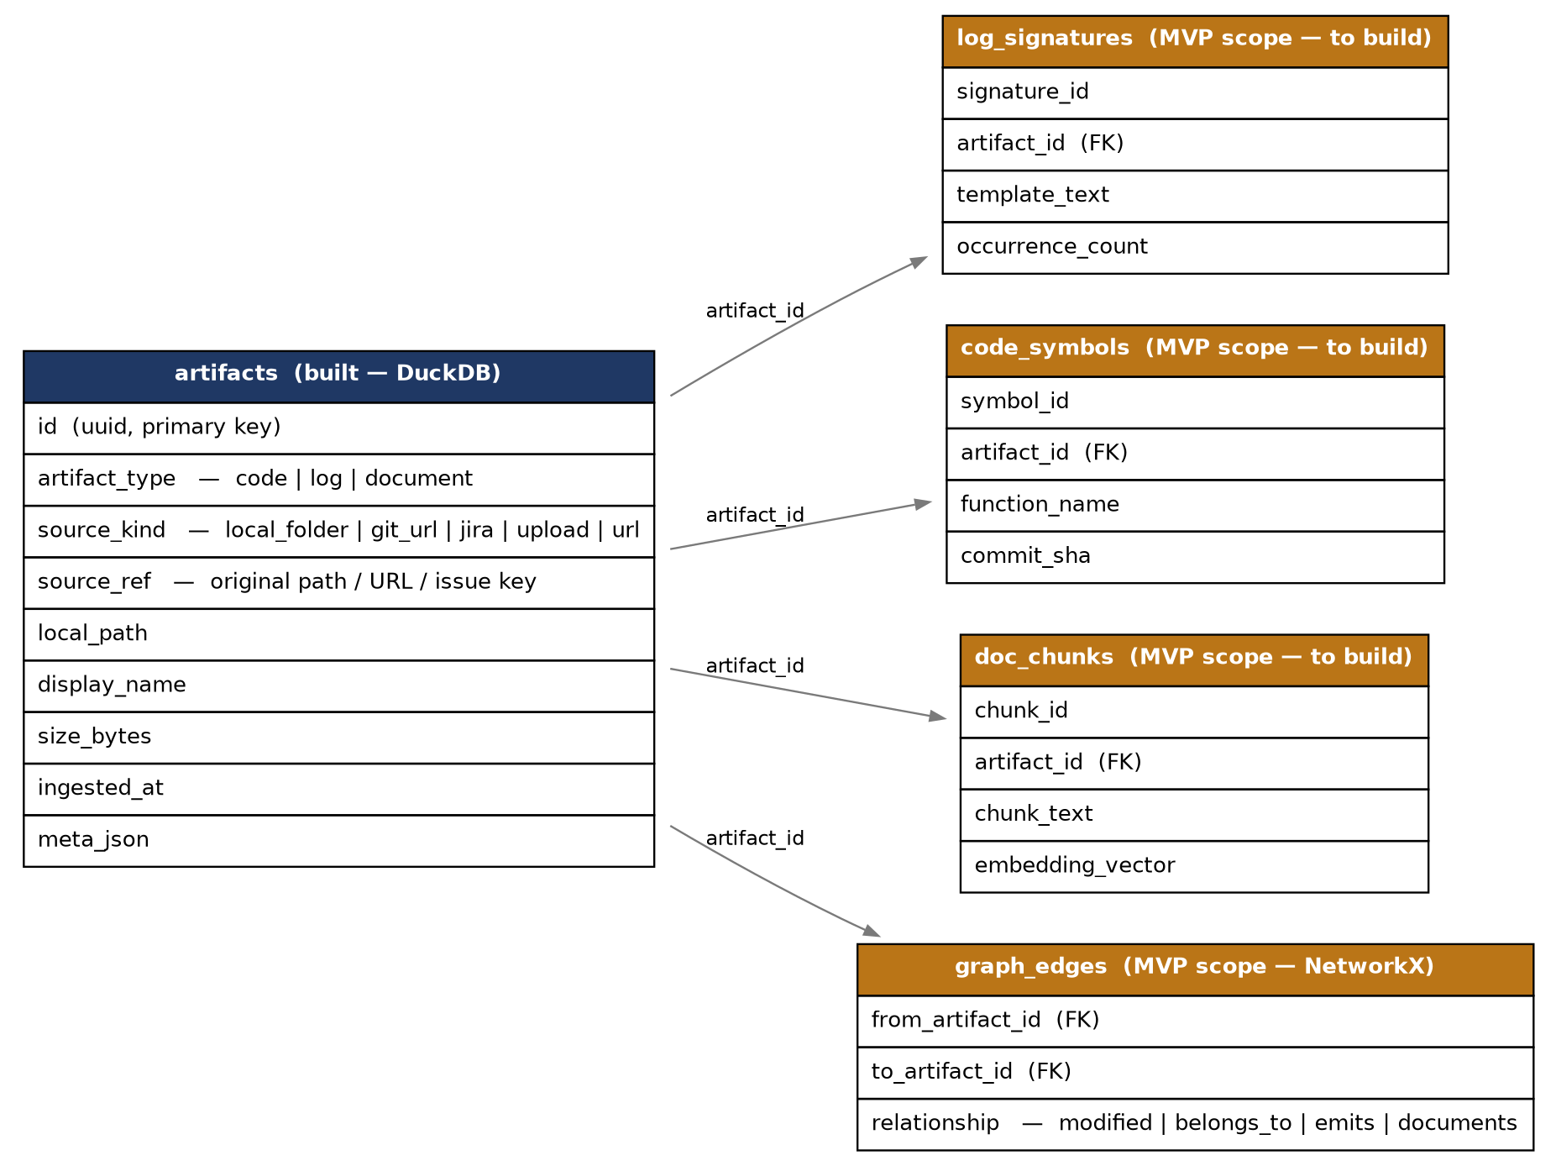
Figure 2 — The artifacts table (implemented) and the MVP-scope extension tables that will key off artifact_id once indexing is built.

3.3 Indexing Layer — MVP scope, to build
The next implementation milestone, required to complete the MVP. Reads unprocessed rows from the artifacts table and produces the structures the retrieval layer needs:
Data type | Processing to build | Output table | Requirement ref.
Logs | Drain3 templating — collapse raw log lines into structured templates with a stable signature ID | log_signatures | AI-FR-001, AI-FR-002
Code | tree-sitter AST-based chunking, function/file extraction, GitPython commit history | code_symbols | AI-FR-012, AI-FR-016
Documents | Semantic chunking + sentence-transformers embeddings | doc_chunks | AI-FR-020

3.4 Retrieval Layer — MVP scope, to build
Combines three retrieval strategies and merges results, mirroring AI-FR-050:
- Vector search over doc_chunks and code embeddings via Chroma (embedded, no server).
- Keyword search via rank_bm25, for exact-match queries (error codes, function symbols, parameter names) that embeddings blur together.
- Graph traversal via NetworkX over the relationships in graph_edges (commit → file → component → log signature → document → incident), the MVP-scale stand-in for the knowledge graph in AI-FR-030/031.

3.5 Agent Layer — MVP scope, to build
A Claude-based tool-calling loop implementing the reason → act → observe pattern from AI-FR-060, using the Anthropic SDK's native tool use directly rather than a heavier orchestration framework, consistent with keeping the MVP's dependency surface small. This is the layer that makes the MVP a usable tool rather than a set of disconnected indexes — without it, an engineer would still have to reason across logs, code, and docs manually. Tools to build:
- search_logs — query log_signatures by frequency, device, or firmware build
- symbolicate_crash — resolve a crash address to function/file/line via addr2line against a matching debug build
- search_code — hybrid search over code_symbols
- graph_query — traverse graph_edges for relationship questions
- search_docs — hybrid search over doc_chunks
- blame_history — commit history for a file/function via GitPython
This tool list is identical to AI-FR-061 in the Requirements Specification — the MVP agent is a direct, smaller-scale implementation of the same tool contract, not a simplified variant of it. This is one of the clearest markers of MVP vs. POC scope: a POC could have stopped at a single hard-coded tool call to prove feasibility; the MVP needs the full six-tool contract to be genuinely useful on a real investigation.

4. Data Architecture

4.1 Storage Choices and Rationale
Data type | MVP storage | Production equivalent (per spec) | Why this substitution is safe
Logs (post-templating) | DuckDB | ClickHouse-class columnar store | Both are columnar and SQL-queryable; DuckDB is the embedded, single-node version of the same storage category
Source code index | Filesystem + tree-sitter/NetworkX (to build) | SCIP-based precise index + graph DB | MVP trades compiler-accurate resolution for AST-based chunking — sufficient for a genuinely useful single-team tool, not yet a replacement for SCIP at fleet scale
Document embeddings | Chroma, embedded (to build) | Hosted/production vector database | Chroma's API is representative of the category; swapping the backend later does not change the retrieval interface
Knowledge graph | NetworkX, in-memory (to build) | Neo4j or similar graph database | NetworkX supports the full entity/relationship model needed for the MVP without standing up a graph database server

4.2 Shared Identifiers at MVP Scale
The production shared identifier schema (Requirements Specification, Section 8.2) is represented at MVP scale by the artifacts table's columns:
Production field | MVP equivalent
firmware_build_id / commit_sha | Captured in meta_json where available (e.g. Jira attachment metadata, git commit at clone time)
component | Not yet enforced at ingestion; to be inferred during indexing (log template → component mapping) — part of the MVP indexing build
log_signature_id | Generated during indexing, stored in log_signatures.signature_id — part of the MVP indexing build
device_model | Captured in meta_json when present in a source (e.g. a Jira custom field or a folder-naming convention)

5. Security & Secrets Handling
- Jira credentials (email + API token) are entered as Streamlit text inputs at runtime, with the token field masked (type="password"); nothing is written to disk or committed to the repository.
- Git credentials for private repositories are the user's responsibility to configure (embedded token in the clone URL, or a local git credential helper) — the MVP does not store or manage git secrets.
- The Claude API key is expected via Streamlit's secrets mechanism (.streamlit/secrets.toml, gitignored) rather than hardcoded or entered in the UI.
- No PII handling, encryption-at-rest, or access control is implemented in the MVP — this is an explicit, accepted gap versus NFR-04/NFR-09 in the Requirements Specification. Acceptable for an internal single-team pilot on non-sensitive data, but required before any deployment involving customer-identifiable information or multiple mutually-untrusted teams.

6. Non-Functional Notes (MVP Scope)
- Single-team, single-process: no multi-tenant isolation, and no locking around concurrent writes — two people ingesting into the same data directory at the same time is not supported. Acceptable for a small pilot team sharing one deployment; not acceptable beyond that.
- No defined latency targets — the NFR-01/NFR-11 targets in the Requirements Specification apply to the production system. The MVP's usability bar is qualitative (Section 1.2's success criteria), not a measured SLA.
- Idempotent re-ingestion is in scope for the MVP, unlike the POC that preceded it: re-ingesting the same source should update existing records rather than silently duplicating or destructively re-fetching (e.g. re-cloning a git URL should not discard local-only state). This closes the gap against AI-FR-023 and is a tracked item for the indexing-layer build in Section 3.3.
- No automated test suite yet — functional verification during the ingestion-layer build was manual. A minimal test suite covering the indexing and retrieval layers is part of completing the MVP, not deferred to post-MVP.

7. Path from MVP to Production
None of the MVP's implementation choices require a redesign to scale up — each is a drop-in substitution behind the same interface, consistent with the hybrid-model principle established in the Requirements Specification. Reaching production is a matter of swapping infrastructure underneath a stable interface, not rebuilding the system:
MVP component | Production substitution | What changes
DuckDB artifacts table | ClickHouse (logs) + relational metadata store | Same schema shape; storage engine swap only
Local folder / manual git clone | CI-triggered indexing on every merge (AI-FR-011) | Add an automation trigger; ingestion logic is reused as-is
NetworkX in-memory graph | Neo4j or equivalent graph database | Same node/edge model; persistence and query language change
Chroma embedded vector store | Hosted/production vector database | Same embedding pipeline; storage backend swap only
Manual Jira URL entry | Automated telemetry/crash pipeline ingestion | Adds a streaming consumer; does not replace the Jira path, which remains useful for one-off investigations
Single-team, no RBAC | Multi-tenant with role-based access control | New auth/authz layer sits in front of the same core modules

8. Repository Structure
Implemented today:
- app.py — Streamlit entry point and UI
- ingestion/code_ingest.py, log_ingest.py, doc_ingest.py — the three ingestion modules
- utils/storage.py — the DuckDB tracking layer
- data/ — runtime storage for raw artifacts and the DuckDB file (gitignored)
- .streamlit/secrets.toml.example — template for API keys/tokens
- requirements.txt, README.md
To be added to complete the MVP:
- indexing/log_templating.py, code_chunking.py, doc_embedding.py — the indexing layer (Section 3.3)
- retrieval/hybrid_search.py — vector + keyword + graph fusion (Section 3.4)
- agent/tools.py, agent/loop.py — the Claude tool-calling agent (Section 3.5)
- tests/ — the minimal test suite called for in Section 6

