High-Level Design
Triage MVP — Data Ingestion, Correlation & AI Root-Cause Assistant
Module design, data design, and key workflows for implementation

Version 1.0
Document Owner: Engineering / QA Tools

Table of Contents

1. Introduction

1.1 Purpose
This High-Level Design (HLD) translates the requirements and architecture already established for the Triage MVP into concrete module boundaries, interfaces, and data structures — the level of detail an engineer needs to start implementing the indexing, retrieval, and agent layers without re-deriving design decisions already made. It does not repeat what those documents already cover; it builds on them and adds the design detail they intentionally left out.

1.2 Document Relationships
This HLD sits between the architecture and the code, and should be read alongside the two documents it builds on:
- Consolidated Requirements Specification — defines what the system must do (functional and non-functional requirements, identified as FR-xxx, AI-FR-xxx, NFR-xx).
- Triage MVP Architecture Document — defines the system's shape: which technology per layer, the deployment model, and what is implemented vs. MVP-scope vs. post-MVP.
- This HLD — defines how each MVP-scope layer is built internally: module boundaries, function-level interfaces, data schemas, and the key workflows that tie them together.

1.3 Scope
This document covers module and interface design for all five layers defined in the Architecture Document: ingestion, tracking, indexing, retrieval, and agent. The ingestion and tracking layers are already implemented; their design is documented here as-built. The indexing, retrieval, and agent layers are MVP-scope but not yet built; their design here is the target for implementation, not a description of existing code.

1.4 Definitions
Terms follow the definitions in the Requirements Specification and Architecture Document. Two additional terms used specifically in this HLD:
Term | Definition
Interface (in this document) | A module's public function signatures — inputs, outputs, and errors — treated as a contract other modules and future implementers can rely on.
Investigation | One end-to-end run of the agent against a question, from first tool call to a final proposed root cause and the engineer's feedback on it.

2. Design Goals & Principles
In addition to the architectural principles already established (local-first, decoupled ingestion from indexing, shared identifiers, hybrid/scale-agnostic design), this HLD applies the following module-level design goals:
- Explicit interfaces over shared state — every module exposes a small set of typed functions; modules never reach into another module's internals or files directly.
- Fail-soft, not fail-fast, during batch operations — one malformed log file or one un-parseable source file should not abort an entire ingestion or indexing run; failures are recorded per-artifact and surfaced to the UI.
- Idempotent by default — re-running ingestion or indexing against the same artifact updates existing records rather than creating duplicates (closing the AI-FR-023 gap noted in the Architecture Document).
- Every design decision that has a real alternative is written down — Section 8 exists so implementation doesn't silently diverge from intent, and so later reviewers can see what was considered.

3. Module Design

3.1 Ingestion Layer — implemented
Three independent modules, each exposing one function per provisioning path. This is the as-built interface:
Function | Inputs | Returns | Raises
code_ingest.ingest_local_code_folder | folder_path: str | int (files registered) | ValueError if path invalid
code_ingest.ingest_code_from_git_url | git_url: str, branch: str | None | int (files registered) | RuntimeError if git clone fails
log_ingest.ingest_local_log_folder | folder_path: str | int (files registered) | ValueError if path invalid
log_ingest.ingest_logs_from_jira | issue_url, email, api_token, only_log_like: bool | int (files downloaded) | requests.HTTPError on auth/API failure
doc_ingest.ingest_uploaded_files | uploaded_files: list[UploadedFile] | int (files registered) | — (per-file failures are logged, not raised)
doc_ingest.ingest_doc_from_url | url: str | int (always 1 on success) | requests.HTTPError on fetch failure

Design note: each function returns a plain count rather than the records themselves — callers that need the records query the tracking layer directly (Section 3.2). This keeps ingestion functions simple and ensures the tracking layer, not the caller, is always the single source of truth for what was ingested.

3.2 Tracking Layer — implemented
A single DuckDB-backed module (utils/storage.py) exposing:
Function | Inputs | Returns
record_artifact | artifact_type, source_kind, source_ref, local_path, display_name, size_bytes, meta: dict | str (generated artifact id)
list_artifacts | artifact_type: str | None | DataFrame of matching artifact rows
artifact_counts | — | dict[artifact_type, count]

Two functions are added to this module as part of completing the MVP, to support the indexing layer:
Function (to add) | Purpose
get_unindexed_artifacts(artifact_type) | Return artifacts not yet present in the corresponding index table — lets the indexing layer run incrementally rather than reprocessing everything on every call.
mark_indexed(artifact_id, index_table, index_id) | Record that an artifact has been indexed and where its indexed record lives, making re-ingestion-triggered re-indexing idempotent (Section 2).

3.3 Indexing Layer — to build
Three modules, one per data type, each reading unindexed artifacts (via get_unindexed_artifacts) and writing to its own output table (Section 4).

3.3.1 log_templating.py
Function | Inputs | Returns
template_log_file | artifact_id: str | list[LogTemplate] (signature_id, template_text, extracted variables)
get_signature_frequency | signature_id: str, group_by: list[str] | DataFrame (counts over time, filterable per AI-FR-005)
Implementation basis: a Drain-family streaming parser (e.g. the drain3 package) run per log file; extracted templates are written to log_signatures keyed by a stable hash of the template text, so the same event occurring in two different files still maps to one signature_id.

3.3.2 code_chunking.py
Function | Inputs | Returns
chunk_source_file | artifact_id: str | list[CodeChunk] (function-level chunks with file/line spans)
extract_commit_history | repo_path: str, file_path: str | list[Commit] (sha, author, date, message)
Implementation basis: tree-sitter (with the C/C++ grammar as the primary target, per the embedded/RDK codebases this system is designed around) for function-boundary chunking, per AI-FR-012; GitPython for commit history, per AI-FR-016. Each chunk is embedded (see 3.3.3's model) and stored with its enclosing function name for later symbol-based lookups.

3.3.3 doc_embedding.py
Function | Inputs | Returns
embed_document | artifact_id: str | list[DocChunk] (chunk text + embedding vector + metadata)
Implementation basis: a local sentence-transformers model (no external API call, keeping indexing cost-free and offline-capable) chunking at paragraph/section boundaries with overlap, per AI-FR-020.

3.4 Retrieval Layer — to build
Function | Inputs | Returns
hybrid_search | query: str, artifact_type: str | None, top_k: int | list[SearchResult] (ranked, each tagged with which method(s) matched it)
graph_query | cypher_like_query: str (a small fixed set of supported query shapes) | list[GraphPath]
hybrid_search internally runs three sub-queries in parallel — a Chroma similarity search over doc_chunks and code_symbols, a rank_bm25 keyword search over the same text, and (where the query names an artifact) a one-hop graph_edges lookup — then merges results with reciprocal rank fusion, per AI-FR-050/AI-FR-051. graph_query supports a small, fixed set of traversal shapes (e.g. "commits touching component X in the last N days") rather than arbitrary graph queries, since NetworkX at MVP scale does not need a full query language.

3.5 Agent Layer — to build
Two modules: a tool registry and the orchestration loop, matching AI-FR-060/AI-FR-061.
Function | Inputs | Returns
loop.investigate | question: str, initial_context: dict | None | Investigation (final answer, citations, full tool-call trace)
tools.dispatch | tool_name: str, tool_args: dict | dict (tool result, passed back to the model as the next turn's context)
loop.investigate implements the reason → act → observe cycle: it calls the Claude API with the six tools (Section 6.2) registered as available tool-use functions, dispatches each requested tool call to tools.dispatch, appends the result to the conversation, and repeats until the model returns a final answer or a bounded step limit is reached (Section 7). Every call and result is appended to tool_call_log_json in the resulting agent_investigations row (Section 4), which is what makes the citations in AI-FR-063 machine-checkable rather than free text.

4. Data Design

4.1 Data Model
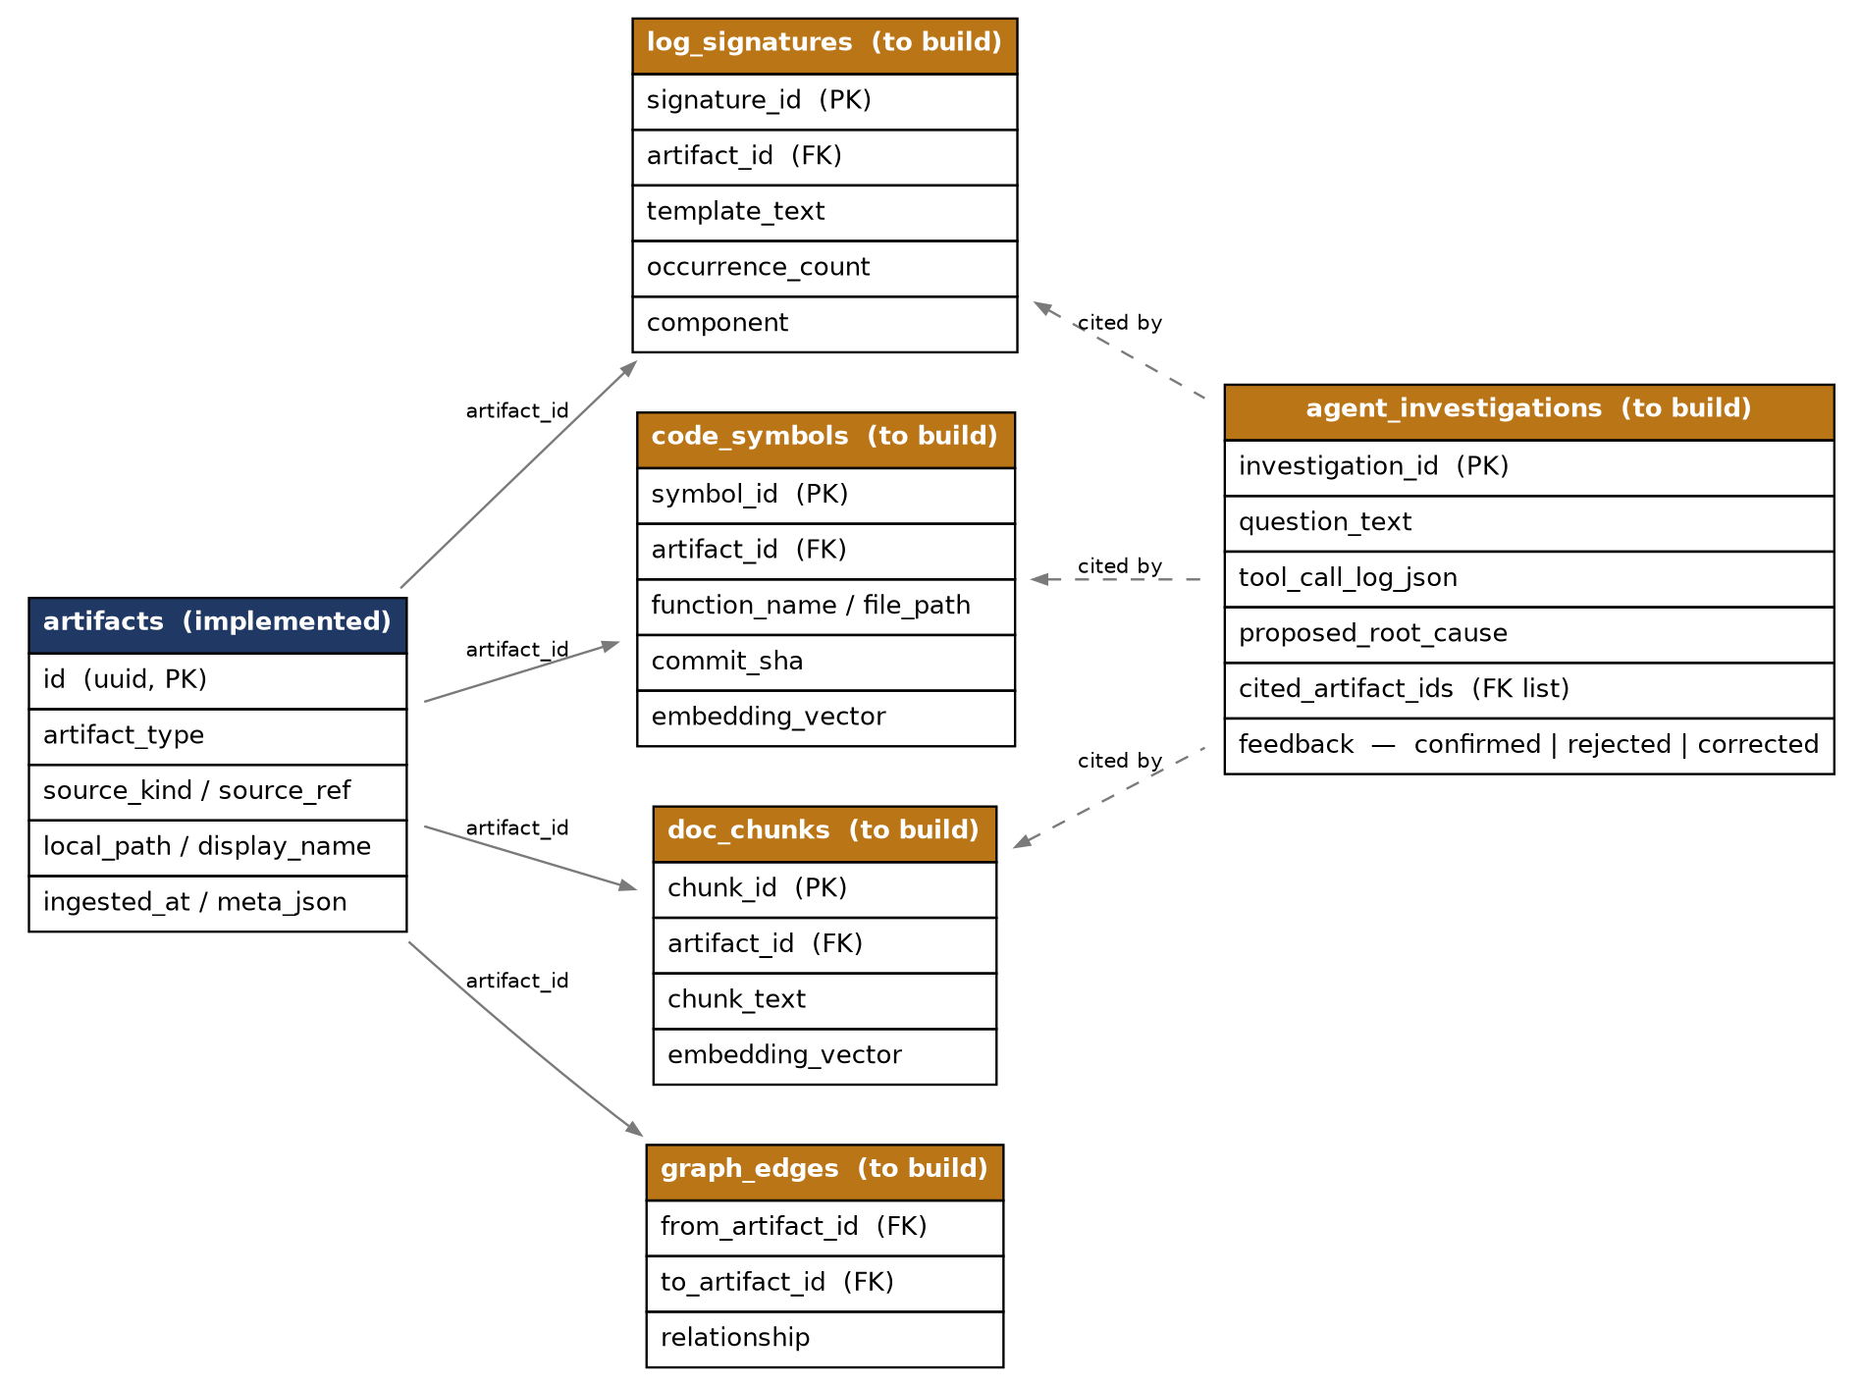
Figure 1 — Full MVP data model. artifacts (implemented) is the hub every other table keys off; agent_investigations is new in this HLD, capturing the citations an investigation relies on.

4.2 Table Definitions

artifacts — implemented
As documented in the Architecture Document, Section 3.2 — unchanged here.

log_signatures — to build
Field | Type | Notes
signature_id | VARCHAR, PK | Stable hash of the normalized template text
artifact_id | VARCHAR, FK → artifacts.id | The log file this occurrence came from
template_text | VARCHAR | The masked/parameterized template, e.g. "signal lock lost on freq <NUM>, retry <NUM>"
occurrence_count | BIGINT | Running count for this signature within the artifact
component | VARCHAR, nullable | Inferred component mapping; populated once available

code_symbols — to build
Field | Type | Notes
symbol_id | VARCHAR, PK | UUID
artifact_id | VARCHAR, FK → artifacts.id | The source file this symbol was extracted from
function_name | VARCHAR
file_path / line_start / line_end | VARCHAR / INT / INT | Span used for symbolication lookups
commit_sha | VARCHAR, nullable | Last commit touching this function, from extract_commit_history
embedding_vector | FLOAT[] | Stored in Chroma, referenced here by id for joinability

doc_chunks — to build
Field | Type | Notes
chunk_id | VARCHAR, PK | UUID
artifact_id | VARCHAR, FK → artifacts.id
chunk_text | VARCHAR
embedding_vector | FLOAT[] | Stored in Chroma, referenced here by id for joinability

graph_edges — to build
Field | Type | Notes
from_artifact_id / to_artifact_id | VARCHAR, FK → artifacts.id | The two linked artifacts
relationship | VARCHAR | One of: modified | belongs_to | emits | documents (per AI-FR-031)

agent_investigations — to build (new in this HLD)
Not present in the Architecture Document's schema — added here because the agent layer needs a durable record of each investigation to satisfy AI-FR-063 (machine-checkable citations) and AI-FR-065 (feedback capture).
Field | Type | Notes
investigation_id | VARCHAR, PK | UUID
question_text | VARCHAR | What the engineer asked
tool_call_log_json | VARCHAR (JSON) | Full ordered trace of every tool call and result — the audit trail behind the agent's answer
proposed_root_cause | VARCHAR | The agent's final answer text
cited_artifact_ids | VARCHAR[] (JSON array), FK → artifacts.id | Every log signature, commit, or document the answer cites
feedback | VARCHAR, nullable | confirmed | rejected | corrected — set by the engineer, per AI-FR-065
created_at | TIMESTAMP

5. Key Workflows

5.1 Workflow — Ingest source code from a Git URL
- 1. Engineer enters a git URL (and optional branch) in the Streamlit UI and clicks "Clone and ingest."
- 2. code_ingest.ingest_code_from_git_url shallow-clones the repository into data/code/<repo-name>.
- 3. The module walks the cloned tree and calls storage.record_artifact once per recognized source file.
- 4. The UI displays the count of files registered and refreshes the "Ingested artifacts" table.

5.2 Workflow — Ingest logs from a Jira issue
- 1. Engineer pastes a Jira issue URL and enters their email and API token.
- 2. log_ingest._parse_jira_issue_url extracts the base URL and issue key from the URL.
- 3. log_ingest.ingest_logs_from_jira calls the Jira Cloud REST API for the issue's attachment list, filters to log-like extensions (if the filter checkbox is on), and downloads each match.
- 4. Each downloaded file is written to data/logs/<issue_key>/ and registered via storage.record_artifact, with the Jira issue key and attachment id captured in meta_json.

5.3 Workflow — End-to-end investigation (target design)
This is the workflow the indexing, retrieval, and agent layers exist to support — it is not yet implemented, and is the primary thing this HLD's Section 3 designs are meant to enable.
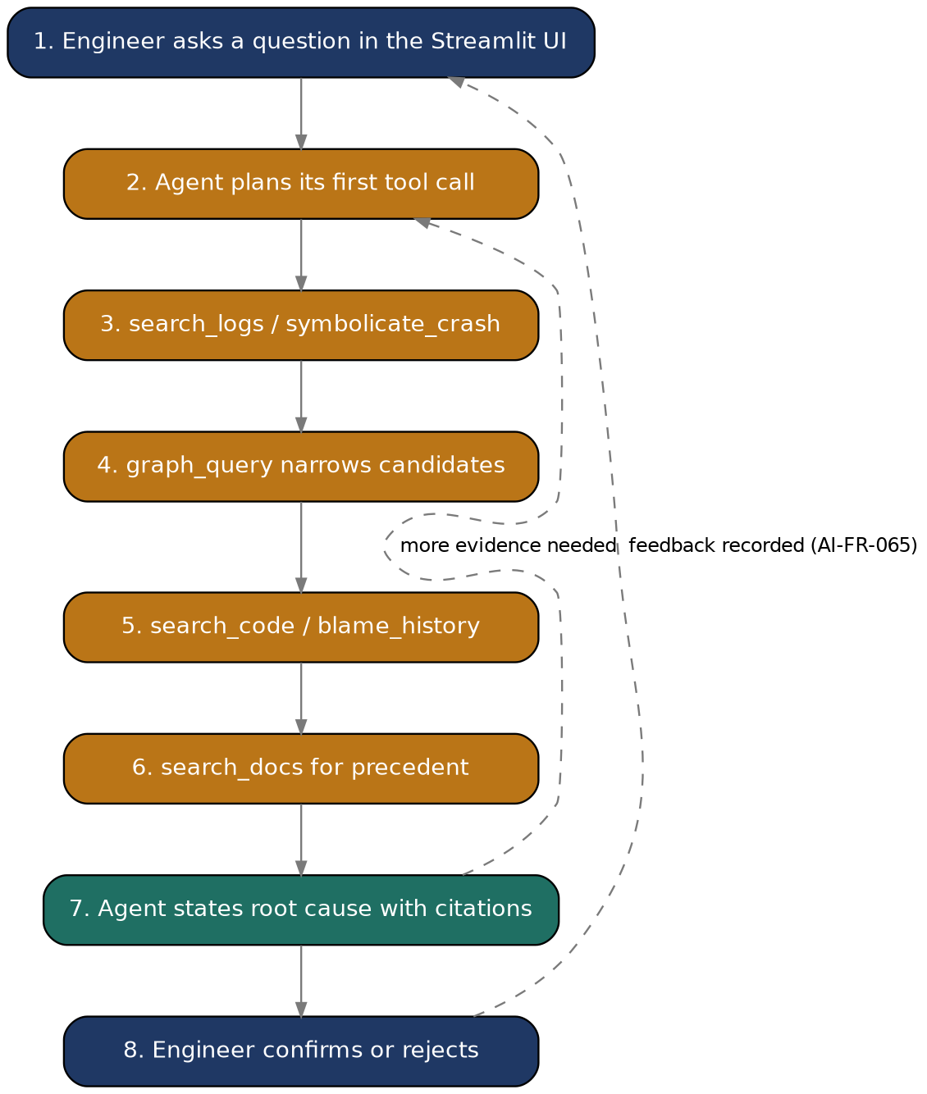
Figure 2 — The agent's reason → act → observe loop, from question to a confirmed or rejected cited answer.
Narrated:
- The engineer types a question in natural language (e.g. "why does the XR400 reboot after standby on RDKV-4.2.118?").
- loop.investigate sends the question and the six available tools to the Claude API; the model decides which tool to call first — typically search_logs or symbolicate_crash if a crash report is attached to the investigation.
- Each tool call is dispatched, its result appended to the conversation, and the model decides the next step — this is the narrow-then-reason pattern from the Architecture Document: graph_query narrows the candidate commits/components before the model reasons over the shortlist in depth.
- Once the model has enough evidence, it returns a final answer citing specific signature_id, commit_sha, and chunk_id values rather than free text.
- The full trace is persisted to agent_investigations; the engineer reviews the citations and marks the answer confirmed, rejected, or corrected — that feedback both closes the loop for this investigation and becomes training signal for future accuracy tuning (AI-FR-065).

6. Interface Design

6.1 Internal Module Interfaces
Consolidated from Section 3 — this is the full internal API surface between layers. No module calls another module's internals directly; every cross-module interaction goes through one of these functions.
Caller | Callee interface
Streamlit UI | ingestion.*.ingest_*(), storage.list_artifacts(), storage.artifact_counts()
Indexing layer | storage.get_unindexed_artifacts(), storage.mark_indexed()
Retrieval layer | log_signatures / code_symbols / doc_chunks / graph_edges (read-only, direct table access — these are the layer's own output tables)
Agent layer | retrieval.hybrid_search(), retrieval.graph_query(), plus direct reads for symbolicate_crash and blame_history
Streamlit UI | agent.loop.investigate() (once the agent layer is built)

6.2 Agent Tool Contract
The six tools registered with the Claude API in loop.investigate, matching AI-FR-061 exactly. Each is described here at the level of detail needed to write its tool-use schema.
Tool | Input | Output
search_logs | signature or free-text query, optional filters (device_model, firmware_build_id, time range) | Matching log signatures with occurrence counts
symbolicate_crash | crash address, firmware_build_id | function name, file, line — or an explicit "unreliable" flag on build mismatch (NFR-13)
search_code | free-text or exact symbol query | Ranked code chunks/symbols with file/line and commit_sha
graph_query | one of the fixed traversal shapes (Section 3.4) | List of connected artifacts/relationships
search_docs | free-text query | Ranked document chunks with source metadata
blame_history | file path or function name | Ordered list of commits touching it

7. Error Handling & Logging Strategy
- Ingestion (implemented): per-file failures during a folder walk or Jira download are logged and skipped, not raised — a single unreadable file must not abort ingestion of the rest of the batch. Whole-operation failures (invalid folder path, failed git clone, Jira auth failure) are raised and surfaced directly to the UI, since those indicate the user's input needs correction.
- Indexing (to build): the same fail-soft principle applies per artifact — a source file tree-sitter cannot parse, or a log file Drain3 chokes on, is flagged in the artifact's tracking record rather than stopping the indexing run. A count of skipped/failed artifacts is surfaced in the UI so failures are visible, not silent.
- Retrieval (to build): a failure in one of the three hybrid_search sub-queries (e.g. Chroma unavailable) degrades to the remaining methods rather than failing the whole query — a keyword-only result is more useful than no result.
- Agent (to build): the reason → act → observe loop is bounded (a fixed maximum number of tool calls, proposed at 15 per AI-FR-062's narrowing guidance) — if the limit is reached without a confident answer, the agent returns its best partial evidence explicitly labeled as inconclusive, rather than forcing a low-confidence final answer that looks equally authoritative.

8. Design Decisions
Decisions with a real alternative, recorded so implementation doesn't silently diverge from intent.
Decision | Alternative considered | Why this choice
DuckDB for tracking + log signatures | SQLite | DuckDB is columnar, matching the production ClickHouse-class target category (Architecture Document, 4.1); SQLite would need to be replaced with a fundamentally different engine later rather than swapped like-for-like
Hand-rolled agent loop on the Anthropic SDK | LangChain / LlamaIndex | Keeps the MVP's dependency surface small and every step debuggable; the six-tool contract is simple enough not to need a framework's abstraction
tree-sitter for code chunking | Regex-based function extraction | AST-based chunking (AI-FR-012) doesn't break on nested braces or macros the way regex does for C/C++, which this system is designed around
Reciprocal rank fusion for hybrid search | Weighted score averaging | RRF doesn't require tuning relative score scales between vector similarity and BM25 scores, which are not naturally comparable numbers
NetworkX in-memory graph | Embedding graph edges directly in DuckDB with recursive SQL | NetworkX's traversal API is a closer match to the fixed query shapes graph_query needs, and migrates more directly to Neo4j's graph model later

9. Traceability
HLD component | Requirement ID(s) | HLD section
Ingestion layer | AI-FR-007, AI-FR-009 | 3.1
Tracking layer / shared IDs | AI-FR-040, Section 8.2 of Requirements Spec | 3.2, 4.2
log_templating.py | AI-FR-001, AI-FR-002, AI-FR-005 | 3.3.1
code_chunking.py | AI-FR-012, AI-FR-016 | 3.3.2
doc_embedding.py | AI-FR-020 | 3.3.3
hybrid_search / graph_query | AI-FR-030, AI-FR-031, AI-FR-050, AI-FR-051 | 3.4
Agent loop + tools | AI-FR-060, AI-FR-061, AI-FR-062, AI-FR-063 | 3.5, 6.2
agent_investigations table | AI-FR-063, AI-FR-065, NFR-14 | 4.2
Build-exact symbolication check | NFR-13 | 6.2, 7

10. Open Design Questions
- Which sentence-transformers model balances embedding quality against local inference speed for this codebase's scale — to be settled during the doc_embedding.py implementation, not decided here.
- The exact bounded step limit for the agent loop (proposed 15 in Section 7) has not been validated against a real investigation — likely needs adjustment once the evaluation harness (AI-FR-066) exists.
- Whether graph_query's fixed traversal shapes are sufficient, or whether a small query DSL is needed, will become clearer once the agent layer is exercised against real investigations.
- component inference from log templates (referenced in 4.2's log_signatures.component) needs a concrete mapping strategy — likely a configurable lookup table keyed by log module tag, but not yet designed in detail.

