

Sri Lanka Institute of Information Technology

IT3021 - Data warehousing and Business Intelligence
Assignment 01
Dahanayake V O
IT23302044
DS.WE.Y3.S1.01.02
Table of Contents

Table of Contents 1
Task 1 — Dataset Selection 3
Task 2 — Data Sources Preparation 5
Task 3 — Solution Architecture 9
Task 4 — Data Warehouse Design & Development 11
Task 5 — ETL Development 15
Task 6 — Accumulating Fact Table 33

Task 1 — Dataset Selection
1. Dataset Selection
Dataset Name: Superstore Sales Dataset
Source: Kaggle — https://www.kaggle.com/datasets/vivek468/superstore-dataset-final
Description:
The selected dataset is the Superstore Sales Dataset, which represents raw transactional sales data from a fictional retail superstore operating across the United States. The dataset is an OLTP-style dataset containing individual order transactions recorded between 2019 and 2022, covering approximately 4 years of business activity.
The dataset contains 9,994 order records with 21 attributes covering customer information, product details, geographical data, and sales metrics. It represents a realistic retail business scenario where customers place orders for products belonging to different categories and subcategories, delivered via different shipping modes.
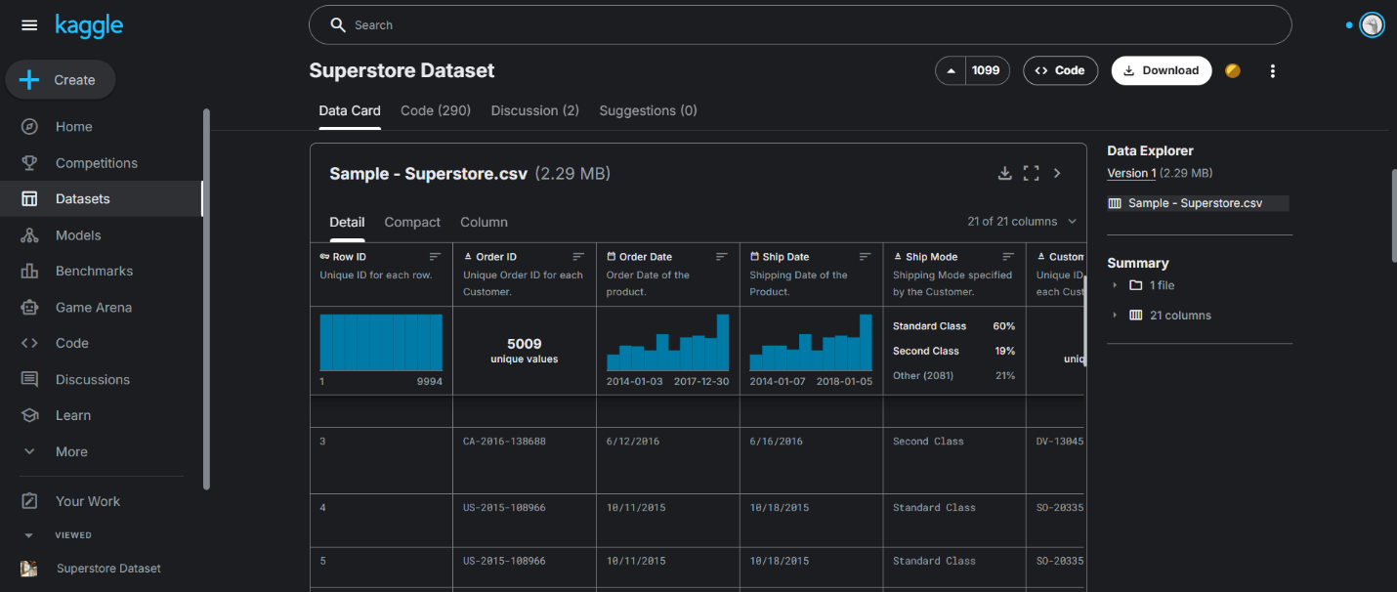

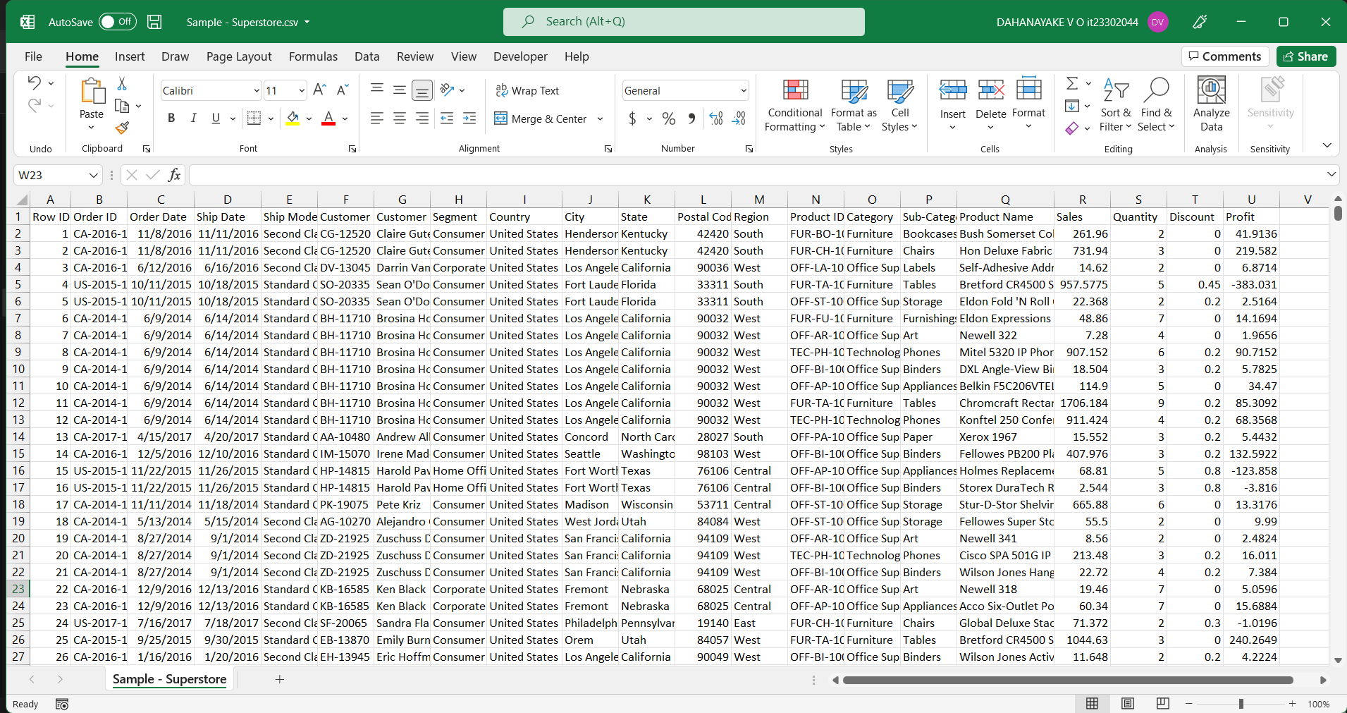

Key Attributes:
Attribute | Description
Order ID | Unique identifier for each order
Order Date / Ship Date | Transaction and shipping dates
Customer ID / Name | Customer identification
Segment | Customer segment (Consumer, Corporate, Home Office)
Region / State / City | Geographic information
Product ID / Name | Product identification
Category / Sub-Category | Product hierarchy
Sales / Profit / Quantity / Discount | Business measures
Ship Mode | Delivery method
Justification:
This dataset was selected because it satisfies all assignment requirements — it is an OLTP transactional dataset (not a pre-built OLAP dataset), covers more than one year of data, contains multiple entities with clear relationships, supports hierarchical analysis (Category → SubCategory → Product), and provides sufficient measures for analytical reporting.

ER Diagram :
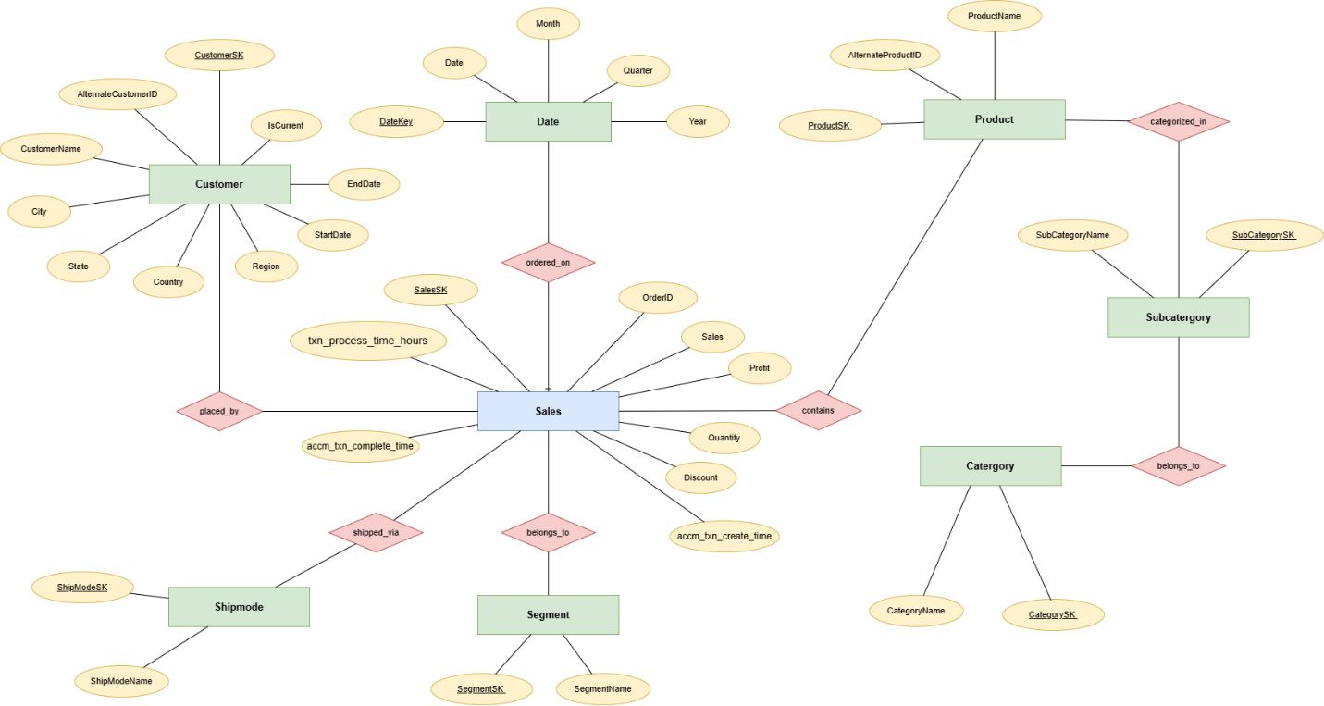

Task 2 — Data Sources Preparation
Preparation of Data Sources
To demonstrate multiple source types as required by the assignment, the Superstore dataset was split into four separate source files of different formats. This simulates a realistic enterprise scenario where data originates from different systems and file types.
Source | Type | Content | Rows
Superstore_SourceDB | SQL Server Database | Customer demographics | 793
Superstore_Source.xlsx | Excel File | Order transactions | 9,994
Products.csv | CSV File | Product catalogue | 1,894
CustomerLocation.txt | Text File | Customer locations | 793

Source 1 — SQL Server Database (Superstore_SourceDB)
The customer demographic information was loaded into a SQL Server database table. This simulates an internal CRM system where customer records are maintained.
Attribute | Detail
Database Name | Superstore_SourceDB
Table Name | Customers
Columns | CustomerID, CustomerName, Segment
Row Count | 793 unique customers
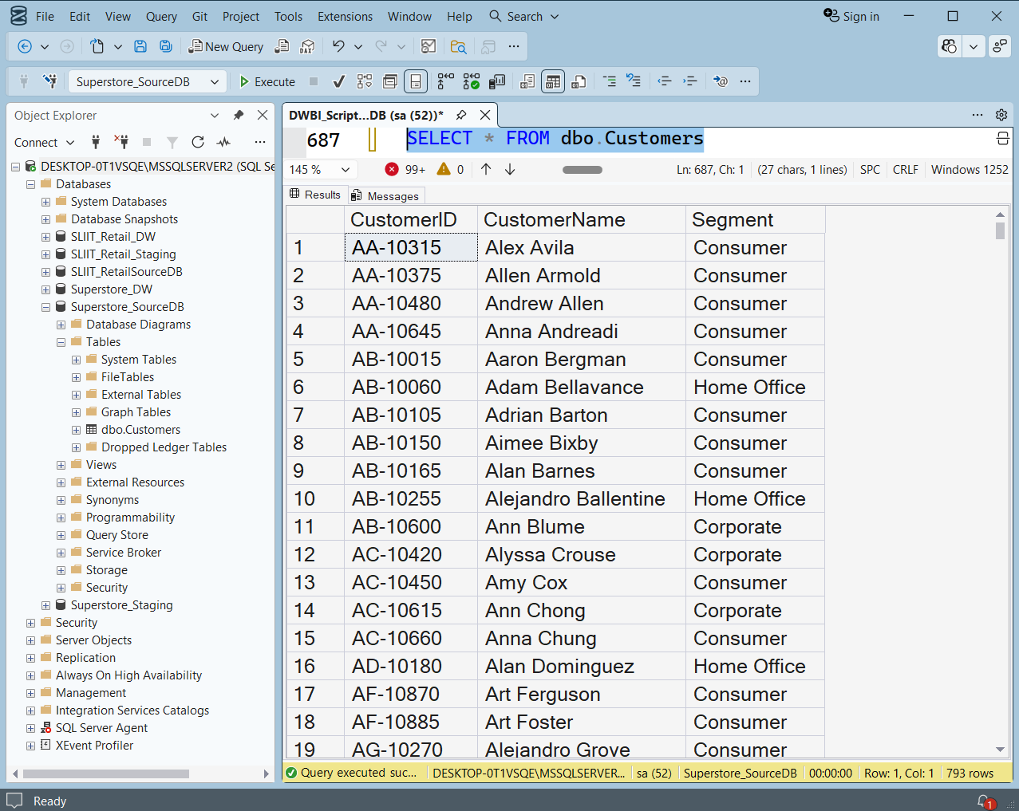

Source 2 — Excel File (Superstore_Source.xlsx)
The order transaction data was kept in an Excel workbook. This simulates a scenario where daily sales transactions are exported from a POS system into Excel.
Attribute | Detail
File Name | Superstore_Source.xlsx
Sheet Name | Orders
Columns | Row ID, Order ID, Order Date, Ship Date, Ship Mode, Customer ID, Product ID, Sales, Quantity, Discount, Profit
Row Count | 9,994 order records

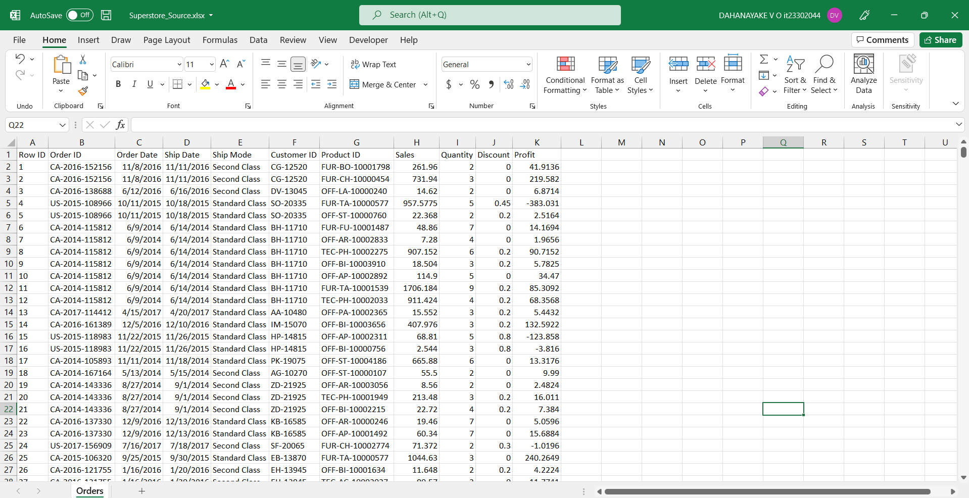
Source 3 — CSV File (Products.csv)
Product details including category and subcategory hierarchy were saved as a CSV file. This simulates a product catalogue maintained by the merchandising team.
Attribute | Detail
File Name | Products.csv
Columns | Product ID, Category, Sub-Category, Product Name
Row Count | 1,894 unique products

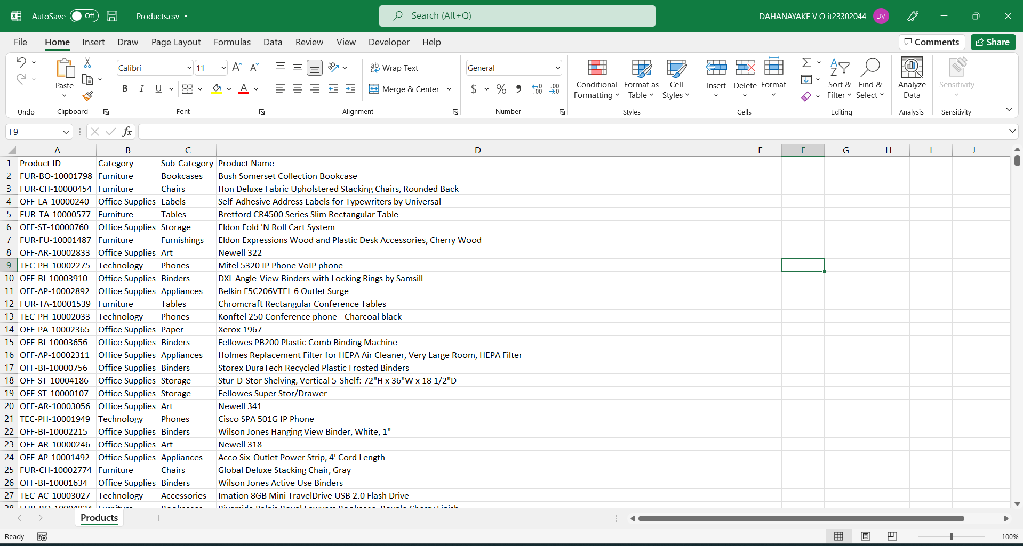
Source 4 — Text File (CustomerLocation.txt)
Customer address and location information was saved as a tab-delimited text file. This simulates address data maintained separately from the core customer database, updated when customers report location changes.
Attribute | Detail
File Name | CustomerLocation.txt
Format | Tab-delimited
Columns | Customer ID, City, State, Postal Code, Region, Country
Row Count | 793 unique customer locations
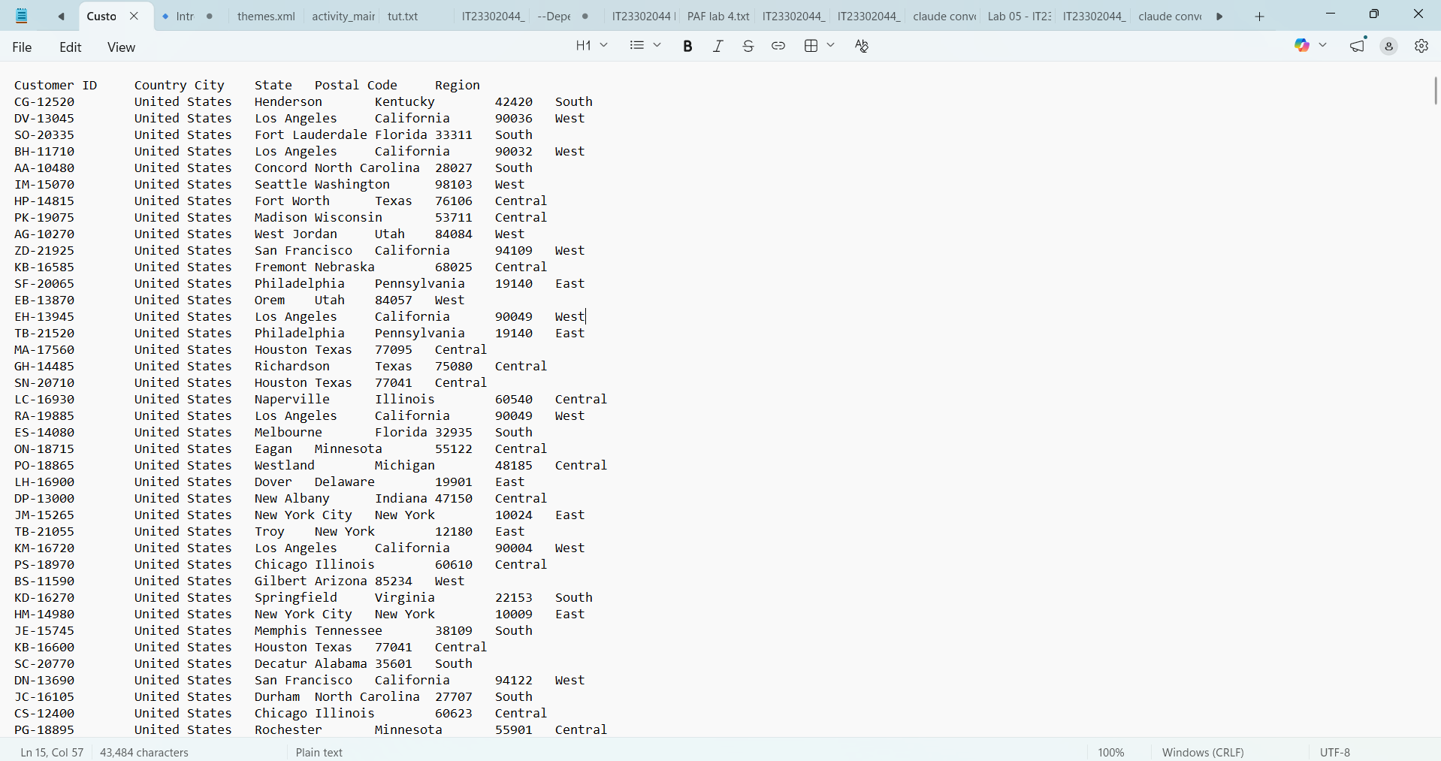

Task 3 — Solution Architecture
Solution Architecture
The following diagram illustrates the high-level Data Warehouse and Business Intelligence solution architecture designed for the Superstore dataset.
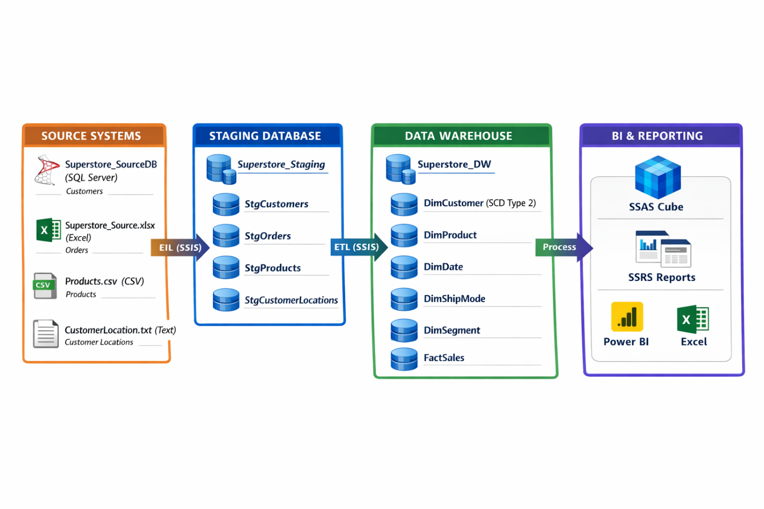
Component Descriptions:
Source Systems
The solution draws data from four different source types representing a realistic multi-source enterprise environment:
- Superstore_SourceDB — A SQL Server database containing customer demographic records
- Superstore_Source.xlsx — An Excel file containing daily order transaction data
- Products.csv — A CSV file containing the product catalogue with category hierarchy
- CustomerLocation.txt — A tab-delimited text file containing customer address information

Staging Layer (Superstore_Staging)
The staging database acts as an intermediate landing zone between the source systems and the data warehouse. Data is extracted from all four sources and loaded into staging tables with minimal transformation. The staging tables mirror the structure of the source data, bringing all sources into a single unified SQL Server environment for further processing. The staging tables include StgCustomers, StgOrders, StgProducts and StgCustomerLocations.
ETL Layer (SSIS)
Two SSIS packages handle the ETL process:
- Superstore_Load_Staging.dtsx — Extracts data from all four source types and loads into the staging database
- Superstore_Load_DW.dtsx — Transforms and loads data from staging into the data warehouse, applying surrogate key generation, lookups, and Slowly Changing Dimension logic
Data Warehouse (Superstore_DW)
The data warehouse follows a Snowflake Schema with one central fact table and seven dimension tables. Surrogate keys are used throughout to maintain referential integrity independently of source system IDs. The DimCustomer table implements SCD Type 2 to track historical address changes.
SSAS Cube
An SSAS (SQL Server Analysis Services) cube is built on top of the data warehouse, enabling multidimensional analysis with hierarchies, measures, and aggregations. The cube supports OLAP operations such as Roll-up, Drill-down, Slice, Dice and Pivot.
Reporting Layer
The BI reporting layer consists of:
- Excel — Connected to the SSAS cube for pivot table analysis and OLAP operations demonstration
- Power BI — Connected to the data warehouse for interactive dashboards, drill-down reports, drill-through reports and cascading slicer reports published to Power BI Service

Task 4 — Data Warehouse Design & Development
Data Warehouse Design and Development
Schema Selection
A Snowflake Schema was selected for the data warehouse design. This decision was made for the following reasons:
- The Superstore dataset has a natural three-level product hierarchy — Category → SubCategory → Product — which maps perfectly to a snowflake structure with separate dimension tables
- Snowflake schema reduces data redundancy by normalizing dimension tables — category names are not repeated for every product
- The assignment requires hierarchies for SSAS cube implementation — separate dimension tables make hierarchy definition cleaner and more maintainable
- The customer data naturally separates into demographic information and location information, which aligns with the snowflake approach.
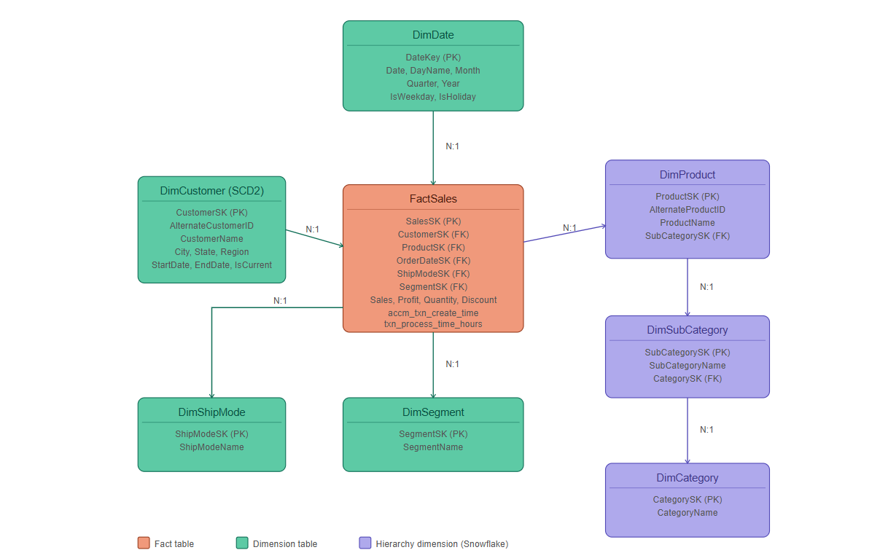
Snowflake Schema Diagram

Dimensional Model
The data warehouse consists of 7 dimension tables and 1 fact table as described below.
Dimension Tables:
Table | Type | Description
DimCategory | Regular | Stores the 3 product categories
DimSubCategory | Regular | Stores 17 product subcategories linked to DimCategory
DimProduct | Regular | Stores 1,862 products linked to DimSubCategory
DimCustomer | SCD Type 2 | Stores customer details with historical address tracking
DimShipMode | Regular | Stores 4 shipping modes
DimSegment | Regular | Stores 3 customer segments
DimDate | Regular | Auto-generated date dimension from DateMaster.sql
Fact Table:
Table | Grain | Measures
FactSales | One row per order line item | Sales, Profit, Quantity, Discount, accm_txn_create_time, accm_txn_complete_time, txn_process_time_hours
Slowly Changing Dimension
DimCustomer is implemented as a SCD Type 2 dimension. Customer address attributes (City, State, PostalCode, Region, Country) are treated as Historical attributes — when a customer's address changes, a new record is inserted with a new StartDate and the old record's EndDate is updated. The IsCurrent flag identifies the latest active record.
Customer phone-related attributes are treated as Changing attributes (Type 1) — these are overwritten when changed as historical tracking is not required.
This design allows the business to answer questions such as "What was the customer's address when they placed that order in 2021?" — critical for accurate historical reporting.
SQL Implementation
All tables were created in SQL Server using the Superstore_DW database. The key design decisions in the SQL implementation include:
- All dimension tables use IDENTITY(1,1) for surrogate key auto-generation
- All text columns use NVARCHAR to support unicode characters
- FactSales contains a computed column txn_process_time_hours calculated as DATEDIFF(HOUR, accm_txn_create_time, accm_txn_complete_time)
- Foreign key relationships link FactSales to all dimension tables
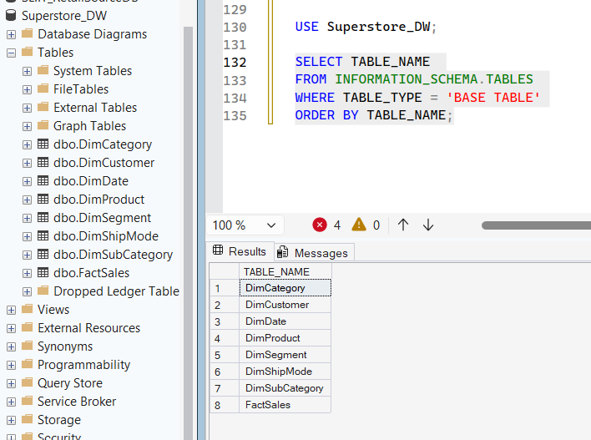

Data Warehouse Row Counts After Loading
Table | Row Count
DimCategory | 3
DimSubCategory | 17
DimProduct | 1,862
DimShipMode | 4
DimSegment | 3
DimCustomer | 793
DimDate | ~39,000
FactSales | 9,986

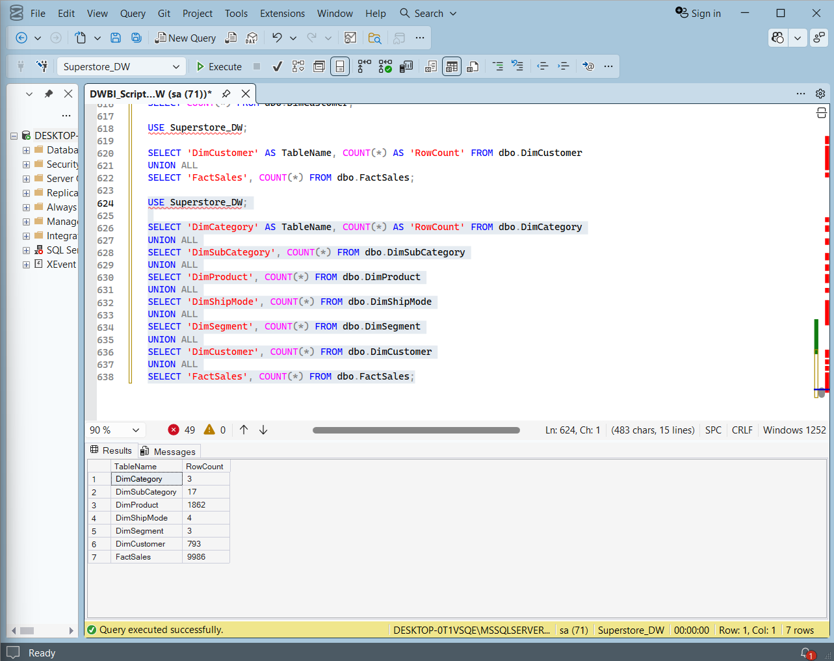

Task 5 — ETL Development
ETL Development
The ETL process was developed using SQL Server Integration Services (SSIS) and consists of two packages:
- Superstore_Load_Staging.dtsx — Extracts data from all 4 source types into the Staging database
- Superstore_Load_DW.dtsx — Transforms and loads data from Staging into the Data Warehouse
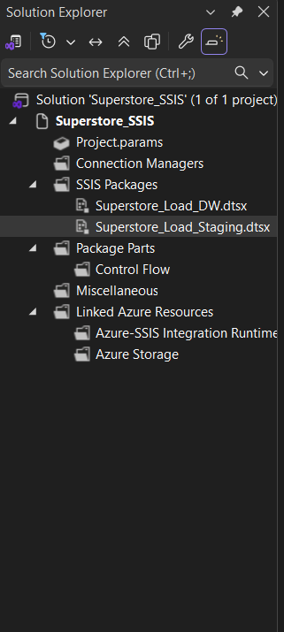

Package 1 — Superstore_Load_Staging.dtsx
This package extracts data from all four source systems and loads them into the staging database with minimal transformation. Each source table has a corresponding staging table.
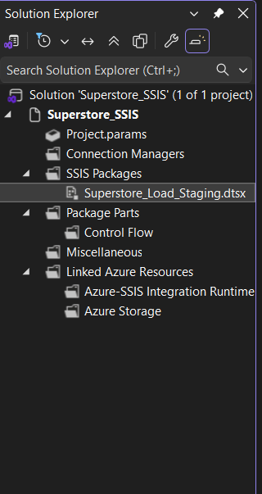
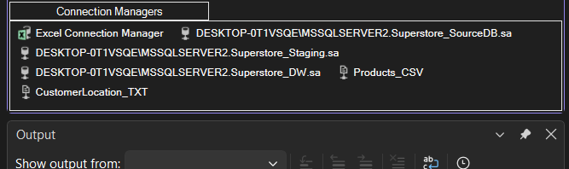

The package contains 4 Data Flow Tasks connected in serial order:
Task 1 — Extract Customer Data to Staging
- Source: Superstore_SourceDB (SQL Server database)
- Destination: StgCustomers in Superstore_Staging
- Rows loaded: 793
- An OnPreExecute Event Handler truncates StgCustomers before each load to prevent duplicates
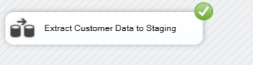
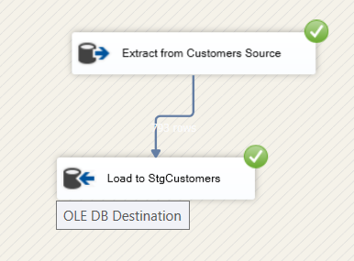

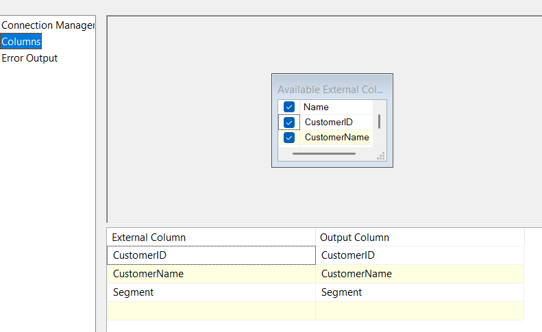
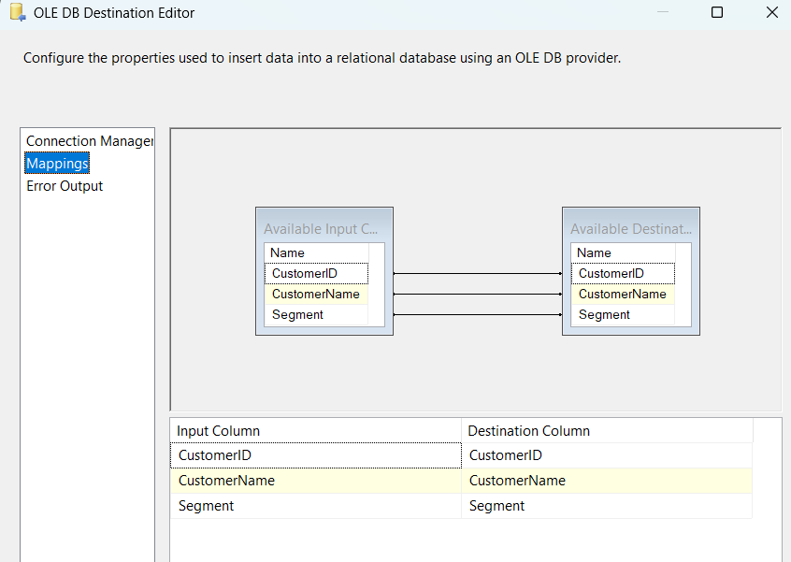
Task 2 — Extract Product Data to Staging
- Source: Products.csv (CSV flat file)
- Destination: StgProducts in Superstore_Staging
- Rows loaded: 1,894
- A Data Conversion component was used to handle unicode/non-unicode conversion from CSV source
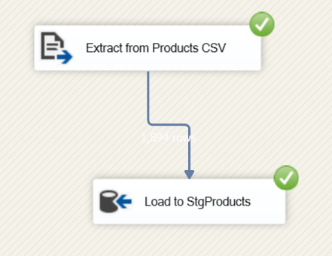
- An OnPreExecute Event Handler truncates StgProducts before each load
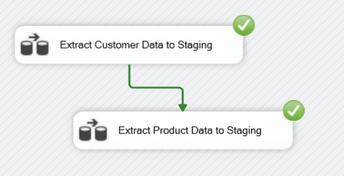
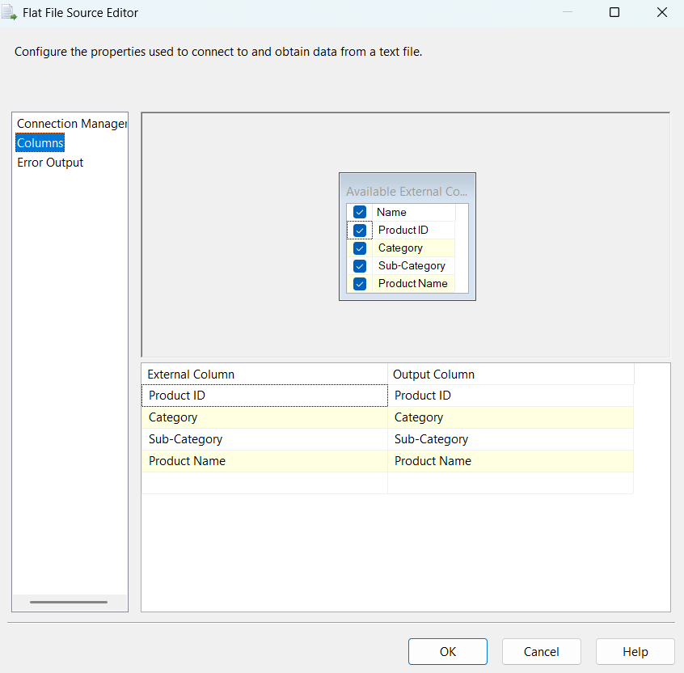
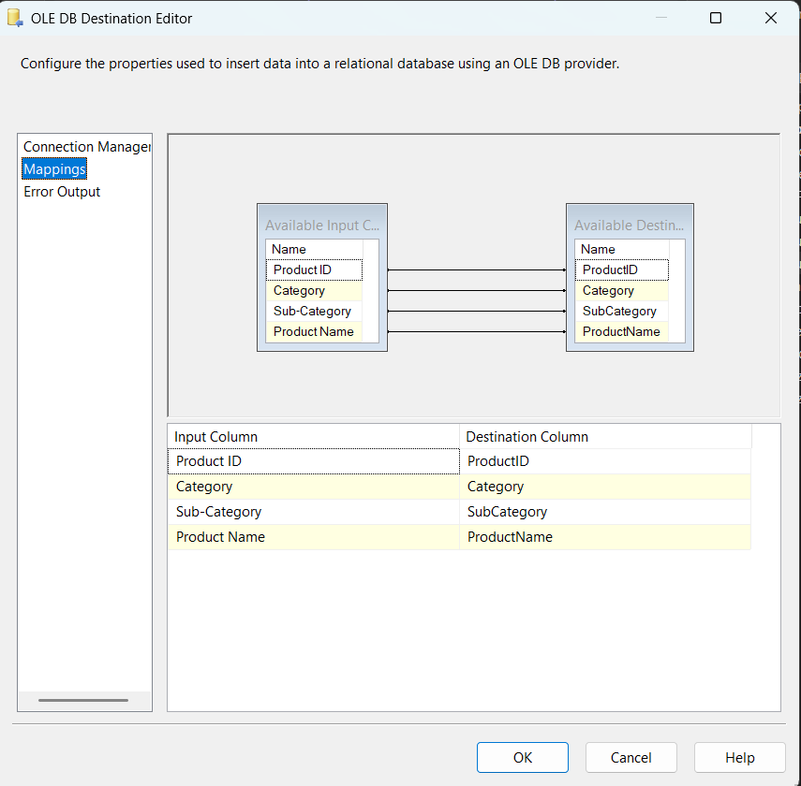
Task 3 — Extract Customer Location Data to Staging
- Source: CustomerLocation.txt (Tab-delimited text file)
- Destination: StgCustomerLocations in Superstore_Staging
- Rows loaded: 793
- An OnPreExecute Event Handler truncates StgCustomerLocations before each load
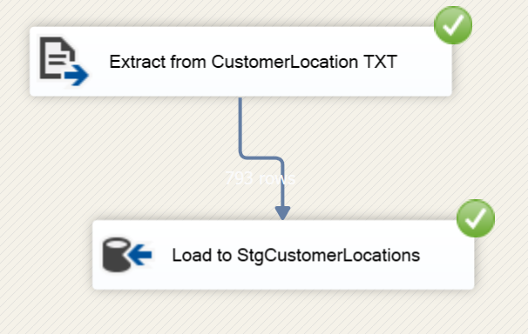
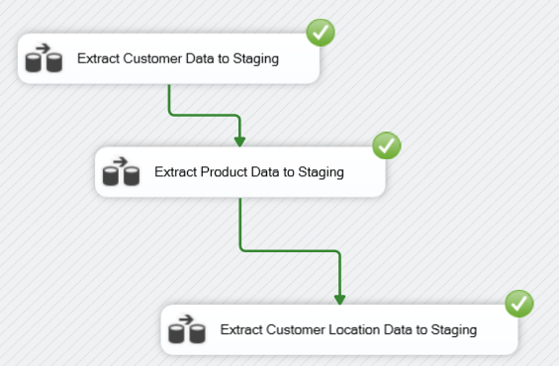

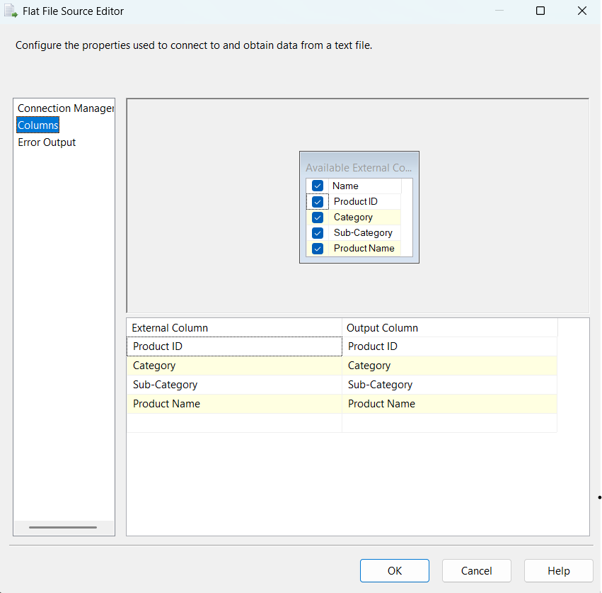
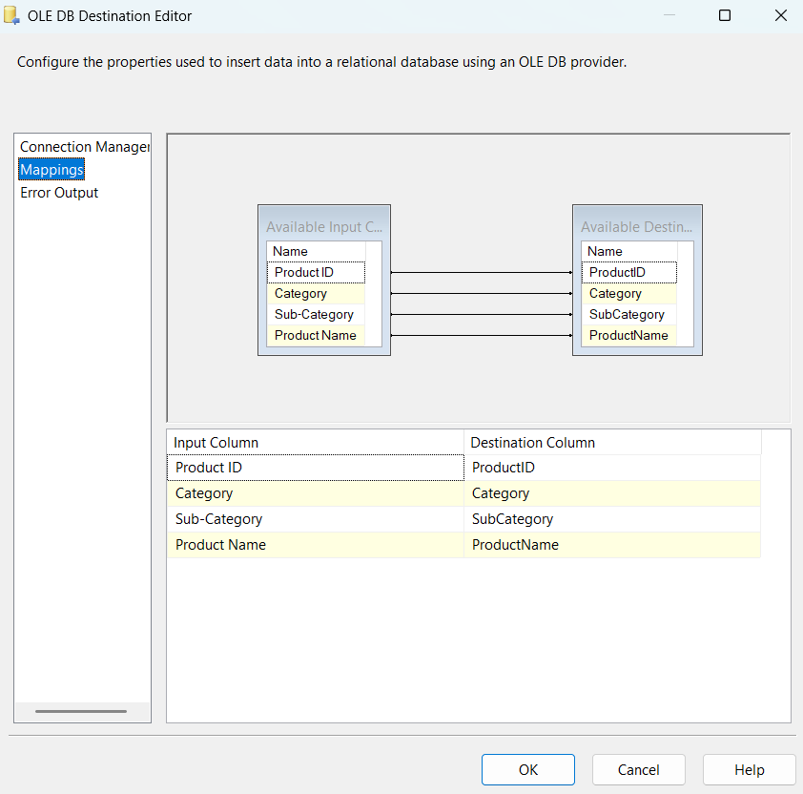

Task 4 — Extract Order Data to Staging
- Source: Superstore_Source.xlsx (Excel file)
- Destination: StgOrders in Superstore_Staging
- Rows loaded: 9,994
- An OnPreExecute Event Handler truncates StgOrders before each load
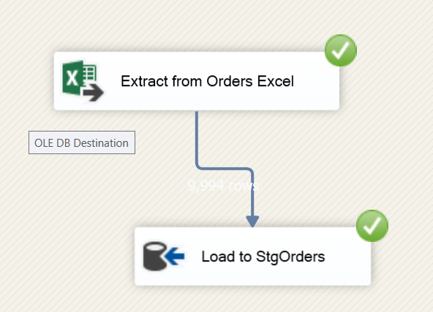
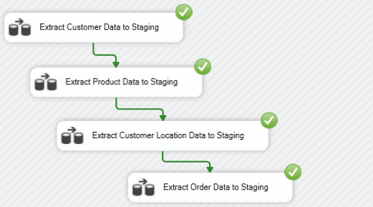

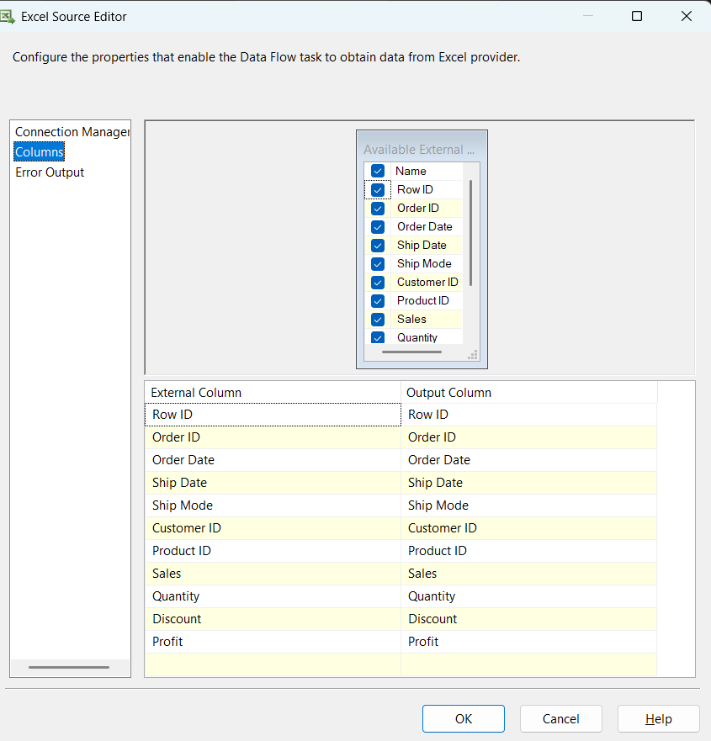
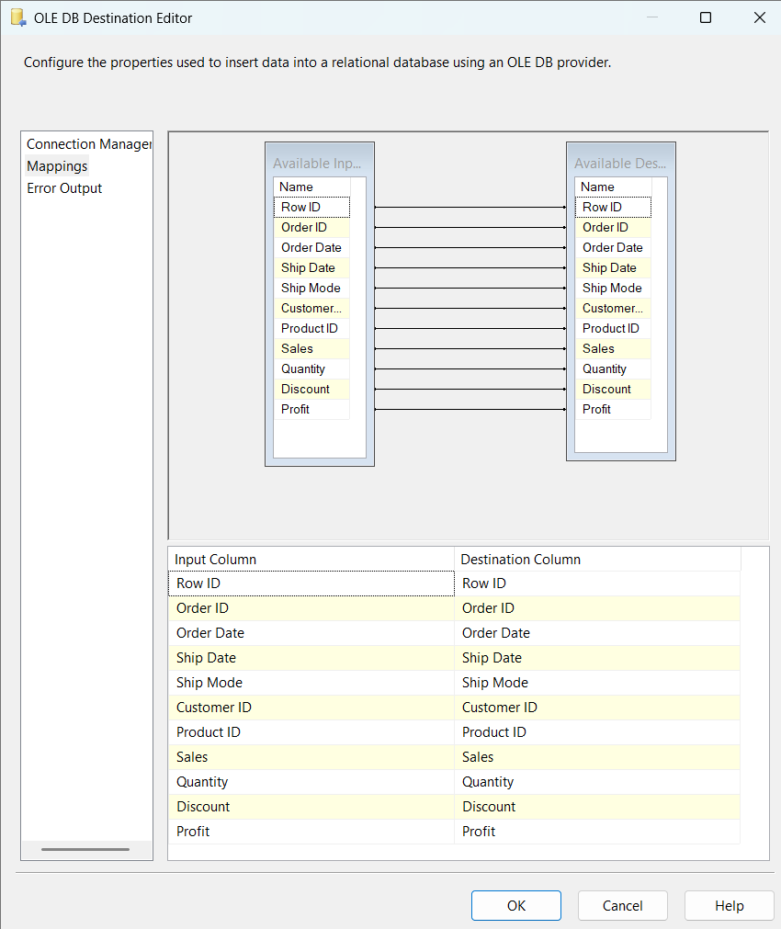
Staging Row Counts After Load:
Staging Table | Source | Rows
StgCustomers | SQL Server DB | 793
StgProducts | CSV File | 1,894
StgOrders | Excel File | 9,994
StgCustomerLocations | Text File | 793

Package 2 — Superstore_Load_DW.dtsx
This package transforms and loads data from the staging database into the data warehouse. It contains 7 Data Flow Tasks executed in order based on foreign key dependencies.
Execution Order (based on foreign key dependencies):
1. Transform and Load Category Data
2. Transform and Load SubCategory Data
3. Transform and Load Product Data
4. Transform and Load ShipMode Data
5. Transform and Load Segment Data
6. Transform and Load Customer Data
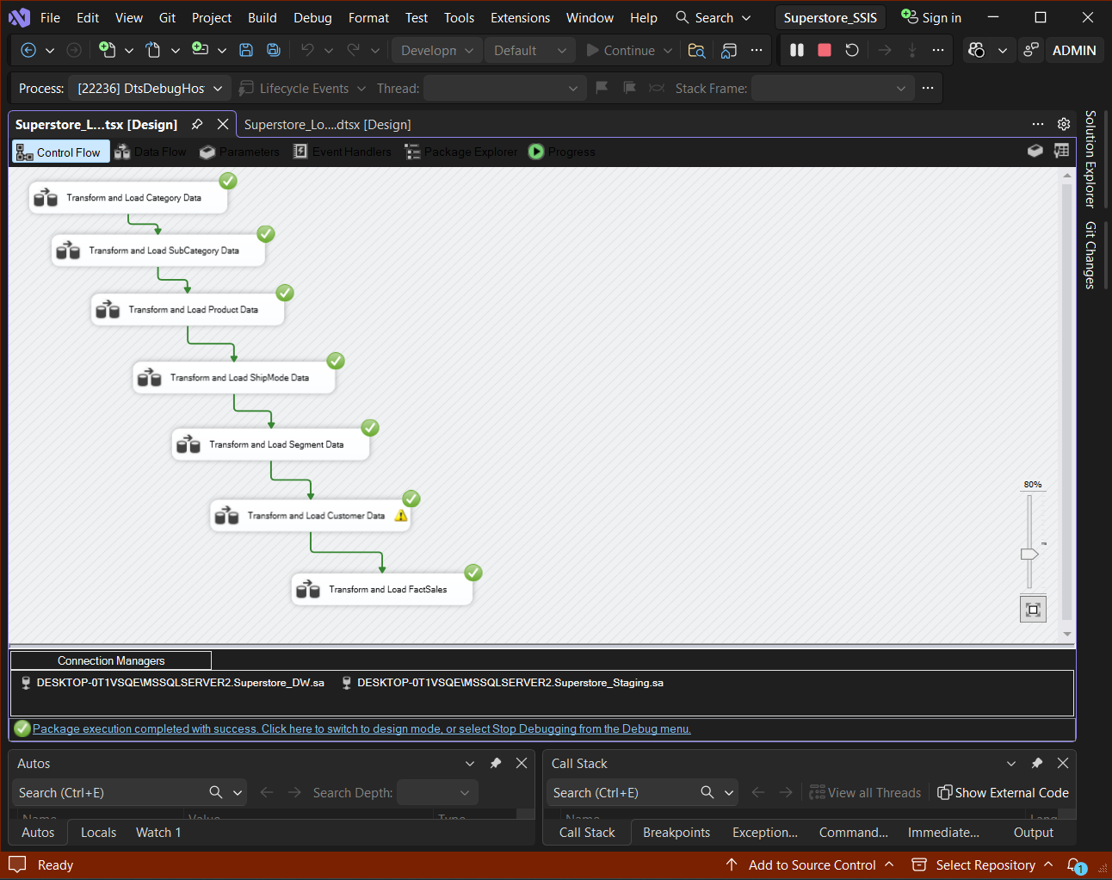
7. Transform and Load FactSales

Task 1 — Transform and Load Category Data
- Source: StgProducts (DISTINCT Category values)
- Stored Procedure: UpdateDimCategory
- Logic: If category doesn't exist → INSERT, else → UPDATE
- Rows loaded: 3
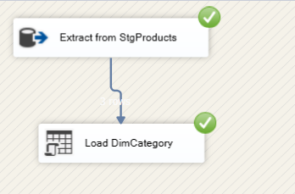

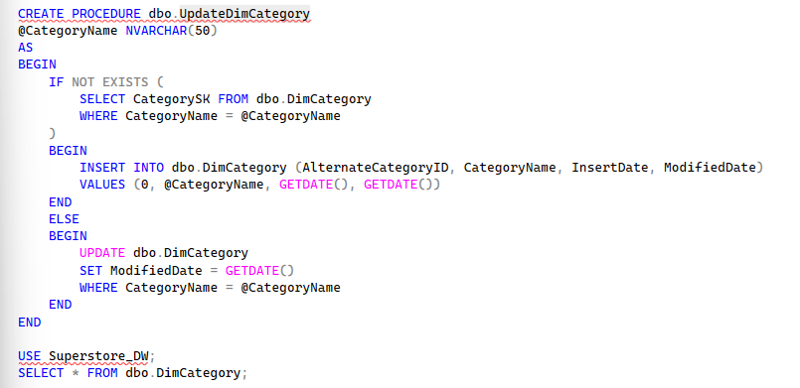

Task 2 — Transform and Load SubCategory Data
- Source: StgProducts (DISTINCT SubCategory + Category values)
- Stored Procedure: UpdateDimSubCategory
- Transformation: Looks up CategorySK from DimCategory using CategoryName — surrogate key swap
- Rows loaded: 17
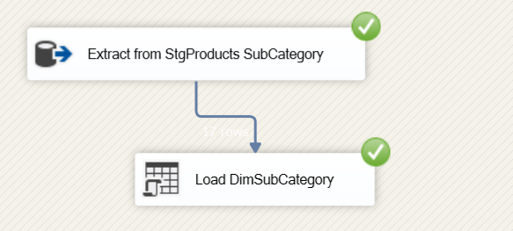

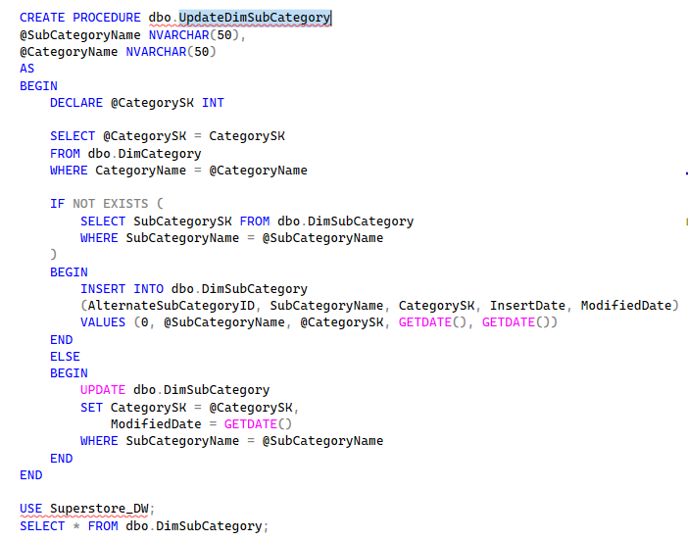
Task 3 — Transform and Load Product Data
- Source: StgProducts
- Stored Procedure: UpdateDimProduct
- Transformation: Looks up SubCategorySK from DimSubCategory — surrogate key swap
- Rows loaded: 1,862
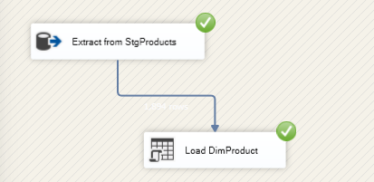
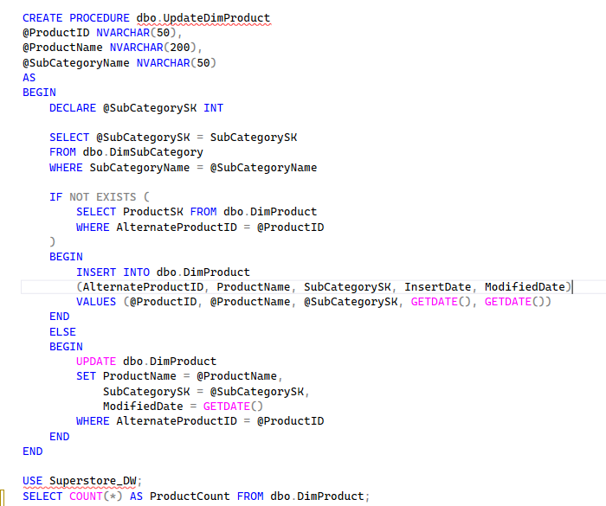

Task 4 — Transform and Load ShipMode Data
- Source: StgOrders (DISTINCT Ship Mode values)
- Stored Procedure: UpdateDimShipMode
- Rows loaded: 4
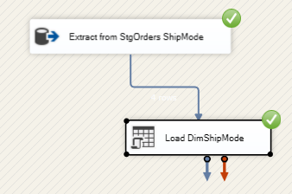
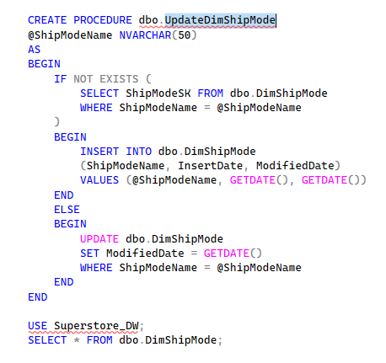
Task 5 — Transform and Load Segment Data
- Source: StgCustomers (DISTINCT Segment values)
- Stored Procedure: UpdateDimSegment
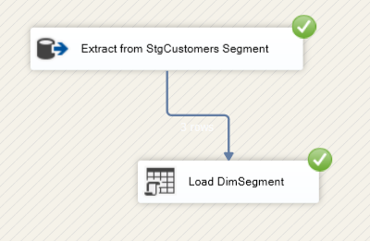
- Rows loaded: 3

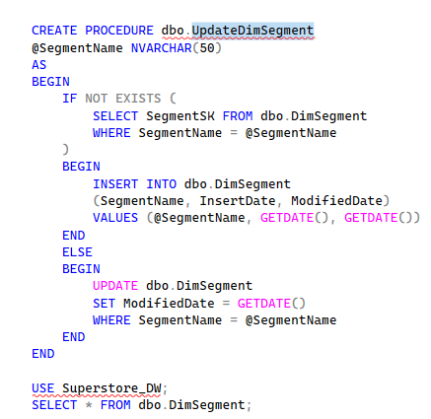

Task 6 — Transform and Load Customer Data (SCD Type 2)
- Source 1: StgCustomers — customer demographics
- Source 2: StgCustomerLocations — customer address data
- Transformation: Two OLE DB Sources → Sort → Merge Join (Left Outer Join on CustomerID) → Derived Column (replace NULL Gender/Title) → Slowly Changing Dimension Wizard
- SCD Configuration:
  - Business Key: CustomerID → AlternateCustomerID
  - Changing attributes (Type 1): CustomerName — overwrite on change
  - Historical attributes (Type 2): City, State, PostalCode, Region, Country — insert new row on change
  - Start/End date columns: StartDate, EndDate
- Rows loaded: 793
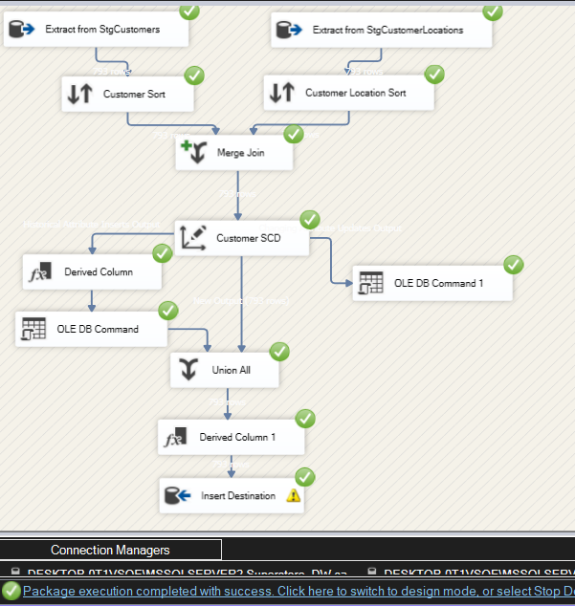

Task 7 — Transform and Load FactSales
- Source: StgOrders joined with StgCustomers (to get Segment)
- Stored Procedure: LoadFactSales
- Transformation: Looks up all Surrogate Keys from all dimension tables inside the stored procedure
- Measures loaded: Sales, Profit, Quantity, Discount
- accm_txn_create_time set to GETDATE() on insert
- Rows loaded: 9,986
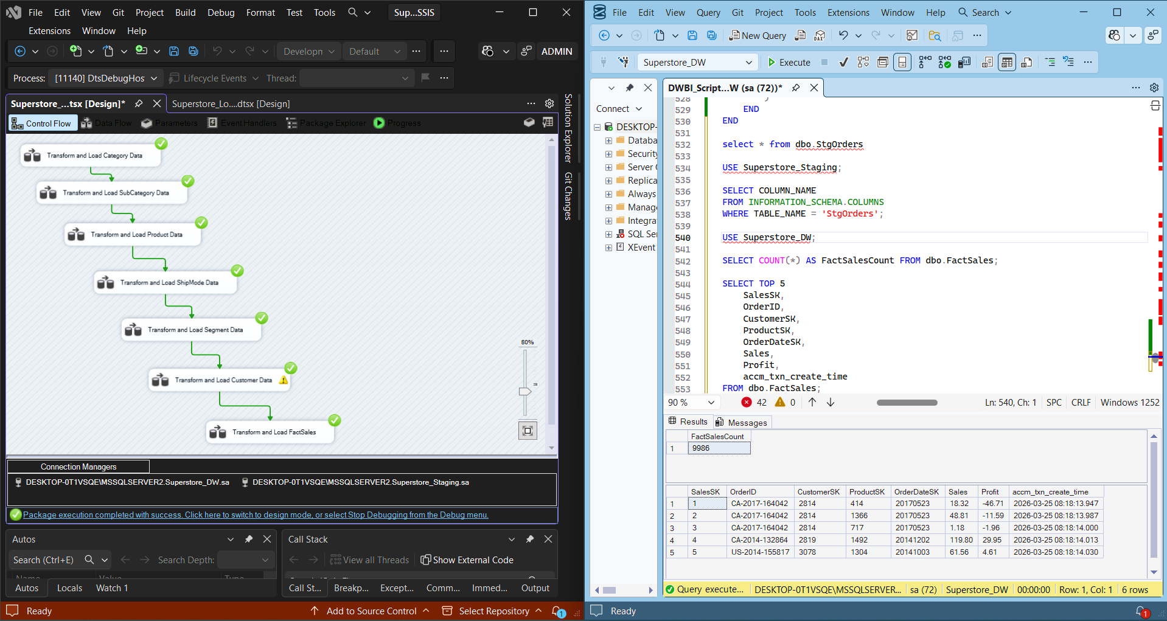
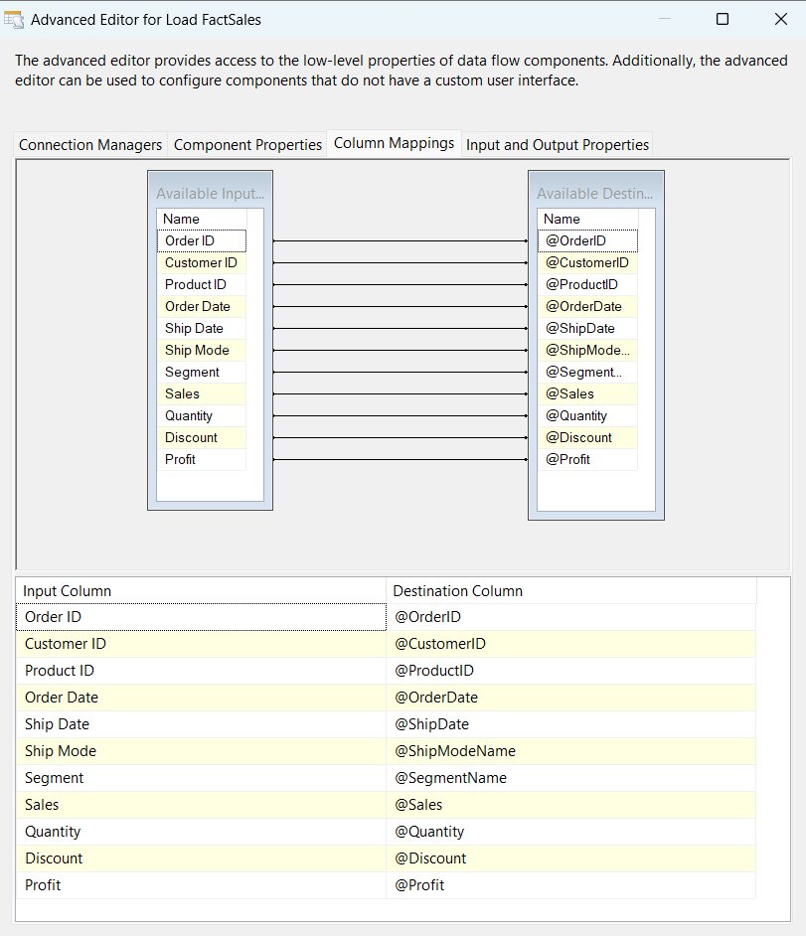
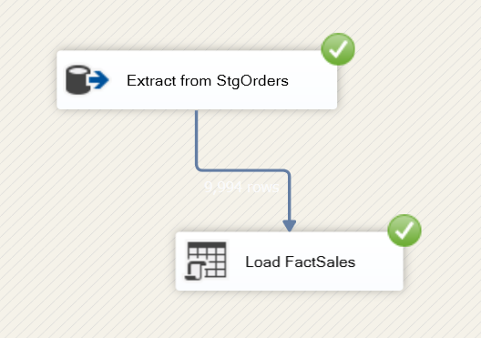
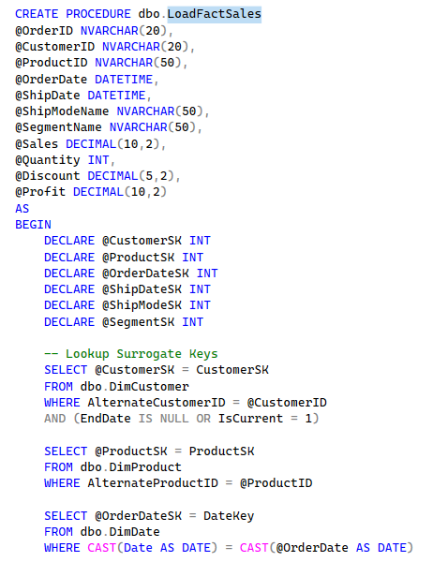
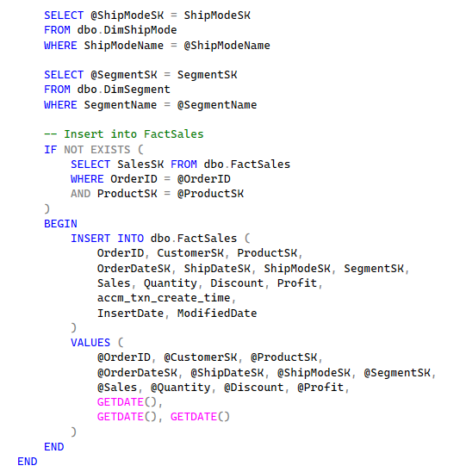
Final DW Row Counts:
Table | Rows
DimCategory | 3
DimSubCategory | 17
DimProduct | 1,862
DimShipMode | 4
DimSegment | 3
DimCustomer | 793
FactSales | 9,986

Task 6 — Accumulating Fact Table

ETL Development — Accumulating Fact Tables
Overview
The FactSales table was extended with accumulating fact columns to track the lifecycle of each sales transaction from creation to completion. This pattern is used in data warehousing to measure process performance — specifically how long it takes for an order to be completed after it is placed.
Additional Columns Added to FactSales
Column | Value | Description
accm_txn_create_time | 2026-03-25 17:01 | When order was loaded into DW
accm_txn_complete_time | 2026-03-27 | When order was completed
txn_process_time_hours | 31 | Hours between creation and completion
Records Updated | 12 | Orders with completion time populated
The txn_process_time_hours is a computed column in SQL Server — it recalculates automatically whenever accm_txn_complete_time is updated, requiring no manual calculation!
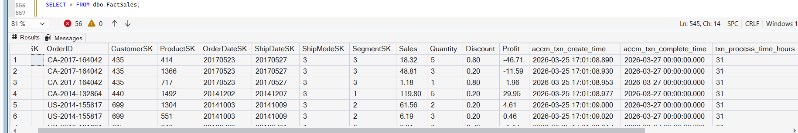
Completion Times Dataset
A separate CSV file OrderCompletions.csv was prepared containing order IDs and their completion timestamps. This simulates a real-world scenario where an external system reports when transactions are completed.
Column | Description
OrderID | Natural key matching OrderID in FactSales
accm_txn_complete_time | The datetime when the transaction was completed

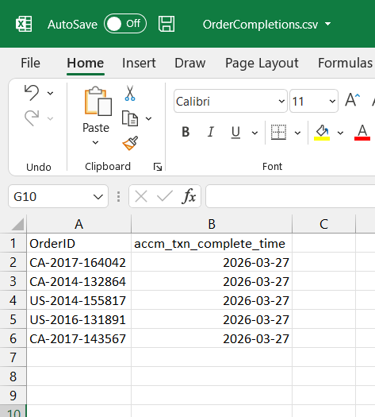

SSIS Package — Superstore_Update_AccumulatingFact.dtsx
A separate SSIS package was developed to read from OrderCompletions.csv and update the corresponding records in FactSales.
Package Design:
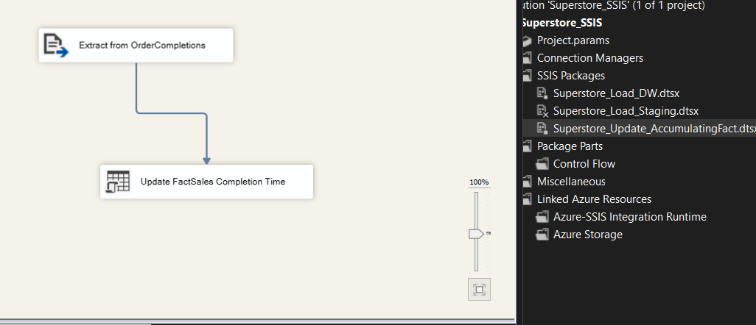
Stored Procedure — UpdateAccumulatingFact:
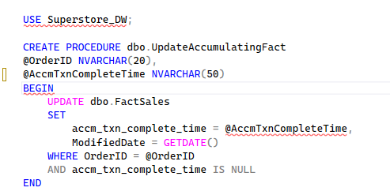
The stored procedure only updates records where accm_txn_complete_time IS NULL — this prevents overwriting already completed transactions if the package is run multiple times!
Verification
After running the accumulating fact update package, the results were verified in SSMS:
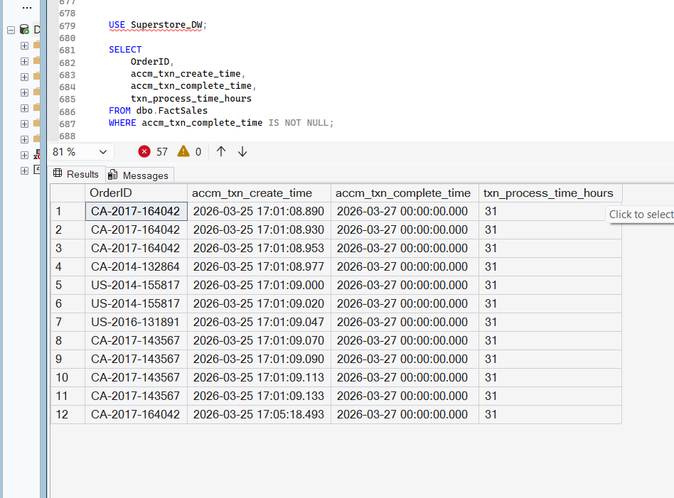
The query returned 12 records showing:
- accm_txn_create_time — when the order was loaded (2026-03-25)
- accm_txn_complete_time — when the order was completed (2026-03-27)
- txn_process_time_hours — 31 hours (automatically computed!)

