

Sri Lanka Institute of Information Technology

IT3021 - Data warehousing and Business Intelligence
Assignment 02
Dahanayake V O
IT23302044
DS.WE.Y3.S1.01.02

Table of Contents

Step 1 — Data Source Description 3
Step 2 — SSAS Cube Implementation 5
Step 3 — OLAP Operations in Excel 10
Step 4 — Power BI Reports 17

Step 1 — Data Source Description
- Data Source for Assignment 2

The data source for Assignment 2 is the Superstore Data Warehouse (Superstore_DW) implemented in Assignment 1. This data warehouse was built on SQL Server 2025 and contains transformed, cleaned and aggregated data from the Superstore Sales dataset.
Data Warehouse Details:
Attribute | Detail
Database Name | Superstore_DW
Database Server | DESKTOP-0T1VSQE\MSSQLSERVER2
Schema Type | Snowflake Schema
Total Tables | 8 (7 dimensions + 1 fact)
Total Records | 9,986 fact records
Dimension Tables:
Table | Rows | Description
DimCategory | 3 | Product categories
DimSubCategory | 17 | Product subcategories
DimProduct | 1,862 | Individual products
DimCustomer | 793 | Customer details (SCD Type 2)
DimShipMode | 4 | Shipping modes
DimSegment | 3 | Customer segments
DimDate | ~39,000 | Date dimension
Fact Table:
Table | Rows | Measures
Table | Rows | Measures
FactSales | 9,986 | Sales, Profit, Quantity, Discount, txn_process_time_hours

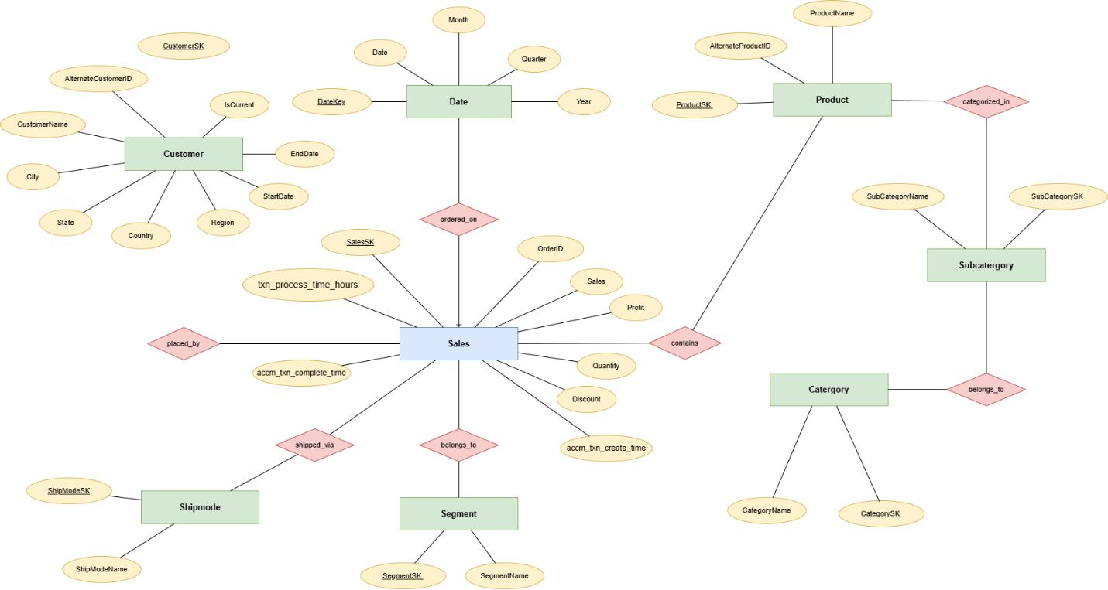

Step 2 — SSAS Cube Implementation
An SSAS (SQL Server Analysis Services) Multidimensional cube was created using SQL Server 2019 Analysis Services instance (DESKTOP-0T1VSQE\SSAS2019) with the Superstore Data Warehouse as the data source.
Step 1 — Created SSAS Project in Visual Studio
A new Analysis Services Multidimensional project named Superstore_SSAS was created in Visual Studio.
Step 2 — Created Data Source
A data source connection was created pointing to Superstore_DW database on DESKTOP-0T1VSQE\MSSQLSERVER2.
Step 3 — Created Data Source View
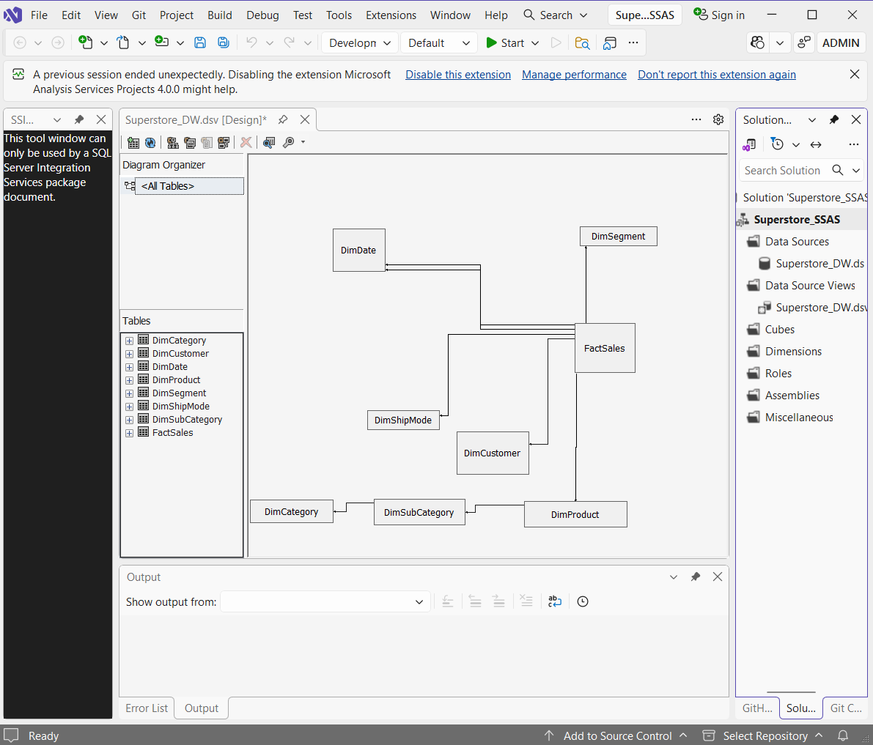
All 8 tables from the data warehouse were added to the Data Source View. Missing relationships were manually added to connect FactSales to all dimension tables.
Step 4 — Created the Cube
The Superstore_Sales_Cube was created using the Cube Wizard:
- Measure Group: FactSales
- Measures included: Sales, Profit, Quantity, Discount, Txn Process Time Hours
- Dimensions included: DimCustomer, DimProduct, DimSubCategory, DimCategory, DimDate, DimShipMode, DimSegment
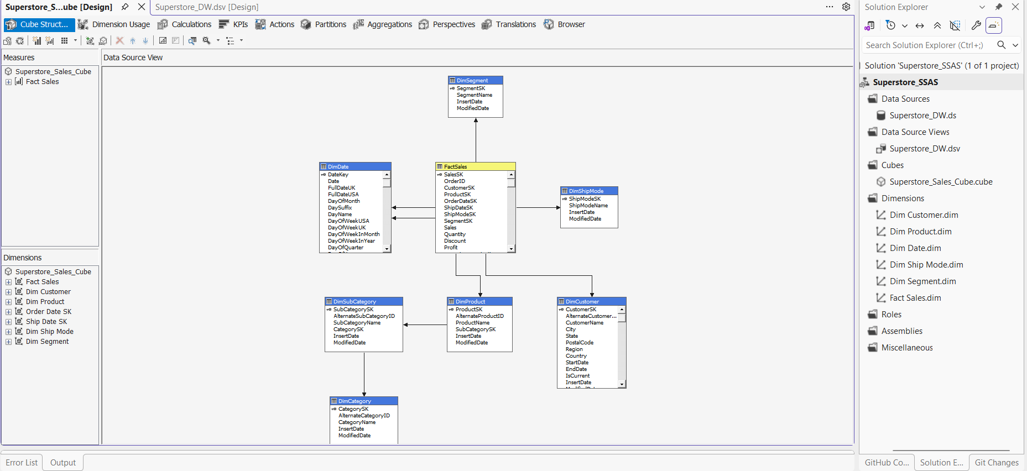

Step 5 — Created Product Hierarchy
A three-level hierarchy was created in the DimProduct dimension:
Product Hierarchy
CategoryName - Level 1
SubCategoryName - Level 2
ProductName - Level 3
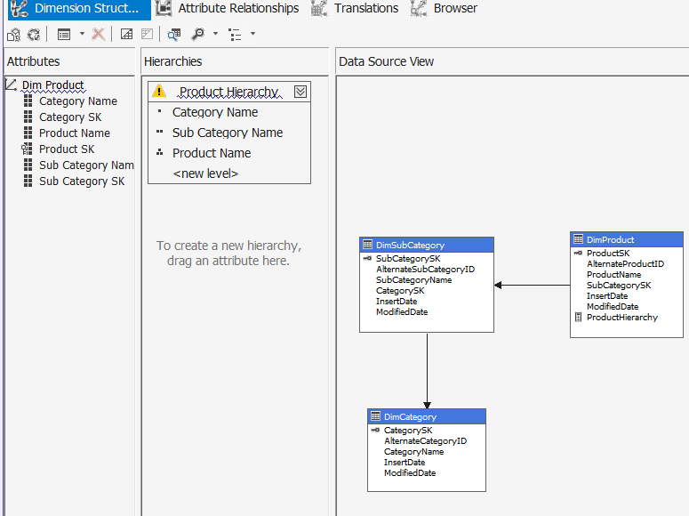

Step 6 — Created Date Hierarchy
A four-level date hierarchy was created in the DimDate dimension:
Date Hierarchy
Year - Level 1
Quarter - Level 2
Month - Level 3
Date - Level 4
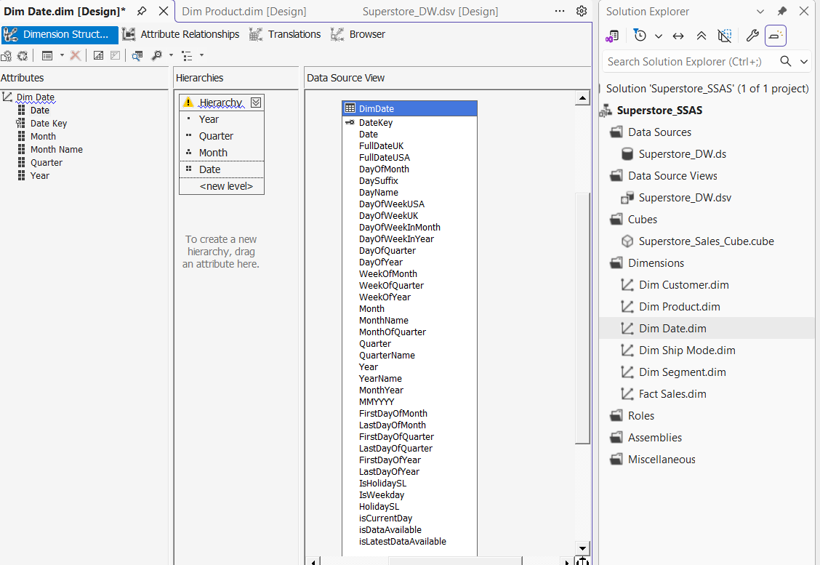
Step 7 — Deployed and Processed the Cube
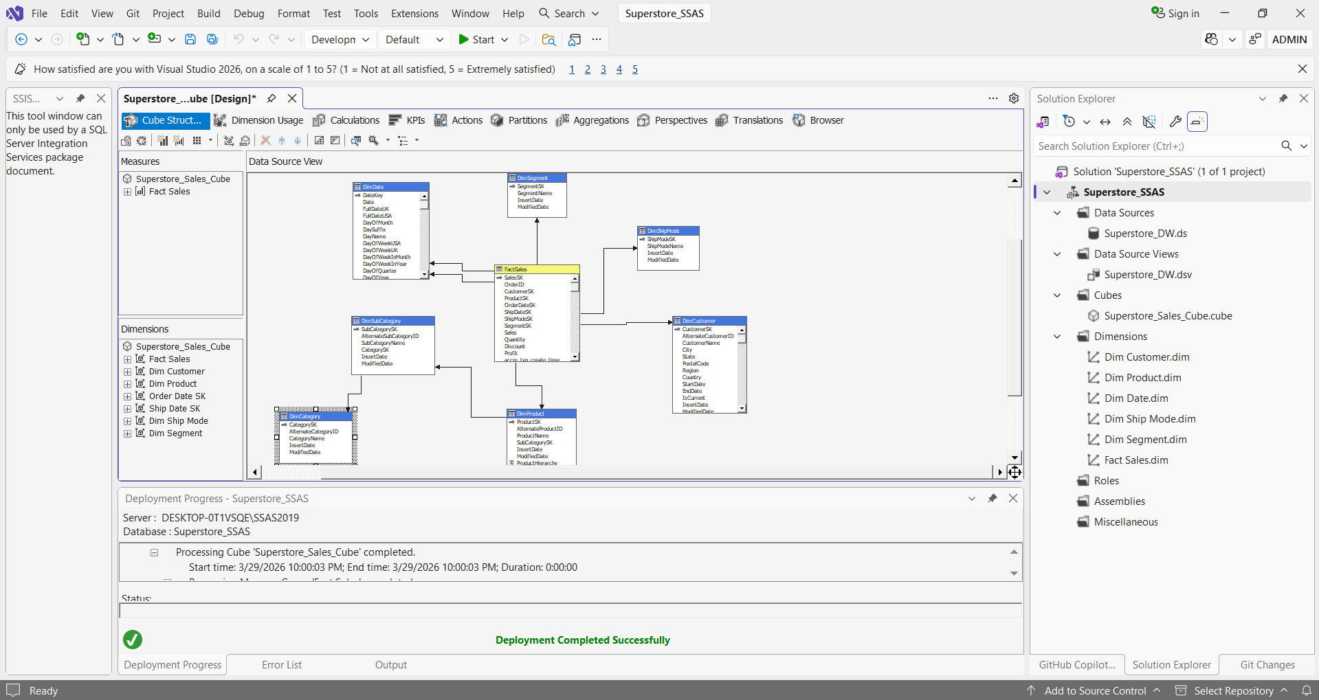
The cube was deployed to DESKTOP-0T1VSQE\SSAS2019 and processed successfully. All data from the Superstore DW was loaded into the cube.
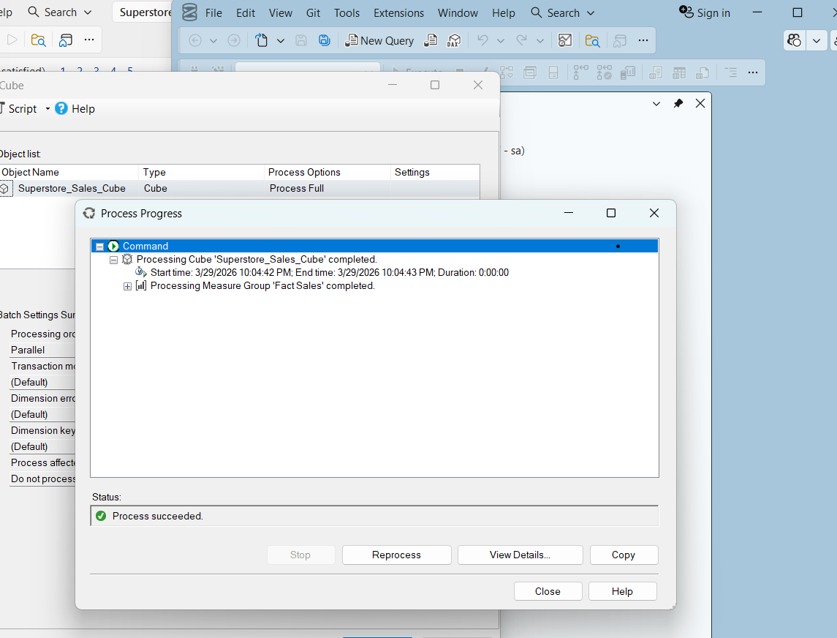

2.3 Cube Structure Summary
Component | Details
Cube Name | Superstore_Sales_Cube
SSAS Instance | DESKTOP-0T1VSQE\SSAS2019
Measure Group | FactSales
Number of Measures | 5
Number of Dimensions | 7
Hierarchies | Product Hierarchy, Date Hierarchy

2.4 Measures in the Cube
Measure | Description | Aggregation
Sales | Total sales amount | Sum
Profit | Total profit amount | Sum
Quantity | Total quantity ordered | Sum
Discount | Total discount given | Sum
Txn Process Time Hours | Transaction processing time | Sum

Step 3 — OLAP Operations in Excel
3. Demonstration of OLAP Operations
An Excel workbook was connected to the Superstore SSAS cube using the Data → Get Data → From Analysis Services feature. PivotTables were used to demonstrate all 5 OLAP operations.
Connection Details:
- Server: DESKTOP-0T1VSQE\SSAS2019
- Database: Superstore_SSAS
- Cube: Superstore_Sales_Cube
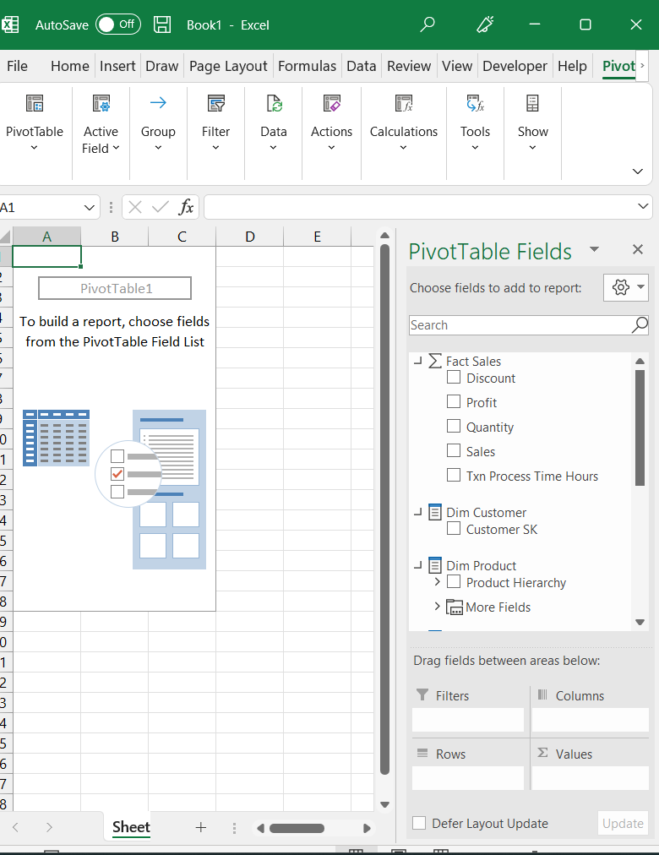
- File: Superstore_OLAP_Analysis.xlsx
3.1 Roll-Up
Roll-up aggregates data from a lower level to a higher level of a dimension hierarchy.
Steps followed:
- Dragged Sales to Values area
- Dragged CategoryName to Rows area
- Sales figures were aggregated at Category level (3 categories)
Result: Sales data was rolled up from individual product level to Category level showing total sales for Furniture, Office Supplies and Technology.
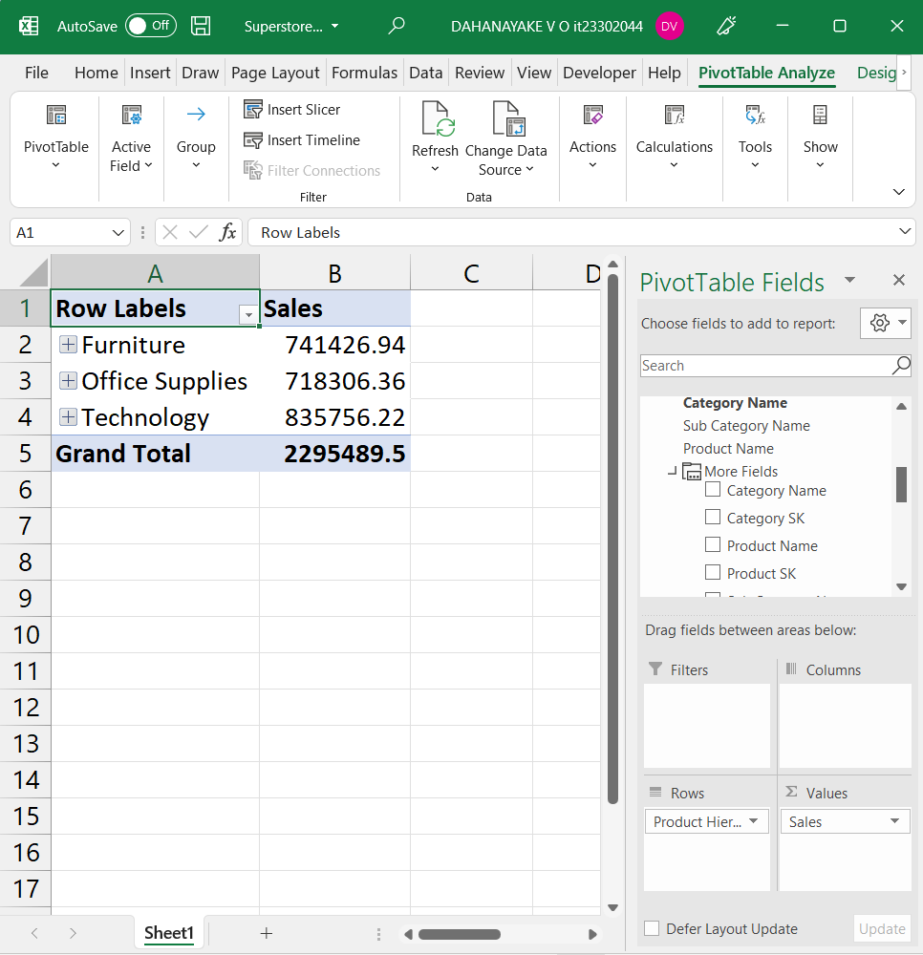

3.2 Drill-Down
Drill-down navigates from a higher summary level to a lower detailed level.
Steps followed:
- Expanded CategoryName in Rows area
- Added SubCategoryName below CategoryName
- Each category was expanded to show its subcategories
Result: Furniture category drilled down to show Bookcases, Chairs, Furnishings and Tables with individual sales figures.
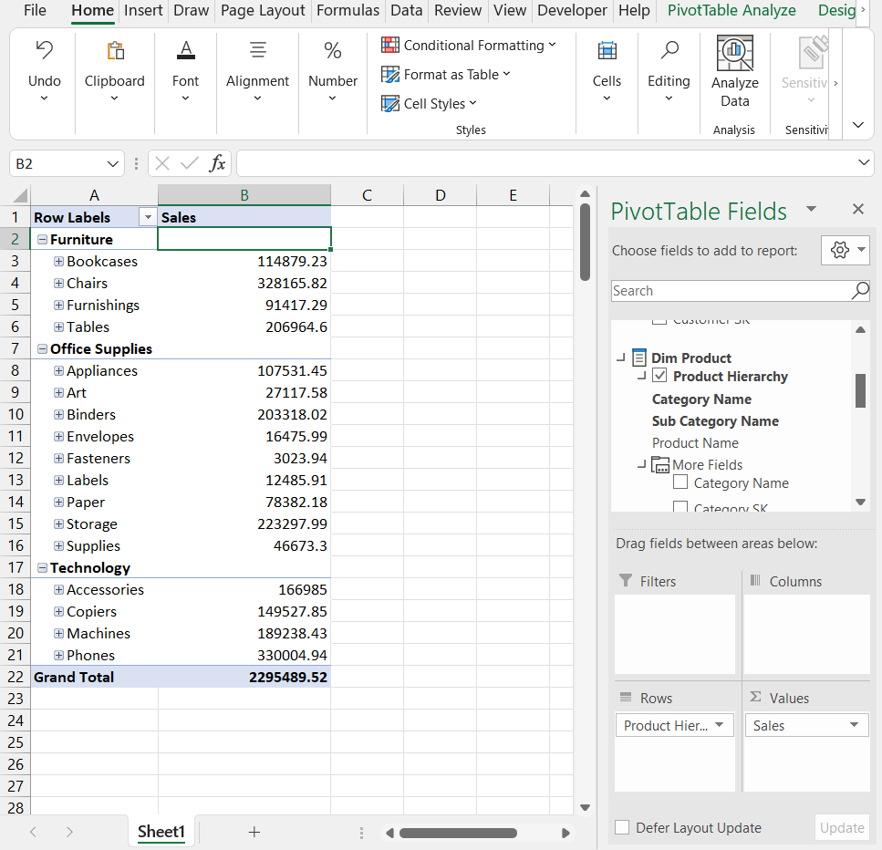
3.3 Slice
Slice filters the data by selecting a single value from one dimension.
Steps followed:
- Dragged Region from DimCustomer to Filters area
- Selected West as the filter value
- PivotTable updated to show only West region data
Result: Data was sliced to show only West region sales across all categories and subcategories.
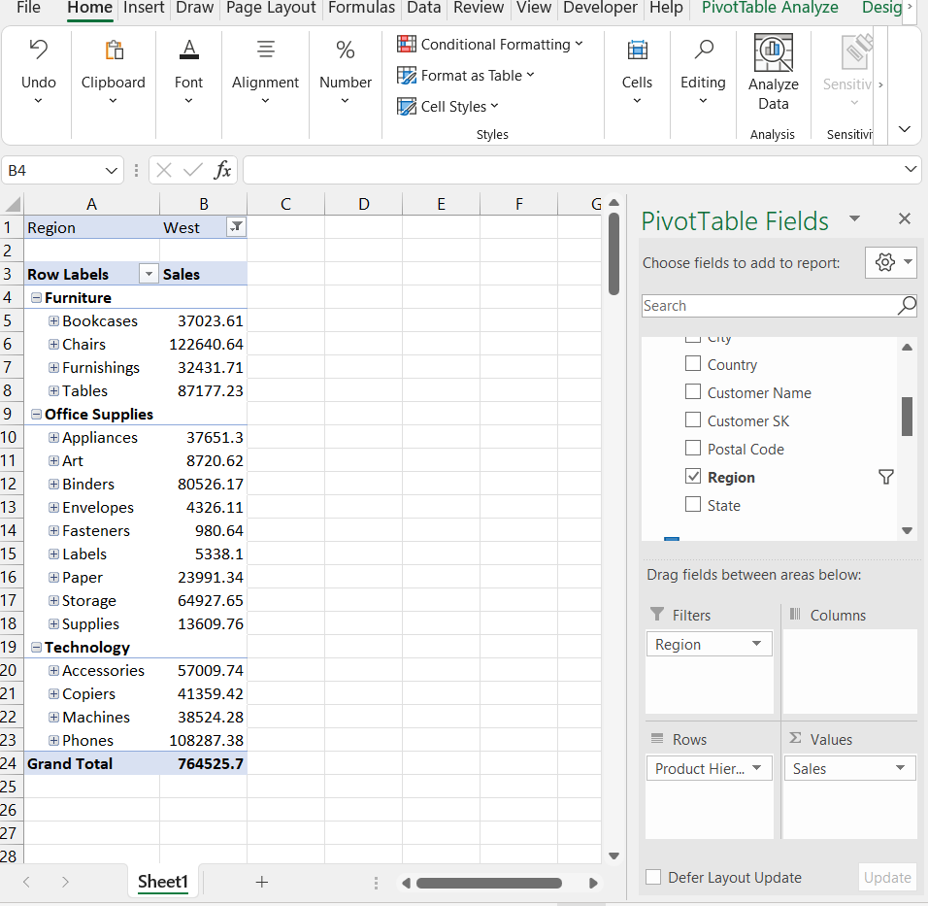
3.4 Dice
Dice filters the data by selecting values from multiple dimensions simultaneously.
Steps followed:
- Kept Region = West filter
- Added SegmentName from DimSegment to Filters area
- Selected Consumer as the segment filter
Result: Data was diced to show only West region AND Consumer segment sales — two dimensions filtered simultaneously.
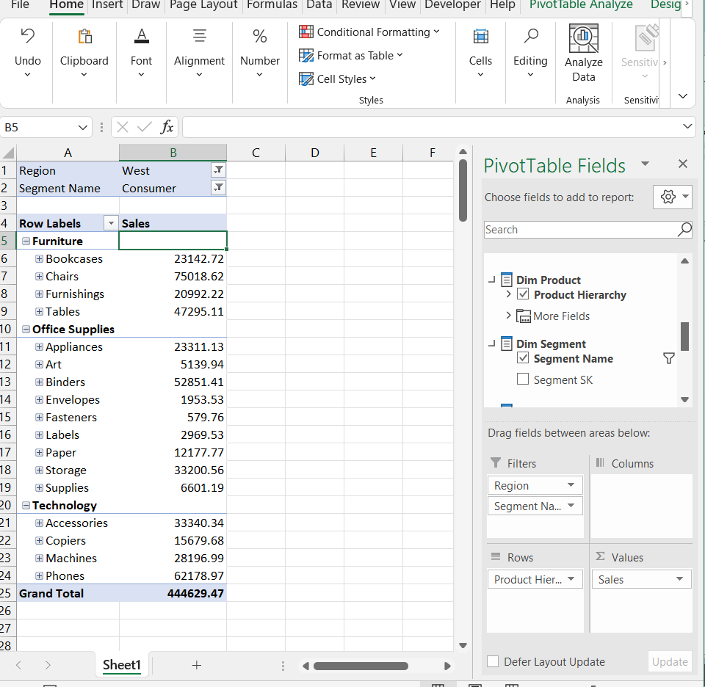
3.5 Pivot
Pivot rotates the data axes to view data from a different perspective.
Steps followed:
- Moved CategoryName from Rows area to Columns area
- Dragged ShipModeName from DimShipMode to Rows area
Result: The PivotTable was rotated showing Ship Modes in rows and Categories in columns — a completely different perspective of the same data.
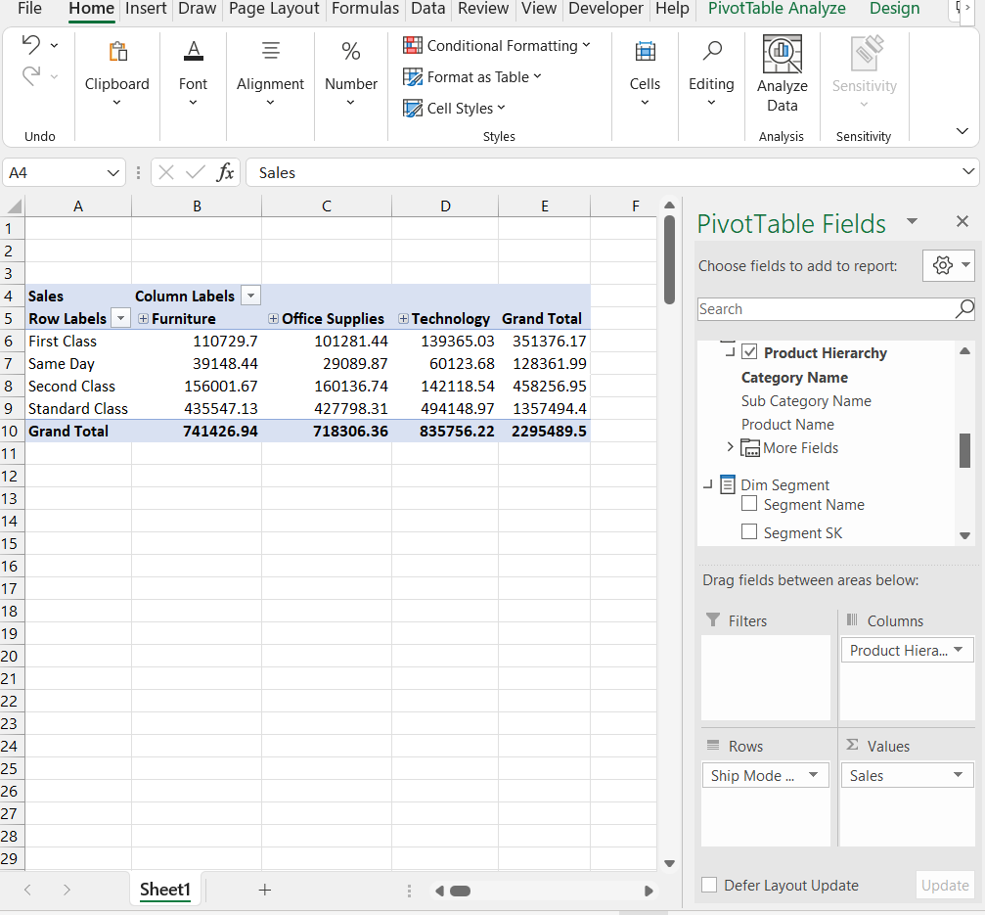

Summary of OLAP Operations:
Operation | Description | Dimension Used
Roll-Up | Aggregated sales by Category | DimProduct (Category level)
Drill-Down | Expanded Category to SubCategory | DimProduct Hierarchy
Slice | Filtered by Region = West | DimCustomer (Region)
Dice | Filtered by Region = West AND Segment = Consumer | DimCustomer + DimSegment
Pivot | Rotated Categories to Columns, Ship Mode to Rows | DimProduct + DimShipMode

Step 4 — Power BI Reports
4. Power BI Reports
Four Power BI reports were developed and published to Power BI Service using Superstore_DW as the data source. All reports were created in Power BI Desktop and published to My Workspace in Power BI Service.
Connection Details:
- Server: DESKTOP-0T1VSQE\MSSQLSERVER2
- Database: Superstore_DW
- Connectivity Mode: Import
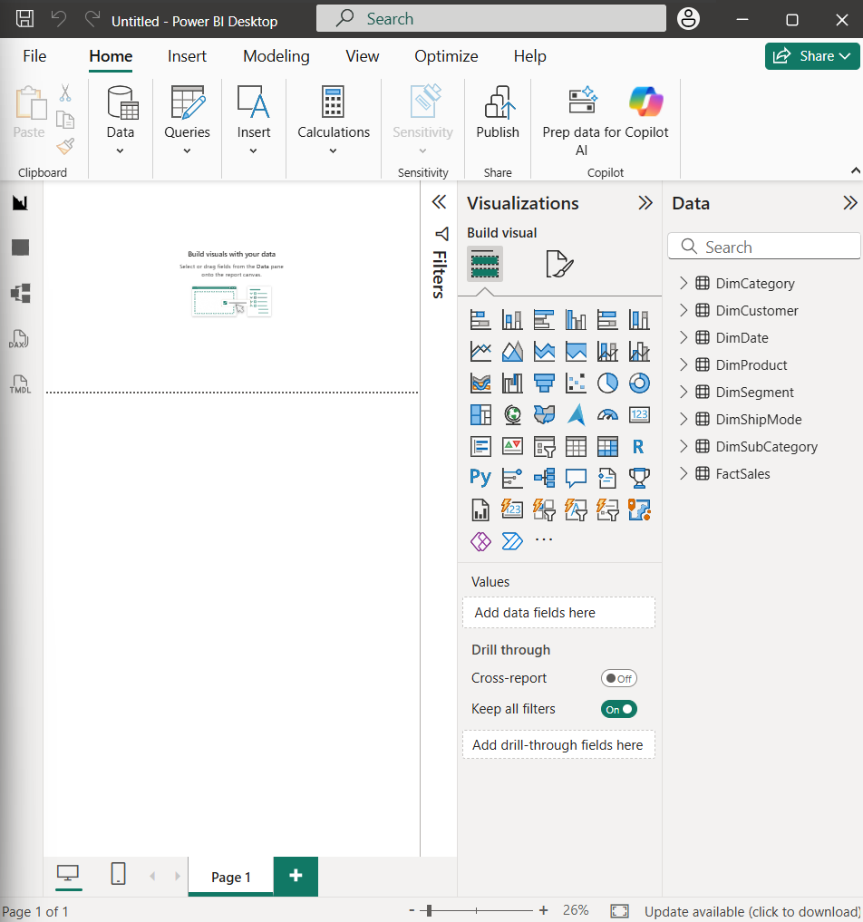
- Published to: Power BI Service — My Workspace
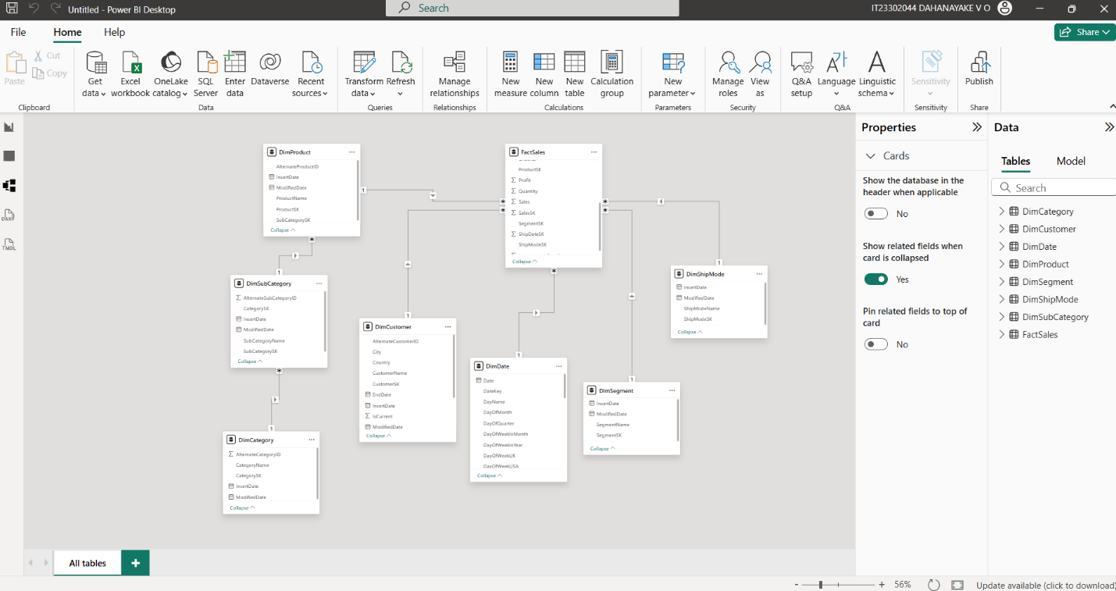
4.1 Report 1 — Matrix Visual
Objective:
Display detailed tabular data with row and column groupings.
Steps followed:
- Added a Matrix visual to the report canvas
- Configured the Matrix:
  - Rows: CategoryName → SubCategoryName (hierarchy)
  - Columns: SegmentName
  - Values: Sales, Profit
Result: The Matrix visual displays Sales and Profit broken down by Category and SubCategory in rows, and Customer Segments (Consumer, Corporate, Home Office) in columns — allowing easy comparison across segments and product hierarchy.
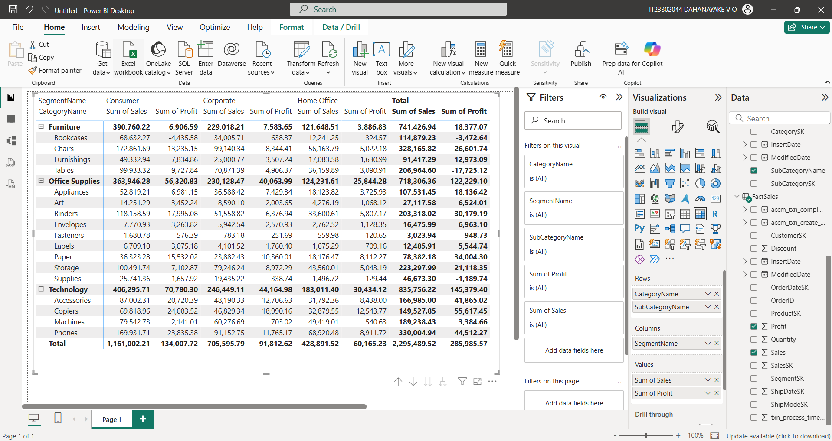

4.2 Report 2 — Cascading Slicers
Objective:
Create multiple slicers where selecting a value in the first slicer dynamically filters the options in the second slicer.
Steps followed:
- Added a List Slicer for CategoryName
- Added a List Slicer for SubCategoryName
- Added a Clustered Bar Chart showing Sales by SubCategory
- Configured slicer interactions so Category slicer filters SubCategory slicer
Result:
When Furniture is selected in the Category slicer, the SubCategory slicer automatically shows only Furniture subcategories (Bookcases, Chairs, Furnishings, Tables) and the bar chart updates accordingly — demonstrating cascading filters.
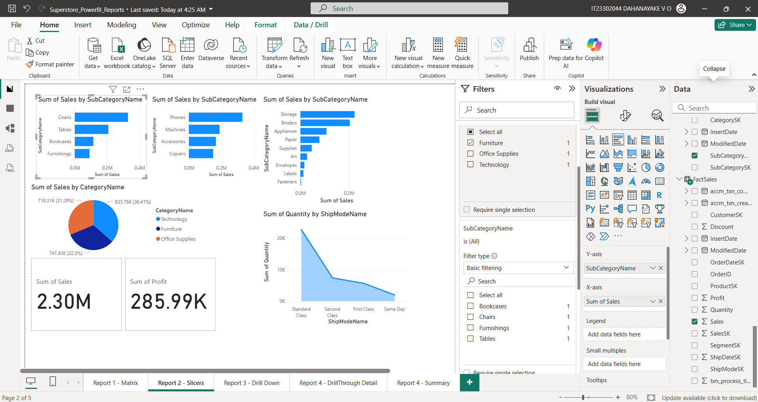

4.3 Report 3 — Drill-Down Report
Objective:
Allow users to explore data hierarchically from Year to Quarter to Month.
Steps followed:
- Added a Clustered Bar Chart
- Configured:
  - X-axis: Year → Quarter → Month (from DimDate)
  - Y -axis: Sales
- Enabled drill-down using the drill-down arrows on the chart
Result:
Users can click the drill-down arrow to navigate from Year level → Quarter level → Month level. Clicking the drill-up arrow returns to the previous level — demonstrating hierarchical data exploration.
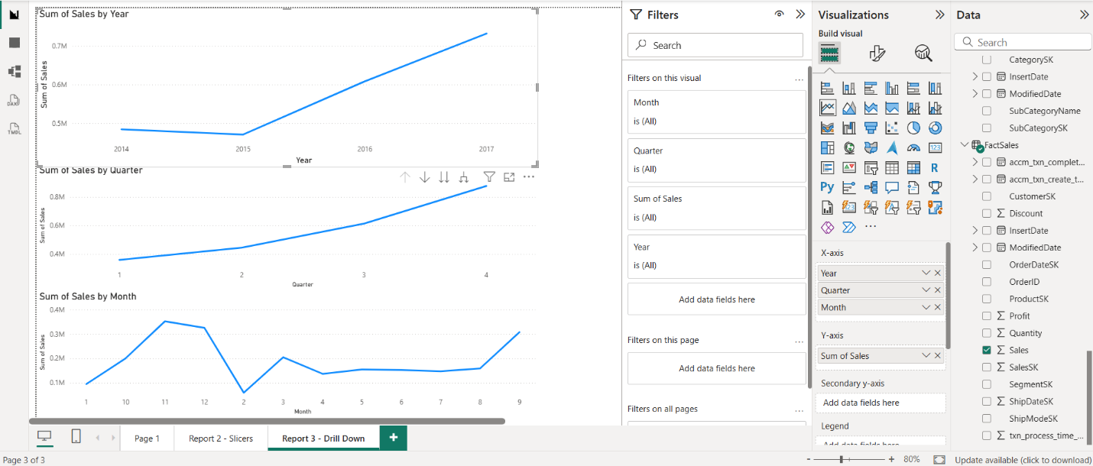

4.4 Report 4 — Drill-Through Report
Objective:
Allow users to right-click on a visual and navigate to a detailed page showing related information.
Steps followed:
- Created a Summary page with a Bar Chart showing Sales by Category
- Created a Detail page with a Table showing:
  - OrderID, CustomerName, ProductName, Sales, Profit, Quantity
- Added CategoryName as the Drill-through field on the detail page
Result:
Users can right-click on any category bar in the Summary page → select Drill through → navigate to the Detail page filtered by that specific category — showing all individual orders for that category.
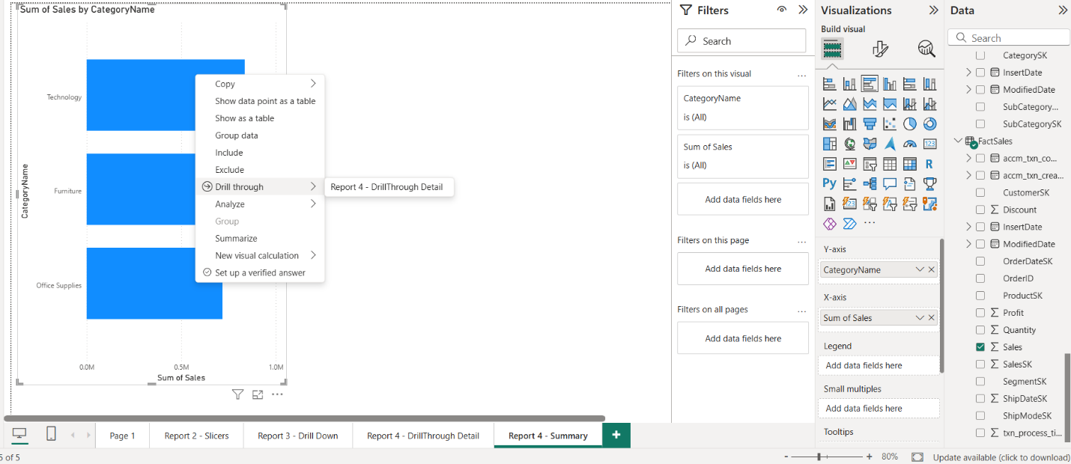
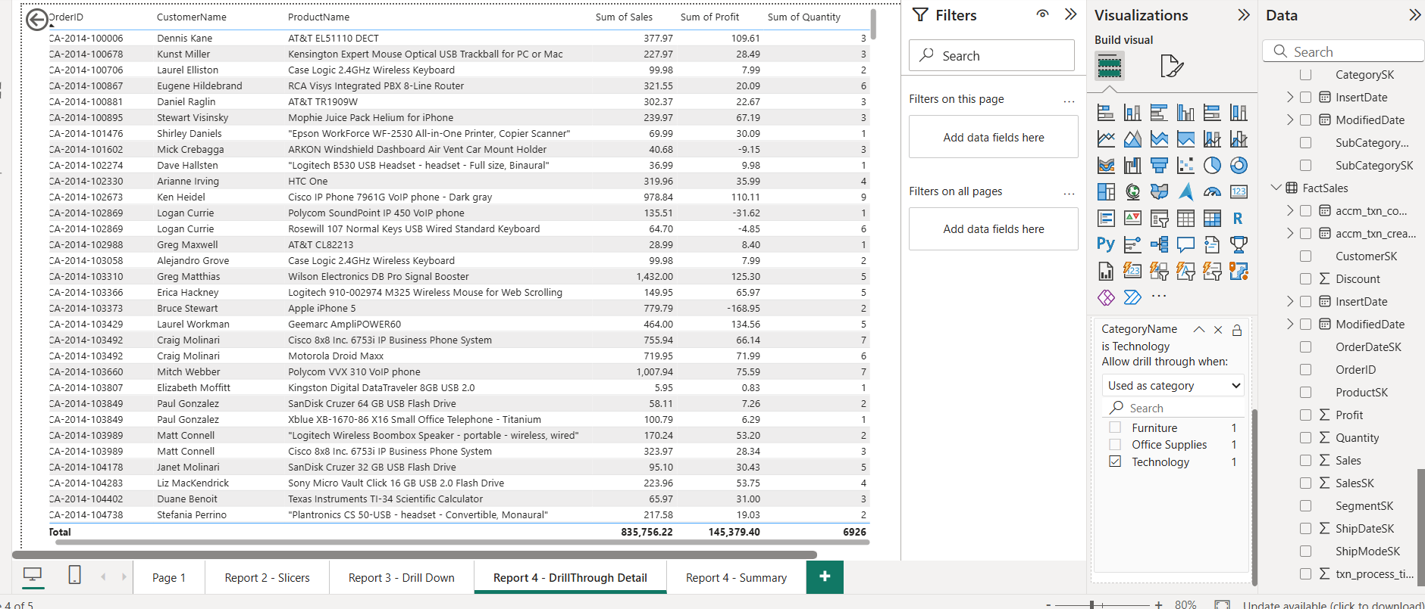
Summary of Power BI Reports:
Report | Visual Type | Key Feature
Report 1 — Matrix | Matrix | Row and column groupings with hierarchy
Report 2 — Slicers | Slicers + Bar Chart | Cascading filters between Category and SubCategory
Report 3 — Drill Down | Bar Chart | Year → Quarter → Month hierarchy navigation
Report 4 — Drill Through | Bar Chart + Table | Right-click navigation to detailed order data

4.5 Publishing to Power BI Service
All four reports were published to Power BI Service using the Publish feature in Power BI Desktop. The reports were published to My Workspace.
Publishing Steps followed:
- Clicked Home → Publish in Power BI Desktop
- Selected My Workspace as the destination
- Waited for publishing to complete successfully
- Opened each report in Power BI Service to verify they display correctly online
Result: All 4 reports are now accessible in Power BI Service and can be viewed, shared and interacted with online — demonstrating full end-to-end BI solution from data warehouse to online reporting.
