OS Assignment 4
S. Vinu Sankar, 16110143

Q1a)
Link for Gist (codes): https://gist.github.com/vinusankars/ea07fab3afc10d2c7946af2e9a8e29a3
Number of files vs. Number of directories
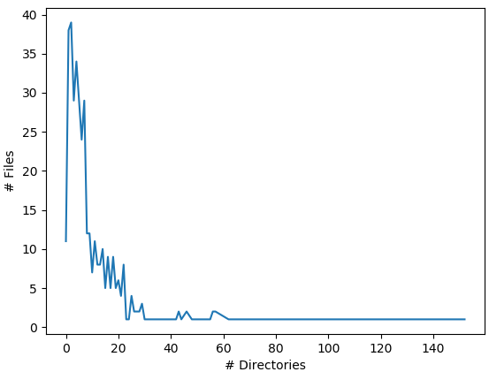
(i) The plot shows that less number of directories have high number of files in them and more number of directories have very small number of files in them. We see more number of files in less number of directories as supported by the above plot.

(ii) The plot show that there are many fies which are small in size. There are very less files with high memory occupancy. In an OS, its likely to say there are many small sized files than bigger ones as supported by the plot below.

Number of files vs. File size

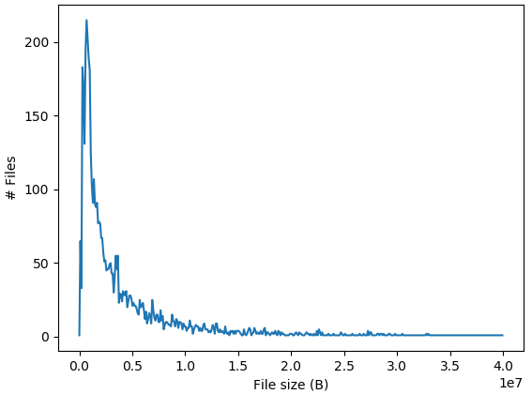
Q1b)
Link for Gist (codes): https://gist.github.com/vinusankars/ea07fab3afc10d2c7946af2e9a8e29a3
The difference is that new files are been allocated and some files are deleted. Those files which are temporarily deleted by the OS remains in the memory until the garbage collector collects them and frees the memory. Also temporary files are created when an existing file is being updated. These files are then renamed over the original file to updaet them.

Q2)
Link to video:
https://drive.google.com/file/d/1U2kg1N2U-aCmkwwxpQsOApuPUSpcZo-n/view?usp=sharing
FIFO takes requests in order 7, 30, 8. But SSTF taes it in order 7, 8, 30. From 7 it is easier to read 8 as shown in video because it is closer. Going to 30 and then coming back to get 8 takes more time. That is why FIFO works bad here.

Q3)
Link to video:
https://drive.google.com/file/d/1Lhzpfqc9fEi2UseBHRwuMZ7TyDxXPFxz/view?usp=sharing

Q4)
Link to video:
https://drive.google.com/file/d/1jGe0UNrZzi2I2vo6f5usoOyi7ZbwaCcD/view?usp=sharing

