Explainable AI-Driven Urban Traffic Accident Severity Prediction Using Machine Learning, Contextual NLP, and Retrieval-Augmented Generation
Anjali Kasarla, Vinusha Muppala, Lasya Geethika
( KLH University, Bowrampet, Hyderabad, Telangana, India,
anjalikasarla@gmail.com, mvinusha9@gmail.com, geethika99590@gmail.com )
Faculty Mentor: Dr. Katanguri Swanthana
(Department of Computer Science and Engineering, Koneru Lakshmaiah Education Foundation, Bowrampet, Hyderabad-500043, Telangana, India,
https://orcid.org/0009-0004-8217-4051 , kswanthana@gmail.com )

Abstract
Road traffic accidents present a major concern in public safety. Intelligent systems are therefore required that can understand accident severity and provide insight into risk factors. Machine Learning methods can provide insights into road accident patterns but have limitations such as class imbalance, lack of interpretability and difficulty in providing meaningful insight from predictions. This research proposes a novel framework for urban traffic accident severity prediction using machine learning, natural language processing, explainable AI and retrieval augmented generation.
The framework utilises structured road accident data where accidents are recorded with attributes relating to time of accident, location, road, vehicle, lighting and weather. Multiple classification models have been tested following data preprocessing and feature engineering to predict road accident severity for three categories: slight, serious and fatal. The main prediction model used was XGBoost. The natural language processing component used DistilBERT to provide contextual embeddings. SHapley Additive exPlanations were used to provide insight into how model features contribute to predictions. A retrieval augmented generation pipeline was used to find relevant road safety information which was then combined with prediction information to create natural language explanations using a large language model.
The framework was created as a full stack application using Python, FastAPI, React and TypeScript. The framework was designed to separate the accident severity prediction into explainable parts to aid transparency. This research also looked at how well the models perform in terms of prediction and how well the explainable predictions could be incorporated into retrieving knowledge about road safety. This framework can be used to further investigate interpretable and knowledge assisted road accident severity prediction.
Keywords—Traffic Accident Severity Prediction, Machine Learning, XGBoost, Explainable AI, SHAP, Natural Language Processing, Distilbert, Retrieval Augmented Generation, Large Language Models, Road Safety

1. INTRODUCTION
1.1 Background
Road traffic accident is a major issue in terms of public safety. Many people get injured or killed during road traffic accidents, and there can be damage to property and economic loss. There are many factors that affect how severe a road traffic accident is. These include: road conditions, weather, lighting, junction type, vehicle type, geographical location and time. Historical data can be analysed using machine learning. This can help spot trends.
Machine learning can help analyse large amounts of data. However, road traffic accident data often have a large class imbalance. Most records will be for minor accidents and only a small amount will be for fatal accidents. This means that the accuracy of the models may not give an accurate indication of how well the models can predict severe accidents.
An explainable machine learning system has been developed to predict the severity of urban traffic accidents. This involves feature engineering, explainable AI and retrieval augmented generation. Using machine learning the system can predict the severity of accidents. It can also highlight the features that have the largest influence on the severity of accidents. Additionally, the system has a knowledge retrieval and language generation pipeline to assist with road safety information.
1.2 Problem Statement
There are many issues that occur when trying to predict the severity of accidents from historical data. Traditional classification models simply provide a label and probability for the prediction. This doesn’t give enough information regarding what factors influence the prediction.
A multiclass pipeline has been developed using the Road Accident Dataset. The target variable is Accident_Severity, with the classes Slight, Serious and Fatal. Features have been engineered to provide the model with temporal, geographical, road, environmental and vehicle information.
Additionally, SHapley Additive exPlanations (SHAP) has been integrated to show how each feature effects the prediction. A retrieval augmented generation pipeline has been created to retrieve information regarding road safety, and provide this as context to the large language model (LLM). The machine learning model will provide the prediction whilst the retrieval and generation pipeline provide supporting information.
1.3 Research Gap
Machine learning techniques have been widely used to classify the severity of accidents. Explainable techniques have been developed to help understand complex models. However, there are issues with the accuracy of the predictions, understanding the model and providing relevant road safety information.
Class imbalance can be an issue. In this case the dataset has a fairly low amount of fatal accidents. This can result in the model having a reasonable accuracy but struggling to accurately predict the minority classes. This means that the model needs to be evaluated on its performance for each class, macro averaged metrics and confusion matrix.
Explainable methods such as feature attribution don’t provide evidence for causality. Additionally, language models can provide explanations. However, this must be based on relevant information. By integrating the predictions, SHAP and knowledge retrieval from the road safety knowledge base, we can create a practical solution.
The focus of this work is to integrate these methods into one application to analyse the severity of accidents. This has also included a TF-IDF and DistilBERT text representation for the extracted text from the accidents. The value of these must be proven by the experiments.
1.4 Research Objectives
The aim of this research is to create an explainable machine learning system to predict traffic accident severity and provide knowledge assisted road safety information.
Objectives:
1. Preprocess and analyse the selected dataset (Road Accident Dataset).
2. Engineer features for the temporal, geographical, road, weather, lighting, junction and vehicle attributes.
3. Develop and evaluate machine learning classifiers to predict the severity of Slight, Serious and Fatal accidents.
4. Investigate text representations for the accident information using TF-IDF and DistilBERT contextual embeddings.
5. Evaluate the selected classifier using accuracy, precision, recall, F1 score, ROC-AUC and confusion matrix.
6. Integrate SHAP to explain the features.
7. Develop a semantic search for road safety information and integrate this information into the large language model.
8. Create an application using FastAPI as the backend and React as the frontend to link the prediction, explainable predictions, knowledge retrieval and natural language generation.
1.5 Research Questions
This research answers the following questions:
RQ1: How effective are machine learning algorithms at predicting the severity of historical accident data (Slight, Serious and Fatal).
RQ2: How does the XGBoost compare to the rest of the classifiers in the evaluation given the class imbalance within the data.
RQ3: What features have the most impact on the predictions of the trained XGBoost model.
RQ4: How can the structure attributes be converted into contextual text representations for NLP.
RQ5: How can SHAP explanations and road safety knowledge be integrated into natural language explanations.
RQ6: How can these be integrated into a web application.
1.6 Contributions
The main contributions of this work are:
1. Accident Severity Prediction: A pipeline has been developed using XGBoost to predict the severity of Slight, Serious and Fatal accidents.
2. Feature Engineering: A consistent pipeline has been developed to provide temporal, geographical, environmental, road, junction and vehicle features.
3. NLP: TF-IDF and DistilBERT have been implemented to provide text representations for the extracted accident information.
4. Explainable Predictions: SHAP has been integrated to provide insights into the features.
5. Knowledge Assisted Road Safety: A pipeline has been developed to provide road safety information to the large language model.
6. Full Stack Application: A full stack application has been developed using FastAPI as the backend and React and TypeScript as the frontend. This links together the prediction, explainable predictions, knowledge retrieval and response.
7. Separated the roles across the model. The machine learning model will decide the severity of the accident, SHAP will explain how the model makes its predictions and the RAG and LLM will provide additional road safety information.
1.7 Organisation
The remainder of this paper is organised as follows. Section 2 looks at related research relating to this project, looking at accident severity prediction, machine learning, contextual NLP, explainable AI and retrieval augmented generation. Section 3 details the methodology of this project, including the dataset, preprocessing, feature engineering, classification, explainable predictions and knowledge retrieval. Section 4 details the experimental setup. Section 5 details the results from evaluating the model, hyperparameter tuning and SHAP. Section 6 details implications from the results. Section 7 details the limitations of the system. Section 8 concludes the paper and details future research. Finally the references.
Feature engineering has been performed with multiple machine learning classifiers to predict the severity of accidents (slight, serious and fatal). XGBoost was used as the main model for prediction and DistilBERT contextual representations were used in the NLP. SHapley Additive exPlanations (SHAP) was also used to understand how the features in the model impact individual predictions. A retrieval augmented generation pipeline has been used to retrieve relevant road safety information. This has then been combined with information about the predictions to provide natural language explanations using a large language model.
The framework has been implemented as a full stack prototype using Python, FastAPI, React and TypeScript. The framework separates the prediction of the severity, explainable predictions, knowledge retrieval and natural language generation. This will improve the transparency of the model and keep a clear distinction between the predictions and recommendations. The model has been evaluated using class sensitive metrics. The explainable predictions have been investigated to see how they can be practically integrated with the knowledge retrieval. This framework can provide a good foundation to further investigate interpretable knowledge assisted traffic accident severity analysis.
Keywords — Traffic Accident Severity Prediction Machine Learning XGBoost Explainable Artificial Intelligence SHAP Natural Language Processing DistilBERT Retrieval Augmented Generation Large Language Models Road Safety
2. RELATED WORK
2.1 Current Methods
Predictive models using statistical analysis, traditional machine learning, ensemble learning and deep learning have been used to predict traffic accident severity. These models aim to find patterns in the data based on accident characteristics. The type of models used depend on the data present and the classes within the data set.
Traditional models can be used to create a good baseline in classification problems. However, the non-linear relationships and interactions between accident characteristics can make it difficult to choose the best model. Ensemble models such as Random Forest and Gradient Boosting can solve this issue. Work has been done on models predicting injury severity of crashes. This work has focused on solving issues of class imbalance and explainability. This has shown that metrics predicting minority class performance can be very important [1], [2].
Although predictive models can be very powerful, they may not provide much insight into how the features are affecting the prediction. Explainable Artificial Intelligence can be used to provide an estimate of how much each feature contributes. Retrieval models can be used to provide information on how the prediction was reached. This can all be put together in the web-based application in this work.
2.2 Machine Learning Models
Logistic Regression is a simple model to use for classification. Decision Tree models produce results in the form of a tree where decisions are made based on splitting the data. Random Forest can be used to improve the robustness of the model by combining multiple decision trees. Support Vector Machine models can be used too.
Gradient Boosting models use an ensemble of decision trees. Each additional tree learns from the error made from the previous trees. XGBoost was introduced by Chen and Guestrin [3] and includes regularisation and optimisations for faster gradient boosting tree learning. This makes it a good option for classifying accident severity.
Within this implementation, Logistic Regression, Decision Tree, Random Forest and XGBoost have been tested. Support Vector Machine has been used as a benchmark but only tested on a sample of 10,000 observations. This means the results need to be viewed separately.
Class imbalance is an important factor within this problem. The data set has many more Slight accidents than Serious/Fatal, so macro averaged metrics and per class performance were prioritised. The final model chosen and hyperparameters tested will all focus on the macro F1 Score.
2.3 Deep Learning
Deep learning models allow for complex patterns to be learnt from large data sets. Transformer models use attention mechanisms to provide context between words and phrases in natural language processing. BERT was created by Devlin et al. and is a bidirectional transformer [4]. DistilBERT was created by Sanh et al. and is a smaller transformer that has been distilled to reduce computation [5].
These models can be useful if there is text data that provides context. TF-IDF provides traditional text data based on term frequencies and inverse document frequencies. Transformers provide text data based on the language model features.
As the data set contains structured features, the NLP part of the project will convert some of the features into descriptive text. This will include features such as junction type, light, road surface, road type, weather, vehicle type and speed limit. TF-IDF and DistilBERT will be used.
As this is being used as part of the NLP section, it cannot be assumed that using contextual embeddings will improve the final results. The XGBoost model uses engineered features for prediction, so if the contextual embeddings improved the predictions, a control would need to be performed using the same data splits, target classes and metrics.
2.4 Explainability
Explainable Artificial Intelligence is used to make it easier to investigate and understand machine learning models. This is important when predicting accident severity as we do not know which characteristics affected the prediction.
SHapley Additive exPlanations (SHAP) were introduced by Lundberg and Lee [6]. It is a unified framework for explaining predictions. SHAP gives an estimate of how much individual features contributed to the prediction compared to an appropriate baseline. It can be used for local explanations and overall analysis.
SHAP has been integrated into this system. Feature importance is analysed for individual predictions and the mean absolute SHAP values are calculated for the sample. This helps to understand which features are affecting the model predictions.
The most important SHAP values within this implementation include speed limit, junction features, urban/rural location and time features. This shows how the model behaves on the data set. It does not show that an individual feature is causing an accident or affecting the severity.
Retrieval Augmented Generation was introduced by Lewis et al. [7]. RAG uses a language generator with retrieval information. A semantic search has been used to retrieve relevant information from a road safety knowledge base. The information is then passed to a large language model. An explanation is then produced.
Each part of the model has its own purpose. The XGBoost model is used to predict the severity category. SHAP is used to explain how the model behaves. The retrieval provides relevant information. The LLM provides a natural language explanation. This is important as the information provided by the retrieval and LLM should not be seen as affecting the output of the classifier.
2.5 Critical Analysis
The existing methods cover a range of different areas within the project. Traditional machine learning can be used for predictive modelling. Ensemble learning can be used for non-linear classification. Transformers provide contextual text. Explainability can be used to understand how the model behaves. Retrieval augmented generation can be used to include external knowledge.
However, they all serve different purposes and should not be directly compared by looking at classification metrics. TF-IDF and DistilBERT are text data methods. SHAP is an explainability method and RAG is a retrieval and generation method. They should therefore be evaluated based on what they contribute.
The main methods relevant to this research are summarised in table 1.
Approach | Main purpose | Strength | Limitation or consideration
Logistic Regression | Classification baseline | Simple and interpretable model structure | May not capture complex nonlinear relationships
Decision Tree | Rule-based classification | Represents learned decisions as tree splits | Can be sensitive to training data
Random Forest | Ensemble classification | Combines multiple decision trees | Predictions can be less directly interpretable
XGBoost | Gradient-boosted classification | Models complex relationships in structured data | Requires careful evaluation and explanation
TF-IDF | Text representation | Efficient representation of word-frequency patterns | Does not inherently capture contextual meaning
DistilBERT | Contextual-text representation | Produces contextual language embeddings | Additional computational cost; value depends on the task and data
Table 1. Comparison of approaches relevant to the proposed system
The system has been built using the different methods. The machine learning model will perform classification, SHAP will aid in interpreting the predictions and the RAG pipeline will provide the road safety information to allow natural language explanations. The NLP models provide another way to represent the contextual information for the accident but the added benefit of aiding prediction can not be claimed unless proven by the comparison.
2.6 Research gap
The methods discussed have shown how useful machine learning models can be for classifying accident severity, transformers to represent contextual text and SHAP for model interpretation. However, the other methods don’t automatically provide a reliable solution for accident analysis. There are three issues to overcome:
Class imbalance may cause accuracy to not be an accurate way to determine how well the model is performing due to low fatal accident numbers. Interpretability will require further analysis to determine what factors have contributed to the classifications. Knowledge retrieval will be required to provide relevant safety information.
This work has provided a solution to these issues through the combined use of feature engineering for the accident features, XGBoost for classifying severity, SHAP for feature contribution and semantic search for road safety advice. A FastAPI backend and React/TypeScript frontend has been used to provide the application.
The contribution is providing an integrated solution for prediction, model interpretation and safety advice through knowledge retrieval. It does not make any assumptions that the language models will improve accuracy, SHAP will provide causative relationships or that the safety advice will replace professional road safety assignment.
3. PROPOSED METHODOLOGY
3.1 Overall Architecture
The framework utilises a combination of Machine Learning, Feature Engineering and Explainable AI techniques, alongside Semantic Knowledge Retrieval and Large Language Model based explanations to provide a solution for the analysis of urban traffic accidents and their severity. Given a set of structured traffic accident data, the framework will predict whether an accident will be classified as Slight, Serious or Fatal based on the severity of the accident. Additionally, probabilities for each class, feature attributions and relevant safety advice will also be provided.
Within the overall pipeline, data preprocessing is performed followed by the feature engineering stage. Various classification models are tested during training and a XGBoost model is used as the main classifier within the implemented application.
During prediction, various accident attributes such as; date and time of accident, junction details, lighting conditions, road surface, road type, weather conditions, speed limit, vehicle type, co-ordinates and location are taken as inputs. These can then be processed through a consistent feature engineering pipeline.
Following classification, SHAP values are calculated to give insight into how much each feature contributed to the prediction. Using the semantic search capabilities of the road safety knowledge base, relevant information is retrieved. This information, alongside the prediction information, is passed into the language generation component to create a structured explanation.
The architecture has been designed so that the prediction and explanation components are clearly separated. The XGBoost model will provide the severity class, SHAP will provide an explanation of the model and the retrieval augmented generation pipeline will provide additional safety advice. The explanation will not make a decision on its own and will not override the predicted class.
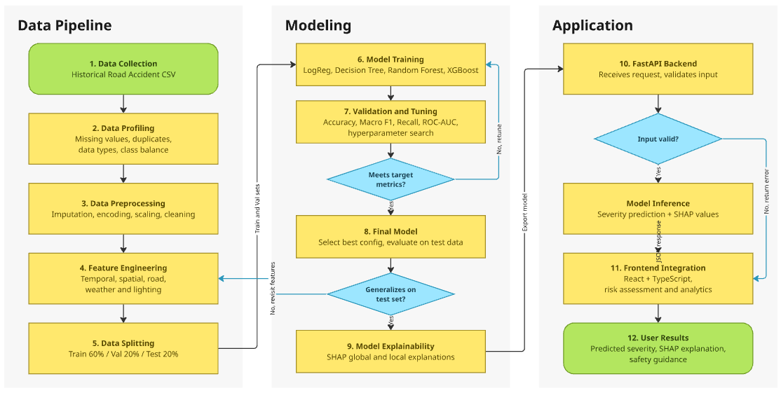
Figure 1. Overall architecture of the proposed accident severity prediction framework.
3.2 Dataset
This study used the Road Accident Dataset from Kaggle. It includes various road, environmental, time, location and vehicle-related features related to historical accident data. This dataset was used to build a multi-class classification model that can predict the severity of an accident based on reported data.
We were provided with 307,973 entries with 23 columns. The target variable of Accident_Severity had 3 classes (Slight, Serious and Fatal). Table 2 provides a summary of the original distribution of classes.
Table 2. Distribution of accident severity classes in the original dataset
Severity class | Number of records | Percentage
Slight | 263,280 | 85.49%
Serious | 40,740 | 13.23%
Fatal | 3,953 | 1.28%
Total | 307,973 | 100%
The data is skewed with most of the samples being of the Slight class. Only a small proportion of the samples are in the Fatal class.
Variables present are: Accident date, Day of the week, Junction, Light, Latitude, Road Surface, Road Type, Speed Limit, Urban, Weather, Vehicle, Casualties and Number of Vehicles.
Within the dataset there is one exact duplicate. There is a large amount of missing data in the Carriageway_Hazards variable. There is also a smaller amount of missing data in the Weather, Road Type, Road Surface and Time variables.
The data does not include any original narrative about the accident. Instead, the NLP part of the project creates narrative based on the selected structured variables.
3.3 Data Preprocessing
Data preprocessing was completed in order to ensure the data was consistent and ready to be used for modelling. Duplicate data has been removed by looking at the duplicate accident data. Any remaining missing data has been addressed within the data preprocessing pipeline. For numerical variables, the missing data will be replaced with the median value, and categorical variables will instead be replaced with the most common category. This is then included in the preprocessing pipeline for the model.
The date and time of the accident have been converted into different time features. This includes: Hour, Day, Month, Week, Day of Year, Minute and Period. This has been done by using common feature engineering functions to create new variables.
The categorical variables have been one hot encoded. Any new categories have been handled by using the unknown category option. The numerical variables have been standardised using the numerical preprocessing pipeline. The preprocessing has been fit to the training subset to help avoid any information leakage.
The research has used a stratified split of 60% training, 20% validation and 20% testing. This ensures the classes are roughly the same across all subsets. A random seed has been set to 42 to ensure the data is split consistently. The validation data has been used to compare models and choose the best hyperparameters. The test set has been kept separate for final evaluation.
The preprocessing and feature engineering has resulted in 307,972 records with 37 engineered features. After the model specific preprocessing has been fit, there are 1,069 encoded features.
3.4 Feature Engineering
The original accident attributes are converted into features representing time related features, road features, environmental features and geographical features. This can help give the classifier a uniform way to represent accidents.
Time related features include day, month, week, hour, minute, day of year, time of day and peak hours. The hour variable is transformed into sine and cosine representations to represent the cyclical nature of hours.
Geographical features include latitude, longitude, regions, areas and lat-long interactions. These are binned in order to have consistent transformations.
Environmental and road features include weather category, road surface category, light category, road category, junction category and speed limit category. Vehicle features include vehicle category and area features include area and police force category.
There are a total of 37 features created from the original accident attributes. These are then passed through the specific model preprocessing steps which includes rescaling numerical features and encoding categorical features.
Descriptive accident context was created using features from the data. This included junction category, light category, road surface category, road category, urban/rural category, weather category, vehicle category and speed limit category. This allows the NLP component to be used without needing the original text descriptions of the accident.
3.5 Feature Representation & Selection
The framework has been designed to use structured features as the main input. These were transformed using the fitted preprocessing steps to create 1069 features to input into our XGBoost classifier.
The NLP component looked at transforming the text using TF-IDF and DistilBERT embeddings. TF-IDF creates text representations based on term frequencies. DistilBERT creates contextual embeddings using a pre-trained transformer model.
TF-IDF was set to transform the text with a max of 5,000 features. It was also set to use uni and bi-grams, a min document frequency of 2, max document frequency of 0.95 and sublinear term frequencies. This created a total of 291 columns for our descriptive accident context.
The DistilBERT embeddings were created using the pre-trained distilbert-base-uncased model. This created a contextual embedding for each observation with 768 dimensions.
Feature selection was not performed within this project. Whilst this was originally planned within our research, the XGBoost pipeline we deployed simply used the engineered features and then applied preprocessing to the numerical and categorical features. We do not claim that any specific feature selection methods were used to improve the performance of our classifier.
3.6 Proposed Model
The classification pipeline will explore 4 different models: Logistic Regression, Decision Tree, Random Forest and XGBoost. A benchmark comparison will be carried out with Support Vector Machines however it will only be based on a small sample of 10,000 observations.
Logistic Regression will be used to establish a baseline for the multi-class classification problem. The Decision Tree model will create a hierarchy of decision rules. The Random Forest model will produce an ensemble of Decision Trees. The main classification model to be used in this application is the XGBoost model.
The XGBoost model will use the multiclass probability objective function (multi:softprob) to predict probabilities for each severity. The model will be trained with 300 estimators, a max depth of 8, learning rate of 0.05, subsampling of 0.8, and column sampling of 0.8. The model will use histogram trees for the training.
Class weights were used by providing weighted samples in the training data to account for the imbalanced classes between Slight, Serious and Fatal. The weights were calculated using the training data.
The hyperparameters were tuned using 10 controlled validation experiments. The models will be chosen based on their macro F1 score since it gives equal weighting to each severity class’ F1 score. The validation experiment setup will be identified. The test set must be kept separate.
3.7 Training and Evaluation
The data was split into training, validation and test sets with a 60/20/20 split using a random seed of 42. The training set was used to train the pre-processing transformations and classification models. The validation set will aid in comparing the models and choosing the best hyperparameters.
The classification pipeline will be assessed using Accuracy, Macro Precision, Macro Recall, Macro F1 Score, Weighted F1 Score, ROC AUC and Confusion Matrix. The precision, recall and f1 scores for each class will be identified to see how well the model can detect the minority classes.
Accuracy shows what percentage of the data was correctly classified. The macro averages will show the value for each class and then an average. The weighted f1 score will take into account the support for each class which can cause it to be heavily influenced by the Slight class.
The confusion matrix will show how the model is predicting correctly and incorrectly for the 3 classes. The precision and recall for the Fatal class will be looked at as there are very few Fatal observations so it can be difficult to classify them accurately.
The hyperparameters will be experimented with using the validation set. The model will be chosen based on the macro F1 score. The final evaluation using the test set should be done separately.

3.8 Explainability
SHapley Additive exPlanations (SHAP) has been added to the inference pipeline. Tree SHAP has been used to explain how the features are contributing to the predictions of the trained XGBoost model.
The SHAP values will give insight as to how the features contribute towards the prediction of each sample. Overall feature importance has been calculated by taking the mean absolute SHAP value. This will allow us to identify which features have a relatively large impact on the model.
The SHAP values have been calculated for a sample of 5,000 test observations. The key features to note are speed limit, junction type, urban or rural and time related features. This shows what behaviour has been learnt by the trained classifier.
The SHAP values do not show causality. For example if speed limit has a high value it does not prove that it caused that accident with the given severity, it simply shows evidence that the model attributes this feature. The explanations are there to add transparency to the model.
The application will also deal with any new categorical values. Any inactive one hot variables will be removed from the explanation to reduce the likelihood of misleading information.
3.9 Algorithm and Mathematical Formulation
Let the accident dataset be represented as
$$D={\left\{\left(x_{i} , y_{i}\right)\right\}}_{i=1}^{N},$$
where $x_{i}$denotes the feature vector for accident record $i$, $y_{i}$is its reported severity class, and $N$is the number of observations. The target space is
$$y_{i}∈\left\{\text{Slight} , \text{Serious} , \text{Fatal}\right\}.$$
A preprocessing function transforms the original feature vector into the model representation:
$$z_{i}=T\left(x_{i}\right),$$
where $T$represents the fitted imputation, scaling, feature transformation, and categorical encoding pipeline.
The trained XGBoost classifier estimates a score for each severity class. The corresponding class probabilities are represented as
$$P\left(y_{i}=k∣z_{i}\right)=\frac{exp⁡\left(f_{k}\left(z_{i}\right)\right)}{\sum_{j=1}^{3}{exp}⁡\left(f_{j}\left(z_{i}\right)\right)},$$
where $f_{k}\left(z_{i}\right)$is the model score associated with class $k$. The predicted class is
$${\hat{y}}_{i}= P\left(y_{i}=k∣z_{i}\right).$$
The trained machine learning model therefore determines the classification result.
For evaluation, accuracy is defined as
$$\text{Accuracy}=\frac{\sum_{k=1}^{3}{C_{kk}}}{\sum_{i=1}^{3}{\sum_{j=1}^{3}{C_{ij}}}},$$
where $C_{ij}$denotes the number of observations belonging to actual class $i$and predicted as class $j$.
For each class, precision and recall are calculated as
$$\text{Precision}=\frac{TP}{TP+FP}, \text{Recall}=\frac{TP}{TP+FN},$$
where $TP$, $FP$, and $FN$represent true positives, false positives, and false negatives, respectively. The class-specific F1-score is
$$F1=2⋅\frac{\text{Precision}⋅\text{Recall}}{\text{Precision}+\text{Recall}}.$$
Macro F1-score is obtained by averaging the F1-scores of the three severity classes without weighting them by class frequency.
For explainability, SHAP represents the prediction contribution of feature $j$for observation $x$as $ϕ_{j}\left(x\right)$. Aggregate feature importance is summarized by.
$$I_{j}=\frac{1}{M}\sum_{i=1}^{M}{∣}ϕ_{j}\left(x_{i}\right)∣,$$
where $M$is the number of observations used for the explanation analysis.
Finally, the RAG component retrieves relevant road safety passages based on the accident context. The retrieved material and model-related information are supplied to the LLM to generate a natural-language explanation. This stage supports interpretation and safety guidance but does not modify the severity class produced by XGBoost.

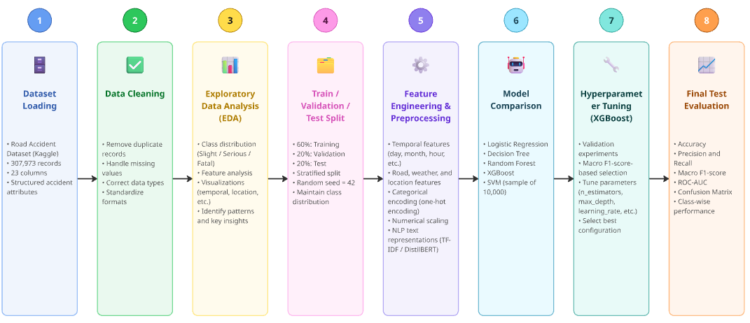
Figure 2 — Dataset and Model Development Workflow

4.EXPERIMENTAL SETUP AND EVALUATION METRICS

4.1 Experimental Setup
Python was used to implement the proposed system. Scikit learn was used for the machine learning pipeline including pre-processing, and baseline classifiers. XGBoost was used for the gradient boosting classifier, and SHAP for the model interpretation. PyTorch and Transformers libraries were used for the DistilBERT based contextual embeddings.
FastAPI was used for the back-end to create an API. The front-end was implemented using React and TypeScript. The safety knowledge component used sentence embeddings and semantic similarity to look up relevant sentences from the road safety knowledge base. The natural language explanation was created by using a large language model.
The XGBoost model and pre-processing were saved as artefacts.
4.2 Data Splitting
The dataset was split into three parts, training, validation and test using a stratified split of 60/20/20. The stratified sampling ensured that the severity classes had an approximately similar distribution between each split.
The training data was used to train the pre-processing and classification models. The validation data allowed for model comparison and hyperparameter tuning. The test data was used to evaluate how well the chosen model performed.
Numerical imputation, scaling and categorical transformation were performed during pre-processing. They were trained on the training data to ensure there was no data leakage. Weights were also calculated from the training data to be used during training with sample weights.
This ensures that all models will be compared fairly.
4.3 Model Selection
The classification models tested were Logistic Regression, Decision Tree, Random Forest and XGBoost. An additional benchmark was run using SVM but only using a sample of 10,000 observations.
Logistic Regression and Decision Tree were both run with class balancing. Random Forest was used to provide an ensemble baseline. XGBoost was the main model used within the prediction application.
The XGBoost model was initially setup with 300 estimators, max depth of 8 and learning rate of 0.05. Subsampling and column subsampling were set to 0.8. The multi:softprob objective function was used with the multi class log loss function and trees were built using histogram.
The features underwent pre-processing with the pipeline. Numerical data was imputed with the median and scaled. Categorical data was imputed with the most common value and one hot encoded. The pre-processing was trained resulting in 1069 features being passed to the classifier.

4.4 Model Evaluation
The models were evaluated using accuracy, macro precision, macro recall, macro F1 score, weighted F1 score, ROC-AUC and confusion matrix.
Accuracy measures how many observations have been correctly classified. Precision measures how many observations have been correctly predicted for a particular class. Recall measures how many observations of a particular class have been correctly identified. The F1 score combines these two metrics into one using the harmonic mean.
The macro average measures calculate the metric using each severity class individually then takes the average. This is important for this dataset as there are far fewer observations of Fatal compared to Slight. The weighted F1 score is also displayed to show the model performance taking class frequency into account.
The confusion matrix helps to see how well the model is at predicting each severity class (Slight, Serious and Fatal). The precision and recall for the Fatal class were of particular interest. This is because errors made when predicting Fatal are important to know when considering the limitations of the system.
When using multi-class ROC-AUC it is important to mention how the average was calculated and what the class probabilities were.
4.5 Hyperparameter Tuning
Hyperparameter tuning was performed to see if any alternative XGBoost settings would help improve the classification. The models were run with 10 controlled experiments using the same stratified data split and pre-processing method on the training data.
The macro F1 score was chosen as the main metric to optimise. This ensures each severity class is equally weighted. However, accuracy, macro recall and ROC-AUC were also recorded.
The hyperparameters searched were estimator numbers, tree depth, learning rate, min child weight, subsampling, column subsampling. The validation data was used to compare the models and choose the best option.
The best settings were 400 estimators, tree depth of 9, learning rate 0.04, min child weight 5, subsampling and column subsampling of 0.8, gamma 0.1, L1 regularisation of 0.1 and L2 regularisation of 2.
The model scored a macro F1-score of 0.3568 on the validation data. This is only the validation result and should not be confused with the final test result. The test data is not used when choosing hyperparameters.
4.6 Interpretability & Safety Advice
SHAP was used to interpretability the model. TreeSHAP was used to calculate feature importance using 5000 test samples. The mean absolute SHAP values were used to determine the relative importance of each feature.
The NLP component was implemented using TF-IDF and the DistilBERT representation of accident context text. This was done to explore how using structured text to describe accidents can be used in contextual text. This doesn’t prove that using them improves the severity classification. This would need to be tested in a controlled setting.
The safety advice component was tested functionally by using semantic search on the road safety knowledge base. The relevant sentences, prediction information and feature importance are passed to the language model to produce a structured natural language explanation.
The system is split into three parts. The XGBoost model predicts the severity class, SHAP provides information on model behaviour, and the semantic search and language model provide additional safety advice. The explanation produced doesn’t provide any evidence that the model is accurately classifying the severity and shouldn’t be used in place of professional road safety assessment.
5. RESULTS & DISCUSSION
5.1 Comparison of Machine Learning Models
Multiple machine learning classifiers were evaluated to find a suitable model for predicting accident severity. Logistic Regression, Decision Tree, Random Forest and XGBoost were assessed. An SVM benchmark was also ran on a sample of 10,000 observations.
The models were evaluated on accuracy, macro precision, macro recall, macro F1 score and ROC-AUC. As there is a significant imbalance in the data between Slight, Serious and Fatal accidents, macro averages were focused upon. This helped to show any differences in performance between the severity classes.
The validation results showed that XGBoost had the highest macro F1 score of 0.3512 followed by Random Forest with a score of 0.3487. Logistic Regression had the lowest macro F1 score with a score of 0.2748 and Decision Tree had a score of 0.3412. This indicates XGBoost had the highest macro F1 score of the full dataset models before hyperparameter tuning.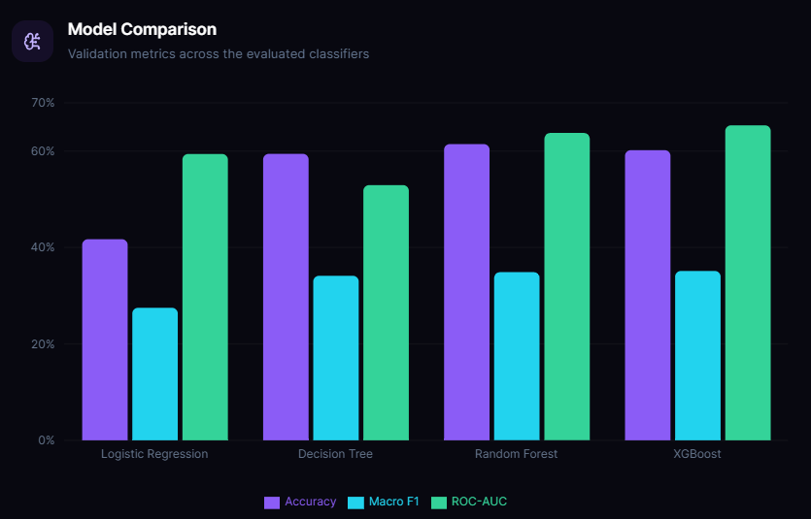
Figure 3. Comparative validation performance of the evaluated machine learning models.
The results suggest that ensemble-based approaches provide competitive performance for the structured accident classification task. However, the differences between XGBoost and Random Forest were modest, and the results do not establish that one model will perform best across every evaluation metric.
5.2 Hyperparameter Optimization Results
Ten controlled XGBoost hyperparameter trials were performed using the validation partition. Macro F1-score was selected as the primary optimization metric, while accuracy, macro recall, and ROC-AUC were recorded to examine additional performance characteristics.
The best validation configuration was Trial 9, which used 400 estimators, a maximum tree depth of nine, a learning rate of 0.04, a minimum child weight of five, subsampling and column subsampling ratios of 0.8, gamma of 0.1, L1 regularization of 0.1, and L2 regularization of 2.
This configuration achieved a validation accuracy of 0.6135 and a macro F1-score of 0.3568. Its macro recall was 0.4669, and its ROC-AUC was 0.6539. Compared with the original validation configuration, the macro F1-score increased from 0.3512 to 0.3568. This represents a modest improvement rather than a substantial change in classification performance.
Trial | Accuracy | Macro F1 | Macro Recall | ROC-AUC
1 | 0.5579 | 0.3326 | 0.4919 | 0.6506
2 | 0.5704 | 0.3404 | 0.4857 | 0.6531
3 | 0.6018 | 0.3512 | 0.4716 | 0.6533
4 | 0.5729 | 0.3407 | 0.4883 | 0.6534
5 | 0.6029 | 0.3505 | 0.4694 | 0.6533
6 | 0.5697 | 0.3395 | 0.4865 | 0.6523
7 | 0.5837 | 0.3450 | 0.4818 | 0.6524
8 | 0.5998 | 0.3511 | 0.4761 | 0.6536
9 | 0.6135 | 0.3568 | 0.4669 | 0.6539
10 | 0.5712 | 0.3403 | 0.4893 | 0.6522
Table 4. Results of the ten XGBoost hyperparameter trials on the validation partition.
The selected configuration was identified using validation results. Its performance must therefore be evaluated on the held-out test partition before conclusions about final generalization performance can be drawn. Validation metrics are not reported as test metrics.
5.3 Final Test Evaluation
The previously evaluated XGBoost configuration achieved a test accuracy of 0.5935, macro precision of 0.3700, macro recall of 0.4749, macro F1-score of 0.3474, weighted F1-score of 0.6679, and ROC-AUC of 0.6500.
These results show that the model identifies patterns in structured accident records but continues to face difficulty across the three severity categories. The difference between macro F1-score and weighted F1-score reflects the effect of class imbalance: the weighted metric gives greater influence to the majority class, whereas the macro metric treats each class equally.
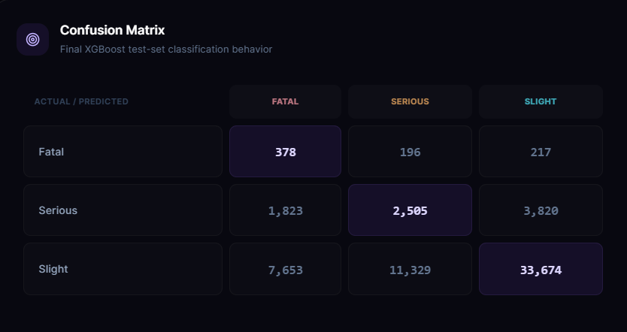
Figure 4. Confusion matrix for the previously evaluated XGBoost model on the held-out test set.
The confusion matrix reveals that many Serious and Slight accidents are misclassified. Fatal accident classification also presents a substantial challenge because Fatal observations form only a small fraction of the dataset. These errors highlight the need to examine class-specific precision and recall rather than relying solely on overall accuracy.
The test metrics in this subsection correspond to the previously evaluated XGBoost configuration. They must not be attributed to the newly selected hyperparameter configuration unless that configuration has been trained and evaluated separately on the held-out test set.
5.4 Class-Wise Classification Analysis
Class-specific evaluation provides further insight into the limitations of the classifier. For the previously evaluated XGBoost model, Fatal-class precision was 0.0384, recall was 0.4779, and F1-score was 0.0710. Serious-class precision was 0.1786, recall was 0.3074, and F1-score was 0.2259. Slight-class precision was 0.8930, recall was 0.6395, and F1-score was 0.7453.
The high precision but comparatively lower recall for the Slight category indicates that the model identifies only part of the observations belonging to this majority class. The Fatal category shows the opposite pattern: recall is higher than precision, but precision remains very low. Thus, many observations predicted as Fatal do not belong to the actual Fatal class.
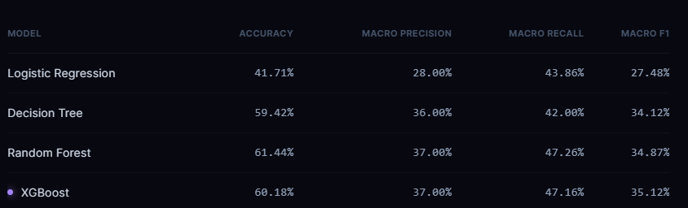
Figure 5. Class-wise precision, recall, and F1-score for the previously evaluated XGBoost model.
These findings demonstrate that overall classification performance must be interpreted alongside class-wise results. The model's low Fatal-class precision limits its suitability for decisions that require reliable identification of fatal accident severity. Its predictions should therefore be treated as analytical outputs rather than definitive safety determinations.
5.5 Explainability Results
SHAP was applied to 5,000 test observations to investigate the contribution of input features to the trained XGBoost model's predictions. Mean absolute SHAP values were used to summarize feature importance across the analyzed observations.
The leading contributors included speed limit, junction configuration, urban or rural area, accident hour, and other temporal and geographical features. Speed limit had the highest mean absolute SHAP value in the recorded analysis, followed by junction and location-related features.
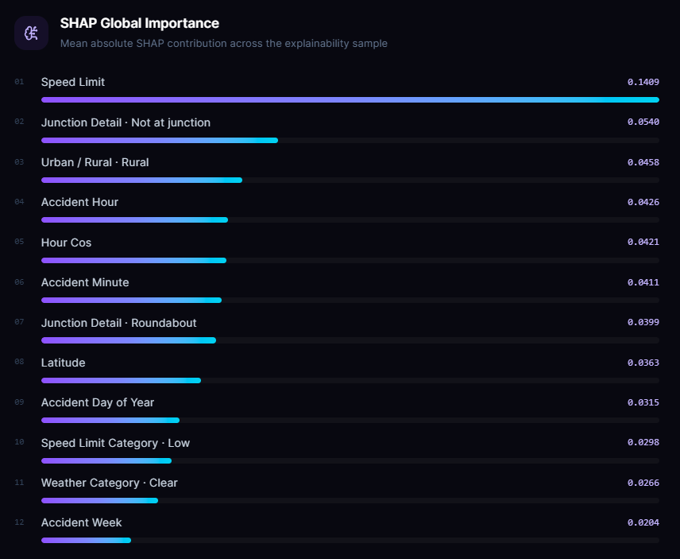
Figure 6. Global feature importance based on mean absolute SHAP values.
The SHAP analysis provides insight into the behaviour of the fitted classifier and helps explain individual predictions. These feature contributions indicate model associations rather than causal relationships. Consequently, the results should not be interpreted as proof that any individual feature independently causes an accident or determines its severity.
5.6 Integrated Prediction and Safety Guidance
The implemented application connects the trained XGBoost classifier with a FastAPI backend and a React/TypeScript frontend. Given accident attributes, the system returns a predicted severity category, class probabilities, SHAP-based feature contributions, retrieved road safety passages, and a generated natural-language explanation.
The semantic retrieval component searches a road safety knowledge base for passages relevant to the accident context. The retrieved information is supplied to a language model to generate an explanation organized around the risk assessment, model-related factors, relevant safety guidance, and limitations.

Figure 7. Web application interface showing an accident risk prediction and its associated explanatory information.
The integration demonstrates how classification, explainability, and retrieved safety information can be presented through a single interface. The classifier determines the predicted severity category; the SHAP component describes feature contributions; and the retrieval and language-generation components provide supplementary guidance.
The application-level integration demonstrates functional connectivity among these components. It does not, by itself, establish that the system reduces accidents, improves road safety outcomes, or outperforms alternative systems in real-world deployment.
5.7 Discussion
The experimental findings demonstrate both the potential and the limitations of machine learning for structured accident severity prediction. XGBoost achieved the highest macro F1-score among the full-dataset validation models in the initial comparison, while the hyperparameter search produced a modest validation improvement. However, the previously evaluated test results show that the model's performance varies substantially across severity classes.
Class imbalance remains a central challenge. In particular, the low Fatal-class precision indicates that the model frequently assigns the Fatal label to observations that are not Fatal in the reported data. This limitation is important when considering possible use in safety-related settings.
The explainability component improves transparency by identifying features that contribute to model outputs, while retrieval-augmented generation connects the prediction context with road safety guidance. These components provide complementary capabilities but do not resolve the underlying classification errors. Further work should investigate class-sensitive learning strategies, calibration, external validation, and controlled comparisons of structured features with TF-IDF and DistilBERT representations.
Overall, the implemented system provides an integrated framework for accident severity classification, model interpretation, and knowledge-grounded safety assistance. Its findings should be interpreted in light of the dataset's imbalance, the observed class-wise errors, and the need for further evaluation before any operational safety use.
6. DISCUSSION
6.1 Interpretation of Findings
The experimental results demonstrate that predicting reported traffic accident severity is a challenging multiclass classification problem, particularly when the target classes are highly imbalanced. Among the evaluated machine learning models, XGBoost achieved the highest validation macro F1-score of 0.3568 after hyperparameter optimization, compared with 0.3512 for the baseline XGBoost configuration, 0.3487 for Random Forest, 0.3412 for Decision Tree, and 0.2748 for Logistic Regression. These results indicate that nonlinear ensemble-based approaches can capture useful relationships among road, environmental, temporal, and vehicle-related attributes. However, the relatively modest macro F1-scores also indicate that accurately classifying all three severity categories remains difficult.
The difference between overall accuracy and macro F1-score is particularly important. Because slight-severity accidents account for approximately 85.49% of the dataset, accuracy alone does not adequately describe the model's performance across all classes. Macro F1 gives equal weight to each severity category, making it more informative when assessing the treatment of minority classes. Although the optimized XGBoost model improved macro F1 over the baseline, the improvement was modest, indicating that hyperparameter tuning alone does not eliminate the challenges associated with class imbalance.
The class-wise results from the previously evaluated XGBoost configuration further illustrate this issue. The model achieved a recall of approximately 0.478 for fatal accidents but a precision of only 0.038. This suggests that it identified a substantial proportion of actual fatal cases while also incorrectly assigning the fatal label to many non-fatal cases. Such behavior demonstrates the trade-off between detecting rare, high-severity events and limiting false-positive predictions. The corresponding precision and recall values must be considered together rather than interpreting fatal-class recall in isolation.
The SHAP analysis identified speed limit as the most influential feature by mean absolute SHAP value, followed by features related to junction details, urban or rural location, accident time, and geographic coordinates. This indicates that the trained model relies on a combination of road characteristics, temporal patterns, and location-related information when producing its predictions. These feature attributions describe how the model uses the available inputs; they do not establish that the identified attributes directly cause accidents or determine their severity.
Overall, the findings support the use of an integrated framework combining severity classification, model explainability, and retrieval-based safety guidance. Nevertheless, the predictive performance results and the usefulness of the generated explanations represent different evaluation dimensions and should be assessed separately.
6.2 Comparison With Previous Studies
Previous research on traffic accident severity prediction has explored statistical methods, conventional machine learning algorithms, ensemble learning, and deep learning techniques. Logistic Regression offers a relatively interpretable baseline, while Decision Trees represent nonlinear relationships through hierarchical decision rules. Random Forest and XGBoost extend these capabilities by combining multiple decision trees, potentially capturing complex interactions among accident-related variables.
The results of this study follow the general motivation for evaluating ensemble-based models alongside simpler classifiers. XGBoost achieved the strongest validation macro F1-score among the evaluated configurations, while Random Forest achieved the highest validation accuracy among the four full-dataset model comparisons. This difference highlights the importance of selecting evaluation metrics that reflect the study's objectives: the model with the highest accuracy is not necessarily the model with the best balanced performance across severity classes.
Research on explainable artificial intelligence has also emphasized the importance of making machine learning predictions more understandable. In this study, SHAP values provide feature-level attributions for the XGBoost model, complementing the numerical severity prediction. This enables users to inspect which input attributes contributed most strongly to a particular prediction or to the model's overall behavior. However, the presence of explanations does not by itself establish that predictions are reliable or that users will interpret them correctly.
A further distinction concerns the integration of predictive models with retrieval-augmented generation. Conventional severity-classification studies generally concentrate on predicting accident categories and evaluating classification performance. The present system extends this workflow by retrieving relevant road-safety guidance and using a language model to formulate contextual explanations. The classifier remains responsible for the severity prediction, whereas the retrieval and language-generation components support the interpretation of the result and the presentation of safety information.
These comparisons should be interpreted in light of the scope of the experiments. Because the present study does not report a controlled, like-for-like comparison against independently reproduced results from previous publications, the findings do not establish that the proposed system outperforms existing published approaches. A rigorous numerical comparison would require verified references, comparable datasets, consistent target definitions, and compatible evaluation protocols.
6.3 Theoretical Implications
The study illustrates the value of separating predictive inference, explainability, and knowledge-based assistance into distinct but connected components. The machine learning model estimates the reported accident severity category from structured accident attributes. SHAP provides information about the model's feature attributions, while retrieval-augmented generation supplies relevant road-safety guidance in natural language. This separation establishes a clear distinction between statistical prediction, model interpretation, and contextual information delivery.
The results also highlight the importance of evaluating multiclass classification under class imbalance. When one category dominates the dataset, a model may obtain a comparatively high accuracy while performing unevenly across the target classes. Reporting macro F1, macro recall, class-wise precision, and class-wise recall alongside accuracy provides a more complete assessment of this behavior.
Another implication concerns the interpretation of feature importance. The prominence of speed limit, junction characteristics, and temporal variables suggests that the model extracts predictive information from multiple dimensions of the structured dataset. However, feature attribution must not be confused with causal inference. Establishing causal relationships would require an appropriate causal research design and additional evidence beyond the predictive analysis conducted in this study.
The integration of structured machine learning with contextual NLP and retrieval-based generation also provides a practical example of a modular AI architecture. Nevertheless, TF-IDF and DistilBERT representations were developed as part of the broader project, and their independent contribution to classification performance has not been established through controlled comparative experiments. Therefore, their inclusion should be viewed as an implemented component of the broader system rather than evidence that NLP improves the classifier's predictive accuracy.
6.4 Practical Implications
The proposed application demonstrates how traffic accident severity predictions can be presented through an interface that combines a predicted category, model explanations, and retrieved road-safety information. Rather than presenting only a classification label, the application is designed to provide contextual information that may help users understand the prediction and explore relevant safety guidance.
For analysts and researchers, the model-comparison results demonstrate why evaluation should consider class-specific performance rather than relying exclusively on accuracy. The low precision observed for the fatal category in the previously evaluated XGBoost configuration indicates that predictions for rare severity classes require careful interpretation. Any operational use would need further calibration, threshold evaluation, independent validation, and assessment of the consequences of false-positive and false-negative predictions.
For road-safety practitioners, the SHAP component can help identify the attributes that influence individual predictions or contribute strongly to the model's overall behavior. Such information may support exploratory analysis and hypothesis generation, but it should not be treated as a substitute for domain expertise or causal evidence.
The retrieval-augmented explanation component offers an additional way to communicate safety information. By retrieving relevant passages from a road-safety knowledge base, the system can connect a model output with supporting guidance. The quality of this capability depends on the coverage and reliability of the knowledge base, the relevance of retrieved passages, and the availability and behavior of the language model. Generated explanations should therefore be checked for factual accuracy and consistency with their retrieved sources.
The system is best regarded as a research and decision-support prototype rather than an autonomous road-safety decision-maker. Its predictions should not independently determine emergency responses, road infrastructure investments, enforcement actions, or other high-impact decisions without further validation and appropriate human oversight.
6.5 Unexpected Findings
One notable finding was the difference between the model that achieved the highest validation accuracy and the model that achieved the highest validation macro F1-score. Random Forest achieved a validation accuracy of 0.6144, whereas the optimized XGBoost configuration achieved a validation macro F1-score of 0.3568. This distinction reinforces the need to select models according to the intended evaluation objective rather than assuming that a single metric adequately represents classification quality.
A second important finding was the low precision associated with the fatal category in the previously evaluated XGBoost configuration, despite its comparatively higher recall for that class. The result illustrates the difficulty of identifying rare events while controlling the number of incorrect high-severity predictions. Although detecting fatal cases is important, a model that generates many false-positive fatal predictions may also have limited practical usefulness. Further evaluation should examine class-specific decision thresholds, probability calibration, and the consequences of different classification errors.
The SHAP analysis also showed that temporal variables and their engineered representations contributed to the model's predictions alongside conventional road and environmental attributes. Features such as accident hour, minute, day of the year, and cyclical hour representations appeared among the influential features. This suggests that the model uses temporal information in addition to static accident characteristics. However, the contribution of correlated or related temporal features should be interpreted cautiously, because importance may be distributed across multiple representations of similar information.
Finally, the experiments demonstrate that hyperparameter optimization produced a measurable but limited improvement in validation macro F1, from 0.3512 for the baseline configuration to 0.3568 for the best trial. This indicates that tuning the XGBoost parameters alone did not resolve the underlying classification difficulties. Future improvements may require more systematic treatment of class imbalance, improved feature evaluation, and additional experiments designed to isolate the effects of individual modelling choices.
Taken together, these findings suggest that the main challenge is not simply selecting a more complex classifier. It is achieving a useful balance across severity categories while maintaining transparent predictions and ensuring that any accompanying safety guidance is relevant, evidence-based, and appropriately presented.
7. LIMITATIONS
Despite the integration of machine learning, explainable artificial intelligence, contextual natural language processing, and retrieval-augmented generation, the proposed Urban Traffic Accident Severity Prediction system has several limitations that should be considered when interpreting its results.
7.1 Dataset Limitations
The study uses a Kaggle road accident dataset containing 307,972 records after duplicate removal. Although the dataset provides structured information about accident circumstances, road characteristics, environmental conditions, and vehicle attributes, its coverage and representativeness may limit the generalizability of the findings. The results may not transfer directly to other geographical regions, road networks, reporting systems, or periods without additional validation.
The dataset also exhibits substantial class imbalance. Slight-severity accidents account for approximately 85.49% of the records, whereas fatal accidents represent only 1.28%. This imbalance makes it difficult for the classifier to achieve balanced performance across all severity categories. In addition, some attributes contain missing values, including carriageway hazards and weather conditions. Although preprocessing techniques were applied to handle missing data, imputation may not fully preserve the information contained in the original observations.
Furthermore, the target variable represents reported accident severity. Consequently, the system predicts the severity category associated with the supplied accident attributes rather than estimating the probability that an accident will occur at a particular location or time in the future.
7.2 Model Performance Limitations
The experimental results indicate that the evaluated models have limited balanced classification performance. Although the optimized XGBoost configuration achieved a validation macro F1-score of 0.3568, the result suggests that distinguishing between the three severity categories remains challenging. The difference between overall accuracy and macro F1 also highlights the influence of class imbalance on model evaluation.
The previously evaluated XGBoost configuration achieved low precision for the fatal category despite identifying a proportion of actual fatal cases. This indicates that the model may incorrectly classify non-fatal accidents as fatal. Such errors could reduce the reliability of the system if its predictions were used in practical decision-making.
Hyperparameter optimization improved the validation macro F1-score compared with the baseline XGBoost configuration, but the improvement was relatively modest. Further work is therefore required to evaluate alternative imbalance-handling strategies, probability calibration, class-specific decision thresholds, and additional modelling approaches. The best validation configuration must also be evaluated on the held-out test set before its final generalization performance can be established.
7.3 Feature Engineering and Interpretability Limitations
The proposed system uses engineered temporal, geographical, road-related, environmental, and vehicle-related features. Although these features provide a structured representation of accident circumstances, their effectiveness depends on the quality and granularity of the source data. Derived features and categorical groupings may simplify complex real-world conditions and may not capture every relevant factor associated with accident severity.
SHAP is used to explain the contributions of input features to model predictions. However, SHAP values describe the model's learned associations rather than causal relationships. Correlated features may share or redistribute attribution, and feature importance does not establish that changing a particular variable would produce a corresponding change in accident severity. Therefore, SHAP explanations should be interpreted as aids to understanding model behavior rather than definitive evidence of accident causation.
7.4 Natural Language Processing Limitations
The dataset primarily contains structured accident attributes rather than original free-text accident narratives. Consequently, the contextual text used in the NLP component is derived from structured fields. Such representations can organize accident circumstances into textual descriptions, but they cannot provide the richness of authentic narrative reports or capture details absent from the original dataset.
TF-IDF and DistilBERT representations have been implemented as part of the broader project. However, controlled experiments have not established their independent contribution to the final classifier's predictive performance. The deployed XGBoost classifier uses engineered structured features; therefore, the presence of NLP components should not be interpreted as evidence that text representations improve classification results.
7.5 Retrieval-Augmented Generation Limitations
The retrieval-augmented generation component relies on a road-safety knowledge base, embedding-based retrieval, and a language model to produce contextual explanations. The usefulness of the generated output depends on the coverage, accuracy, and relevance of the available guidance. If the knowledge base does not contain suitable information for a particular prediction, the retrieved passages may provide only limited support.
The language model may also produce explanations that are incomplete, ambiguous, or insufficiently supported by the retrieved material. Moreover, external model-service availability and usage limits can affect the generation of responses. Therefore, the system cannot guarantee that a generated explanation will always be available or fully accurate.
The RAG and language-generation components are intended to explain predictions and present relevant safety guidance; they do not determine or override the classifier's severity label. Nevertheless, the reliability of generated explanations requires dedicated evaluation beyond the classification metrics reported for the machine learning models.
7.6 Deployment and Generalization Limitations
The application integrates a FastAPI backend with a React-based frontend to provide predictions, explanations, and safety-related information. However, implementation as a functional research prototype does not establish readiness for operational deployment. Further evaluation is necessary to assess performance under real-world workloads, security requirements, data-quality variations, and changing road conditions.
The current experiments do not establish that the system can predict future accident occurrence, estimate causal risk, or improve real-world road-safety outcomes. Its outputs should therefore be treated as decision-support information rather than as a substitute for expert assessment. Additional external validation, monitoring, and human oversight would be necessary before considering use in high-impact road-safety applications.
In summary, the principal limitations concern dataset representativeness, severe class imbalance, modest balanced classification performance, the interpretive scope of SHAP, the unverified predictive contribution of NLP representations, and the reliability and availability of generated explanations. Addressing these limitations will be important for improving the robustness, transparency, and practical applicability of the proposed system.
8. CONCLUSION AND FUTURE WORK
8.1 Conclusion
This study presents an integrated framework for urban traffic accident severity classification that combines machine learning, explainable artificial intelligence, contextual natural language processing, and retrieval-augmented generation. The primary objective is to classify reported accident severity using structured accident attributes while improving the interpretability and contextual usefulness of the resulting predictions.
The framework was developed using a road accident dataset containing 307,972 records after duplicate removal. The preprocessing pipeline incorporates missing-value handling, categorical encoding, numerical scaling, and temporal and geographical feature engineering. Logistic Regression, Decision Tree, Random Forest, and XGBoost were evaluated using a stratified training, validation, and test methodology. Among the evaluated validation configurations, the optimized XGBoost model achieved the highest macro F1-score of 0.3568, demonstrating a modest improvement over the baseline configuration. However, the results also highlight the difficulty of obtaining balanced classification performance because slight-severity accidents substantially outnumber serious and fatal accidents.
To improve model transparency, SHAP was integrated to identify features contributing to the model's predictions. The analysis highlighted speed limit, junction characteristics, urban or rural location, and temporal attributes among the influential features. These explanations provide insight into the model's behavior but should not be interpreted as evidence of causal relationships.
The system also incorporates a retrieval-augmented generation component that retrieves relevant road-safety guidance and uses a language model to formulate contextual explanations. A FastAPI backend and React-based frontend connect these components within a unified application. Importantly, the severity classifier remains responsible for the predicted category, while the retrieval and language-generation components support explanation and safety-information delivery.
Overall, the study demonstrates the feasibility of integrating severity classification, explainability, and retrieval-based safety guidance within a single application. Nevertheless, the modest classification performance, imbalance between severity classes, and need for further evaluation of generated explanations indicate that additional research is required before the system can be considered suitable for operational road-safety decision-making.
8.2 Future Work
Several directions can be explored to improve the proposed framework.
Improving class-wise classification performance: Future experiments can investigate alternative class-imbalance strategies, including carefully evaluated resampling methods, cost-sensitive learning, probability calibration, and class-specific decision thresholds. These approaches should be assessed using macro F1, macro recall, and class-wise precision and recall, with particular attention to the consequences of false-positive and false-negative predictions for fatal accidents.
External validation and generalization: The model can be evaluated on independent datasets from different geographical regions and time periods to assess whether its performance generalizes beyond the current dataset. Such experiments could also investigate changes in performance across road types, environmental conditions, and severity categories.
Further feature and model evaluation: Additional experiments can examine feature-selection strategies, alternative ensemble models, and the effect of individual feature groups on predictive performance. A controlled comparison is also needed to determine whether TF-IDF and DistilBERT-derived contextual representations improve classification when compared with the existing structured-feature model.
Enhancing explainability: Future work can evaluate complementary explanation methods and assess the stability and consistency of feature attributions across different observations and model configurations. Explanations should be tested for clarity and usefulness among intended users rather than evaluated solely through feature-importance rankings.
Improving retrieval-augmented generation: The road-safety knowledge base can be expanded with verified guidance from authoritative sources. Future evaluation can measure retrieval relevance, factual consistency, source support, and the clarity of generated explanations. Additional safeguards could help distinguish information directly supported by retrieved passages from model-generated interpretation.
Real-time and spatial analysis: With suitable timestamped and location-specific data, future versions could explore temporal monitoring, geographic accident-pattern analysis, and integration with mapping systems. These capabilities would require separate experimental validation and should not be assumed to follow automatically from the current severity-classification model.
Deployment and human-centered evaluation: Future work can assess system reliability, response latency, security, scalability, and usability under realistic operating conditions. Feedback from road-safety analysts and other intended users could help determine whether the predictions and explanations support informed decisions. Human oversight should remain central to any future high-impact deployment.
In conclusion, the proposed framework establishes a foundation for combining machine learning predictions with explainability and retrieval-based safety information. Addressing the identified limitations through rigorous validation, improved minority-class performance, and systematic evaluation of the NLP and RAG components could strengthen its reliability and practical value for traffic accident analysis.
Declarations
Conflict of Interest: The authors declare that they have no known competing financial interests or personal relationships that could have influenced the work reported in this paper.
Funding: This research received no specific grant from any funding agency in the public, commercial, or not-for-profit sectors.
Data Availability: The dataset used in this study is publicly available through Kaggle. The processed data and experimental results are subject to the availability and reproducibility of the project's implementation.
Ethical Approval: This study uses an existing accident dataset and does not involve direct experimentation on human participants. Any additional ethical requirements depend on the dataset's terms of use and the applicable institutional guidelines.
Author Contributions: The author contributed to the conceptualization, methodology, implementation, experimentation, analysis, and preparation of the manuscript.
Acknowledgements
The author would like to express sincere gratitude to the faculty members and academic mentors who provided guidance and encouragement throughout this project. Appreciation is also extended to the developers of the open-source libraries, machine learning frameworks, and tools used in the implementation of the proposed system. The publicly available road accident dataset used in this research is gratefully acknowledged.
REFERENCES
[1] T. Chen and C. Guestrin, “XGBoost: A scalable tree boosting system,” in Proceedings of the 22nd ACM SIGKDD International Conference on Knowledge Discovery and Data Mining, 2016, pp. 785–794, doi: 10.1145/2939672.2939785.
[2] L. Breiman, “Random forests,” Machine Learning, vol. 45, pp. 5–32, 2001, doi: 10.1023/A:1010933404324.
[3] J. H. Friedman, “Greedy function approximation: A gradient boosting machine,” The Annals of Statistics, vol. 29, no. 5, pp. 1189–1232, 2001, doi: 10.1214/aos/1013203451.
[4] S. M. Lundberg and S. I. Lee, “A unified approach to interpreting model predictions,” in Advances in Neural Information Processing Systems, vol. 30, 2017, pp. 4765–4774.
[5] M. T. Ribeiro, S. Singh, and C. Guestrin, “Why should I trust you?: Explaining the predictions of any classifier,” in Proceedings of the 22nd ACM SIGKDD International Conference on Knowledge Discovery and Data Mining, 2016, pp. 1135–1144, doi: 10.1145/2939672.2939778.
[6] J. Devlin, M.-W. Chang, K. Lee, and K. Toutanova, “BERT: Pre-training of deep bidirectional transformers for language understanding,” in Proceedings of the 2019 Conference of the North American Chapter of the Association for Computational Linguistics: Human Language Technologies, vol. 1, 2019, pp. 4171–4186, doi: 10.18653/v1/N19-1423.
[7] V. Sanh, L. Debut, J. Chaumond, and T. Wolf, “DistilBERT, a distilled version of BERT: Smaller, faster, cheaper and lighter,” arXiv:1910.01108, 2019.
[8] P. Lewis et al., “Retrieval-augmented generation for knowledge-intensive NLP tasks,” in Advances in Neural Information Processing Systems, vol. 33, 2020, pp. 9459–9474.
[9] C. Panda, A. K. Mishra, A. K. Dash, and H. Nawab, “Predicting and explaining severity of road accident using artificial intelligence techniques, SHAP and feature analysis,” International Journal of Crashworthiness, vol. 28, no. 2, pp. 186–201, 2023, doi: 10.1080/13588265.2022.2074643.
[10] S. Moosavi, M. H. Samavatian, S. Parthasarathy, and R. Ramnath, “A countrywide traffic accident dataset,” arXiv:1906.05409, 2019.
[11] X. Berge, “Road Accident Dataset,” Kaggle. [Online]. Available: https://www.kaggle.com/datasets/xavierberge/road-accident-dataset. [Accessed: Oct. 29, 2026].

