E-commerce Application on IBM Cloud Foundry

**Development Part 2**

Building an e-commerce platform with user authentication, a shopping cart, and checkout functionality is a complex task. It typically involves multiple components and technologies. I'll provide a high-level overview of the steps and technologies involved in implementing these features.

**1. User Authentication:**

User authentication is crucial for securing user data and providing personalized experiences. Here's how you can implement it:

**a. User Registration:**

* Create a registration form where users can enter their information like name, email, password, and address.
* Use a backend server (e.g., Node.js, Python with Django, Ruby on Rails) to handle user registration.
* Hash and salt passwords to store them securely in your database.

**b. User Login:**

* Develop a login form for users to enter their credentials.
* Implement a session management system or use JSON Web Tokens (JWT) to handle user sessions.

**c. Password Recovery:**

* Add a feature for users to reset their passwords through email verification.

**2. Shopping Cart:**

A shopping cart is where users can add and manage items they want to purchase.

**a. Cart Data Structure:**

* Create a data structure to store cart items for each user.
* Use a database (e.g., MySQL, MongoDB) to store this information.

**b. Cart Operations:**

* Implement functionality to add, remove, and update items in the cart.
* Calculate the total price of items in the cart.

**c. User Interface:**

* Design a user-friendly cart page for users to view and manage their items.

**3. Checkout Functionality:**

Checkout functionality involves order summary, payment processing, and order confirmation.

**a. Order Summary:**

* Create an order summary page displaying the items in the cart, their prices, and the total order cost.

**b. Payment Processing:**

* Integrate a payment gateway (e.g., Stripe, PayPal) to handle payment processing.
* Implement secure payment handling and store transaction records.

**c. Order Confirmation:**

* Show users an order confirmation page and send a confirmation email.
* Store order details in a database.

**4. Security:**

Ensure the security of user data, payment information, and your platform in general. This includes using HTTPS, encryption, and input validation to prevent security vulnerabilities.

**5. User Profiles:**

Create user profiles where users can view their order history, shipping addresses, and payment methods.

**6. Testing:**

Thoroughly test the entire e-commerce platform, especially the checkout process, to ensure a smooth user experience and identify and fix any bugs.

**7. Responsive Design:**

Make sure the platform is responsive and works well on various devices and screen sizes.

**8. Legal and Compliance:**

Comply with data protection regulations, such as GDPR, and other e-commerce laws applicable in your region.

**9. Scalability:**

Design your platform to be scalable so it can handle increased traffic and data over time.

**10. Hosting and Deployment:**

Select a reliable hosting service, and deploy your platform. Use continuous integration and continuous deployment (CI/CD) for efficient updates.

Remember that building an e-commerce platform is a significant undertaking, and it's essential to keep security, scalability, and user experience in mind throughout the development process. It may be helpful to work with a team of developers, designers, and possibly legal experts to ensure the platform's success.

Top of Form

Implementing user registration and authentication features using a backend server (e.g., Node.js or Python) is a fundamental step in building your e-commerce platform. Here's a basic outline of how to achieve this:

**1. Set Up Your Backend:**

You can choose a backend framework for your web application. In this example, we'll use Node.js with Express.js. You can also use Python with frameworks like Django or Flask.

**Node.js with Express.js:**

1. Install Node.js and npm (Node Package Manager) if you haven't already.
2. Create a new directory for your project, navigate to it, and run:

Follow the prompts to set up your project.

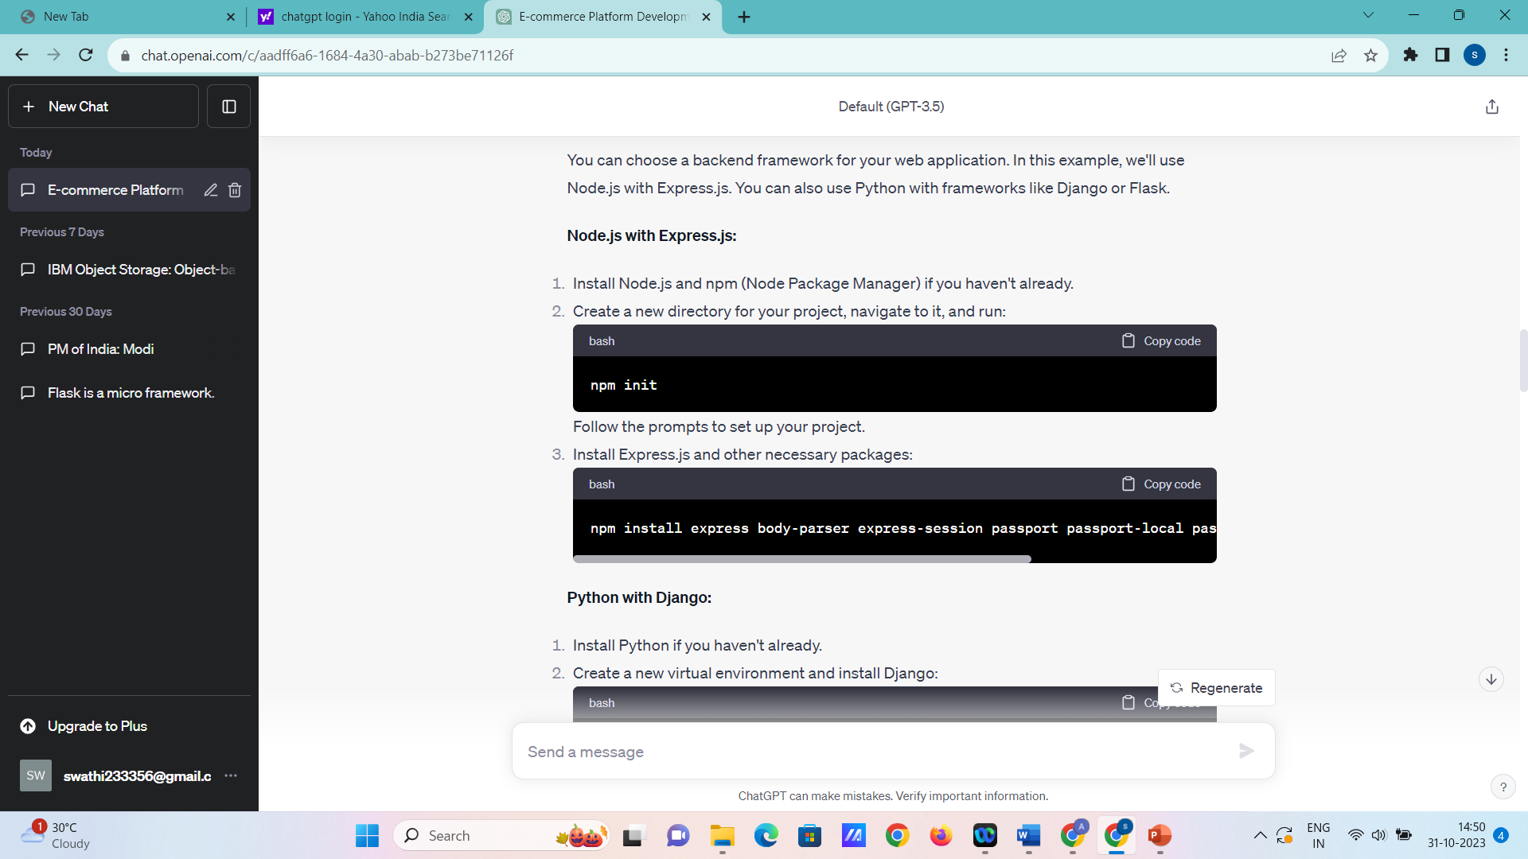

1. Install Express.js and other necessary packages:

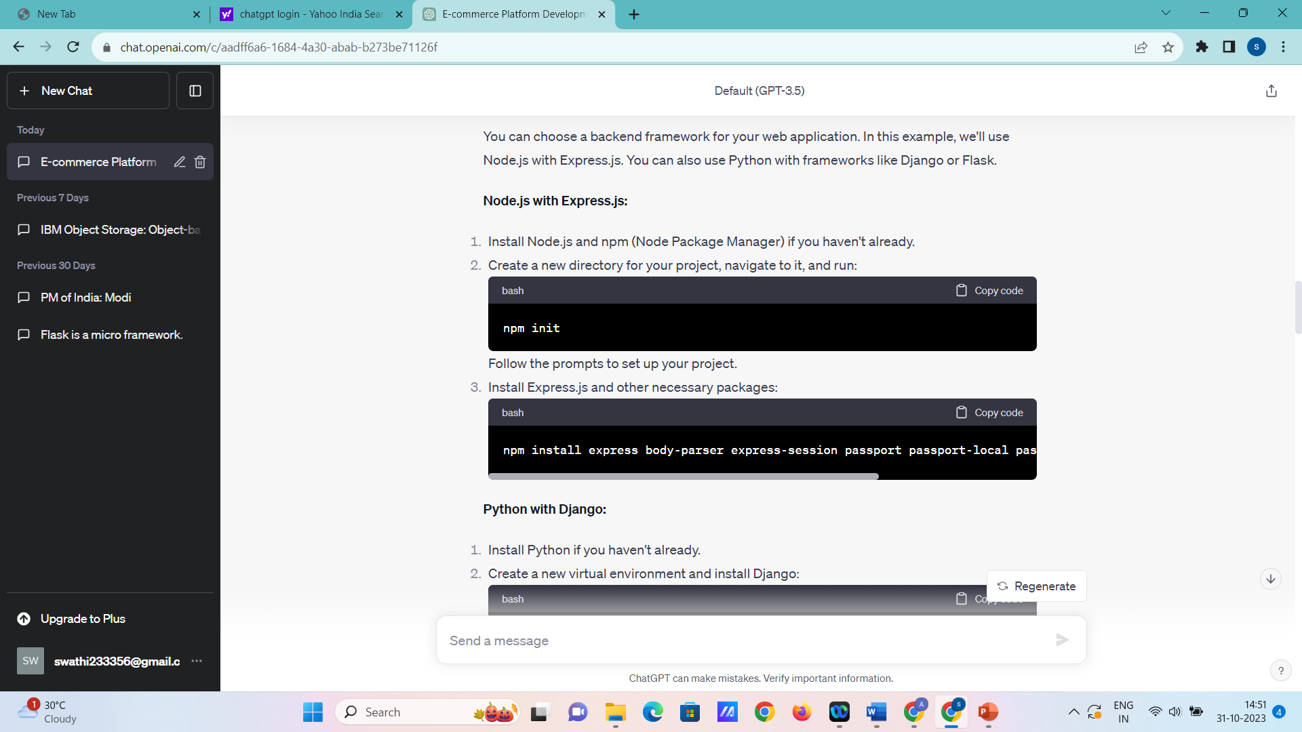mongoose

**Python with Django:**

1. Install Python if you haven't already.
2. Create a new virtual environment and install Django:

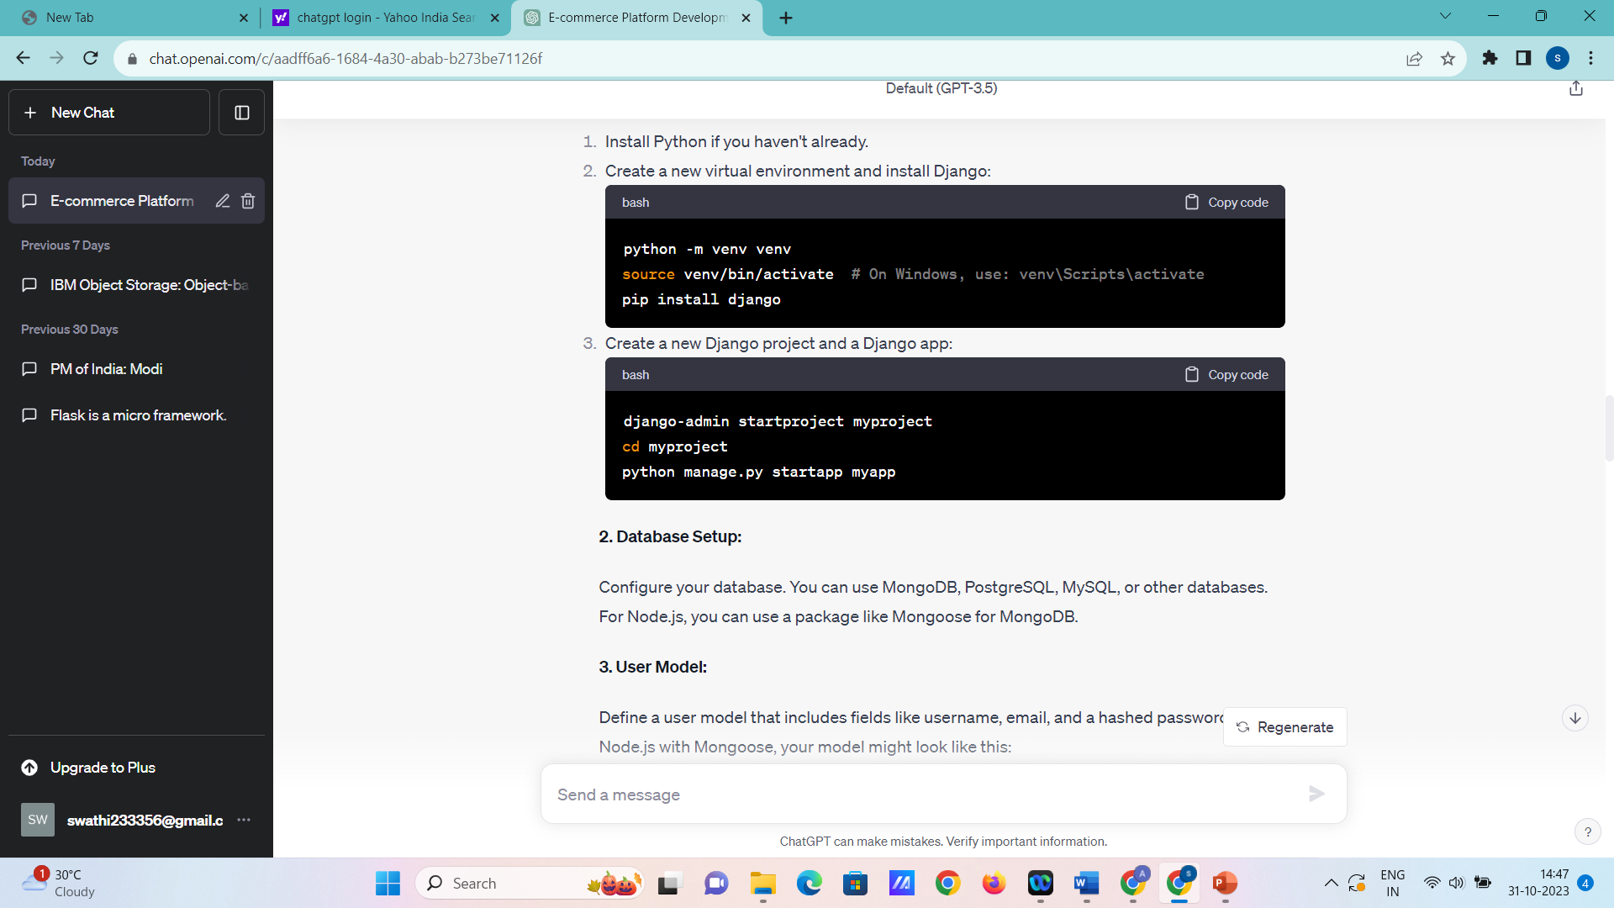

1. Create a new Django project and a Django app:

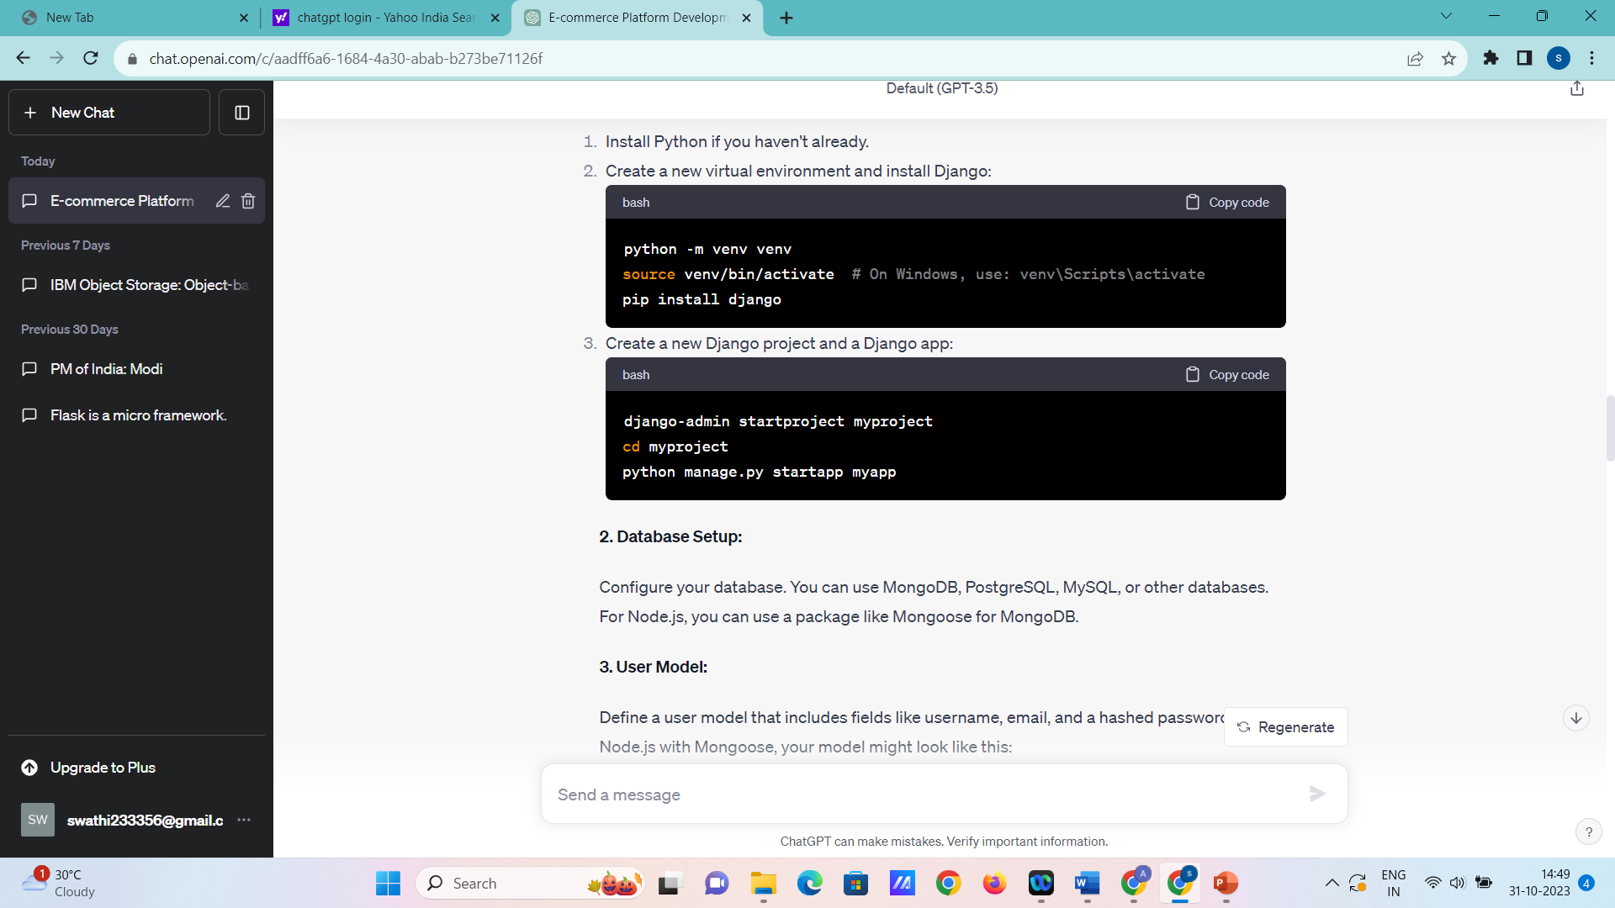

pp

**2. Database Setup:**

Configure your database. You can use MongoDB, PostgreSQL, MySQL, or other databases. For Node.js, you can use a package like Mongoose for MongoDB.

**3. User Model:**

Define a user model that includes fields like username, email, and a hashed password. In Node.js with Mongoose, your model might look like this:

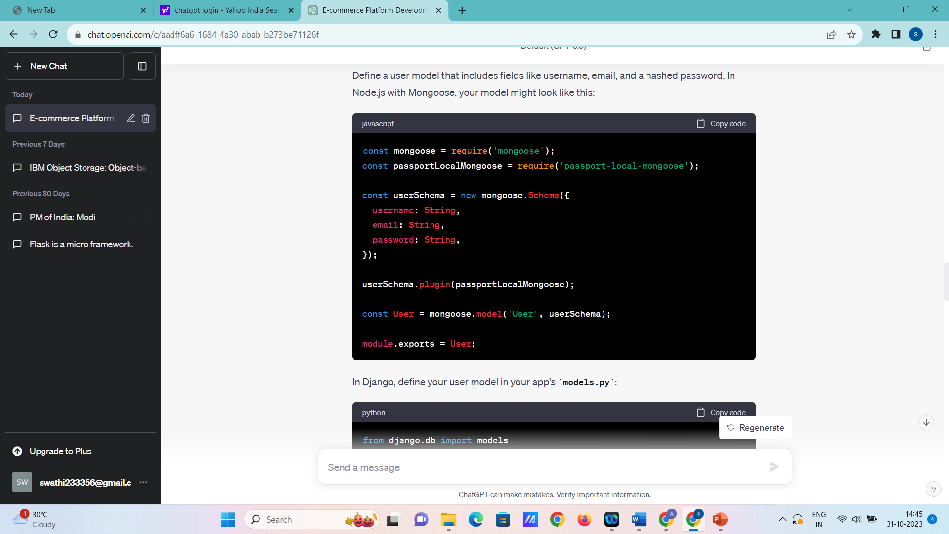

In Django, define your user model in your app's **models.py**:

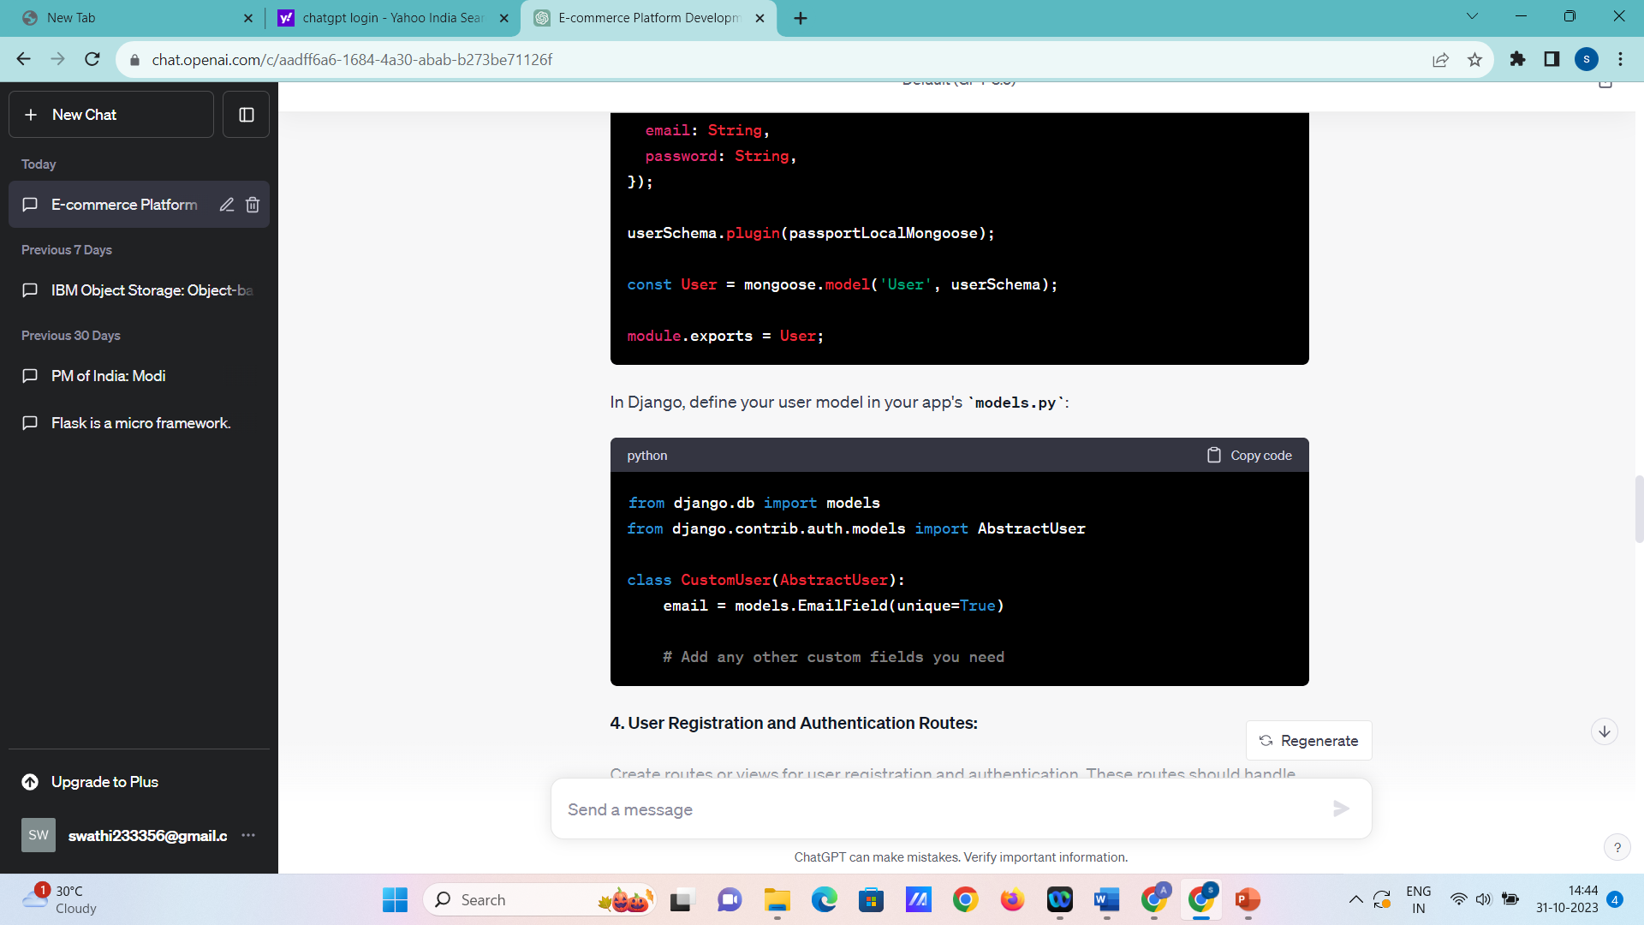

**4. User Registration and Authentication Routes:**

Create routes or views for user registration and authentication. These routes should handle user registration, login, and logout.

**Node.js with Express.js**

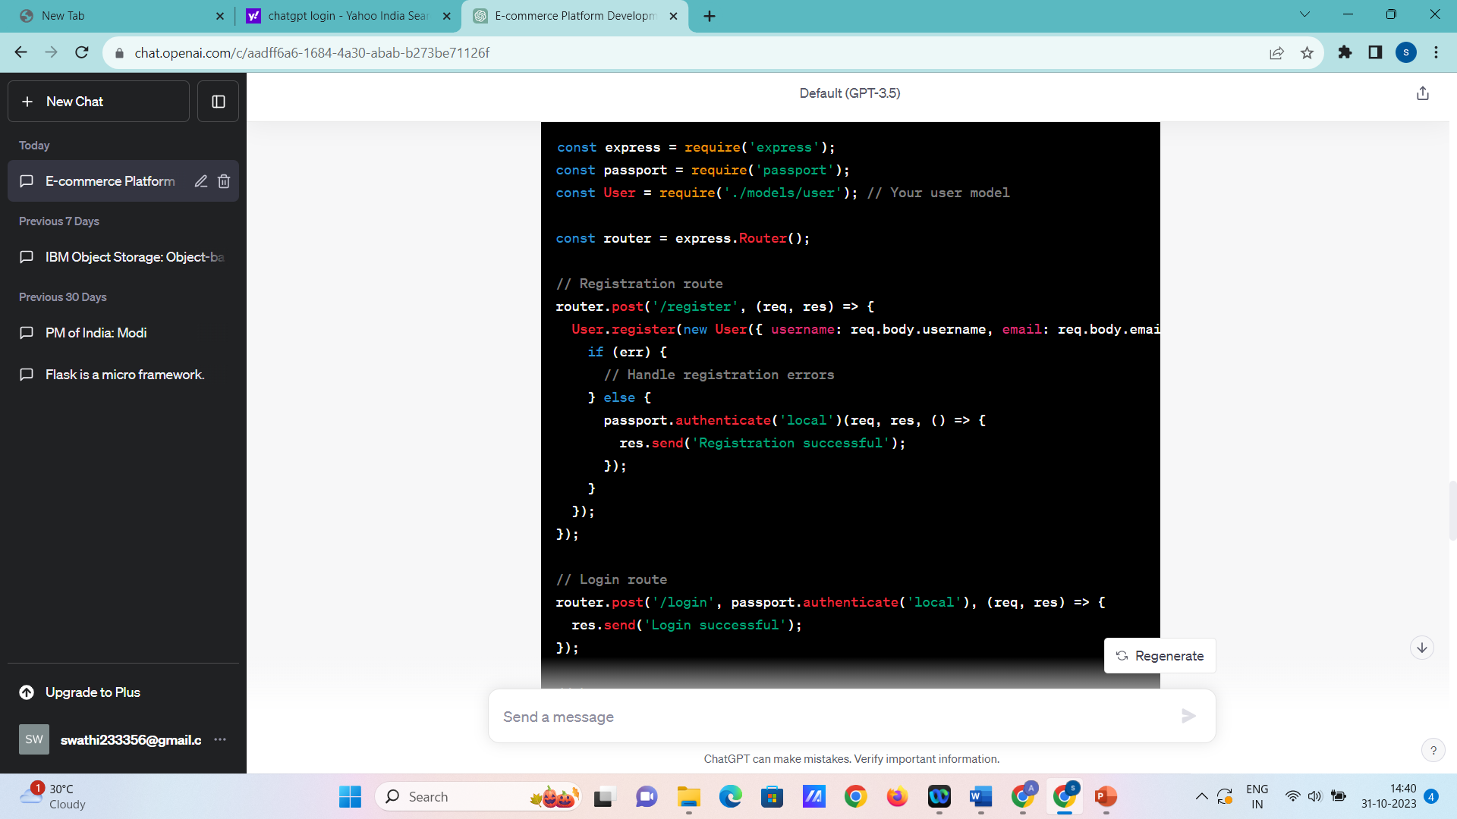

**Python with Django:**

In Django, you can use Django's built-in authentication views and forms for registration and login. You'll need to configure URLs and templates accordingly.

**5. Middleware and Passport (Node.js):**

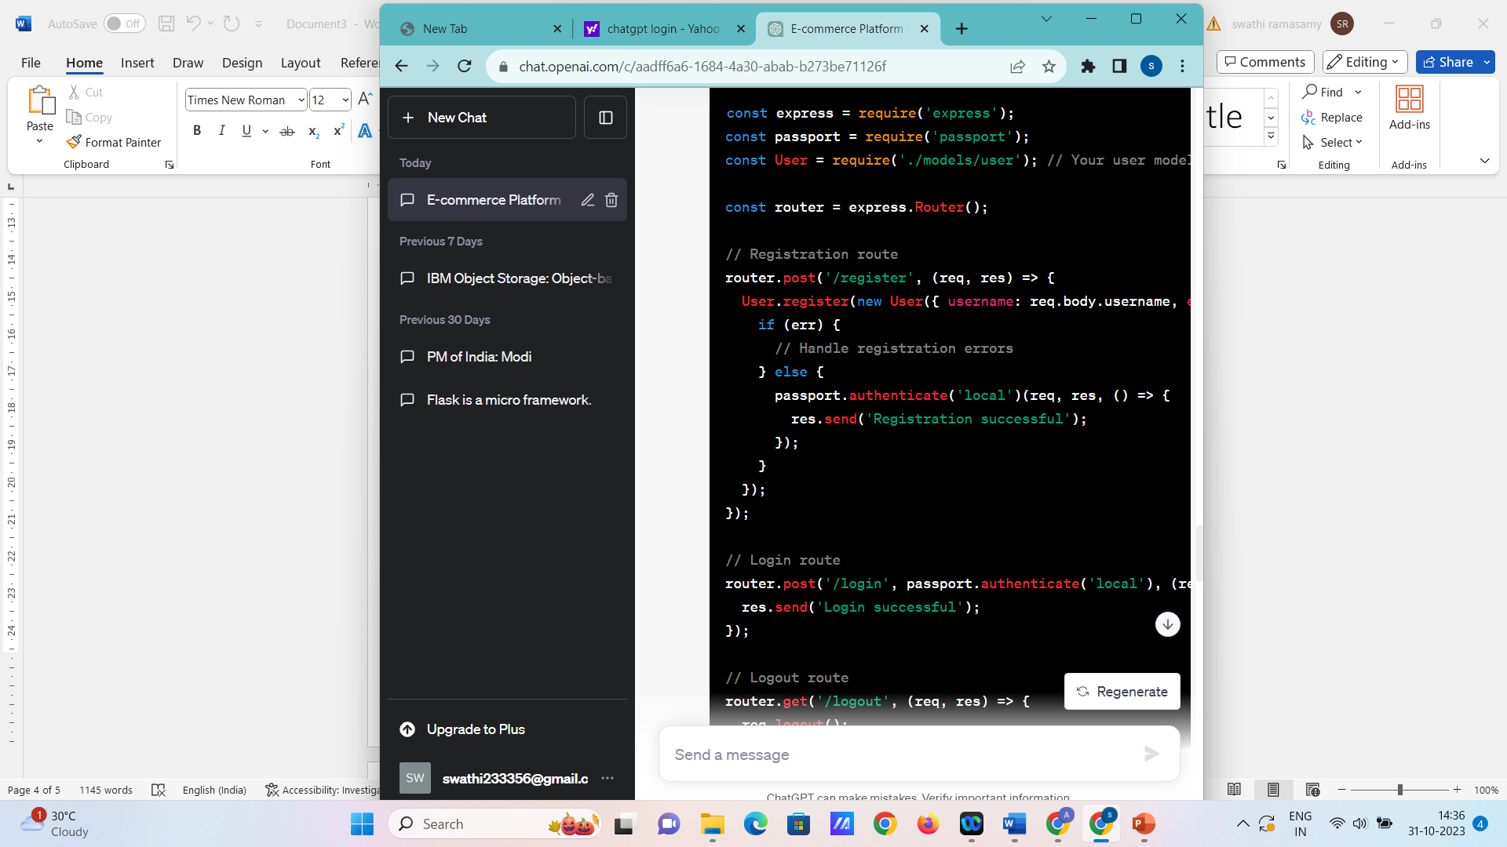

**6. Frontend Integration:**

Create registration and login forms on your frontend and connect them to your backend routes. You'll typically use AJAX, Fetch, or a frontend library like React, Angular, or Vue.js for this.

**7. Test and Secure:**

Thoroughly test your registration and authentication features to ensure they work as expected. Implement security features like rate limiting, input validation, and password policies to enhance security.

This is a simplified outline of setting up user registration and authentication using Node.js with Express.js or Python with Django. Depending on your specific requirements, you may need to expand on these steps and implement additional features such as email verification, password reset, and user profile management.

Top of Form

Implementing shopping cart functionality, calculating the total, and enabling a smooth checkout process is crucial for your e-commerce platform. Below are the steps to implement these features:

**1. Shopping Cart Functionality:**

Create the shopping cart functionality that allows users to add and manage items in their cart.

**Node.js with Express.js:**

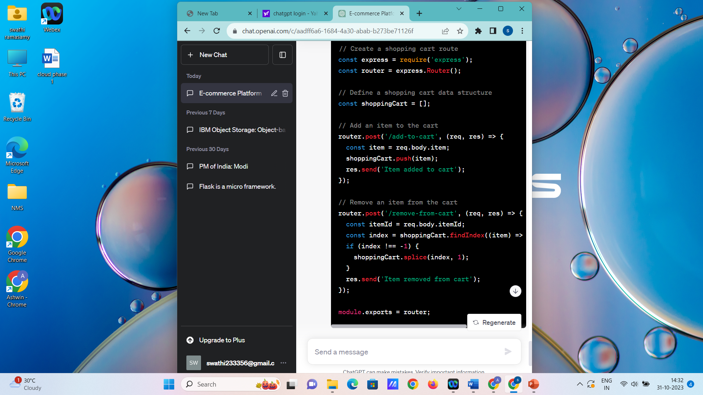

In a Python Django application, you would follow a similar pattern, creating views and routes for adding and removing items

done by:

V. VINUSHA

R. SWATHI

S. DEEPIKA