1.Implement an 8-puzzle problem using

i. DFS

goal = (1, 2, 3, 4, 5, 6, 7, 8, 0)

def dfs(state, depth, limit, path):
if state == goal:
return path

if depth == limit:
return None

zero = state.index(0)
row, col = zero // 3, zero % 3

moves = [(-1, 0), (1, 0), (0, -1), (0, 1)]

for dr, dc in moves:
r, c = row + dr, col + dc

if 0 <= r < 3 and 0 <= c < 3:
pos = r * 3 + c
new_state = list(state)

new_state[zero], new_state[pos] = (
new_state[pos], new_state[zero]
)

new_state = tuple(new_state)

if new_state not in path:
result = dfs(
new_state, depth + 1, limit,
path + [new_state]
)

if result:
return result

return None

start = tuple(map(int, input("Enter 9 numbers: ").split()))
limit = int(input("Enter depth limit: "))

solution = dfs(start, 0, limit, [start])

if solution:
print("Solution found:")
for state in solution:
for i in range(0, 9, 3):
print(state[i:i+3])
print()
else:
print("Solution not found within depth limit.")
Output:
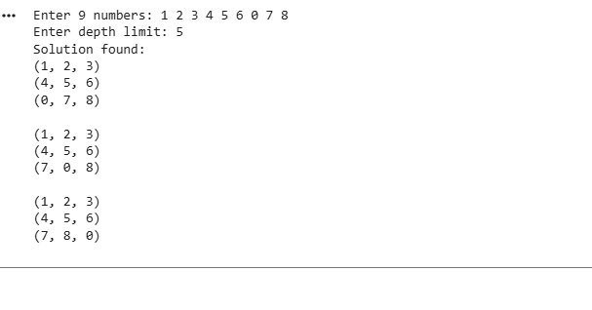
ii. Iterative deepening search (IDS) algorithm

goal = (1, 2, 3, 4, 5, 6, 7, 8, 0)

def dfs(state, limit, path):
if state == goal:
return path

if limit == 0:
return None

zero = state.index(0)
row, col = zero // 3, zero % 3

moves = [(-1, 0), (1, 0), (0, -1), (0, 1)]

for dr, dc in moves:
r, c = row + dr, col + dc

if 0 <= r < 3 and 0 <= c < 3:
pos = r * 3 + c
new_state = list(state)

new_state[zero], new_state[pos] = (
new_state[pos], new_state[zero]
)

new_state = tuple(new_state)

if new_state not in path:
result = dfs(
new_state, limit - 1, path + [new_state]
)

if result is not None:
return result

return None

def ids(start):
depth = 0

while True:
print("Trying depth:", depth)

result = dfs(start, depth, [start])

if result is not None:
return result

depth += 1

def display(solution):
for state in solution:
for i in range(0, 9, 3):
print(state[i:i + 3])
print()

start = tuple(map(int, input("Enter 9 numbers (0 for blank): ").split()))

solution = ids(start)

print("\nSolution found!")
print("Number of moves:", len(solution) - 1)
display(solution)
OUTPUT:
