SYNOPSIS

**Title: Covid19 Data Analysis**

**Introduction:**

The COVID-19 pandemic has profoundly impacted India, with diverse effects across its States and Union Territories. This project seeks to analyze COVID-19 data across these regions, examining key statistics such as total cases, active cases, recoveries, deaths, and population size. The dataset provides detailed insights into the severity and recovery trends through ratios like the active case ratio, discharge ratio, and death ratio, offering a comparative view of how different regions managed the pandemic. Additionally, the dataset includes a breakdown of COVID-19 deaths based on vaccination status—partially vaccinated, fully vaccinated, and unvaccinated—as well as age-group distributions (0–17, 18–59, and 60+), shedding light on the demographic impacts of COVID-19 on mortality.

By using Python and its robust data analysis libraries, including Pandas for data handling, Matplotlib for visualization, and Scikit-Learn for machine learning, this analysis aims to uncover trends and patterns in COVID-19 cases and deaths across India. These insights can be invaluable for public health decision-makers, helping them understand the pandemic's impact on different regions and demographic groups and informing strategies to enhance preparedness for future health crises.

**Objective:**

1. To analyze COVID-19 data across various States and Union Territories in India, focusing on total cases, active cases, recoveries, deaths, and vaccination impact.
2. To identify trends in COVID-19 spread, mortality, and recovery rates, highlighting differences among regions.
3. To assess the influence of population and vaccination status on COVID-19 outcomes.
4. To explore the distribution of COVID-19 fatalities by age group and vaccination status.
5. To visualize relationships between key variables to understand factors affecting COVID-19 recovery and mortality rates.

**Scope of Work:**

Data Exploration :

* Dataset Understanding: Familiarize with the COVID-19 dataset, which includes critical features such as total cases, active cases, recovered cases, deaths, and population by State and Union Territory. Also, explore vaccination details (partially, fully vaccinated deaths) and age-wise mortality distributions.
* Growth and Mortality Trends: Analyze the overall trends in cases, recoveries, and deaths across states to identify patterns in COVID-19 spread, response, and impact over time.

Data Preprocessing :

* Data Cleaning: Address missing or inconsistent data points, such as regions with incomplete records or abnormal values.
* Feature Engineering: Calculate additional features like active case ratio, discharge ratio, and death ratio for more detailed analysis. Also, calculate ratios of vaccination status for mortality cases and age-group distributions to better understand the demographics of COVID-19 mortality.
* Normalization and Scaling: Normalize and scale features like population and case ratios to facilitate comparison and improve model performance.

Data Visualization :

* Trend Analysis: Plot total cases, active cases, recoveries, and death ratios to observe trends across different regions. Visualize vaccination progress and its correlation with COVID-19 mortality rates to understand the impact of vaccination.
* Correlation Analysis: Use heatmaps and correlation matrices to explore relationships between variables, such as the impact of population and vaccination status on death ratios, and identify influential factors affecting COVID-19 outcomes.
* Age-wise and Vaccination-wise Mortality Visualizations: Create bar charts and pie charts to illustrate the age and vaccination distribution of COVID-19 fatalities across states.

Model Building (Optional) :

* Predictive Modeling: Build machine learning models, if applicable, to predict factors influencing recovery and mortality rates based on the dataset, including vaccination coverage, population, and age distribution data.

**Methodology:**

1. **Data Collection:**
   * 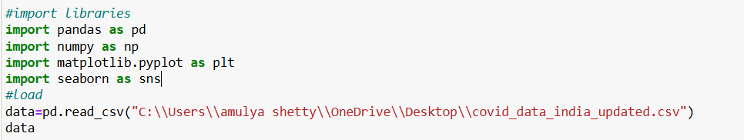Collect data from reliable sources such as Johns Hopkins University, WHO, or government databases (e.g., case numbers, vaccination rates).
2. **Data Preprocessing:**
   * Handle missing or erroneous data using techniques like forward filling or imputation.
   * Detect and remove outliers or inconsistent records.
   * Normalize data for model input (e.g., Min-Max scaling).

Handling missing values:

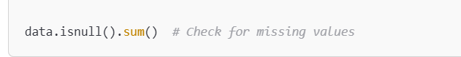

Feature Engineering:

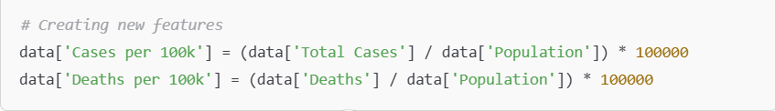

1. **Exploratory Data Analysis (EDA):**
   * Use descriptive statistics to summarize case trends and daily infection rates.
   * Visualize trends using line plots and bar charts for new cases, deaths, and recoveries.
   * Generate heatmaps to explore correlations between variables such as vaccination rates and infection trends.

Basic Information:

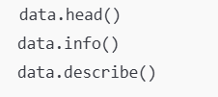

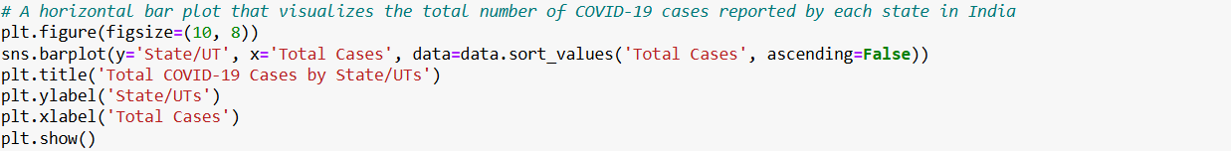Data Visualization:

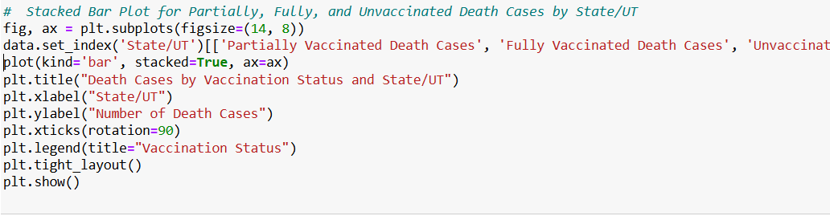

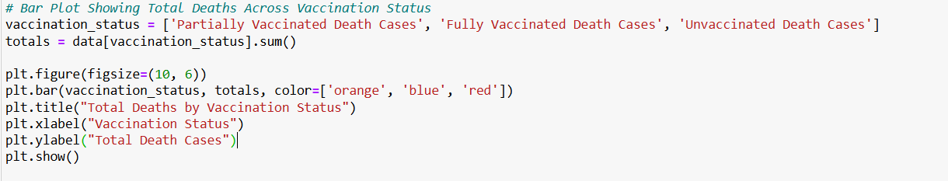

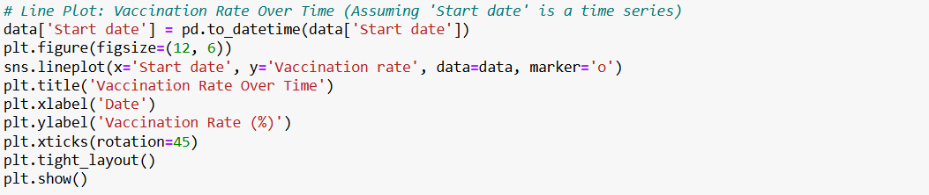

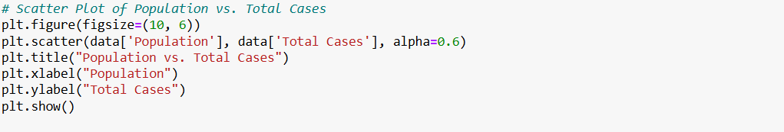

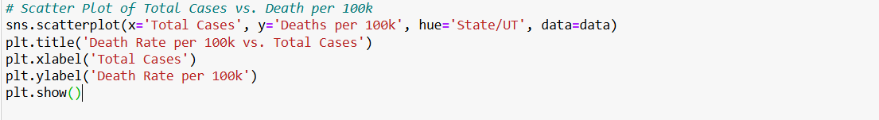

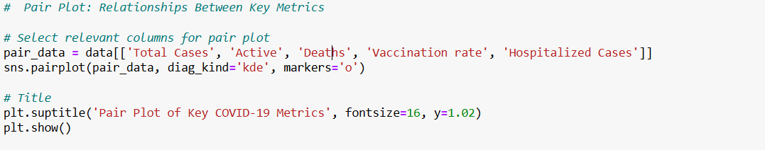

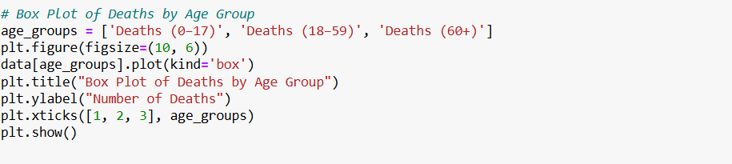

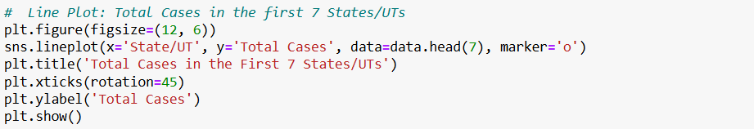

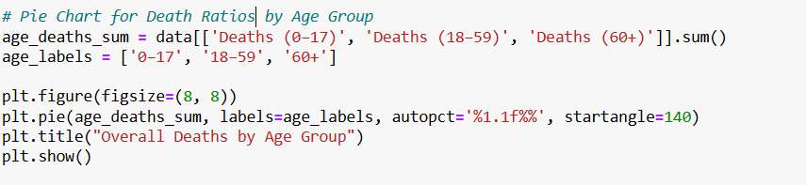



**4. Model Building**

* Linear Regression to predict Death Ratios:

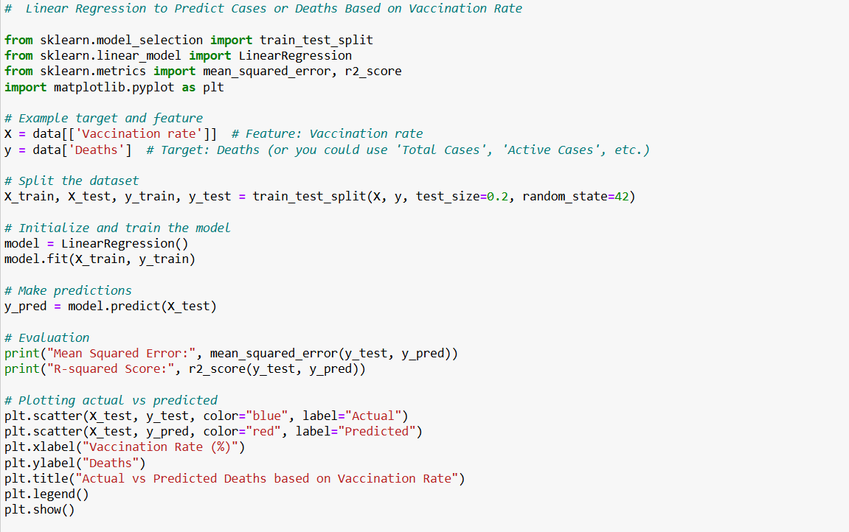

* 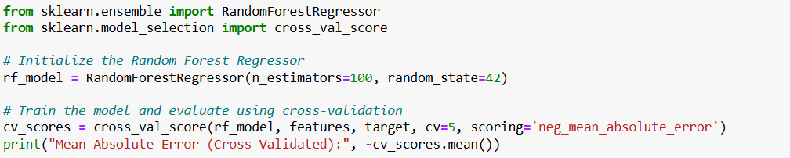Random Forest Regressor:

**Timeline**

Completed:

* Week 1: Data Collection and Preprocessing
* Week 2: Exploratory Data Analysis and Feature Selection
* Week 3: Model Building and Evaluation
* Week 4: Visualization, Reporting, and Final Submission

**Tools and Technologies:**

* **Programming Language:** Python
* **Libraries:** Pandas, NumPy, Matplotlib, Seaborn,
* **Data Source:** Dataset from Kaggle.
* **IDE:** Jupyter Notebook or Google Colab

**Conclusion:**

In this analysis, we examined COVID-19 data across various Indian states and Union Territories, focusing on case trends, mortality rates, recovery rates, and the impact of vaccination status and population demographics on COVID-19 outcomes. By exploring infection rates, age-wise mortality, and vaccination-based death distributions, we gained valuable insights into how COVID-19 affected different regions. Visualizations helped uncover correlations and highlight trends, showing that vaccination efforts played a significant role in reducing severe outcomes. Additionally, our findings underscore the importance of population demographics and healthcare responses in managing COVID-19 impacts across diverse regions. This analysis not only enhances our understanding of COVID-19 trends in India but also provides insights that can support future decision-making in public health and pandemic preparedness.