An Advanced News Classification System Using Natural Language Processing and Machine Learning
ABSTRACT
In recent years, with the rapid advancement of Artificial Intelligence (AI), machines have demonstrated superior judgment compared to humans in many domains. In this study, AI is leveraged to train a computer model to classify news articles based on their content efficiently. The system ensures that when a news category is unmarked or flagged incorrectly, the model can automatically categorize it accurately, significantly reducing human effort, cost, and processing time.Furthermore, this approach enables the development of an automated news classification system for social networks. The system is designed to classify news articles from multiple sources and social media platforms, improving information organization and accessibility. To achieve this, we incorporated web crawling, data preprocessing, Jieba (a Chinese word segmentation tool), and Natural Language Processing (NLP) for model training.
After multiple training iterations with a large dataset, the experimental results demonstrate a high classification accuracy of 97.43%. This AI-powered system not only enhances news categorization efficiency but also plays a crucial role in combating misinformation by ensuring that content is correctly classified and analyzed. Additionally, this model can be further optimized and integrated into various news aggregation platforms to improve personalized news recommendations and content filtering.
Existing System | Proposed System
- The existing system relies on manual summarization or rule-based algorithms, which are time-consuming and often fail to capture the essence of complex texts. Traditional extractive methods use TF-IDF (Term Frequency-Inverse Document Frequency) and TextRank, which select key sentences based on word importance but lack contextual understanding. Abstractive summarization, which generates new sentences, has been limited due to computational constraints and the complexity of language processing.  - Additionally, existing systems often lack scalability, automation, and real-time processing, making them inefficient for handling large volumes of data. Many conventional approaches also struggle with handling diverse writing styles, context variations, and domain-specific terminology, reducing the overall accuracy of summaries. | - The proposed system utilizes Natural Language Processing (NLP) and Machine Learning to create an efficient, automated text summarization tool. It incorporates extractive and abstractive summarization techniques, leveraging deep learning models like BERT, T5, or GPT-based architectures for better contextual understanding. Preprocessing techniques such as tokenization, stopword removal, and named entity recognition (NER) are applied to refine input text before summarization.  - The system is built using Flask, allowing a lightweight and scalable web application for seamless user interaction. It integrates Python libraries such as NLTK, spaCy, and Hugging Face Transformers to enhance text processing and summarization accuracy. Users can input text or upload documents, and the model will generate concise, meaningful summaries in real-time.
Traditional Text Summarization | NLP-Natural Language Processing
- Traditional text summarization approaches are rule-based or statistical methods designed to generate concise summaries from large texts. These approaches rely on predefined linguistic rules, word frequency analysis, and graph-based ranking techniques to extract or generate key information. They are primarily classified into extractive summarization and abstractive summarization. Extractive summarization selects the most important sentences directly from the original text using techniques such as TF-IDF (Term Frequency-Inverse Document Frequency), TextRank, and Latent Semantic Analysis (LSA). These methods rank sentences based on their relevance but often result in summaries that may lack coherence.  - On the other hand, abstractive summarization attempts to generate new sentences that convey the core meaning of the original text. This approach relies on rule-based templates, synonym replacement, and sentence compression to produce more concise summaries. However, traditional abstractive methods struggle with complex sentence structures, flexibility, and contextual accuracy, often leading to summaries that sound unnatural. Unlike modern deep learning models, these methods do not truly "understand" the context of the text, limiting their effectiveness in generating high-quality summaries. | - A Natural Language Processing (NLP) algorithm is a computational method designed to analyze, understand, and generate human language. NLP algorithms leverage techniques from linguistics, machine learning, and deep learning to process text and speech data. These algorithms help computers perform various language-related tasks such as text summarization, sentiment analysis, machine translation, speech recognition, and chatbot interactions.  - NLP algorithms can be broadly categorized into rule-based, statistical, and deep learning-based approaches. Rule-based NLP uses predefined grammatical and syntactical rules to process text but lacks adaptability. Statistical NLP applies probabilistic models like Hidden Markov Models (HMMs) and Naïve Bayes to make predictions based on linguistic patterns. Modern deep learning-based NLP employs transformers (BERT, GPT, T5) and recurrent neural networks (RNNs, LSTMs) for advanced text understanding, enabling context-aware and human-like language processing.
Disadvantages:  - Lack of Contextual Understanding  - Inefficient for Large Datasets  - No Semantic Understanding | Advantages:  - Automates Text Processing  - Enhances Communication  - Enables Sentiment Analysis

System architecture
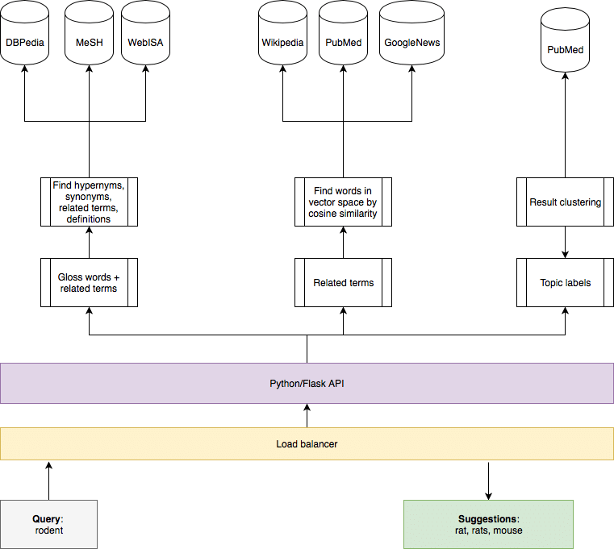

HARDWARE AND SOFTWARE REQUIREMENTS
Hardware requirements:
Processer : Any Update Processer
Ram : Min 4 GB
Hard Disk : Min 100 GB

Software requirements:
Operating System : Windows family
Technology : Python
IDE : Spyder

