**ShopNest Store Sales Data Analysis**

**Question/Task1 : Top categories by Total Sales**

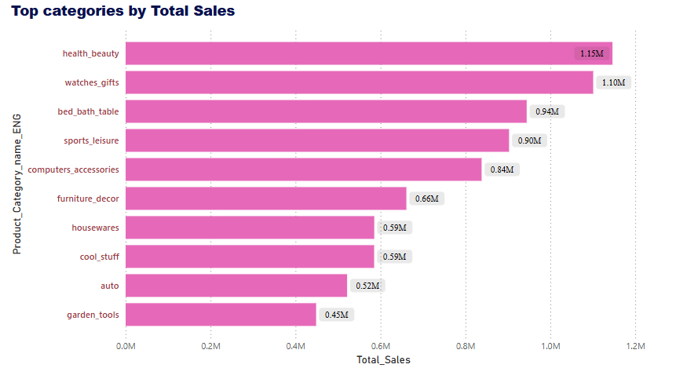

**Summary :**

* At 1,146,175.07, health_beauty had the highest Total_Sales and was 155.58% higher than garden_tools, which had the lowest Total_Sales at 448,464.20.﻿﻿ ﻿﻿
* H﻿ealth_beauty accounted for 14.82% of Total_Sales.﻿﻿ ﻿﻿ ﻿﻿
* Second highest with close to first highest is watches_gifts with total sales of 1,205,005.68.
* Second lowest is auto with total sales of 592,720.11.
* Across all 10 Product Categories, Total_Sales ranged from 448,464.20 to 1,146,175.07.﻿﻿ ﻿﻿ ﻿

**Question/Task 2: Delayed Order Analysis**

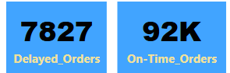

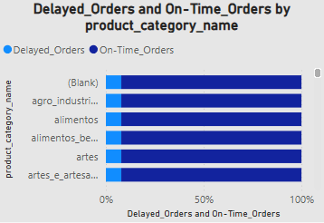

**Summary :**

* Total Delayed Orders count is 7827.
* Total On-Time orders were 91,614.

**Question/Task 3: Monthly Comparison of Delayed Order Analysis**

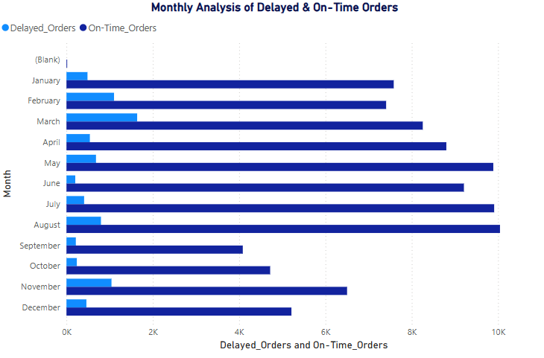

**Summary :**

* March had the highest Delayed_Orders of 1638 and was 702.94% higher than June, which had the lowest Delayed_Orders at 204.﻿﻿ ﻿﻿
* ﻿﻿March accounted for 20.93% of Delayed_Orders.﻿﻿ ﻿﻿ ﻿﻿
* On-Time_Orders and Delayed_Orders diverged the most when the Month was July, when On-Time_Orders were 9500 higher than Delayed_Orders.﻿﻿ ﻿﻿ ﻿

**Question/Task 4: Payment Method Analysis**

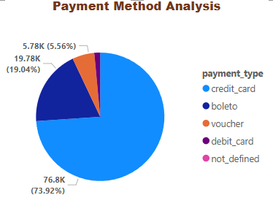

**Summary :**

* Credit card was the highest used payment method with total of 76795 and was 73.92% while not defined is 3(lowest).
* Boleto accounted for 19,784 (19.04%).
* Voucher was total of 5,775 (5.56%).
* Debit card with 1,529 and was 1.47%.
* Not defined may refer to cash on delivery payments, etc and is the least, second lowest is debit card.
* Payment method ranges 76795(highest) to 3(lowest).

**Question/Task 5 : Product Rating Analysis**

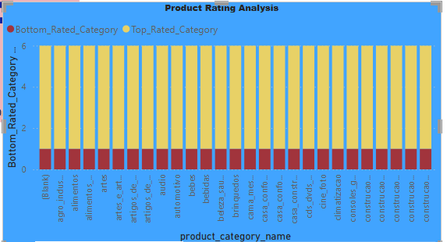

**Summary :**

* Review score 5 total count is 57420.
* Review score 1 total count is 11858.
* Top rated products and bottom rated products are

**Question/Task 6 : State wise Sales Analysis**

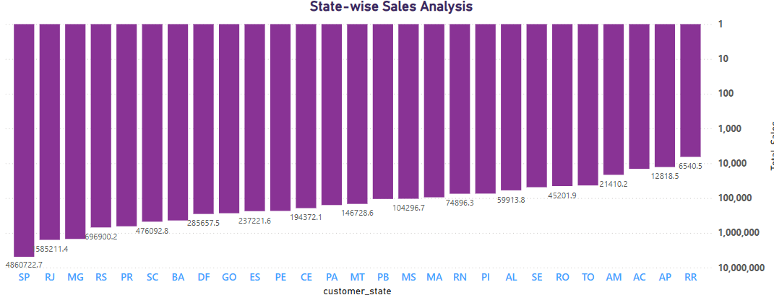

**Summary :**

* SP had the highest Total_Sales of 4,860,722.65 and was 74,216.84% higher than RR, which had the lowest Total_Sales at 6,540.54.﻿﻿ ﻿﻿ ﻿﻿
* ﻿﻿SP accounted for 39.10% of Total_Sales.﻿﻿ ﻿﻿ ﻿﻿
* Across all 27 customer_state, Total_Sales ranged from 6,540.54 to 4,860,722.65.﻿﻿ ﻿﻿

**Question/Task 7: Seasonal Sales Pattern**

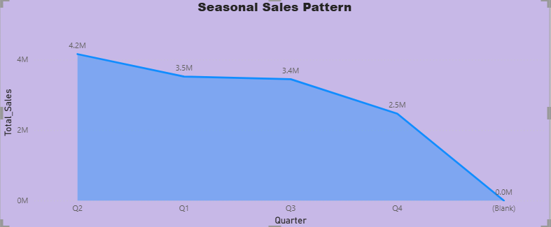

**Summary** **:**

* Q2 had the highest Total Sales at 4,157,326.71, followed by Q3, Q1, and Q4.﻿﻿ ﻿﻿
* Q2 accounted for 30.59% of Total_Sales.
* Q3 accounted for 3,446,878.37 in Total Sales.
* Q1 had 3,519,382.70 in Total Sales.
* Q4 had the lowest Total Sales﻿ at 2,467,923.53.
* Across all 4 Quarters, Total_Sales ranged from 2,467,923.53 to 4,157,326.71.

**Question/Task 8: Yearly Revenue Analysis**

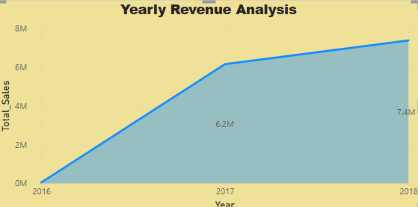

**Summary** **:**

* At 7,386,050.80, 2018 had the highest Total_Sales whereas 2016 had the lowest Total_Sales at 49653.53.
* ﻿﻿﻿2018 had the highest Total_Sales at 7,386,050.80, followed by 2017, 2016.﻿﻿
* 2017 accounted for 6,155,806.98 in Total Sales.
* ﻿﻿2018 accounted for 54.34% of Total_Sales.﻿﻿ ﻿﻿
* ﻿﻿Across all 3 Years, Total_Sales ranged from 49653.53 to 7,386,050.80.﻿﻿ ﻿﻿ ﻿