1. **Cd**
2. **Cd /**
3. **Cd ..**
4. **Ls -l**
5. **Pwd**
6. **Whoami**
7. **Ls -ltr -- newly created at the bottom**
8. **Touch vinu1 vinu2 vinu3 -- we can also create file through cp and vi commands.**
9. **Cp -R config /temp/config-backup -- -R recursive define subdirectories and subfiles within directories.**
10. **Find . -name “vinuth” – in a current directories**
11. **Find / -name “ifcfg-enpso3”**
12. **Touch abc{1..9}-xyz**
13. **Ls -l abc\***
14. **Rm *xyz**
15. **Ls -l ?xyz\***
16. **Ls -l *[cd]\***
17. 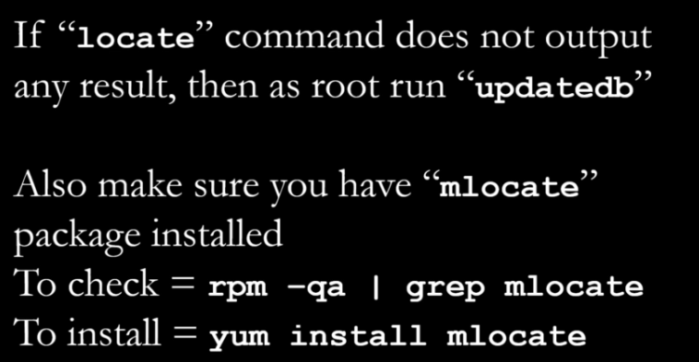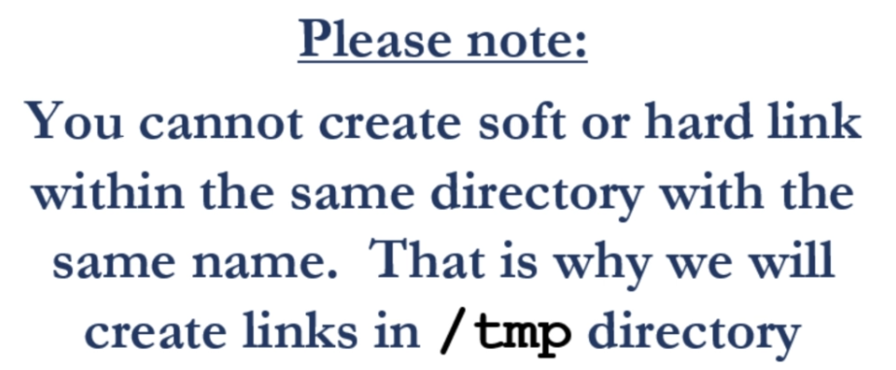
18. 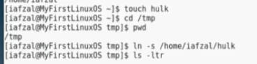
19. **Ls -li or ls -ltri to know the inode number**
20. 