SQL Assignment 4

DATA Model 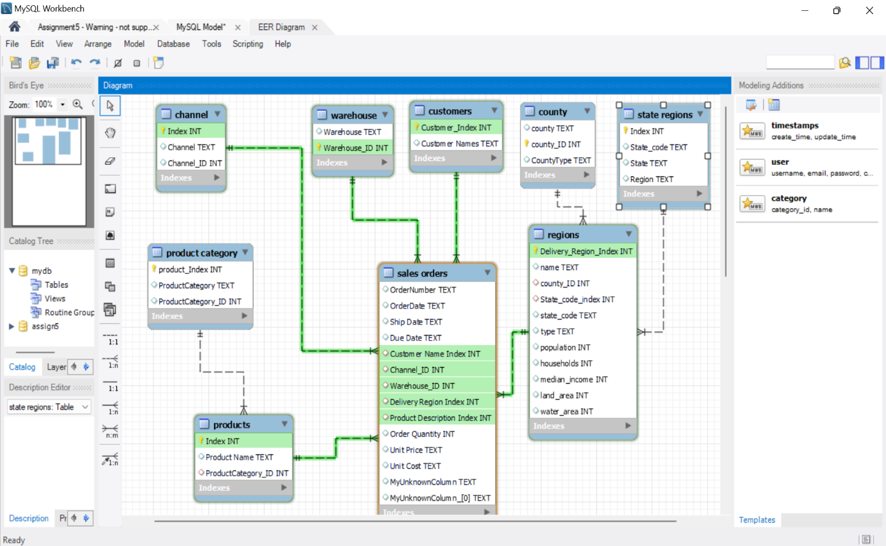

1. Top 5 Product category in terms of product Category 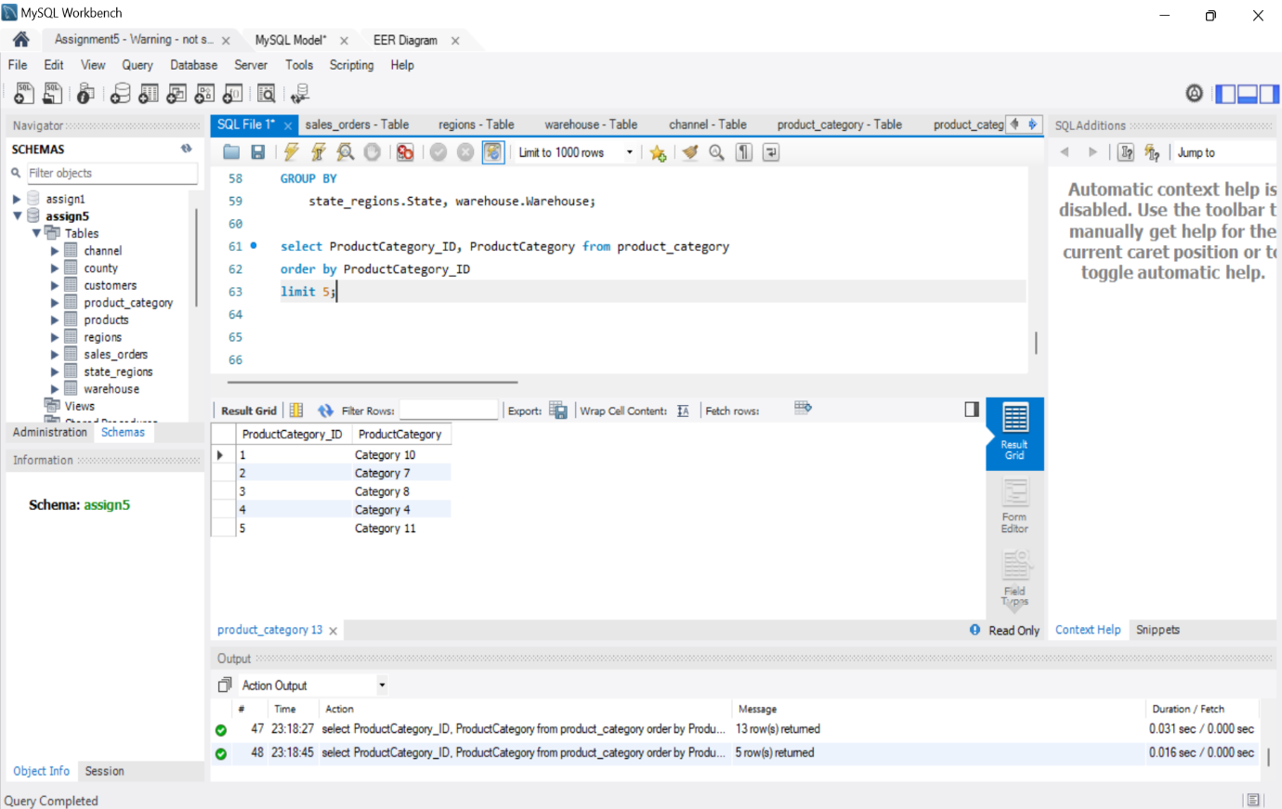

1. Arrange Total sales of customers in descending order, also display their respective county 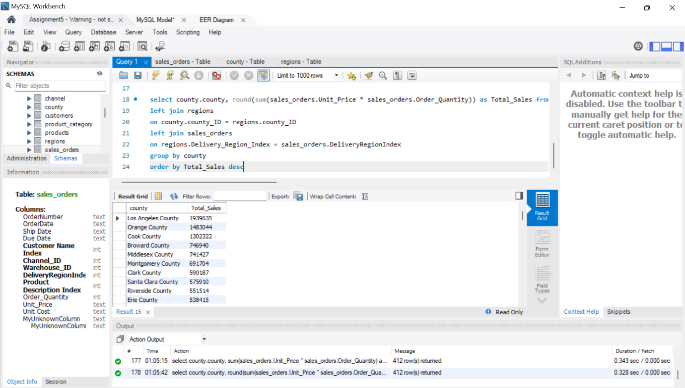
2. What is Per capita income of each state and try to find total sales for each state as well in the same table 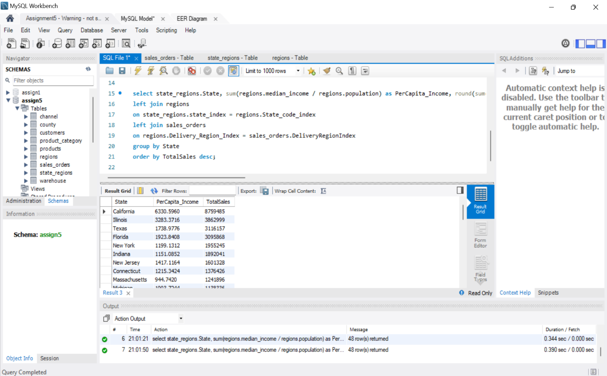
3. Each product sales and cost and display their respective warehouse 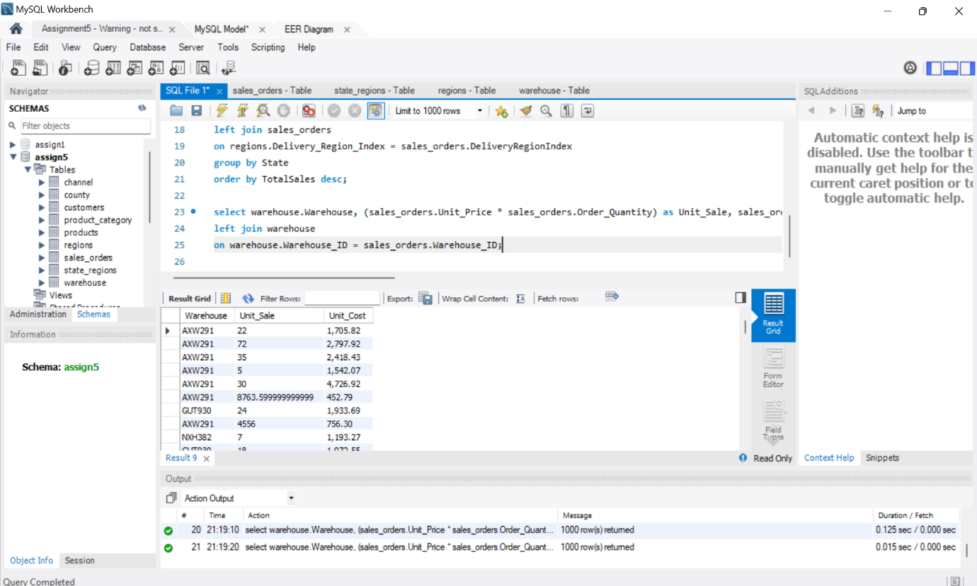
4. Find out any useful information of your own and retrieve the data(Minimum 3 joins to be performed) 