Smarter Banking Modification Output

In below screen we have added extra module for users to submit loan application and this application will review by admin by using AADHAR or PAN no and then update status as Accepted or Rejected. Each loan application will be associated with unique ID. In below screen we are showing modified output. User can interact with Chatbot to take desired details regarding loan and then apply

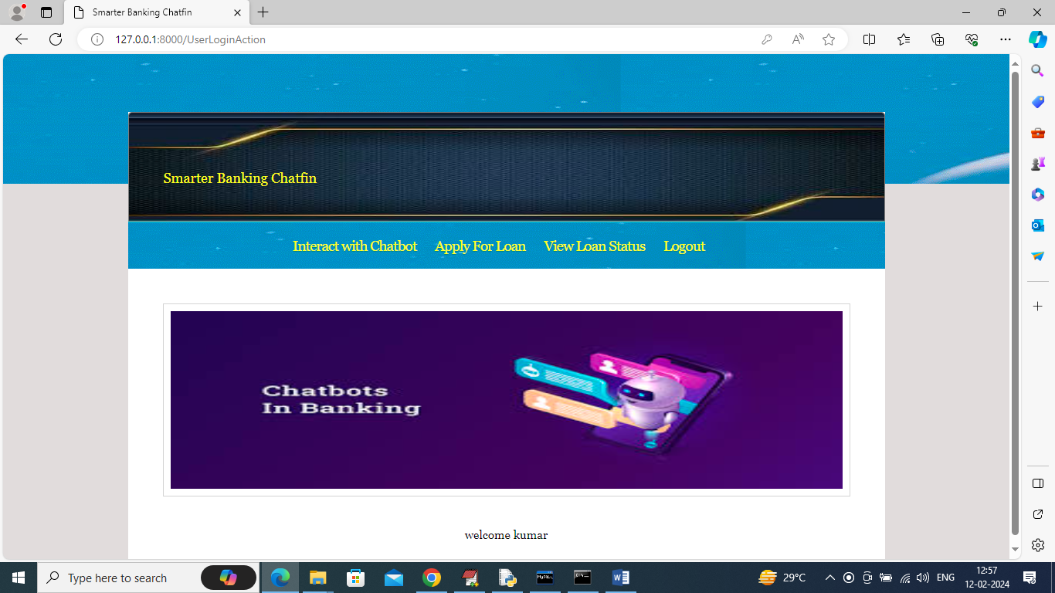

In above screen click on ‘Apply For Loan’ link to get below page

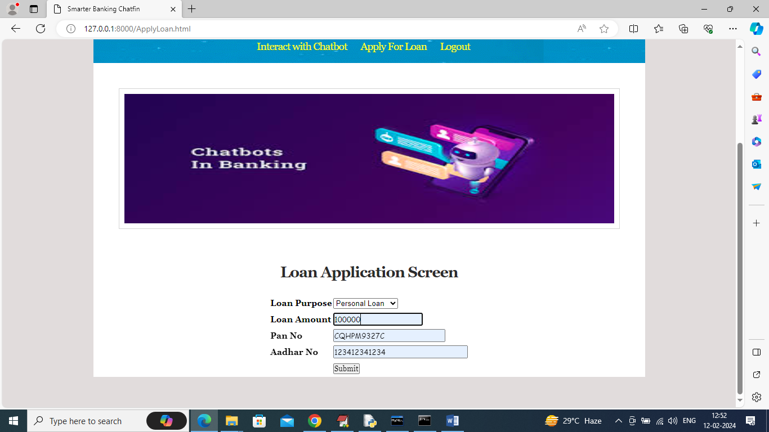

In above screen user can enter require loan details and then press button to submit loan and get below page

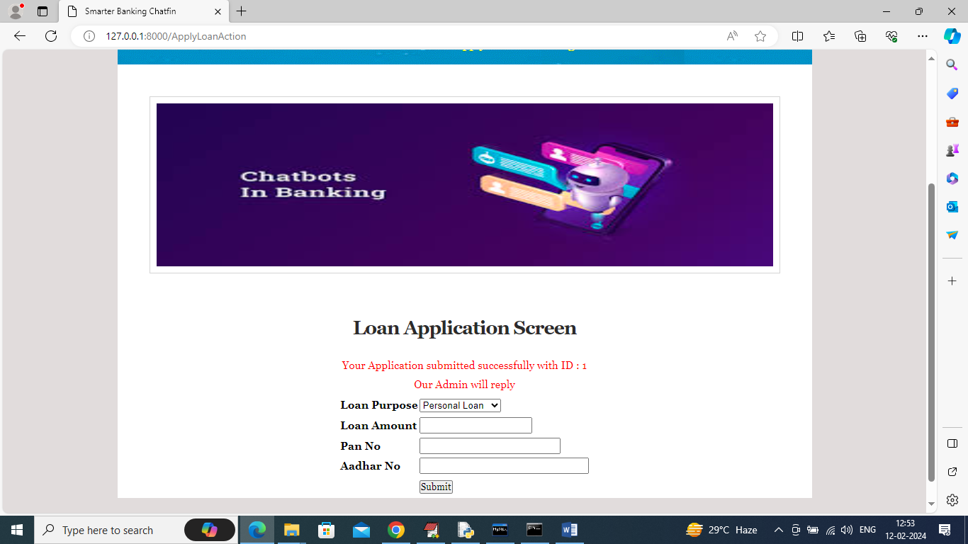

In above screen displaying application status and now click on ‘View Status’ link to get below status details

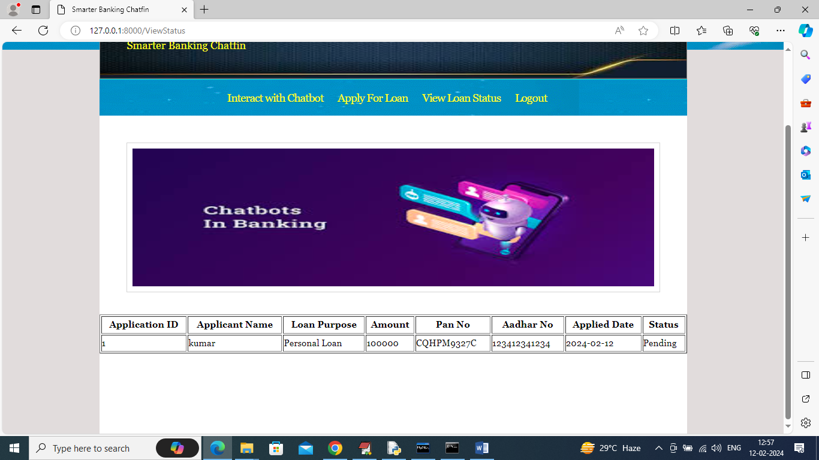

In above screen application status is Pending and now login as admin and then update status

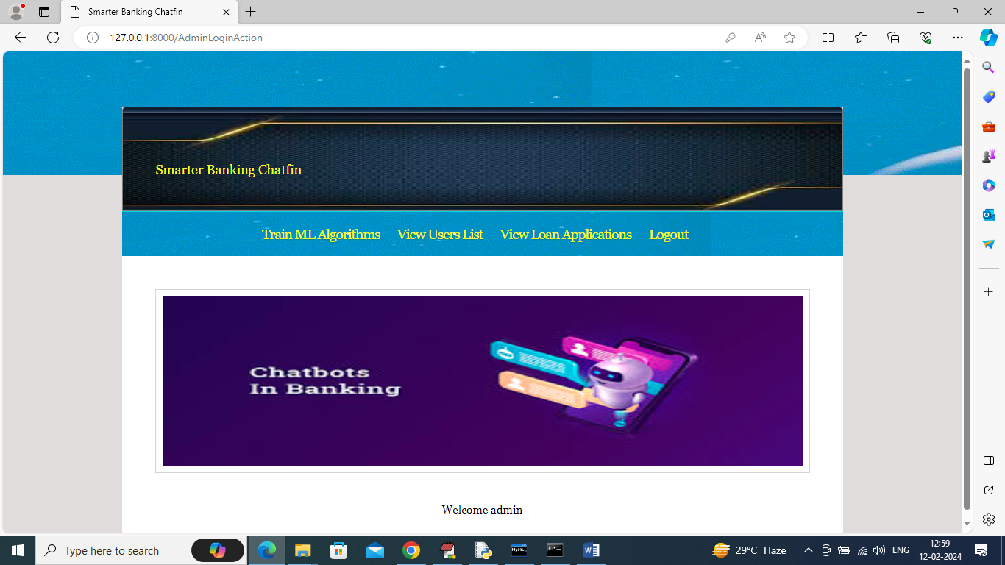

In above screen admin can click on ‘View Loan Applications’ link to get below page

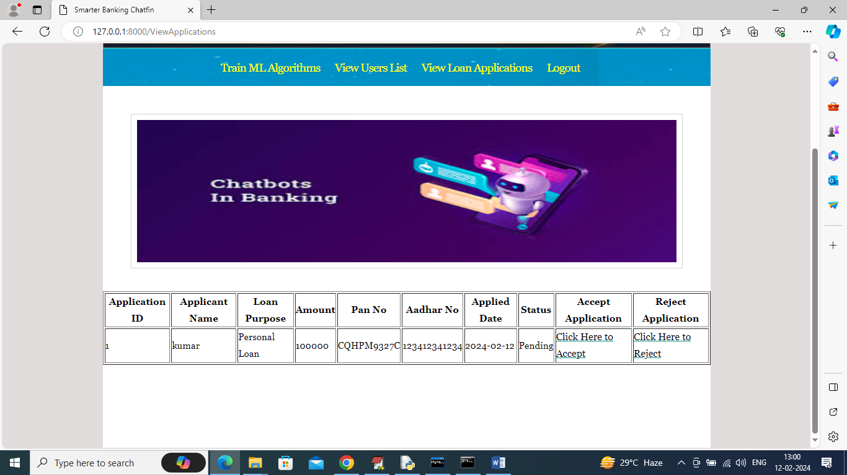

In above screen admin will review all details and then click on either ‘Click Here to Accept’ or ‘Click Here to Reject’ link to accept or reject loan and now clicking on ‘Accept’ link to get below page

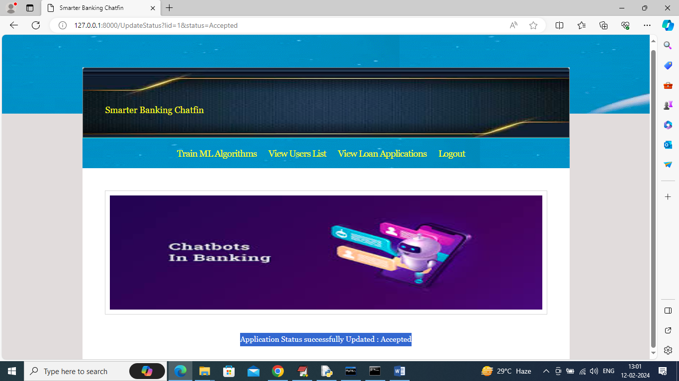

In above screen can see loan status updated to accepted and now user can login and view status

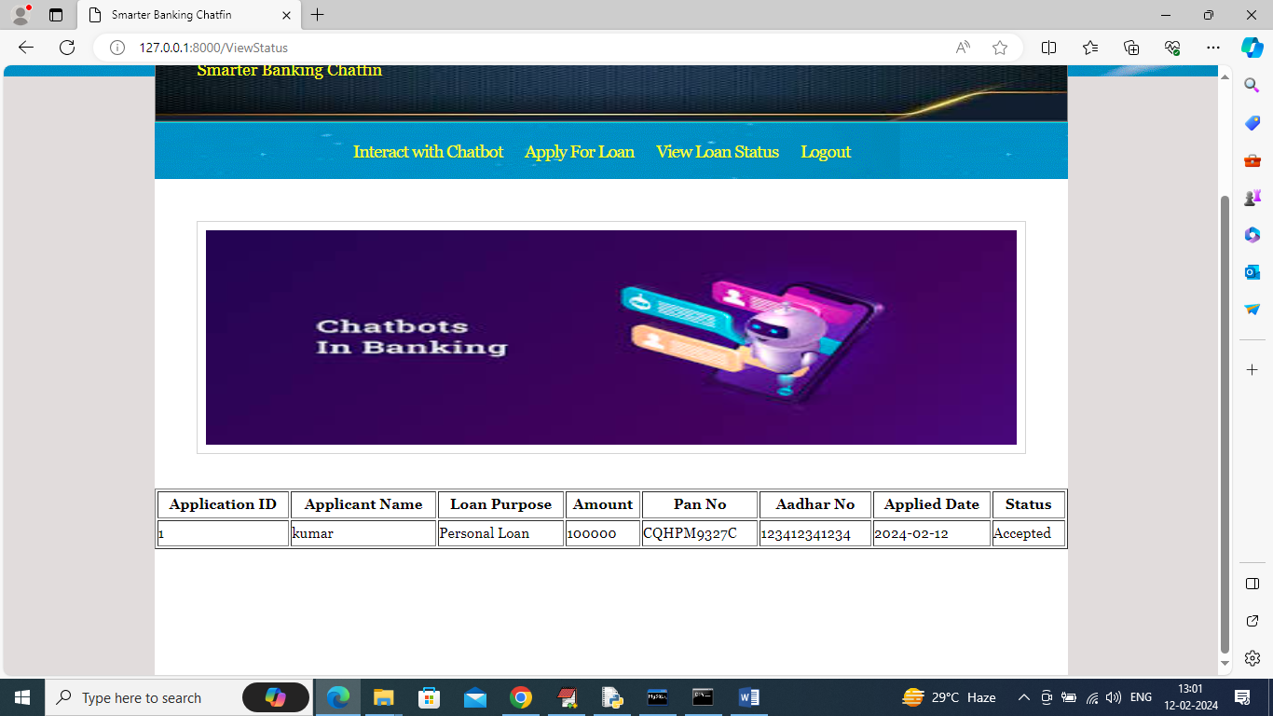

In above screen user can see Loan status as ‘Accepted’.

Similarly by following above screens you can apply for loans also