Smarter Banking Chatfin

In this project we have employed Artificial Intelligence technique to process text data and then employ machine learning algorithms to predict answers for user questions. Chatbot will take user queries and then employ ML algorithm to predict answer and then this answer will be given as output to the user.

To get accurate answer we have evaluate performance of multiple algorithms like Random Forest, KNN and SVM. In all algorithms Random Forest is giving best accuracy.

To train above algorithms we have utilized banking question and answers dataset showing in below screen

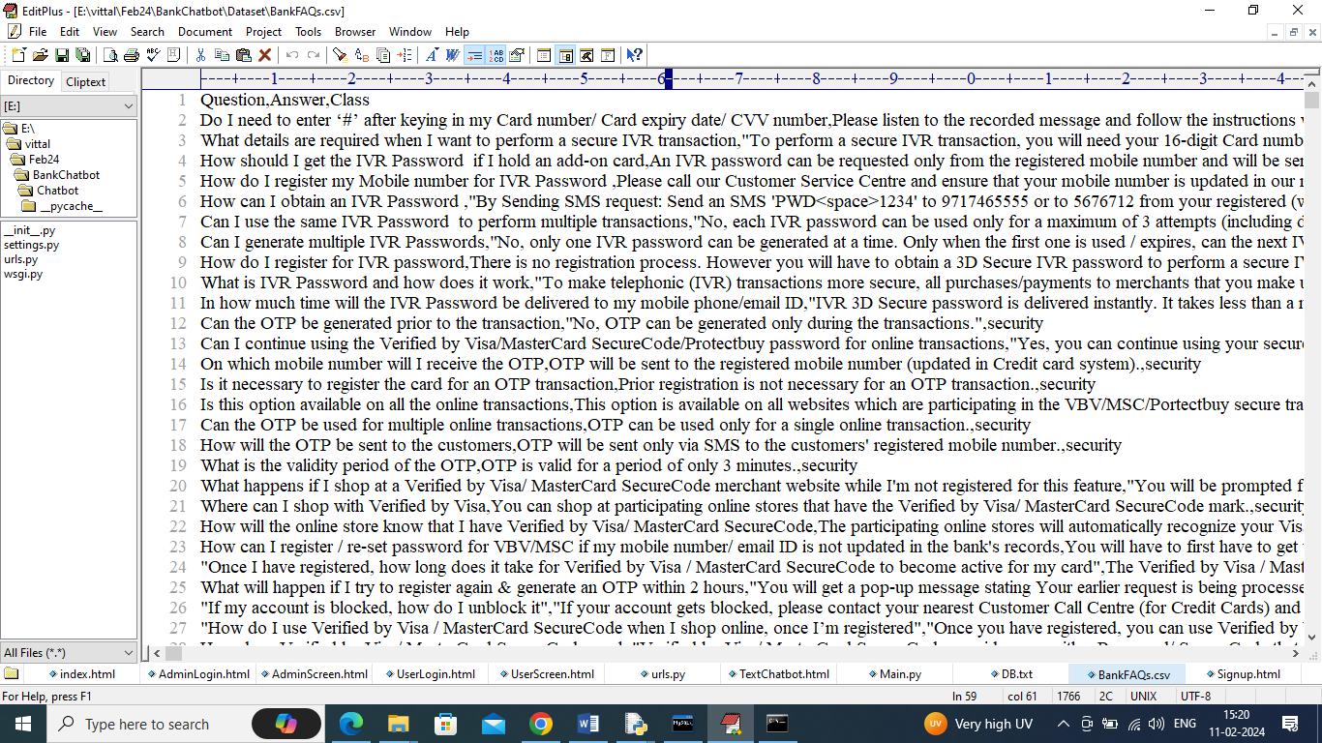

In above dataset we have questions and answers and Chatbot will get trained using above dataset to predict answers for users questions.

To implement this project we have designed following modules

1. Admin Login: using this module admin can login to system using username and password as ‘admin’ and then can train ML algorithms. Admin can view list of sign up users and can view all interaction between all users and Chatbot.
2. New user sign up: using this module user can sign up with the application
3. User Login: registered user can login to system
4. Interact with Chatbot: using this module user can communicate with Chatbot.

SCREEN SHOTS

To run project install MYSQL and then install python 3.7 and then copy content from DB.txt file and paste in MYSQL console to create database.

Double click on run.bat file to start python web server and then will get below page

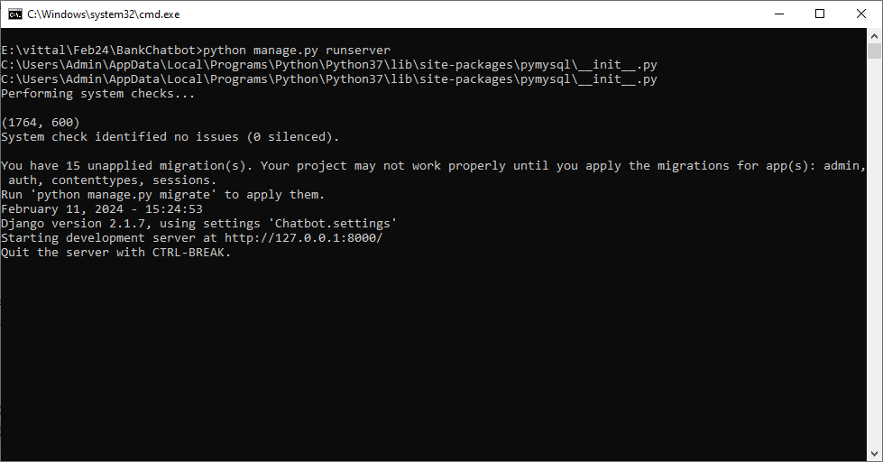

In above screen python server started and now open browser and then enter URL as <http://127.0.0.1:8000/index.html> and then press enter key to get below page

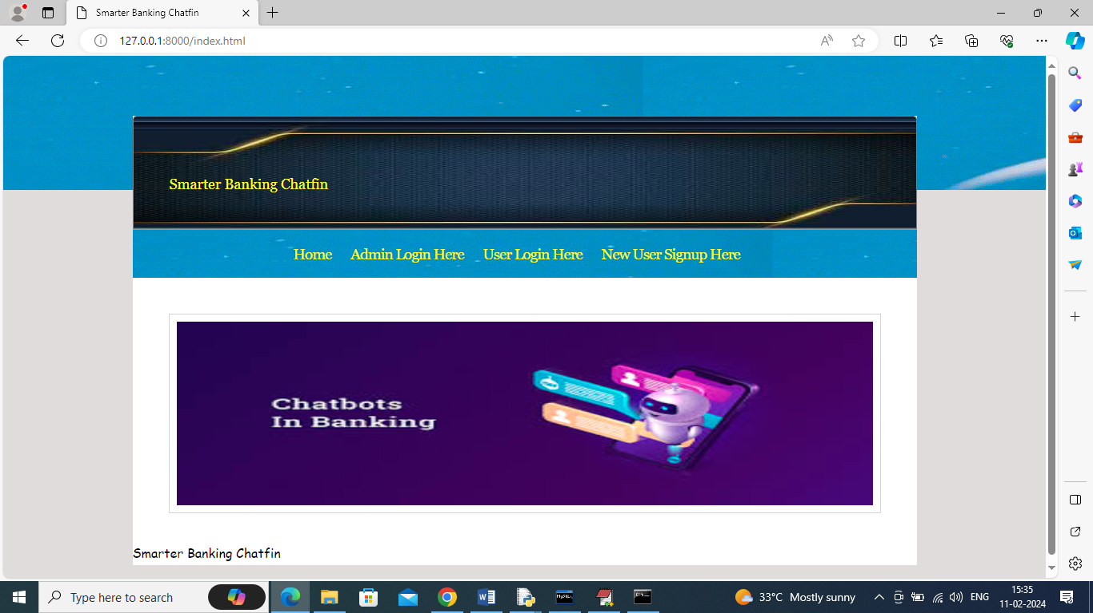

In above screen click on ‘Admin Login Here’ link to get below login page

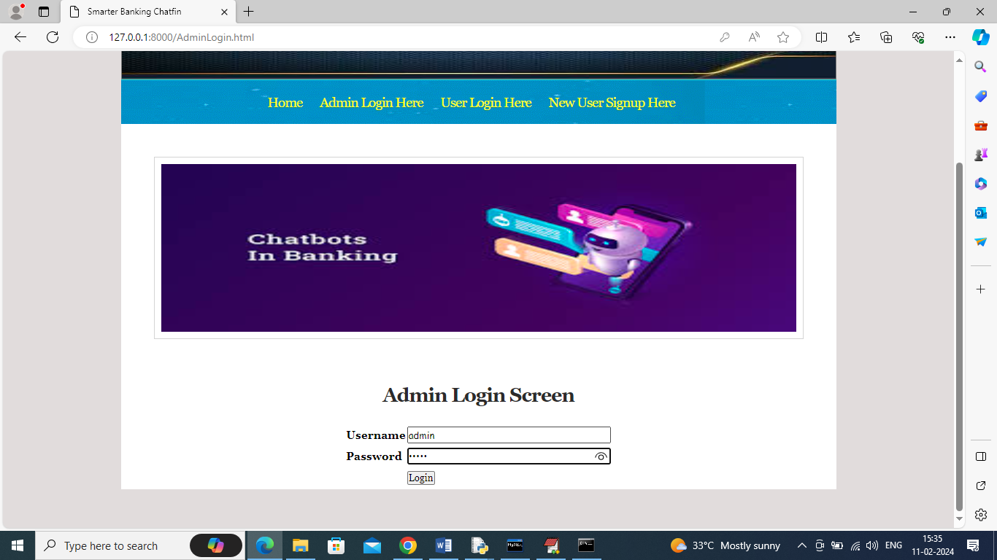

In above screen admin is login and after login will get below page

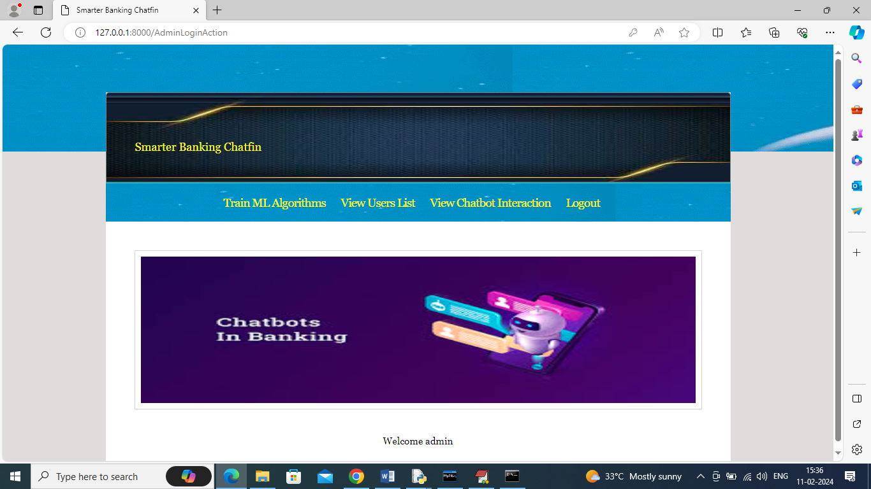

In above screen click on ‘Train ML Algorithms’ link to train algorithms and get below page

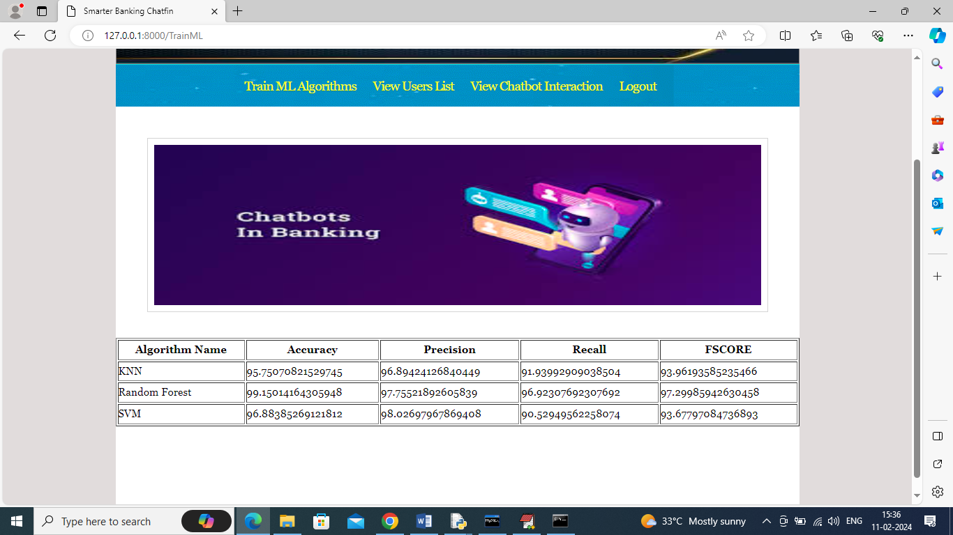

In above screen can see result of all ML algorithms and in all algorithms Random Forest got high accuracy and now ‘Logout’ and sign up new user

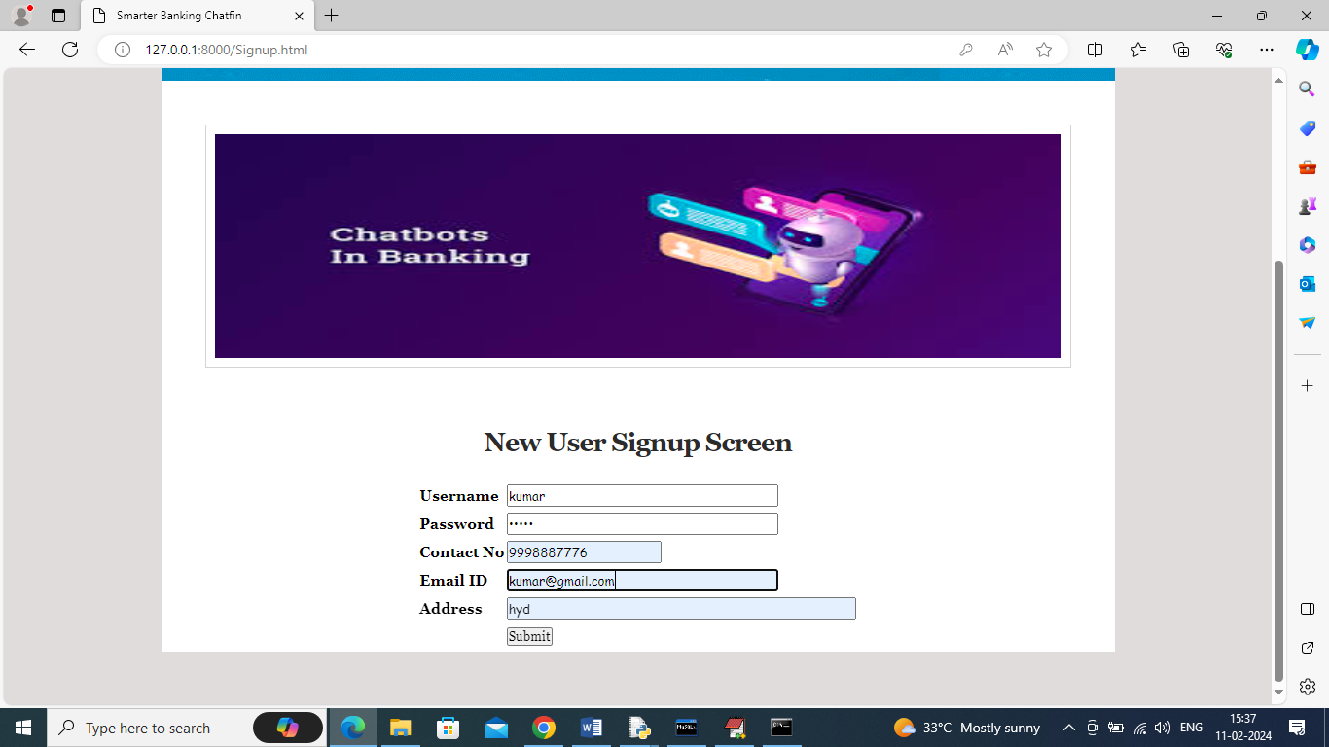

In above screen user is entering sign up details and then press button to get below page

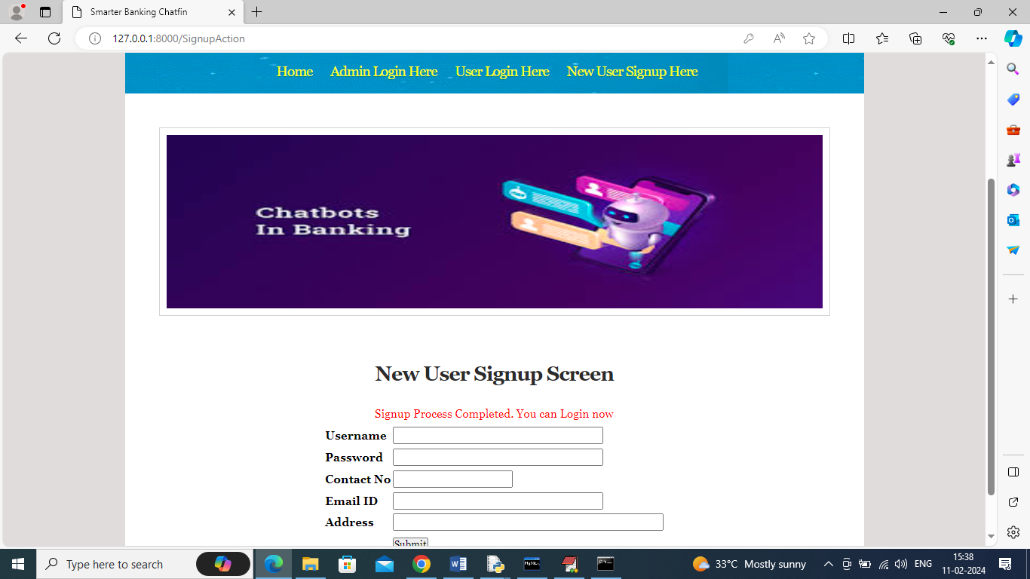

In above screen sign up task completed and now click on ‘User Login’ link to get below page

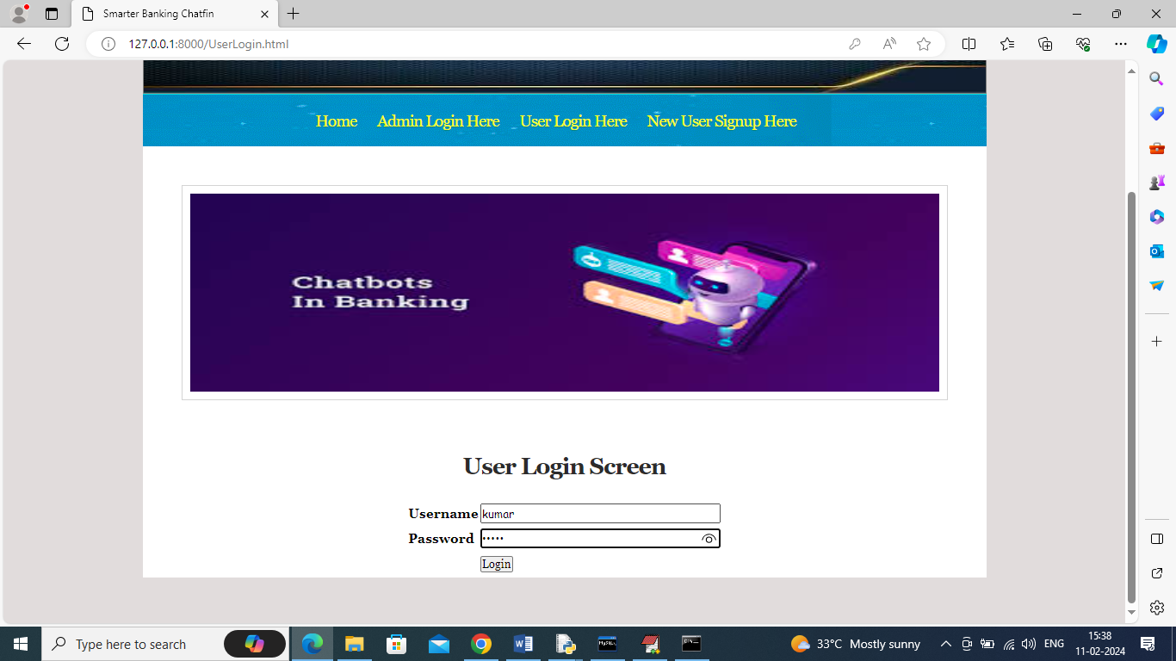

In above screen user is login and after login will get below page

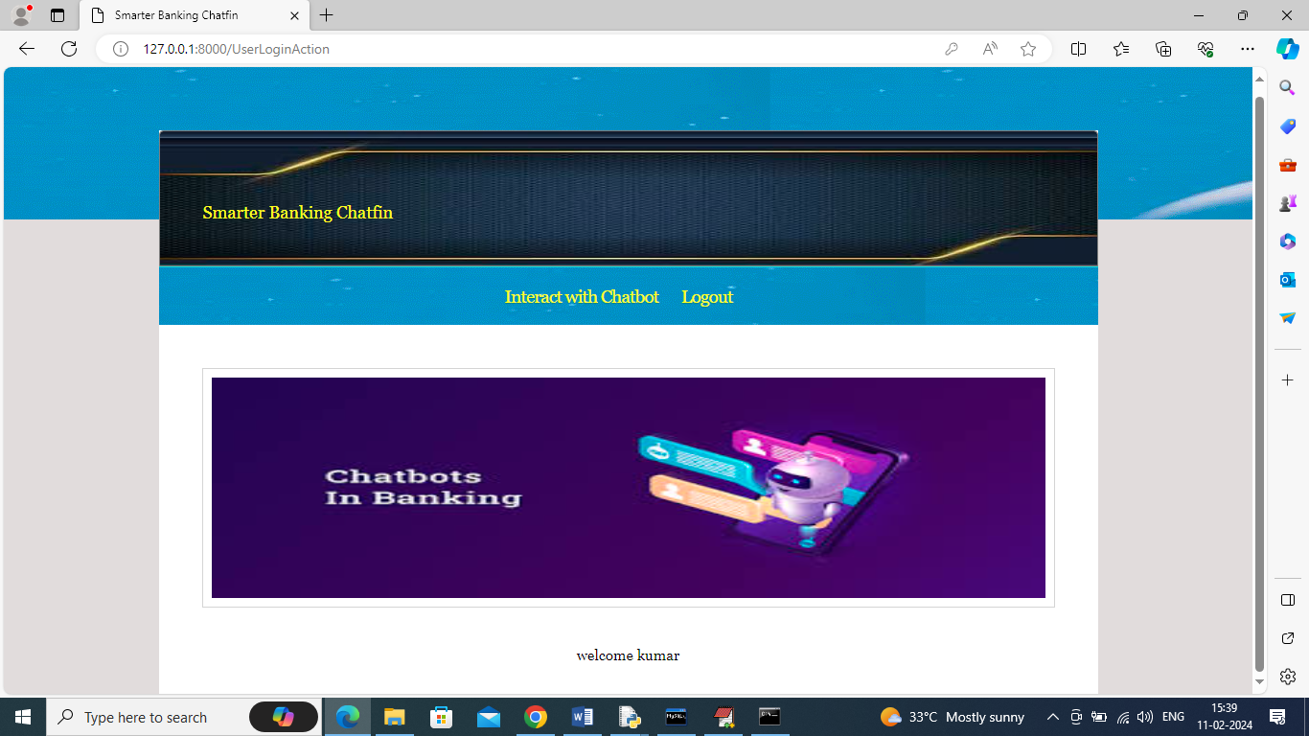

In above screen click on ‘Interact with Chatbot’ link to get below page

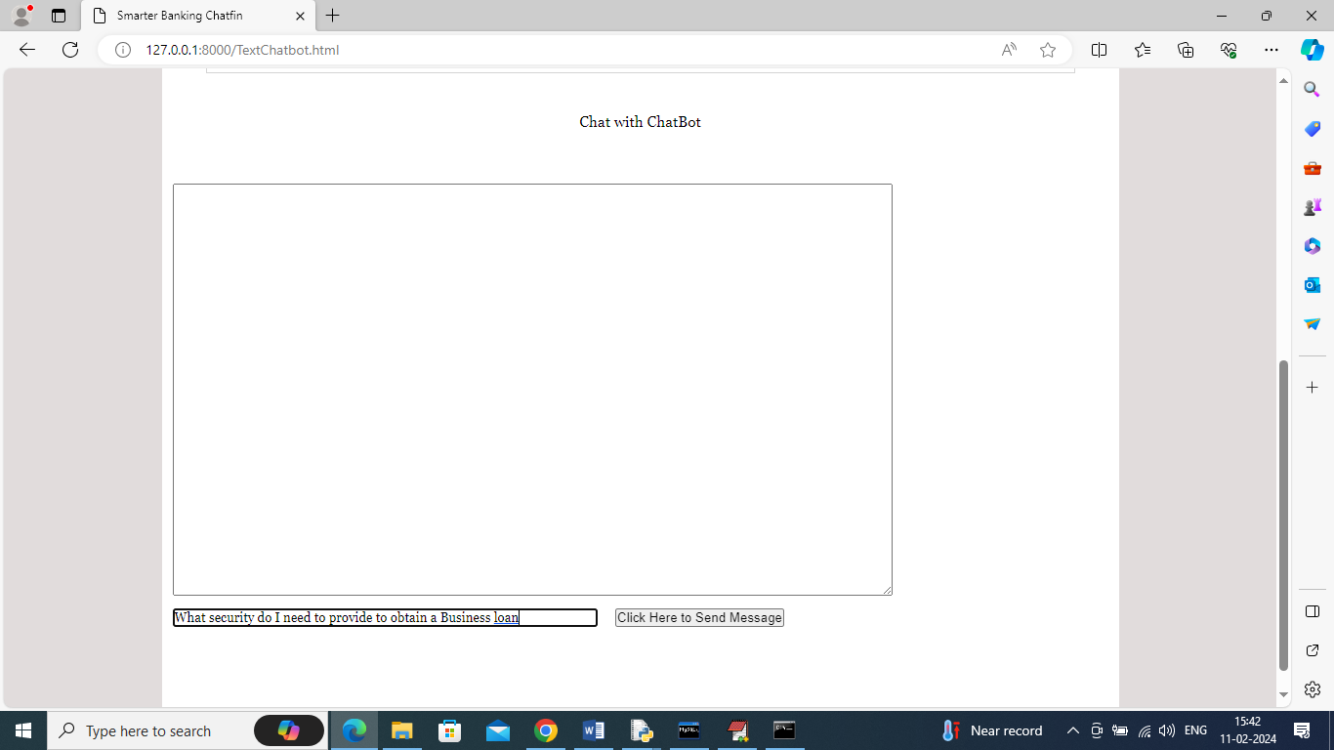

In above screen in text box I entered some text and then press button to get reply from Chatbot like below page

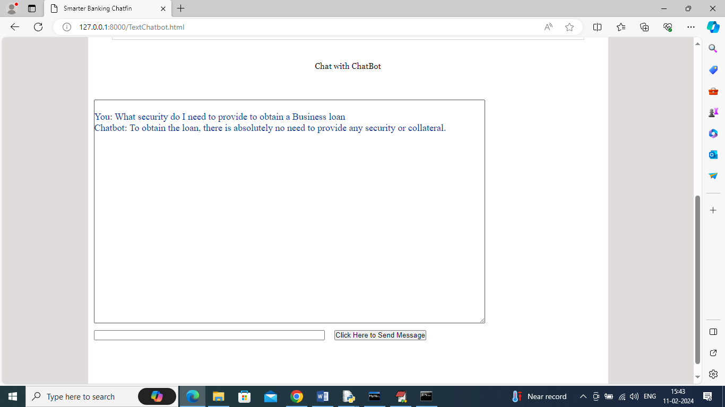

In above text area ‘You’ refers to user question and then can see Chatbot answer and similarly you can ask any question from dataset and get reply

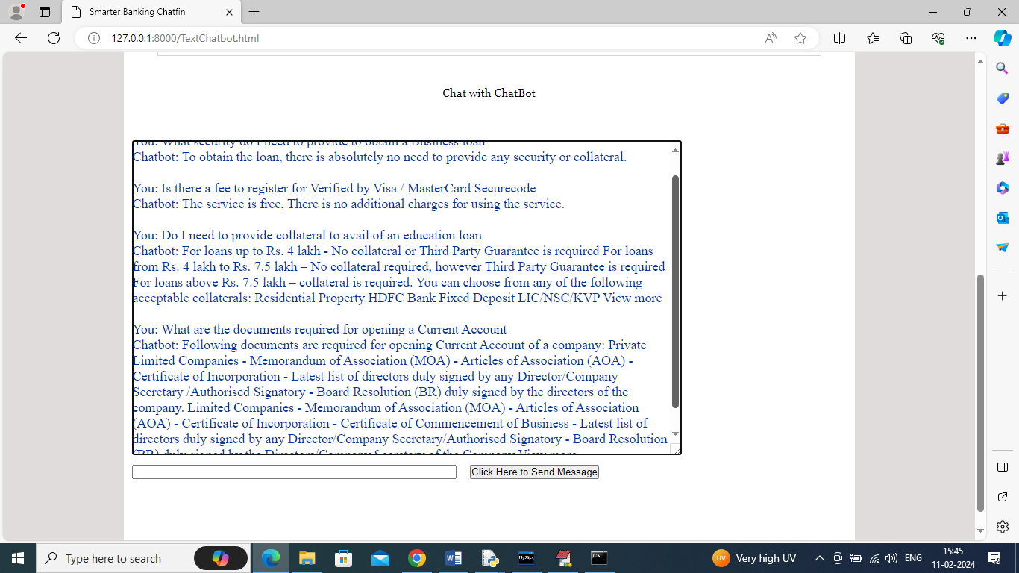

In above screen I entered some questions and then Chatbot replied for all questions

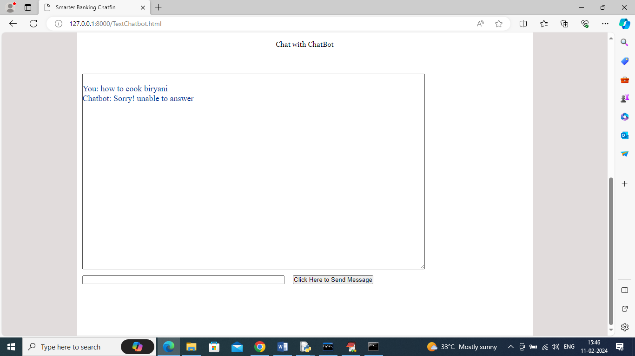

In above screen if we ask unrelated questions then Chatbot will reply with error message and now logout and login as ‘admin’ to view all interaction

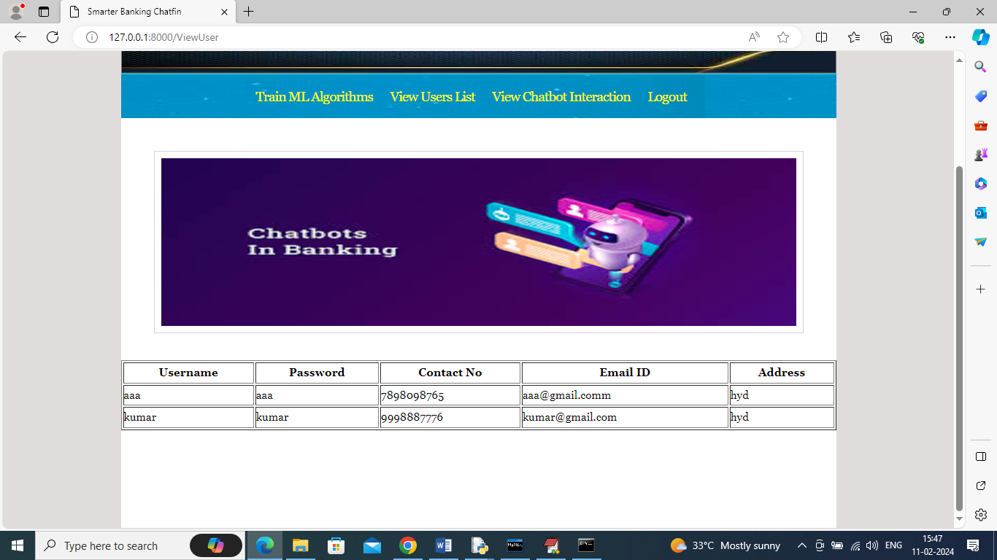

In above screen admin can click on ‘View Users List’ link to get all registered users list and now click on ‘View Chatbot Interaction’ link to get all interactions list

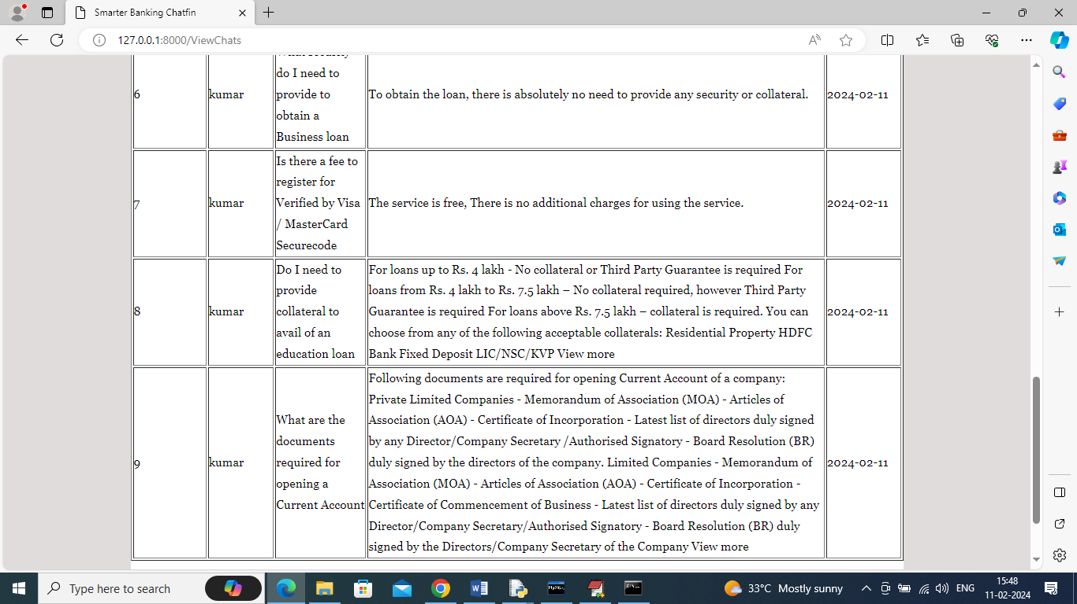

In above screen admin can view which users ask what questions and what is the Chatbot reply along with date can be viewed by admin.

Similarly by following above screens you can run entire project.