

1.TRANSFER OF DATA FROM USER LIST TO MASTER LIST
The objective of the project was to transfer data of employees from one file to another ,by the use of python tools generating a new updated file.

.TOOLS USED
.python
.VS Code
.Pandas

.SOURCE OF DATA
The data used in this task was obtained from the employee records of India Optel Limited. Two datasets were provided for data integration and analysis:
- user_list.csv – Containing employee profile information such as employee names, gender, category, phone number, group, designation, and other user-related details.
- employee master list.xlsx – Containing the master employee database with employee names, personnel numbers (PERNO), designations, sections, and units.
- COLUMNS TRANSFERRED=
The following data/columns were transferred from User List to Employee Data file, creating a new updated file
.Phone Number
.Group
.Gender
.Category

Step 1: Project Setup
A new project folder was created in VS Code. The following files were placed inside the project folder:
- user_list.csv
- employee master list.xls
- merge_names.py

Step 2: Loading Data
The Pandas library was imported to study,process and merge data from CSV and Excel files.The User_List was used loaded using csv reader and the Employee_Master file was loaded using Excel files.
Commands:
user_list = pd.read_csv("user_list.csv")
employee_master = pd.read_excel("employee master list.xlsx")

Step 3: Data Inspection
The column names of both files were displayed to identify the common fields required for matching records.
Common name fields identified:
- Full_Name (User List)
- NAME (Employee Master)

Step 4: Data Cleaning
. Names were converted to String format
Command: .astype(str)
. Spaces from the both ends of the names were trimmed
Command: .str.strip()
. All of the Names were converted to Uppercase
Command: .str.upper()

Step 5: Merge the Files
A left merge operation was performed using:
- NAME from Employee Master
- Full_Name from User List
This ensured that all records from the Employee Master file were retained while adding the required information from the User List.
Command: result = employee_master.merge( user_list[[ "Full_Name","Gender","Category","Phone_Number","Group” ]]

Step 6: Managing Duplicates
duplicate records were removed based on the Full_Name column before performing the merge operation .
Command: user_list = user_list.drop_duplicates(subset=["Full_Name"])

Step 7: Exploratory Data Analysis
An exploratory analysis was performed on both datasets to understand their structure and quality before data integration.
The following activities were carried out:
- Examined the dimensions of both datasets using shape analysis.
Command: user_list.shape
- Inspected column names and data types.
Command: user_list.columns.tolist()
user_list.dtypes
- Identified missing values in each dataset.
Command: user_list.isnull().sum()
- Analyzed the distribution of employees based on Gender, Category, and Group.
Command: user_list["Gender"].value_counts()
- Generated bar charts to visualize the frequency distribution of these variables
Command: .plot(kind="bar")
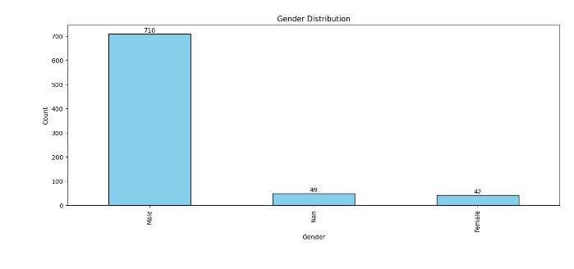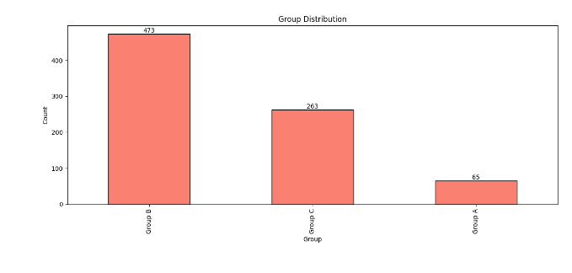
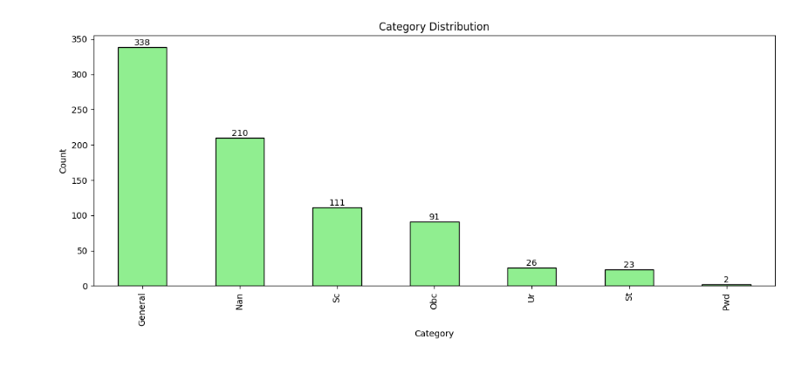

Step 8: Final Result
Results
The employee data integration process was successfully completed using Python and the Pandas library. Employee information from the User List dataset was matched with records in the Employee Master dataset and the required fields were transferred.
Summary of Results:
- User List records: 802
- Employee Master records: 1903
- Successfully matched records: 779
- Output file generated: employee_master_updated.xlsx

Q2. Measures of Central Tendency and Dispersion using R

Objective
The objective of this analysis is to compute and analyze the measures of central tendency and dispersion for the selected variable Total_Learning_Hours from the India Optel Limited Employee Learning Dataset using R programming.

- Measures of Central Tendency
The measures of central tendency were calculated to understand the central or typical value of the data.

Analysis
-The mean value of Total Learning Hours is 12.95 hours, which represents the average learning hours completed by employees.
.Mean = 12.94712
Command - mean_value <- mean(hours)

-The median value is 3.52 hours, indicating that half of the employees have learning hours below 3.52 and half have learning hours above 3.52.
.Median = 3.52
Command - median_value <- median(hours)

The mode is 0 hours, which means that the most frequently occurring value in the dataset is zero learning hours.
-Mode = 0
Command -
mode_value <- as.numeric(names(sort(table(hours), decreasing = TRUE)[1]))

- Measures of Dispersion
The measures of dispersion were calculated to understand the spread and variability of the data.
Analysis
- The range of 2144.45 hours shows a very large difference between the minimum and maximum learning hours.
. range = 2144.45
Command - range_value <- max(hours) - min(hours)

- The variance of 6671.51 indicates considerable variation among employee learning hours.
.varience = 6671.51
Command - variance_value <- var(hours)

- The standard deviation of 81.68 hours shows that the learning hours are widely dispersed around the mean.
.standard deviation = 81.6791
Command - sd_value <- sd(hours)

3 - Interpretation
The analysis reveals that most employees have relatively low learning hours, while a small number of employees have exceptionally high learning hours. As a result, the distribution of Total Learning Hours is positively skewed. The high range, variance, and standard deviation further confirm that there is substantial variation in learning participation among employees.

Limitations
The matching process was performed using employee names. Records containing abbreviations, initials, honorific titles, or variations in naming conventions may not match automatically. The use of a unique employee identifier would further improve matching accuracy and reduce the possibility of unmatched records.

Conclusion
The data is successfully transferred from the two datasets to a new dataset. The process reduced manual effort, ensured consistency, and generated an updated master file efficiently. Data cleaning techniques such as standardizing name formats and handling duplicate records were applied to improve matching accuracy. The final output preserved all records from the Employee Master file while enriching it with additional employee information from the User List dataset.

