Spam dataset is done using the Decision Trees Classification and K Nearest Neighbors Classification (KNN)

Preprocessing techniques

**Data Cleaning**: This was done by removing duplicates and null values from the dataset.

Removing duplicate in dataset.

|  |
| --- |
| Getting the duplicates in the dataset |
| Data_set.duplicated() |
| 0 False  1 False  2 False  3 False  4 False  ...  4596 False  4597 False  4598 False  4599 False  4600 False  Length: 4601, dtype: bool |
| removing the duplicate values |
| Data_set.drop_duplicates(inplace=True) |

Removing null values

|  |
| --- |
| Data_set.isna().sum() |
| word_freq_make 0  word_freq_address 0  word_freq_all 0  word_freq_3d 0  word_freq_our 0  word_freq_over 0  word_freq_remove 0  word_freq_internet 0  word_freq_order 0  word_freq_mail 0  word_freq_receive 0  word_freq_will 0  word_freq_people 0  word_freq_report 0  word_freq_addresses 0  word_freq_free 0  word_freq_business 0  word_freq_email 0  word_freq_you 0  word_freq_credit 0  word_freq_your 0  word_freq_font 0  word_freq_000 0  word_freq_money 0  word_freq_hp 0  word_freq_hpl 0  word_freq_george 0  word_freq_650 0  word_freq_lab 0  word_freq_labs 0  word_freq_telnet 0  word_freq_857 0  word_freq_data 0  word_freq_415 0  word_freq_85 0  word_freq_technology 0  word_freq_1999 0  word_freq_parts 0  word_freq_pm 0  word_freq_direct 0  word_freq_cs 0  word_freq_meeting 0  word_freq_original 0  word_freq_project 0  word_freq_re 0  word_freq_edu 0  word_freq_table 0  word_freq_conference 0  char_freq_; 0  char_freq_( 0  char_freq_[ 0  char_freq_! 0  char_freq_$ 0  char_freq_# 0  capital_run_length_average 0  capital_run_length_longest 0  capital_run_length_total 0  spam 0  dtype: int64 |
| Removing the target column |
| data=Data_set.drop(labels=['spam'], axis=1)  data.head() |

**Data Transformation:** outliers were removed using standard scaling.

Since capital_run_lenghth_avarage,capital_run_length_longest and Capital_run_lenghth_total are outliers

Remove the outliers using the IQR method

code

|  |
| --- |
| import numpy as np  # Calculate the interquartile range for each column  Q1 = Data_set.quantile(0.25)  Q3 = Data_set.quantile(0.75)  IQR = Q3 - Q1  # Remove the outliers using the IQR method  Data_set_outliers_removed = Data_set[~((Data_set < (Q1 - 1.5 * IQR)) | (Data_set > (Q3 + 1.5 * IQR))).any(axis=1)]  # Create individual box plots for the columns with outliers removed  fig, axs = plt.subplots(1, 3, figsize=(15, 5))  axs[0].boxplot(Data_set_outliers_removed['capital_run_length_total'], vert=False)  axs[0].set_title('Capital Run Length Total (outliers removed)')  axs[0].set_xlabel('')  axs[0].set_xlim([0, 600])  axs[1].boxplot(Data_set_outliers_removed['capital_run_length_average'], vert=False)  axs[1].set_title('Capital Run Length Average (outliers removed)')  axs[1].set_xlabel('')  axs[1].set_xlim([0, 10])  axs[2].boxplot(Data_set_outliers_removed['capital_run_length_longest'], vert=False)  axs[2].set_title('Capital Run Length Longest (outliers removed)')  axs[2].set_xlabel('')  axs[2].set_xlim([0, 50])  plt.show() |

Used Standard Scaler on the dataset

Before standard scaler

Mean

Code – performing standard scaler on the dataset

|  |
| --- |
| # Perform Standard Scaling on the data  scaler = StandardScaler()  scaled_data = scaler.fit_transform(Data_set.iloc[:, :-1])  Data_scaled = pd.DataFrame(data=scaled_data, columns=Data_set.columns[:-1]) |

Boxplot after performing the standard scaler on the dataset

Mean

Variance graph

Splitting the dataset into the Training set and Test set

* 20 percent of the dataset was used to test the dataset.
* 80 percent of the dataset was used to train the dataset

Code

|  |
| --- |
| from sklearn.model_selection import train_test_split  X_train, X_test, y_train, y_test = train_test_split(X, y, test_size = 0.20, random_state = 0) |

Decision Tree Classification

**Accuracy of testing dataset** : 0.9560570071258907

Summary of the dataset

code

|  |
| --- |
| from sklearn.metrics import classification_report  predicted_labels = clf.predict(X_test)  classification_report = classification_report(y_test, predicted_labels)  print(classification_report) |

Classification report

**Accuracy of the training dataset of the decision tree**: 1.0

Decision tree

Confusion Matrix before pruning

Equations

True positive rate: measures the proportion of positive instances correctly identified as positive.

* FN = False Negative : Number of positive instances that are incorrectly classified as positive.

TPR = TP / (TP + FN)

False positive rate : measures the proportion of negative instances incorrectly identified as positive.

* TN = true negative : The number of negative instances that are correctly classified as negative

FPR = FP / (FP + TN

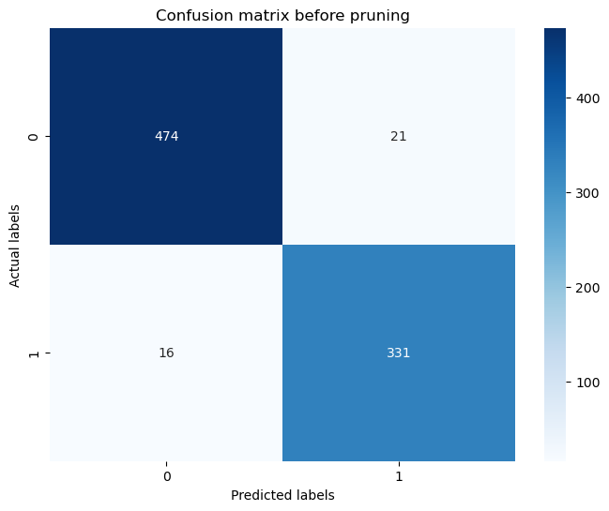

* TP :474 mails are correctly identified as not spam.
* FP : 21 mails are incorrectly identified as spam as not spam.
* TN :331 mails are correctly identified as spam.
* FN : 16 mails are incorrectly identified as not spam as spam.

Receiver Operating Characteristics (ROC) : A plot to test sensitivity as the y coordinate versus its 1-specificity or false positive rate (FPR) as the x coordinate, is an effective method of evaluating the performance of diagnostic tests.

AUC score for the code: 0.96

**Pruning the Decision tree** : Pruning is a technique that removes the parts of the Decision Tree which prevent it from growing to its full depth. The parts that it removes from the tree are the parts that do not provide the power to classify instances.

A graph is plotted between ‘Total impurity of leaves’ as Y axis and ‘Effective alpha’ as the X axis. Using the graph, we can find the optimal ‘ccp alpha’ value required for pruning.The regularization parameter ccp alpha balances the accuracy and model complexity in decision trees.

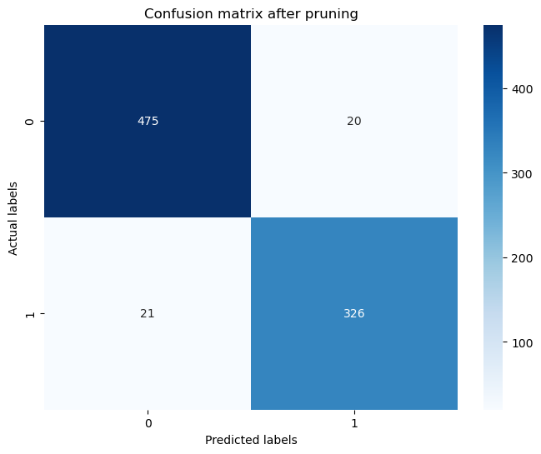

* TP :475 mails are correctly identified as not spam.
* FP : 20 mails are incorrectly identified as spam as not spam.
* TN :326 mails are correctly identified as spam.
* FN : 21 mails are incorrectly identified as not spam as spam.

Decision Tree obtaining after pruning.

K Nearest Neighbors (KNN) Classification

Classification Report of KNN

Confusion matrix of KNN

* TP: 480 mails are correctly identified as not spam.
* FP: 51 mails are incorrectly identified as spam as not spam.
* TN: 296 mails are correctly identified as spam.
* FN: 35 mails are incorrectly identified as spam as spam.

KNN Accuracy: 0.8729216152019003