COLLEGE OFCOMPUTING & INFORMATION SCIENCES
First Semester, Academic Year 2025-2026

CS 315: ELECTIVE 2 (INTELLIGENT SYSTEM)

STUDENT INFORMATION
Student | Vince B. Comon | Activity # | 1
College/Program/  Course/Level/Section | CCIS/BSCS 3B1 | Module 3. Artificial Neural Networks | Supervised Learning (Single Layer Perceptron & Multilayer Perceptron)

- SINGLE LAYER PERCEPTRON

A Single Layer Perceptron is an ANN model that maps a set of input features to an output using a weighted sum, activation function, and learning rule (usually the perceptron learning algorithm). It does not contain any hidden layers—just inputs directly connected to outputs.
Key Features:
- Simple architecture with no hidden layer
- Effective only for linearly separable problems

CODE SNIPPET:

import numpy as np
import customtkinter as ctk
import matplotlib.pyplot as plt
from matplotlib.backends.backend_tkagg import FigureCanvasTkAgg

ctk.set_appearance_mode("light")
ctk.set_default_color_theme("blue")

# ================== PERCEPTRON ==================

class Perceptron:
def __init__(self, lr=0.1):
self.lr = lr
self.w = np.random.randn(2)
self.b = np.random.randn()

def predict_raw(self, x):
return np.dot(self.w, x) + self.b

def predict(self, x):
return 1 if self.predict_raw(x) >= 0 else 0

def train(self, X, y, epochs):
errors = []
for _ in range(epochs):
err = 0
for xi, yi in zip(X, y):
pred = self.predict(xi)
update = self.lr * (yi - pred)
self.w += update * xi
self.b += update
err += abs(yi - pred)
errors.append(err)
return errors

# ================== GUI ==================

class PerceptronApp(ctk.CTk):
def __init__(self):
super().__init__()
self.title("Perceptron Logic Gate Simulator")
self.geometry("1500x820")

self.lr = ctk.DoubleVar(value=0.1)
self.epochs = ctk.IntVar(value=25)
self.logic = ctk.StringVar(value="AND")

self.user_x1 = ctk.DoubleVar(value=0)
self.user_x2 = ctk.DoubleVar(value=0)

self.perceptron = None

self.create_widgets()
self.set_logic_data()

# ========== LOGIC DATA ==========
def set_logic_data(self):
self.X = np.array([[0,0],[0,1],[1,0],[1,1]])

if self.logic.get() == "AND":
self.y = np.array([0,0,0,1])
elif self.logic.get() == "OR":
self.y = np.array([0,1,1,1])
else: # XOR
self.y = np.array([0,1,1,0])

self.plot_data()

# ========== UI ==========
def create_widgets(self):
left = ctk.CTkFrame(self)
left.pack(side="left", fill="both", expand=True, padx=10, pady=10)

right = ctk.CTkScrollableFrame(self, width=450)
right.pack(side="right", fill="y", padx=10, pady=10)

# ---- DATA PLOT ----
self.fig, self.ax = plt.subplots(figsize=(5, 5))
self.canvas = FigureCanvasTkAgg(self.fig, master=left)
self.canvas.get_tk_widget().pack(fill="both", expand=True)

# ---- LOGIC SELECTOR ----
ctk.CTkLabel(right, text="Logic Gate", font=("Arial", 18)).pack(pady=5)
ctk.CTkOptionMenu(
right,
values=["AND", "OR", "XOR"],
variable=self.logic,
command=lambda _: self.set_logic_data()
).pack()

# ---- TRAINING ----
ctk.CTkLabel(right, text="Training Controls", font=("Arial", 18)).pack(pady=10)
ctk.CTkLabel(right, text="Learning Rate").pack()
ctk.CTkEntry(right, textvariable=self.lr).pack()
ctk.CTkLabel(right, text="Epochs").pack(pady=(5,0))
ctk.CTkEntry(right, textvariable=self.epochs).pack()
ctk.CTkButton(right, text="Train Perceptron", command=self.train).pack(pady=10)

# ---- WEIGHTS ----
self.weights_box = ctk.CTkTextbox(right, width=400, height=100)
self.weights_box.pack()

# ---- USER INPUT ----
ctk.CTkLabel(right, text="Test the Neuron", font=("Arial", 18)).pack(pady=10)
ctk.CTkLabel(right, text="x₁").pack()
ctk.CTkEntry(right, textvariable=self.user_x1).pack()
ctk.CTkLabel(right, text="x₂").pack()
ctk.CTkEntry(right, textvariable=self.user_x2).pack()
ctk.CTkButton(right, text="Compute Output", command=self.compute).pack(pady=10)

# ---- CALCULATION ----
self.calc_box = ctk.CTkTextbox(right, width=400, height=260)
self.calc_box.pack(pady=5)

# ---- NEURON VISUAL ----
ctk.CTkLabel(right, text="Neuron Model Visualization", font=("Arial", 18)).pack(pady=10)
self.neuron_fig, self.neuron_ax = plt.subplots(figsize=(5, 3))
self.neuron_canvas = FigureCanvasTkAgg(self.neuron_fig, master=right)
self.neuron_canvas.get_tk_widget().pack()

# ---- ERROR ----
self.err_fig, self.err_ax = plt.subplots(figsize=(4, 2))
self.err_canvas = FigureCanvasTkAgg(self.err_fig, master=right)
self.err_canvas.get_tk_widget().pack(pady=10)

# ========== PLOTS ==========
def plot_data(self):
self.ax.clear()
for x, y in zip(self.X, self.y):
self.ax.scatter(x[0], x[1], color="blue" if y else "red", s=120)
self.ax.set_xlim(-0.5, 1.5)
self.ax.set_ylim(-0.5, 1.5)
self.ax.set_xlabel("x₁")
self.ax.set_ylabel("x₂")
self.ax.set_title(self.logic.get())
self.canvas.draw()

# ========== TRAIN ==========
def train(self):
self.perceptron = Perceptron(self.lr.get())
errors = self.perceptron.train(self.X, self.y, self.epochs.get())
self.plot_data()

x_vals = np.linspace(-0.5, 1.5, 100)
y_vals = -(self.perceptron.w[0]*x_vals + self.perceptron.b)/self.perceptron.w[1]
self.ax.plot(x_vals, y_vals, "k--")
self.canvas.draw()

self.weights_box.delete("1.0", "end")
self.weights_box.insert("end",
f"w₁ = {self.perceptron.w[0]:.4f}\n"
f"w₂ = {self.perceptron.w[1]:.4f}\n"
f"bias = {self.perceptron.b:.4f}"
)

self.err_ax.clear()
self.err_ax.plot(errors, marker="o")
self.err_ax.set_title("Training Error")
self.err_canvas.draw()

# ========== NEURON DRAW ==========
def draw_neuron(self, x1, x2, w1, w2, b, y):
ax = self.neuron_ax
ax.clear()
ax.set_xlim(0, 10)
ax.set_ylim(0, 10)
ax.axis("off")

ax.text(1, 7, f"x₁={x1}", fontsize=12)
ax.text(1, 3, f"x₂={x2}", fontsize=12)

ax.arrow(2.5, 7, 3, -1, head_width=0.2, length_includes_head=True)
ax.arrow(2.5, 3, 3, 1, head_width=0.2, length_includes_head=True)

ax.text(4, 6, f"w₁={w1:.2f}")
ax.text(4, 4, f"w₂={w2:.2f}")

circle = plt.Circle((6.5, 5), 1.2, fill=False, linewidth=2)
ax.add_patch(circle)
ax.text(6.5, 5, "Neuron", ha="center", va="center")

ax.text(6.5, 3.2, f"b={b:.2f}", ha="center")

ax.arrow(7.7, 5, 1.5, 0, head_width=0.2, length_includes_head=True)
ax.text(9.4, 5, f"y={y}", fontsize=12, va="center")

self.neuron_canvas.draw()

# ========== COMPUTE ==========
def compute(self):
if not self.perceptron:
return

x1, x2 = self.user_x1.get(), self.user_x2.get()
w1, w2 = self.perceptron.w
b = self.perceptron.b

z = w1*x1 + w2*x2 + b
y = 1 if z >= 0 else 0

self.calc_box.delete("1.0", "end")
self.calc_box.insert("end",
f"Logic: {self.logic.get()}\n"
"--------------------\n"
f"z = w₁x₁ + w₂x₂ + b\n"
f"z = ({w1:.3f}×{x1}) + ({w2:.3f}×{x2}) + {b:.3f}\n"
f"z = {z:.4f}\n\n"
f"Output y = {y}"
)

self.draw_neuron(x1, x2, w1, w2, b, y)

# ================== RUN ==================
if __name__ == "__main__":
PerceptronApp().mainloop()

OUTPUT:

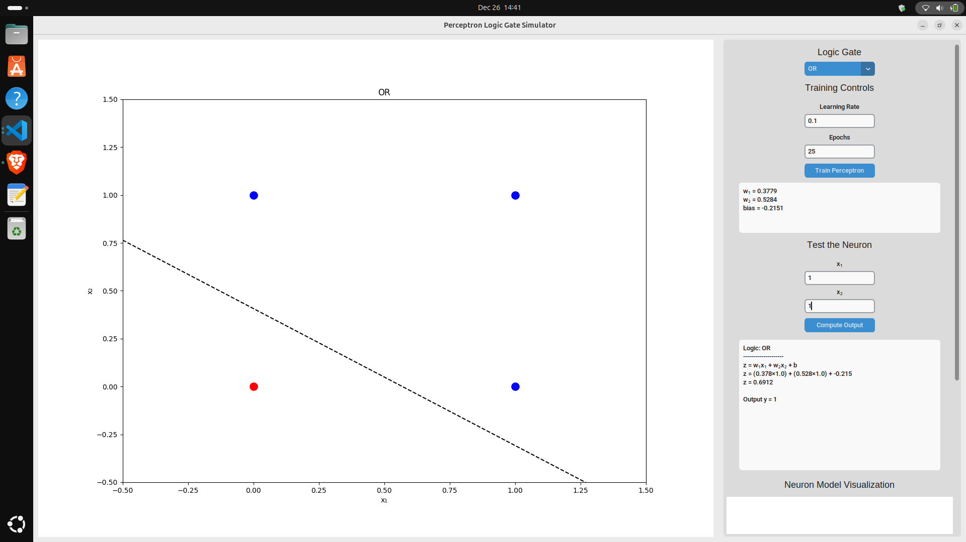
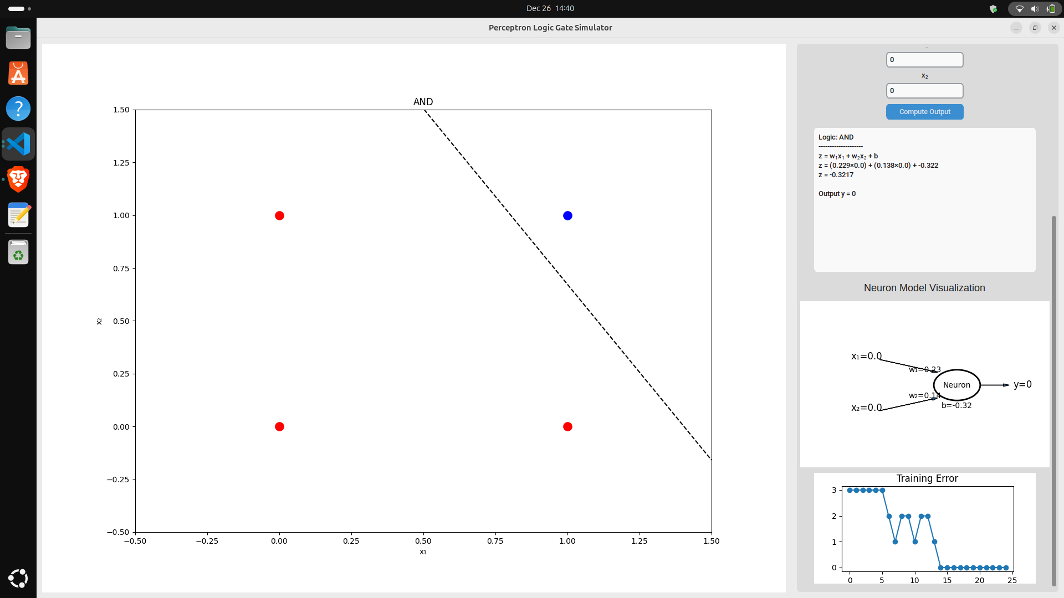

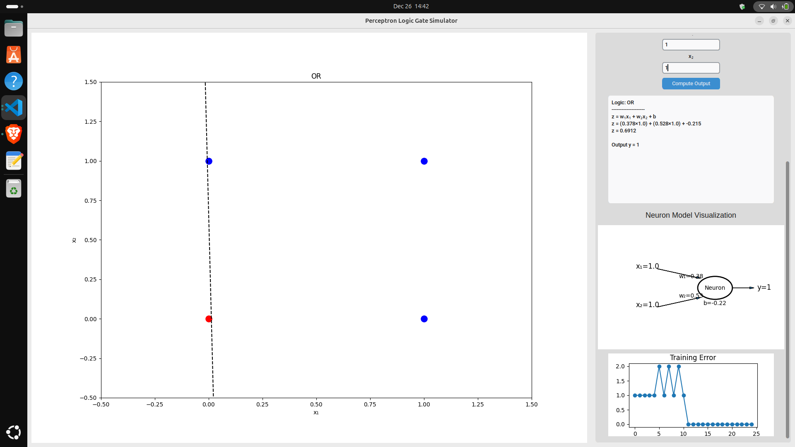

- MULTI LAYER PERCEPTRON

A Multi-Layer Perceptron is a feedforward neural network consisting of an input layer, one or more hidden layers, and an output layer. Unlike the Single Layer Perceptron, an MLP uses nonlinear activation functions, enabling it to model complex relationships and solve problems that are not linearly separable.
Key Features:
- Has one or more hidden layers
- Can learn nonlinear patterns

CODE SNIPPET:

import tkinter as tk
from tkinter import ttk, Canvas, scrolledtext
import numpy as np
import json
import os

# ---------------- MODEL -------------
class MultiLayerPerceptron:
"""
A simple two-layer (one hidden layer) neural network for classification.
"""
def __init__(self, input_size, hidden_size, output_size, lr):
# Parameters for Input -> Hidden Layer (W1, b1)
# Initializes weights with small random values to break symmetry
self.W1 = np.random.randn(input_size, hidden_size) * 0.1
self.b1 = np.zeros((1, hidden_size))

# Parameters for Hidden -> Output Layer (W2, b2)
self.W2 = np.random.randn(hidden_size, output_size) * 0.1
self.b2 = np.zeros((1, output_size))

self.lr = lr

def sigmoid(self, x):
"""The sigmoid activation function."""
return 1 / (1 + np.exp(-x))

def sigmoid_derivative(self, x):
"""Derivative of the sigmoid function (for backpropagation)."""
return x * (1 - x)

def forward(self, X):
"""Performs the forward pass through the network."""
# Layer 1: Input to Hidden
self.z1 = X @ self.W1 + self.b1
self.a1 = self.sigmoid(self.z1) # Hidden layer output (activation)

# Layer 2: Hidden to Output
self.z2 = self.a1 @ self.W2 + self.b2
self.out = self.sigmoid(self.z2) # Output layer output (prediction)

return self.out

def backward(self, X, y):
"""Performs backpropagation to update weights and biases."""
# --- Output Layer (L2) Backpropagation ---
# 1. Output Error (y - out)
error_L2 = y - self.out
# 2. Delta (Gradient) for L2: error * derivative of activation
delta_L2 = error_L2 * self.sigmoid_derivative(self.out)

# --- Hidden Layer (L1) Backpropagation ---
# 3. Error for L1: Propagated error from L2
error_L1 = delta_L2 @ self.W2.T
# 4. Delta (Gradient) for L1: error * derivative of activation
delta_L1 = error_L1 * self.sigmoid_derivative(self.a1)

# --- Update Weights and Biases ---
# Update W2 and b2
self.W2 += self.a1.T @ delta_L2 * self.lr
self.b2 += np.sum(delta_L2, axis=0, keepdims=True) * self.lr

# Update W1 and b1
self.W1 += X.T @ delta_L1 * self.lr
self.b1 += np.sum(delta_L1, axis=0, keepdims=True) * self.lr

def predict(self, X):
"""Returns the output prediction for given input."""
return self.forward(X)

# ---------------- APP ----------------
class App:
def __init__(self):
self.root = tk.Tk()
self.root.title("Multi-Layer Perceptron - Letter Recognition")
self.root.geometry("1200x720")

self.rows, self.cols = 7, 5
self.pixel_size = 35
self.pixels = [[0] * self.cols for _ in range(self.rows)]
self.input_size = self.rows * self.cols # 7 * 5 = 35 inputs
self.hidden_size = 10

self.lr = 0.1
self.epochs = 1000

self.data = []
self.labels = []
self.label_map = {}
self.rev_map = {}

self.model = None

self.build_ui()
self.root.mainloop()

# ---------------- UI ----------------
def build_ui(self):
self.root.grid_rowconfigure(1, weight=1)
self.root.grid_columnconfigure(0, weight=1)

main = tk.Frame(self.root, bg="#E3F2FD")
main.grid(row=0, column=0, sticky="nsew", padx=5, pady=5)
main.grid_columnconfigure(0, minsize=350)
main.grid_columnconfigure(1, weight=1)
main.grid_columnconfigure(2, minsize=350)

# -------- LEFT PANEL (Controls) --------
left = tk.Frame(main, bg="#E3F2FD")
left.grid(row=0, column=0, sticky="ns", padx=5)

tk.Label(left, text="Multi-Layer Perceptron - Letter Recognition",
font=("Arial", 16, "bold")).pack(pady=10)

# Hidden Layer Size Control
tk.Label(left, text="Hidden Layer Size").pack(pady=(5, 0))
self.hs_slider = tk.Scale(left, from_=1, to=20, orient=tk.HORIZONTAL, command=self.set_hidden_size)
self.hs_slider.set(self.hidden_size)
self.hs_slider.pack(padx=15)
self.hs_label = tk.Label(left, text=f"{self.hidden_size} neurons")
self.hs_label.pack()

# Learning Rate Control
tk.Label(left, text="Learning Rate").pack(pady=(10, 0))
self.lr_slider = tk.Scale(left, from_=0.01, to=1.0, resolution=0.01, orient=tk.HORIZONTAL, command=self.set_lr)
self.lr_slider.set(0.1)
self.lr_slider.pack(padx=15)
self.lr_label = tk.Label(left, text="0.10")
self.lr_label.pack()

# Epochs Control
tk.Label(left, text="Training Epochs").pack(pady=(10, 0))
self.ep_slider = tk.Scale(left, from_=100, to=5000, orient=tk.HORIZONTAL, command=self.set_epochs)
self.ep_slider.set(1000)
self.ep_slider.pack(padx=15)
self.ep_label = tk.Label(left, text="1000 epochs")
self.ep_label.pack()

tk.Button(left, text="Train Network",
bg="#1976D2", fg="white",
command=self.train).pack(pady=10, padx=15, fill="x")

# Dataset Info
info = tk.Frame(left, bg="#E3F2FD")
info.pack(padx=10, pady=5, fill="x")

tk.Label(info, text="Dataset Information",
font=("Arial", 12, "bold")).pack(pady=5)

self.info_box = scrolledtext.ScrolledText(info, height=5, wrap=tk.WORD)
self.info_box.pack(padx=5, pady=5, fill="x")
self.info_box.insert("1.0", "No data loaded")
self.info_box.configure(state="disabled")

# -------- CENTER PANEL (Canvas) --------
center = tk.Frame(main, bg="#E3F2FD")
center.grid(row=0, column=1, sticky="nsew", padx=5)

tk.Label(center, text="Draw a Letter",
font=("Arial", 14, "bold")).pack(pady=10)

self.canvas = Canvas(center,
width=self.cols * self.pixel_size,
height=self.rows * self.pixel_size,
bg="white",
highlightthickness=3,
highlightbackground="#2196F3")
self.canvas.pack()
self.canvas.bind("<Button-1>", self.paint)
self.canvas.bind("<B1-Motion>", self.paint)

self.draw_grid()

tk.Button(center, text="Clear Canvas",
command=self.clear_canvas).pack(pady=5)

tk.Button(center, text="Recognize Letter",
bg="#0D47A1", fg="white",
command=self.recognize).pack(pady=5)

# -------- RIGHT PANEL (Results & Data Ops) --------
right = tk.Frame(main, bg="#E3F2FD")
right.grid(row=0, column=2, sticky="ns", padx=5)

tk.Label(right, text="Recognition Result",
font=("Arial", 14, "bold")).pack(pady=10)

self.result = tk.Label(right, text="Draw a letter",
font=("Arial", 20, "bold"),
fg="#2196F3")
self.result.pack(pady=10)

self.conf = tk.Label(right, text="")
self.conf.pack()

self.label_entry = tk.Entry(right)
self.label_entry.pack(pady=5, padx=15)
self.label_entry.insert(0, "Enter letter (A-Z)")
self.label_entry.bind("<FocusIn>", self.clear_placeholder)
self.label_entry.bind("<FocusOut>", self.set_placeholder)

tk.Button(right, text="Add Sample",
bg="#0D47A1", fg="white",
command=self.add_sample).pack(pady=10, padx=15, fill="x")

# Dataset Operations (RIGHT)
ops = tk.Frame(right, bg="#E3F2FD")
ops.pack(padx=15, pady=10, fill="x")

tk.Label(ops, text="Dataset Operations",
font=("Arial", 12, "bold")).pack(pady=5)

tk.Button(ops, text="Load Dataset",
command=self.load_dataset).pack(fill="x", pady=2)

tk.Button(ops, text="Save Dataset",
command=self.save_dataset).pack(fill="x", pady=2)

tk.Button(ops, text="Clear All Data",
bg="#F44336", fg="white",
command=self.clear_all).pack(fill="x", pady=2)

# -------- TRAINING HISTORY --------
hist = tk.Frame(self.root, bg="#E3F2FD")
hist.grid(row=1, column=0, sticky="nsew", padx=5, pady=5)

tk.Label(hist, text="Training History",
font=("Arial", 14, "bold")).pack(anchor="w", padx=10)

self.log = scrolledtext.ScrolledText(hist)
self.log.pack(fill="both", expand=True, padx=10, pady=5)

# ---------------- LOGIC ----------------
def draw_grid(self):
"""Draws the 7x5 pixel grid on the canvas."""
for r in range(self.rows + 1):
self.canvas.create_line(0, r * self.pixel_size,
self.cols * self.pixel_size, r * self.pixel_size, fill="#ccc")
for c in range(self.cols + 1):
self.canvas.create_line(c * self.pixel_size, 0,
c * self.pixel_size, self.rows * self.pixel_size, fill="#ccc")

def paint(self, e):
"""Fills a pixel when the user clicks or drags."""
r, c = e.y // self.pixel_size, e.x // self.pixel_size
if 0 <= r < self.rows and 0 <= c < self.cols:
if self.pixels[r][c] == 0:
self.pixels[r][c] = 1
x1, y1 = c * self.pixel_size, r * self.pixel_size
self.canvas.create_rectangle(x1, y1,
x1 + self.pixel_size, y1 + self.pixel_size,
fill="black", outline="")

def clear_canvas(self):
"""Resets the canvas and the internal pixel array."""
self.canvas.delete("all")
self.draw_grid()
self.pixels = [[0] * self.cols for _ in range(self.rows)]
self.result.configure(text="Draw a letter")
self.conf.configure(text="")

def get_input(self):
"""Flattens the 7x5 pixel grid into a 1x35 NumPy array."""
return np.array(self.pixels).reshape(1, -1)

def set_lr(self, v):
"""Updates the learning rate."""
self.lr = float(v)
self.lr_label.configure(text=f"{self.lr:.2f}")

def set_epochs(self, v):
"""Updates the number of training epochs."""
self.epochs = int(float(v))
self.ep_label.configure(text=f"{self.epochs} epochs")

def set_hidden_size(self, v):
"""Updates the hidden layer size."""
self.hidden_size = int(float(v))
self.hs_label.configure(text=f"{self.hidden_size} neurons")

def clear_placeholder(self, event):
if self.label_entry.get() == "Enter letter (A-Z)":
self.label_entry.delete(0, "end")

def set_placeholder(self, event):
if not self.label_entry.get():
self.label_entry.insert(0, "Enter letter (A-Z)")

def add_sample(self):
"""Adds the current canvas drawing and entered label to the dataset."""
label = self.label_entry.get().upper()
if not label or label == "ENTER LETTER (A-Z)":
return

if label not in self.label_map:
idx = len(self.label_map)
self.label_map[label] = idx
self.rev_map[idx] = label

self.data.append(self.get_input()[0].tolist())
self.labels.append(self.label_map[label])

self.update_info()
self.log.insert("end", f"Added sample: {label}\n")

self.clear_canvas()
self.label_entry.delete(0, "end")

def train(self):
"""Initializes and trains the Multi-Layer Perceptron model."""
if not self.data:
self.log.insert("end", "Error: No data to train on.\n")
return

X = np.array(self.data)
# One-hot encoding for labels
output_size = len(self.label_map)
y = np.zeros((len(X), output_size))
for i, lbl in enumerate(self.labels):
y[i][lbl] = 1

# Instantiate the MultiLayerPerceptron
self.model = MultiLayerPerceptron(self.input_size,
self.hidden_size,
output_size,
self.lr)

self.log.insert("end", f"======== STARTING TRAINING ========\n")
self.log.insert("end", f"Network Config: (Input: {self.input_size}, Hidden: {self.hidden_size}, Output: {output_size})\n")
self.log.insert("end", f"LR: {self.lr:.2f}, Epochs: {self.epochs}\n")

# Training loop
for epoch in range(self.epochs):
self.model.forward(X)
self.model.backward(X, y)

# Simple logging every 100 epochs
if (epoch + 1) % 100 == 0:
cost = np.mean(np.square(y - self.model.out))
self.log.insert("end", f"Epoch {epoch+1}/{self.epochs}, Avg MSE Loss: {cost:.4f}\n")

self.log.insert("end", "Training complete\n")
self.log.insert("end", "===================================\n")
self.log.see("end")

def recognize(self):
"""Predicts the letter and logs the result and confidence."""
if not self.model:
self.result.configure(text="N/A")
self.conf.configure(text="Network not trained")
self.log.insert("end", "Recognition: Failed. Network not trained.\n")
self.log.see("end")
return

# Get prediction
input_data = self.get_input()
pred = self.model.predict(input_data)
idx = np.argmax(pred)

recognized_letter = self.rev_map.get(idx, "?")
confidence_value = pred[0][idx] * 100

# Update GUI
self.result.configure(text=recognized_letter)
self.conf.configure(text=f"Confidence: {confidence_value:.1f}%")

# Log to History
self.log.insert("end", "\n===================================\n")
self.log.insert(
"end",
f"Recognized: '{recognized_letter}' with {confidence_value:.1f}% confidence\n"
)
self.log.insert("end", "===================================\n\n")
self.log.see("end") # Scroll to the end of the log

# -------- DATASET SAVE / LOAD / INFO --------
def save_dataset(self):
"""Saves the current dataset to a JSON file."""
if not self.data:
self.log.insert("end", "No data to save.\n")
return

# Saves to the current working directory
path = os.path.join(os.getcwd(), "letters_dataset.json")

try:
with open(path, "w") as f:
json.dump({
"data": self.data,
"labels": self.labels,
# Note: Keys of label_map must be strings for JSON, NumPy ints are fine as values
"map": self.label_map
}, f)
self.log.insert("end", f"Dataset saved to:\n{path}\n")
except Exception as e:
self.log.insert("end", f"Error saving dataset: {e}\n")

def load_dataset(self):
"""Loads a dataset from a JSON file."""
# Loads from the current working directory
path = os.path.join(os.getcwd(), "letters_dataset.json")

if not os.path.exists(path):
self.log.insert("end", "No saved dataset found\n")
return

try:
with open(path, "r") as f:
d = json.load(f)

self.data = d["data"]
self.labels = d["labels"]
# Convert map values back to integers
self.label_map = {k: int(v) for k, v in d["map"].items()}
self.rev_map = {v: k for k, v in self.label_map.items()}

self.update_info()
self.log.insert("end", "Dataset loaded\n")
except Exception as e:
self.log.insert("end", f"Error loading dataset: {e}\n")

def clear_all(self):
"""Clears all data, maps, and resets the model."""
self.data.clear()
self.labels.clear()
self.label_map.clear()
self.rev_map.clear()
self.model = None
self.update_info()
self.log.insert("end", "All data cleared (Dataset and Model)\n")

def update_info(self):
"""Updates the Dataset Information box."""
self.info_box.configure(state="normal")
self.info_box.delete("1.0", "end")

info_text = f"Samples: {len(self.data)}\nClasses: {len(self.label_map)}\n"

# Add Class Map details to the info box
if self.label_map:
map_str = ", ".join([f"'{k}': {v}" for k, v in self.label_map.items()])
info_text += f"Classes Map: {{{map_str}}}"

self.info_box.insert("1.0", info_text)
self.info_box.configure(state="disabled")

# ---------------- RUN ----------------
if __name__ == "__main__":
App()

OUTPUT:
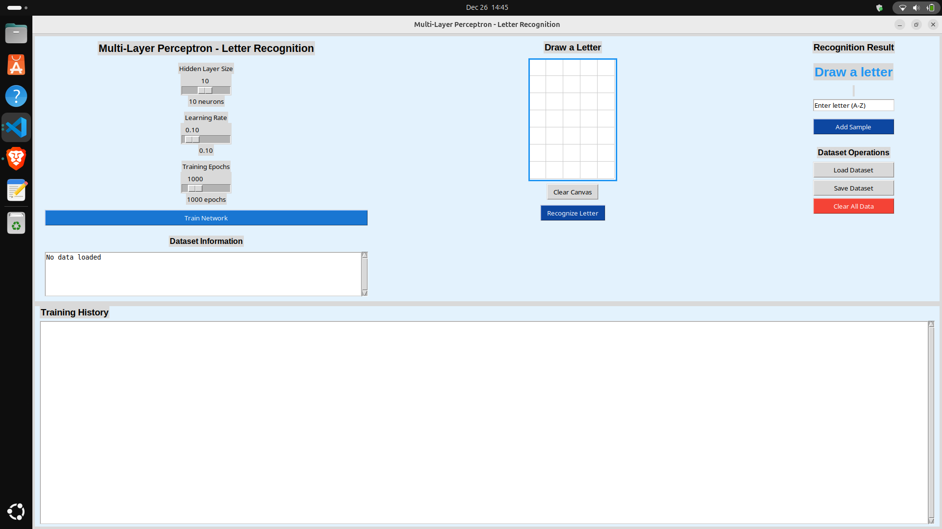

Training: to reocognize letter T.
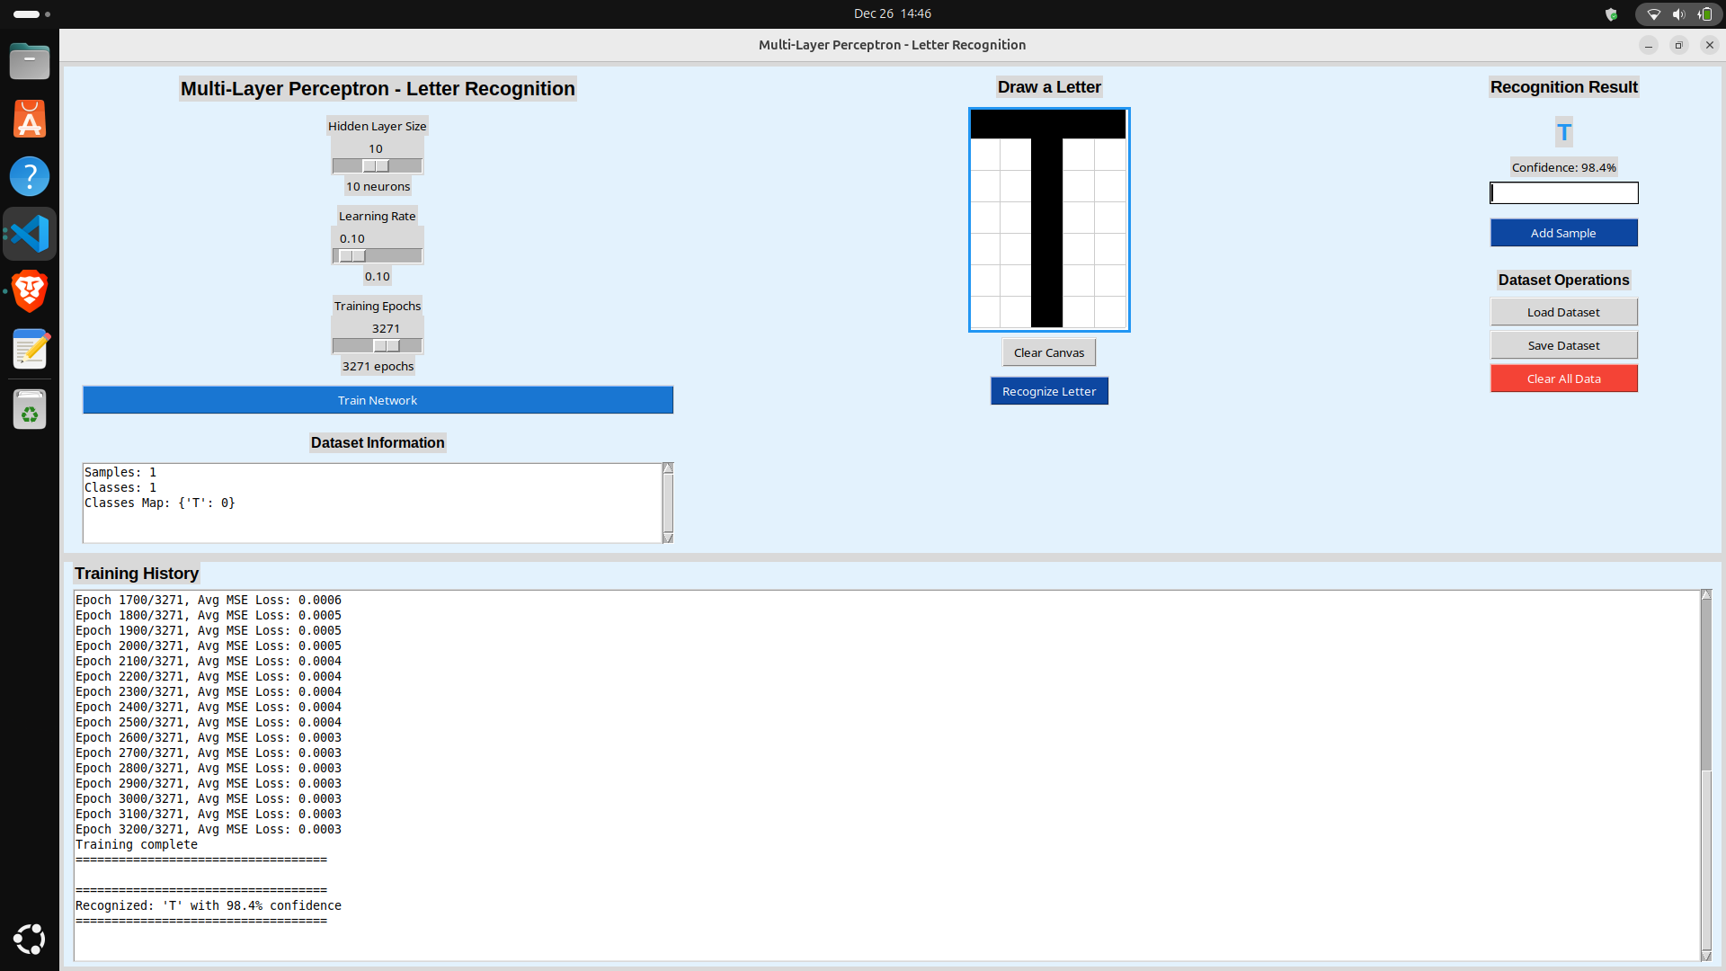

COLLEGE OF ENGINEERING & INFORMATION TECHNOLOGY
First Semester, Academic Year 2025-2026

CS 315: ELECTIVE 2 (INTELLIGENT SYSTEM)
Rubric – Laboratory Simulation on Artificial Neural Networks
Total Points: 100

Criteria | Weight | 4 - Excellent  (100) | 3 - Very Good  (85) | 2 - Satisfactory  (70) | 1 - Needs Improvement  (55) | Rating
Correctness of Simulation Results | 40% | Simulation results are highly accurate; SLP/MLP models run correctly; outputs (accuracy, predictions, loss curves) match expected behavior. | Results mostly accurate with minor inconsistencies; simulations generally correct. | Partially correct results; some errors in training, evaluation, or output interpretation. | Major errors or incomplete results; simulations fail to produce meaningful outputs.
Proper Application of ANN Concepts | 30% | Excellent use of ANN principles: correct architecture, activation functions, training parameters, and reasoning behind choices. | Good application with minimal conceptual mistakes or unclear parameter choices. | Basic application with some conceptual gaps; incorrect or unjustified parameters. | Weak understanding of ANN concepts; incorrect architecture or missing foundational elements.
Clarity in Reporting Results | 20% | Report is very clear, well-structured, complete; includes visuals (graphs/tables) and strong explanations. | Report is clear and organized but may lack some detail or refinement. | Report is understandable but lacks clarity, organization, or supporting visuals. | Report is poorly written, unclear, or incomplete; hard to interpret results.
Timely Submission | 10% | Submitted on or before the deadline. | 1–2 days late | 3–5 days late | More than 5 days late
TOTAL
Remarks:

Prepared by:
MONALEE A. DELA CERNA, DIT
Faculty, CCIS

