**NLP PROJECT REPORT ……………………ON**

**“TEXT SUMMARIZATION”**

**SUBMITTED IN PARTIAL FULFILMENT OF THE REQUIREMENTS OF DEGREE OF**

**BACHELOR OF ENGINEERING BY**

**PRANAV NAGE - 15**

**VINYAS HEGDE - 07**

**YUKTA DIVAKAR -06**

## SUPERVISOR

**Ms. AKANKSHA PATIL**



## DEPARTMENT OF COMPUTER ENGINEERING

**PILLAI HOC COLLEGE OF ENGINEERING AND TECHNOLOGY, PILLAI HOCL EDUCATIONAL CAMPUS, HOCL COLONY, RASAYANI, TAL: KHALAPUR, DIST: RAIGAD, 410207 UNIVERSITY OF MUMBAI**

**[2024-25]**



**Mahatma Education Society’s**

**Pillai HOC College of Engineering and Technology, Rasayani-410207**

**2024-25**

**Certificate**

This is to certify that the IOT Project Report entitled **“TEXT SUMMARIZATION”** is a bonafide work of **Pranav Nage(15), Vinyas Hegde (07), Yukta Divakar(06)** submitted to the University of Mumbai in partial fulfillment of the requirement for the award of the degree of **“Undergraduate”** in **“Computer Engineering”.**

### Ms. Akanksha Patil

(Supervisor)

We declare that this written submission represents our ideas in our own words and where others ideas or words have been included. We have adequately cited and referenced the original sources. We also declare that we have adhered to all principles of academic honesty and integrity and have not misrepresented or fabricated or falsified any idea/data/fact/source in our submission. We understand that any violation of the above will because for disciplinary action by the Institute and can also evoke penal action from the sources which have thus not been properly cited or from whom proper permission has not been taken when needed.

## Pranav Nage

**Vinyas Hegde**

**Yukta Divakar**

## Date:

**Abstract**

This project implements an advanced text summarization system utilizing the BART Seq2Seq model, renowned for its state-of-the-art performance in natural language processing tasks. The system processes input text through a comprehensive pipeline that includes text preprocessing, sentence tokenization, and feature extraction. By leveraging the capabilities of the BART model, the system generates coherent and contextually relevant summaries, effectively condensing large volumes of information into concise formats. The user-friendly interface allows users to input text and receive summaries, enhancing information accessibility and comprehension. This project demonstrates the efficacy of modern neural network architectures in transforming text summarization tasks, paving the way for further research and application in the field of automated content generation.

**i**

|  |  |  |
| --- | --- | --- |
| **Figure No.** | **Figure Name** | **Page No.** |
| Fig 4.2.1 | Block Diagram | **14** |
| Fig 4.2.2 | Flow Diagram | **15** |
| Fig 4.2.3 | Sequence Diagram | **16** |

**ii**

|  |  |
| --- | --- |
| **Table of Contents** | |
| **Content** | **Page No.** |
| **Abstract** | **i** |
| **List of Figures** | **ii** |
| **Chapter 1: Introduction** | **1** |
| 1.1 Introduction | **2** |
| 1.2 Background | **3** |
| 1.3 Motivation | **5** |
| **Chapter 2: Literature Survey** | **6** |
| 2.1 Basic Terminologies | **7** |
| 2.2 Existing System | **8** |
| 2.3 Problem Statement | **9** |
| **Chapter 3: Requirement Gathering** | **10** |
| 3.1 Software and Hardware Requirements | **11** |
| **Chapter 4: Plan of Project** | **12** |
| * 1. Method of Work   2. Proposed System Architecture | **13**  **14** |
| **Chapter 5: Conclusion**  5.1 Conclusion | **17**  **18** |
| **References** | **19** |

**Chapter 1 Introduction**

**1.1 INTRODUCTION**

The rapid advancement of technology and the digitalization of information have led to an explosion in the volume of text data being generated daily. From news articles to social media posts, scientific papers, and business reports, the sheer amount of text that individuals and organizations need to process has become overwhelming. In such a scenario, automatic text summarization has emerged as an essential tool to condense large volumes of text into more manageable summaries, allowing users to extract the most critical information without reading entire documents.

Over the years, a variety of methods have been employed for text summarization. Early approaches relied on rule-based systems or statistical methods such as term frequency-inverse document frequency (TF-IDF) to identify key sentences. While effective for short texts, these methods struggled with long documents, context, and meaning. More recently, machine learning and deep learning techniques, particularly with the introduction of transformer-based models, have revolutionized the field of Natural Language Processing (NLP). Transformers have enabled significant improvements in various NLP tasks, including translation, question answering, and summarization, due to their ability to model long-range dependencies in text.This project aims to implement an abstractive text summarization system using the BART Seq2Seq model, showcasing its ability to summarize long documents while retaining state-of-the-art performance. The model's architecture, which utilizes both encoder-decoder capabilities, allows it to handle large datasets and generate meaningful, human-like summaries. With applications ranging from news aggregation to scientific research, text summarization is a crucial task that enables users to navigate vast amounts of information quickly and efficiently.

.

**1.2 BACKGROUND**

In In the modern era of digital communication, the sheer volume of textual data being generated and consumed is unprecedented. With the rise of social media platforms, news outlets, scientific publications, and various other forms of written content, individuals are constantly faced with the challenge of efficiently processing vast amounts of information. This explosion of data has made it more difficult to keep up with the rapid flow of information, leading to an increased demand for tools that can assist in summarizing content without losing critical meaning. Text summarization has emerged as a key technology in addressing this issue by enabling users to condense lengthy documents into shorter, more digestible versions.Text summarization is broadly categorized into **extractive** and **abstractive** approaches. Extractive summarization focuses on identifying and extracting key sentences or phrases from the original text to form a summary. This method, while effective, can often lead to summaries that are disjointed or lack coherence, as the sentences are directly pulled from different parts of the document without modification. In contrast, **abstractive summarization** generates new sentences that paraphrase the original text. This allows for more fluid, human-like summaries but poses greater technical challenges due to the complexity of generating natural language that captures the full meaning of the source material.

Over the years, various models and techniques have been developed to address the challenge of abstractive summarization. Early approaches relied heavily on rule-based and statistical methods, such as TF-IDF (Term Frequency-Inverse Document Frequency) and latent semantic analysis, which lacked the ability to generate coherent, contextually relevant summaries. These methods struggled with understanding the nuances of language, including syntax, grammar, and long-range dependencies within text, making them less effective for more complex summarization tasks.

The breakthrough came with the introduction of the **Transformer architecture** by Vaswani et al. in 2017. Transformers revolutionized the field of NLP by enabling models to process entire input sequences simultaneously, thanks to their self-attention mechanism. This innovation allowed for better handling of long-range dependencies and context, paving the way for more advanced NLP models like **BERT** (Bidirectional Encoder Representations from Transformers), **GPT** (Generative Pre-trained Transformer), and ultimately **BART** (Bidirectional and Auto-Regressive Transformers).BART, developed by Facebook AI, represents a major advancement in the field of sequence-to-sequence (Seq2Seq) modeling. It is a **denoising autoencoder** designed to generate coherent and contextually relevant text. The BART model is pre-trained by corrupting input text and learning to reconstruct it, making it particularly well-suited for tasks like text generation, translation, and summarization. BART combines both the encoder and decoder architectures of transformer models, making it highly effective for summarization tasks. Unlike earlier models, which struggled with capturing context over longer sequences, BART excels at generating high-quality, human-like summaries while retaining the most important aspects of the original content.

**Functionality and Features**

This text summarization system will be designed to accept long documents as input and automatically generate concise summaries that capture the essence of the content. Key features of the system include:

1. **Abstractive Summarization**: The system will use the BART model to generate new sentences that paraphrase the original text, ensuring that the summaries are coherent and contextually relevant.
2. **Pre-trained Model**: The project will leverage a pre-trained BART model, fine-tuning it on a summarization dataset to optimize its performance for the task at hand.
3. **ROUGE Evaluation**: Summaries will be evaluated using ROUGE scores to ensure their quality and relevance to the original text.

**Significance**

The significance of this project lies in its ability to enhance information accessibility and reduce the cognitive load associated with processing large volumes of text. By providing high-quality, human-like summaries, the BART model helps users navigate vast amounts of information more efficiently. Whether in academic research, news aggregation, or business reports, text summarization tools play a critical role in helping individuals and organizations make informed decisions without spending hours reading through lengthy documents.

In conclusion, this project represents a meaningful contribution to the field of NLP by advancing the capabilities of automatic text summarization. By utilizing the BART model's powerful Seq2Seq architecture, the project aims to achieve state-of-the-art performance in generating concise, coherent, and contextually accurate summaries, addressing the limitations of traditional summarization methods.

**1.3 MOTIVATION**

The motivation behind this project is driven by the growing need to efficiently process large volumes of text and distill them into concise and coherent summaries. With the vast amount of textual information available today, from research articles to news reports and user-generated content, it has become increasingly challenging for individuals and organizations to quickly find relevant information. Manual summarization is time-consuming and often impractical for long documents or large datasets.The advent of deep learning and transformer-based models, particularly BART, has provided a powerful tool to automate the summarization process. This project aims to harness the potential of BART for state-of-the-art text summarization, addressing the limitations of traditional methods and offering a scalable solution to the problem of information overload.

The choice of the BART model is motivated by its superior performance in various NLP tasks, including summarization, where it has outperformed many of its predecessors. The ability of BART to generate fluent, meaningful, and contextually accurate summaries makes it an ideal candidate for this project. Additionally, the transformer architecture's capacity to model long-range dependencies in text ensures that the generated summaries are both informative and concise, even for lengthy documents.

**Chapter 2**

**Literature Survey**

**2.1 BASIC TERMINOLOGIES**

1. **NLP (Natural Language Processing)**: AI field enabling computers to understand and process human language.
2. **BART**: A Seq2Seq model for text generation tasks like summarization.
3. **Seq2Seq**: A model that converts an input sequence into an output sequence.
4. **Transformer Architecture**: A neural network design using self-attention for parallel sequence processing.
5. **Abstractive Summarization**: Summarization by generating new sentences that paraphrase the original text.
6. **Extractive Summarization**: Summarization by selecting key sentences from the text.
7. **Self-Attention**: A mechanism that helps models focus on different parts of the input sequence.
8. **ROUGE**: A metric for evaluating summaries by comparing them to reference summaries.
9. **Pre-trained Model**: A model trained on a large dataset, later fine-tuned for specific tasks.
10. **Fine-tuning**: Training a pre-trained model further on a specific dataset to improve performance.

**2.2 EXISTING SYSTEM**

In the field of text summarization, several models and techniques have been developed to address the growing need for concise and accurate summaries of lengthy texts. Current systems use either **extractive** or **abstractive** methods for summarization:

1. **Extractive Models**: These models focus on selecting and extracting key sentences from the original text to form a summary. Popular tools include:
   * **LexRank**: A graph-based approach that ranks sentences by their similarity to identify key information, but it may produce disjointed summaries.
   * **TextRank**: Similar to LexRank, it ranks the importance of sentences in a document, but often leads to summaries that lack coherence.
2. **Abstractive Models**: These generate new sentences by paraphrasing the original content. Some prominent systems include:
   * **Seq2Seq LSTM Models**: Early neural networks that generate summaries, but they often struggle with long sequences and context retention.
   * **GPT-based Models**: Generate high-quality text but may require large amounts of data for fine-tuning.
3. **Hybrid Approaches**: Some systems attempt to combine both extractive and abstractive techniques to improve coherence and accuracy but can be computationally expensive.

**Limitations of Existing Systems**

* **Coherence**: Extractive models often produce summaries that feel disjointed and lack fluidity.
* **Context Understanding**: Many models struggle with long-range dependencies, leading to incomplete summaries.
* **Customization**: Most systems do not allow users to adjust summaries based on specific needs or preferences.
* **Computational Cost**: Abstractive models, especially transformer-based ones, can require significant computational resources for fine-tuning and inference.

**2.3 PROBLEM STATEMNET**

In today's information-rich world, individuals and organizations often need to process large volumes of text quickly and efficiently. Summarizing lengthy documents manually can be time-consuming, while existing automated summarization systems face significant limitations in terms of coherence, context understanding, and ease of use. Extractive systems often produce fragmented summaries, while abstractive models, though more flexible, struggle with long-range dependencies and require substantial computational resources. Moreover, many current systems lack customization options and are not easily adaptable to specific user needs.

This project aims to address these challenges by developing an abstractive text summarization system using the **BART Seq2Seq model**. By leveraging advanced transformer-based techniques, this project seeks to produce summaries that are both coherent and contextually relevant, while reducing computational costs. The system will focus on delivering high-quality, customizable summaries that cater to a wide range of applications, from academic research to business reports, enhancing the overall user experience.

.

**Chapter 3**

**Requirement Gathering**

**3.1 SOFTWARE AND HARDWARE REQUIREMENT**

**Software**:

1. **Python**:
   * Python is the chosen programming language due to its extensive support for NLP libraries and ease of integration with machine learning frameworks.
2. **Hugging Face Transformers**:
   * This library is used to access pre-trained models like BART for text summarization, providing state-of-the-art transformer models for NLP tasks.
3. **PyTorch**:
   * PyTorch is used as the deep learning framework for model implementation, allowing for flexible and efficient training and fine-tuning of the BART model.
4. **Google Colab**:
   * The project is developed and tested using Google Colab, a cloud-based Jupyter notebook environment offering GPU acceleration, making it ideal for training models without local hardware requirements.

**Hardware**:

1. **Standard Personal Computer/Laptop**:
   * A standard PC or laptop with at least 4GB RAM was used for basic development tasks. Heavy computation tasks were handled using Colab's cloud infrastructure.
2. **GPU (Google Colab)**:
   * Google Colab's GPU support was utilized for training and running the BART model efficiently, speeding up computations.
3. **Internet Access**:
   * A stable internet connection was necessary for using Google Colab and accessing model weights and datasets from online sources.

**Chapter 4**

**Plan of Project**

**4.1 METHOD OF WORK**

• **Requirement Analysis**

The initial phase focused on identifying the core features necessary for effective text summarization, such as:

* Generating concise summaries from long documents.
* Preserving the essential meaning of the text while reducing length.
* Handling both extractive and abstractive summarization.
* Ensuring the system works on various types of text (articles, reports, etc.).

• **Tool Selection**

After understanding the requirements, we selected BART from Hugging Face's model repository as the primary model for text summarization due to its high performance on abstractive tasks. Python was chosen for development because of its strong ecosystem for machine learning and NLP tasks, and Google Colab was used as the development environment due to its GPU support and cloud-based resources.

• **Text Preprocessing**

Before summarization, the input text was preprocessed to improve the model’s performance:

* **Tokenization**: The text was tokenized into sentences and words to manage text more efficiently during model training and prediction.
* **Cleaning**: The text was cleaned by removing special characters and extra spaces to avoid errors during summarization.

• **Model Implementation and Summarization**

The core summarization functionality was implemented using the BART model:

* **Training**: Pre-trained BART was fine-tuned on specific datasets to improve summarization quality.
* **Abstractive Summarization**: The model generated new sentences that paraphrased the key points of the input text.
* **Extractive Summarization**: Although primarily focused on abstractive summarization, extractive techniques were also considered by selecting key sentences.

• **Summary Output and Evaluation**

* **Generated Summary**: The model produced a condensed version of the original text while preserving the main ideas.
* **Evaluation**: The quality of the generated summaries was measured using metrics like ROUGE, comparing them with human-created summaries to assess accuracy and relevance.

#### .4.2 PROPOSED SYSTEM ARCHITECTURE

**BLOCK DIAGRAM:**

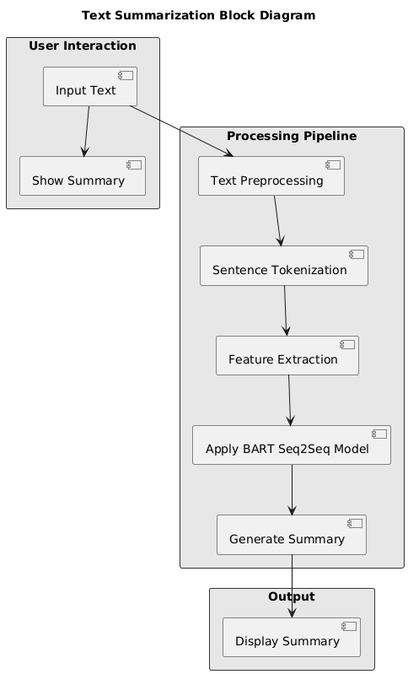

*Fig.4.2.1*

**FLOW DIAGRAM:**

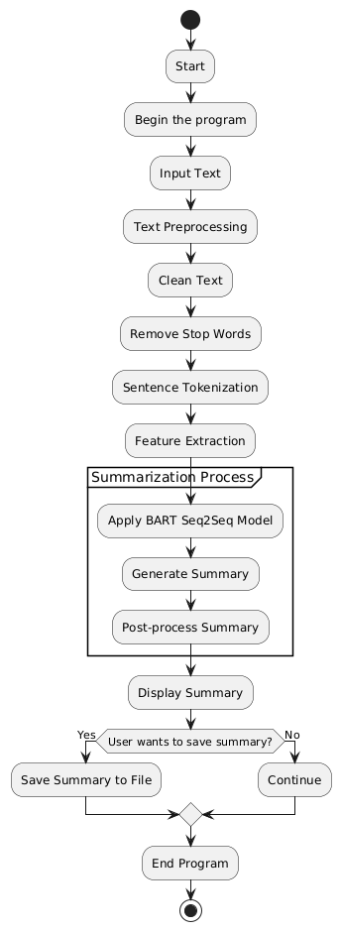

*Fig.4.2.2*

**SEQUENCE DIAGRAM:**

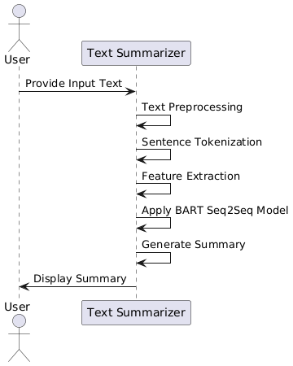

*Fig.4.2.3*

**Chapter 5**

**Conclusion**

**5.1 CONCLUSION**

This project successfully demonstrates the implementation of an advanced text summarization system using the BART Seq2Seq model, a state-of-the-art solution for abstractive summarization. By leveraging transformer architecture, the model is capable of generating coherent and concise summaries that retain the essential meaning of the original text. The project highlights the significance of NLP techniques in processing large volumes of data, making information more accessible and digestible.

In conclusion, this project contributes to the growing field of natural language processing by offering a reliable and scalable solution for summarization tasks. The potential applications of this system span across various domains, including education, research, and business, where rapid and accurate information processing is essential. Future enhancements may involve extending the model’s capabilities to handle more specialized texts or improving its efficiency for real-time applications.

**REFERENCES**

* Lewis, M., Liu, Y., Goyal, N., et al. (2020). BART: Denoising Sequence-to-Sequence Pre-training for Natural Language Generation, Translation, and Comprehension. arXiv preprint arXiv:1910.13461.
* Raffel, C., Shazeer, N., Roberts, A., et al. (2020). Exploring the Limits of Transfer Learning with a Unified Text-to-Text Transformer. arXiv preprint arXiv:1910.10683.
* Vaswani, A., Shazeer, N., Parmar, N., et al. (2017). Attention Is All You Need. In Advances in Neural Information Processing Systems (NIPS).
* Devlin, J., Chang, M. W., Lee, K., & Toutanova, K. (2019). BERT: Pre-training of Deep Bidirectional Transformers for Language Understanding. In Proceedings of the 2019