Task 1: 8-Puzzle
Description:
This project implements an A* search algorithm to solve the 3x3 8-Puzzle from randomly generated start states. Before executing the search, the system performs a mathematical solvability check to ensure the generated puzzle is valid. The search engine evaluates paths using two different heuristics: the Hamming distance, which counts the number of misplaced tiles, and the Manhattan distance, which calculates the total grid steps tiles must move to reach the goal state. Finally, the algorithm's complexity is benchmarked across 100 random searches, measuring both computation time and memory usage (expanded nodes) to evaluate the efficiency of each heuristic.

Software architecture diagram:
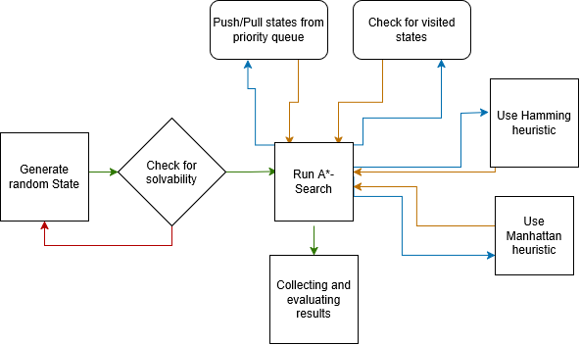

Modules and interfaces:
row_calc(index)
- Function: Calculates the row within the 3x3 grid.
- Inputs: Array index for a number on the grid.
- Outputs: Row number.
col_calc(index)
- Function: Calculates the column within the 3x3 grid.
- Inputs: Array index for a number on the grid.
- Outputs: Column number.
get_neighbors(state)
- Function: Generates all valid next states by sliding the blank tile.
- Inputs: state (tuple representing the 3x3 board).
- Outputs: list of tuples (all valid adjacent states).
checkSolvability(start_state)
- Function: Calculates solvability of the starting grid using inversion count.
- Inputs: starting state of grid.
- Outputs: Boolean based on calculation.
a_star_search(start_state, heuristic_function)
- Function: Main puzzle solving function, running a loop until the final result is reached.
- Inputs: starting state of grid and which heuristic function is to be used.
- Outputs: Number of nodes tested, and if goal is reached also amount of tiles moved to reach goal.
heuristic_hamming(state)
- Function: Calculates the Hamming distance by counting how many tiles are not in their correct position. Blank tile (0) is ignored.
- Inputs: state (current 3x3 board state).
- Outputs: misplaced_count (sum of misplaced tiles).
heuristic_manhatten(state)
- Function: Calculates the Manhattan distance by summing vertical and horizontal distances of each tile to its target position. Blank tile (0) is ignored.
- Inputs: state (current 3x3 board state).
- Outputs: total_distance (sum of all Manhattan distances).

Design decisions:
State Representation (Tuples vs. Lists): Board states are represented as immutable tuples rather than mutable lists. Immutability is a strict requirement for Python hashing, which is necessary to store the states in a set. A flat 1D structure was chosen over a 2D array (matrix) to simplify index mathematics for grid movements and to minimize memory overhead during state generation.
Visited States Tracking (Hash Sets): A Python set() is utilized to track all previously visited board states. Because the A* algorithm evaluates thousands of nodes, checking if a state has already been explored is a very frequently executed operation. A set is superior to a list for tracking visited states because checking if an item exists in a set is practically instant, regardless of how much data it holds
Priority Queue: The collection of unexplored states is managed using Python's heapq module, which implements a binary min-heap. A* search requires continuously extracting the state with the lowest total cost. heapq executes this extraction and inserts new neighbours, while ensuring the core search loop remains highly performant even when the queue scales to thousands of nodes.
Pre-Search Solvability Validation: An inversion counting algorithm is executed before initializing the search loop to mathematically prove solvability via parity. This architectural decision acts as a fail-safe, preventing the algorithm from blindly searching an impossible state space and ultimately exhausting system memory.

Discussion and conclusions:
Our Experience
Developing this A* search algorithm highlighted the great impact that data structures and heuristic accuracy have on performance. Initially, the sheer size of the 8-puzzle state space was surprising. Implementing the solvability check using inversion parity was a crucial learning step to prevent the algorithm from trying to solve unsolvable grids. The most significant takeaway was observing the performance gap between the two heuristics; Manhattan distance proved far superior because it provides a much more precise estimate of the remaining path, allowing the algorithm to navigate directly toward the goal rather than blindly exploring thousands of dead end paths.
Complexity Comparisons of Different Heuristics
Heuristic | Nodes Expanded (Mean ± StdDev) | Execution Time (Mean ± StdDev)
Hamming | 16,389.53 ± 17,852.10 | 0.04044s ± 0.04610s
Manhattan | 1,707.72 ± 2,092.46 | 0.00586s ± 0.00744s

Conclusion on Complexity: The empirical data demonstrates that the Manhattan heuristic reduces both time and space complexity by a factor of nearly 10 compared to Hamming. Because Manhattan calculates exact grid distances rather than simple binary placement, it creates a much tighter heuristic bound, resulting in significantly fewer expanded nodes, memory usage and faster execution times.
Possible Improvements in Future
- Object-Oriented Refactoring: Currently, the implementation relies on loose functions and passing raw tuples around. A solid structural improvement would be encapsulating the puzzle logic into dedicated Python classes. This would make the codebase cleaner and easier to maintain.
- Adding a Step-by-Step Visualization: The program can currently only output raw performance numbers and node counts to the terminal. Building a simple graphical interface to visually animate the winning path would make it much easier to debug and present how the algorithm actually navigates the grid.

