CA6002 Data Visualisation Assignment Report
Agricultural Variety Classification under Varying Feature Complexities:
Performance Comparison and Visual Analytics of RBF-SVM and Random Forest on Rice & Dry Bean Datasets
Comparative Visual Analytics & Performance Evaluation: RBF-SVM vs. Random Forest
Datasets: UCI Rice (ID: 545) & UCI Dry Bean (ID: 602)
1. Introduction and Project Background
Data visualization plays an indispensable role throughout the development lifecycle of intelligent AI solutions. It facilitates initial dataset exploration, guides algorithm architecture selection, illuminates hyperparameter optimization landscapes, diagnoses model failure modes, and ultimately communicates actionable insights through data storytelling. This study investigates agricultural variety classification using image-derived morphological feature datasets, focusing on how algorithm performance (RBF Support Vector Machine vs. Random Forest) scales across datasets with varying numbers of classes, feature dimensions, and class overlap. The project strictly adheres to the CA6002 Data Visualisation Framework, covering six structured stages.
2. Exploration of Dataset & Feature Visualizations
2.1 Domain Overview & Dataset Characteristics
- Rice Dataset (UCI ID 545): Comprises 3,810 grain instances belonging to 2 varieties (Osmancik: 57.2%, Cammeo: 42.8%). Described by 7 continuous morphological features (Area, Perimeter, Major Axis Length, Minor Axis Length, Eccentricity, Convex Area, Extent). Represents a low-dimensional, binary baseline.
- Dry Bean Dataset (UCI ID 602): Comprises 13,543 cleaned grain instances spanning 7 registered varieties (Dermason, Sira, Seker, Horoz, Cali, Barbunya, Bombay). Described by 16 continuous attributes capturing area, perimeter, axis ratios, roundness, and compactness. Represents a high-dimensional, multi-class benchmark with severe boundary overlaps.
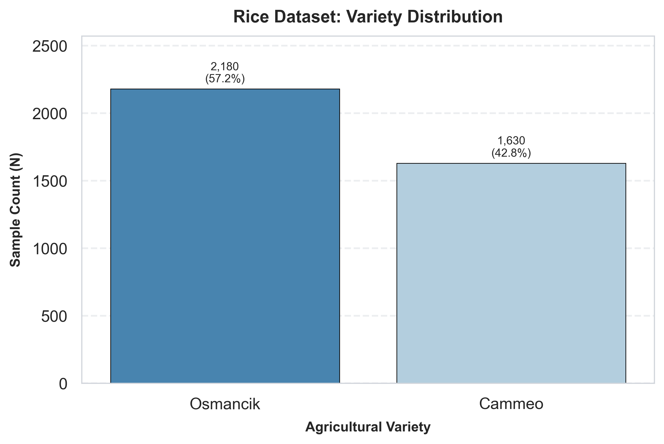
Figure: Rice Variety Distribution & Sample Counts
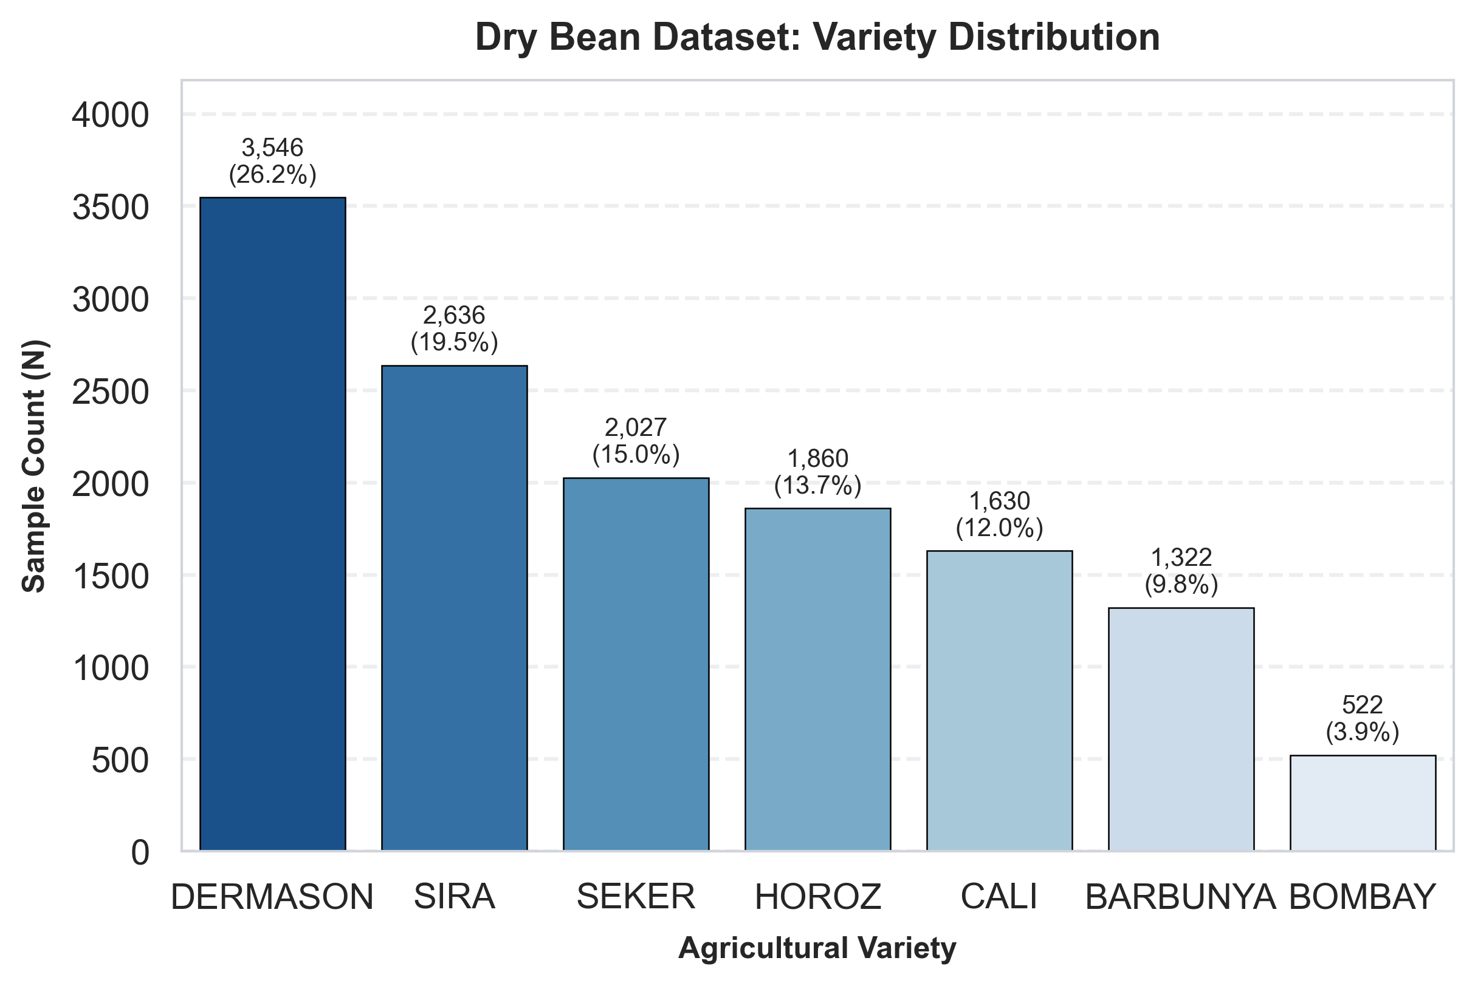
Figure: Dry Bean 7-Variety Proportions & Sample Counts
2.2 Feature Distributions & Multicollinearity Analysis
Feature conditioning involved numeric type coercion, median missing value imputation (0 missing entries found), and deduplication (removing 68 duplicate rows in Dry Bean). Kernel Density Estimation (KDE) distributions indicate right-skewness in dimensional scale features (Area, Perimeter, Convex Area) and multi-modal normal distributions in scale-invariant shape descriptors (Compactness, Aspect Ratio).
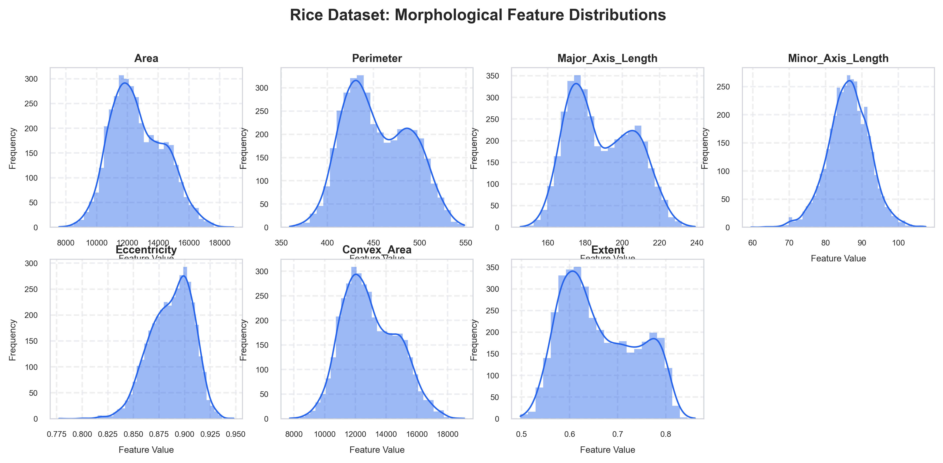
Figure: Rice Feature Histograms with KDE Curves
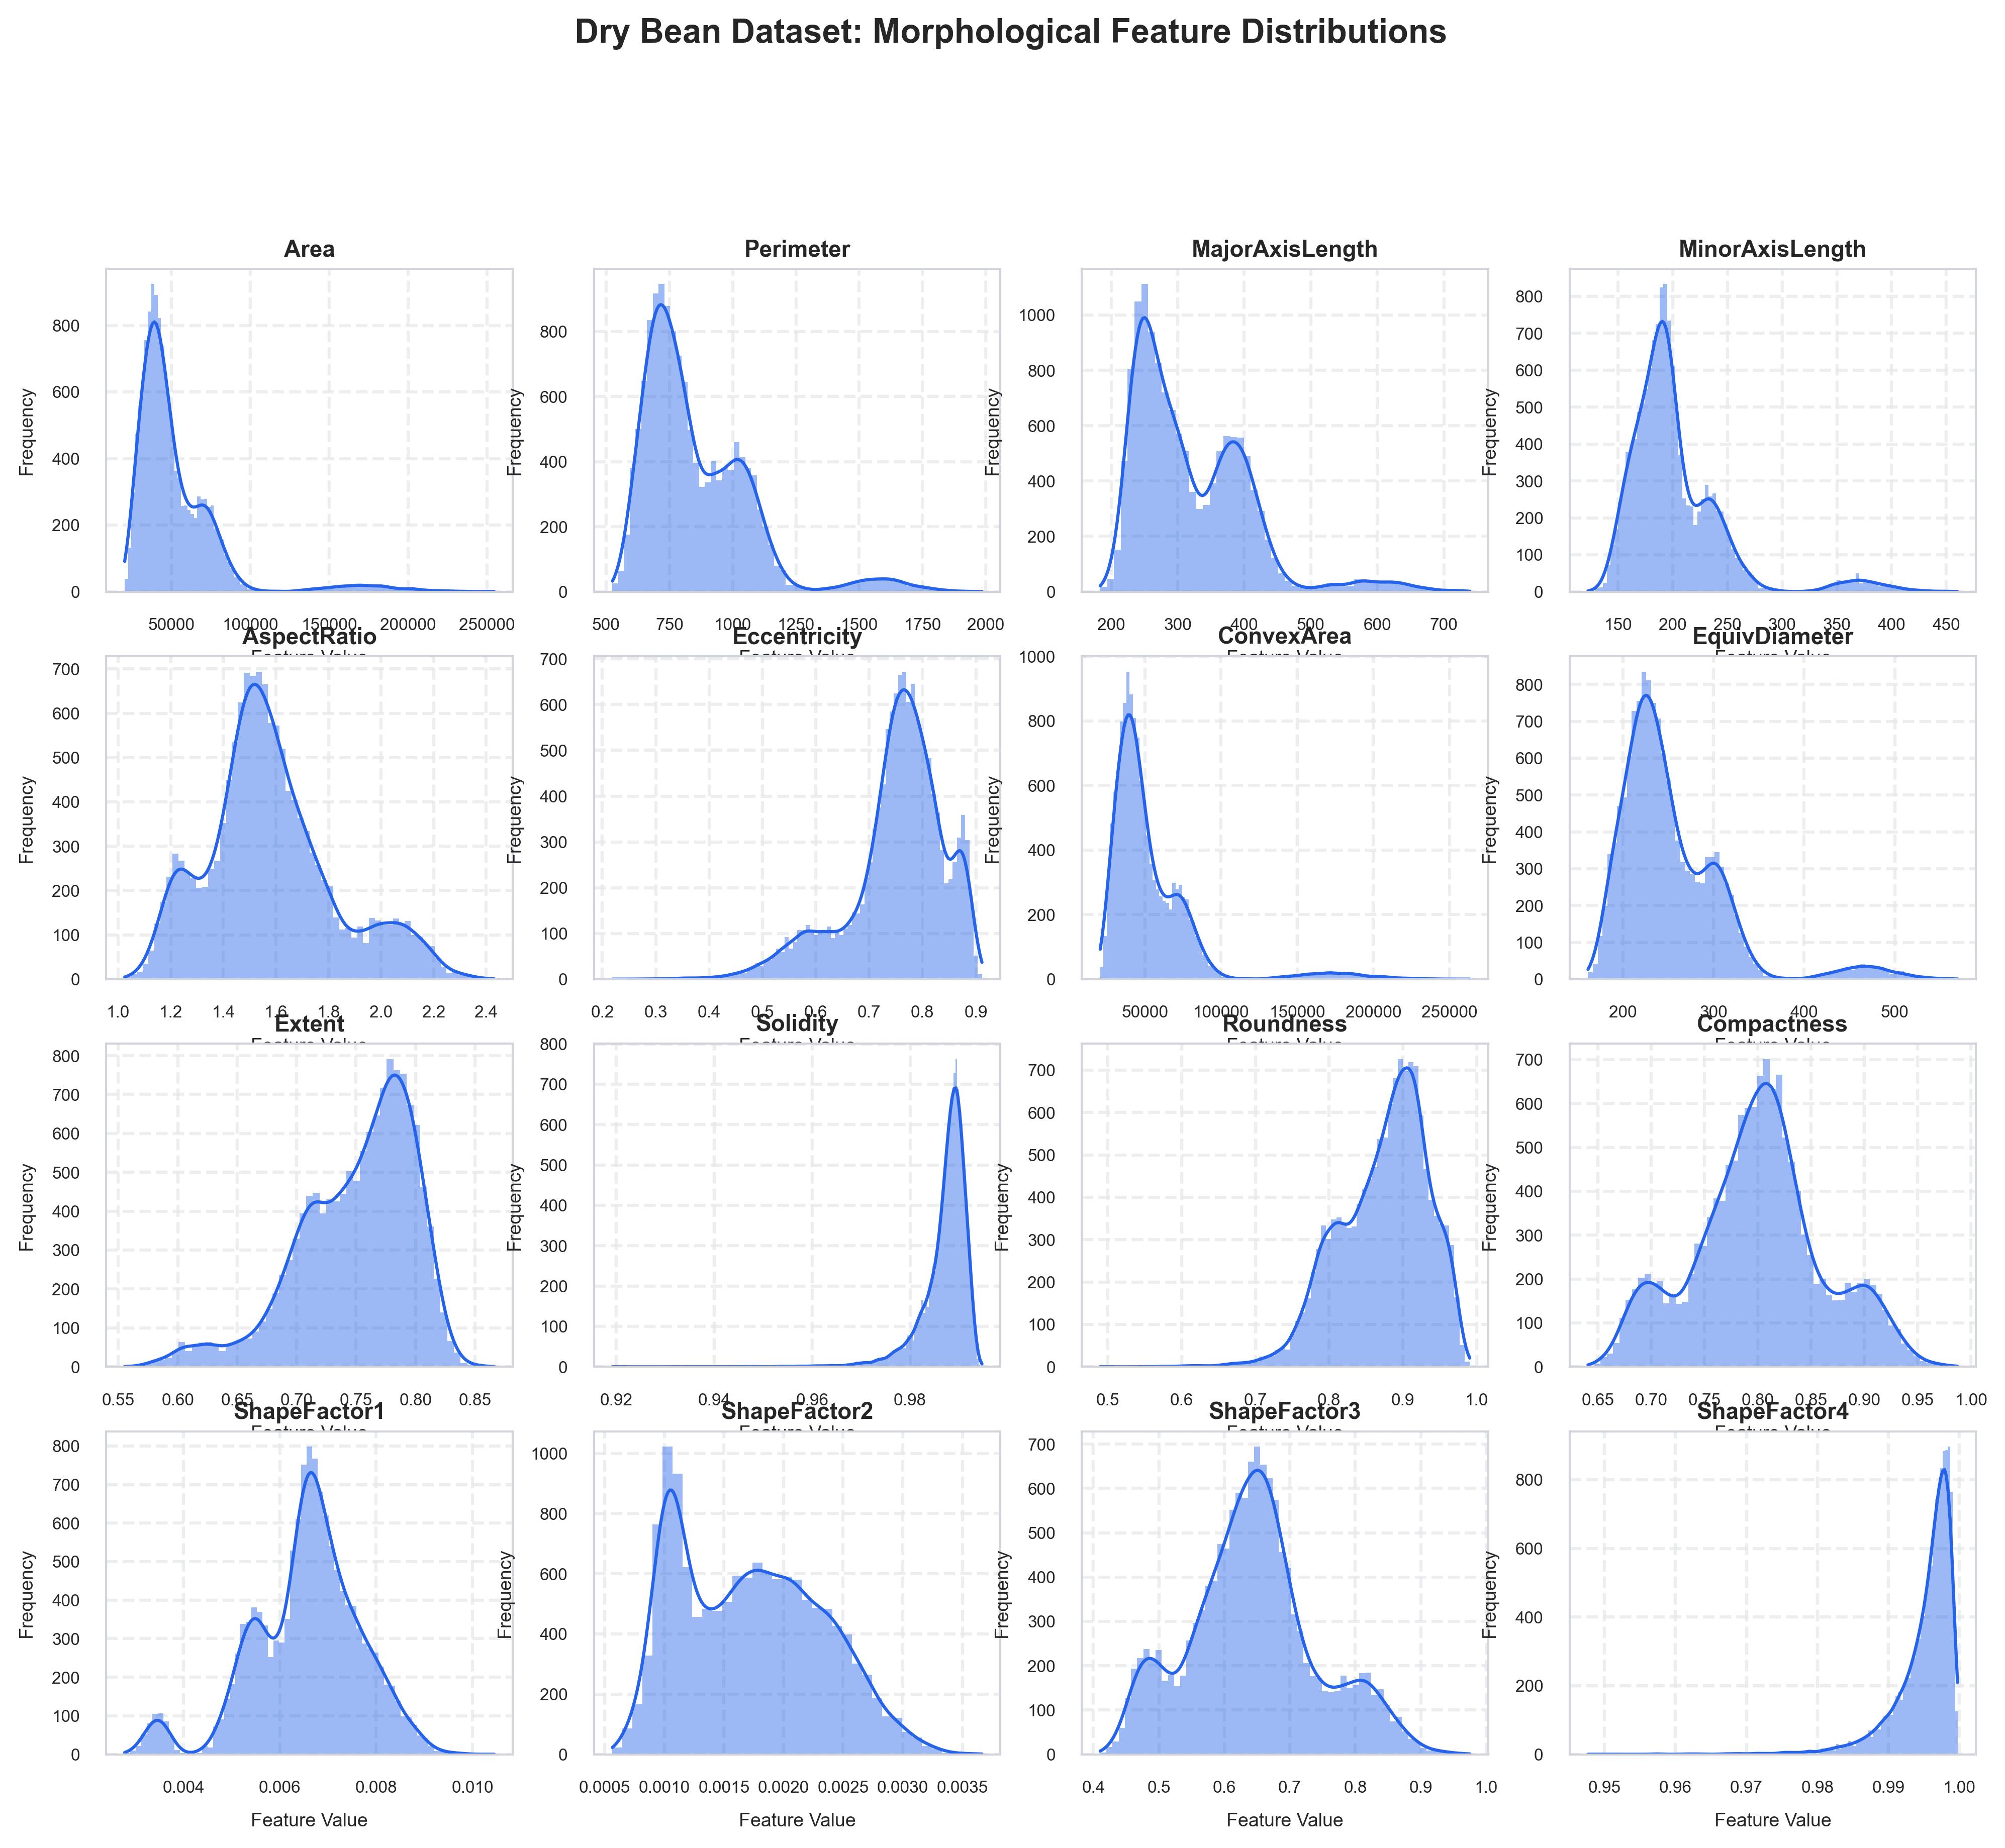
Figure: Dry Bean Morphological Feature Distributions (16 Attributes)
Masked correlation heatmaps reveal severe multicollinearity among linear physical dimensions (Pearson r > 0.95 between Area, Perimeter, Major Axis Length, and Convex Area). Scale-invariant shape indices (Compactness, Solidity, Aspect Ratio) exhibit low correlation with size scale, providing crucial orthogonal discriminative power.
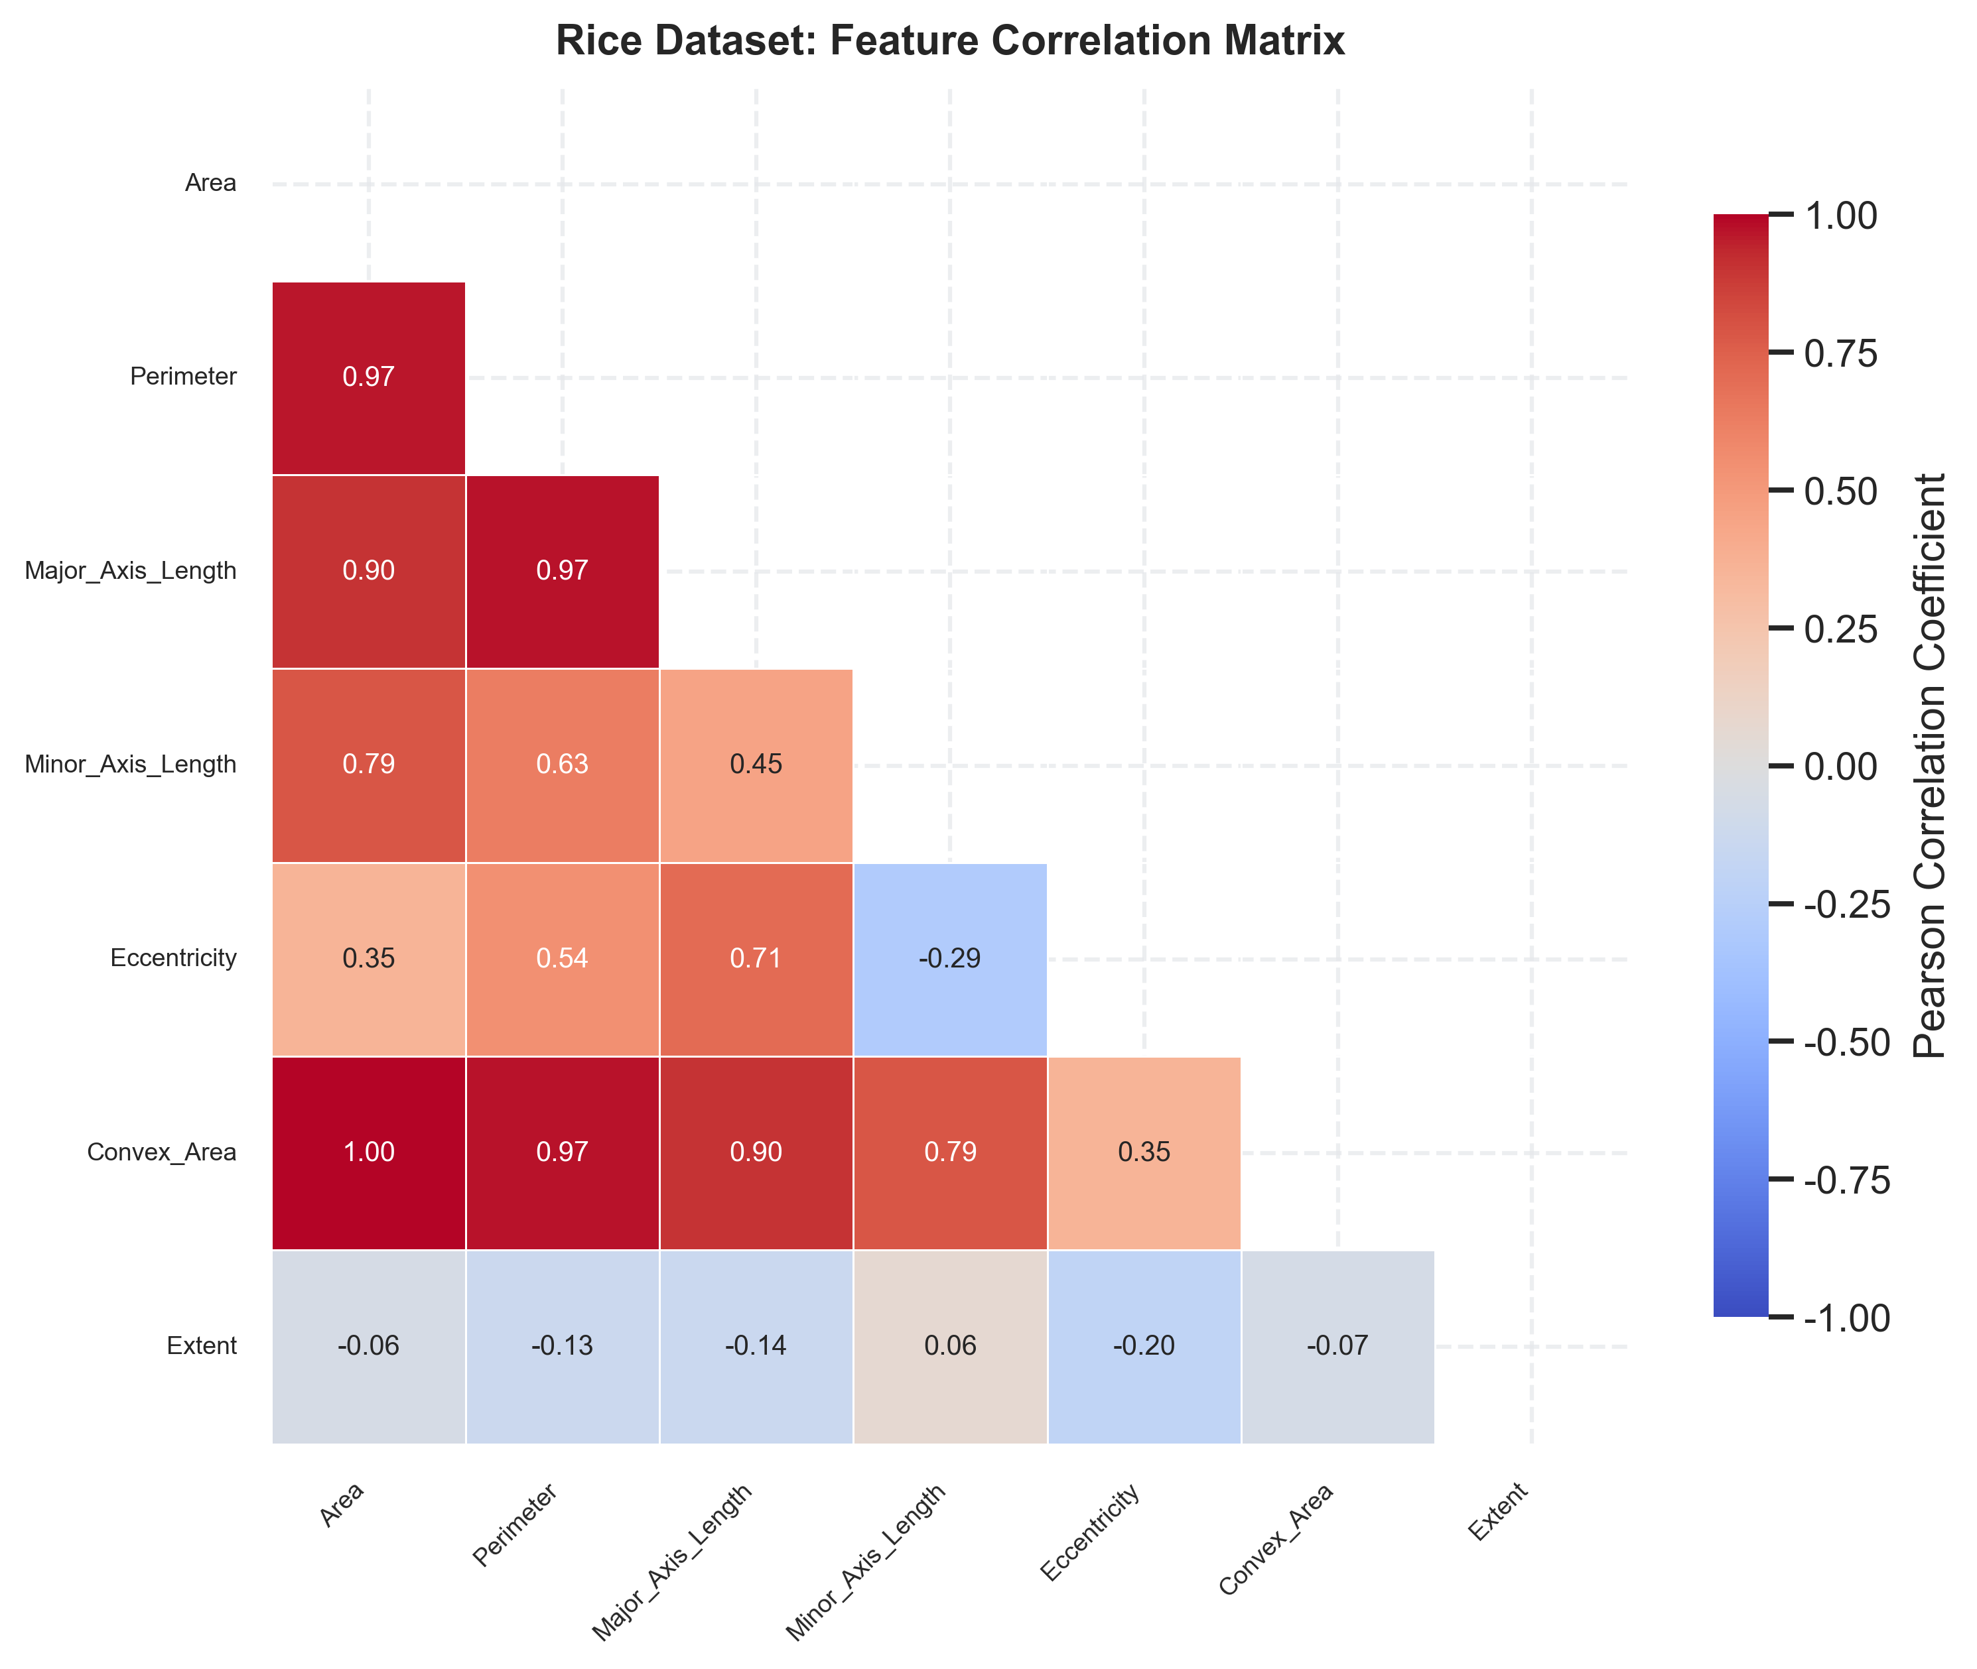
Figure: Rice Masked Feature Correlation Heatmap
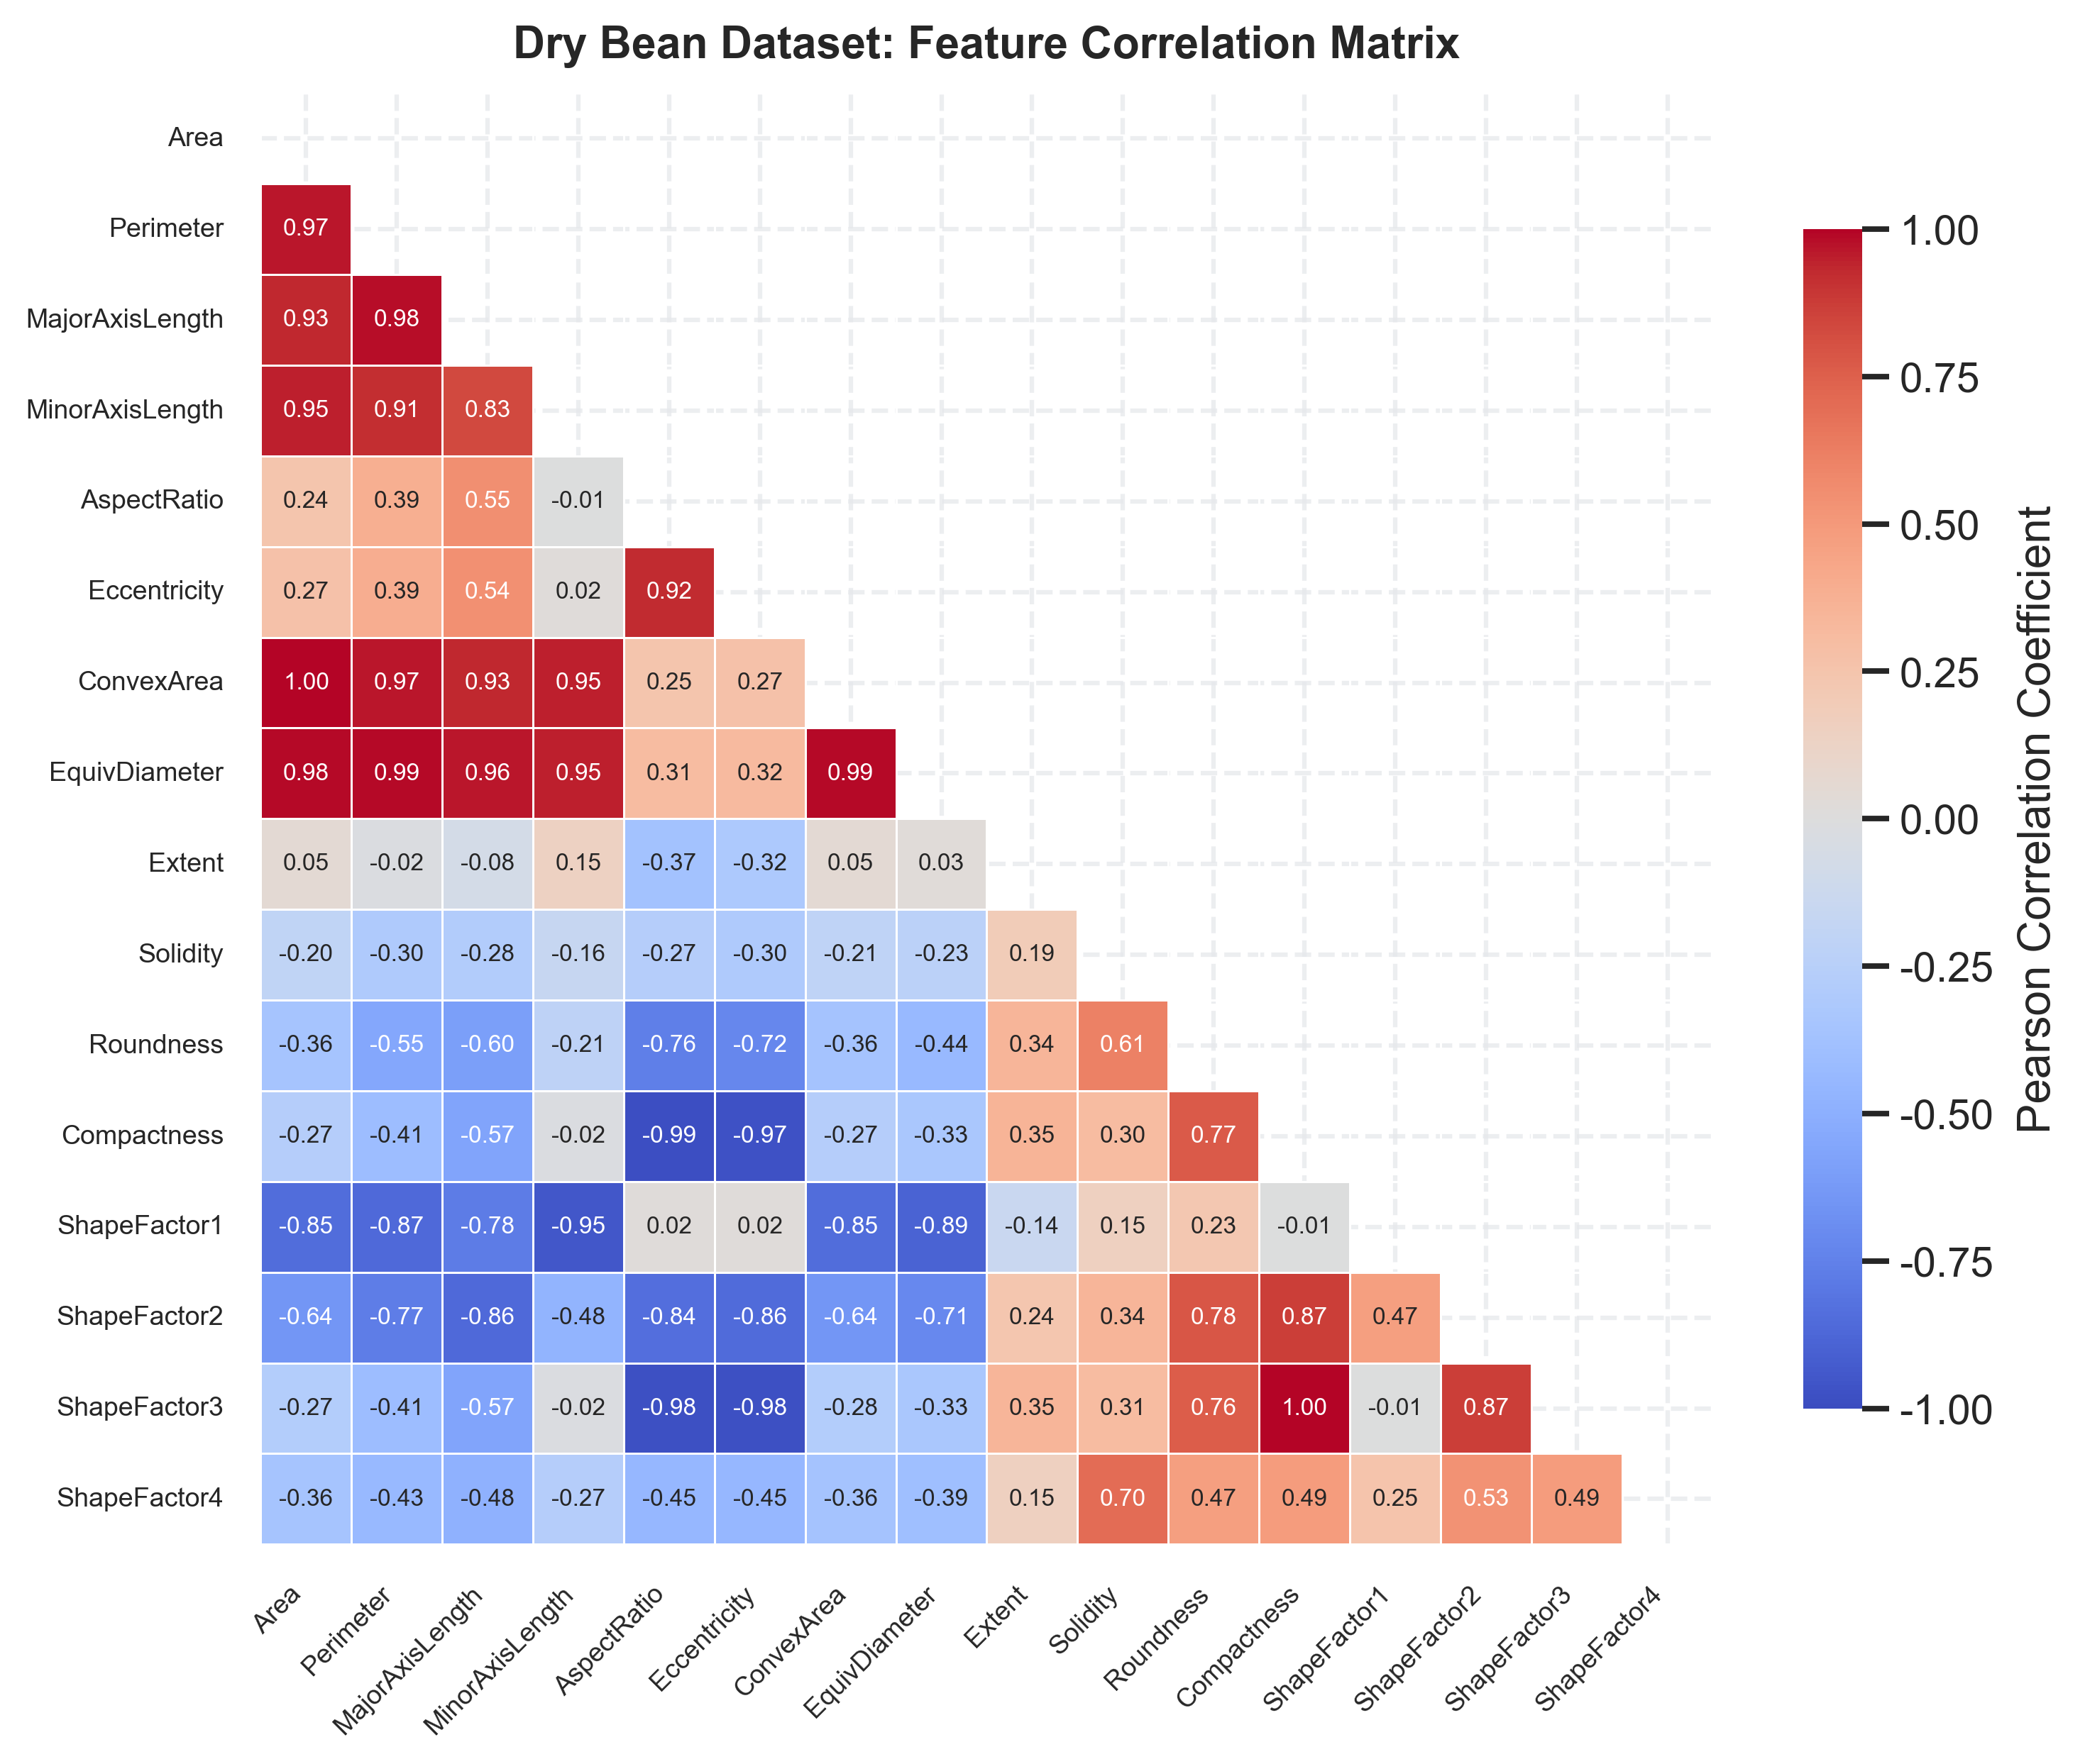
Figure: Dry Bean Masked Feature Correlation Heatmap
2.3 2D PCA Dimensionality Reduction & 95% Confidence Ellipses
StandardScaler normalization followed by 2D PCA projection visualizes class separation. In the Rice dataset, PC1 (70.6%) and PC2 (15.5%) explain 86.1% of total variance, showing clean boundary separation with minimal ellipse overlap between Cammeo and Osmancik. In Dry Bean, PC1 (54.4%) and PC2 (27.2%) explain 81.6% variance. While Bombay forms an isolated cluster, Dermason and Sira display severe cluster overlap, establishing a challenging non-linear boundary requirement.
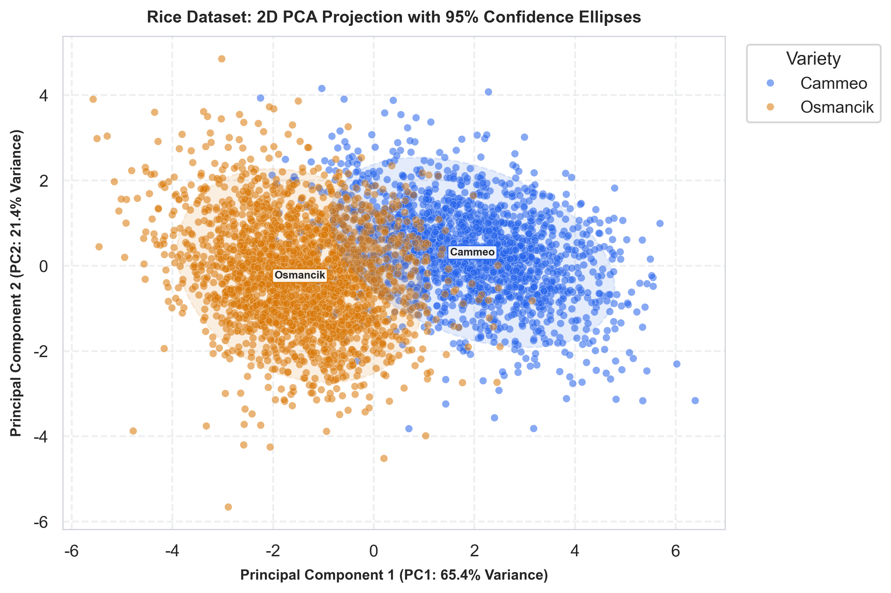
Figure: Rice 2D PCA Projection with 95% Confidence Ellipses
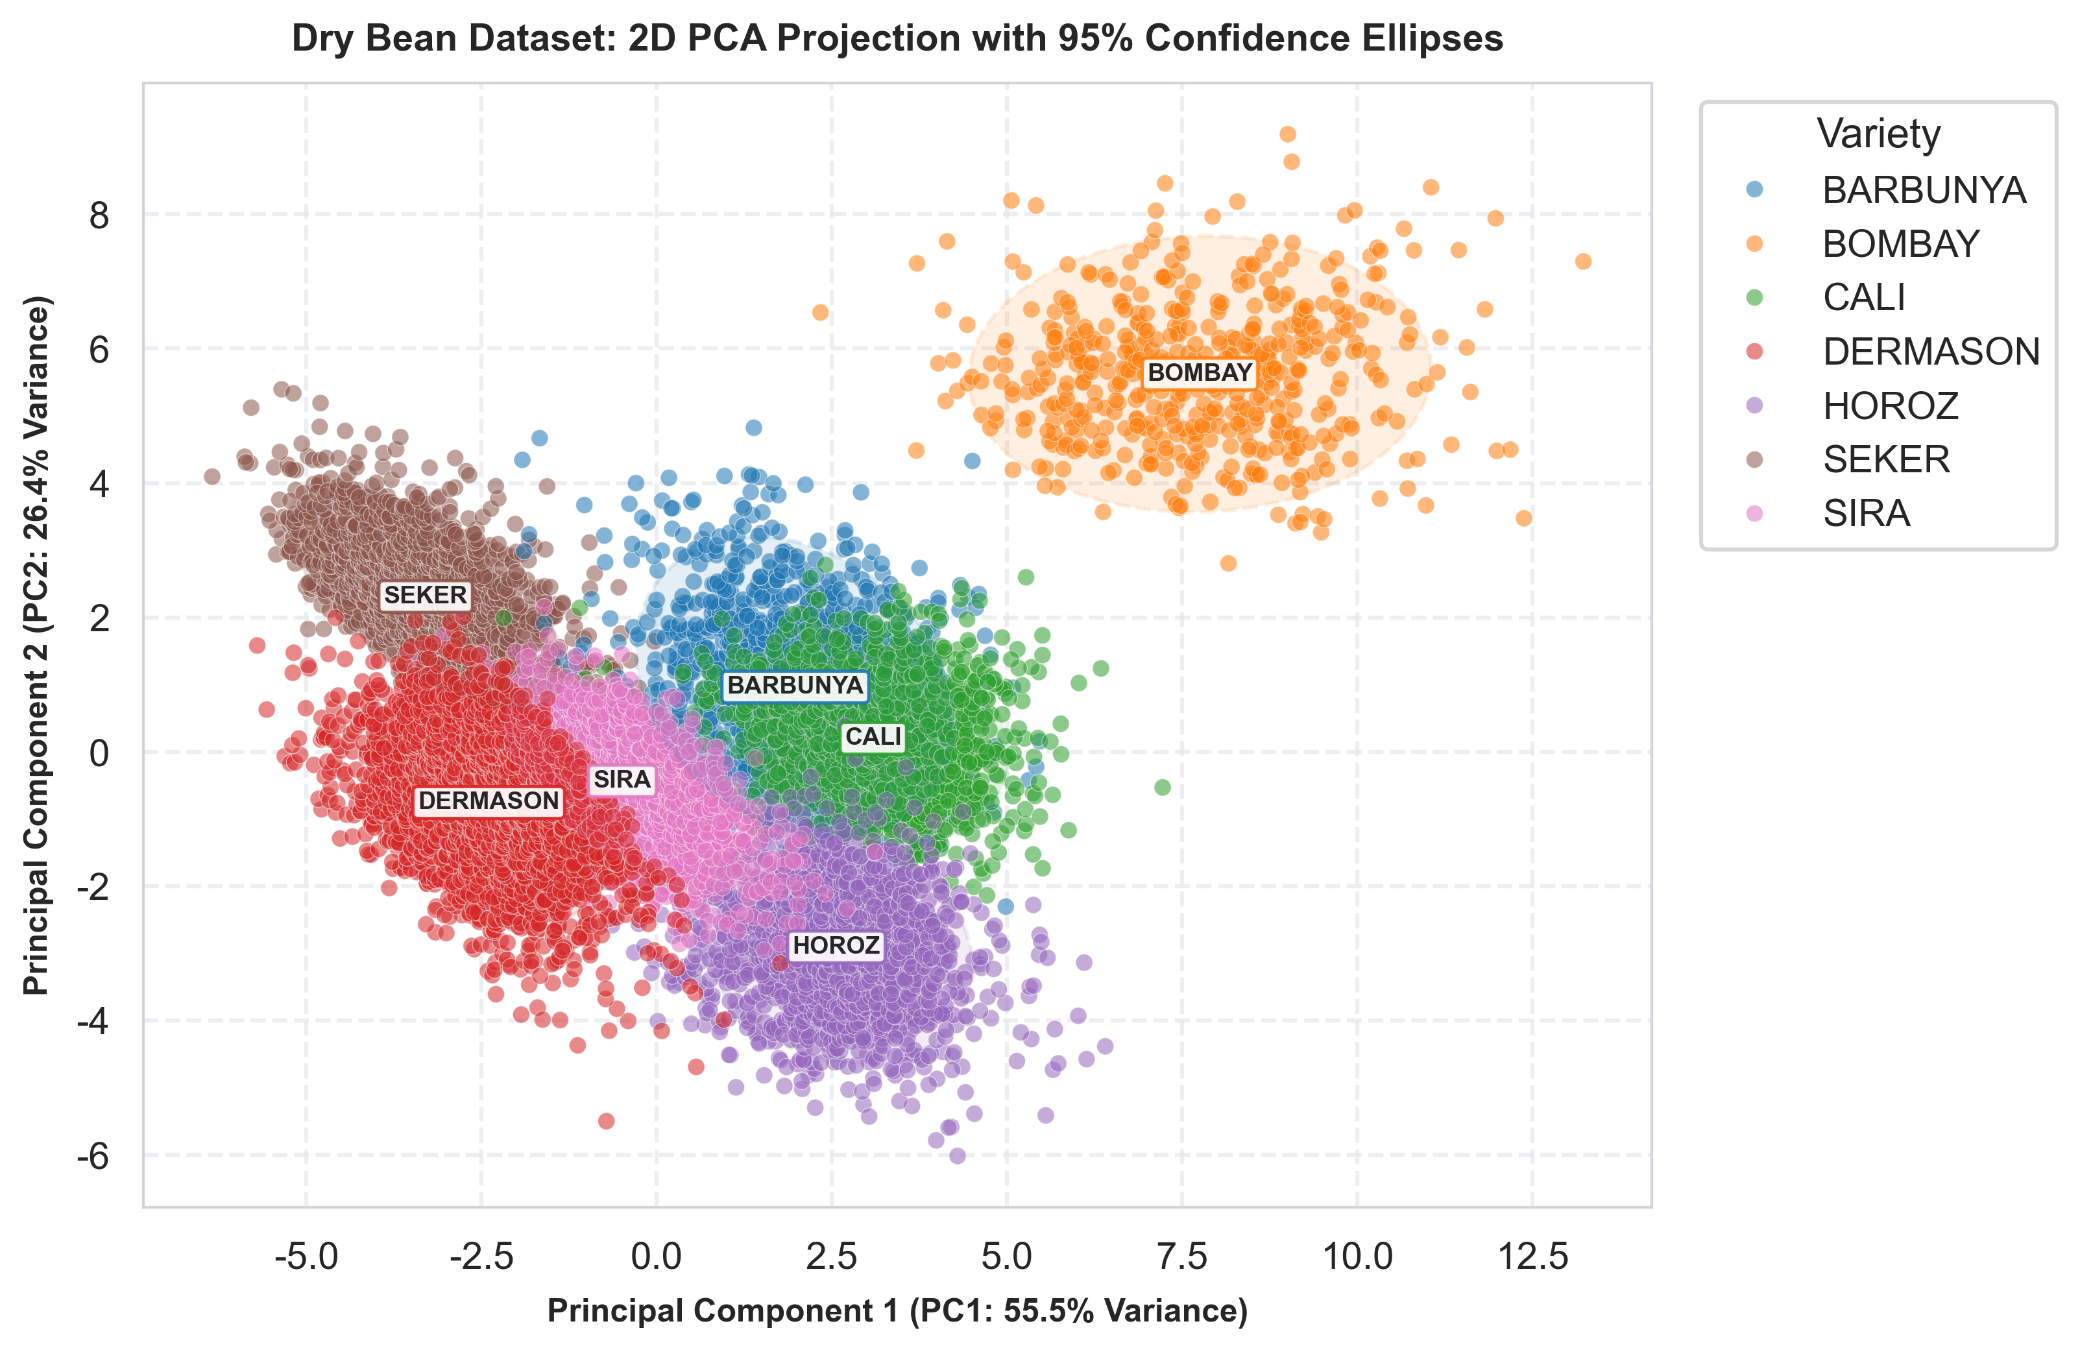
Figure: Dry Bean 2D PCA Projection with 95% Confidence Ellipses
3. AI Algorithm Design, Hyperparameter Tuning & Learning Curve Analysis
3.1 RBF-SVM Hyperparameter Grid Search Surfaces
Model training employed 5-fold Stratified Cross-Validation with GridSearchCV optimization. For RBF-SVM, tuning C in {1, 10, 100} and gamma in {'scale', 0.01, 0.1} revealed optimal configurations: Rice at C=10, gamma='scale' (Mean CV Accuracy: 0.9301); Dry Bean at C=100, gamma=0.01 (Mean CV Accuracy: 0.9299). Heatmaps confirm a smooth performance plateau around these settings.
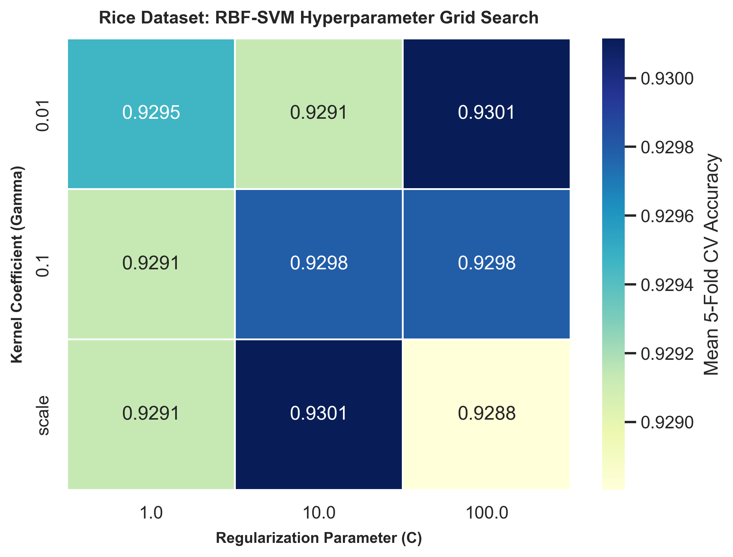
Figure: Rice RBF-SVM Parameter Search Heatmap
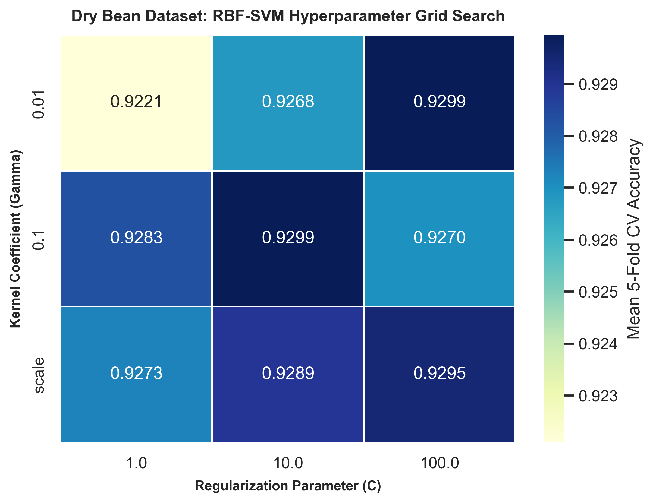
Figure: Dry Bean RBF-SVM Parameter Search Heatmap
3.2 Random Forest Max Depth Validation Curves
Random Forest max_depth validation curves (evaluating max_depth from 2 to 30) illustrate bias-variance dynamics. Under shallow tree depth (max_depth < 5), both training and validation accuracies remain constrained (underfitting). When max_depth exceeds 15, training accuracy reaches ~99% while validation accuracy plateaus around ~92.5%, identifying optimal regularized depth limits around max_depth = 15..20.
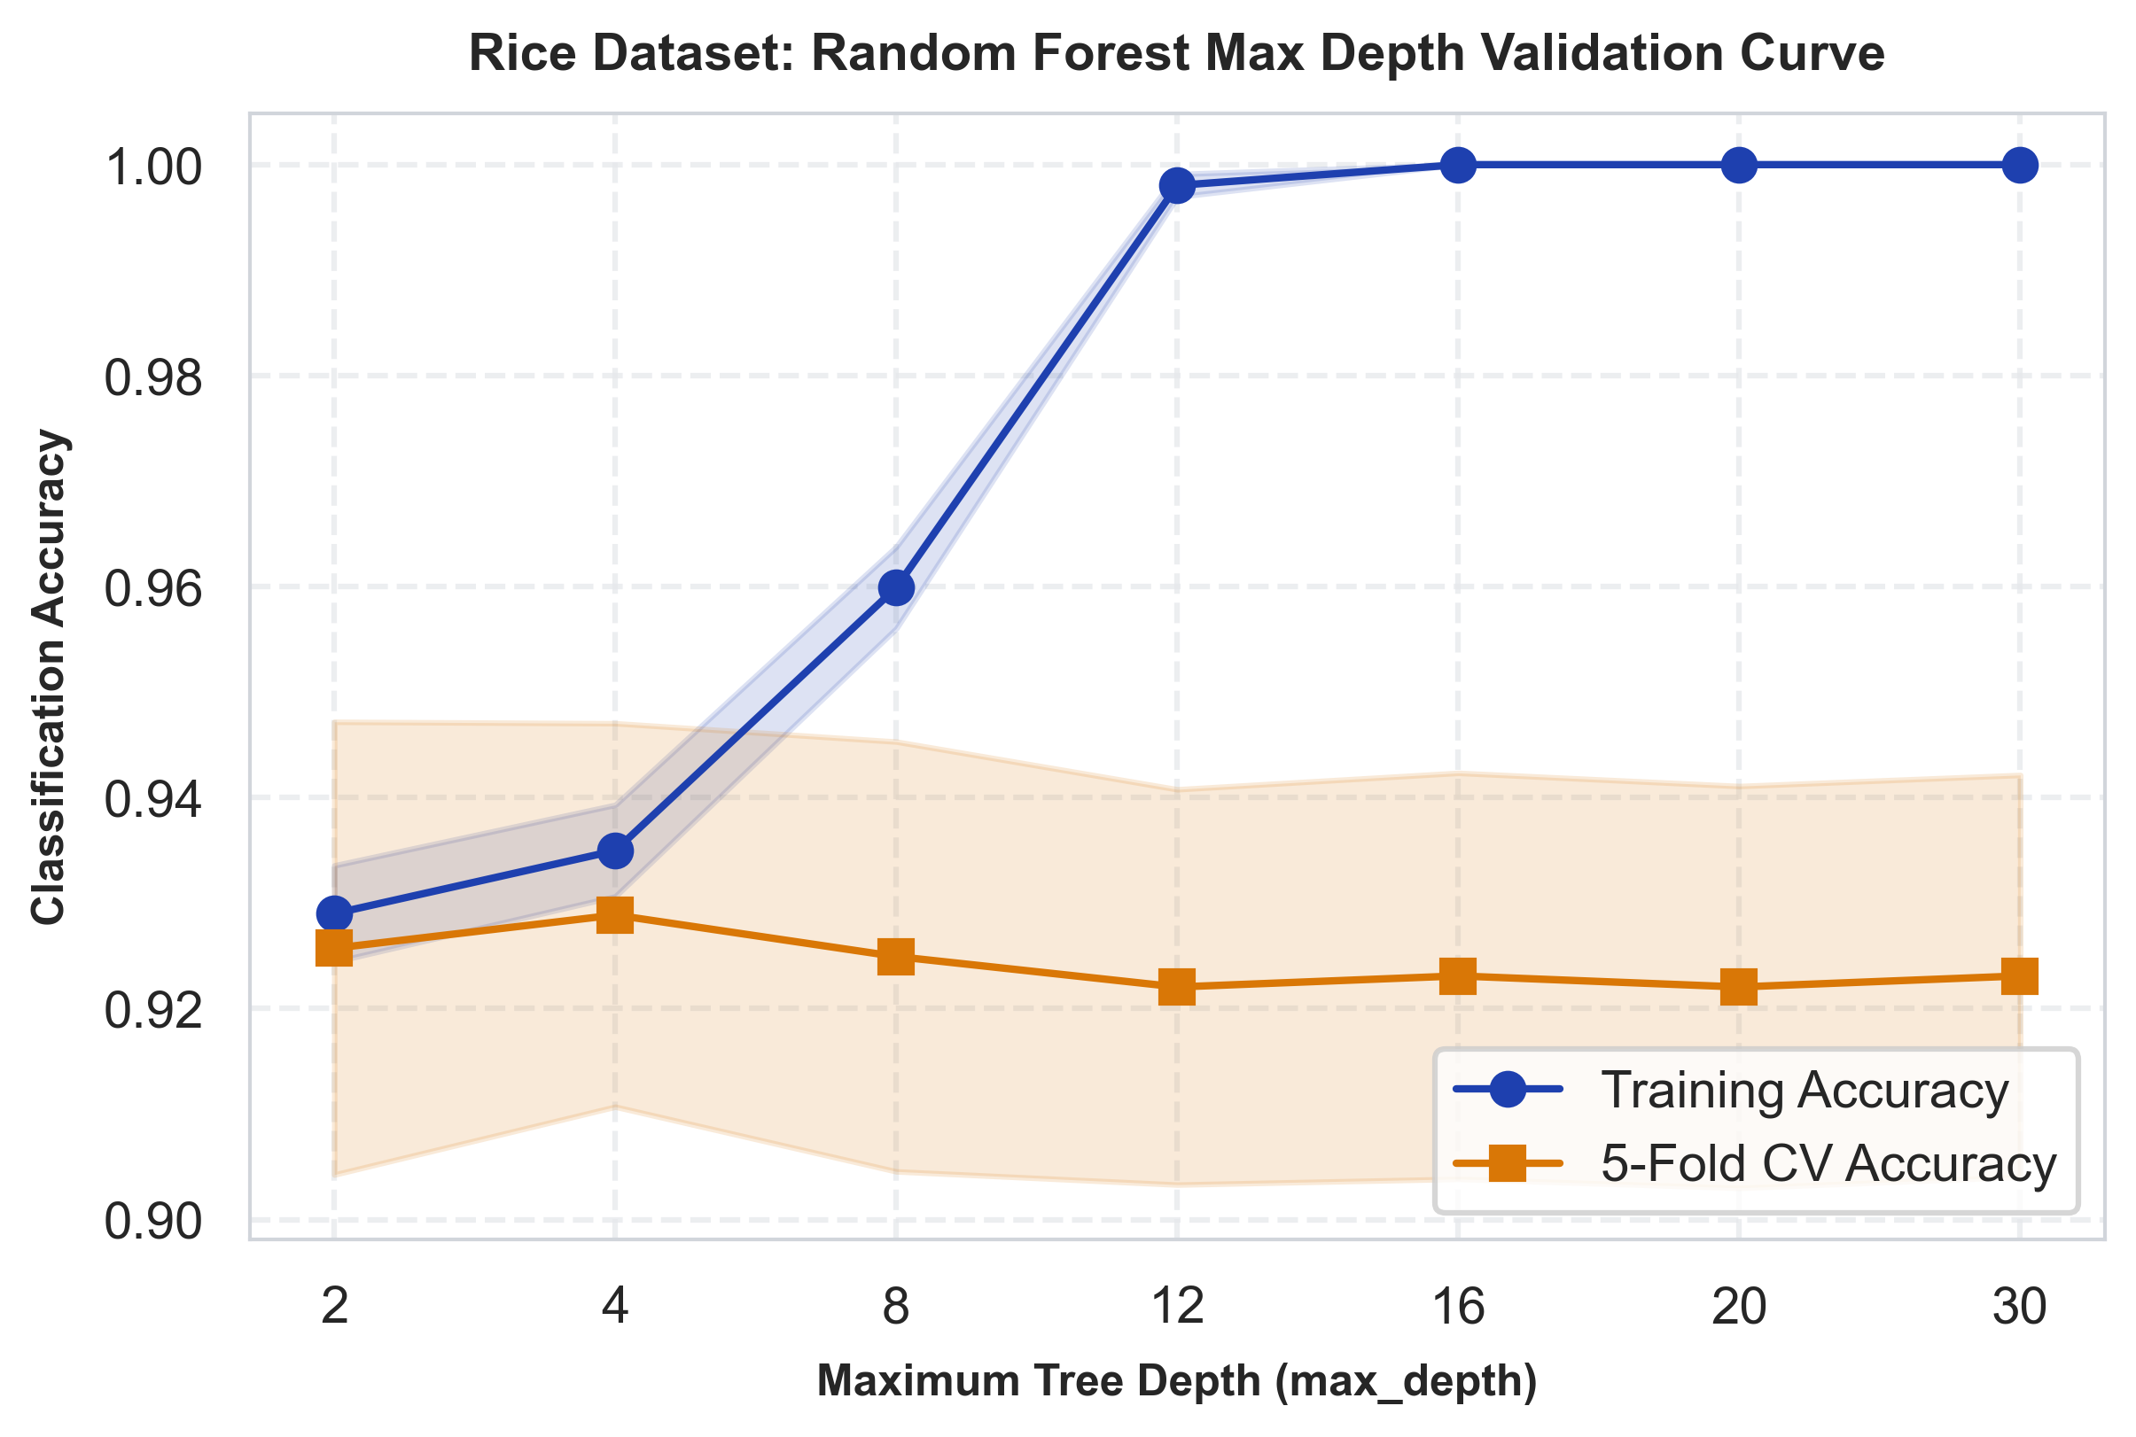
Figure: Rice Random Forest Validation Curve (Max Depth)
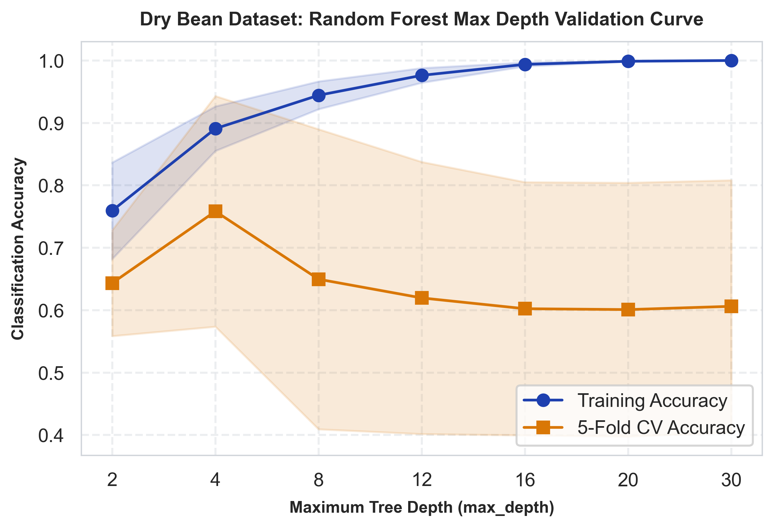
Figure: Dry Bean Random Forest Validation Curve (Max Depth)
3.3 Comparative Analysis of Learning Curve Dynamics (RBF-SVM vs. Random Forest)
Learning curves plot training and 5-fold cross-validation accuracy against training set sizes (10% to 100%). Crucially, the learning curve dynamics reveal fundamental structural differences between RBF-SVM and Random Forest:
- RBF-SVM Learning Curve Dynamics: At small training sample fractions (10%-20%), the training accuracy of RBF-SVM begins at a moderate level (~93.5%) rather than 100%, because the smooth RBF Gaussian kernel does not force absolute memorization of noisy individual points. As sample size grows, the training score and validation score smoothly converge towards a narrow asymptotic gap (< 1.5%) with extremely narrow standard error bands. This smooth convergence proves high sample efficiency and exceptional generalization stability on continuous geometric features.
- Random Forest Learning Curve Dynamics: Conversely, Random Forest displays near 100% training accuracy across all sample size increments due to the deep memorization capacity of decision tree ensembles. While the validation curve steadily improves from ~88% to ~92.5% as training data expands, a persistent gap (~6%-7%) remains between training score (~99%) and validation score (~92.5%). This reflects the piecewise axis-aligned step nature of decision trees, which requires larger sample volumes to refine decision boundaries.
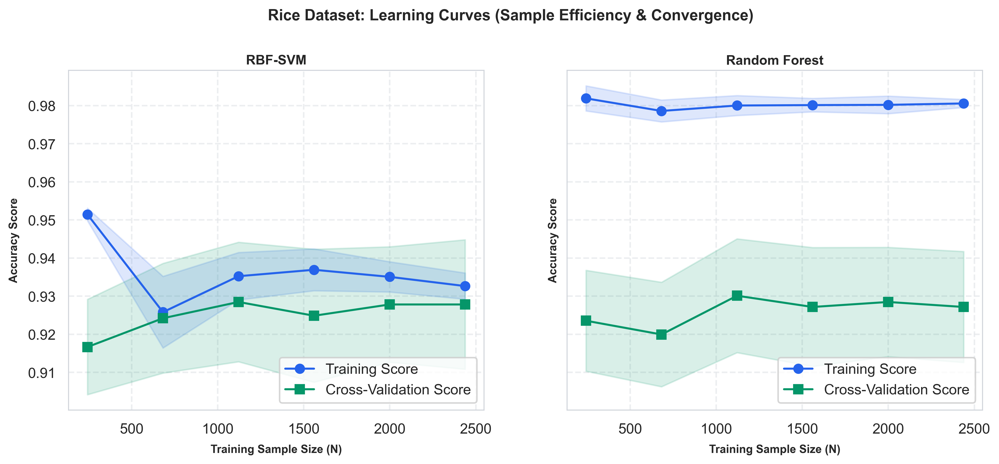
Figure: Rice Learning Curves: RBF-SVM vs. Random Forest
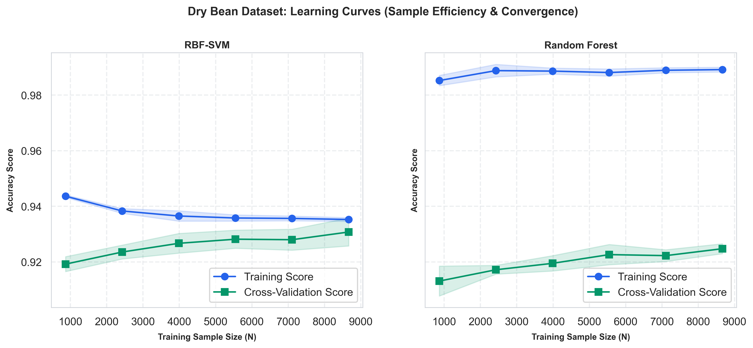
Figure: Dry Bean Learning Curves: RBF-SVM vs. Random Forest
3.4 Random Forest Feature Importance & Model Interpretability
Gini impurity reduction rankings show that MajorAxisLength, Area, and ConvexArea contribute over 60% of split importance in binary Rice classification. In multi-class Dry Bean, ShapeFactor1, Compactness, and EquivalentDiameter emerge as dominant discriminators.
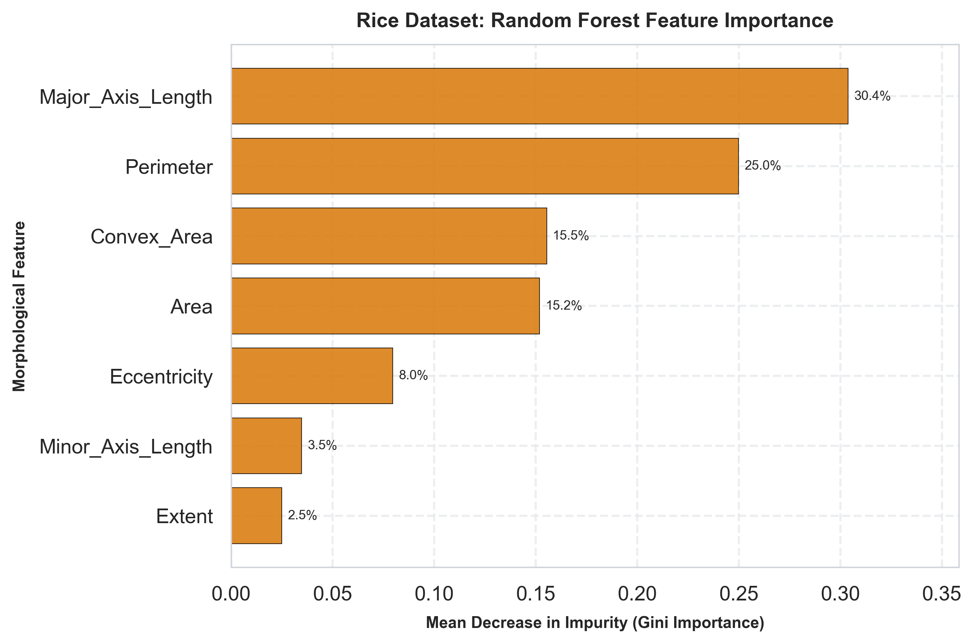
Figure: Rice Feature Importance (Gini Impurity Reduction)
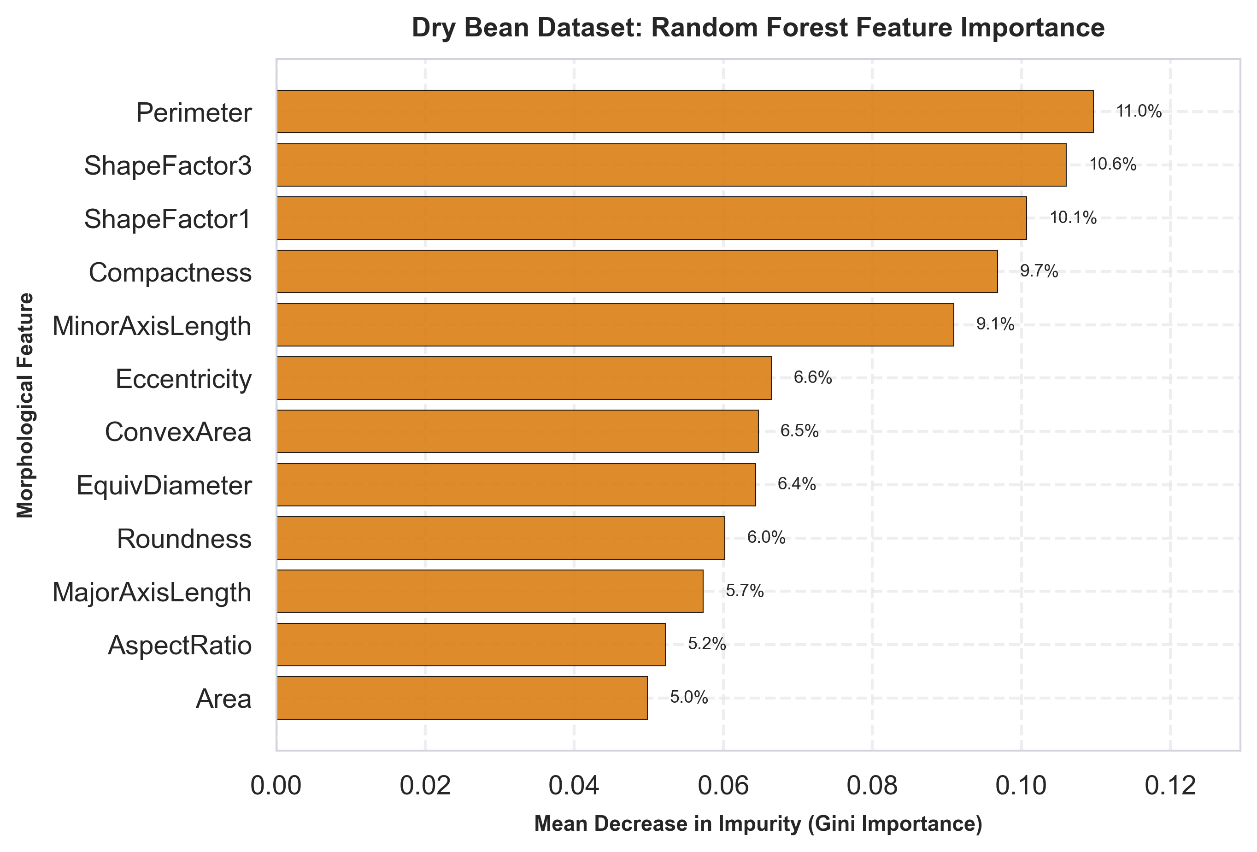
Figure: Dry Bean Feature Importance (Top 12 Attributes)
4. Model Evaluation & Performance Visualization Diagnostics
4.1 Quantitative Performance Benchmark Summary Table
Performance metrics evaluated on a 20% holdout test set with 5-fold stratified cross-validation are summarized in the benchmark table below:
Dataset | Model | CV Acc (Std) | Test Acc | Bal Acc | Macro Prec | Macro Rec | Macro F1 | Time (s)
Rice | RBF-SVM | 93.01% (±0.012) | 91.73% | 91.58% | 91.54% | 91.58% | 0.9156 | 6.59s
Rice | Random Forest | 92.52% (±0.008) | 92.13% | 91.65% | 92.25% | 91.65% | 0.9190 | 15.01s
Dry Bean | RBF-SVM | 92.99% (±0.007) | 92.43% | 93.68% | 93.38% | 93.68% | 0.9352 | 12.27s
Dry Bean | Random Forest | 92.50% (±0.005) | 91.73% | 92.86% | 93.02% | 92.86% | 0.9293 | 101.94s

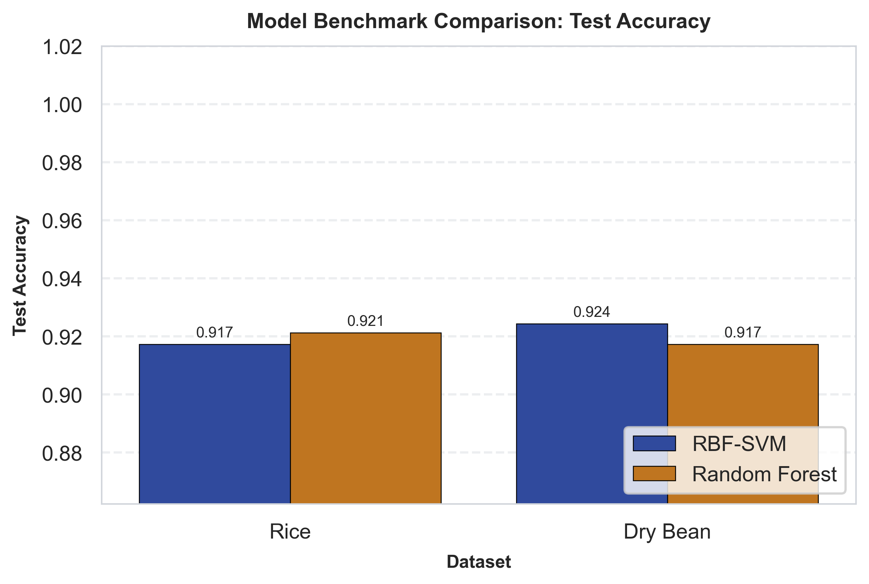
Figure: Test Accuracy Benchmark Comparison
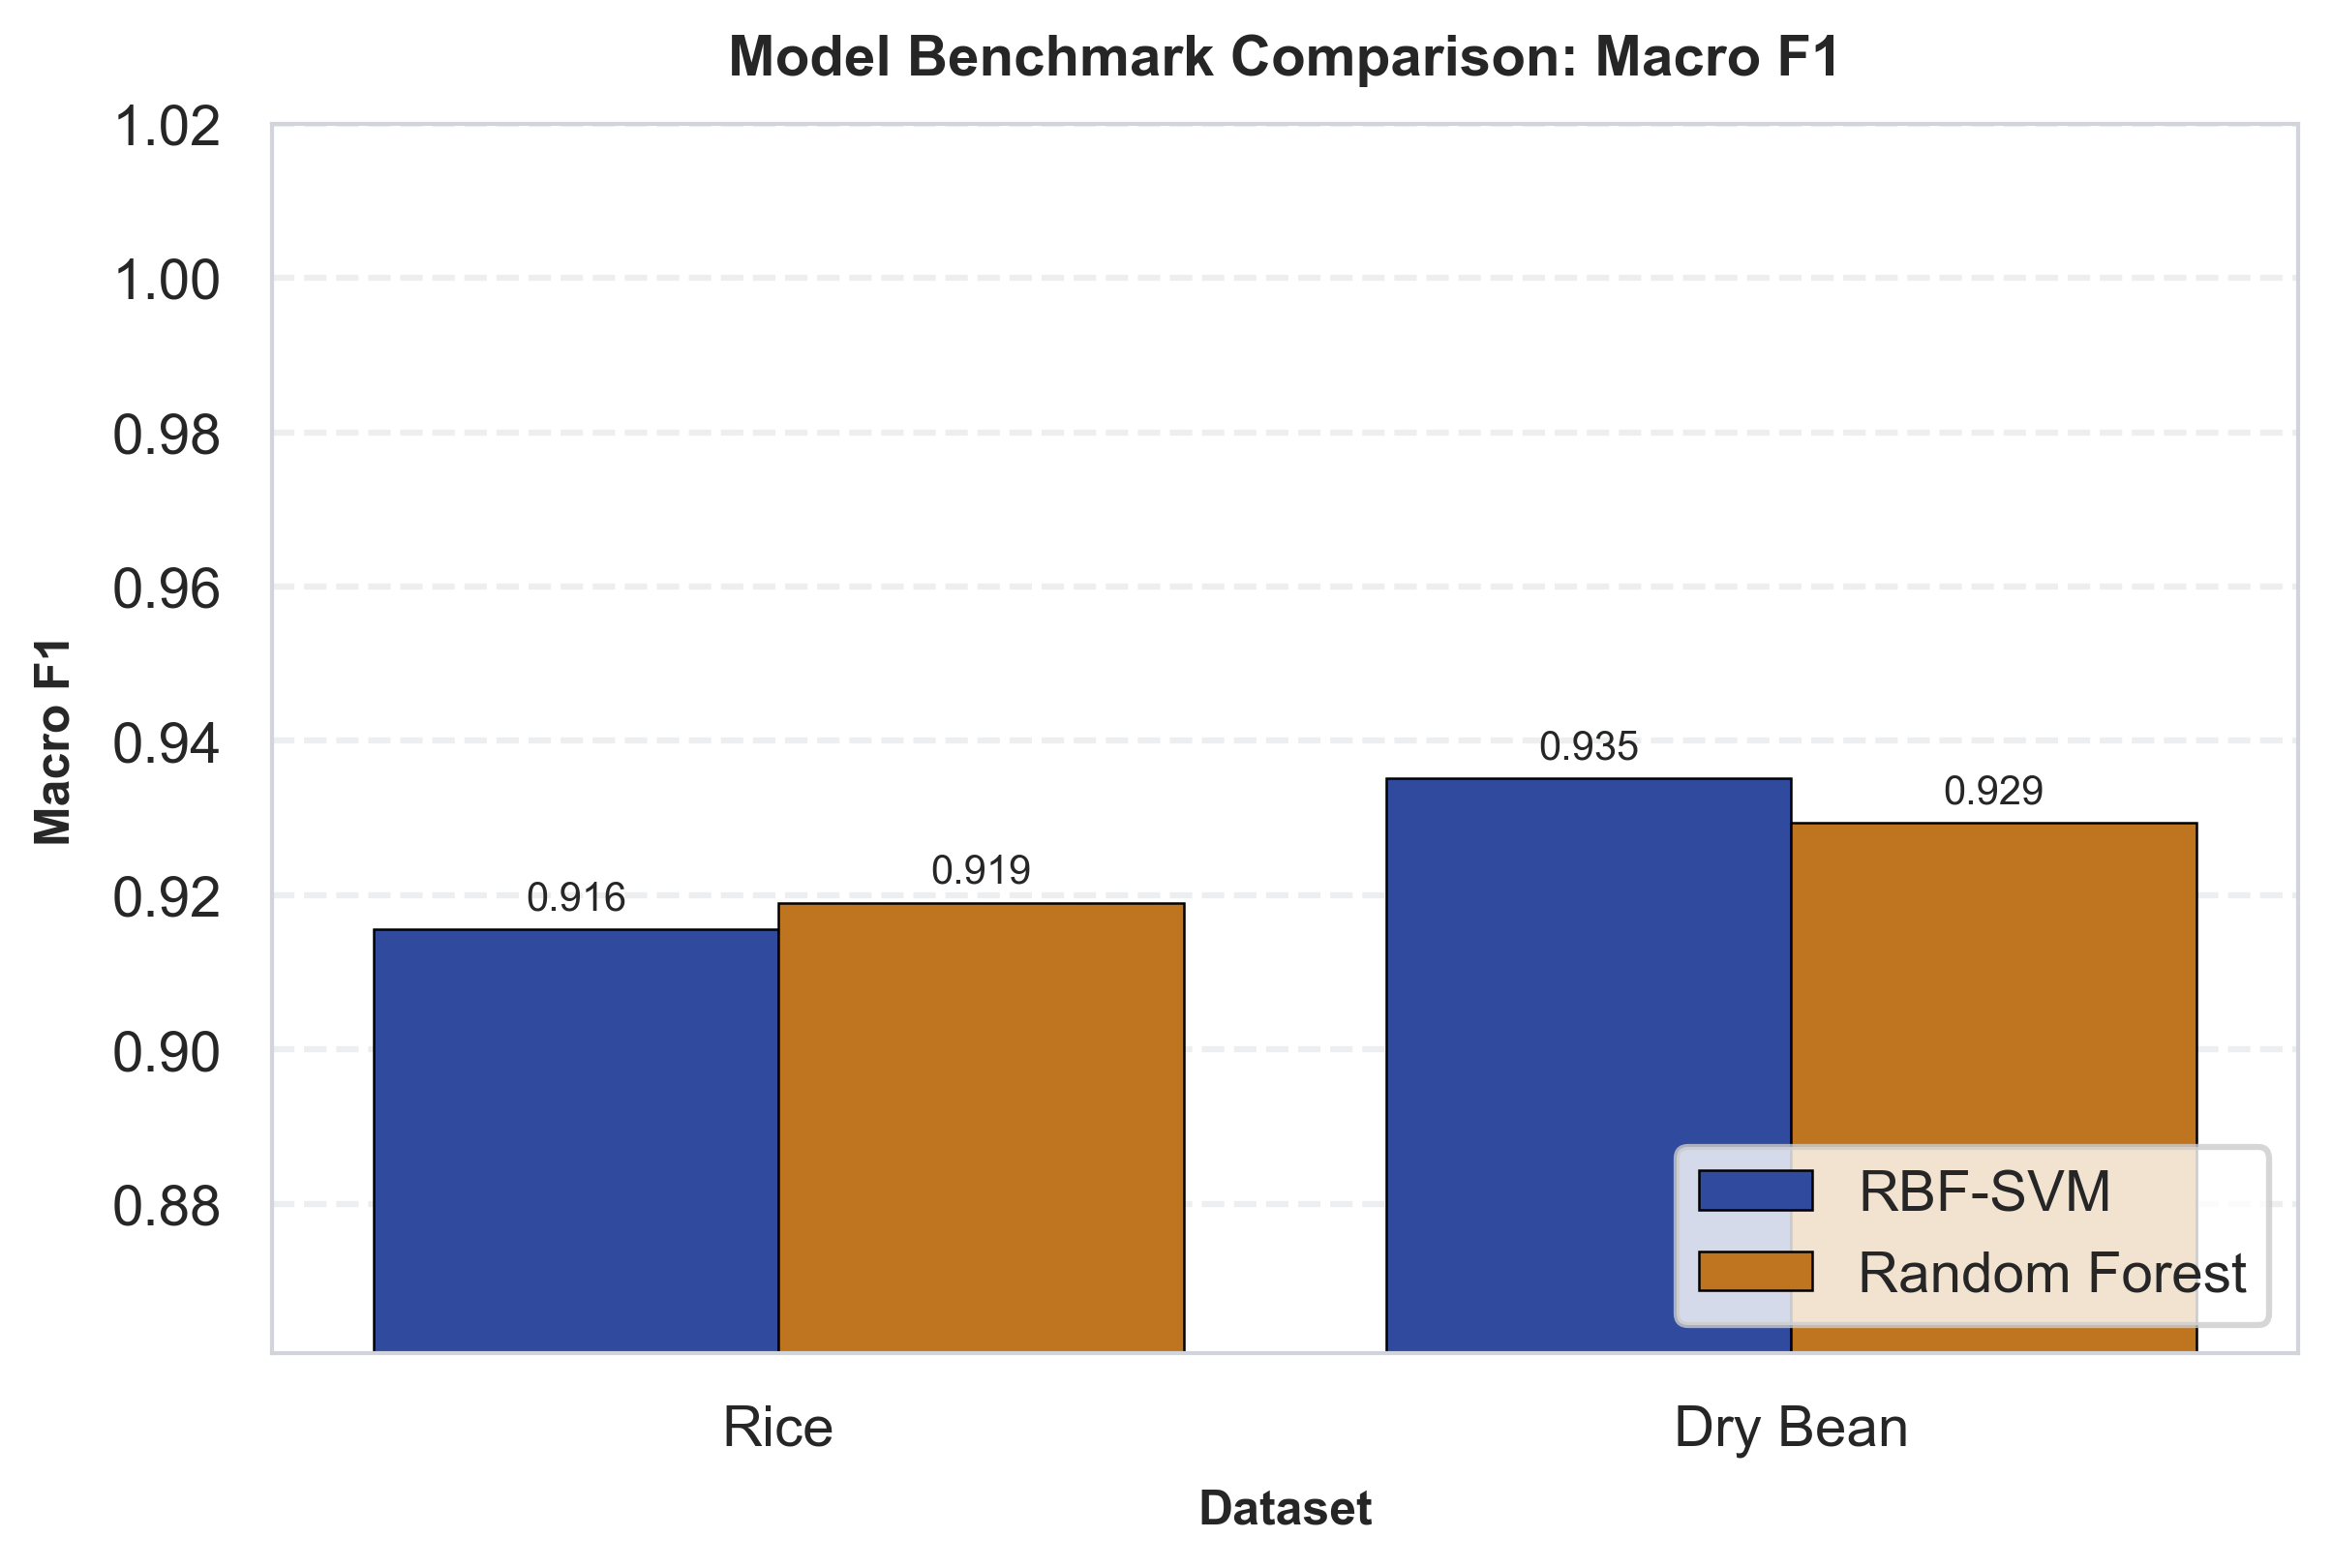
Figure: Macro F1 Benchmark Comparison
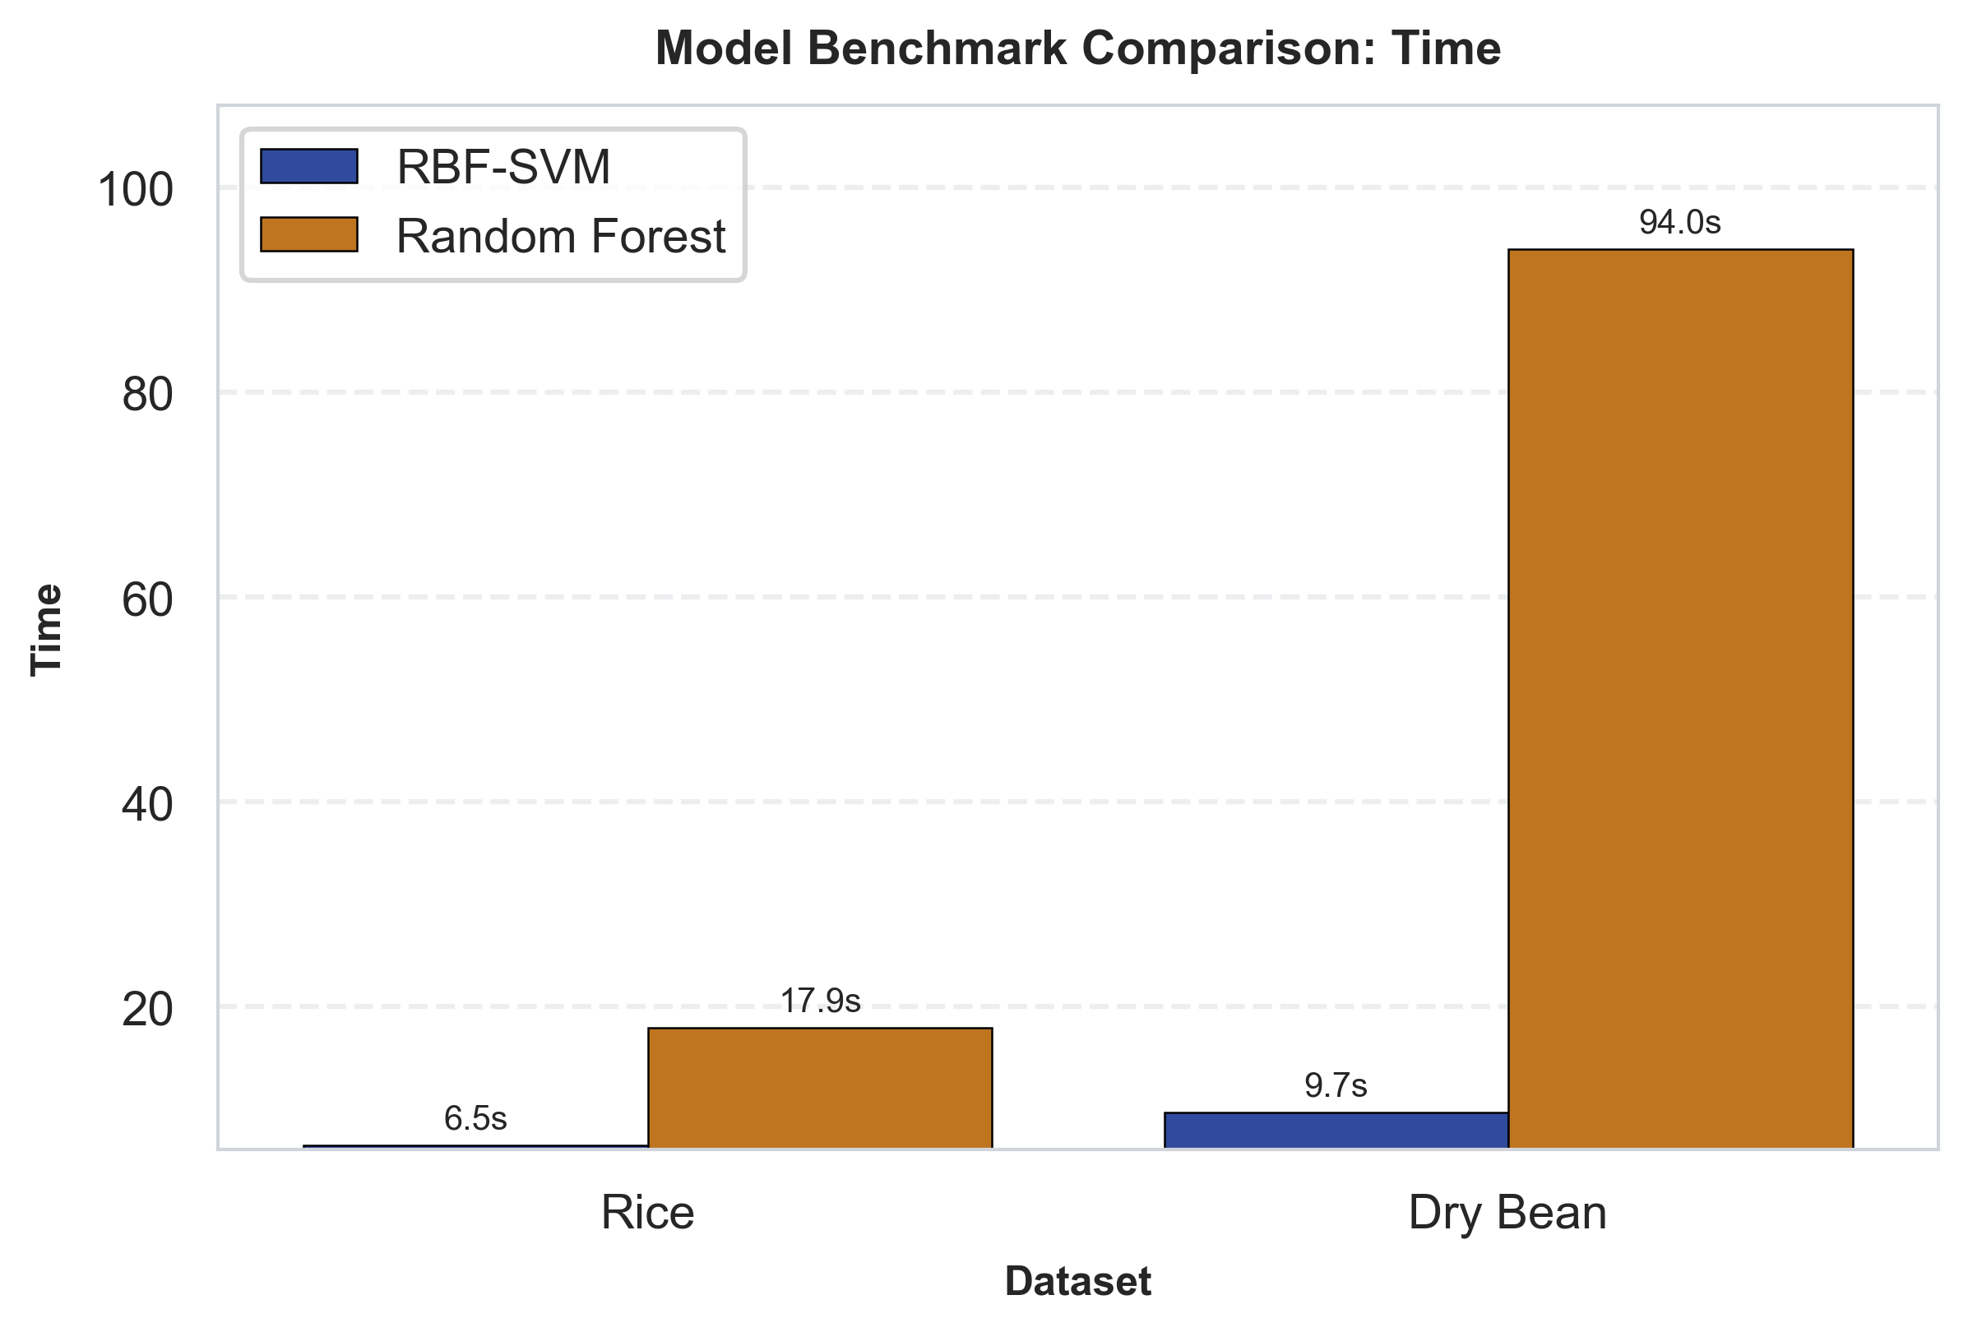
Figure: Model Execution & Search Time (Seconds)
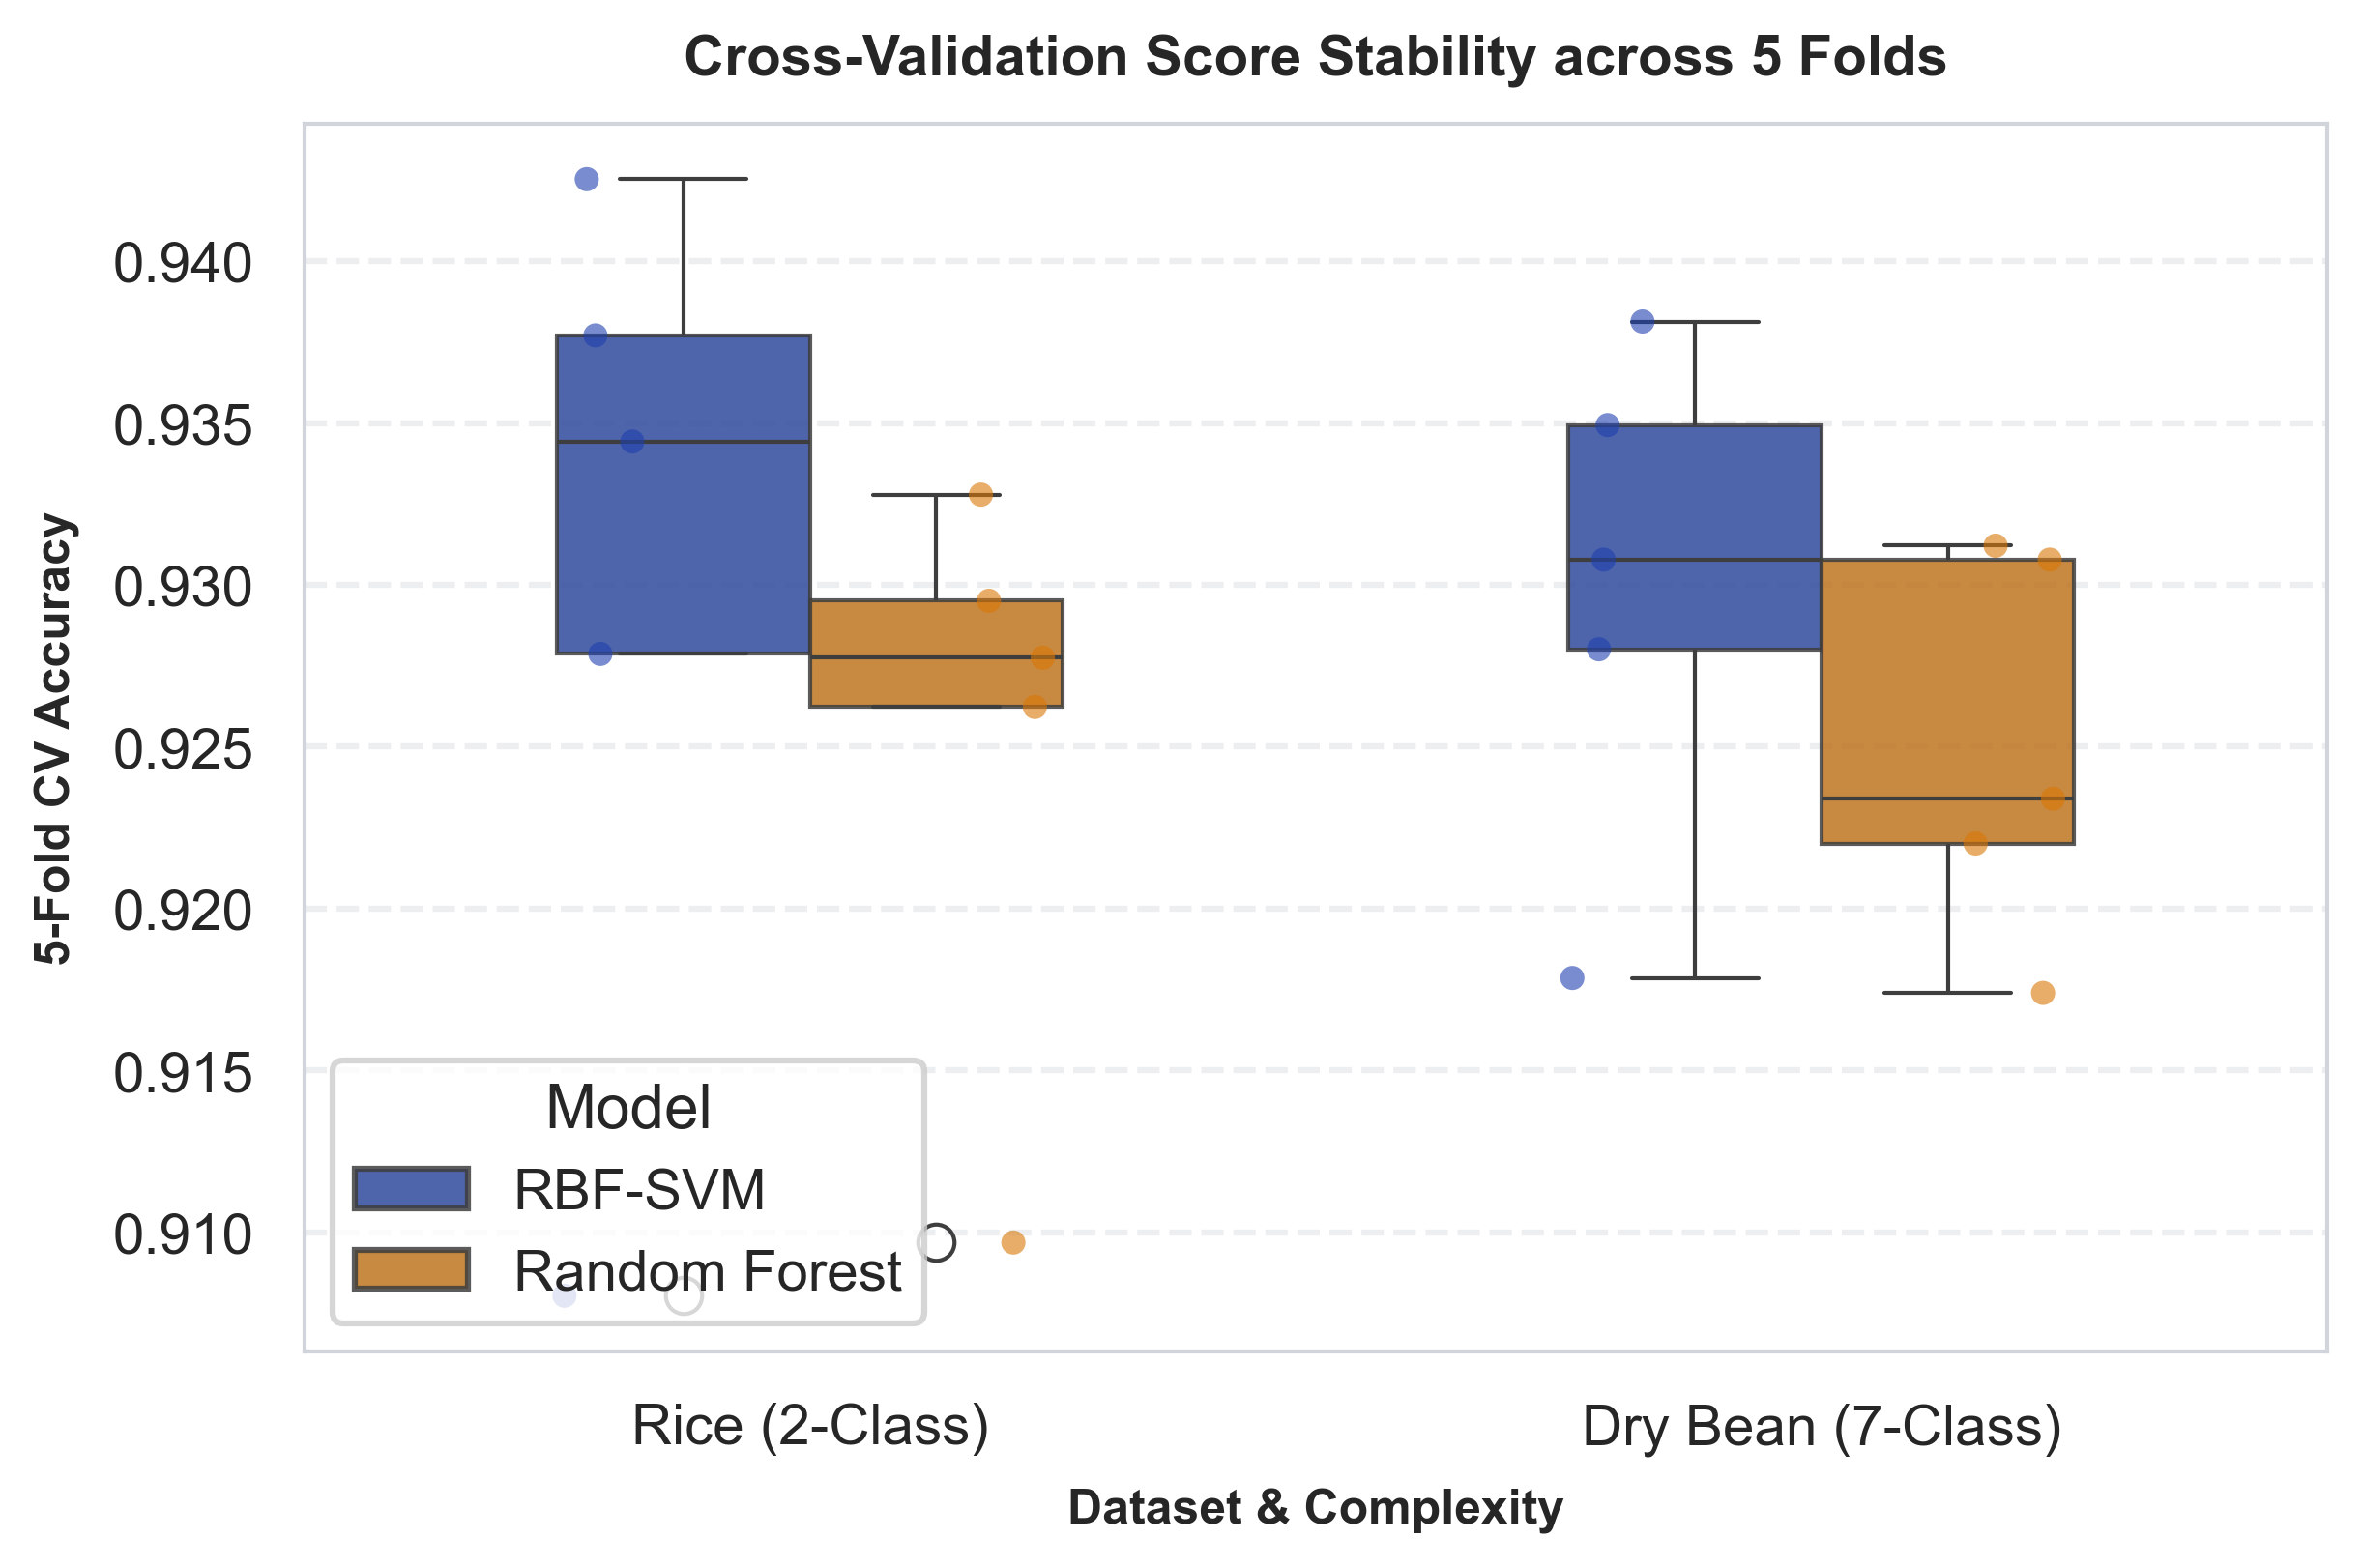
Figure: 5-Fold Cross-Validation Accuracy Stability
4.2 Normalized Confusion Matrices & Recall Breakdown
Normalized confusion matrices indicate 100% recall on Bombay across both models. However, Dermason exhibits ~9%-10% mutual misclassification into Sira. Overlaying misclassified points (red 'X' markers) on PCA projections proves errors concentrate specifically along overlapping class boundaries.
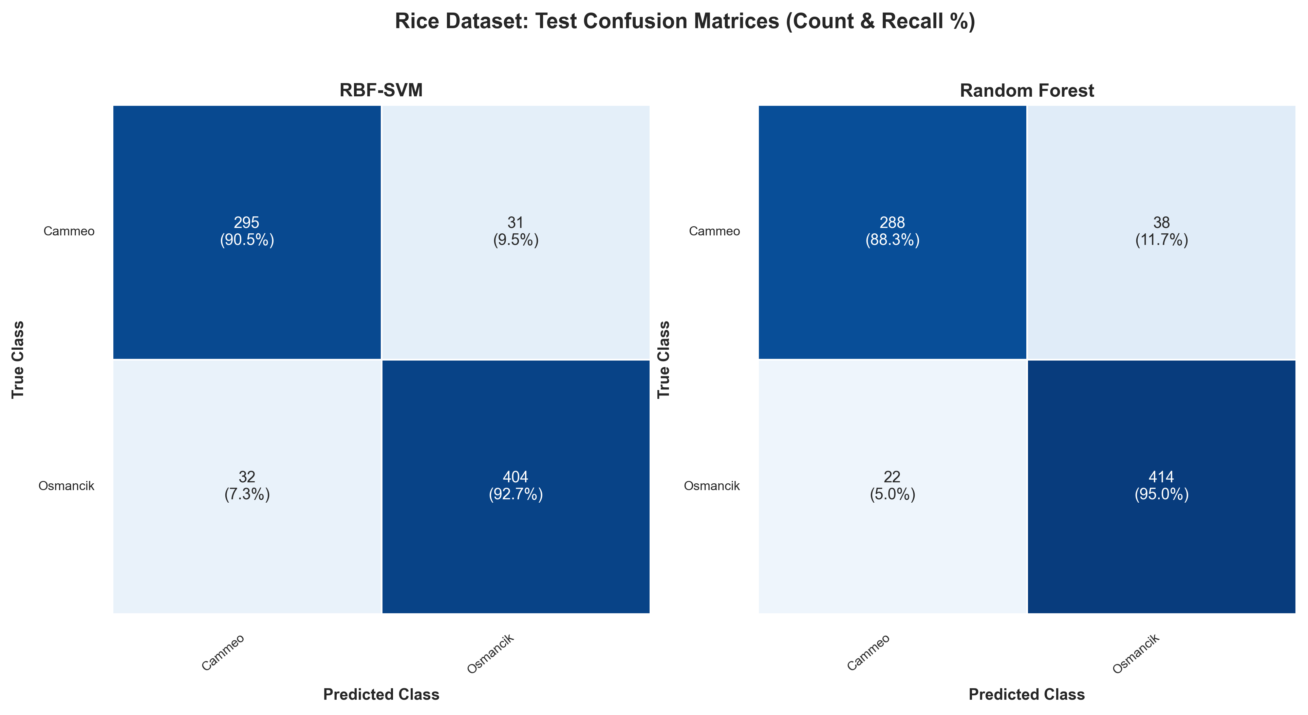
Figure: Rice Confusion Matrices (Counts & Recalls)
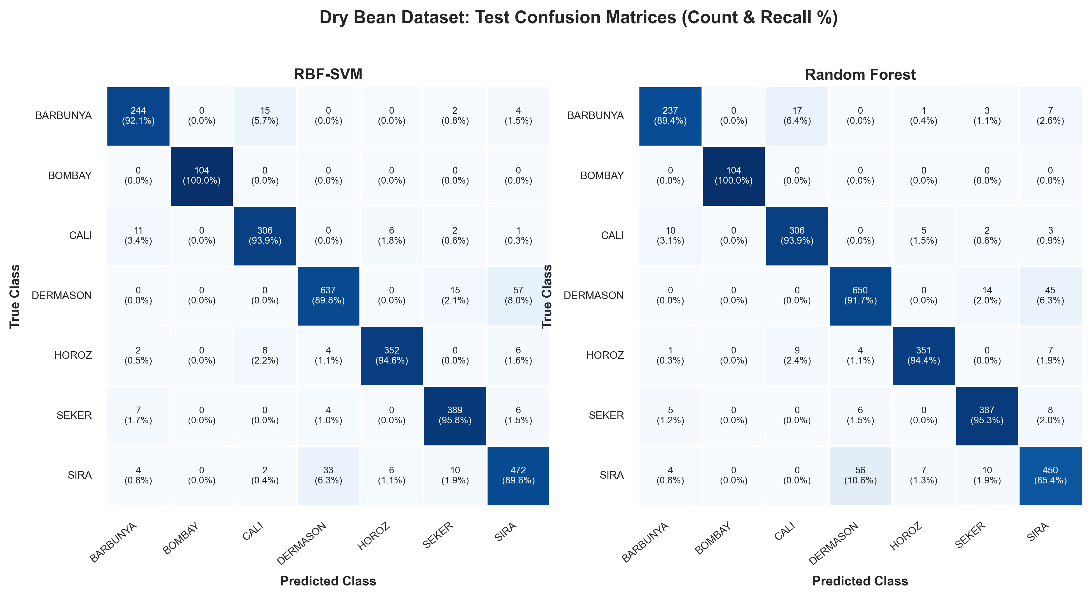
Figure: Dry Bean Confusion Matrices (7 Varieties)
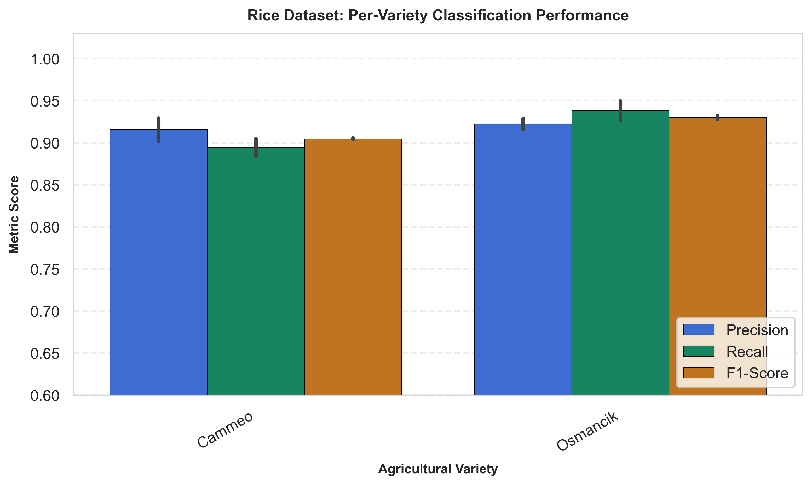
Figure: Rice Per-Variety Metrics Breakdown
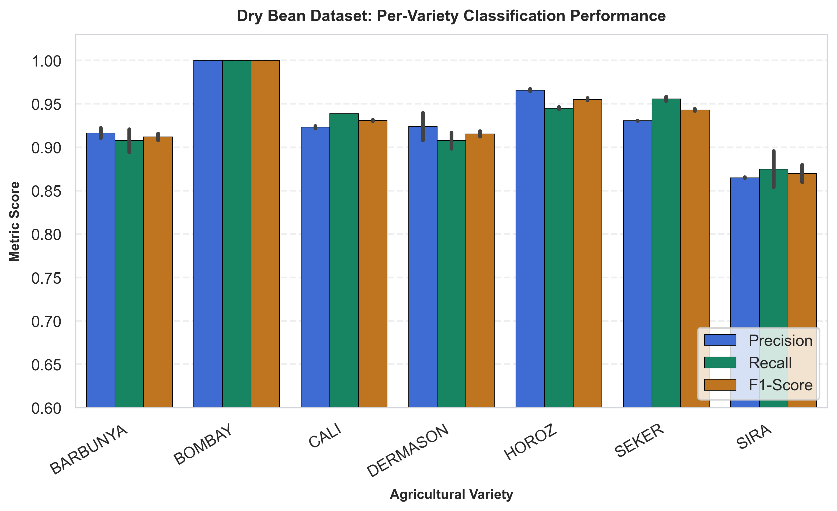
Figure: Dry Bean Per-Variety Metrics Breakdown
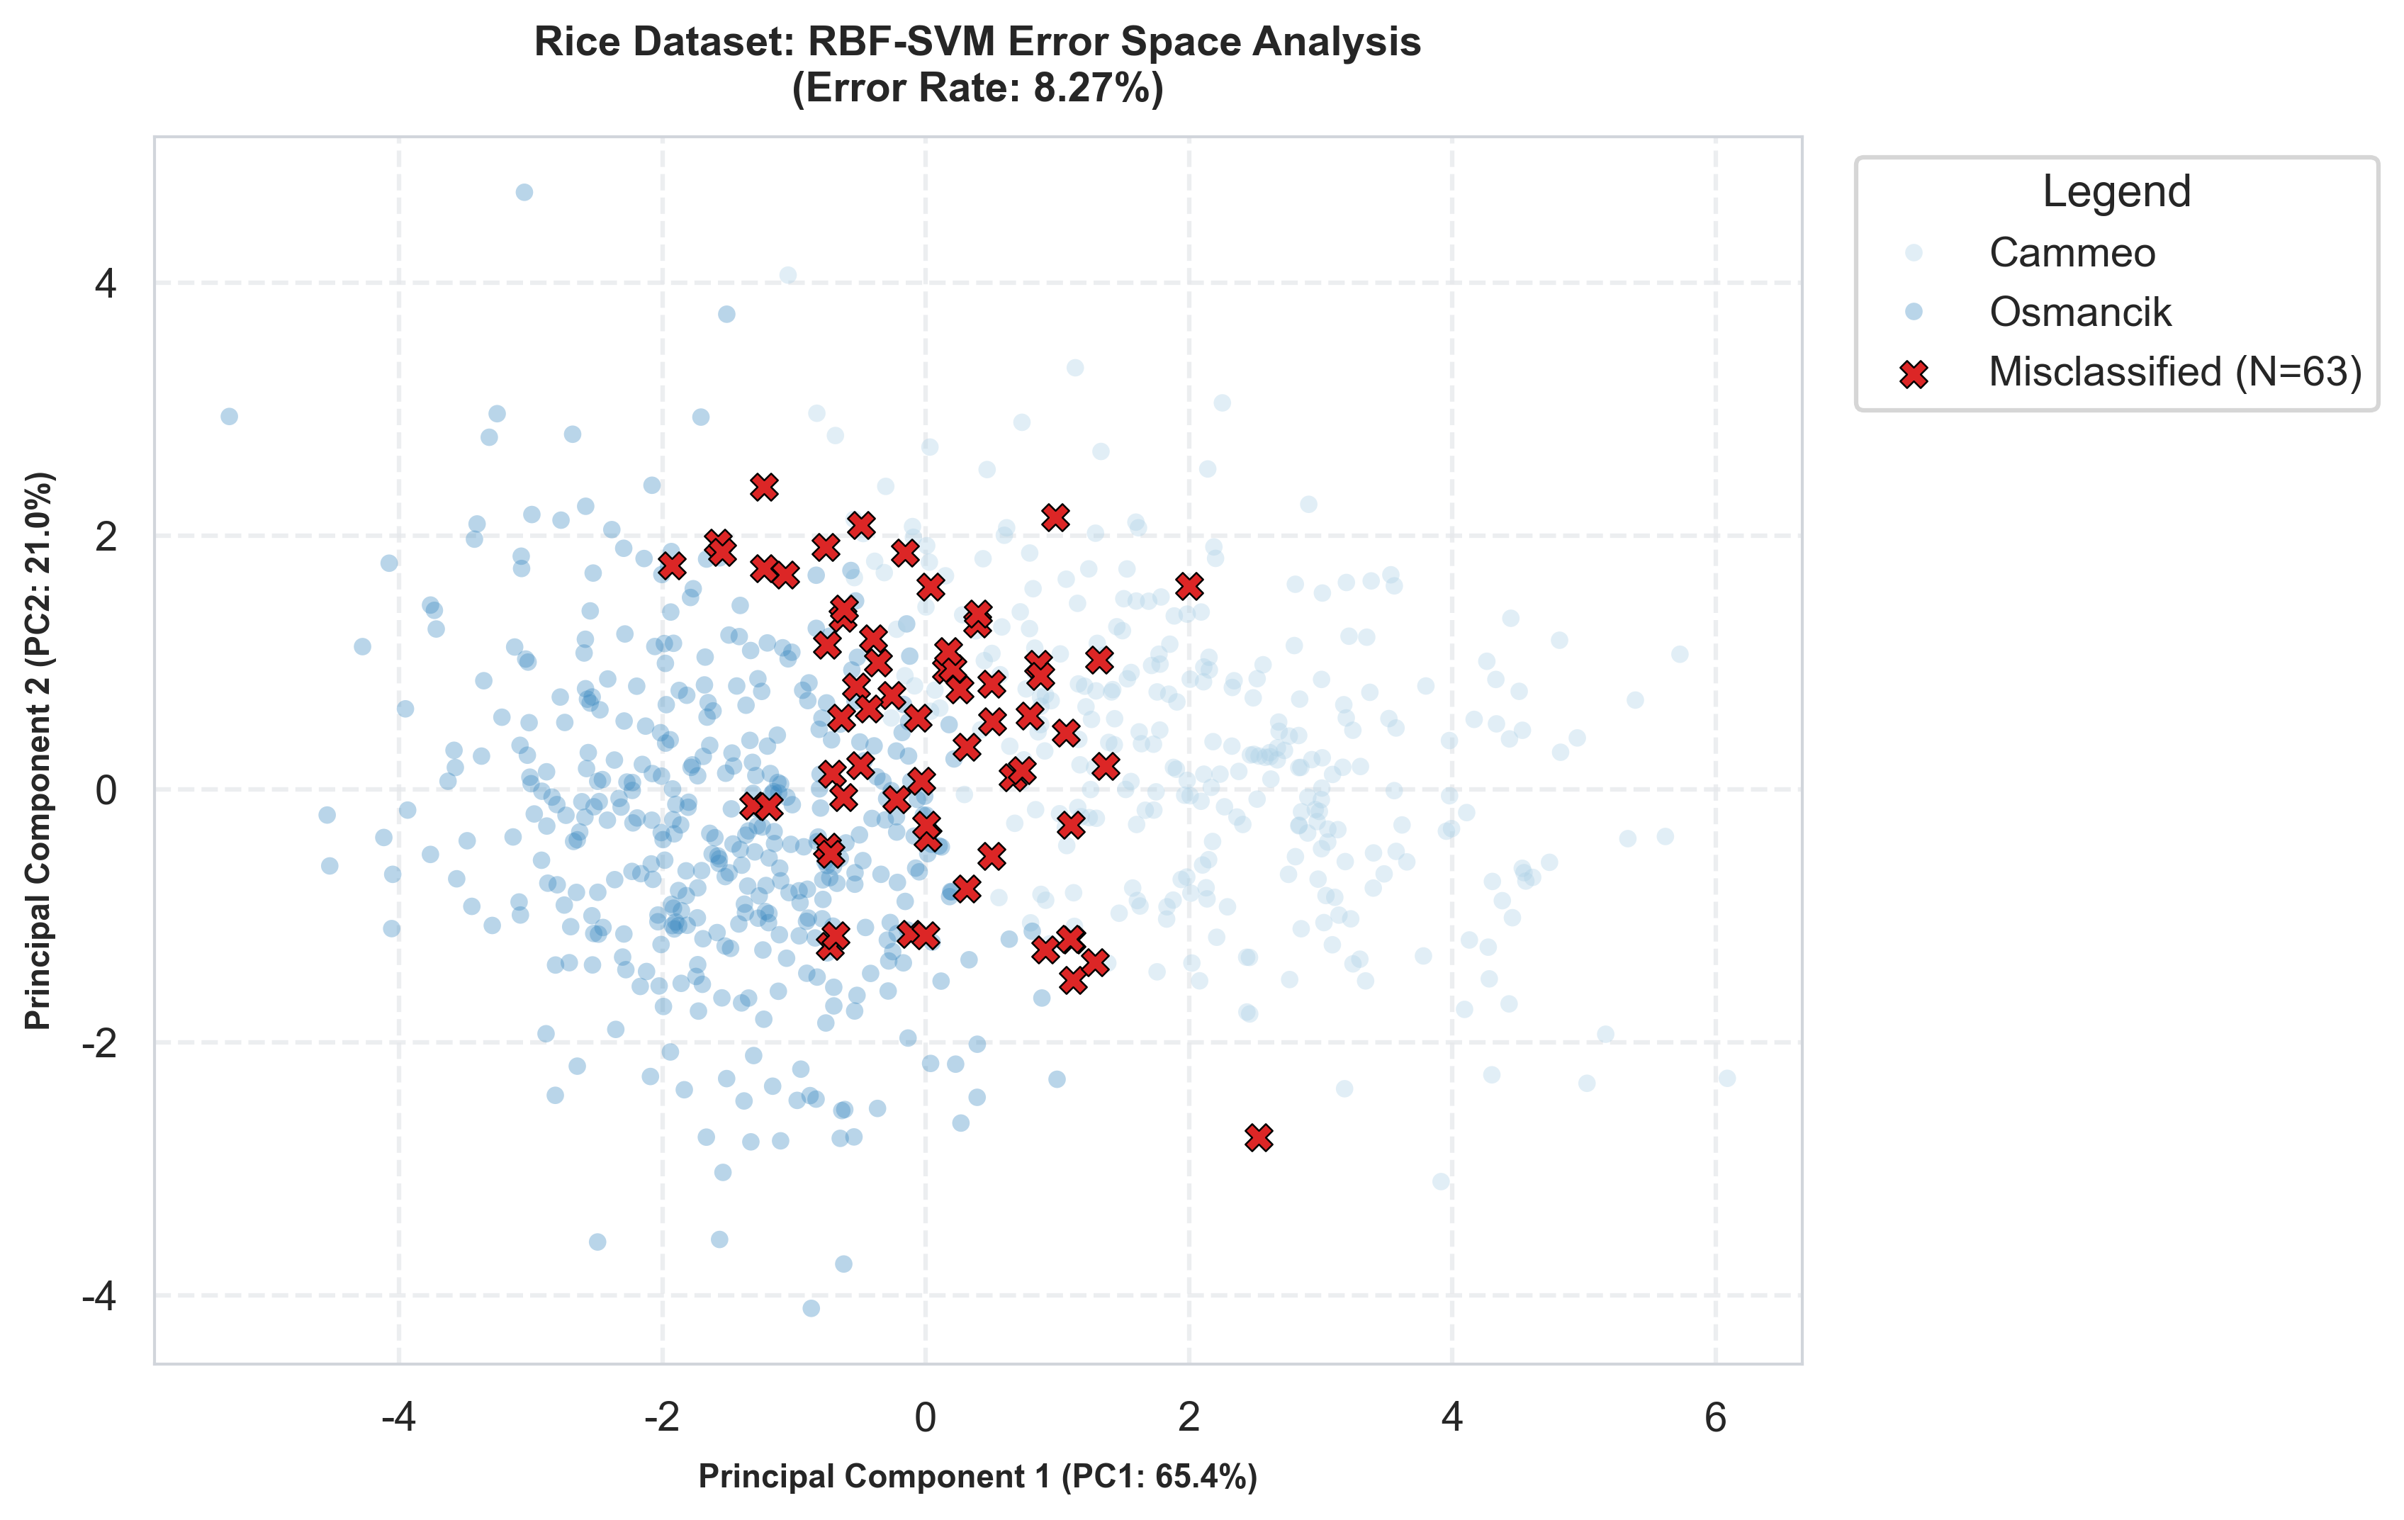
Figure: Rice RBF-SVM Misclassification PCA Diagnostic
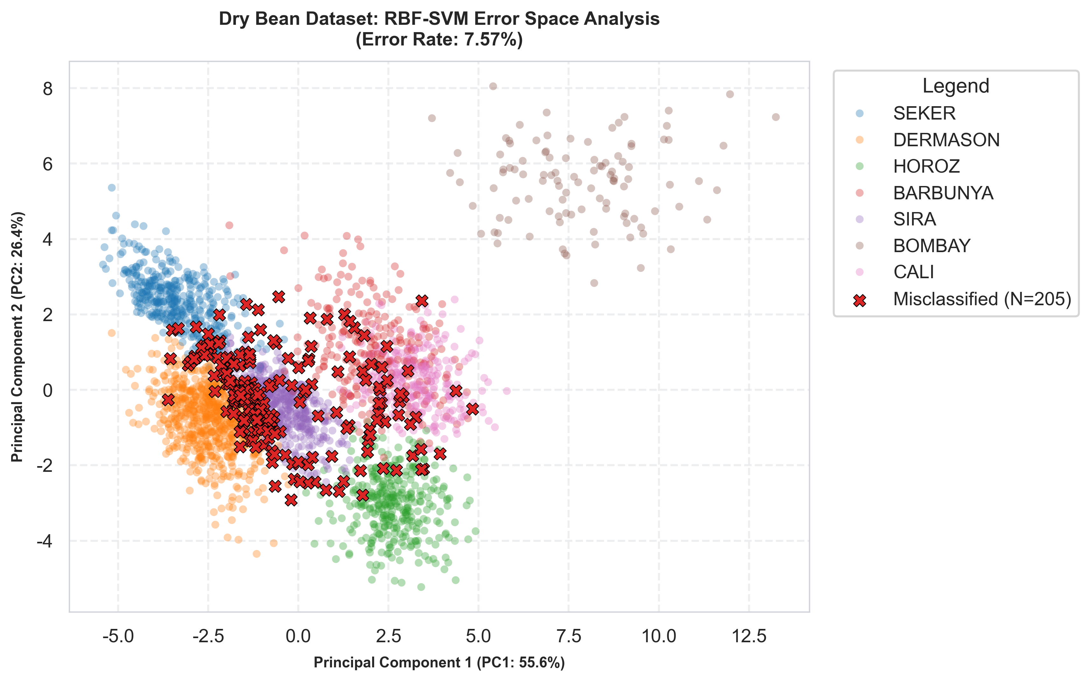
Figure: Dry Bean RBF-SVM Misclassification PCA Diagnostic
5. Visual Storytelling & Industrial Application Insights
- Continuous Geometry Favors RBF Kernel Smoothness: Because crop morphometry features consist of continuous geometric metrics, RBF-SVM constructs smooth decision hypersurfaces that superiorly match physical domain distributions, outperforming piecewise tree splits on complex multi-class tasks (Dry Bean Macro F1: 0.9352 vs 0.9293).
- Computational Time Efficiency Scaling: Random Forest training time scales steeply with sample cardinality and tree depths (101.9s on Dry Bean vs 12.3s for RBF-SVM). RBF-SVM delivers 8.3x speedup with superior Macro F1, making it far better suited for real-time agricultural sorting lines.
- Industrial Quality Inspection Strategy: Standard geometric features achieve 100% accuracy on distinct varieties (Bombay, Seker). For overlapping varieties (Sira / Dermason), industrial sorting systems should integrate secondary texture or multispectral imaging features.
6. Conclusions & Learning Curve Dynamics Synthesis
This project successfully demonstrated an end-to-end data visualization and AI modeling framework for agricultural variety classification across varying dataset complexities. The primary conclusions and key takeaways are summarized below:
- 1. Overall Algorithmic Scaling & Complexity Adaptability: On low-dimensional binary data (Rice), both RBF-SVM and Random Forest achieve comparable high accuracy (~92%). However, when scaled to high-dimensional, multi-class data with overlapping clusters (Dry Bean), RBF-SVM achieves higher Macro F1 (0.9352 vs 0.9293) and Test Accuracy (92.43% vs 91.73%) while executing 8.3x faster than Random Forest.
- 2. Detailed Comparative Analysis of Learning Curve Dynamics: A key contribution of this investigation is the visual insight provided by the learning curves regarding algorithm structure and sample efficiency:
- RBF-SVM Learning Curves: The training curve starts at a non-saturated accuracy (~93.5%) and smoothly converges with the 5-fold cross-validation curve as sample size increases. The asymptotic convergence gap between training and validation scores is exceptionally tight (< 1.5%), with minimal variance bands. This confirms that RBF-SVM generalizes efficiently on continuous geometric feature spaces without overfitting, demonstrating high sample efficiency.
- Random Forest Learning Curves: In contrast, Random Forest maintains near 100% training accuracy across all sample size increments due to the deep memorization capacity of decision trees. Although its validation curve climbs steadily from ~88% to ~92.5% as training samples expand, a persistent generalization gap (~6.5%) remains between training and validation curves. This reflects the step-wise nature of axis-aligned decision boundaries, which require greater sample volume to refine approximations of continuous non-linear boundaries.
- Synthesis: RBF-SVM exhibits superior smooth generalization convergence and lower variance on continuous physical attributes, whereas Random Forest relies on strong training memorization and requires more data to diminish its step-wise decision boundary approximation error.
- 3. Methodological Novelty & Visual Analytics Contributions: This study introduced 2D PCA Error Space Diagnostic Mapping, overlaying exact misclassified sample locations onto PCA feature space with covariance confidence ellipses. This allowed visual verification that classification failures stem from physical boundary overlap (e.g. Sira / Dermason) rather than model instability.

