Міністерство науки і освіти України

ВІННИЦЬКИЙ НАЦІОНАЛЬНИЙ ТЕХНІЧНИЙ УНІВЕРСИТЕТ

Кафедра обчислювальної техніки

**Паралельні та розподілені обчислення**

**Лабораторна робота № 1**

Виконав: Свіріпа С.М.

Перевірив: Семеренко В.П.

Вінниця 2019

Розв’язати рівняння: у= $\left(b-d\right)*a^{2}+\frac{{(c-d)}^{2}}{a}$

Складемо інформаційний базис:

M={a,b,c,d}

F={f1,f2,f3,f4,f5,f6,f7}

f1: y1=b-d;

f2: y2=c-d;

f3: y3=a*a;

f4: y4=y2*y2;

f5: y5=y1*y3;

f6: y6=y4/a;

f7: y7=y5 + y6;

Часова діаграма:

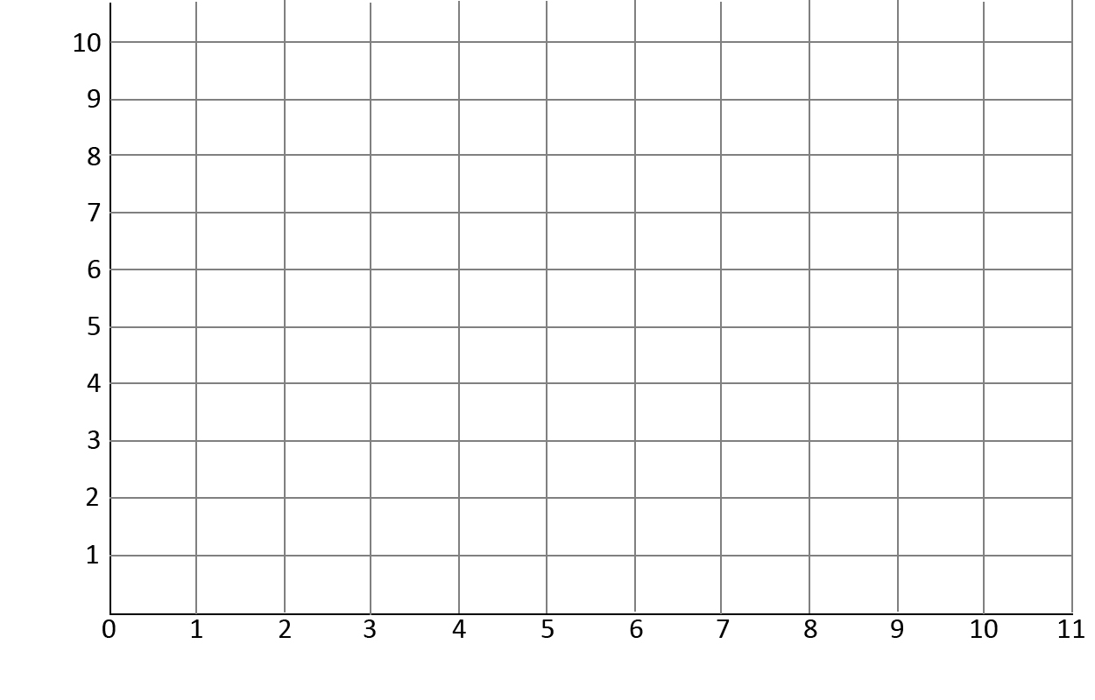

Лістинг програми:

using System;

using System.Collections.Generic;

using System.Linq;

using System.Threading;

namespace ConsoleApplication1

{

class Program

{

static long i;

static int a, b, c, d;

static int y, y1, y2, y3, y4, y5, y6, y7;

public static void ThreadFunc1()

{

for (i = 0; i < 100000000; i++) ;

y1 = b - d;

Console.WriteLine("Privet of thread {0}! ",

Thread.CurrentThread.GetHashCode());

}

private static void ThreadFunc2()

{

for (i = 0; i < 100000000; i++) ;

y2 = c - d;

Console.WriteLine("Privet of thread {0}! ",

Thread.CurrentThread.GetHashCode());

}

private static void ThreadFunc3()

{

for (i = 0; i < 100000000; i++) ;

y3 = a * a;

Console.WriteLine("Privet of thread {0}! ",

Thread.CurrentThread.GetHashCode());

}

private static void ThreadFunc4()

{

for (i = 0; i < 100000000; i++) ;

y4 = y2 * y2;

Console.WriteLine("Privet of thread {0}! ",

Thread.CurrentThread.GetHashCode());

}

private static void ThreadFunc5()

{

for (i = 0; i < 100000000; i++) ;

y5 = y1 * y3;

Console.WriteLine("Privet of thread {0}! ",

Thread.CurrentThread.GetHashCode());

}

private static void ThreadFunc6()

{

for (i = 0; i < 100000000; i++) ;

y6 = y4 / d;

Console.WriteLine("Privet of thread {0}! ",

Thread.CurrentThread.GetHashCode());

}

public static void CheckTime(Object start)

{

Console.WriteLine(DateTime.Now);

}

static void Main(string[] args)

{

int y;

a = 2;

b = 2;

c = 4;

d = 2;

TimerCallback tc = new TimerCallback(CheckTime);

Thread thread1 = new Thread(new ThreadStart(Program.ThreadFunc1));

Thread thread2 = new Thread(new ThreadStart(Program.ThreadFunc2));

Thread thread3 = new Thread(new ThreadStart(Program.ThreadFunc3));

Thread thread4 = new Thread(new ThreadStart(Program.ThreadFunc4));

Thread thread5 = new Thread(new ThreadStart(Program.ThreadFunc5));

Thread thread6 = new Thread(new ThreadStart(Program.ThreadFunc6));

Timer t = new Timer(tc, null, 0, 1000);

Console.WriteLine("thread1.TreadState=" + thread1.ThreadState);

Console.WriteLine("thread2.TreadState=" + thread2.ThreadState);

Console.WriteLine("thread3.TreadState=" + thread3.ThreadState);

Console.WriteLine("thread4.TreadState=" + thread4.ThreadState);

Console.WriteLine("thread5.TreadState=" + thread5.ThreadState);

Console.WriteLine("thread6.TreadState=" + thread6.ThreadState);

thread1.Start();

thread2.Start();

Console.WriteLine("thread1.TreadState=" + thread1.ThreadState);

Console.WriteLine("thread2.TreadState=" + thread2.ThreadState);

Console.WriteLine("thread3.TreadState=" + thread3.ThreadState);

Console.WriteLine("thread4.TreadState=" + thread4.ThreadState);

Console.WriteLine("thread5.TreadState=" + thread5.ThreadState);

Console.WriteLine("thread6.TreadState=" + thread6.ThreadState);

thread1.Join();

thread2.Join();

Console.WriteLine("thread1.TreadState=" + thread1.ThreadState);

Console.WriteLine("thread2.TreadState=" + thread2.ThreadState);

Console.WriteLine("thread3.TreadState=" + thread3.ThreadState);

Console.WriteLine("thread4.TreadState=" + thread4.ThreadState);

Console.WriteLine("thread5.TreadState=" + thread5.ThreadState);

Console.WriteLine("thread6.TreadState=" + thread6.ThreadState);

Console.WriteLine("new treads endinf");

Console.WriteLine("y1=" + y1);

Console.WriteLine("y2=" + y2);

thread3.Start();

thread4.Start();

Console.WriteLine("thread1.TreadState=" + thread1.ThreadState);

Console.WriteLine("thread2.TreadState=" + thread2.ThreadState);

Console.WriteLine("thread3.TreadState=" + thread3.ThreadState);

Console.WriteLine("thread4.TreadState=" + thread4.ThreadState);

Console.WriteLine("thread5.TreadState=" + thread5.ThreadState);

Console.WriteLine("thread6.TreadState=" + thread6.ThreadState);

thread3.Join();

thread4.Join();

Console.WriteLine("thread1.TreadState=" + thread1.ThreadState);

Console.WriteLine("thread2.TreadState=" + thread2.ThreadState);

Console.WriteLine("thread3.TreadState=" + thread3.ThreadState);

Console.WriteLine("thread4.TreadState=" + thread4.ThreadState);

Console.WriteLine("thread5.TreadState=" + thread5.ThreadState);

Console.WriteLine("thread6.TreadState=" + thread6.ThreadState);

Console.WriteLine("new treads endinf");

Console.WriteLine("y3=" + y3);

Console.WriteLine("y4=" + y4);

Thread5.Start();

thread6.Start();

Console.WriteLine("thread1.TreadState=" + thread1.ThreadState);

Console.WriteLine("thread2.TreadState=" + thread2.ThreadState);

Console.WriteLine("thread3.TreadState=" + thread3.ThreadState);

Console.WriteLine("thread4.TreadState=" + thread4.ThreadState);

Console.WriteLine("thread1.TreadState=" + thread5.ThreadState);

Console.WriteLine("thread2.TreadState=" + thread6.ThreadState);

thread6.Join();

thread5.Join();

Console.WriteLine("thread1.TreadState=" + thread1.ThreadState);

Console.WriteLine("thread2.TreadState=" + thread2.ThreadState);

Console.WriteLine("thread3.TreadState=" + thread3.ThreadState);

Console.WriteLine("thread4.TreadState=" + thread4.ThreadState);

Console.WriteLine("thread5.TreadState=" + thread5.ThreadState);

Console.WriteLine("thread6.TreadState=" + thread6.ThreadState);

Console.WriteLine("new treads endinf");

Console.WriteLine("y5=" + y5);

Console.WriteLine("y6=" + y6);

Thread.Sleep(2000);

y = y5 + y6;

Console.WriteLine("y=" + y);

t.Dispose();

Console.ReadLine();

}

}

}

Висновок:

Навчився працювати в середовищі Visual C#. Отримав знання з об’єктно-орієнтованого програмування на мові C#. Навчився використовувати класи та методи. Вивчив бібліотеки, що відповідають за багато поточність в C#, та підвищив знання в паралельному програмуванні.