PROJECT

Course: Web Technologies & Programming

Topic: Online Movie Booking

Date of submission: 29/05/2025

Worked by: Viola Zeneli (SWE2-C)

Accepted by: Olsi Shehu

EXPLANATION

My website is about buying online movie tickets.
I have used html, php, css and javascript.

If you are not logged in, but navigate to my website as a Guest, you can:
- Open in the header only pages Home, All Movies, About Us and Contacts.
- For movies you can view their details, check available seats and even select what seats you want, but you can’t pay for them. You need to login first.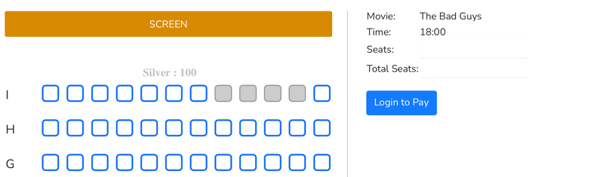
- Also, you can’t send feedback and of course can’t view your tickets.

There are 2 user levels: User (that buys tickets) and Admin (that manages movies):
Users can:
- Register, Login as user, Change username, Change password and Logout
- Navigate to all pages of header, even Feedback (so they can send a feedback) and Your Tickets (so they can view the tickets that they have bought)
- Make payment for movies after they have selected the seats.
Admin can:
- Login as admin and Sign out
- View all admins
- View all movies, delete, edit and even add another movie
- View all customers (all users buying a ticket for a movie)
- View all user feedbacks and even delete them if they want to
- View all users (that are logged in) and even delete them if they want to
- View all tickets bought from all customers.
DATABASE

Database: moviebook
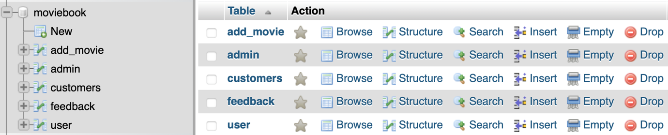
Table add_movie:
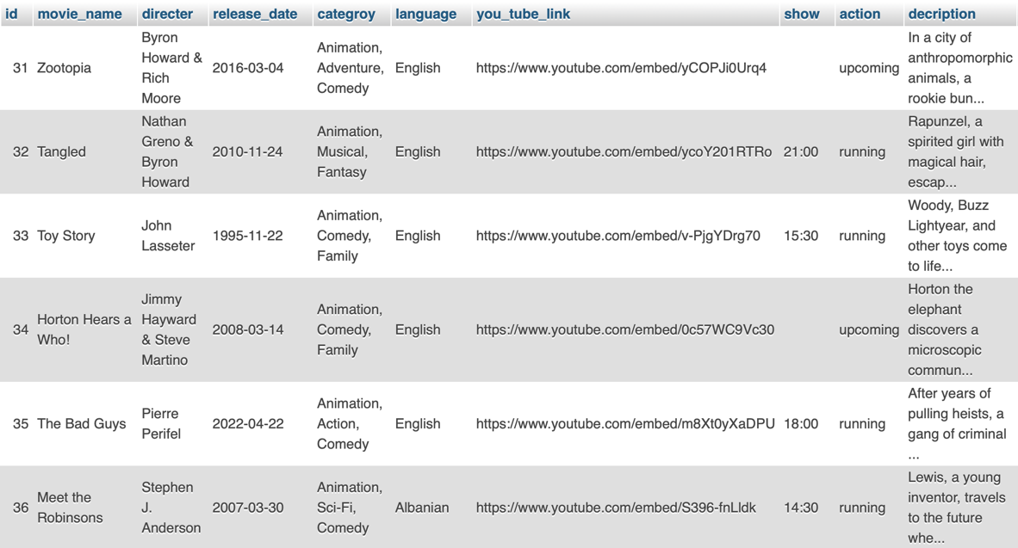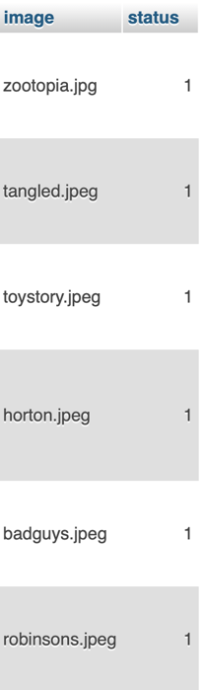
Table admin:
Table user:

Table feedback:
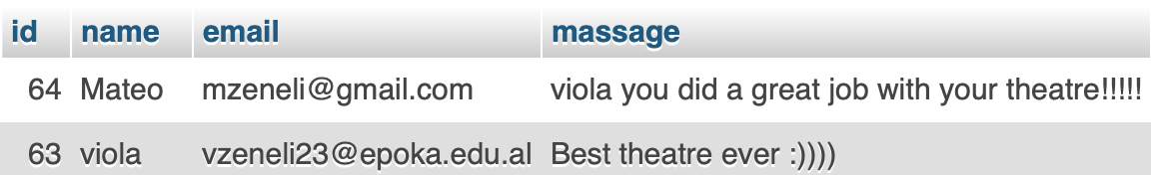

Table customers:
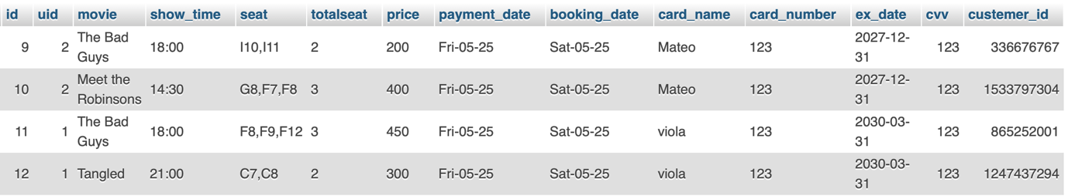

WEBSITE
Home (all 4 pictures below)
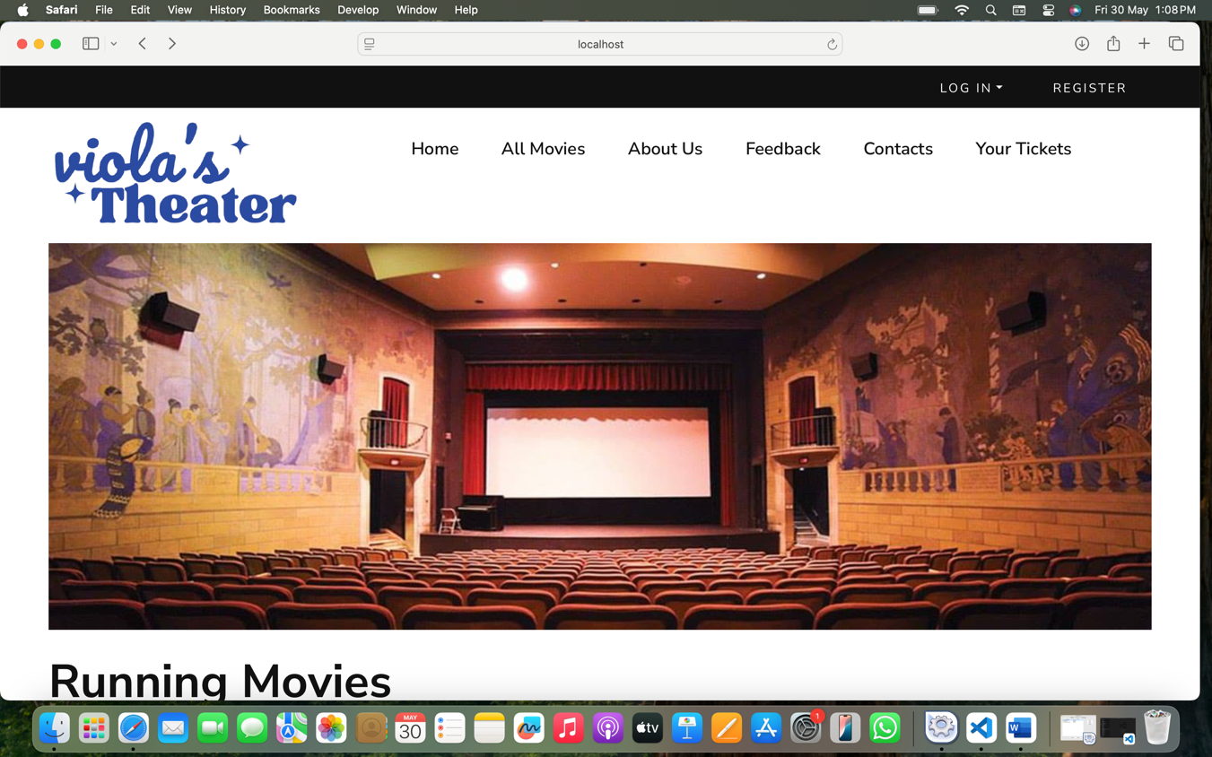
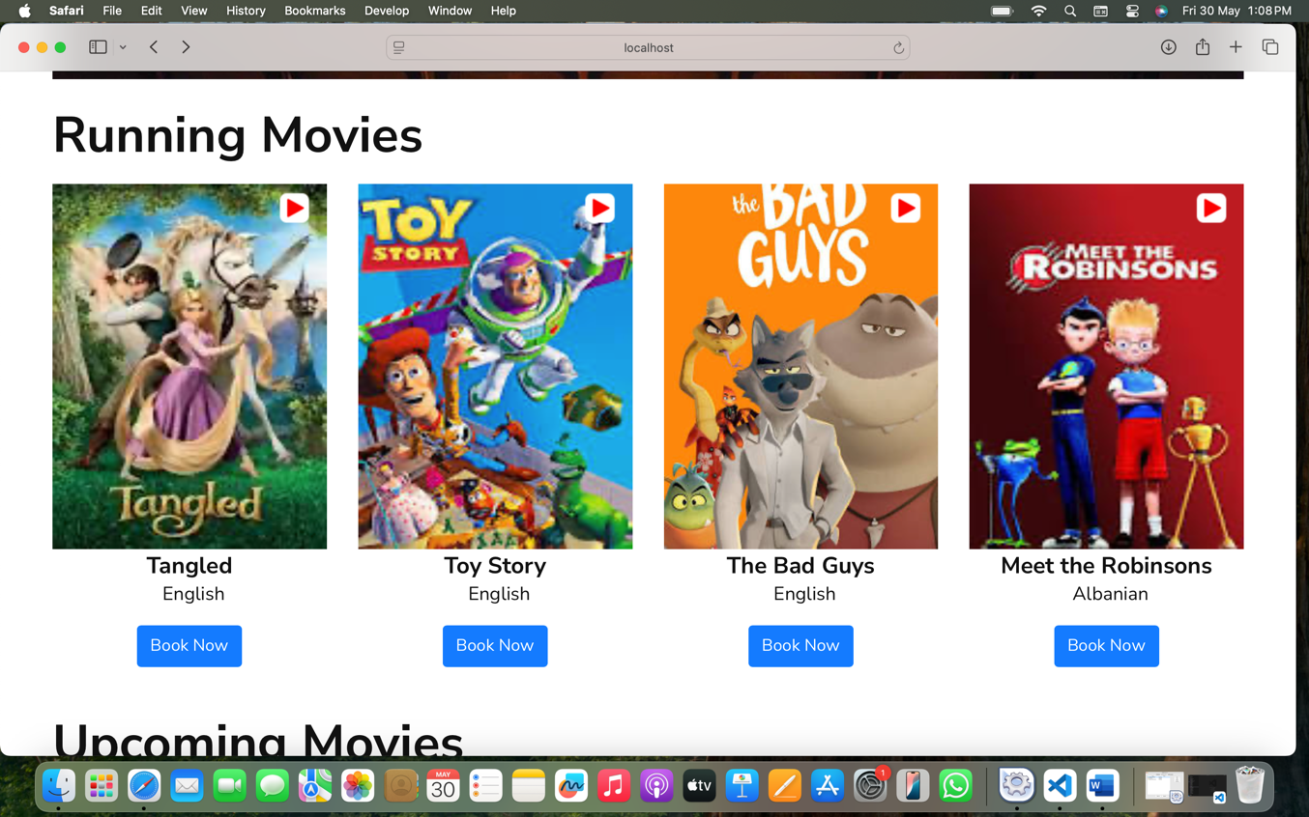

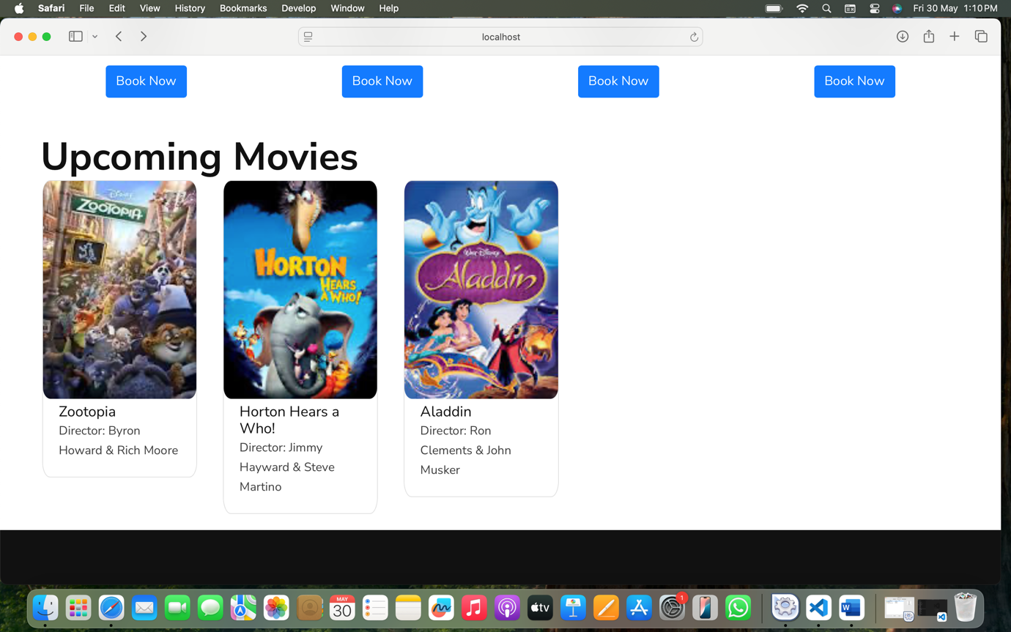

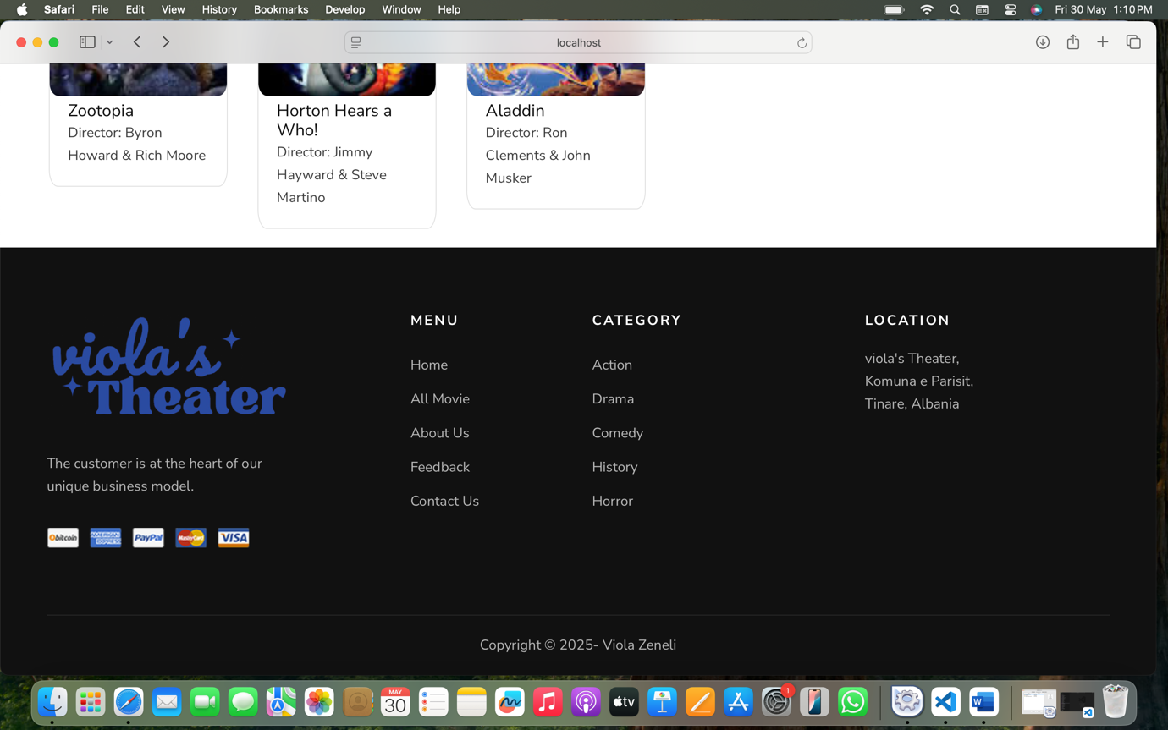
All Movies
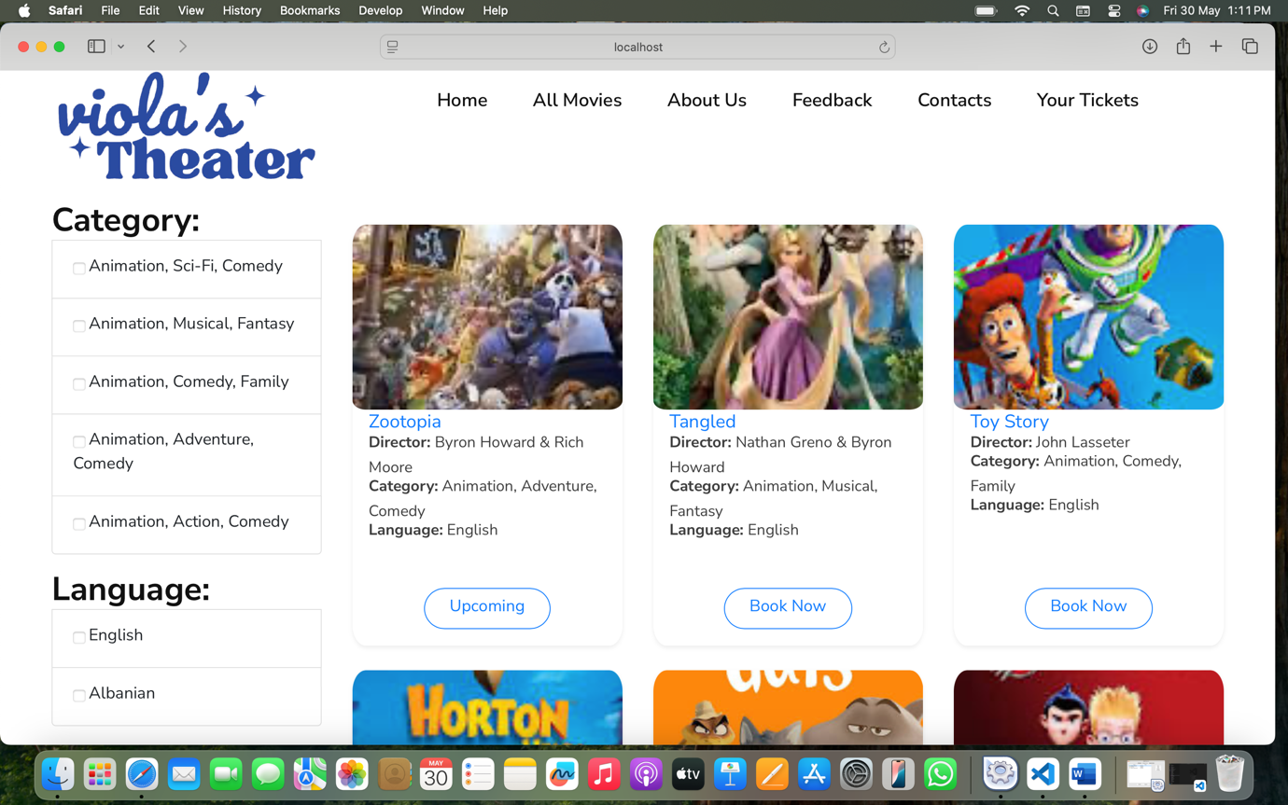
Selecting category and language:
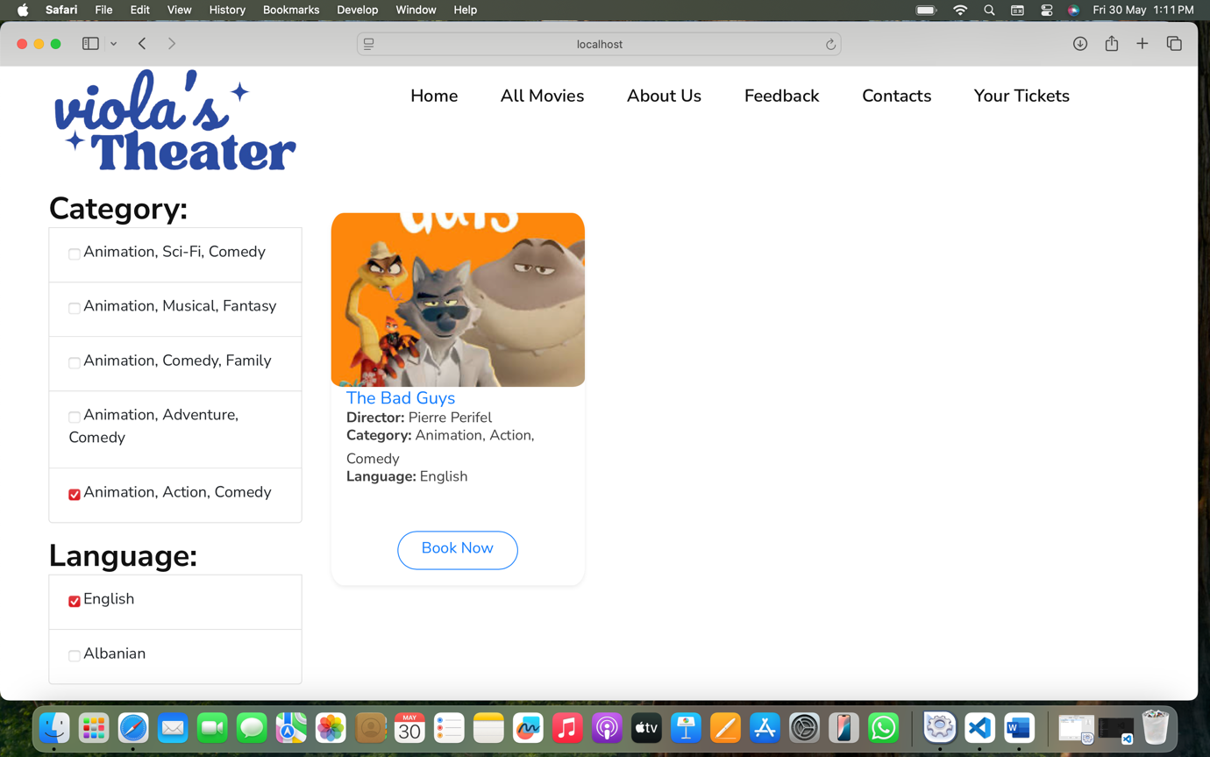
About Us (2 pictures below)
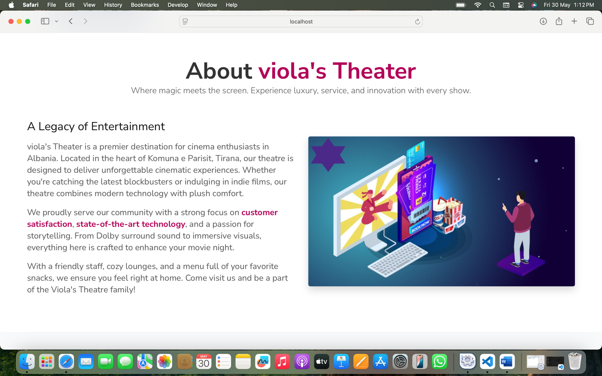
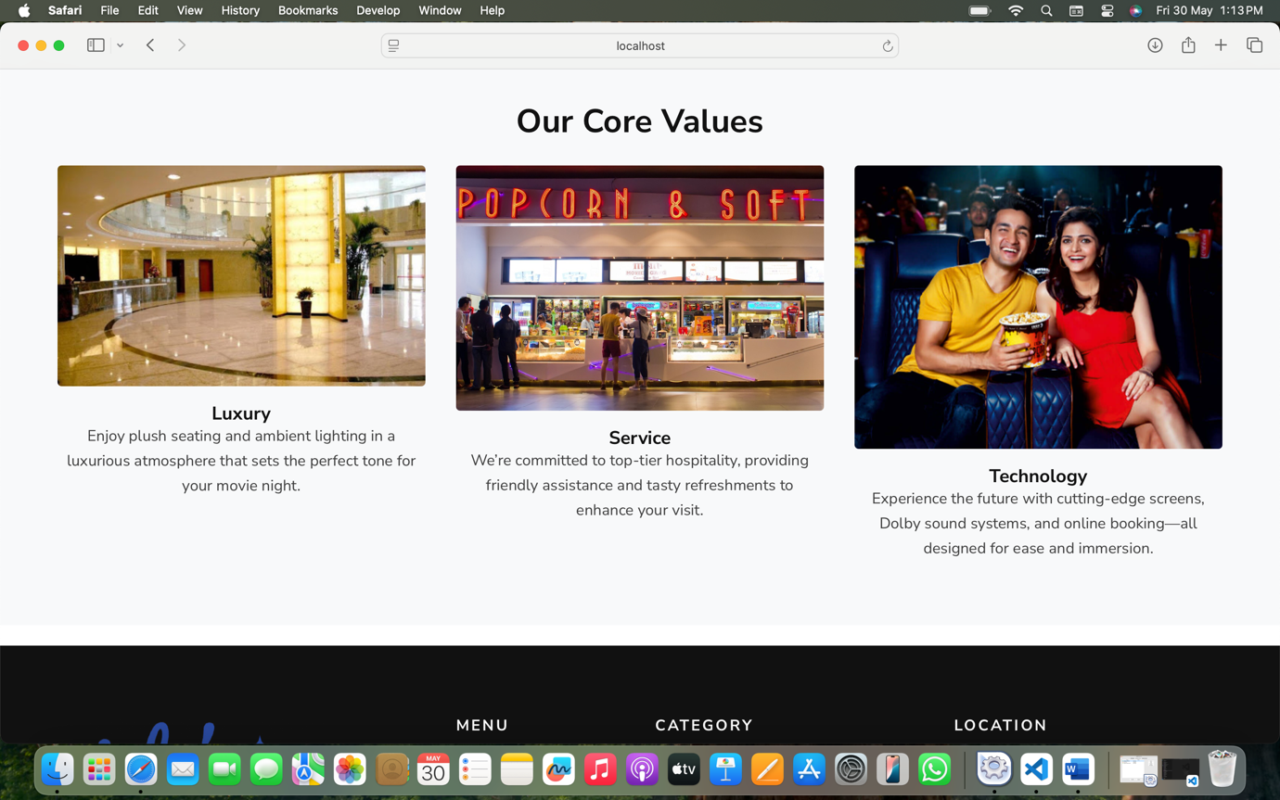

Contacts
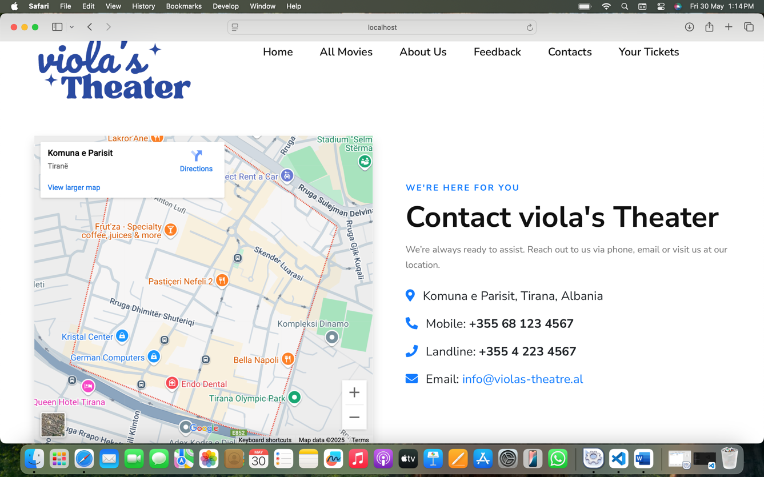
Feedback & Your Tickets
(if not logged in show this alert + redirect to user login.php)
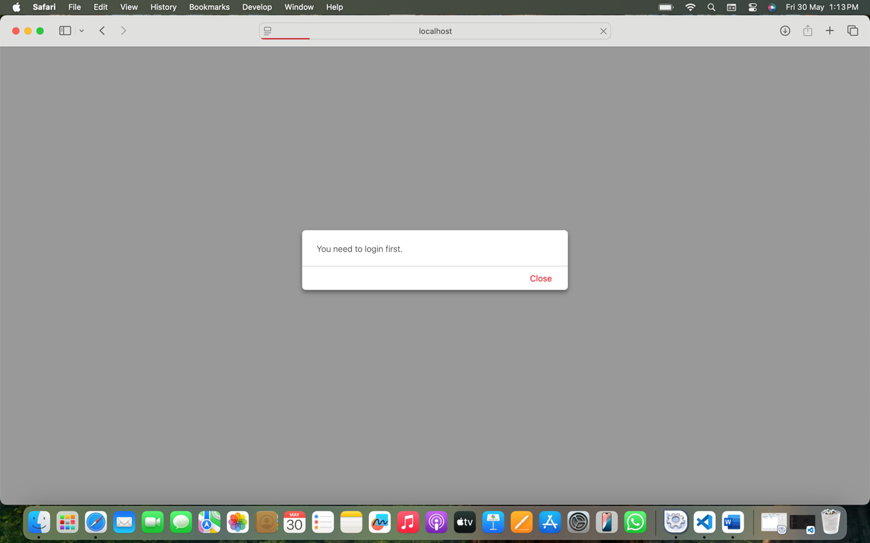
Header (2 Logins + Registration)
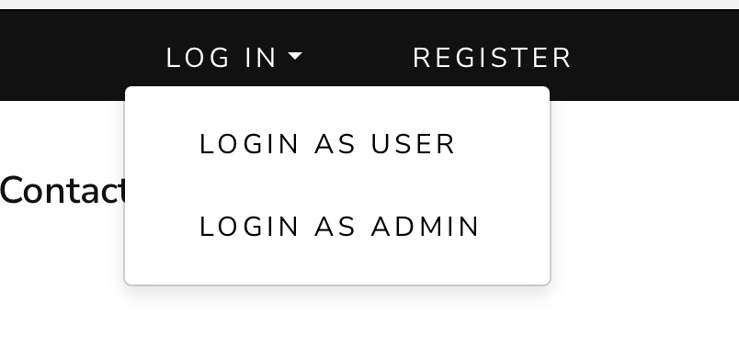
REGISTER:
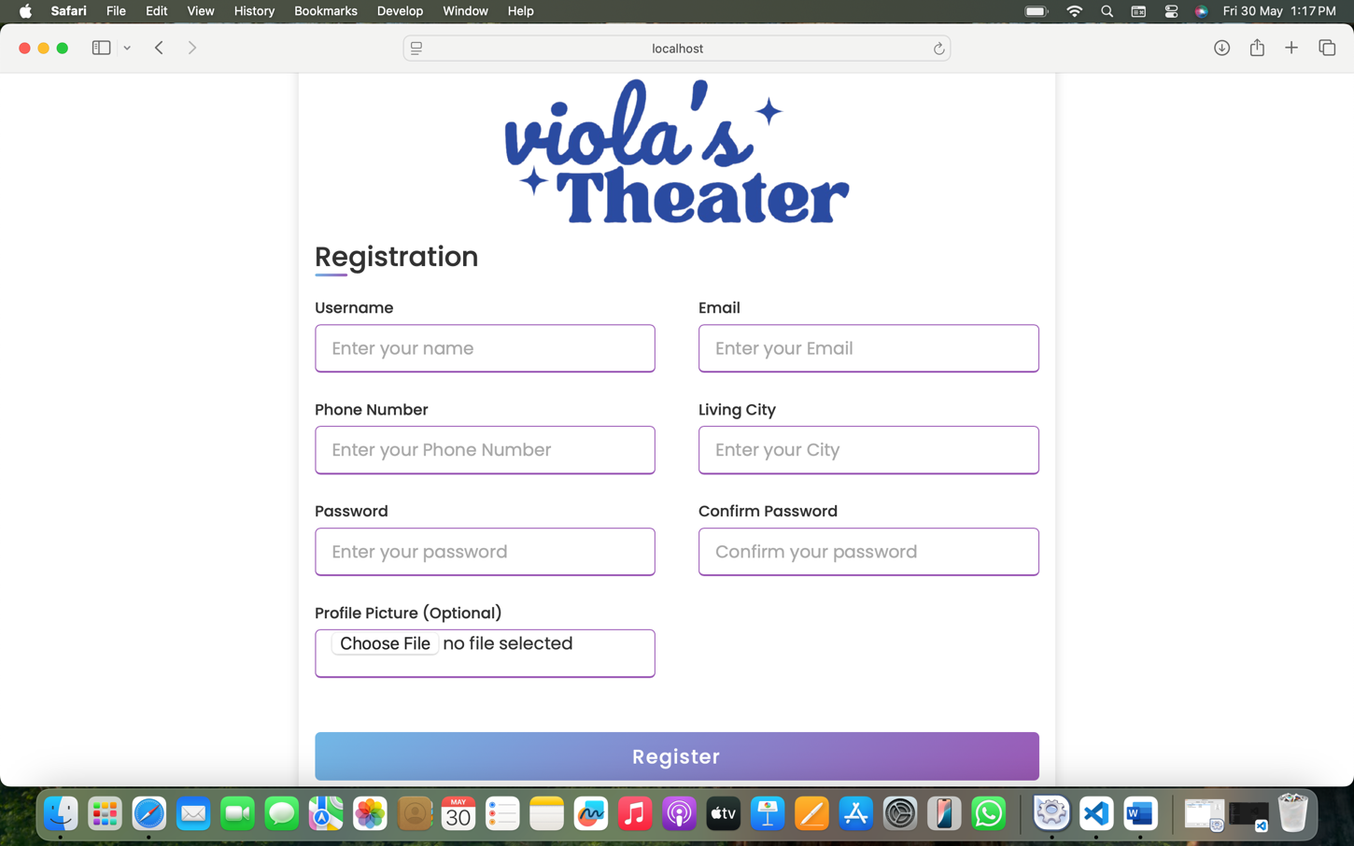

LOGIN AS USER:
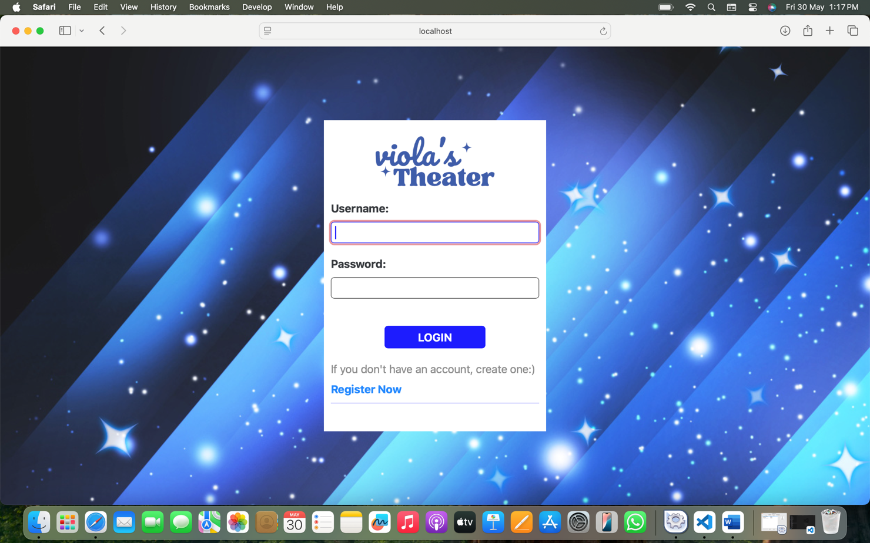

After logging in, header is like this:
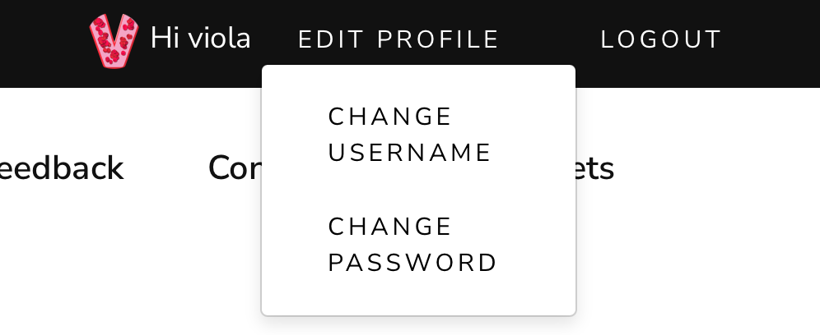

CHANGE USERNAME:
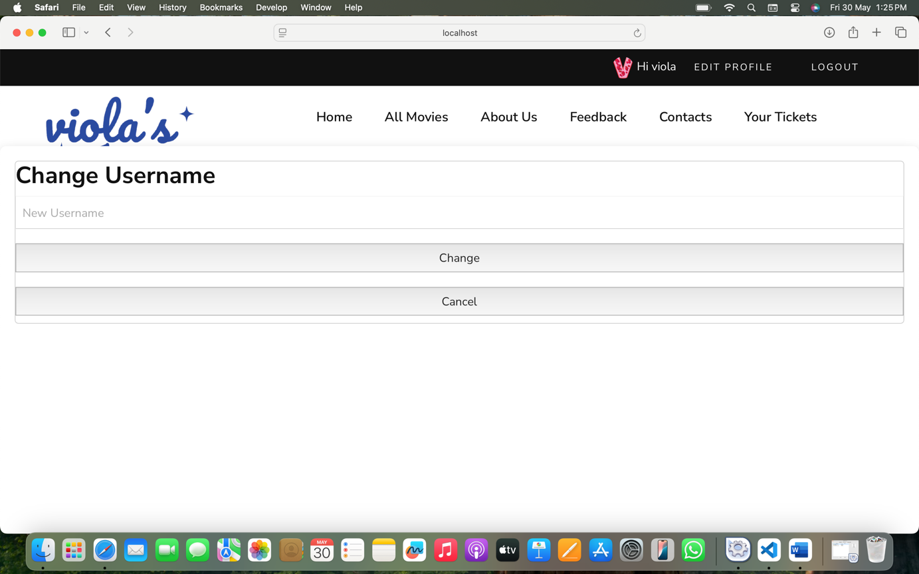
CHANGE PASSWORD:
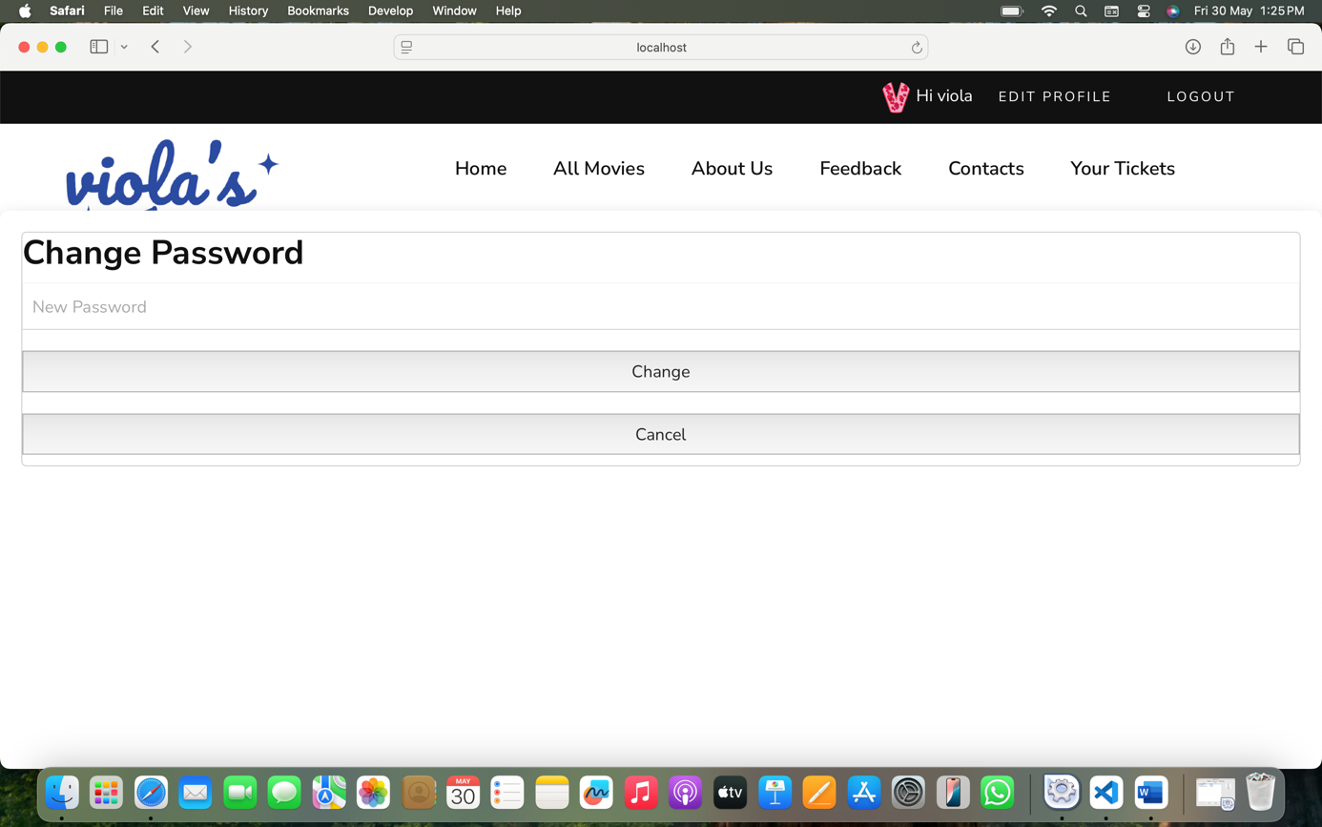
Feedback and Your Tickets pages (after successfully logging in)
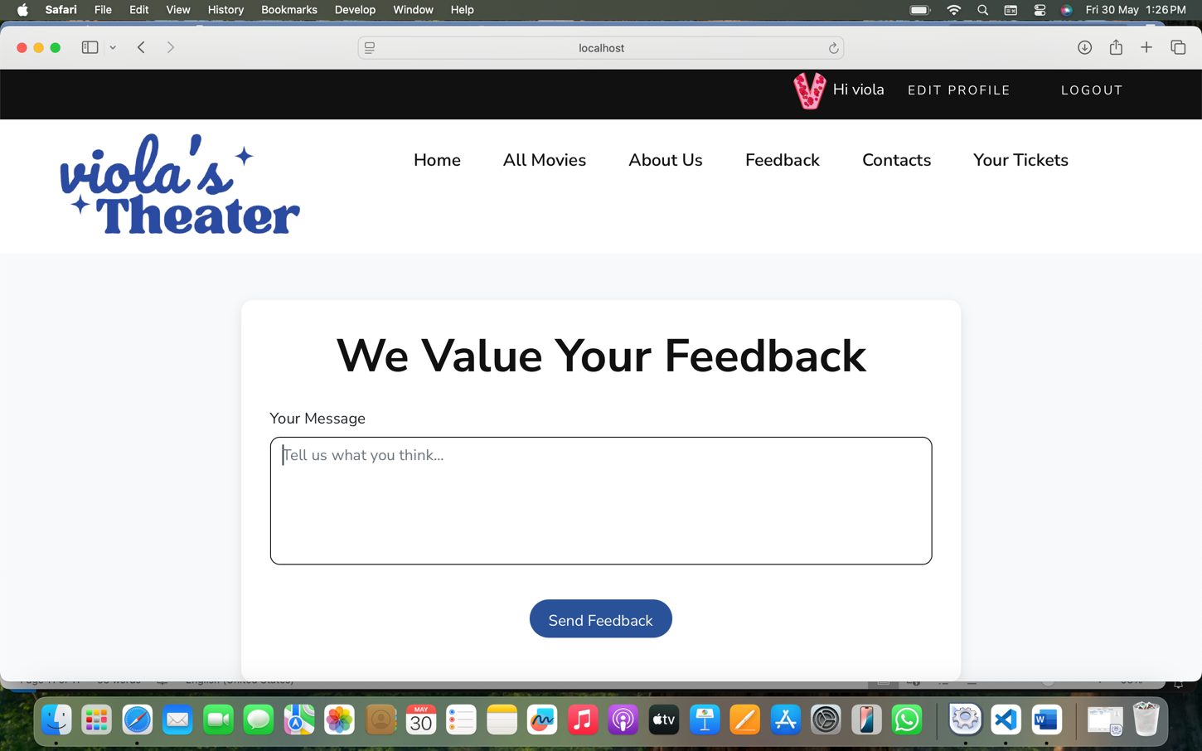
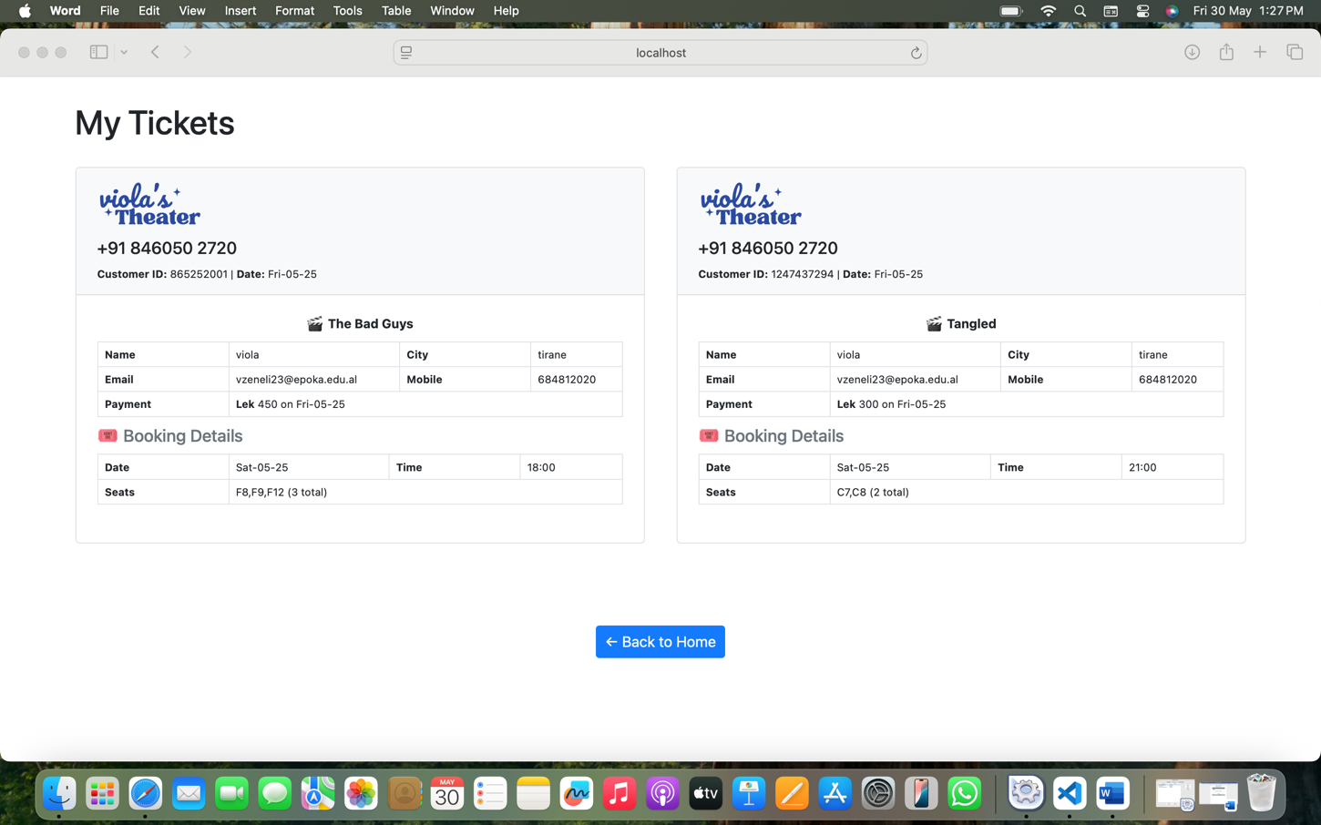
Now that I am logged in, I can even book a movie

If the YouTube icon is clicked, this shows:
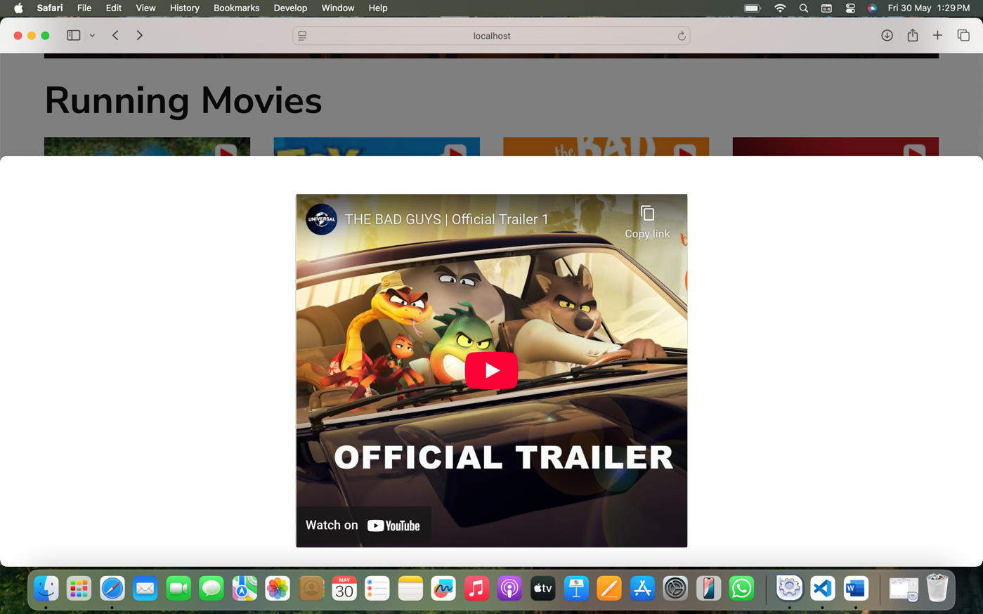
If Book Now is clicked:
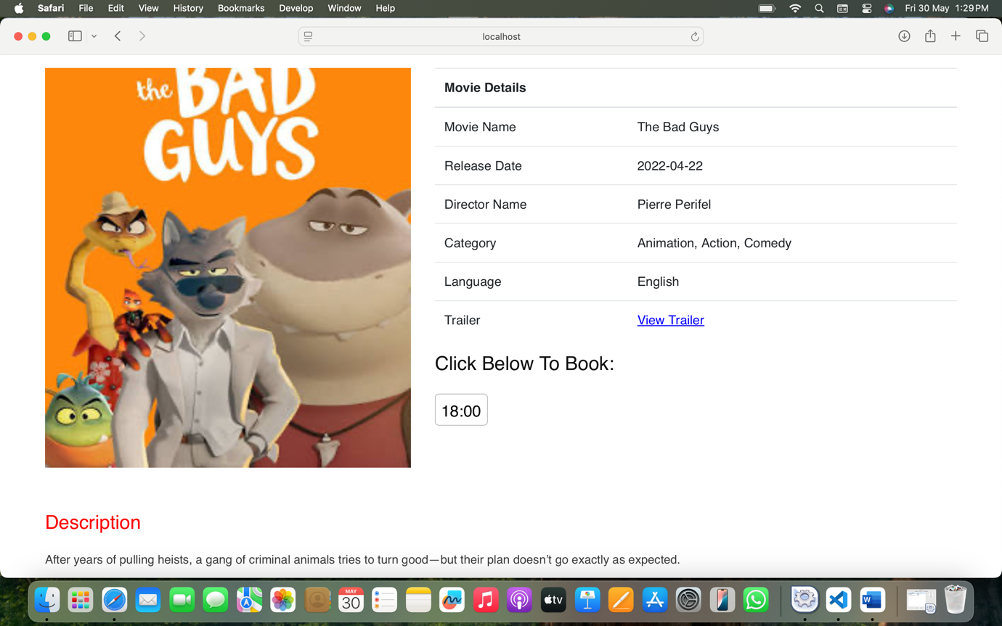
If the show time is clicked (in this case 18:00):
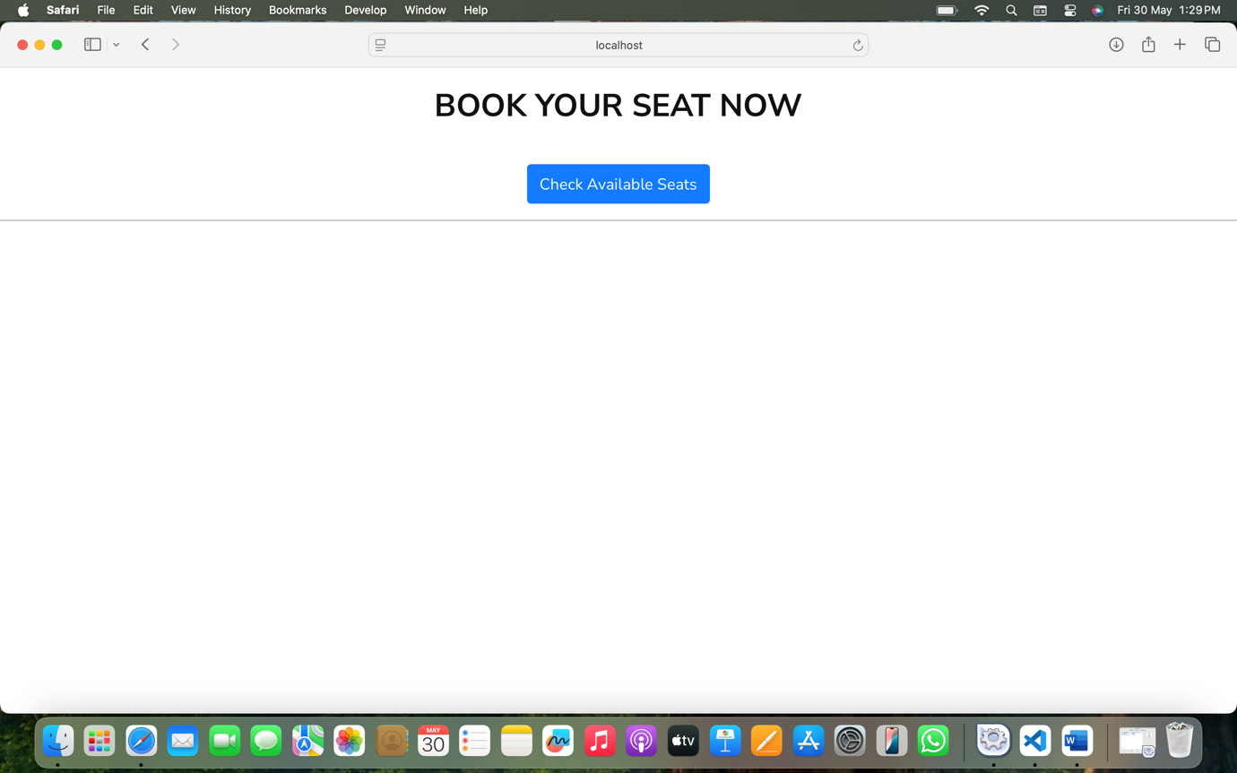
If Check Available Seats is clicked:
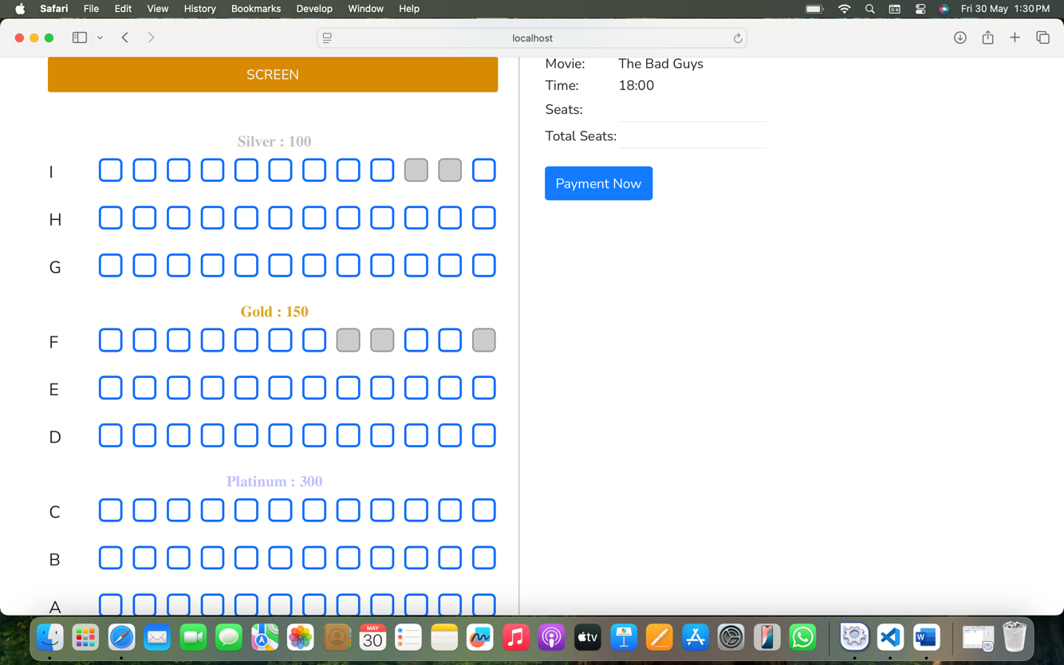
Only the seats that have not been selected before (that are not in table customers) can be selected:
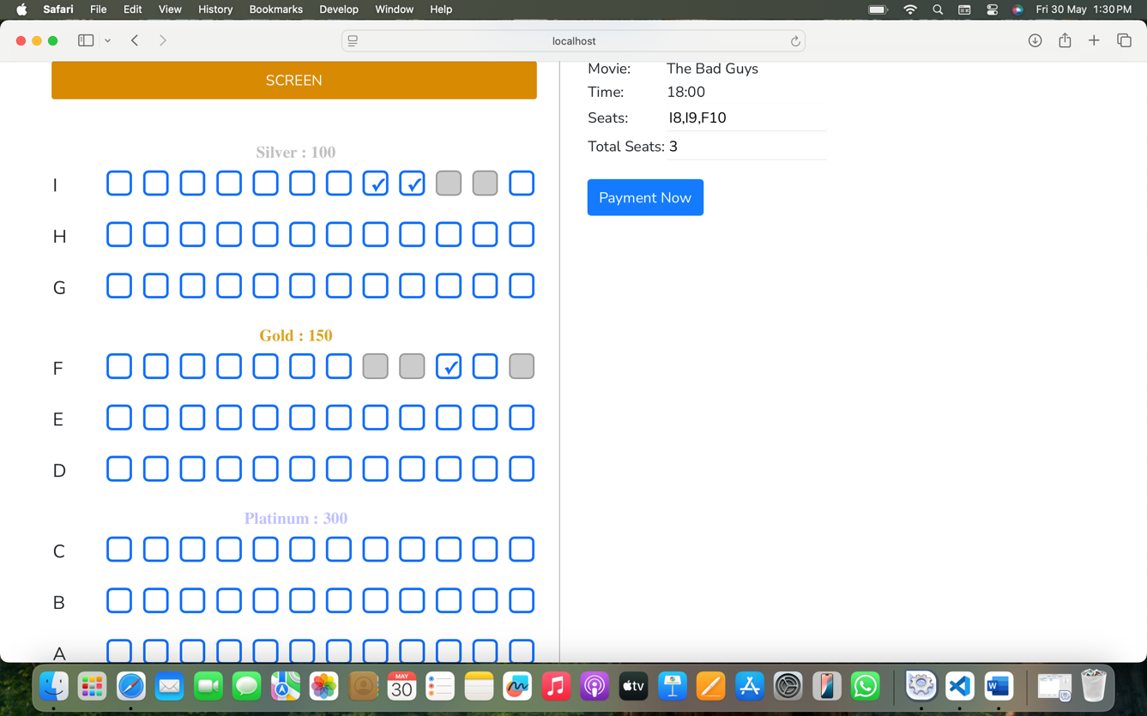
If Payment Now is clicked:
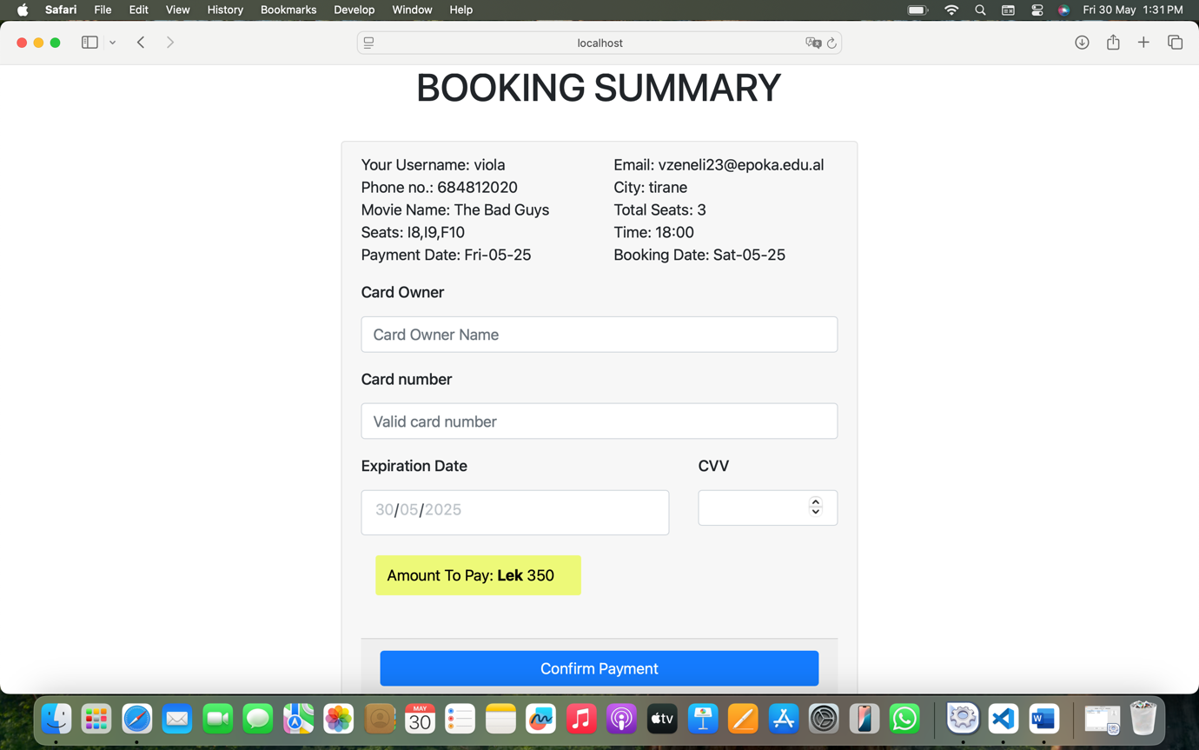
If Confirm Payment is clicked:
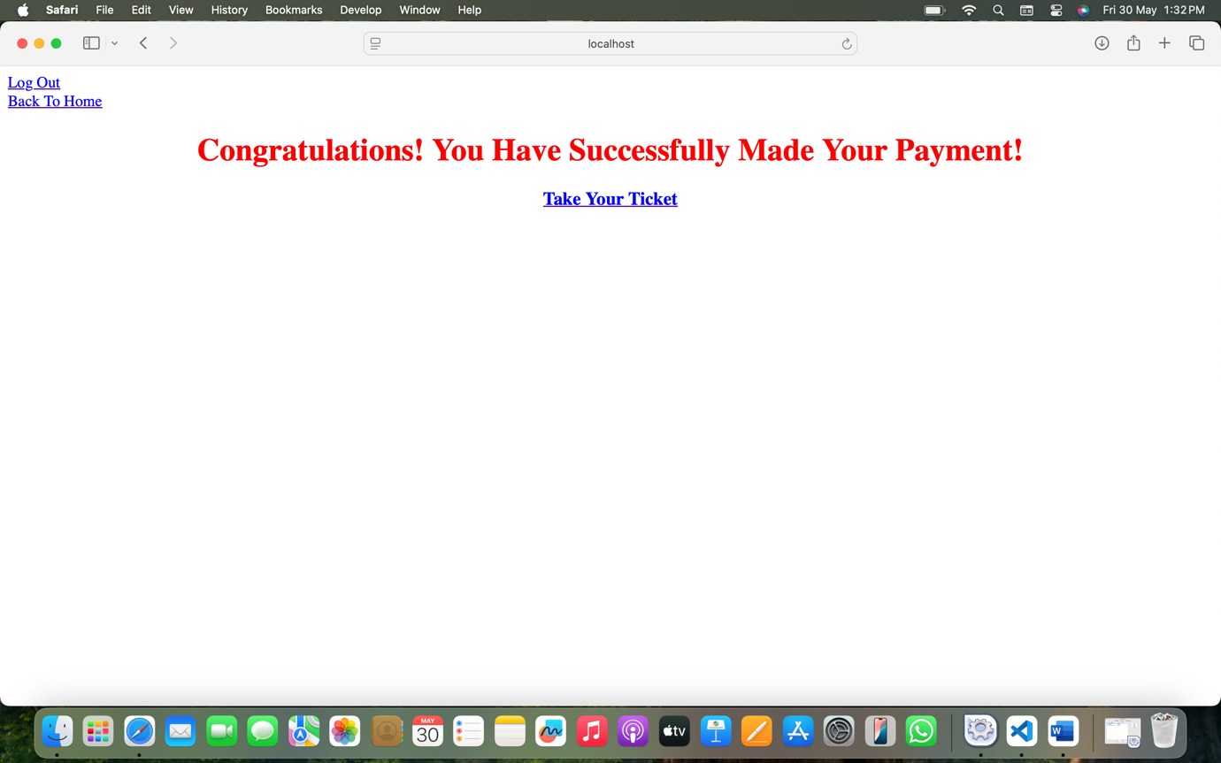
If Take Your Ticket is clicked:
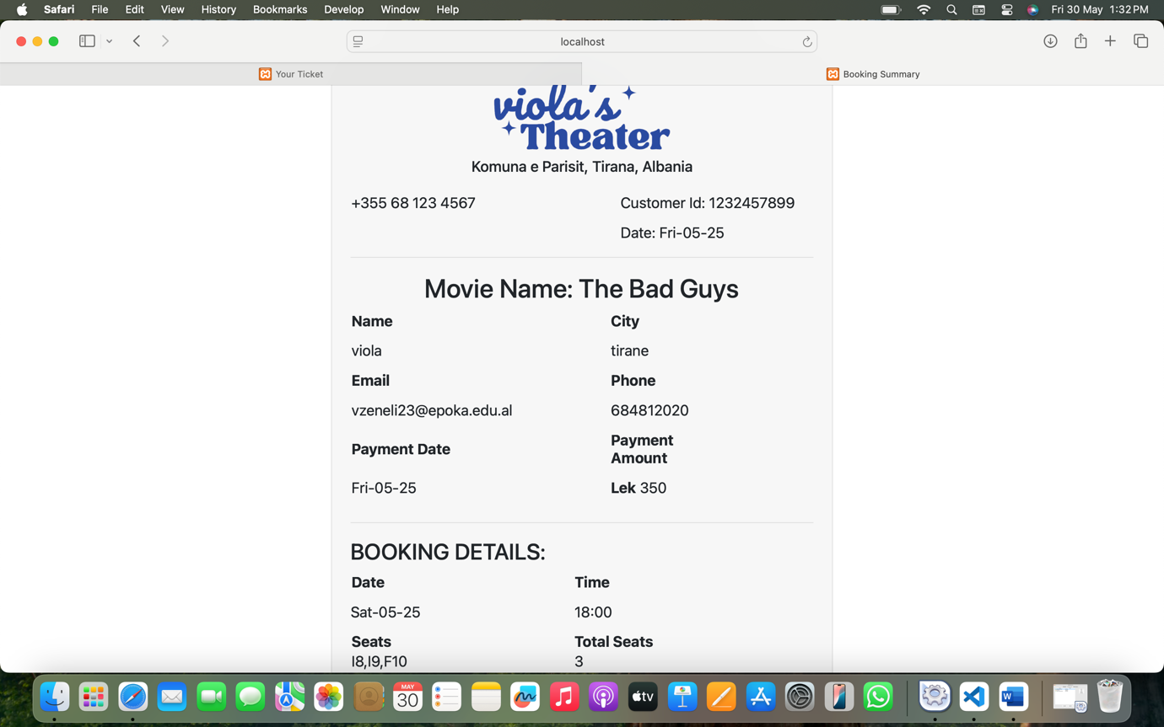
Then if you click in the Your Tickets in header, the new ticket is there:
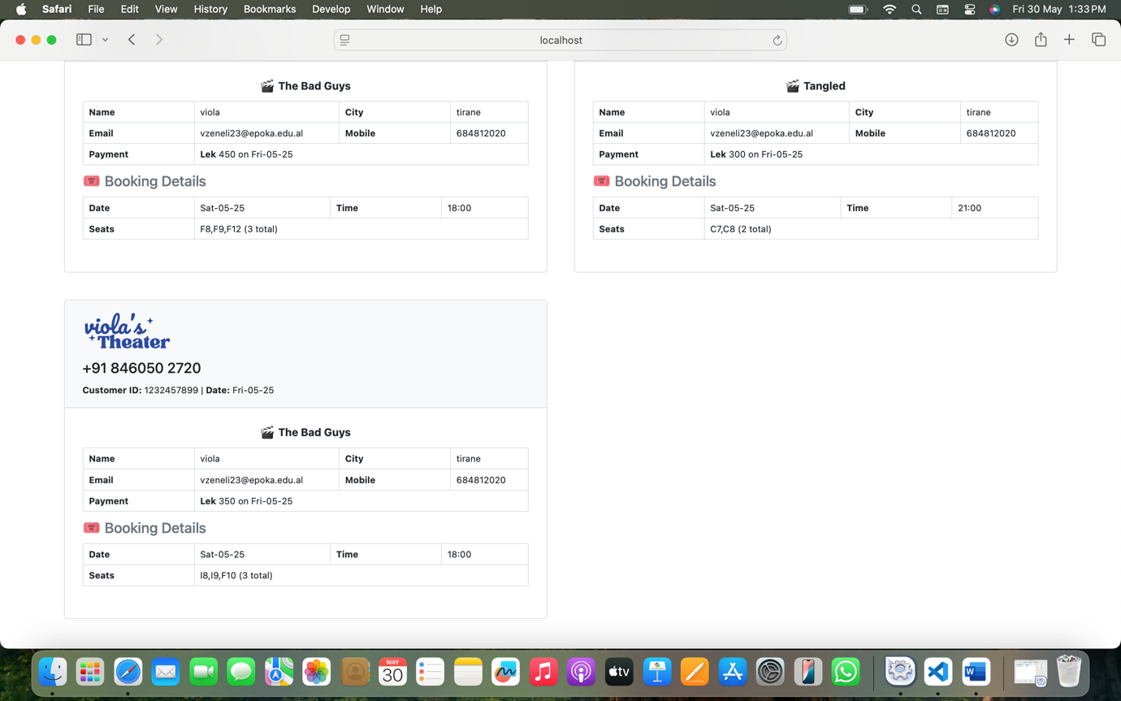
LOGIN AS ADMIN:
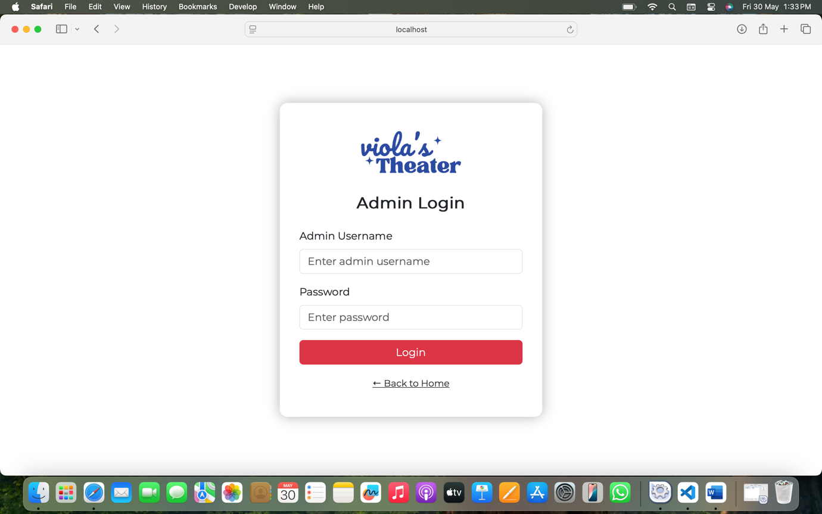
All Admins:
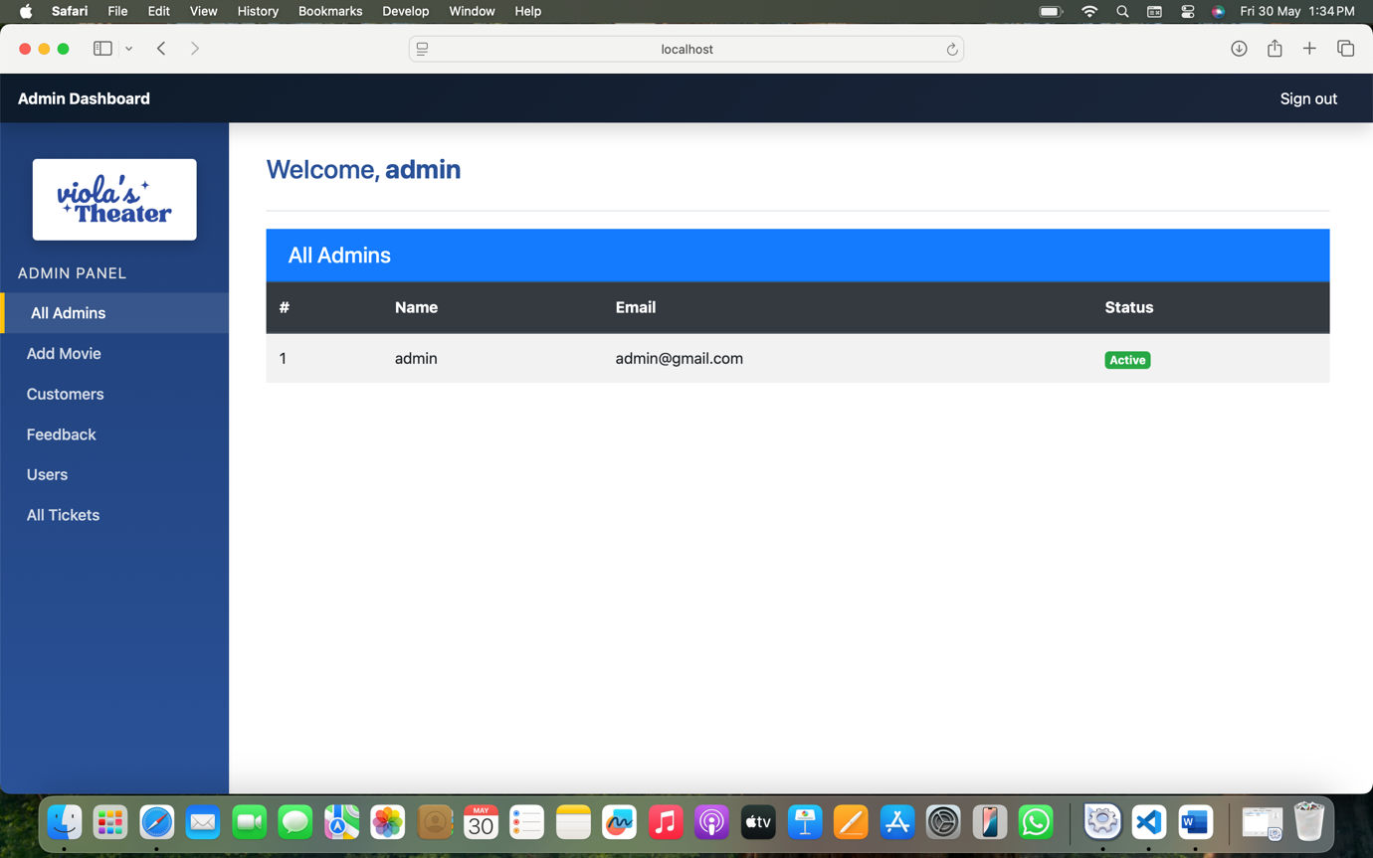
Add Movie:
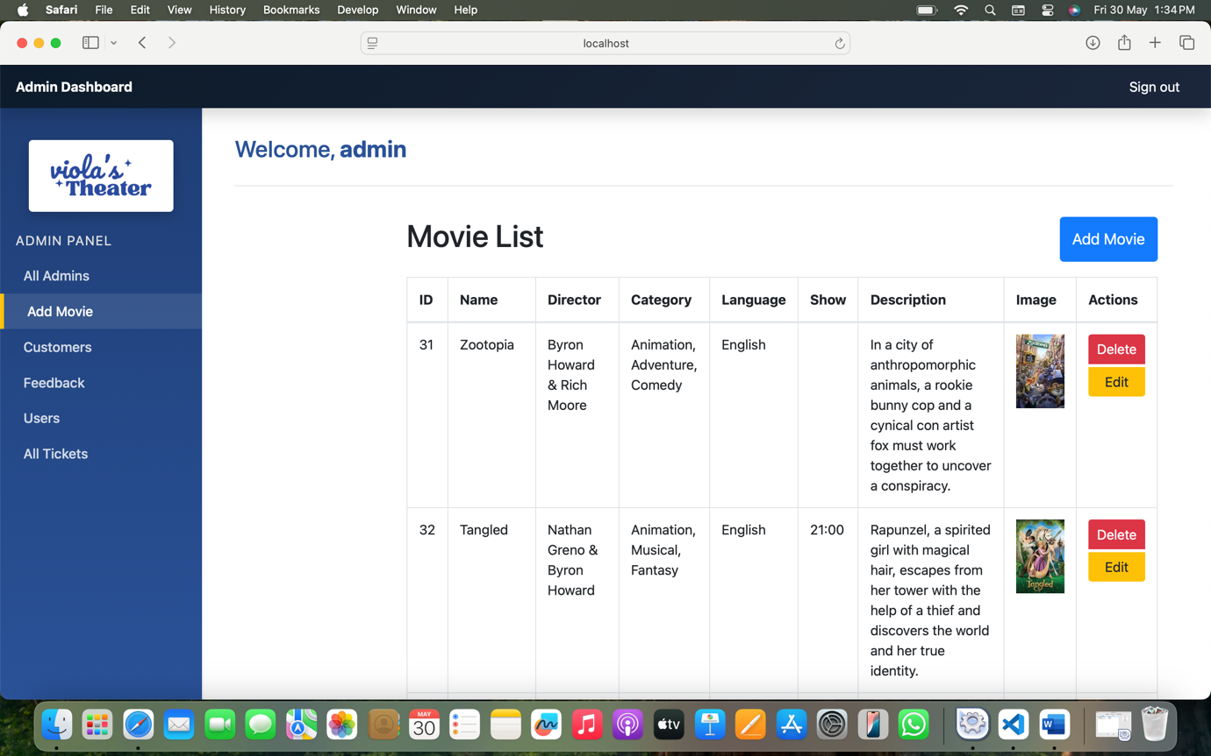
If Delete is clicked:
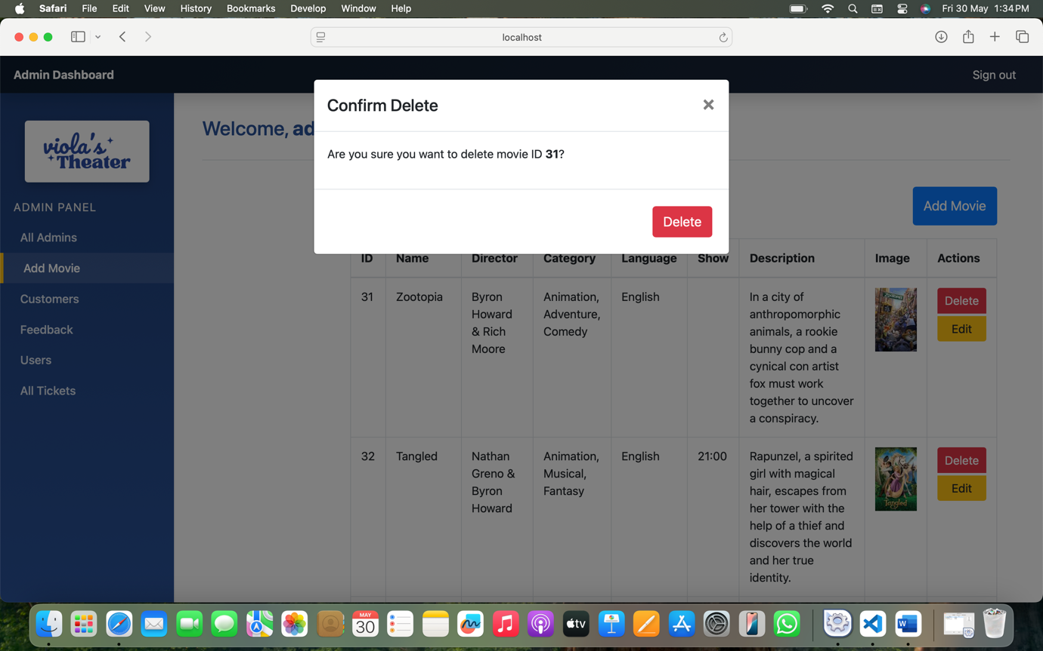
If Edit is clicked:
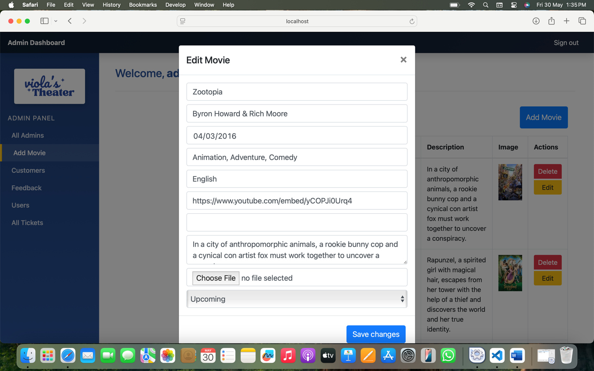
If Add Movie is clicked:
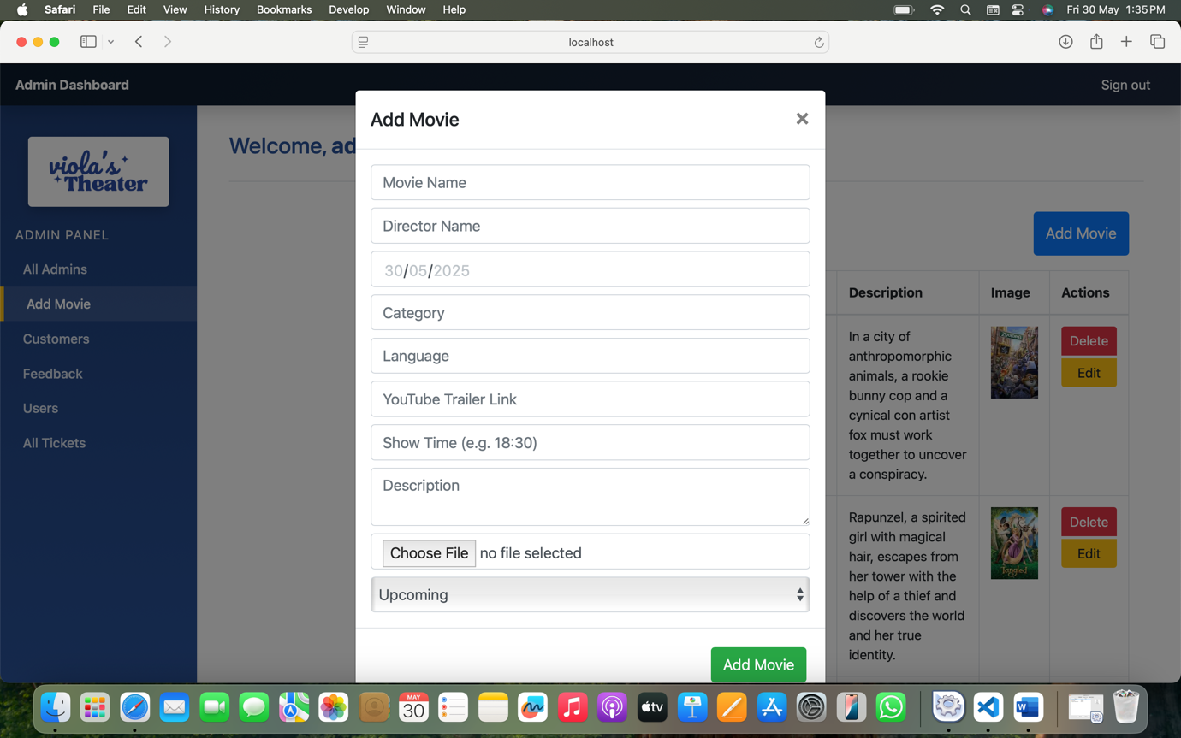
Customers (all users that booked a movie):
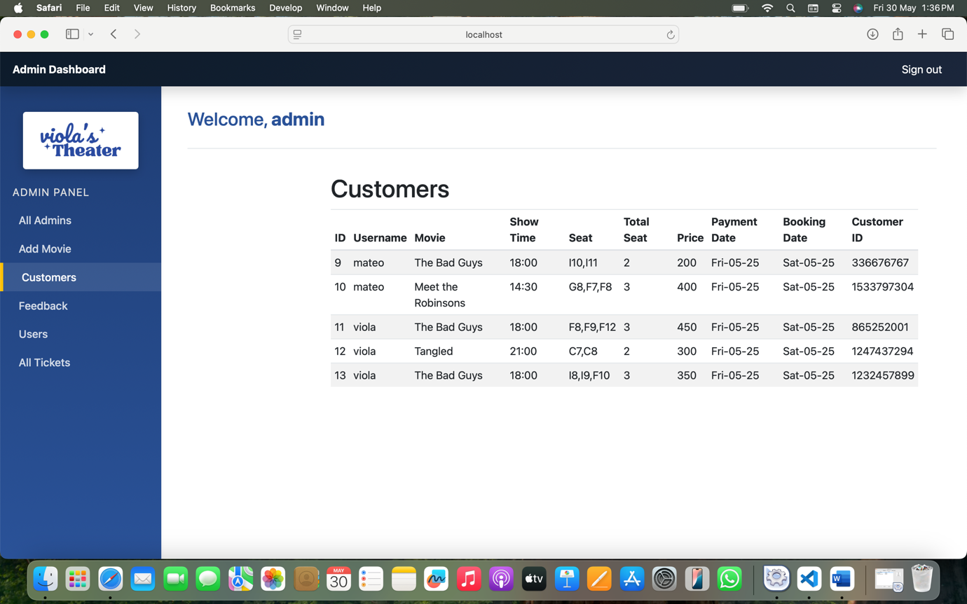
Feedback:
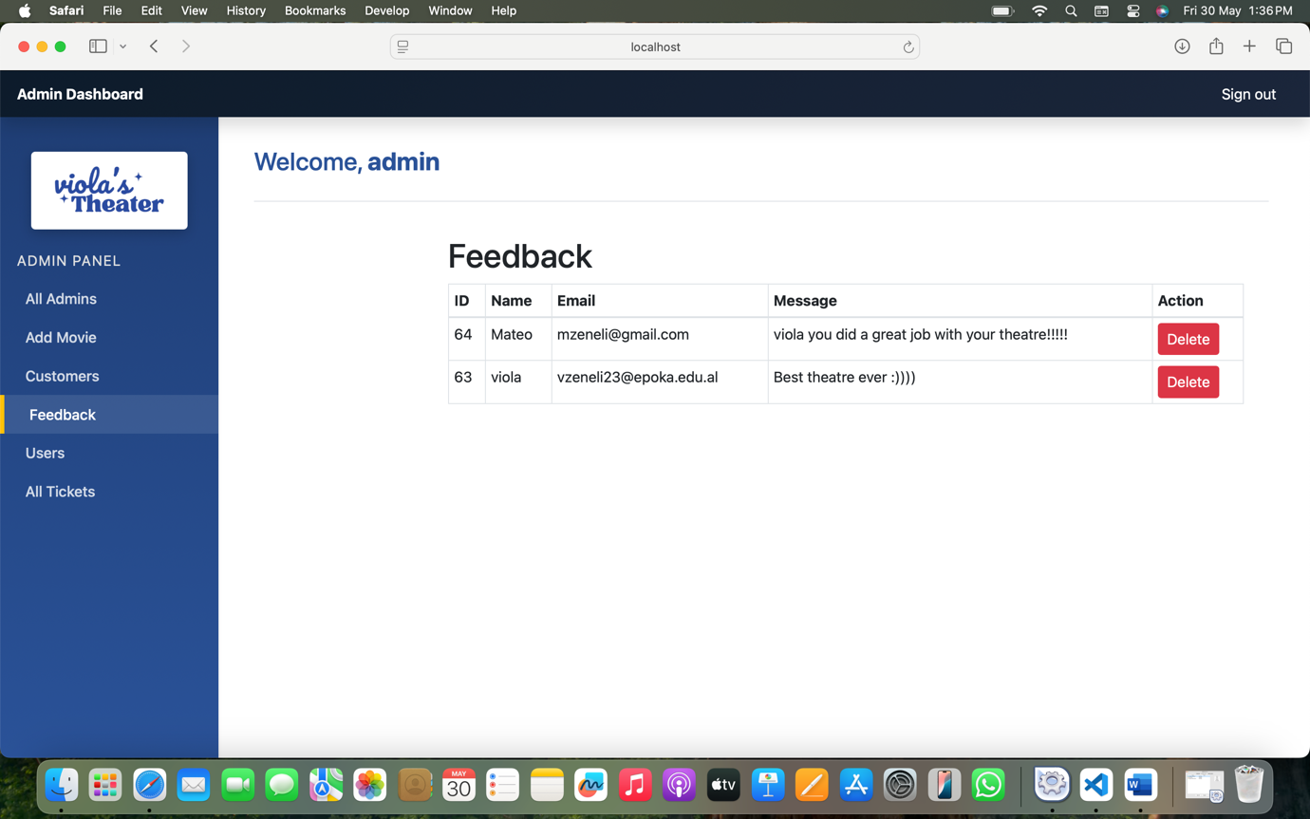
Users:
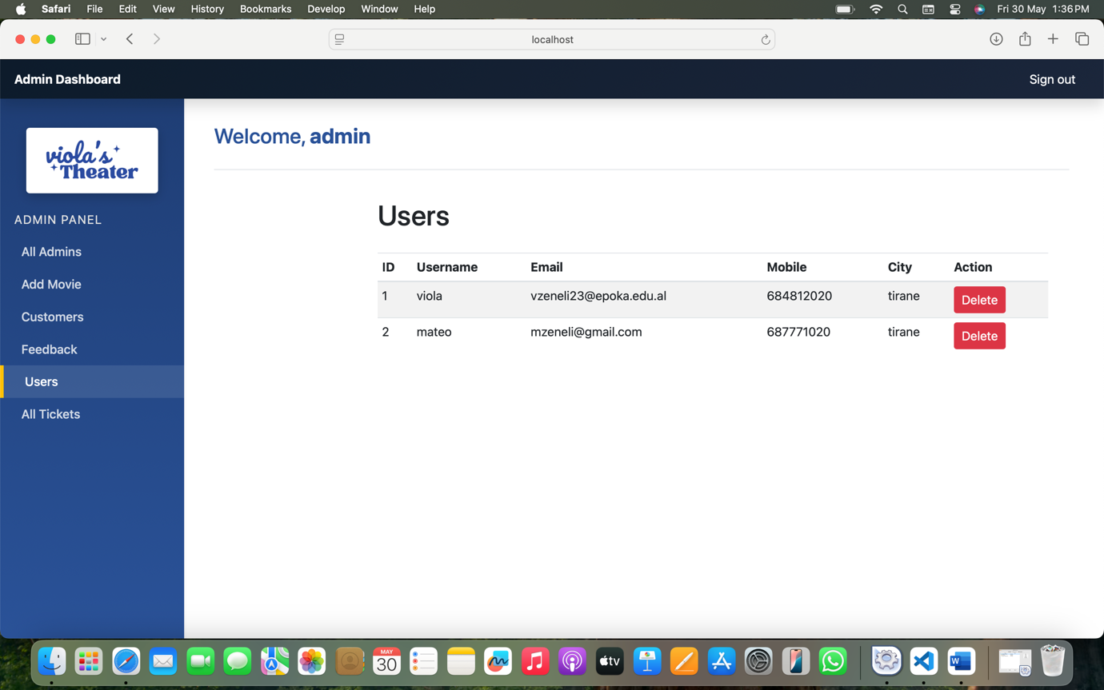
All Tickets:
