Software Modeling & Design Project

Title: Waste Management System

Requirements Specification

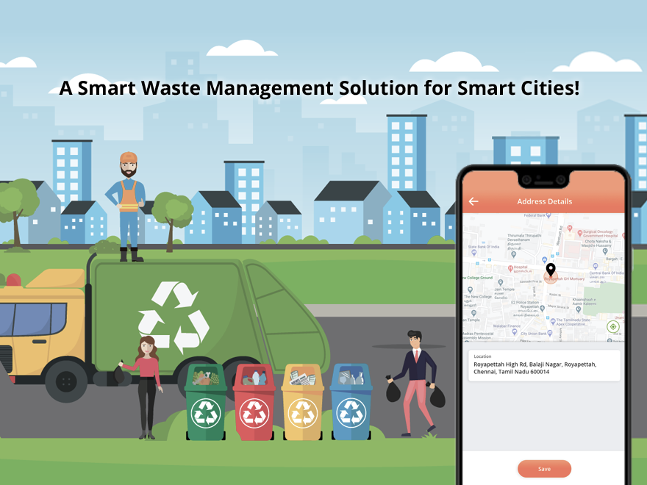
Team Members:
- Viola Zeneli
- Sidrit Rrustemi
- Suada Terolli
- Alesia Dardha
- Nikol Dalipi
- Noel Zani
- Mirsad Amuli

Lecturers: M.Sc. Ari Gjerazi, M.Sc. Edlira Cani
TABLE OF CONTENTS
1. EXECUTIVE SUMMARY 3
1.1 PROJECT OVERVIEW 3
2. PRODUCT/SERVICE DESCRIPTION 5
2.1 PRODUCT CONTEXT 5
2.2 USER CHARACTERISTICS 6
2.3 ASSUMPTIONS 8
2.4 CONSTRAINTS AND DEPENDENCIES 9
3. REQUIREMENTS 10
3.1 FUNCTIONAL REQUIREMENTS 10
3.2 NON-FUNCTIONAL REQUIREMENTS 28
3.2.1 PRODUCT REQUIREMENTS 28
3.2.1.1 USABILITY REQUIREMENTS 28
3.2.1.2 PERFORMANCE REQUIREMENTS 28
3.2.1.3 AVAILABILITY 28
3.2.1.4 SECURITY 28
3.2.1.5 BACK-UP & RECOVERY 29
3.2.1.6 SUPPORTABILITY 29
3.2.2 ORGANIZATIONAL REQUIREMENTS 29
3.2.3 EXTERNAL REQUIREMENTS 29
4. USER SCENARIOS/USE CASES 30
5. DIAGRAMS 65
5.1 ER DIAGRAM 65
5.2 USE CASE DIAGRAM (GENERAL) 66
5.3 ACTIVITY DIAGRAM 67
5.4 CLASS DIAGRAM 91
5.6 SEQUENCE DIAGRAM 100
5.7 COLLABORATION DIAGRAM 119
6. DESIGN PATTERNS 135
7. APPENDIX 139

EXECUTIVE SUMMARY

PROJECT OVERVIEW
The Waste Management and Recycling System is designed to optimize waste collection, transportation, recycling, and community engagement. It integrates smart waste bins, AI-based classification, real-time tracking, and citizen reward systems to enhance efficiency, sustainability, and user participation. The system supports company managers, garbage collection employees, citizens, recycling facility operators, and finance offices in streamlining operations and ensuring compliance with environmental regulations.
- Waste Generation & Smart Bin Usage
- Citizens dispose waste into smart bins categorized for paper, plastic, metal & glass, organic waste, and hazardous materials (for institutions).
- Each bin has a barcode that users can scan when disposing waste, ensuring traceability and adding points to their profiles if the waste is correctly classified.
- If an item is placed in the wrong bin, the system issues a penalty (point deduction) and notifies the manager, so that this bin is checked again in the recycling facility.
- Bin capacity is monitored using sensors, which notify the manager when bins approach their limits. These sensors also make possible the scanning of waste when disposed to check whether they are of the proper type.
- Waste Collection & Transportation Optimization
- The system provides a service territory map that marks pickup locations, institutions, and recycling facilities.
- Waste collection is optimized using statistics-based scheduling that predicts waste accumulation based on past data and adjusts pickup schedules accordingly.
- Collection routes are optimized using Google Maps, ensuring efficient vehicle dispatching and special routes for institutions that require hazardous waste handling. There is a different vehicle for institutions.
- In extreme weather conditions, the system adjusts collection schedules and notifies operators and citizens.
- Garbage collectors receive real-time notifications about their assigned routes and pickup schedules.
- Real-time vehicle tracking allows managers to monitor collection operations.
- Recycling & Waste Processing
- The vehicle has 5 containers where the 4 respective bins are divided and the last one is for the bins that alerted wrong disposal (they need to be checked again).
- Waste is transported to the recycling facility, where the contents of the 5th container of each vehicle undergo additional scanning and classification to ensure proper segregation. Also, glass is further divided from metal.
- Institutions have dedicated vehicles for hazardous waste collection.
- Each material undergoes its respective process of recycling after they are all divided into their proper material types, for ex organic waste goes into composting process.
- The system tracks the recycling process in real-time, including waste conversion rates and financial returns from recycled materials.
- User Interaction & Awareness
- Citizens have personal profiles that store their waste disposal activity, accumulated points, rewards and pickup requests.
- A reward system grants users points based on the amount and type of waste they dispose of correctly. Points can be redeemed for discounts or vouchers at partnered businesses.
- Points are gained from waste disposal (weight/density of material), donations or participation in events.
- The system enables pickup requests for large or special waste disposals.
- Users can upload an image of an item, and the system will determine the appropriate bin for disposal, if the user has doubts where to put that material.
- The system integrates with other applications to show advertisements.
- Users can submit reports and feedback regarding waste management issues.
- Compliance, Reporting & Analytics
- Citizens are billed automatically based on waste collection services, with various payment methods available.
- The system generates detailed reports and analytics, tracking waste disposal by area, carbon footprint, recycling profits, and government funding contributions.
- Predictive analytics help forecast future waste generation trends for better resource planning.
- Automates billing and tax reporting for government compliance.
- Predicts waste generation trends and suggests optimizations.
- Tracks financial performance, fraud detection, and dispute resolution mechanisms.
- Community & Educational Initiatives
- The system organizes awareness events such as clean-up campaigns on special occasions like Earth Day.
- Users can donate used items at designated centers and receive points when scanned. When a considerate amount is collected, we give them to donation agencies.
- A leaderboard ranks users and communities based on their results on our events, with rewards for top 3 performers (funded by government).

PRODUCT/SERVICE DESCRIPTION

PRODUCT CONTEXT
This product is not entirely independent or self-contained; rather, it interfaces with multiple external systems and services to ensure smooth operation, including:
Geographic & Routing Services
- Google Maps API → Used for route optimization, ensuring efficient waste collection and transportation scheduling.
- Weather Forecast APIs → Provides real-time weather data to adjust collection schedules in extreme conditions.
Payment & Financial Systems
- Online Payment Gateways (PayPal, Stripe, etc.) → Enables citizens to pay their waste bills conveniently.
- Banking & Government Tax Systems → Supports automated financial reporting, compliance, and tax submissions.
Smart IoT & Sensor Integration
- Bin Capacity Sensors → Monitors bin fill levels and alerts managers when near full capacity.
- Barcode Scanners → Tracks waste disposal activity, ensuring accountability.
- AI-Based Image Recognition → Users upload images of waste items, and the system determines the correct disposal bin (for Waste Classification Assistance); and also, when waste is thrown in the bin they are scanned to check if they are of the proper type.
Reward & Business Integration
- Partnership with Local Businesses → Citizens can redeem points for discounts, linking the system with supermarket chains, e-commerce platforms, and local service providers.
- Government Incentives & Grants → Government funding supports waste recycling, donation programs, and citizen engagement incentives.
Community & Awareness Platforms
- Donation Agencies & Charity Organizations → Citizens donate used items, and the system notifies relevant agencies when sufficient donations are collected.
- Integration with other Apps → Advertisements are made in other apps for our service.

USER CHARACTERISTICS
- CITIZENS:
EXPERIENCE & EXPERTISE:
- Basic or no technical expertise.
- Familiar with everyday waste disposal but may need guidance on sorting waste properly.
- Interested in rewards, notifications, and sustainability programs.
CHARACTERISTICS:
- Dispose of waste correctly using smart bins categorized by material type.
- Login their profiles (even sign up or log out).
- Scan bin barcodes to earn reward points for proper waste separation.
- Request waste pickups for large or special disposals.
- Receive notifications about collection schedules, environmental awareness programs, and system updates (if they allow those notifications).
- Participate in community recycling events and donate used items at designated centers.
- Access their personal waste profile to track points, disposal history and rewards. Also, to find in which bin a product belongs by uploading a photo of it.
- INSTITUTIONS:
EXPERIENCE & EXPERTISE:
- Varying levels of technical expertise, depending on the institution.
- Familiar with waste regulations, especially for hazardous waste.

CHARACTERISTICS:
- Log in to their institutional profiles.
- Select the type of waste they need to dispose of, including hazardous waste (e.g., electronic, medical, chemical).
- Schedule waste pickup by selecting a date and time that suits their operations.
- Receive confirmation notifications for scheduled pickups.
- Access waste disposal records for compliance and tracking.
- GARBAGE COLLECTION EMPLOYEES:
EXPERIENCE & EXPERTISE:
- Low to moderate technical expertise.
- Experienced in waste collection, truck operation, and handling bin issues.

CHARACTERISTICS:
- Follow optimized collection routes based on schedules and real-time updates.
- Receive notifications for daily pickups and special requests.
- Use GPS tracking and route maps to navigate efficiently.
- Collect waste from smart bins and institutions, putting each bin’s material in the correct container.
- Transport waste to recycling and processing facilities.
- COMPANY MANAGERS (SYSTEM ADMINISTRATORS):

EXPERIENCE & EXPERTISE:
- Moderate to advanced experience in waste management and logistics.
- Familiar with data analysis, policy enforcement, and system monitoring.
CHARACTERISTICS:
- Oversee system operations, waste collection schedules, and vehicle tracking.
- Send all the notifications to users or even employees.
- Monitor real-time data and analytics on waste generation, recycling efficiency, and system performance.
- Ensure compliance with environmental regulations and municipal waste management policies.
- Manage citizen reports, feedback, and issue resolution.
- Handle business integrations, allowing users to spend their points there.
- Maintain system security, scalability, and third-party integrations (e.g., payment processing, Google Maps, AI-based waste classification, weather updates).
- RECYCLING AND PROCESSING FACILITY OPERATORS & TECHNICIANS:

EXPERIENCE & EXPERTISE:
- Moderate to high technical expertise in waste classification and recycling processes.
- Familiar with sorting machines, AI-based verification, and composting techniques.
CHARACTERISTICS:
- Receive and process waste transported from collection vehicles.
- Conduct secondary waste classification using AI, sensors, or manual sorting to ensure proper recycling—only for containers flagged due to incorrect disposal.
- Operate and maintain machinery used for recycling, sorting, and processing waste materials.
- Track recycling efficiency, waste diversion rates, and facility operations.
- Handle hazardous waste disposal in compliance with safety regulations.
- Perform routine inspections and repairs on processing equipment.
- Report waste processing data to system administrators for analytics and sustainability tracking.
- FINANCE OFFICER:

EXPERIENCE & EXPERTISE:
- High expertise in financial management and compliance.
- Familiar with billing, fraud detection, and budget planning.
CHARACTERISTICS:
- Monitor transactions for anomalies, investigate suspicious activity, and take corrective actions.
- Record, categorize, and analyze expenses to support budgeting decisions.
- Verify financial data, generate tax reports, and ensure regulatory compliance.
- Handle billing disputes, validate claims, and process refunds.
- Analyze historical data, predict financial trends, and assist in budget planning.

ASSUMPTIONS

USER EXPERTISE:
- Citizens have smartphones to scan barcodes, and access their profile on the system.
- Citizens have knowledge to use our app.
- Garbage collection employees are trained to use mobile applications for task scheduling and tracking.
- Finance officers and company managers are trained to use financial analytics and fraud detection tools.
- Recycling facility operators and technicians are trained to use AI-assisted waste classification tools.
- Company managers understand how to optimize collection schedules and analyze system-generated reports.

EQUIPMENT AVAILABILITY:
- Smart waste bins have barcodes and sensors for tracking and monitoring.
- Waste collection vehicles are equipped with GPS for real-time tracking.
- The system integrates with weather forecasting services for schedule adjustments.
- The system integrates with Google Maps for route optimization.
- AI-based image recognition tools are available for waste classification assistance.
- Payment gateways are available to process online billing and reward redemptions.
- Recycling facilities are equipped with sorting mechanisms (AI, sensors, or manual inspection tools).
- The system has cloud-based storage to manage and analyze waste disposal data.

CONSTRAINTS AND DEPENDENCIES

CONSTRAINTS:
- Legal and Regulatory Compliance – The system must adhere to local waste management laws, data protection regulations, and tax reporting requirements.
- Budget Limitations – Implementation and maintenance costs must align with the company’s financial capacity.
- Hardware Limitations – The accuracy and reliability of smart bin sensors, GPS trackers, and AI tools depend on available technology.
- Internet and Connectivity – The system requires a stable internet connection for real-time tracking, data processing, and cloud storage.
- User Adoption – The success of the reward points system depends on citizen participation and correct waste disposal behavior.

DEPENDENCIES:
- Google Maps Integration – The system relies on Google Maps for route optimization and navigation.
- Weather Forecast Services – The system depends on external weather APIs for adjusting waste collection schedules.
- Payment Gateways – Online billing and reward redemption require integration with third-party payment systems.
- AI and Machine Learning Models – Waste classification and predictive analytics depend on trained AI models.
- Government Auditors and Compliance Bodies – Financial and tax reporting functions depend on regulatory review and approval.

REQUIREMENTS

FUNCTIONAL REQUIREMENTS

ID | Module Name  (Organized by Feature) | Applicable End Users | Requirement  Definition | Detailed System  Functionality | Priority | Date Rvwd | Worked by:  (All approved  by VIOLA & SIDRIT)
FR_01 | Waste  Collection & Transportation Optimization | Company Managers | Working Zone Map | Company managers shall define and update service territory maps with pickup destinations, institution locations, and recycling facilities. The system shall allow adding new locations if bins are added.  Process:  1.The system provides an interactive map where managers can view and modify service territories.  2.Company managers place markers for pickup points, institutions, and recycling sites, configuring details such as location type and waste categories.  3.The system validates new locations, preventing duplicates and ensuring data consistency.  4.Managers save updates, and the system applies changes to optimize collection routes. | 2 | 10/  03/  2025 | VIOLA  ZENELI
FR_02 | Waste  Collection & Transportation Optimization | Company Managers, Garbage Collection Employees | Statistics-Based Schedule Optimization | Company Managers shall use statistical analysis to optimize employee schedules.  Process:  1.The system retrieves waste generation statistics from smart bin sensors, citizen pickup requests, and historical trends.  2.It calculates the optimal number of pickups required per area.  3.Company managers review and adjust the generated schedule if necessary (e.g., for holidays or special events).  4.The final schedule is confirmed, and the system logs it for tracking and future analysis.  5.If data inconsistencies prevent automated scheduling, managers manually input collection needs based on past data. | 3 | 10/  03/  2025 | VIOLA  ZENELI
FR_03 | Waste  Collection & Transportation Optimization | Company Managers, Garbage Collection Employees, Citizens (requesting special pickups) | Schedule and Plan | Company managers shall manage both scheduled pickups (routine) and special pickup requests made by users.  Process:  1.The system retrieves the predefined routine waste collection schedule.  2.The company manager reviews the current schedule.  3.The system displays new special pickup requests.  4.The system provides weather and road condition updates.  5.The manager adjusts the schedule based on pickup requests, weather conditions, and road blockages.  6.The system checks for conflicts and validates the schedule to prevent overlapping tasks.  7.The manager finalizes the updated schedule.  8.If the manager is unavailable, the system suggests automatic rescheduling based on priority and workload distribution. | 2 | 10/  03/  2025 | VIOLA  ZENELI
FR_04 | Waste  Collection & Transportation Optimization | Company Managers, Garbage Collection Employees | Route Optimization | The system optimizes waste collection routes using Google Maps and real-time vehicle tracking. It ensures efficient routing under normal conditions and dynamically adjusts routes in response to road blockages, weather conditions, or special pickup requests.  Process:  1.The system retrieves predefined waste collection routes optimized for normal conditions.  2.It continuously tracks vehicle locations in real-time.  3.The company manager reviews the optimized routes and verifies their accuracy.  4.If all conditions are normal, employees follow the predefined route.  5.If road blockages or adverse weather conditions occur, the system recalculates and suggests an optimized alternate route.  6.If a special pickup request is received, the system identifies the nearest available vehicle for efficient handling.  7.The company manager reviews and confirms new routing adjustments, and the system updates assigned routes accordingly. | 3 | 10/  03/  2025 | VIOLA  ZENELI
FR_05 | Waste  Collection & Transportation Optimization | Garbage Collection Employees, Company Managers, Garbage Collection Employees | Notification for Collection | Garbage collection employees shall receive notifications about their daily pickup tasks based on their assigned work schedules.  Process:  1.The company manager logs into the system and reviews available employees (excluding those on leave or unavailable).  2.The manager assigns daily work schedules and pickup tasks based on employee availability.  3.The system generates and sends notifications to assigned employees about their tasks.  4.Employees log into the system to check their assigned tasks and notifications before starting work.  5.Employees proceed with waste collection based on their schedule and optimized routes.  6.If rescheduling occurs, the system updates assignments and sends new notifications to employees. | 3 | 10/  03/  2025 | VIOLA  ZENELI
FR_06 | Waste  Collection & Transportation Optimization | Company Managers | Vehicle Tracking | The system shall allow company managers to track waste collection vehicles in real-time using GPS technology integrated with Google Maps.  Process:  1.The system retrieves real-time GPS location of all waste collection vehicles.  2.Managers can view the current location of all vehicles on an interactive dashboard.  3.The system displays to the manager the real-time location of the vehicle that he wants to see. | 3 | 10/  03/  2025 | NOEL ZANI
FR_07 | Waste  Collection &  Transportation Optimization | Company Managers, Garbage Collection Employees, Citizens | Weather-Based Collection Adjustment | The system shall integrate with weather forecast services to help adjust waste collection schedules and routes in extreme conditions (storms, heavy snowfall, heat waves).  Process:  1.The system retrieves weather forecasts from a weather API at regular intervals.  2.If extreme weather conditions (e.g., storms, snowfall) are detected, the system sends an alert to company managers.  3.Managers can also view weather forecasts (daily/weekly) if they want to.  4.The system logs adjustments and decisions made based on weather conditions for reporting and analysis. | 3 | 10/  03/  2025 | NOEL ZANI
FR_08 | Smart Waste Bins & Citizen Engagement | Citizens, Company Managers, Garbage Collection Employees | Barcode for Traceability | Citizens shall scan the unique bin barcode to log waste disposal activity and earn points. Company managers shall track waste disposal trends via barcode data.  Process:  1.Each smart container (donation container/ smart bin) is assigned a unique barcode linked to a database entry.  2.Citizens use a mobile application to scan the barcode when disposing of waste.  3.Company managers can monitor disposal trends and analyze barcode data to improve waste management strategies. | 2 | 10/  03/  2025 | NOEL ZANI
FR_09 | Smart Waste Bins & Citizen Engagement | Company Managers | Bin and Container Capacity Control | The system shall use sensors to detect capacity of bins and donation containers. Company managers shall receive notifications when they are near full capacity.  Process:  1.Smart sensors monitor the fill level of waste bins or donation containers continuously.  2.The system receives capacity data from each sensor and updates the central dashboard.  3.When 90% capacity is reached, the system triggers an alert to notify company managers.  4.Then, the system automatically schedules waste collection.  5.If a bin sensor malfunctions, the system generates a maintenance request for technicians.  6.The system logs historical bin capacity data for future analysis and predictive waste collection planning. | 3 | 10/  03/  2025 | NOEL ZANI
FR_10 | Smart Waste Bins & Citizen Engagement | Citizens | Citizen Profile Management | Citizens shall use their profiles to track their points, schedule pickups, and receive notifications for events, donations, and updates.  Process:  1.Users log into their waste management profile.  2.The system stores and displays waste disposal history, notifications and users’ points.  3.Users can modify their profile by setting a new username, password, phone number, email or even address.  4.The system encrypts user data to ensure security and privacy of citizen profiles. | 2 | 10/  03/  2025 | NOEL ZANI
FR_11 | Smart Waste Bins & Citizen Engagement | Company Manager, Garbage Collection Employees | Smart Bin Categorization and Distribution | The company manager shall use the system to order and track the placement of smart bins in designated locations.  Process:  1.The company manager assigns smart bin locations based on mapped areas.  2.The system logs bin placement orders and notifies garbage collection employees.  3.Employees place bins at the assigned locations and confirm placement.  4.If an issue arises (e.g., restricted area, missing bin), the system alerts the manager for corrective actions.  5.Once confirmed, the system updates the bin placement records. | 2 | 10/  03/  2025 | SIDRIT RRUSTEMI
FR_12 | Smart Waste Bins & Citizen Engagement | Citizens, Company Managers | Reward Points System | The system shall allocate and manage reward points based on waste disposal accuracy.  Process:  1.The system scans and verifies the waste disposed of by the citizen.  2.If the waste is correctly placed, the system allocates reward points to the citizen.  3.If the waste is incorrectly placed, points are not rewarded fully, and the citizen is notified.  4.The system maintains a record of reward points for each user.  5.Company managers can review disposal trends and take corrective actions if frequent errors occur. | 3 | 10/  03/  2025 | SIDRIT RRUSTEMI
FR_13 | Smart Waste Bins & Citizen Engagement | Citizens,  Finance  Office | Dynamic Pricing for Waste | The system shall enable finance officers to manage and adjust waste disposal costs dynamically based on weight and type.  Process:  1.The system records the weight and type of waste disposed of by citizens.  2.For special pickup requests, the system calculates the cost based on predefined pricing rules.  3.The finance officer reviews the pricing data and makes adjustments if necessary.  4.If an adjustment is made, the system updates the disposal cost and notifies the citizen.  5.The system logs all pricing changes for auditing and reporting. | 2 | 10/  03/  2025 | SIDRIT RRUSTEMI
FR_14 | Smart Waste Bins & Citizen Engagement | Citizens, Company Managers | Smart Bin Error  Handling | The system shall notify citizens of incorrect waste disposal and alert company managers to frequent errors for corrective actions.  Process:  1.The system scans and verifies the waste disposed of by the citizen.  2.If the waste is incorrectly placed, the system notifies the citizen with corrective instructions.  3.The system logs disposal errors for tracking.  4.If a bin records multiple errors within a set period, an alert is sent to the company manager.  5.The bin displays if it has incorrect type of waste disposed.  6.The company manager reviews error trends and takes corrective actions (e.g., awareness campaigns etc). | 2 | 10/  03/  2025 | SIDRIT RRUSTEMI
FR_15 | Community & Educational Initiatives | Citizens, Company Managers | Organization of Events | The system shall assist company managers in organizing events for waste management.  Process:  1.The company manager schedules a competitive event (e.g., Earth Day campaign) using the system.  2.The system records event details, including date, location, and objectives.  3.Citizens receive notifications for events and participation invitations.  4.The system tracks attendance and engagement metrics.  5.After the event, the company manager reviews participation data and logs key insights for future improvements. | 3 | 10/  03/  2025 | SIDRIT RRUSTEMI
FR_16 | Community & Educational Initiatives | Citizens, Company Managers | Educational Programs | The system shall assist company managers in organizing informative awareness programs for citizens regarding waste management and sustainability.  Process:  1.The system allows company managers to create and schedule educational programs related to waste management (such as in schools).  2.Citizens receive notifications and invitations to participate in upcoming events.  3.Attendance and participation data are recorded and stored in the system.  4.Citizens can give feedback and suggestions on the effectiveness of educational programs.  5.Managers can analyze participation trends and engagement levels to improve future programs. | 3 | 10/  03/  2025 | NIKOL  DALIPI
FR_17 | Recycling  & Waste  Processing | Recycling Facility  Operators, Company Managers | Waste  Further Processing and Verification | Recycling facility operators shall conduct secondary waste classification using AI, sensors, or manual inspection, but only for waste that has been flagged as incorrectly disposed of. Waste flagged for reclassification is stored separately in a designated compartment within the waste collection vehicles.  Process:  1.The system receives waste classification data from collection vehicles, specifically identifying flagged bins that contained incorrectly disposed waste.  2.AI-based image recognition and sensors analyze the waste stored in the special compartment to verify incorrect disposal.  3.If errors are confirmed, the system flags the incorrect waste for manual inspection.  4.Recycling facility operators manually inspect and correct misclassified waste if necessary.  5.Properly classified waste is then prepared for recycling or disposal. | 2 | 10/  03/  2025 | NIKOL  DALIPI
FR_18 | Recycling & Waste  Processing | Recycling Facility  Operators | Recycling Management | The system shall ensure proper waste disposal by sorting collected waste into designated categories based on how they were originally disposed of in the smart bins. Glass and metal waste, although placed in the same bin initially, will be further separated at the recycling facility to allow for their respective recycling processes.  Process:  1.The system directs waste into recycling categories based on their original bin placement.  2.AI-powered sorting mechanisms assist in processing waste according to designated material types.  3.Facility operators oversee the sorting process to ensure smooth operation and address any unexpected issues.  4.Glass and metal waste are further separated at the recycling facility to optimize their individual recycling processes. | 2 | 10/  03/  2025 | NIKOL  DALIPI
FR_19 | Recycling & Waste  Processing | Company Managers, Finance  Office | Recycling Process Tracking | The system shall track recycling operations and provide real-time data on waste conversion rates.  Process:  1.The system tracks the movement of recyclable materials through different processing stages.  2.Facility operators log conversion rates and processing times for different waste types.  3.The system generates real-time reports on recycling efficiency and profitability.  4.Data is stored for historical analysis and sustainability assessments.  5.Company managers can access interactive dashboards to monitor recycling performance. | 3 | 10/  03/  2025 | NIKOL  DALIPI
FR_20 | User  Interaction & Awareness | Citizens, Garbage Collection Employees, Recycling Facility  Operators | Report & Feedback | Citizens shall be able to report issues and submit feedback for service improvements via the system.  Process:  1.Citizens and employees can submit reports on issues (e.g., overflowing bins, missed collections).  2.The system categorizes reports and forwards them to the appropriate department.  3.Company managers review and assign reports for resolution.  4.The system updates citizens on the status of their reported issues.  5.Employees can submit suggestions for system improvements.  6.The system generates monthly feedback reports to evaluate service performance. | 3 | 10/  03/  2025 | NIKOL  DALIPI
FR_21 | User  Interaction & Awareness | Citizens, Garbage Collection Employees, Company Managers | Informative Notifications | Users shall select which notifications they wish to receive from the system.  Process:  1.Users are able to go to their settings menu on their profile, and from there on the notifications tab they can select which notifications they want to receive from the system.  2.Users shall have the option to receive real-time alerts about waste collection schedules, delays, or changes based on their selected preferences. | 3 | 10/  03/  2025 | ALESIA DARDHA
FR_22 | User  Interaction & Awareness | Citizens | Waste Classification Assistance | Citizens shall be able to upload images of waste items, and the system shall use image recognition to determine the correct bin.  Process:  1.Citizens shall be able to upload images of waste items through the system’s mobile app  2.The system shall use image recognition to analyze the waste item and suggest the correct bin for disposal.  3.The system shall provide additional details about the waste item, such as whether it is recyclable or hazardous. | 3 | 10/  03/  2025 | ALESIA DARDHA
FR_23 | User  Interaction & Awareness | Citizens, Garbage Collection Employees | Pickup Request | Citizens shall request and schedule waste pickups through the system.  Process:  1.The system shall allow users to schedule a pickup for their waste for institutions or people that don’t have the ability to bring the waste to the proper specified bin.  2.The system shall allow users to specify the type of waste to ensure proper handling.  3.The Garbage Collection Employees get a notification about the pickup location, and are able to confirm or deny the request for pickup  4.Users shall receive a confirmation notification with the scheduled pickup date and time. | 3 | 10/  03/  2025 | ALESIA DARDHA
FR_24 | User  Interaction & Awareness | Citizens | Community Leaderboard & Incentives | The system shall rank communities based on their waste disposal performance and provide incentives for the top-performing groups.  Process:  1.The system shall track and rank communities based on metrics such as waste reduction, recycling rates, and proper waste disposal habits.  2.Users shall be able to view the leaderboard through the system’s dashboard, with rankings updated periodically.  3.The top-performing communities shall receive incentives such as discounts like explained in FR_25 or recognition badges. | 3 | 10/  03/  2025 | ALESIA DARDHA
FR_25 | User  Interaction & Awareness | Citizens,  Businesses, Finance  Officer. | Integration with Businesses | The system shall integrate with businesses (e.g., supermarkets) to allow citizens to redeem points as vouchers.  Process:  1.The system shall allow businesses to register and participate in the reward program by offering vouchers or discounts in exchange for recycling points.  2.Citizens shall be able to accumulate points based on their waste disposal activities like specified in FR_12.  3.Based on the points earned the users can get vouchers from the collaborating businesses.  4.The system shall generate QR codes or digital coupons that users can redeem at participating businesses for discounts or rewards. | 3 | 10/  03/  2025 | ALESIA DARDHA
FR_26 | User  Interaction & Awareness | Company Managers | Integration with Other Apps | The system shall support integration with third-party applications for advertisements and promotional content.  Process:  1.Company managers configure external app integrations through the system settings.  2.The system connects to third-party APIs and retrieves advertisement content.  3.Ads are displayed to citizens based on their profile preferences and activity.  4.Company managers track engagement metrics and adjust integration settings as needed. | 3 | 10/  03/  2025 | SUADA TEROLLI
FR_27 | Community & Educational Initiatives | Citizens, Company Managers | Collaboration with Donation Agencies | The system shall enable citizens to donate reusable items at collection centers and coordinate with donation agencies.  Process:  1.Citizens drop off items at designated collection centers and scan the item barcode.  2.The system verifies the item category and assigns donation points.  3.Once a specified donation threshold is reached, company managers are notified.  4.Company managers coordinate with donation agencies for collection and distribution.  5.The system updates citizens on donation status and impact reports. | 3 | 10/  03/  2025 | SUADA TEROLLI
FR_28 | Compliance, Reporting & Analytics | Finance  Office,  Citizens | Automated Billing | The system shall automatically calculate waste collection bills based on predefined rates and waste volume, after the pickup request of the citizen is confirmed.  Process:  1.The system records waste disposal activity and categorizes waste by type and weight.  2.Based on predefined rates, the system calculates the billing amount for the citizen.  3.Finance officers review the billing summary for accuracy and approve the bill.  4.Citizen receives the billing notification via email or mobile app.  5.The system processes payments through integrated payment gateways. | 2 | 10/  03/  2025 | SUADA TEROLLI
FR_29 | Compliance, Reporting & Analytics | Citizens,  Finance  Office,  Garbage Collector Employee | Pay Bill | Citizens shall be able to pay waste collection bills using multiple payment options.  Process:  1.Citizens access their account and select the “Pay Bill” option.  2.The system displays the total amount to be paid.  3.Citizens choose a payment method (credit card, bank transfer, digital wallets, cash).  4.The system processes the payment and updates the citizen’s billing history.  5.The Finance Office manages and oversees the billing and payment process.  6.A payment confirmation receipt is sent via email and displayed in the citizen’s account. | 1 | 10/  03/  2025 | SUADA TEROLLI
FR_30 | Compliance, Reporting & Analytics | Company Managers | Statistics of Waste Generation for Different Areas | The system shall analyze historical waste data to predict future waste generation trends.  Process:  1.The system collects and stores historical waste disposal data by location.  2.AI models analyze trends in waste generation based on smart bin sensors, citizen pickup requests, and historical trends.  3.The system generates predictive reports indicating expected waste volumes for different areas.  4.Company managers review predictions.  5.The system continuously refines predictions based on new data inputs. | 3 | 10/  03/  2025 | SUADA TEROLLI
FR_31 | Financial  Management & Compliance | Finance  Office | Fraud Detection & Prevention | The system shall monitor financial transactions and reward redemptions using fraud detection algorithms.  Process:  1.System logs all financial transactions  2.If an anomaly (e.g., unusually high reward points, duplicate transactions) is found, the finance officer receives an alert  3.The officer investigates and marks the case as fraudulent or legitimate  4.If fraud is confirmed, corrective actions (e.g., blocking user, reversing transactions) are taken. | 2 | 17/  03/  2025 | MIRSAD  AMULI
FR_32 | Financial  Management & Compliance | Finance  Office, Company Managers | Expense Tracking & Cost Analysis | The finance officer records and categorizes all operational expenses, which the system then analyzes for cost trends.  Process:  1.Finance officers input expenses (e.g., vehicle maintenance, employee salaries, bin manufacturing, and reward payouts) and categorize them (e.g., waste collection costs, recycling incentives).  2.Company managers review expense trends and adjust budgets accordingly.  3.The system generates financial reports, showing areas where costs can be reduced. | 2 | 17/  03/  2025 | MIRSAD  AMULI
FR_33 | Financial  Management & Compliance | Finance  Office, Government Auditors | Government Compliance & Tax Reporting | The system shall generate automated tax reports detailing revenue, recycling incentives, and operational expenses for regulatory compliance. This ensures legal compliance, avoids penalties, and streamlines audits.  Process:  1.The system collects tax-related data from all financial transactions.  2.Finance officers verify tax calculations and ensure compliance and then submit reports to regulatory authorities.  3.Government auditors review and validate the submitted reports. | 1 | 17/  03/  2025 | MIRSAD  AMULI
FR_34 | Financial  Management & Compliance | Finance  Office,  Citizens, Company Managers | Dispute Resolution & Refund Management | The system shall allow users to dispute billing errors, incorrect reward points, or failed payments.  Process:  1.Citizens submit complaints/disputes with evidence (e.g., screenshots, transaction details).  2.The system assigns disputes to finance officers.  3.Finance officer reviews and validates the claim. If valid, corrections are made and user is notified and refunded.  4.Company managers oversee dispute trends and implement policies to prevent future issues. | 3 | 17/  03/  2025 | MIRSAD  AMULI
FR_35 | Financial  Management & Compliance | Finance  Office, Company Managers | Financial Forecasting & Budget Planning | The system shall analyze past financial data to predict future revenue, operational costs, and funding needs. This prevents budget shortfalls, optimizes resource allocation, and supports long-term sustainability.  Process:  1.System collects historical financial data.  2.AI models analyze trends and predict future cash flow.  3.Finance officers review forecasts.  4.Company managers adjust budgets based on predictions. | 2 | 17/  03/  2025 | MIRSAD  AMULI

NON-FUNCTIONAL REQUIREMENTS

PRODUCT REQUIREMENTS

3.2.1.1 USABILITY REQUIREMENTS

ID | REQUIREMENT
NFR_01 | The system interface shall follow accessibility guidelines to ensure usability for all users, including those with disabilities (e.g., visual or motor impairments).
NFR_02 | The user interface shall maintain simplicity in both design and interactions, ensuring that all screens follow a consistent layout to minimize users getting confused.
NFR_03 | The system shall provide clear error messages to assist users in troubleshooting.
NFR_04 | The system shall include guidance through AR (Automatic Response) to help users understand the waste management process and how to use the system effectively.

3.2.1.2 PERFORMANCE REQUIREMENTS

ID | REQUIREMENT
NFR_05 | The system shall respond to user requests within 2 seconds under normal load conditions.
NFR_06 | The system shall handle up to 5,000 concurrent users without significant performance degradation.
NFR_07 | Sensors shall detect bin capacity with 100% accuracy and provide real-time status updates to the system.
NFR_08 | The system shall process bin pickup requests and vehicle tracking data within 3 seconds to ensure efficient operations.

3.2.1.3 AVAILABILITY

ID | REQUIREMENT
NFR_09 | The system should remain available at least 99.9% of the time, ensuring smooth operation, especially during peak waste collection hours when reliability is most critical.
NFR_10 | The system shall include redundant servers and databases for high availability and rapid recovery from failure scenarios.
NFR_11 | The system must be available 24/7 to handle waste collection requests, barcode scans and other services.
NFR_12 | The system shall be designed to scale for future growth, handling new services without degrading performance.

3.2.1.4 SECURITY

ID | REQUIREMENT
NFR_13 | The system shall implement role-based access control to ensure that users can only access features based on their role.
NFR_14 | The system shall support two-factor authentication (2FA) for administrators and critical operations.
NFR_15 | The system must conduct regular security audits to address any threats.

3.2.1.5 BACK-UP & RECOVERY

ID | REQUIREMENT
NFR_16 | The system shall include daily backups and a disaster recovery plan that ensures data can be restored within 30 minutes of a system failure.
NFR_17 | The system shall guarantee data integrity during backup and recovery operations, ensuring no data loss in the event of system outages.

3.2.1.6 SUPPORTABILITY

ID | REQUIREMENT
NFR_18 | The system shall be supported by a robust maintenance program, including regular software updates, bug fixes, and performance enhancements.
NFR_19 | The system shall include diagnostic tools to allow administrators to identify and resolve technical issues quickly and effectively.

ORGANIZATIONAL REQUIREMENTS
- Requirements which are a consequence of organizational policies and procedures.
ID | REQUIREMENT
NFR_20 | The system shall support flexible waste collection schedules and billing rates, allowing customization based on local regulatory needs.
NFR_21 | The system shall provide tools for generating reports on waste collection, processing, and recycling, meeting the needs of management for compliance and operational control.

EXTERNAL REQUIREMENTS
- Requirements which arise from factors which are external to the system and its development process e.g., interoperability requirements, legislative requirements, etc.

ID | REQUIREMENT
NFR_22 | The system shall integrate with third-party payment gateways, government databases, and external waste management systems via APIs to enable seamless data exchange.
NFR_23 | The system shall be capable of interfacing with local weather services to adjust collection routes based on real-time weather conditions (e.g., snowstorm, heavy rain).
NFR_24 | The system shall support internationalization, offering multi-language support.
NFR_25 | The system shall automate financial reporting for tax compliance, tracking revenue, incentives (recycling, events…), and expenses while integrating with government auditing systems.
NFR_26 | The system shall adhere to waste management legislation, ensuring compliance with environmental regulations by tracking waste collection, disposal, and recycling data.

USER SCENARIOS/USE CASES

VIOLA ZENELI

Working Zone Map
UC Name | UC_01: Working Zone Map
Summary | This use case describes how company managers define, update, and manage service territory maps, including pickup destinations, institution locations, and recycling facilities. The system allows adding new locations when bins are added.
Dependency | None.
Actors | Company Managers
Preconditions | - The system must have access to geographical mapping tools.  - There must be an initial map setup in the system, with all the current destinations shown.  - The company managers must have appropriate permissions to modify maps, if destinations change, are added or removed (where bins are placed).
Description of  the Main  Sequence | - Step 1: Company Manager logs in to the system.  - Step 2: Manager navigates to the 'Working Zone Map' section in the system dashboard.  - Step 3: Manager selects an existing map. He can just view it or make changes to it.  - Step 4: To make changes the manager defines pickup locations, institutions, and recycling facilities by placing markers on the map.  - Step 5: Manager configures details for each location, including type (residential, industrial, commercial), and waste types (our 4 smart bins / institution bins/ textile collection centre).  - Step 6: Manager saves the updated map configuration.
Description of  the Alternative  Sequence | - Step 1: If login credentials are wrong, the system prompts a message and gives the opportunity to login again.  - Step 4: If a duplicate location is detected, the system prompts the manager to merge or edit existing locations.  - Step 6: If an error occurs during map update, the system notifies the company manager.
Non-functional  requirements | - Performance: The system must update maps in real time with minimal latency.  - Usability: The interface should be user-friendly and allow drag-and-drop (of markers placed) features for location updates.  - Security: Only authorized personnel should have access to modify the map.  - Availability: The system should maintain 99.9% uptime to ensure continuous access to working zone maps.
Postconditions | - The updated map is saved in the system.

Statistics-Based Schedule Optimization
UC Name | UC_02: Statistics-Based Schedule Optimization
Summary | This use case allows company managers to optimize employee schedules for waste collection using statistical analysis. The system uses waste generation statistics from different areas (these statistics come from FR_30) to determine the optimal number of pickups required, ensuring efficiency in waste collection operations.
Dependency | Depends on UC_30 (Statistics of Waste Generation for Different Areas), as the waste production data is required to optimize schedules.
Actors | Company Managers, Garbage Collection Employees
Preconditions | - Waste generation data for different areas must be available in the system.  - The system must have up-to-date records of employee availability and existing schedules.
Description of  the Main  Sequence | - Step 1: The system retrieves waste generation statistics from different areas, (done in REQ_30, based on how often smart bins sensors sending capacity reached signals, citizens schedule pick-ups and on past trends also).  - Step 2: The system calculates the optimal number of pickups required per area based on these statistics.  - Step 3: Company managers review the generated scheduling recommendations.  - Step 4: If necessary, managers manually adjust the schedule to account for exceptions (e.g., holidays, special events).  - Step 5: The final optimized schedule is confirmed.  - Step 6: The system logs the schedule for tracking and future analysis.
Description of  the Alternative  Sequence | Step 3: If automated scheduling fails due to missing or inconsistent data, the company manager manually inputs waste collection needs based on previous data.
Non-functional  requirements | - Performance: The system should generate optimized schedules within 10 seconds.  - Availability: The system must be available 24/7 to allow managers to update schedules at any time.  - Usability: The scheduling interface should be user-friendly, allowing for easy manual adjustments if needed.  - Security: Only authorized company managers should be able to modify schedules.
Postconditions | - An optimized schedule is generated and assigned to garbage collection employees.  - The system stores the schedule for future analysis and improvements.

Schedule and Plan
UC Name | UC_03: Schedule and Plan
Summary | This use case enables company managers to manage both scheduled pickups (routine) and special pickup requests made by users. The system ensures that all waste collection requests are efficiently planned and assigned to garbage collection employees.
Dependency | Depends on:  - UC_02 (Statistics-Based Schedule Optimization)  - UC_07 (Weather-Based Waste Collection Adjustments)  - UC_23 (Pick-Up Request)
Actors | Company Managers, Garbage Collection Employees, Citizens (requesting special pickups)
Preconditions | - The system must have an up-to-date schedule of routine pickups.  - The system must store special pickup requests submitted by users.  - The system must prevent scheduling conflicts (e.g., assigning an employee to multiple pickup routes at the same time).
Description of  the Main  Sequence | - Step 1: The company manager logs in to the system.  - Step 2: The system retrieves the predefined routine waste collection schedule.  - Step 3: The company manager reviews the current waste collection schedule.  - Step 4: The system displays any new special pickup requests.  - Step 5: The system displays weather and road condition updates.  - Step 6: The company manager adjusts schedules based on pickup requests and weather conditions or road blockages.  - Step 7: The system validates the new schedule, ensuring no employee is assigned to overlapping tasks.  - Step 8: The company manager finalizes the schedule.  - Step 9: The system logs the schedule.
Description of  the Alternative  Sequence | - Step 1: If login credentials are wrong, the system prompts a message and gives the opportunity to login again.  - Step 6: If the manager is unavailable, the system suggests automatic rescheduling based on priority and workload distribution.
Non-functional  requirements | - Performance: The system must update maps in real time with minimal latency.  - Usability: The interface should be user-friendly and allow drag-and-drop (of markers placed) features for location updates.  - Security: Only authorized personnel should have access to modify the map.  - Availability: The system must be available 24/7 for company managers.
Postconditions | - A finalized schedule integrating routine and special pickups is generated.  - The system logs all schedules for tracking and future optimization.

Route Optimization
UC Name | UC_04: Route Optimization
Summary | This use case ensures that garbage collection routes are optimized using Google Maps to enhance efficiency. Under normal conditions, an optimized route is generated and used consistently. However, in case of rescheduling due to road blockages, special pickups, or other disruptions, the system recalculates routes dynamically to select the best available path. Additionally, the system tracks vehicles and assigns the nearest available one for special pickup requests.
Dependency | Depends on:  - UC_03 (Schedule and Plan): if a reschedule is done, it needs to be reoptimized.  - UC_07 (Vehicle Tracking): used by the system in route optimizations.
Actors | Company Managers, Garbage Collection Employees
Preconditions | - The system must have an internet supply.  - The system must integrate with Google Maps.  - Garbage collection vehicles must be equipped with GPS tracking.  - A predefined waste collection schedule exists.
Description of  the Main  Sequence | - Step 1: The company manager logs in to the system.  - Step 2: The system retrieves the predefined waste collection routes optimized through Google Maps in normal conditions.  - Step 3: The company manager reviews the system’s optimized routes and verifies correctness.  - Step 4: The system logs the optimized routes.
Description of  the Alternative  Sequence | - Step 1: If login credentials are wrong, the system prompts a message and gives the opportunity to login again.  - Step 2: If there is a reschedule done (in UC_03), the system reoptimizes the locations entered by the manager, using Google Maps and Vehicle Tracking (UC_06).
Non-functional  requirements | - Performance: Route recalculation must be completed within 5 seconds in case of rescheduling.  - Availability: The system must be accessible 24/7 for route tracking and rescheduling.  - Usability: The system must provide a user-friendly interface for visualizing routes and modifying assignments if necessary.  - Security: Only authorized company managers can modify routes, while employees can only view assigned routes.
Postconditions | - A final, optimized route is generated and assigned to garbage collection employees.

Notification for Collection
UC Name | UC_05: Notification for Collection
Summary | This use case ensures that garbage collection employees receive notifications about their daily pickup tasks based on their assigned schedules. The system notifies employees about their tasks, and they review these notifications before proceeding with their work. Notifications are updated dynamically in case of rescheduling.
Dependency | Depends on UC_03 (Schedule and Plan): notifications come based on every schedule that exists or that is rescheduled. Either way the employee will be notified.
Actors | Company Managers, Garbage Collection Employees
Preconditions | - The system must have an up-to-date employee work schedule.  - The manager must have assigned work schedules for employees.  - The system must be able to send notifications to employees.
Description of  the Main  Sequence | - Step 1: The company manager logs into the system  - Step 2: The system retrieves the list of employees.  - Step 3: Reviews the list of available employees (excluding those on leave or unavailable).  - Step 4: The manager assigns daily work schedules and pickup tasks to employees, for each predefined schedule (UC_03).  - Step 5: The system generates notifications.  - Step 6: The system sends notifications to assigned employees about their daily tasks.  - Step 7: Employees view notifications.  - Step 8: Employees proceed with waste collection based on their assigned schedule and optimized route.
Description of  the Alternative  Sequence | - Step 1: If login credentials are wrong, the system prompts a message and gives the opportunity to login again.  - Step 6: If rescheduling occurs (based on FR_03), the system updates the assigned schedules and sends new notifications to employees.
Non-functional  requirements | - Performance: Notifications must be sent within 2 seconds after schedule assignment or rescheduling.  - Availability: Employees must be able to access notifications 24/7 via the system.  - Usability: The notification system must be clear and easily accessible through the employee interface.  - Security: Only authorized employees can access their respective notifications.
Postconditions | - Employees receive their assigned schedules and notifications.  - Employees proceed with their tasks based on the latest updates from the system.

NOEL ZANI

Vehicle Tracking

UC Name | UC_06: Vehicle Tracking
Summary | This use case describes how company managers track waste collection vehicles in real-time using GPS data. The system retrieves live location updates, allowing managers to monitor routes.
Dependency | No dependencies
Actors | Primary Actor: Company Managers  Secondary Actor: Garbage Collection Employees
Preconditions | 1. Garbage collection vehicles must have GPS tracking enabled.  2. The system must have internet access to retrieve live location data.
Description of  the Main  Sequence | 1. Step 1: The system retrieves real-time GPS location of vehicles.  2. Step 2: The company manager logs into the system and navigates to the vehicle tracking dashboard.  3. Step 3: The manager monitors vehicle movement through the system.  4. Step 4: The system displays to the manager the real-time location of the vehicle that he wants to see.
Description of  the Alternative  Sequence | 1. Step 1: If the GPS signal is lost, the system notifies managers and uses the last known location.
Non-functional  requirements | • Performance: The system must update vehicle locations at least every 5 seconds with minimal latency.  • Usability: The tracking dashboard should be user-friendly, featuring an interactive map with zooming and filtering options.  • Security: Only authorized company managers should have access to tracking data and rerouting controls.  • Availability: The system should maintain 99.9% uptime to ensure uninterrupted tracking and monitoring.
Postconditions | The system logs tracking data and provides analytical insights for route optimization.

Weather-Based Collection Adjustment

UC Name | UC_07: Weather-Based Collection Adjustment
Summary | This use case describes how the system adjusts waste collection schedules based on real-time weather forecasts. If extreme weather conditions (e.g., storms, heavy snowfall) are detected, the system alerts managers and modifies collection plans to prevent service disruptions. Notifications shall be sent to all affected users.
Dependency | No dependency
Actors | Primary Actor: Company Managers  Secondary Actor: Garbage Collection Employees, Citizens
Preconditions | - The system must have access to real-time weather data from an API.
Description of  the Main  Sequence | 1. Step 1: The system retrieves live weather forecasts from the API.  2. Step 2: If hazardous weather is detected, an alert is sent to company managers.  3. Step 3: The company manager reviews the warning sent.
Description of  the Alternative  Sequence | 1. Step 1: If manager wants to check the weather forecasts, he selects which one he wants (current, for a specific day or weekly) and the proper forecast is displayed because of our system’s integration with weather app.
Non-functional  requirements | • Performance: The system must fetch weather updates every 30 minutes and generate notifications within 5 minutes.  • Usability: Notifications should be clear and detailed, displaying alternative collection dates if applicable.  • Security: Only company managers should be allowed to modify collection schedules.  • Availability: The system must maintain high availability (99.9% uptime) to ensure timely notifications.
Postconditions | The system ensures safe and efficient waste collection during adverse weather conditions.

Barcode for Traceability

UC Name | UC_08: Barcode for Traceability
Summary | This use case describes how citizens scan unique barcodes on waste bins to log their waste disposal activity. The system records disposal frequency and verifies correct waste categorization.
Dependency | No dependency
Actors | Primary Actor: Citizens
Preconditions | 1. Waste bins must have unique barcodes.  2. Citizens must have a registered profile in the system.
Description of  the Main  Sequence | 1. Step 1: The citizen scans the bin’s barcode using the mobile app.  2. Step 2: The system logs disposal data and verifies correct waste classification.
Description of  the Alternative  Sequence | 1. Step 1: If barcode scanning fails, the system provides a manual entry option.
Non-functional  requirements | • Performance: The system must process barcode scans within 2 seconds.  • Usability: The barcode scanning interface should be simple and intuitive, with visual feedback upon successful scans.  • Security: Only registered users should be able to log barcode scans.  • Availability: The system must support high traffic loads (at least 1,000 scans per hour) without performance issues.
Postconditions | Waste disposal activity is logged and users are rewarded for proper waste management.

Bin and Container Capacity Control

UC Name | UC_09: Bin and Container Capacity Control
Summary | This use case describes how smart sensors monitor waste bin and donation container’s capacity and alert company managers when they are nearly full to prevent overflow.
Dependency | No dependency
Actors | Primary Actor: Company Managers  Secondary Actor: Garbage Collection Employees
Preconditions | 1. Waste bins and donation containers must be equipped with smart capacity sensors.  2. The system must have real-time data collection enabled.
Description of  the Main  Sequence | 1. Step 1: The sensor detects bin/container fill level and transmits data to the system.  2. Step 2: The system analyzes sensor data and determines if the bin/container is approaching capacity.  3. Step 3: If 90% capacity is reached, the system generates an alert.  4. Step 4: The system notifies company managers to schedule an immediate collection.  5. Step 5: The system updates the status to "empty" after the bin/container has been emptied.
Description of  the Alternative  Sequence | 1. Step 3: If a sensor malfunctions, the system logs an error and alerts maintenance staff.
Non-functional  requirements | • Performance: The system must process bin capacity updates every 10 minutes.  • Usability: The bin status dashboard must provide color-coded alerts for bins nearing capacity.  • Security: Only authorized company managers should be able to access bin capacity data.  • Availability: The system should operate with 99.9% uptime to ensure continuous monitoring.
Postconditions | 1. Bins are emptied before overflow occurs.  2. Collection teams operate more efficiently by responding only to full bins.

Citizen Profile Management

UC Name | UC_10: Citizen Profile Management
Summary | This use case describes how citizens manage their waste disposal profile.
Dependency | No dependency
Actors | Primary Actor: Citizens
Preconditions | Citizens must register an account in the system.
Description of  the Main  Sequence | 1. Step 1: The citizen logs into their waste management system profile.  2. Step 2: The citizen can modify his/her profile if they want to (username, password, phone number, email or even their address).  3. Step 3: The citizen has the possibility to log out of his account.
Description of  the Alternative  Sequence | 1.Step 1: If a citizen forgets their password, the system provides a password reset option.  2.Step 2: System handles same usernames or weak passwords.
Non-functional  requirements | • Performance: The system must allow citizens to update their profile information within 3 seconds.  • Usability: The profile interface must be mobile-friendly and easy to navigate.  • Security: Personal data must be encrypted to protect user privacy.  • Availability: The system must support 50,000+ active users simultaneously without performance issues.
Postconditions | - The citizen can track their waste disposal activity and access services efficiently.

SIDRIT RRUSTEMI
Smart Bin Categorization and Distribution
UC Name | UC_11: Smart Bin Categorization and Distribution
Summary | This use case describes how the company manager assigns garbage collection employees to place categorized smart bins (paper, plastic, metal & glass, organic, and hazardous for institutions) at designated locations. The system supports the mapping of bin categories to specific places based on the manager’s order.
Dependency | No dependencies
Actors | - Primary Actor: Company Manager  - Secondary Actors: Garbage Collection Employees
Preconditions | - The company manager has access to the system to assign bin locations.  - The smart bins are pre-labeled with their specific categories.  - The system has a mapped layout of the areas where bins should be placed.
Description of the Main Sequence | Step 1: The company manager accesses the system and selects the locations where bins should be placed.  Step 2: The manager assigns a type of bin to each location (paper, plastic, metal & glass, organic, and hazardous for institutions).  Step 3: The system generates a list of required bins and their designated locations.  Step 4: The garbage collection employees receive the order and begin placing the bins according to the manager’s specifications.  Step 5: Once bins are placed, the system updates the bin placement map and confirms the locations.
Description of the Alternative Sequence | Step 3: If a required bin (e.g., hazardous waste bin) is out of stock, the system alerts the company manager, who places an order for the bin.
Non-functional requirements | - Performance: Bin placement instructions should be processed and assigned to employees within 10 minutes.  - Accuracy: Bin categories should be clearly defined and match the locations where they are assigned.  - Usability: The system’s map should be clear and easy to update for managers when assigning bin locations.
Postconditions | - The bins are placed at their designated locations, and the system confirms the placements.  - The waste categories are accurately mapped to their respective locations, with hazardous waste bins placed in institutions as needed.  - Garbage collection employees can begin collecting waste according to the assigned categories.

Reward Points System

UC Name | UC_12: Reward Points System
Summary | This use case describes how citizens earn or lose points based on their waste disposal behavior. The system tracks correct and incorrect disposals and adjusts user points accordingly.
Dependency | No dependencies
Actors | - Primary Actor: Citizen  - Secondary Actor: Company Manager
Preconditions | - The citizen has access to the waste bins.  - Waste bins have not reached full capacity.  - The system is operational and linked to a user profile.  - Waste bins have sensors to detect and verify correct disposal.
Description of the Main Sequence | Step 1: Citizen approaches the designated waste bin.  Step 2: Citizen disposes of waste in the correct bin.  Step 3: Smart bin sensors confirm the waste category.  Step 4: If correct, points are added to the user's account.  Step 5: System updates the user's total points and logs the transaction.  Step 6: Company managers can review user point history and reward eligibility.
Description of the Alternative Sequence | Step 4: If incorrect, points are added in accordance to the percentage the waste belongs to that bin, and the system provides feedback.
Non-functional requirements | - Performance: The system must update points within 5 seconds of disposal.  - Security: Users' point transactions should be protected and only accessible to authorized personnel.  - Usability: The reward system should be easy to understand, with clear feedback on point changes.  - Scalability: The system must handle multiple users and bins across different locations.
Postconditions | - Users receive points based on their waste disposal actions.  - The system logs disposal and point transactions for future analysis.  - Company managers can access reports on user engagement and point distribution.

Dynamic Pricing for Waste

UC Name | UC_13: Dynamic Pricing for Waste
Summary | This use case describes how the finance officer determines and adjusts waste disposal costs dynamically based on waste weight and type, particularly for special pickup requests.
Dependency | No dependencies
Actors | - Primary Actor: Finance Officer  - Secondary Actor: Citizen
Preconditions | - Pricing rules must be predefined based on waste type and weight.  - The system must provide real-time waste data (e.g., weight, type, special requests).  - The finance officer must have access to pricing controls.
Description of the Main Sequence | Step 1: The system gathers waste data (type, weight, special pickup request details).  Step 2: The finance officer reviews the data and applies pricing rules.  Step 3: If necessary, the finance officer adjusts the pricing based on factors such as distance, urgency, or additional services.  Step 4: The system updates the final price and stores it in the records.  Step 5: The citizen is notified of the finalized price.  Step 6: The system logs the transaction for tracking and reporting.
Description of the Alternative Sequence | Step 3: If the system detects an issue (e.g., missing data), the finance officer is alerted to manually review and correct the pricing.  Step 5: The citizen can also dispute the charge.
Non-functional requirements | - Performance: Pricing updates must be processed within 10 seconds of data review.  - Security: Only authorized finance officers can modify pricing.  - Usability: The system should provide a clear and intuitive interface for pricing adjustments.  - Scalability: The pricing model should be flexible to accommodate different waste categories and service levels.
Postconditions | - The system has stored an accurate and approved waste disposal price.  - Citizens are informed about the finalized cost.  - The finance officer’s decision is logged for auditing and reporting.

Smart Bin Error Handling

UC Name | UC_14: Smart Bin Error Handling
Summary | This use case describes how the system notifies citizens when they incorrectly dispose of waste and alerts company managers to frequent disposal errors for corrective actions.
Dependency | No dependencies
Actors | - Primary Actor: Citizen  - Secondary Actor: Company Manager
Preconditions | - The smart bins must be operational and capable of detecting incorrect disposal.  - Citizens must be registered in the system to receive notifications.
Description of the Main Sequence | Step 1: Citizen disposes of waste in a smart bin.  Step 2: The smart bin scans and verifies whether the waste matches the correct category.  Step 3: If the waste is correctly disposed of, the process ends.  Step 4: If incorrect disposal is detected, the system notifies the citizen via mobile app or screen display on the bin.  Step 5: The system logs the error and points are added in accordance to the percentage the waste belongs to that bin.  Step 6: The bin displays if any incorrect waste is disposed.  Step 7: If a bin records multiple errors over a set period, the system generates a report and notifies the company manager.  Step 8: Company managers analyze error trends and take corrective actions (e.g., improving signage, educating users etc).
Description of the Alternative Sequence | Step 7: If a bin does not record multiple errors over a set period, the system doesn’t need to alert the company manager.
Non-functional requirements | - Performance: Error detection and notifications must be processed within 5 seconds of disposal.  - Security: Only company managers can view error reports.  - Usability: Notifications must be clear and easy to understand for citizens.  - Scalability: The system should support error tracking across multiple smart bins and locations.
Postconditions | - Citizens are notified when they incorrectly dispose of waste.  - Company managers receive reports on frequent disposal errors.  - Corrective actions can be taken to improve waste sorting compliance.

Organization of Events

UC Name | UC_15: Organization of Events
Summary | This use case describes how company managers organize community awareness programs, such as Earth Day campaigns, to promote proper waste disposal and raise environmental awareness.
Dependency | No dependencies
Actors | - Primary Actor: Company Manager  - Secondary Actor: Citizen
Preconditions | - Citizens are registered in the system and can receive event notifications.
Description of the Main Sequence | Step 1: Company manager selects an event (e.g., Earth Day campaign) to organize.  Step 2: The manager defines event details such as date, location,and objectives.  Step 3: The system generates promotional materials (e.g., posters, digital content) and schedules notifications to citizens.  Step 4: The company manager reviews and approves the event details.  Step 5: Citizens receive notifications and reminders about the event.  Step 6: Citizens participate in the event, engaging in activities like waste collection or education on proper disposal.  Step 7: After the event, the company manager evaluates participation and success, collecting feedback.
Description of the Alternative Sequence | Step 3: If promotional materials are not automatically generated, the company manager manually creates or uploads them.  Step 5: If some citizens do not receive notifications, the manager can send them manually via email or text.
Non-functional requirements | - Performance: Event details should be processed and notifications sent to citizens within 1 hour of the event being scheduled.  - Security: Only company managers can organize and modify events.  - Usability: Event information and notifications must be clear and easy to follow for citizens.  - Scalability: The system should support organizing multiple events in various locations with different campaigns.
Postconditions | - Citizens are informed and participate in the awareness programs.  - Company managers receive feedback on event success and participation.  - The event is logged for future reference and planning.

NIKOL DALIPI
Educational Programs

UC Name | UC_16: Educational Programs
Summary | This use case describes how company managers organize educational programs to raise awareness about sustainable waste management and encourage responsible disposal practices (such as in schools).
Dependency | No dependency
Actors | Primary Actor: Company Managers  Secondary Actor: Citizens
Preconditions | 1. The system must support event creation and scheduling.  2. Citizens are registered and are able to receive notifications about the events.
Description of  the Main  Sequence | 1. Step 1: The company manager logs into the system and navigates to the Educational Programs section.  2. Step 2: The manager creates an awareness event, specifying the topic, date, location and target audience.  3. Step 3: The system notifies citizens about the event.  4. Step 4: The event is conducted, and participant attendance is recorded.
Description of  the Alternative  Sequence | Step 2: If the manager fails to provide necessary details, the system prompts for missing information.
Non-functional  requirements | • Performance: The system must allow event creation within 10 seconds.  • Usability: The event scheduling interface should provide a calendar view and drag-and-drop scheduling.  • Security: Only authorized company managers should be able to create events.  • Availability: Notifications must be sent to all registered users within 1 hour of event creation.
Postconditions | The event is successfully created and recorded in the system. Citizens receive notifications and updates.

Waste Further Processing and Verification

UC Name | UC_17: Waste Further Processing and Verification
Summary | This use case describes how recycling facility operators conduct secondary waste classification using AI, sensors, or manual inspection to ensure proper waste segregation when it comes to the garbage bins that were flagged for improper classification.
Dependency | No dependency
Actors | Primary Actor: Recycling Facility Operators  Secondary Actor: Company Managers
Preconditions | 1. Waste must be transported to the recycling facility.  2. The system must support AI-based classification tools.
Description of  the Main  Sequence | 1. Step 1: The system receives waste categorization data from collection vehicles.  2. Step 2: The recycling facility operator reinspects the waste from the bins that were flagged with improper classification, correctly dividing them.  3. Step 3: All the waste, now properly classified, is moved to the next processing stage.  4. Step 4: The system logs all processing actions for reporting.  5. Step 5: The company manager confirms the recycling report.
Description of  the Alternative  Sequence | 1. Step 2: If there has been no waste placed incorrectly, the waste is moved to the next processing stage.
Non-functional  requirements | • Performance: AI-based classification must process waste within 5 seconds.  • Usability: The system must provide detailed visual reports for classification accuracy.  • Security: Only authorized operators and managers can modify classification data.  • Availability: The system must maintain at least 98% accuracy in classification.
Postconditions | 1. Waste is properly classified and ready for recycling.  2. The system updates processing logs for auditing and future analysis.

Recycling Management

UC Name | UC_18: Recycling Management
Summary | This use case describes how the system ensures proper waste disposal by sorting collected waste into four designated material categories.
Dependency | No dependency
Actors | Primary Actor: Recycling Facility Operators
Preconditions | 1. Waste must be pre-classified before final sorting.  2. The system must support tracking of different waste categories.
Description of  the Main  Sequence | 1. Step 1: The system receives waste data from AI or manual classification.  2. Step 2: The system directs waste into designated sorting bins.  3. Step 3: Glass and metal waste are further separated at the recycling facility by the Recycling Facility Operators to optimize their individual recycling processes.  4. Step 4: Properly sorted waste is sent to respective recycling facilities.
Description of  the Alternative  Sequence | 1. Step 2: If a sorting bin is full, the system suggests alternative storage locations.
Non-functional  requirements | • Performance: Sorting operations must be real-time with no delay.  • Usability: The system must provide clear indicators for waste classification status.  • Security: Only authorized recycling operators can modify sorting parameters.  • Availability: The system must track and store sorting data for future audits.
Postconditions | 1. Waste is sorted and ready for recycling.

Recycling Process Tracking

UC Name | UC_19: Recycling Process Tracking
Summary | This use case describes how the system tracks recycling operations and provides real-time data on waste conversion rates from recycling.
Dependency | No dependency
Actors | Primary Actor: Recycling Facility Operators  Secondary Actor: Company Managers
Preconditions | 1. The recycling facility must record waste processing data.  2. The system must support real-time tracking of recycling operations.
Description of  the Main  Sequence | 1. Step 1: Facility operators log conversion rates and processing times for different waste types.  2. Step 2: The system collects real-time data on recycling operations.  3. Step 3: Company managers can access interactive dashboards to monitor recycling performance.
Description of  the Alternative  Sequence | 1. Step 2: If there is a problem with the tracking from the system, a company manager is notified.
Non-functional  requirements | • Performance: Reports must be generated within 10 seconds.  • Usability: The system must provide interactive financial dashboards.  • Security: Only authorized finance officers and managers should access revenue data.  • Availability: The system must store historical recycling data for at least 5 years.
Postconditions | 1. Company managers have access to real-time recycling performance reports.

Report & Feedback

UC Name | UC_20: Report & Feedback
Summary | This use case describes how citizens and employees report issues and submit feedback to improve waste management services.
Dependency | No dependency
Actors | Primary Actor: Citizens, Garbage Collection Employees, Recycling Facility Operators  Secondary Actor: Company Managers
Preconditions | 1. The system must support user feedback submission.
Description of  the Main  Sequence | 1. Step 1: A citizen or employee logs into the system.  2. Step 2: The user navigates to the Report & Feedback section.  3. Step 3: The user submits a complaint, suggestion, or issue.  4. Step 4: The system routes feedback to the appropriate department.  5. Step 5: The responsible team reviews and resolves the issue.  6. Step 6: The system keeps the user updated on how their report is being handled.
Description of  the Alternative  Sequence | 1. Step 1: If internet connection is lost, the system saves the report for later submission.
Non-functional  requirements | • Performance: Reports must be processed within 24 hours.  • Usability: The system must provide status updates on submitted reports.  • Security: Only authorized departments should access complaints.  • Availability: The system should operate 24/7 to allow continuous feedback submission.
Postconditions | - Issues are logged and addressed by the waste management team.

ALESIA DARDHA

Informative Notifications

UC Name | UC_21: Informative Notifications
Summary | This requirement allows users to filter what kind of notifications they want to get from the system
Dependency | No dependencies
Actors | Citizens
Preconditions | The citizen has an active account in the system.  The system has a notification management feature.
Description of the Main Sequence | - Step 1: The citizen logs into the system via the mobile app  - Step 2: The citizen navigates to their profile settings.  - Step 3: The citizen selects the Notifications tab within the settings menu.  - Step 4: The system displays a list of available notification types (e.g., waste collection schedules, service disruptions, recycling tips).  - Step 5: The citizen selects or deselects the notifications they wish to receive.  - Step 6: The system saves the citizen’s preferences and updates the notification settings accordingly.  - Step 7: The system sends the corresponding notifications to the users.
Description of the Alternative Sequence | - Step 6: The citizen exits the notification settings without saving changes. If this happens, the system retains the previous notification preferences.
Non-functional requirements | Security: The system must ensure that user notification preferences are stored securely and cannot be accessed or altered by unauthorized parties.  Usability: The notification management interface should be easy to navigate, allowing users to quickly modify their preferences without confusion.
Postconditions | The citizen only receives the selected notifications and the system ensures the notifications are delivered based on the updated preferences.

Waste Classification Assistance

UC Name | UC_22: Waste Classification Assistance
Summary | This requirement allows users to detect the type of waste via AI image recognition to determine the correct disposal place
Dependency | No dependencies
Actors | Citizens
Preconditions | The system has an active image recognition feature.  The user has given access to the gallery and to the use of camera during the usage of the app
Description of the Main Sequence | - Step 1: The citizen opens the system’s mobile app and navigates to the waste classification assistance feature.  - Step 2: The citizen takes a photo of the waste item using their device’s camera or uploads an existing image from their gallery.  - Step 3: The system processes the image using image recognition technology to identify the type of waste.  - Step 4: The system determines the correct waste category and suggests the appropriate disposal bin.  - Step 5: The citizen confirms the classification result and follows the disposal guidance provided by the system.
Description of the Alternative Sequence | - Step 2: The citizen tries to upload an image but has no internet connection. The system notifies the user that image classification requires an internet connection. The citizen is prompted to retry once a stable connection is available.  - Step 3: The uploaded image is blurry, unclear, or contains multiple waste items. The system displays an error message asking the citizen to retake or upload a clearer image and the citizen retries with a better image.
Non-functional requirements | Performance: The image recognition system must classify waste items within 5 seconds of receiving the image to provide timely feedback to the user.  Security: The system must ensure that images uploaded by users are securely processed and stored, protecting user privacy and data from unauthorized access.  Availability: The waste classification feature must be available 24/7, allowing users to access it at any time to classify waste items.
Postconditions | The citizen is able to dispose the waste on the correct bin based on the instructions given by the system.

Pickup Request

UC Name | UC_23: Pickup Request
Summary | This requirement allows citizens or institutions to schedule a waste pickup directly from their location.
Dependency | No dependencies
Actors | Citizens, Institutions, Garbage Collection Employee
Preconditions | The system has a waste pickup scheduling feature
Description of the Main Sequence | - Step 1: The citizen/institution logs into the system.  - Step 2: The citizen/institution navigates to the "Pickup Request" section of the system.  - Step 3: The citizen/institution selects the type of waste to be picked up (e.g., general waste, hazardous, etc.).  - Step 4: The citizen selects a preferred pickup date and time from the available options.  - Step 5: The system checks for availability and confirms the selected time slot.  - Step 6: The citizen receives a confirmation notification with the scheduled pickup date and time, as well as the assigned waste collection service.  - Step 7: The system schedules the pickup and sends a reminder notification the day before the scheduled pickup.
Description of the Alternative Sequence | - Step 4: The system finds that no available time slots are matching the requested schedule. The system notifies the citizen that no time slots are available and suggests alternative available dates/times. The citizen selects an alternative time slot and proceeds with the request.  - Step 6: Before confirming, the citizen decides to cancel the pickup request. The system returns the citizen to the main screen without saving the request
Non-functional requirements | Performance: The system must process pickup requests and confirm the scheduled time within 5 seconds to provide immediate feedback to the citizen.  Security: The system must ensure that any personal data provided during the pickup request process (e.g., address, contact details) is securely stored and protected from unauthorized access.
Postconditions | The citizen has successfully scheduled a waste pickup. The system creates the pickup request and informs the waste management team.

Community Leaderboard & Incentives

UC Name | UC_24: Community Leaderboard & Incentives
Summary | This requirement allows citizens to view the ranking leaderboard based on the users’ waste disposal performance and provide incentives for the top-performing groups.
Dependency | No dependencies
Actors | Citizens
Preconditions | The system tracks community waste disposal performance and has an incentive program in place.
Description of the Main Sequence | - Step 1: The citizen logs into the system  - Step 2: The citizen navigates to the "Community Leaderboard" section of the system.  - Step 3: The system displays a leaderboard ranking communities based on their overall waste management performance  - Step 4: The citizen views the leaderboard and sees their community's current ranking and progress.  - Step 5: The system updates the leaderboard periodically to reflect changes in performance.
Description of the Alternative Sequence | - Step 2: The citizen attempts to view the leaderboard but has no internet connection. The system notifies the citizen that an internet connection is required to access the leaderboard and suggests retrying when connected.
Non-functional requirements | Performance: The system must update the leaderboard and calculate rankings in real-time or at regular intervals (e.g., hourly) to ensure accurate, up-to-date information is available to citizens.  Availability: The leaderboard and incentives feature must be available 24/7 to allow citizens to check their community's standing and view available rewards at any time.
Postconditions | The citizen has accessed the current leaderboard and reviewed their community’s standing.

Integration with Businesses

UC Name | UC_25: Integration with Businesses
Summary | This requirement allows citizens to view the points earned from following the disposal rules and redeeming them in the form of vouchers.
Dependency | UC_12(Reward Points System)
Actors | Citizens, Businesses, Finance Officer
Preconditions | The system has integrated with participating businesses for the reward program.  Businesses have registered with the system and offer vouchers or discounts for points redemption.
Description of the Main Sequence | - Step 1: The citizen logs into the system  - Step 2: The citizen navigates to the "Reward Program" section of the system.  - Step 3: The citizen checks the available businesses where they can redeem their earned points (e.g., supermarkets, stores).  - Step 4: The citizen accumulates points by engaging in sustainable actions such as participating in waste management activities or disposing a certain type of waste into the correct bin.  - Step 5: The system updates the citizen’s points balance and notifies them when new points are earned.  - Step 6: The citizen selects a participating business they want to get a voucher from.  - Step 7: The system generates a digital voucher or QR code that the citizen can present at the business for redemption.  - Step 8: The citizen redeems the voucher or discount at the participating business.
Description of the Alternative Sequence | - Step 4: The citizen tries to redeem a reward but does not have enough points. The system displays a message indicating the insufficient points balance and suggests ways to earn more points.
Non-functional requirements | Usability: The points redemption interface should be intuitive, allowing citizens to easily view available rewards, select businesses, and redeem points with minimal effort.  Security: The system must ensure that transaction data (e.g., points balance, redemption details) is securely transmitted and stored, protecting users' financial and personal information.
Postconditions | The citizen successfully redeems their points at a participating business.  The system logs the transaction and updates the citizen’s points balance.

SUADA TEROLLI

Integration with other Apps

UC Name | UC_26: Integration with other Apps
Summary | This use case describes how company managers integrate third-party applications (e.g., for advertisements and promotions) into the system.
Dependency | No dependencies.
Actors | Company Manager
Preconditions | The system must have API support for external integrations.  The company manager must have permission to configure integrations.
Description of the Main Sequence | - Step 1: The company manager logs into the system.  - Step 2: They navigate to the "Third-Party Integration" settings.  - Step 3: They select the app or service they want to integrate (e.g., an ad network).  - Step 4: The system establishes a connection with the third-party API.  - Step 5: The system retrieves and displays advertisements or promotions.  - Step 6: The company manager reviews and confirms the integration.
Description of the Alternative Sequence | • Step 4: If the selected third-party app does not support integration, the system notifies the company manager.  • Step 5: If there is a connection error, the system logs the issue and prompts the manager to retry.
Non-functional requirements | Performance: The integration process should take less than 5 seconds to complete.  Security: The system must ensure data security when sharing information with external applications.
Postconditions | The external application is successfully integrated, and ads or promotions are displayed to users.

Collaboration with Donation Agencies

UC Name | UC_27: Collaboration with Donation Agencies
Summary | This use case describes how citizens donate items, and company managers coordinate with donation agencies for collection.
Dependency | Depends on UC_8: Barcode for Traceability  Depends on UC_09: Bin and Container Capacity Control
Actors | Citizens, Company Manager
Preconditions | The citizen must have access to a registered donation center.  The system must track donation points.
Description of the Main Sequence | - Step 1: The citizen drops off an item at a designated donation center.  - Step 2: They scan the item’s barcode using the system.  - Step 3: The system verifies and categorizes the item as reusable or recyclable.  - Step 4: The system assigns donation points to the citizen’s profile.  - Step 5: Once a certain donation threshold is reached, the system notifies the company manager.  - Step 6: The company manager coordinates with donation agencies for pickup.
Description of the Alternative Sequence | Step 6: If the citizen does not scan the barcode of the item, he does not get any donation points.
Non-functional requirements | Performance: The system should verify and assign points within 3 seconds.  Security: Data regarding donations should be securely stored and retrievable for reports.
Postconditions | The donated item is recorded, and points are assigned. The company manager ensures the item reaches a donation agency.

Automated Billing

UC Name | UC_28: Automated Billing
Summary | This use case describes how the system calculates waste collection bills and allows finance officers and company managers to review them.
Dependency | Depends on UC_23: Pickup Request. If the citizen has requested a pickup, then a bill is automatically calculated for the citizen to be paid.  Depends on UC_13: Dynamic Pricing for Waste.
Actors | Finance Office, Citizens
Preconditions | The system must have recorded waste disposal activity.  The finance officer must have access to billing data.
Description of the Main Sequence | - Step 1: The system collects waste disposal for the citizen who has requested the pickup.  - Step 2: It calculates the bill based on predefined rates.  - Step 3: The system generates a billing summary.  - Step 4: The finance officer reviews the bill for accuracy.  - Step 5: The system sends the final bill to the citizen.
Description of the Alternative Sequence | Step 5: If the calculated bill seems incorrect, the finance officer can manually adjust it.  Step 6: If the citizen disputes the charge, the finance officer investigates the issue.
Non-functional requirements | Performance: The system should generate bills within 5 seconds.  Security: Payment processing must be secure and comply with financial regulations.
Postconditions | The citizen receives their bill.  The company manager ensures accuracy and compliance.

Pay Bill

UC Name | UC_29: Pay Bill
Summary | This use case describes how citizens pay for waste collection services through the system.
Dependency | Depends on UC_28: Automated Billing. The bill is paid by the citizen after it is calculated and generated by the system.  Depends on UC_31: Fraud detection and Prevention.
Actors | Citizens, Finance Office, Garbage Collector Employee
Preconditions | The citizen must have a pending bill.  The system must support online payment processing.
Description of the Main Sequence | - Step 1: The citizen logs into their profile and selects "Pay Bill".  - Step 2: The system displays the total amount due.  - Step 3: The citizen selects a payment method (credit card, bank transfer, cash, etc.).  - Step 4: If cash is selected, the Garbage Collector Employee takes care of the money and returns any change, if not, the system processes the payment through the secure payment gateway.  - Step 5: The Finance Office manages the billing and payment process and makes sure everything is right.  - Step 6: The system updates the billing status and sends a receipt.
Description of the Alternative Sequence | Step 5: If the payment fails, the citizen is asked to retry with another method.  Step 6: If the system detects fraud, the finance officer is alerted.
Non-functional requirements | Performance: Payments should be processed within 3 seconds.  External: The system must comply with financial security standards (e.g., encryption).
Postconditions | The citizen’s bill is marked as paid, and they receive a receipt.

Statistics of Waste Generation in Different Areas

UC Name | UC_30: Statistics of Waste Generation in Different Areas
Summary | This use case describes how the system predicts future waste generation based on statistics on past data to optimize collection schedules.
Dependency | Depends on UC_09: Bin and Container Capacity Control  Depends on UC_23: Pickup Request
Actors | Company Manager
Preconditions | The system must have collected past waste data.  The AI model must be trained to analyze waste trends.
Description of the Main Sequence | - Step 1: The system gathers waste disposal records from different locations.  - Step 2: The AI model analyzes patterns based on smart bin sensors, citizen pickup requests, and historical trends.  - Step 3: The system generates reports predicting waste levels for each area.  - Step 4: The company manager reviews the predictions.
Description of the Alternative Sequence | Step 3: If the AI model detects anomalies, it alerts the company manager for review.
Non-functional requirements | Performance: Predictions should be generated within 10 seconds.  Usability: The AI system must continuously learn from new data.
Postconditions | The company manager has an optimized collection schedule.

MIRSAD AMULI

Fraud Detection & Prevention
UC Name | UC_31: Fraud Detection & Prevention
Summary | This requirement describes how the system monitors financial transactions and reward redemptions using fraud detection algorithms to prevent fraud related activities.
Dependencies | No dependencies.
Actors | Finance Office
Preconditions | The system must have access to financial transactions, and a fraud detection algorithm must be in place.
Description of the Main Sequence | 1.System logs all financial transactions – Every financial transaction and reward redemption is recorded in the system for monitoring.  2.System analyzes transactions – The fraud detection algorithm continuously scans transactions for anomalies.  3.System detects anomalies – If an unusual pattern is found (e.g., excessive reward points, duplicate transactions), an alert is sent to the finance officer.  4.Finance officer reviews the flagged transaction – The officer investigates the anomaly and determines whether it is fraudulent or legitimate.  5.Fraud determination is made – If the transaction is confirmed as fraudulent, the system flags it for corrective action.  6.Corrective actions are applied – The system enforces measures such as blocking the fraudulent user, reversing transactions, or notifying law enforcement if necessary.
Description of the Alternative Sequence | - If an anomaly is found but cannot be immediately classified as fraudulent, the finance officer may request additional verification from the user before taking action.  - If a false positive occurs (i.e., a legitimate transaction is mistakenly flagged as fraud), the transaction is approved, and the system refines its fraud detection algorithm to reduce errors in the future.  - If the fraud detection algorithm fails to detect fraud, a manual review by the finance officer may identify suspicious activity, leading to an update in detection rules.
Non-functional requirements | The fraud detection system must operate efficiently, processing transactions in real-time with a response time of no more than a few seconds to flag suspicious activities. It should be scalable to handle high transaction volumes without performance degradation, ensuring smooth operation during peak times. Robust security measures, such as encryption and access controls, must be in place to protect sensitive financial data from unauthorized access. The system’s fraud detection algorithm should be highly accurate, minimizing both false positives and false negatives, while ensuring that fraudulent transactions are effectively flagged.
Postconditions | All financial transactions are logged, detected fraud is investigated and appropriately classified, corrective actions are taken for confirmed fraud, and a fraud detection report is generated for compliance and audit purposes.

Expense Tracking & Cost Analysis

UC Name | UC_32: Expense Tracking & Cost Analysis
Summary | The system records and categorizes operational expenses, analyzing cost trends to optimize financial management.
Dependencies | No dependencies.
Actors | Finance Office, Company Managers.
Preconditions | The finance officer must have access to the expense entry system.
Description of the Main Sequence | 1.Finance officers input expenses (e.g., vehicle maintenance, fuel consumption, employee salaries, reward payouts) and categorize them (e.g., waste collection costs, fuel cost).  2.The system analyzes expenses and generates financial reports.  3.Company managers review expense trends and adjust budgets accordingly to the results they see.  4.The system highlights areas where cost reductions are possible.
Description of the Alternative Sequence | - If the finance officer is unable to input expenses due to system issues, they will be prompted to try again or use an offline method (manual logging or alternative tools) until the system is available again.  - If the system encounters data validation errors (e.g., missing fields or incorrect categories), it will notify the finance officer to correct the entries before proceeding. If data is unavailable, the officer may submit a partial report with a warning.  - If the system fails to generate reports or shows incomplete data, the company managers can manually review previous reports or rely on other tools until the system is fixed.  - If the system does not automatically flag cost reduction areas the finance officer can manually review trends and suggest areas for potential savings.
Non-functional requirements | The expense recording and analysis process must be completed in a timely manner, with each expense entry taking no more than 3 seconds to input and categorize. The system must be capable of processing up to 10,000 transactions per day during peak periods, ensuring that financial data is accurately recorded and reports generated in under 10 seconds. Additionally, the system should support real-time financial analysis to provide insights into cost trends, helping company managers adjust budgets promptly and effectively.
Postconditions | After the process is completed, all financial transactions are successfully logged and categorized in the system, financial reports are generated, highlighting cost trends and potential savings opportunities so the company managers review the reports and adjust the budget accordingly.

Government Compliance & Tax Reporting

UC Name | UC_33: Government Compliance & Tax Reporting
Summary | The system generates automated tax reports detailing revenue, recycling incentives, and operational expenses to ensure regulatory compliance.
Dependencies | No dependencies.
Actors | Finance Office, Government Auditors
Preconditions | The system must have access to all financial transactions and expense records.
Description of the Main Sequence | 1.The system collects tax-related data from all financial transactions.  2.Finance officers verify tax calculations and ensure compliance.  3.Finance officers submit reports to regulatory authorities.  4.Government auditors review and validate the submitted reports.
Description of the Alternative Sequence | - If the system identifies discrepancies in financial data or missing records, an error message is displayed, prompting the Finance Office to rectify the issue before generating the report.  - In cases where the system experiences a failure while generating the report (e.g., technical issues, insufficient data), the Finance Office receives a notification to retry or check the issue for resolution.  - If a government auditor requests a manual review of the tax report or specific data points, the Finance Office prepares a physical or alternative digital version of the report for submission.  - If there is a delay in the synchronization of financial transactions or expense records with the system, the Finance Office is notified, and the system may suggest a new report generation timeline.
Non-functional requirements | The system needs to perform quickly and securely. It should generate tax reports without delays, ideally in under a few minutes, even if there is a lot of data. The system should be able to handle growth in data and still work smoothly. As for security, it must protect all sensitive financial information using strong encryption methods. Only authorized users, like the Finance Office, Government Auditors, and Company Managers, should be able to access or change the reports. The system should also keep a record of all actions taken, so there’s a clear history of who did what and when, in case there are security concerns or audits.
Postconditions | The tax report is successfully generated, stored securely, and made available to authorized users. The system has logged all actions for audit purposes, ensuring compliance and traceability.

Dispute Resolution & Refund Management

UC Name | UC_34: Dispute Resolution & Refund Management
Summary | The system allows users to dispute billing errors, incorrect reward points, or failed payments. It ensures that disputes are reviewed and resolved fairly.
Dependencies | No dependencies.
Actors | Finance Office, Citizens, Company Managers.
Preconditions | The system must store transaction history and have access to users’ activity and users must have access to dispute submission.
Description of the Main Sequence | 1.Citizens submit complaints/disputes with evidence (e.g., screenshots, transaction details).  2.The system assigns disputes to finance officers.  3.Finance officers review and validate claims. If valid, corrections are made users are notified and refunded.  4.Company managers see the dispute trends and implement changes in system and new policies to prevent future issues.
Description of the Alternative Sequence | - If the user submits an incomplete or invalid dispute (e.g., missing evidence or incorrect transaction details), the system notifies the user to provide additional information.  - If the finance officer determines the dispute is invalid (e.g., no evidence of error), the user is notified that the claim has been rejected, along with the reasons for the decision, and no corrections or refunds are made.  - If there are technical issues or delays in the system (e.g., server downtime, slow processing), users and finance officers are notified of the delay, and the dispute resolution process is temporarily paused until the issue is resolved.
Non-functional requirements | The system must operate quickly and securely. It should resolve disputes and process claims without delays as quickly as possible even when handling a large volume of disputes. The system should be able to scale and manage increased user activity while maintaining high performance. In terms of security, all sensitive user and transaction data must be encrypted to ensure protection. Only authorized users, such as Finance Officers and Company Managers, should have access to dispute details and resolution actions. Additionally, the system must log all dispute activities, providing a clear and auditable record of actions taken, ensuring accountability and compliance for future audits or security reviews.
Postconditions | After the dispute is resolved, the system updates the user's account with the necessary corrections or refunds, logs all actions taken, and ensures that the dispute status is accessible to authorized users for review.

Financial Forecasting & Budget Planning

UC Name | UC_35: Financial Forecasting & Budget Planning
Summary | The system analyzes past financial data to predict future revenue, operational costs, and funding needs, helping prevent budget shortfalls and optimize resource allocation.
Dependencies | No dependencies.
Actors | Finance Office, Company Managers
Preconditions | The system must have access to historical financial data and an AI-powered analysis tool.
Description of the Main Sequence | 1.The system collects historical financial data.  2.AI models analyze trends and predict future cash flow.  3.Finance officers review forecasts.  4.Company managers adjust budgets based on predictions.
Description of the Alternative Sequence | - If the system detects missing or incomplete historical data, it notifies the Finance Office to provide the necessary information before generating accurate forecasts.  - If the AI-powered analysis predicts unrealistic or inaccurate financial trends, the Finance Office may manually adjust the forecast before it is reviewed by Company Managers.  - If the AI tool encounters a technical issue or error during the analysis, the system alerts the Finance Office, and the forecasting process is paused until the tool problem is resolved or the finance take on the job of the tool itself.
Non-functional requirements | The system should generate financial forecasts. The system must be capable of handling growing amounts of data and still provide accurate predictions without performance degradation. In terms of security, all financial data and forecast predictions must be protected using strong encryption methods to prevent unauthorized access. Only authorized users, such as Finance Officers and Company Managers, should be able to access or modify financial forecasts. The system must also maintain a detailed audit trail of all actions taken, ensuring that every adjustment, prediction, or decision is traceable for accountability and security purposes.
Postconditions | After the forecast is generated, the system updates the budget with the predicted values, logs all actions taken, and ensures that the forecast is accessible to authorized users for review and adjustment.

5. DIAGRAMS

5.1 ER DIAGRAM
WORKED BY: ALL GROUP

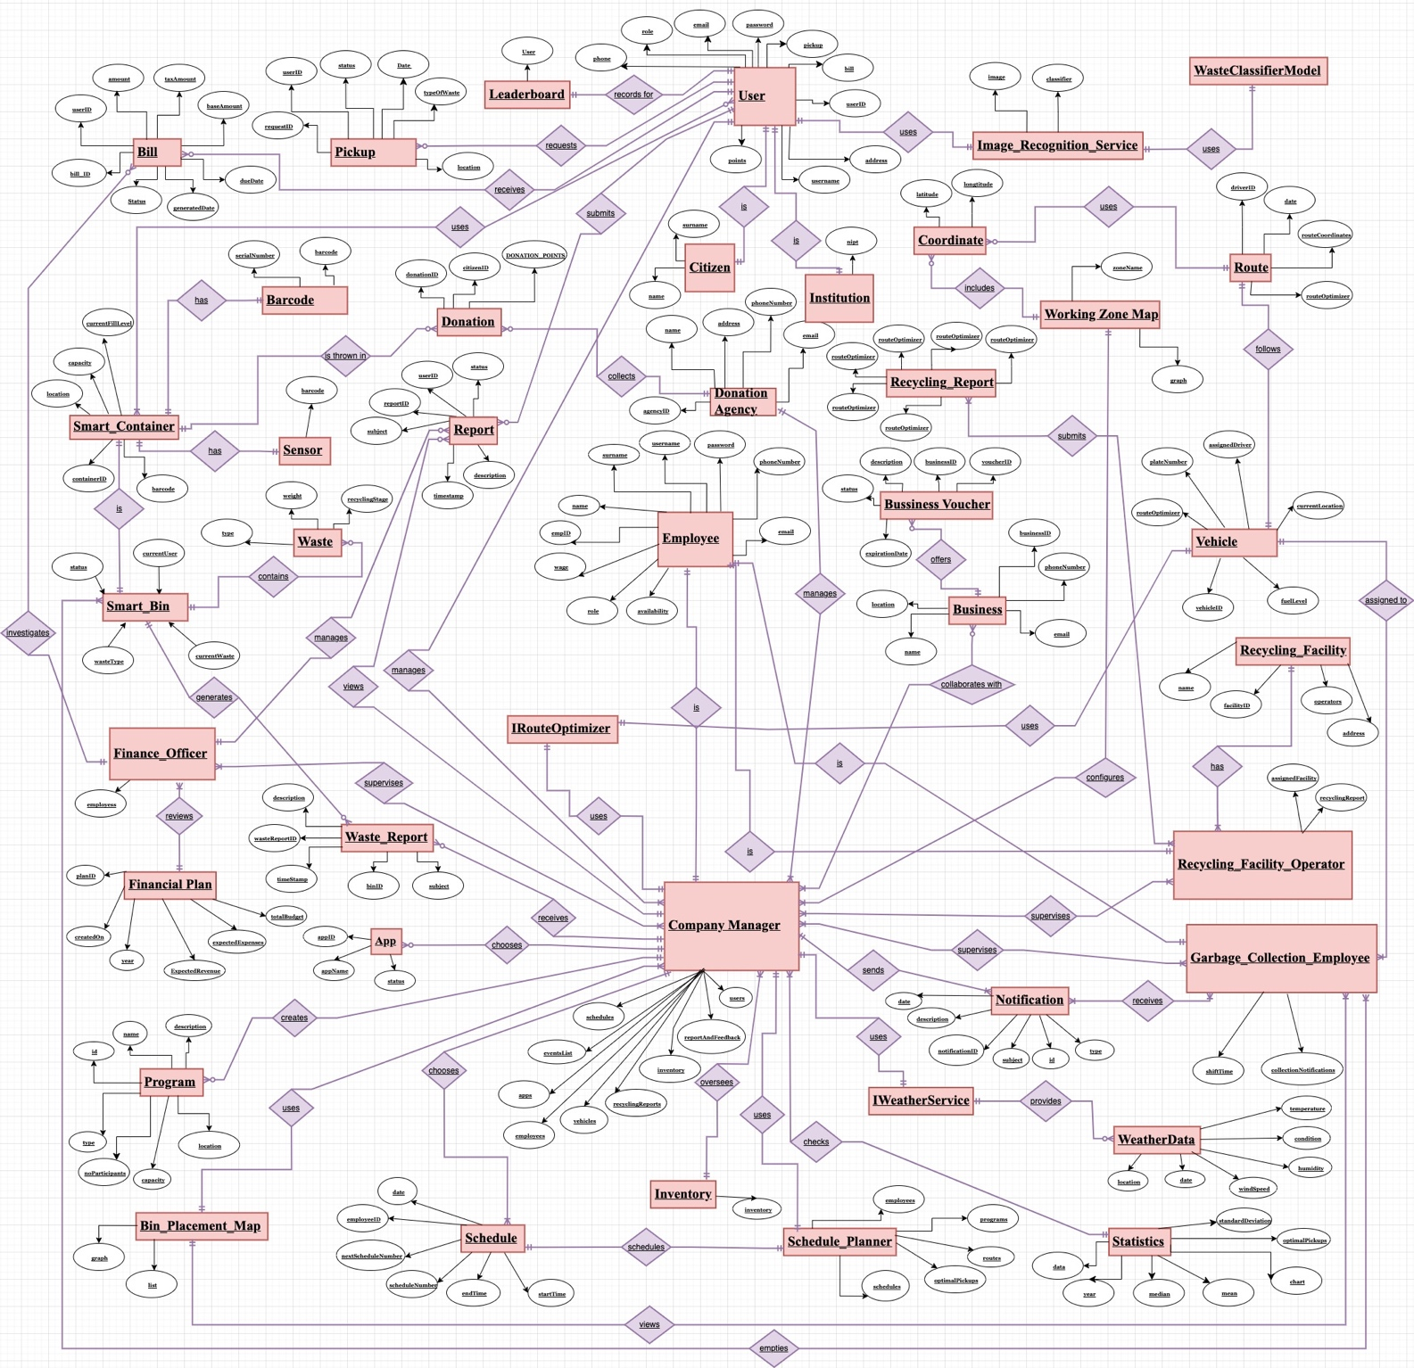

Note: For ease of identification, we have made: system actors pink and relationships purple.

5.2 USE CASE DIAGRAM (GENERAL)
WORKED BY: ALL GROUP
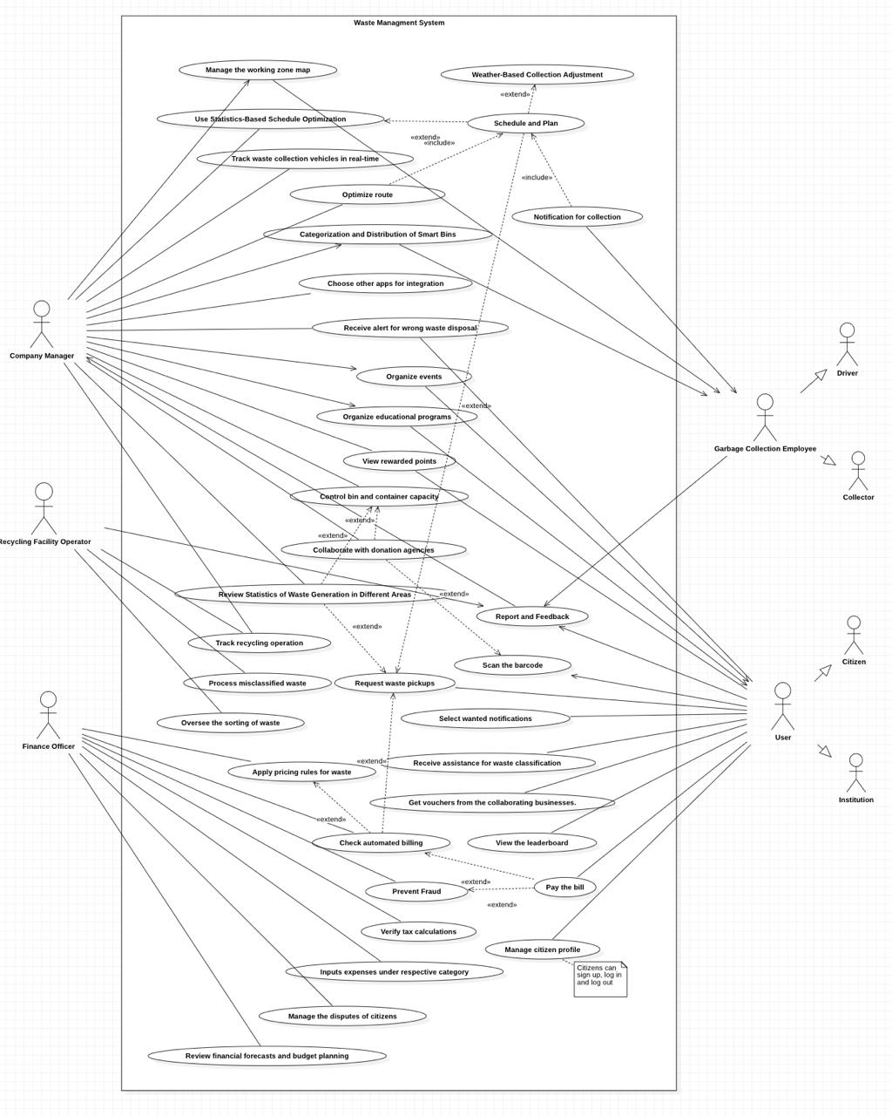

5.3 ACTIVITY DIAGRAM

VIOLA ZENELI

AC_01: Working Zone Map

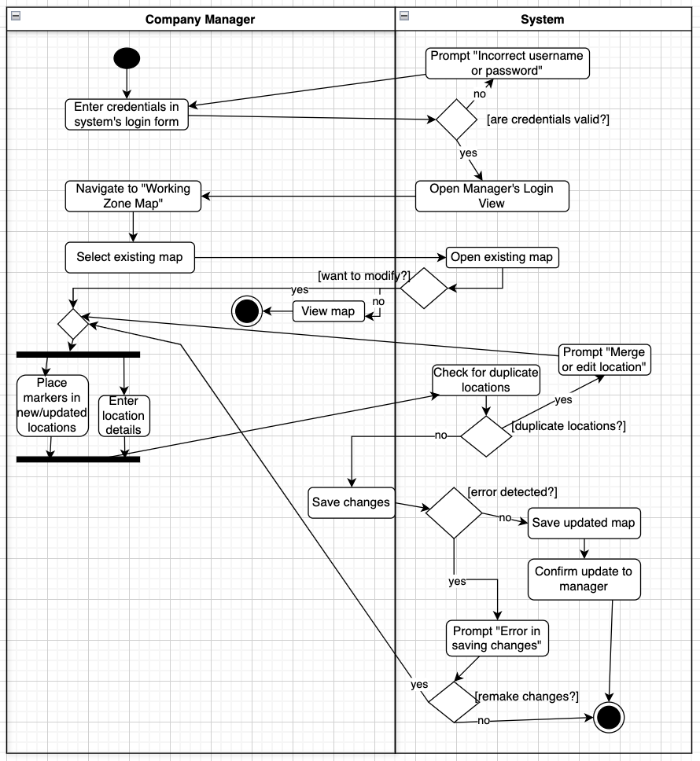

AC_02: Statistics-Based Schedule Optimization

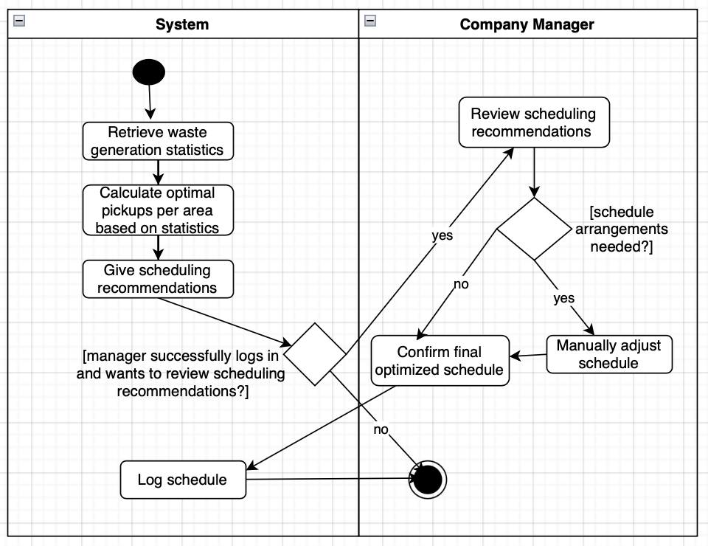

AC_03: Schedule and Plan

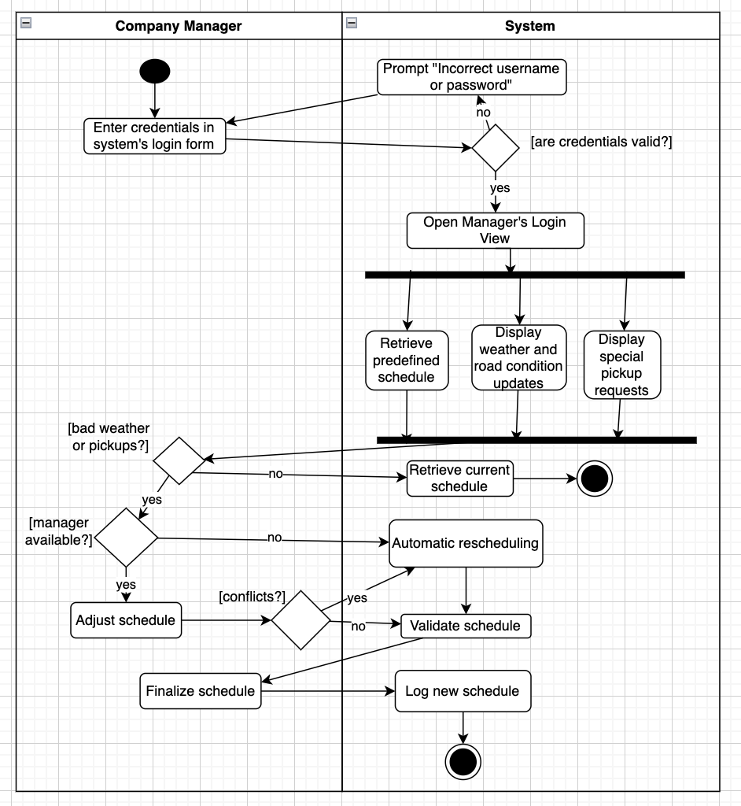

AC_04: Route Optimization

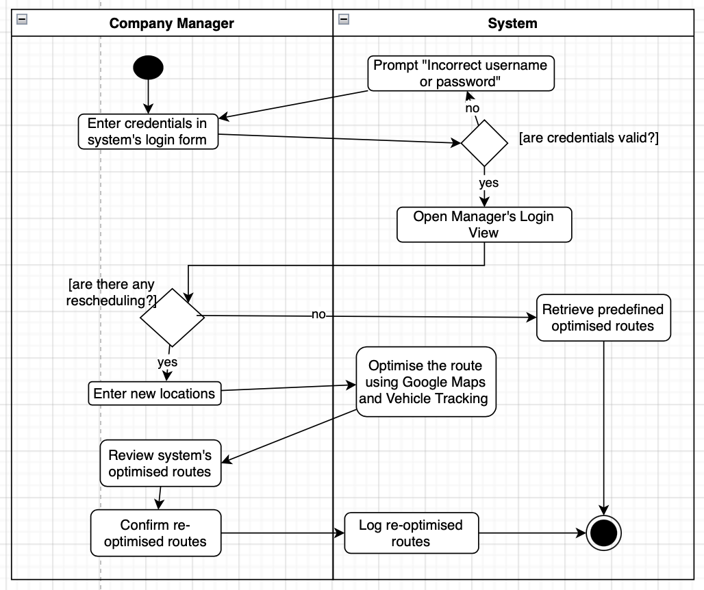

AC_05: Notification for Collection

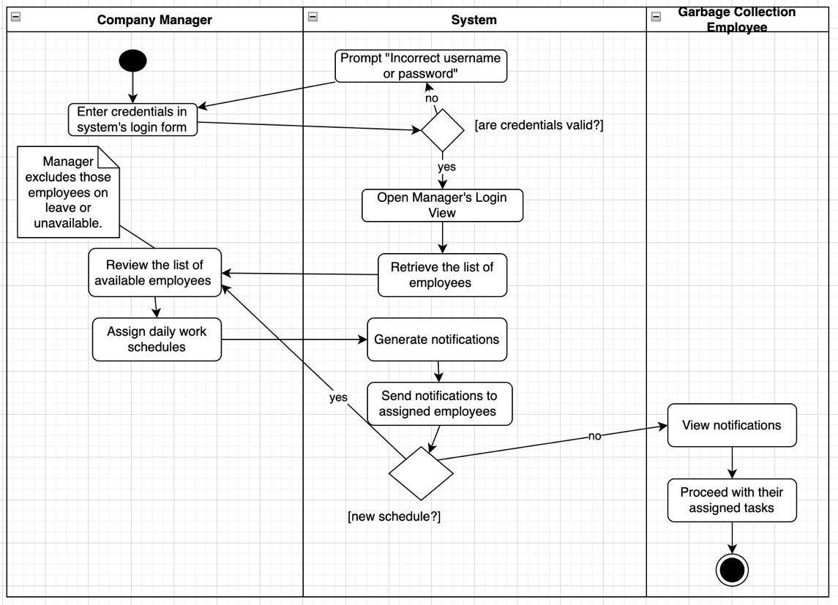

NOEL ZANI

AC_06: Vehicle Tracking

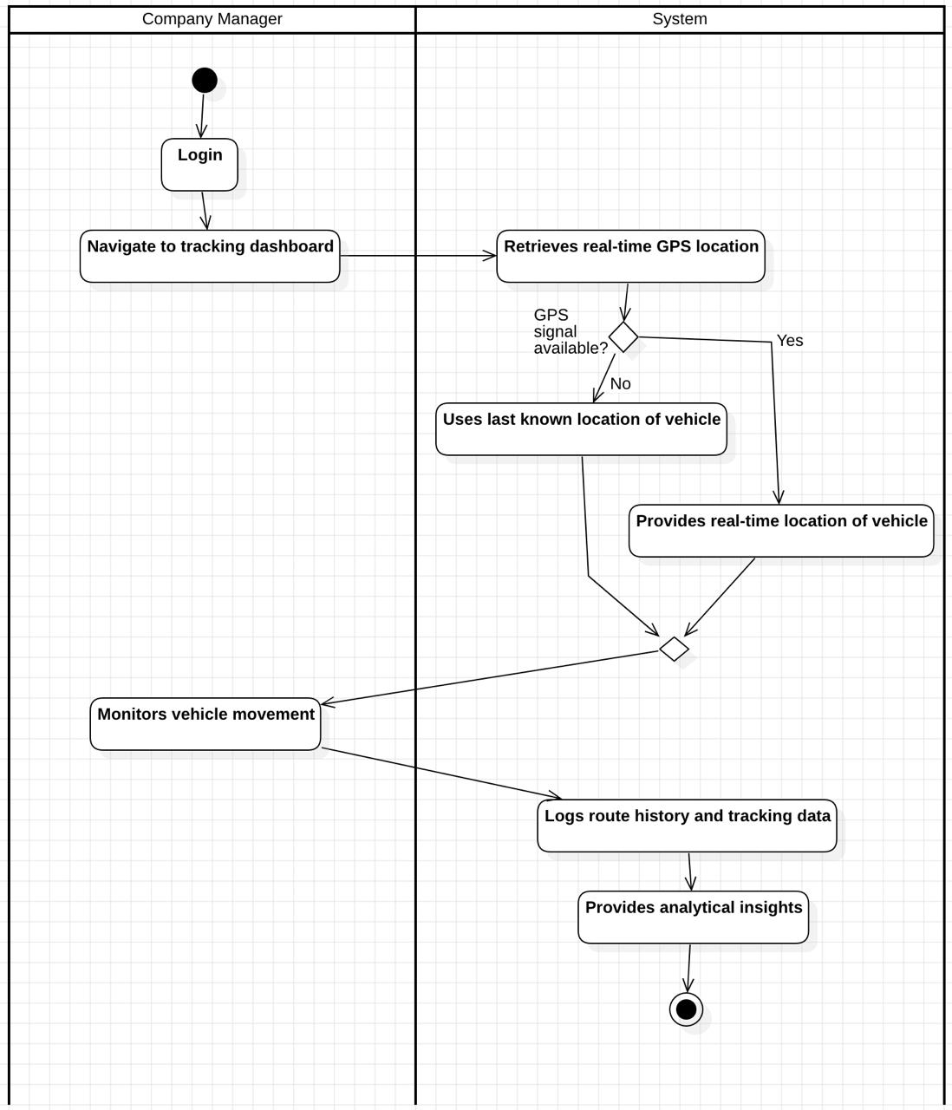

AC_07: Weather-Based Collection Adjustment
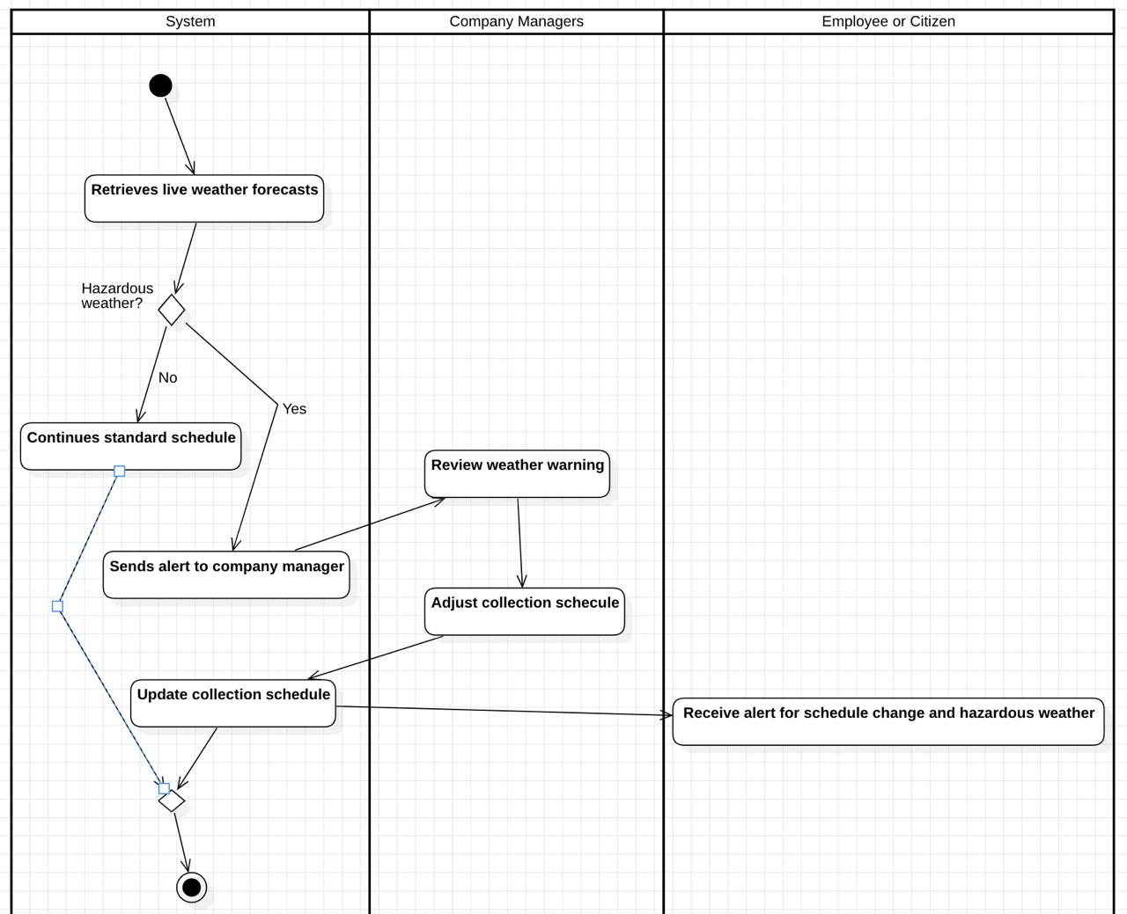

AC_08: Barcode for Traceability
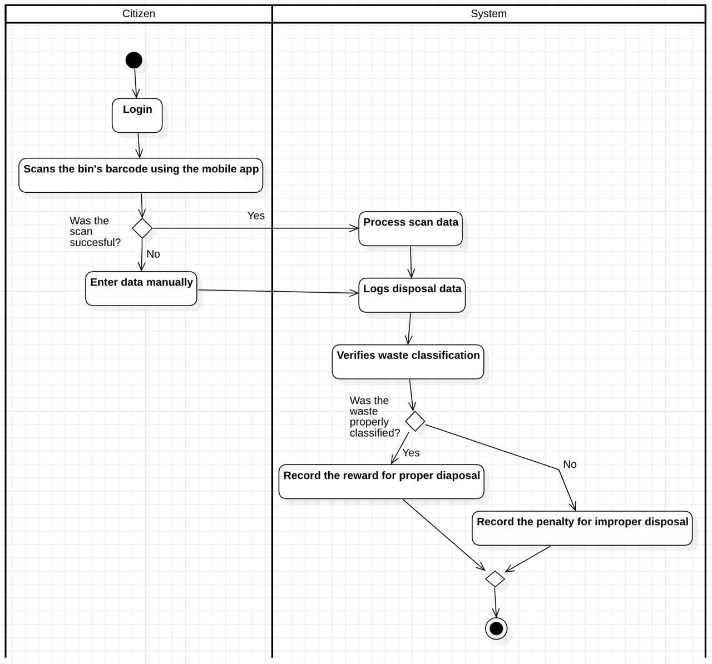

AC_09: Bin and Container Capacity Control
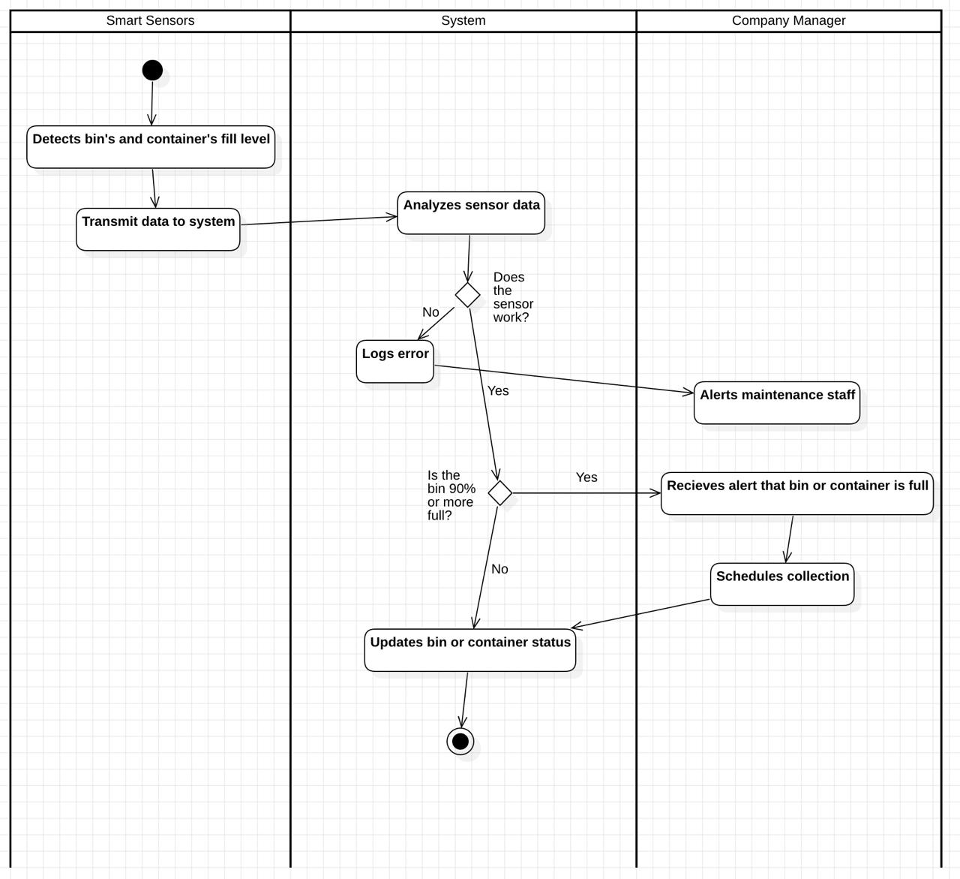

AC_10: Citizen Profile Management
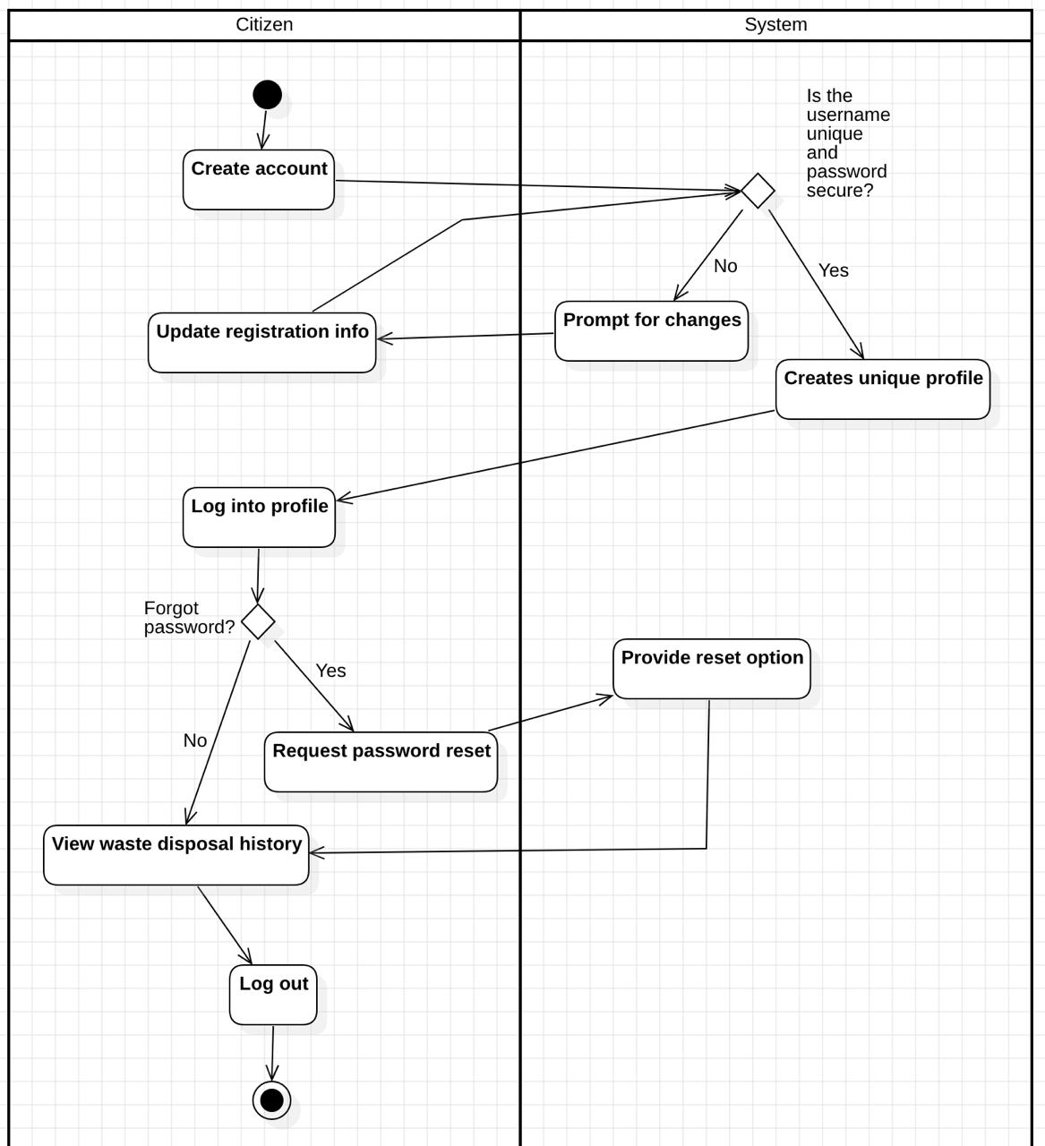

SIDRIT RRUSTEMI

AC_11: Smart Bin Categorization and Distribution

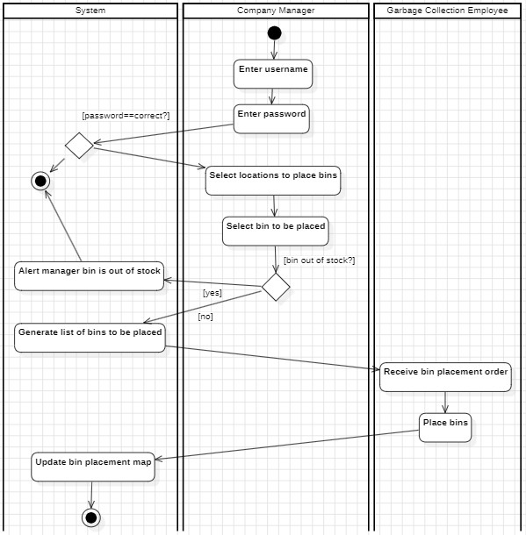

AC_12: Reward Points System
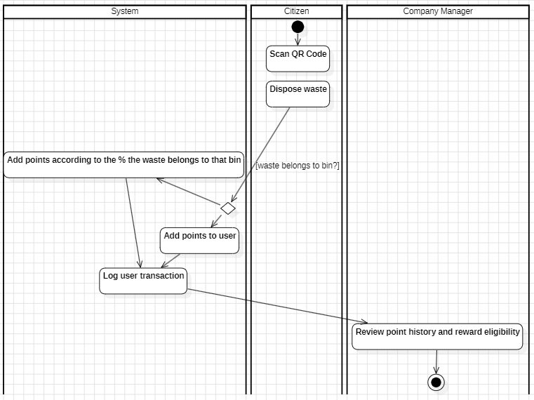

AC_13: Dynamic Pricing for Waste
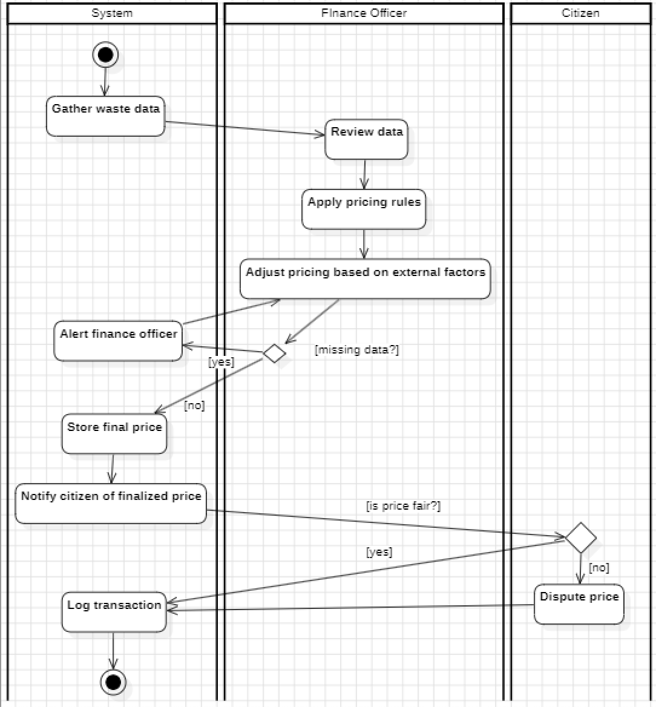

AC_14: Smart Bin Error Handling

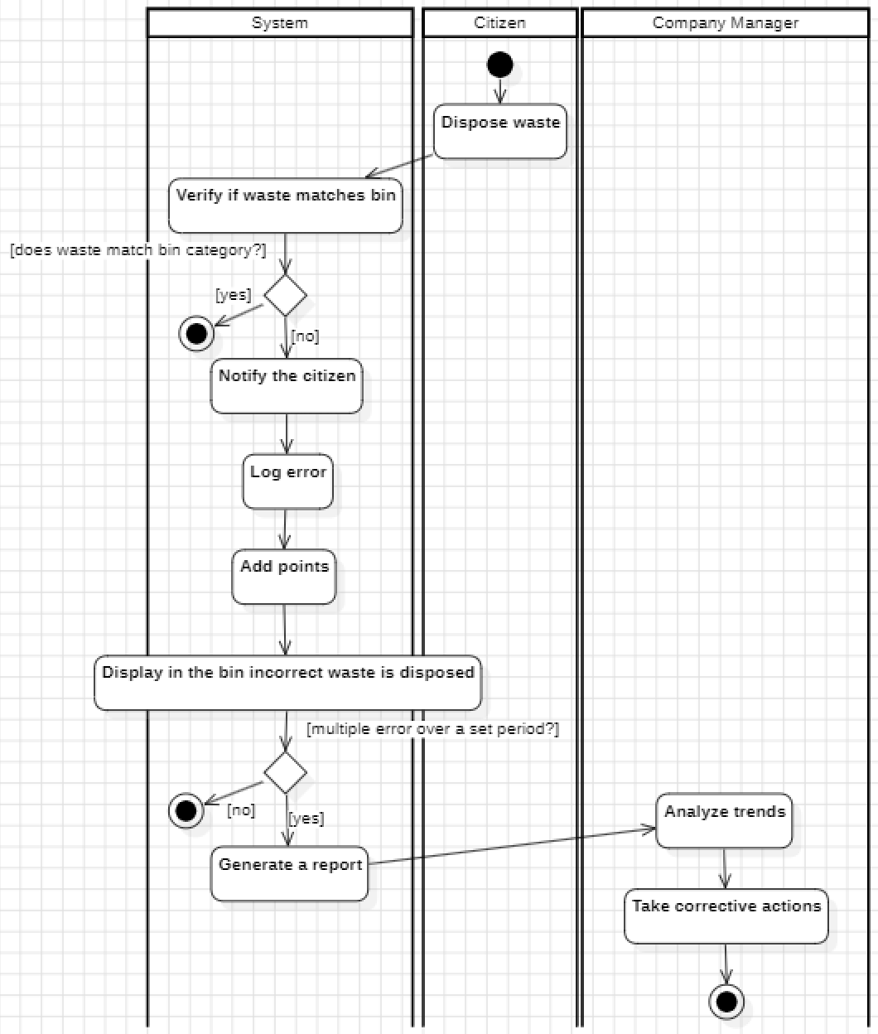

AC_15: Organization of Events

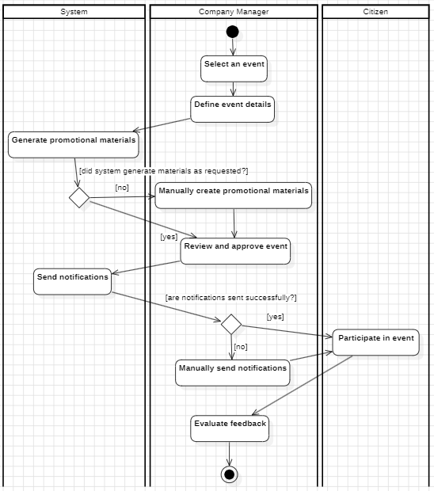

NIKOL DALIPI

AC_16: Educational Programs
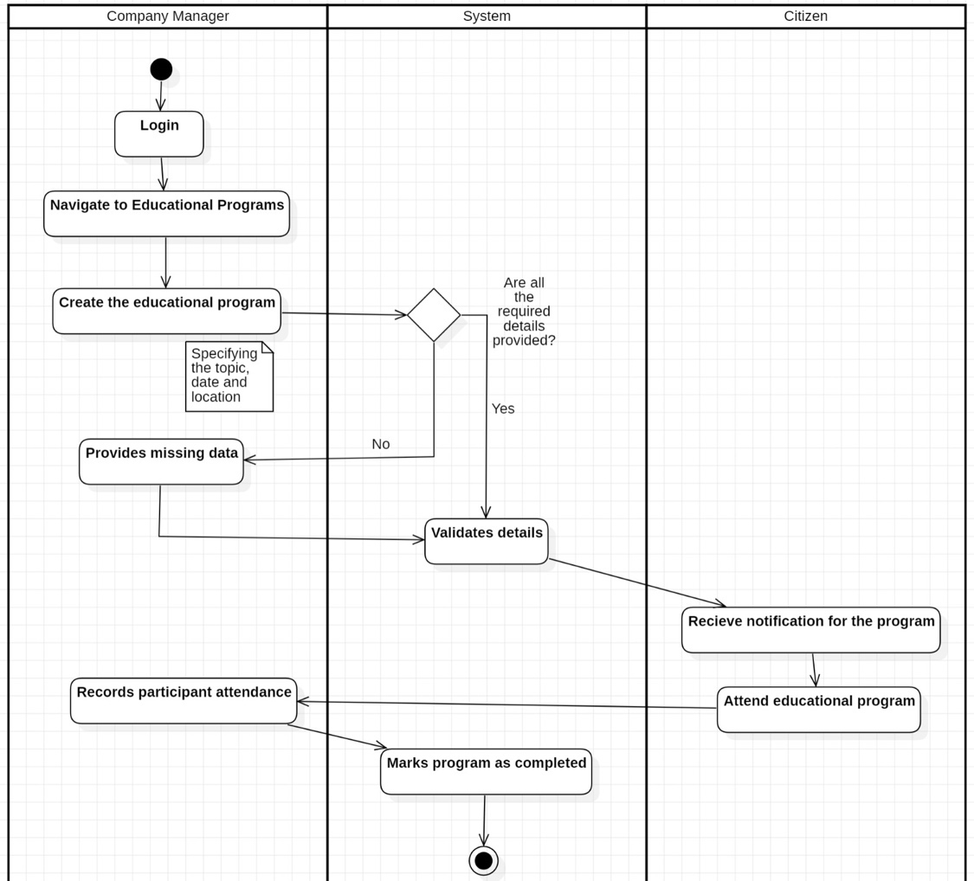

AC_17: Waste Further Processing and Verification
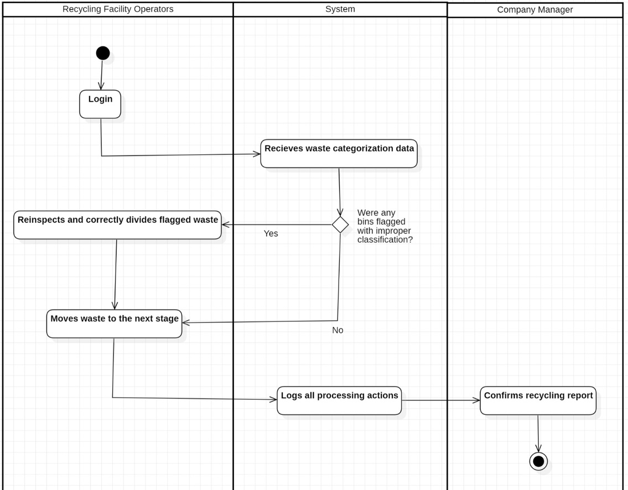

AC_18: Recycling Management

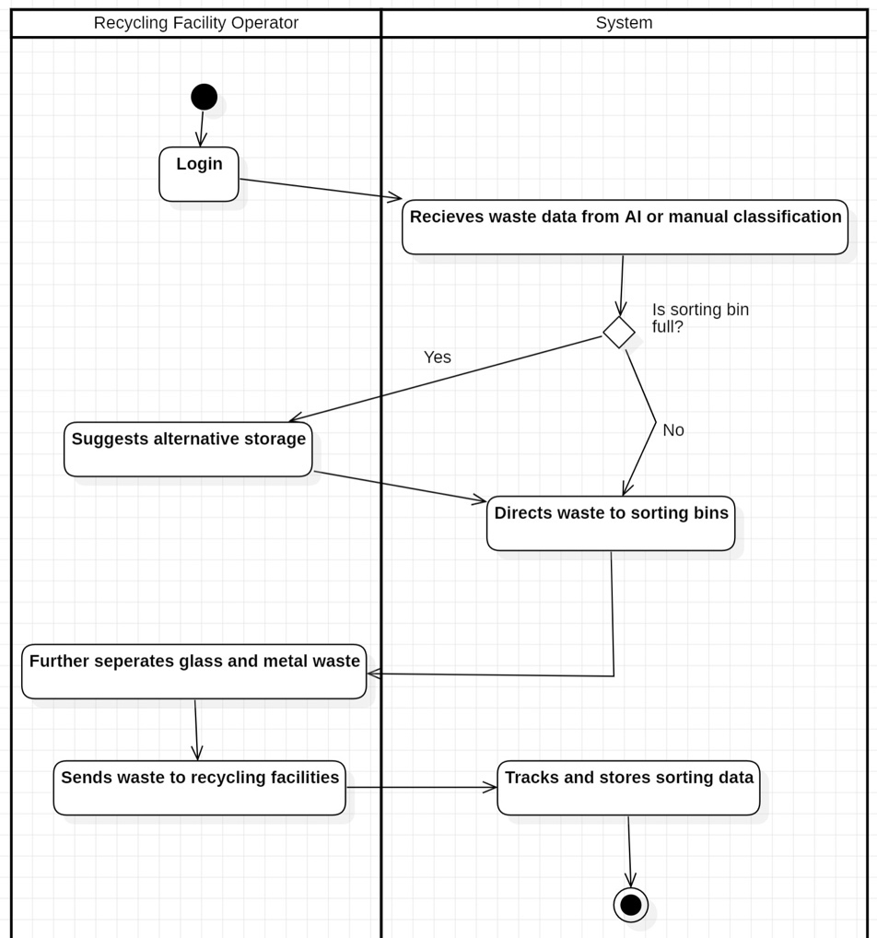

AC_19: Recycling Process Tracking

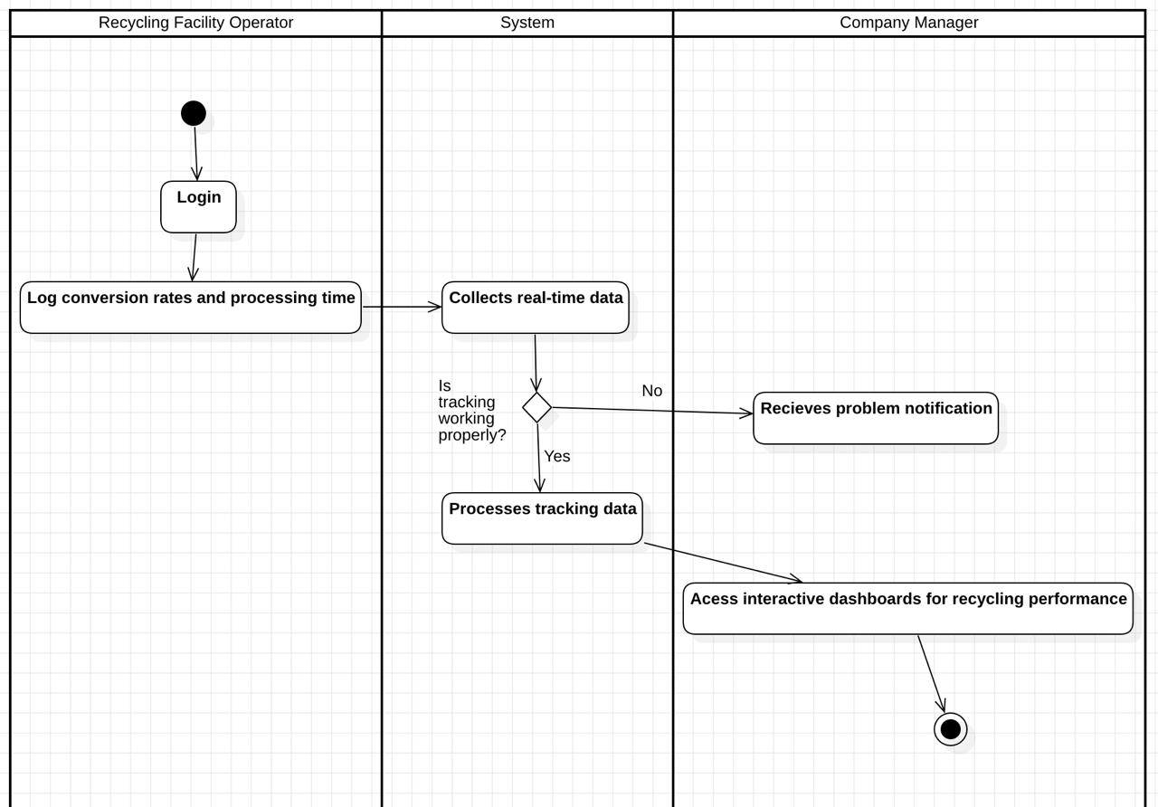

AC_20: Report & Feedback

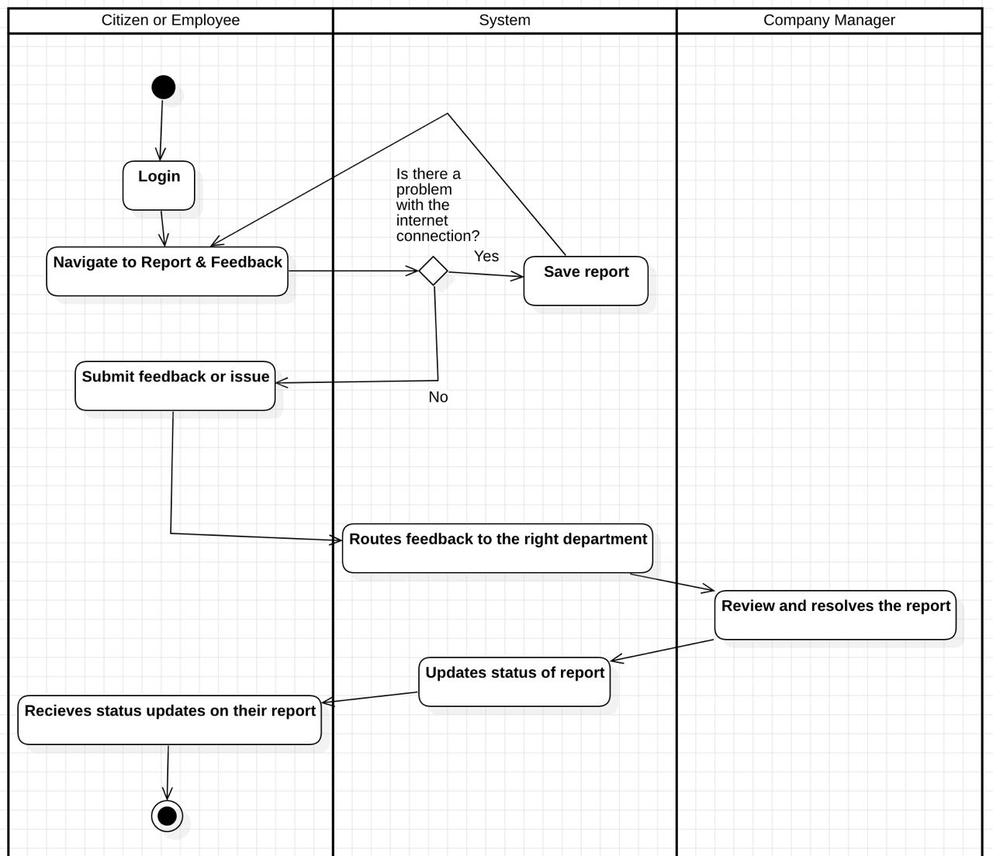

ALESIA DARDHA

AC_21: Informative Notifications

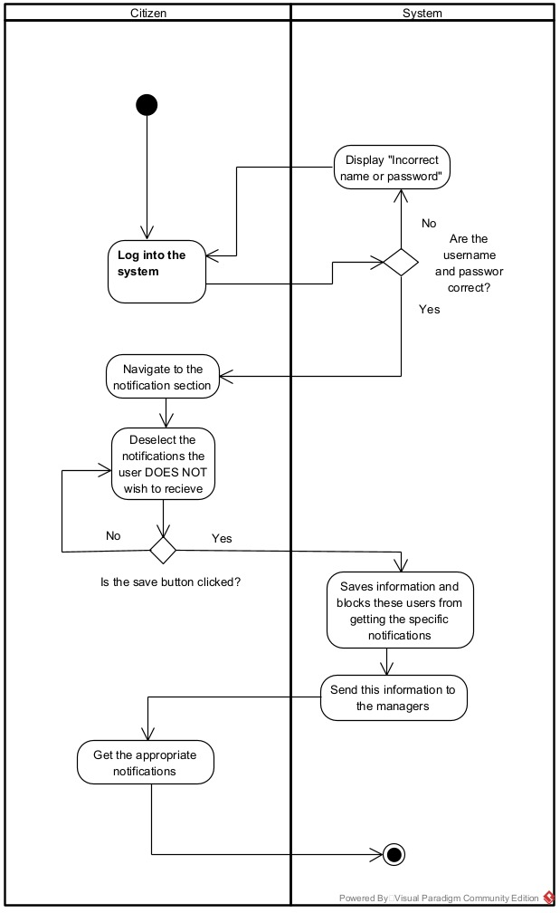

AC_22: Waste Classification Assistance

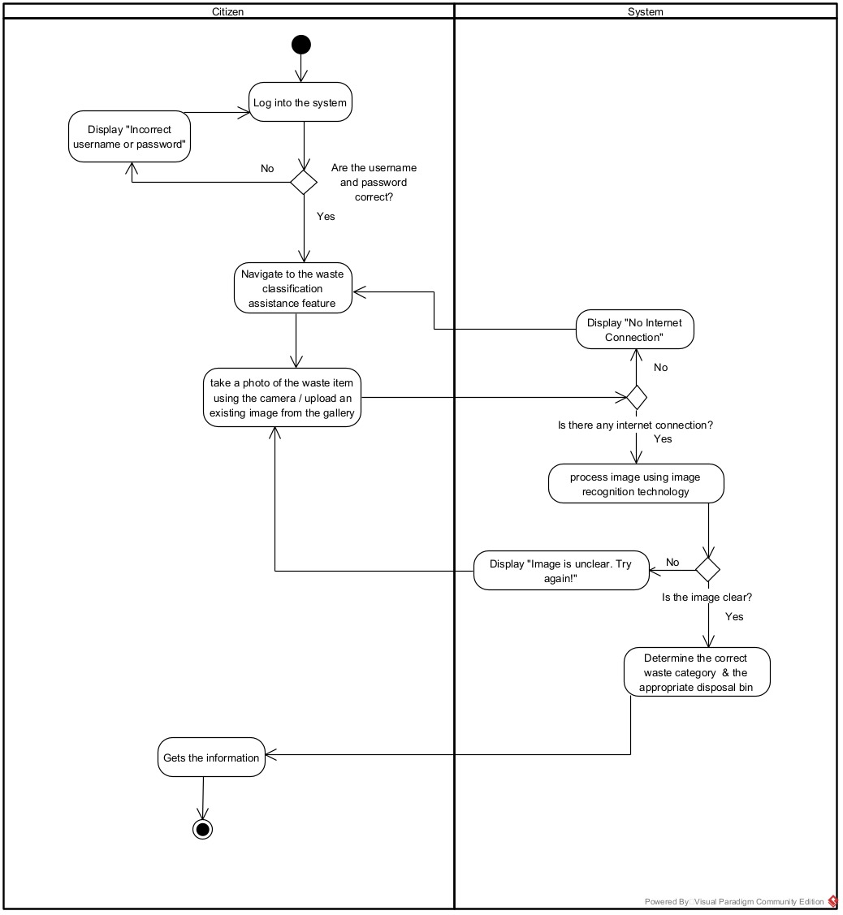

AC_23: Pickup Request

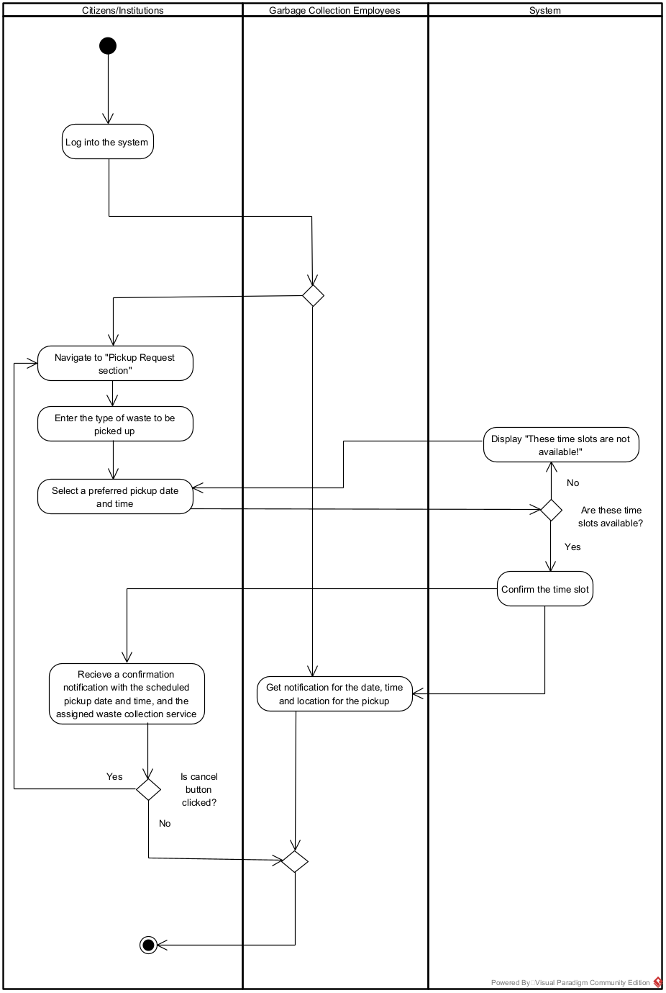

AC_24: Community Leaderboard & Incentives

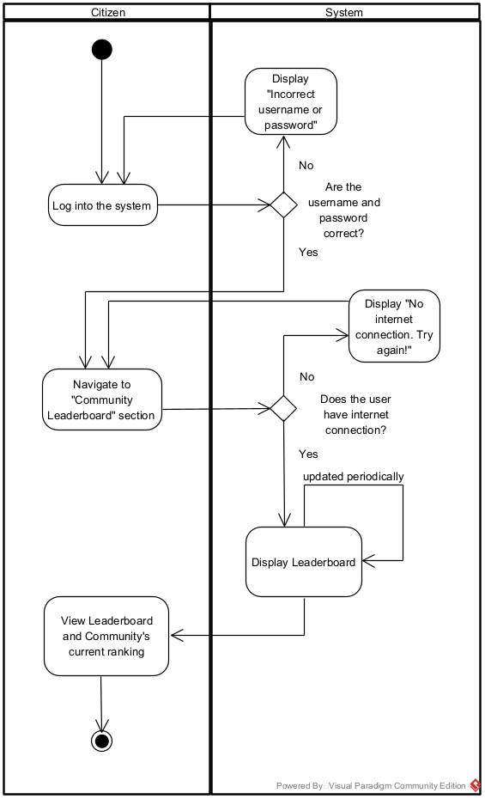

AC_25: Integration with Businesses

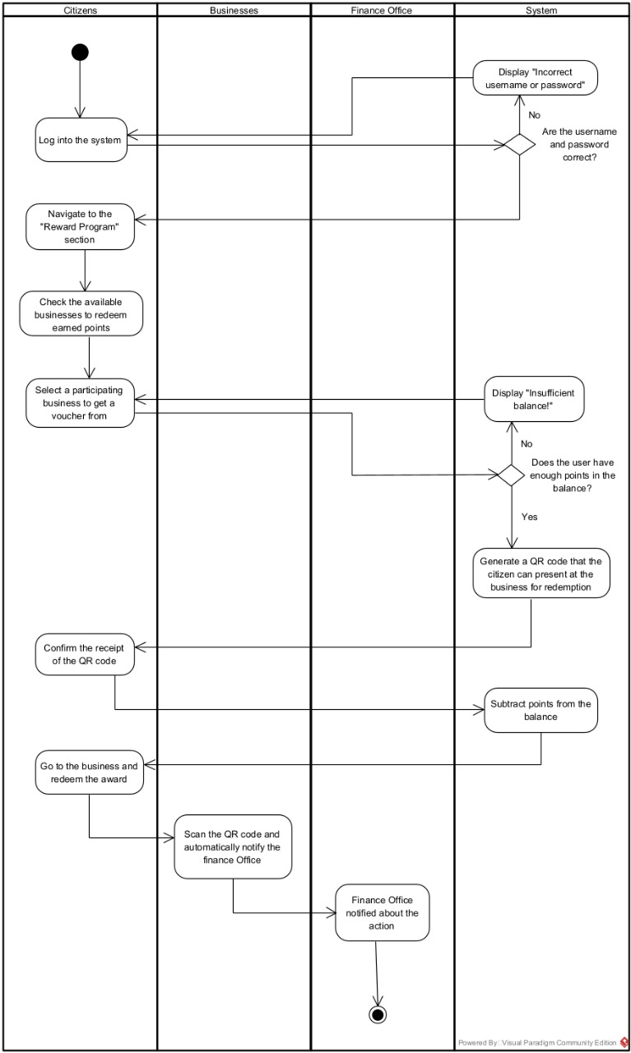

SUADA TEROLLI

AC_26: Integration with other Apps

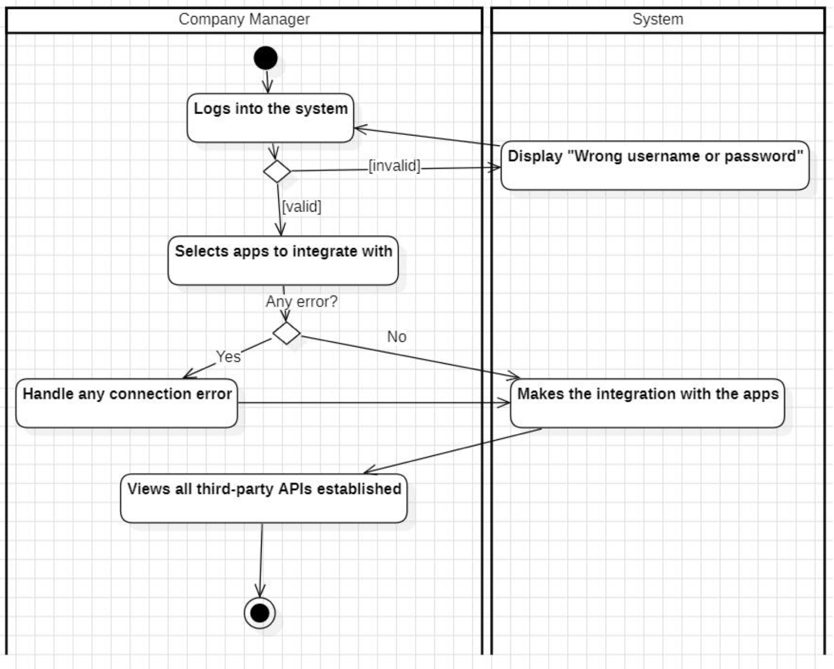

AC_27: Collaboration with Donation Agencies

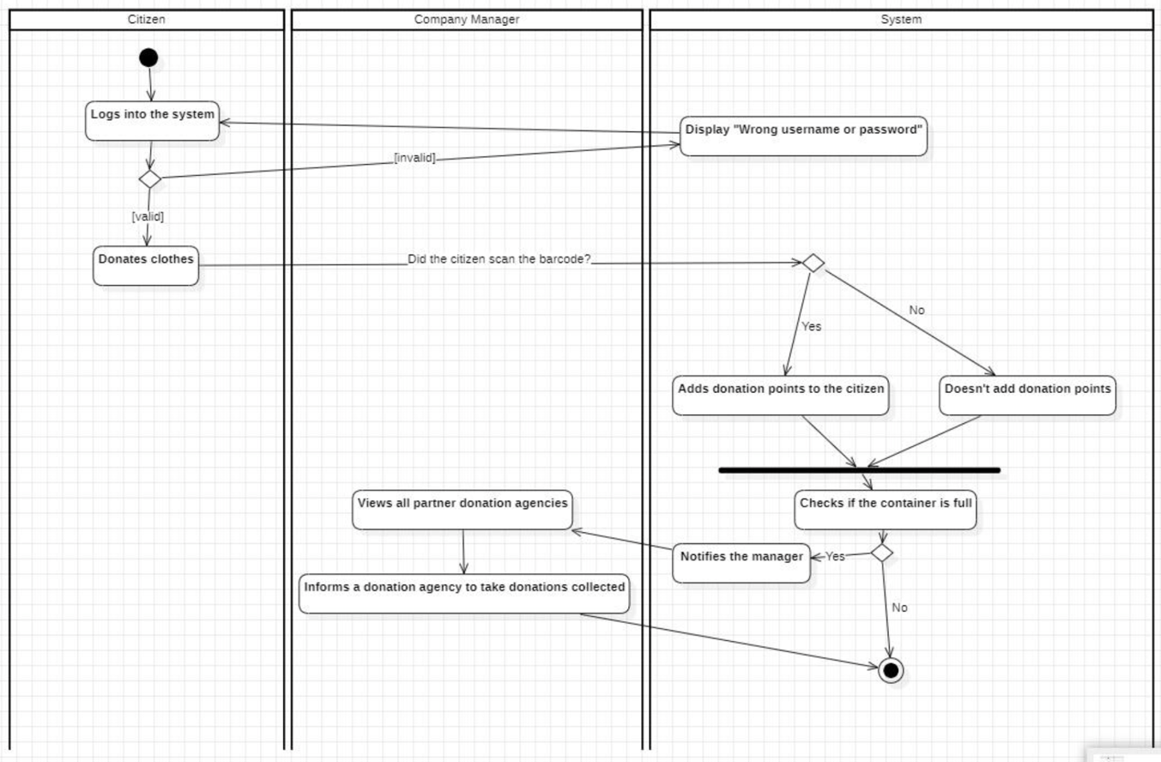

AC_28: Automated Billing

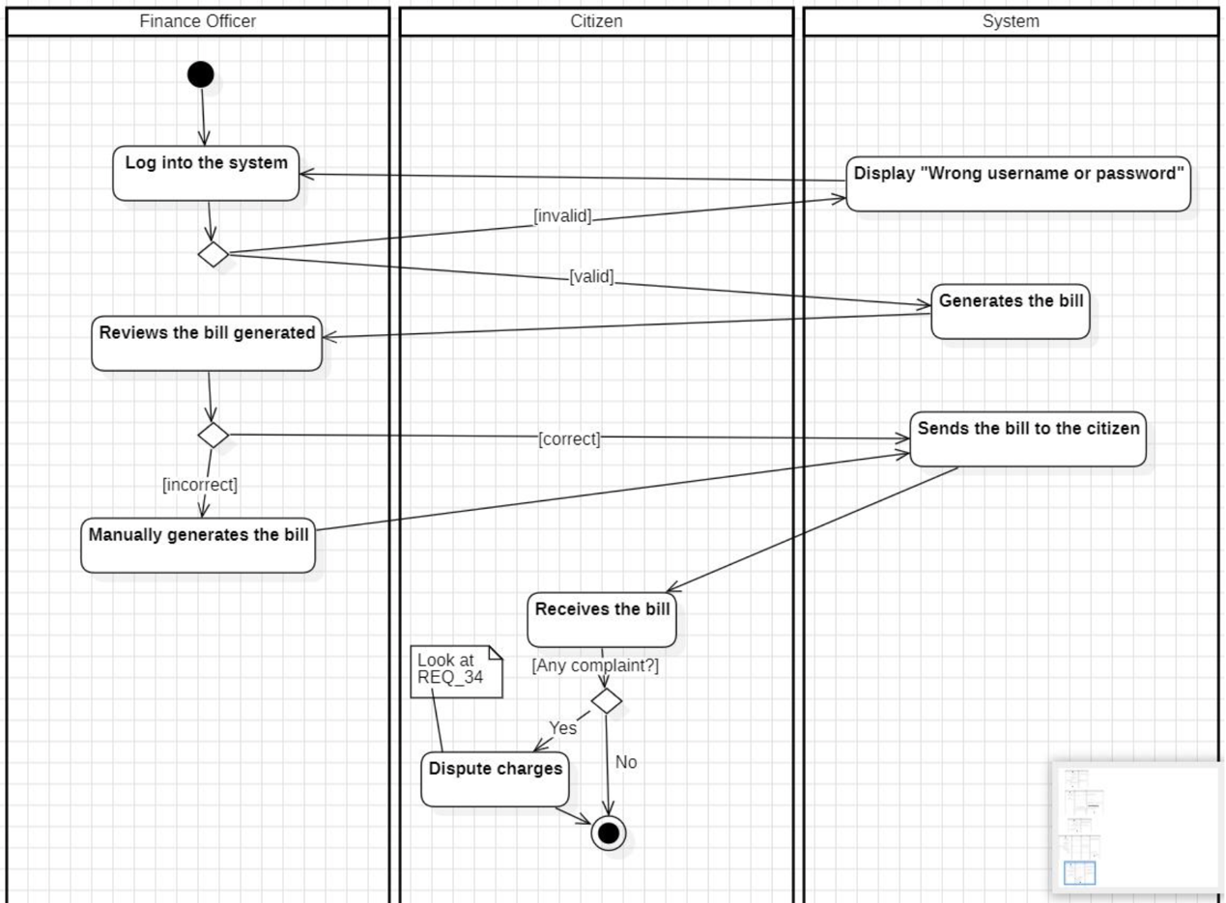

AC_29: Pay Bill

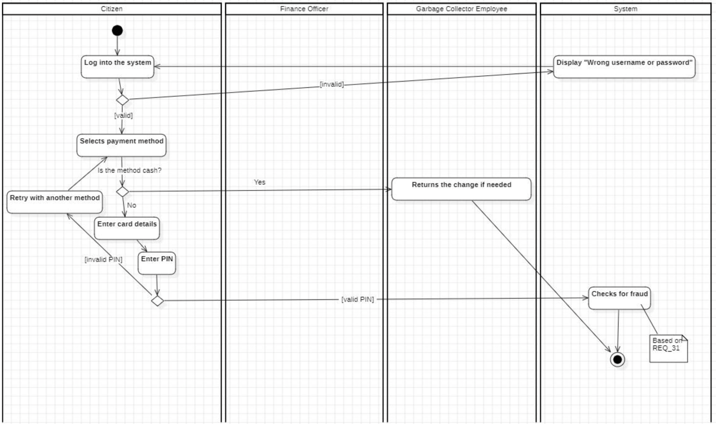

AC_30: Statistics of Waste Generation in Different Areas

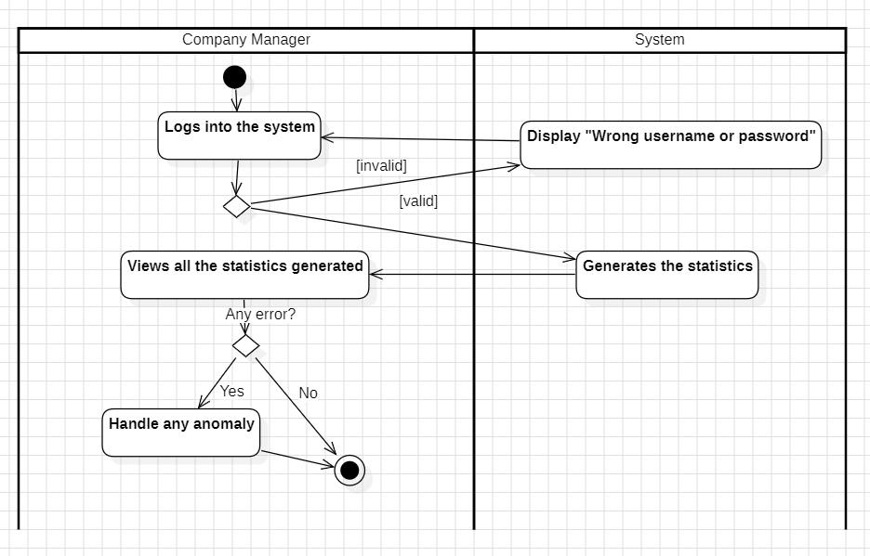

MIRSAD AMULI

AC_31: Fraud Detection & Prevention

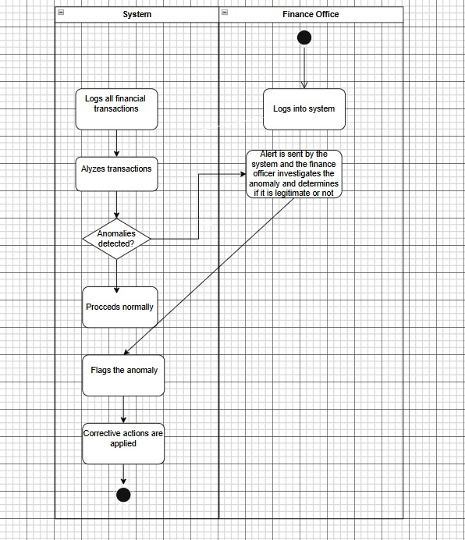

AC_32: Expense Tracking & Cost Analysis

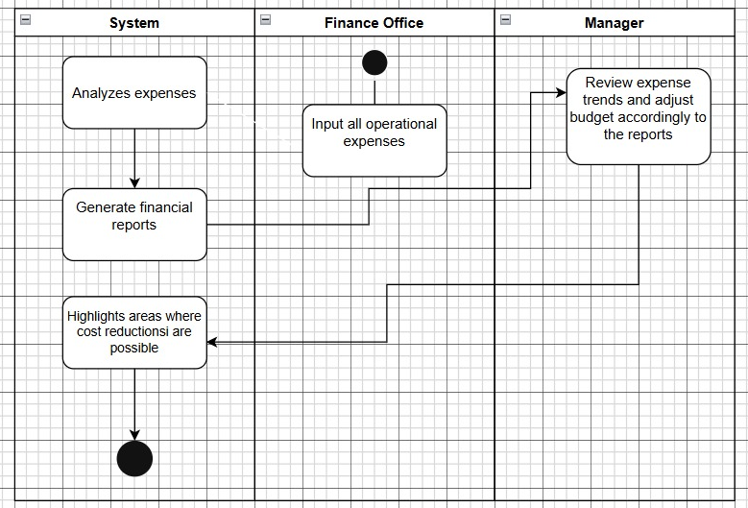

AC_33: Government Compliance & Tax Reporting

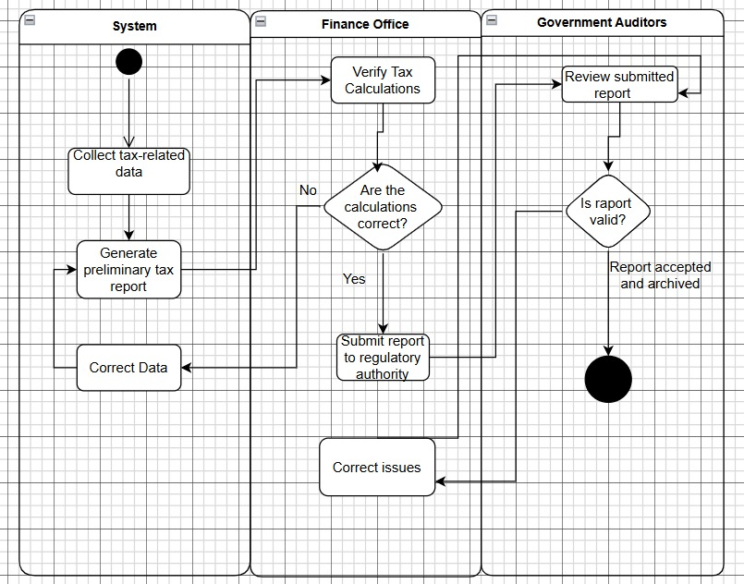

AC_34: Dispute Resolution & Refund Management

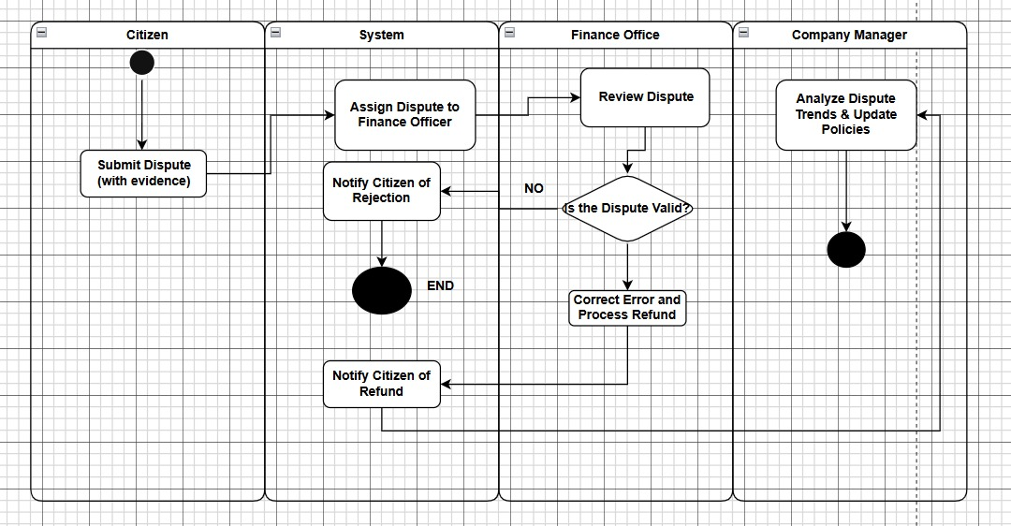

AC_35: Financial Forecasting & Budget Planning

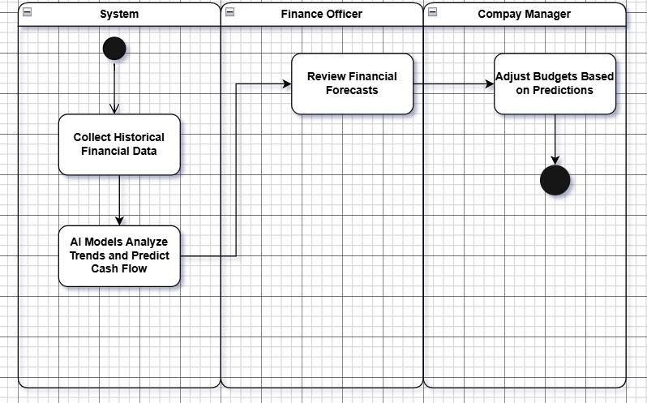

5.4 CLASS DIAGRAM
WORKED BY: VIOLA ZENELI & SIDRIT RRUSTEMI

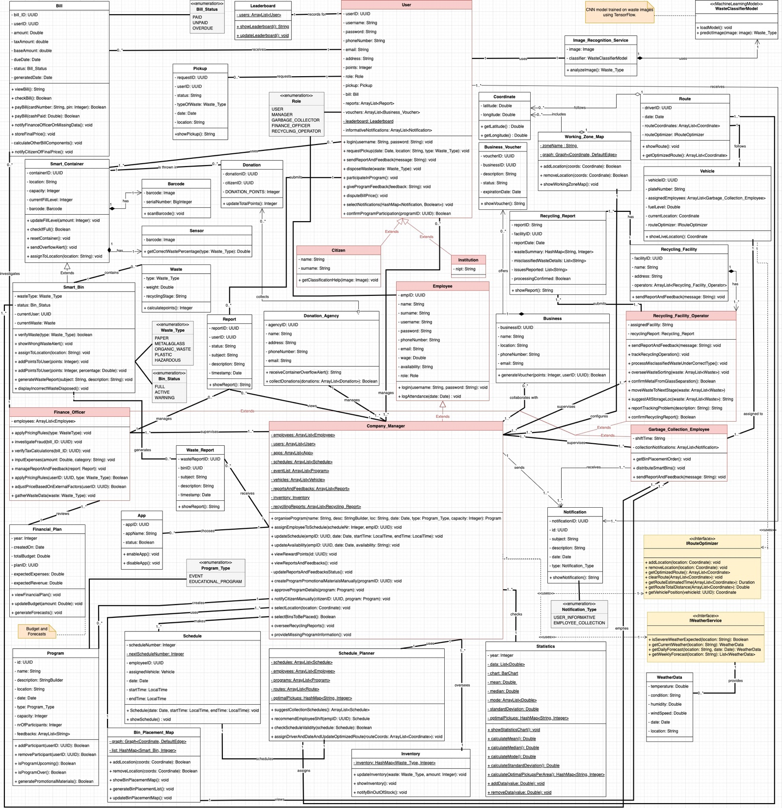

Note:
- All classes in the diagram are assumed to have getters and setters for each of their attributes, but we have omitted them for brevity.
- For ease of identification, we have made: system actors pink, interfaces yellow, notes orange and enumerations grey.

5.5 STATE DIAGRAM
WORKED BY: ALESIA DARDHA, SUADA TEROLLI, NIKOL DALIPI & NOEL ZANI

ALESIA DARDHA:

Citizen Profile State:

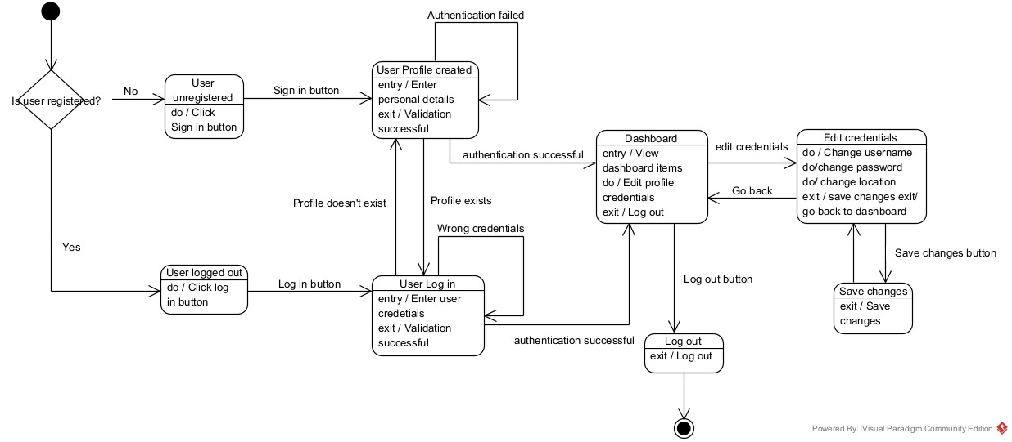

Reward Redemption Flow:

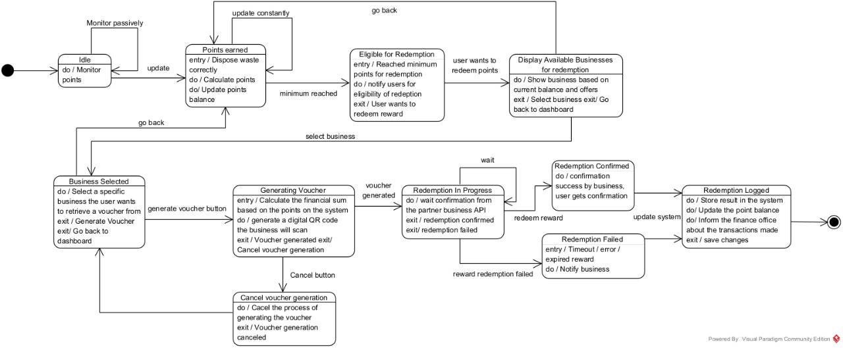

Recycling Process State:
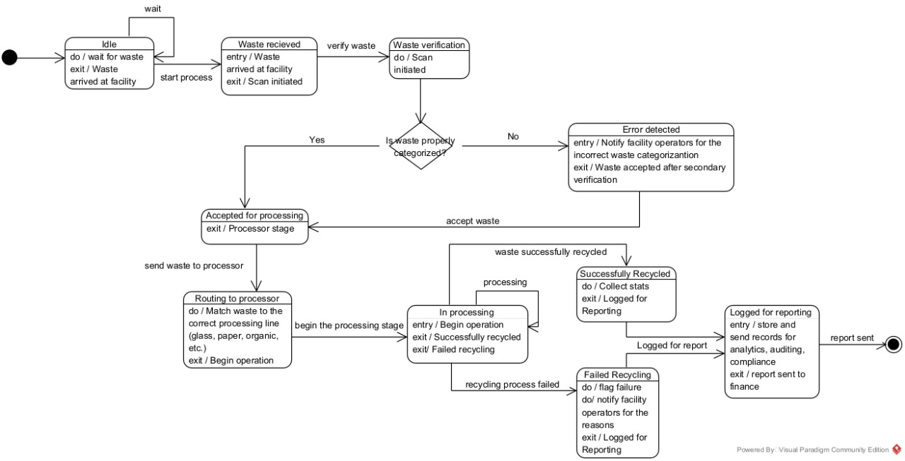

SUADA TEROLLI:

Pickup Request Lifecycle:
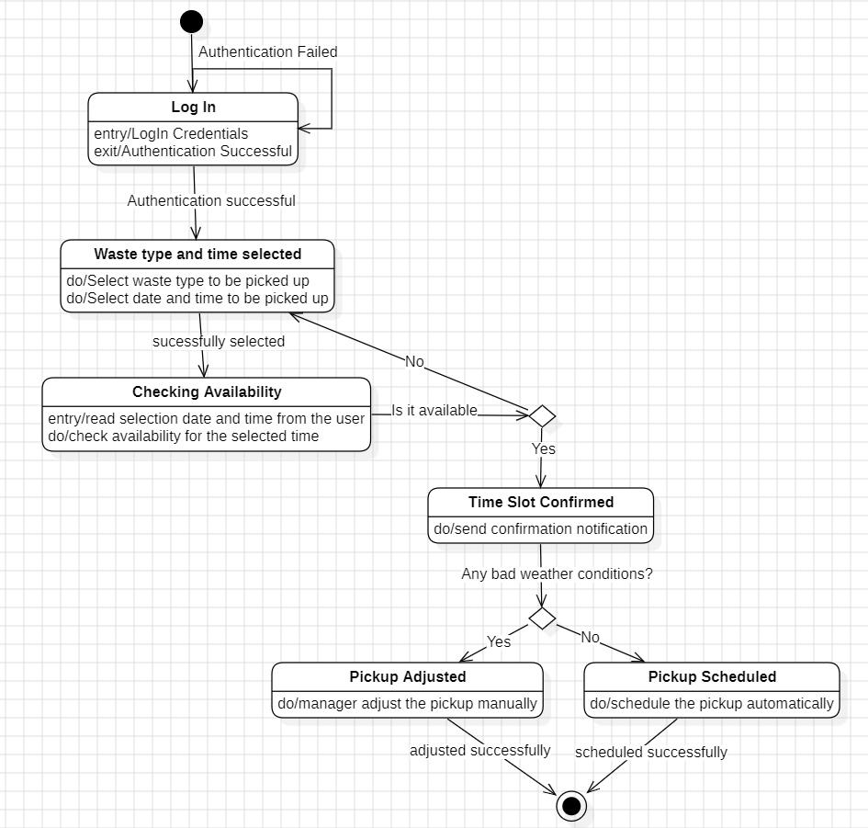
Collection Task State:
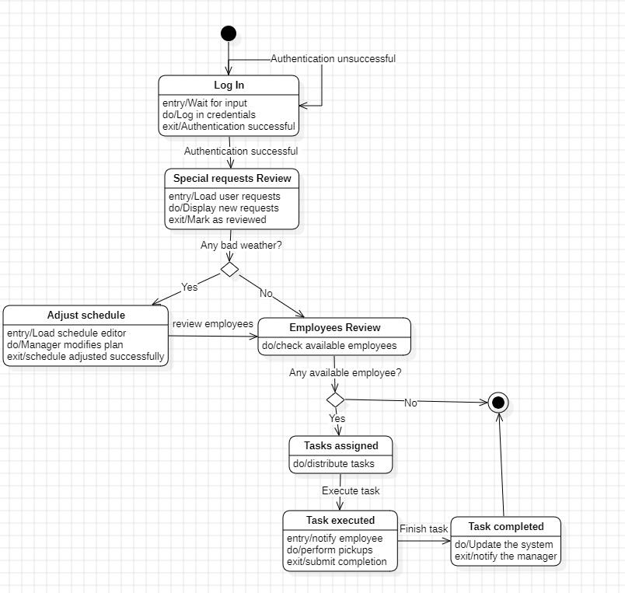

Sensor Health & Monitoring:
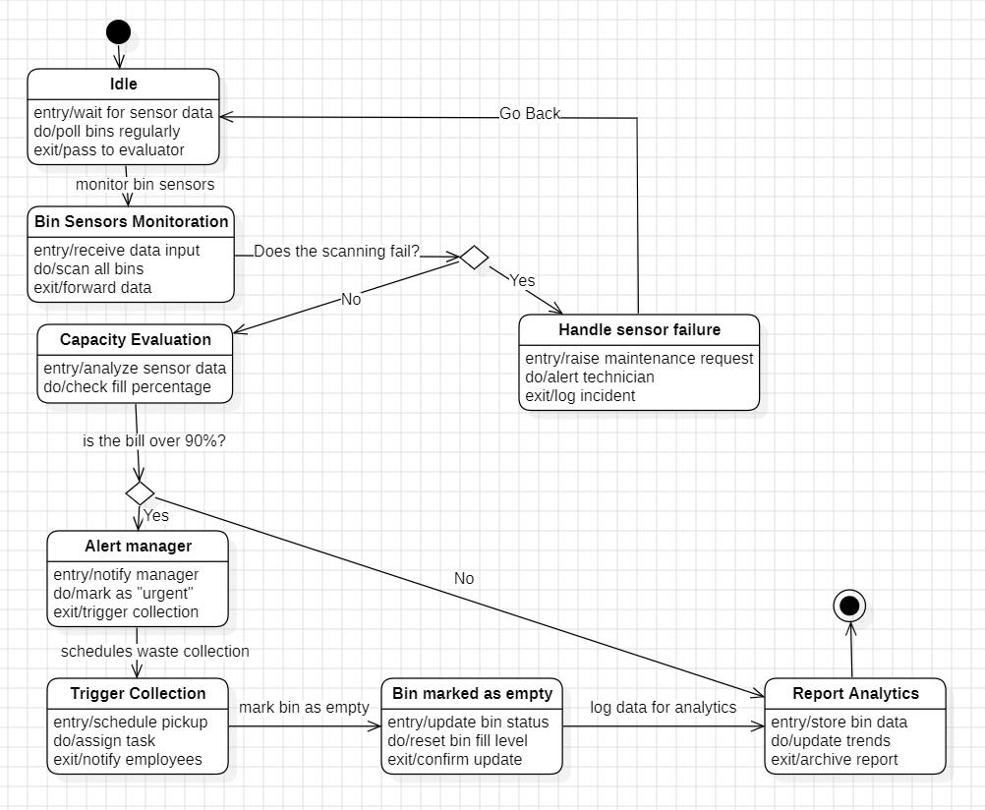

Report & Feedback Flow:

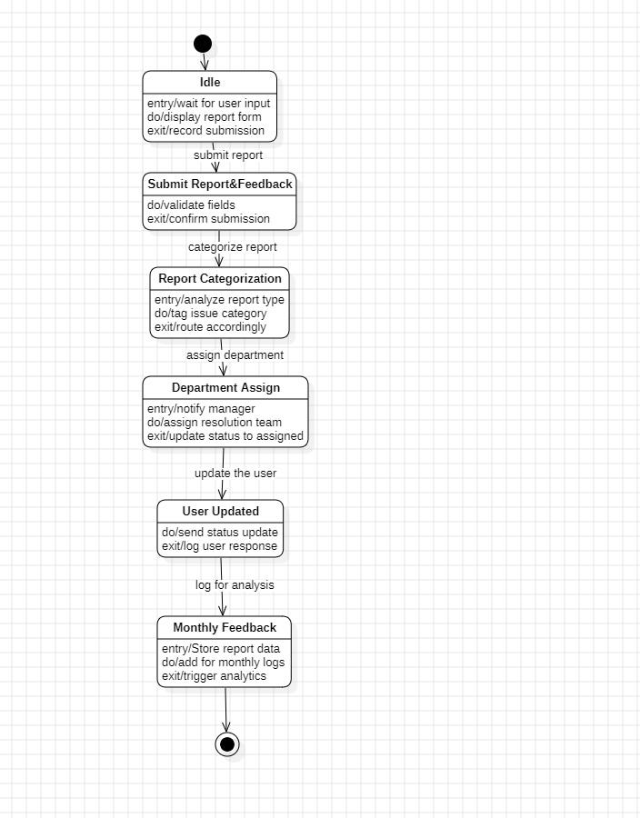

NIKOL DALIPI:

Reward Points Flow:

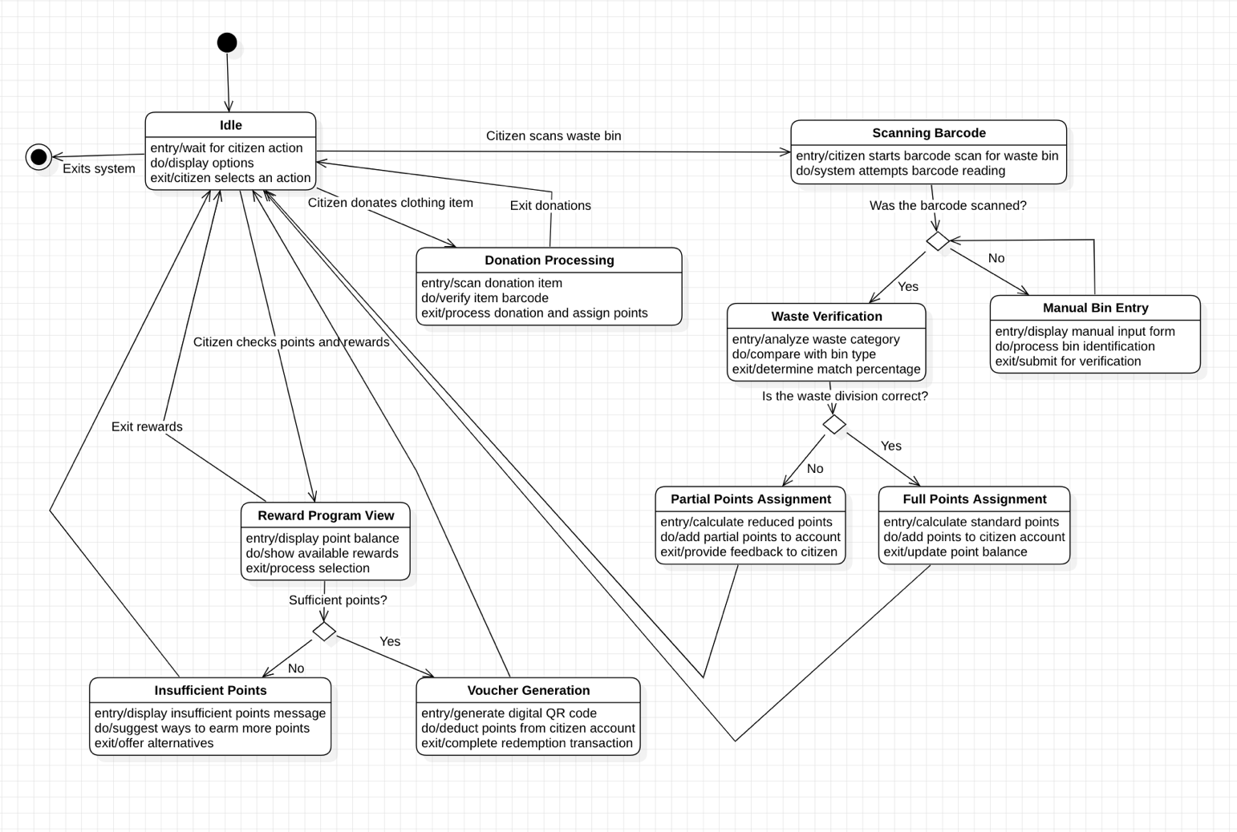

Smart Bin State And Error Handling:

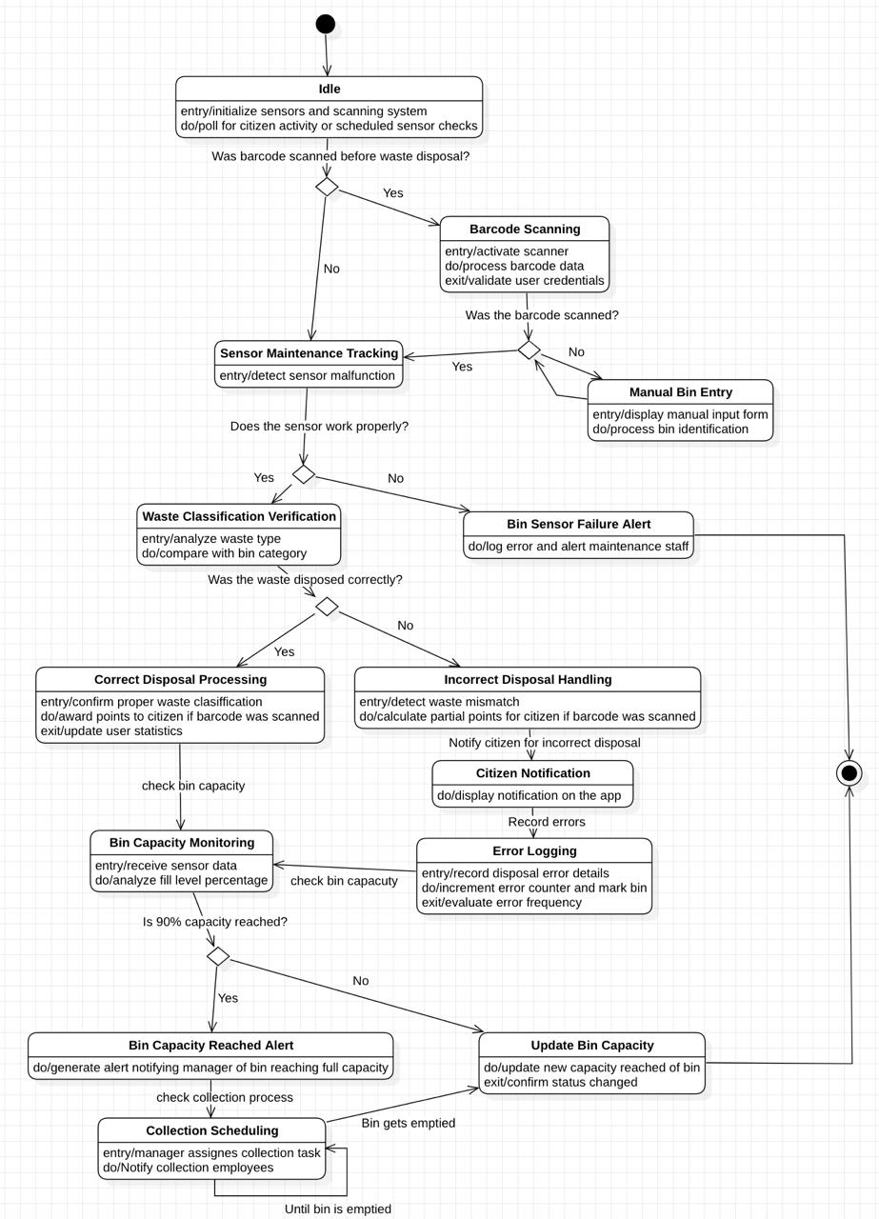
NOEL ZANI:

Vehicle Operation State
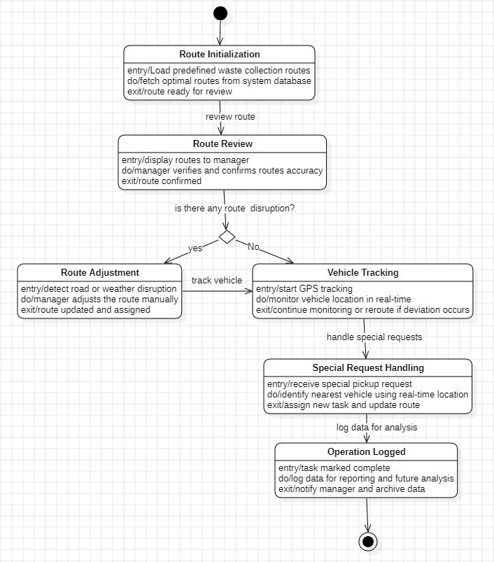

Route Plan State
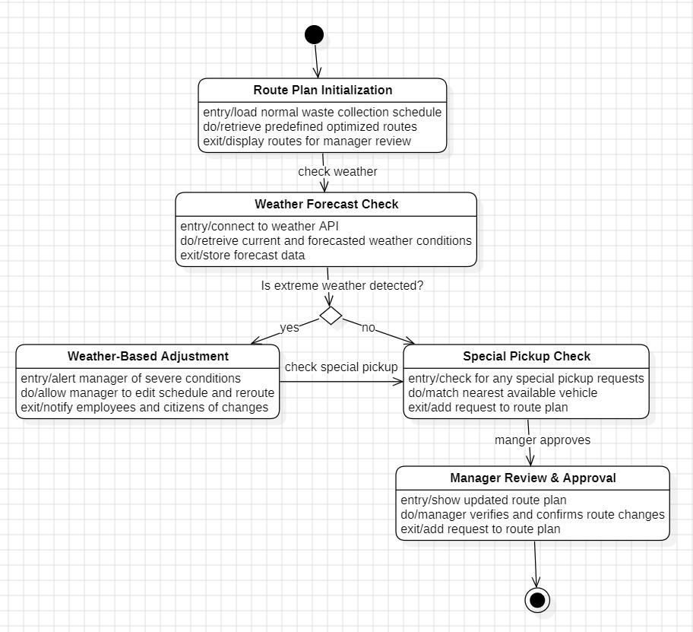

Billing Lifecycle

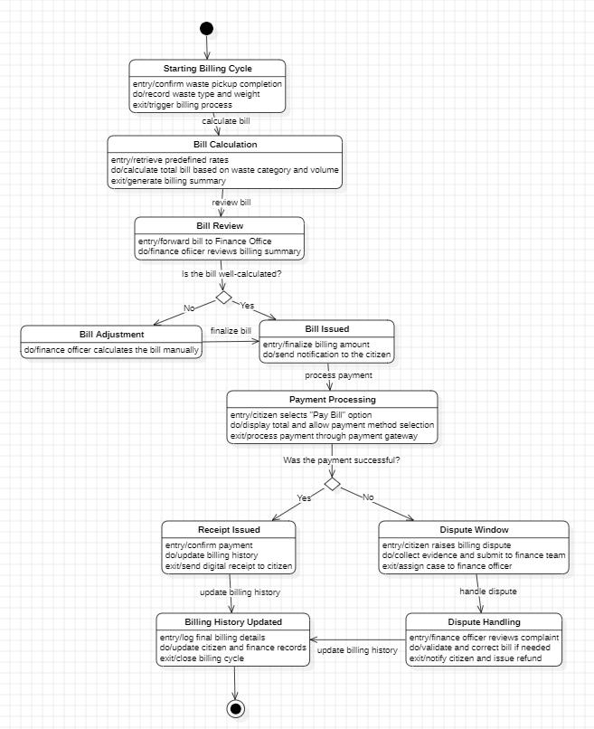

5.6 SEQUENCE DIAGRAM

VIOLA ZENELI

SC_01: Working Zone Map
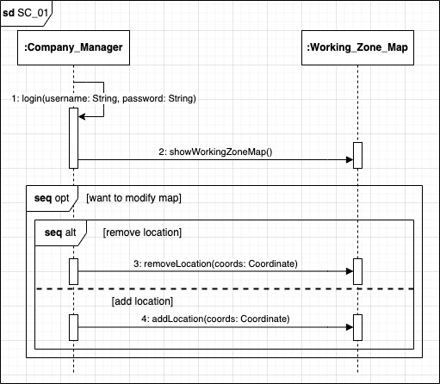

SC_02: Statistics-Based Schedule Optimization
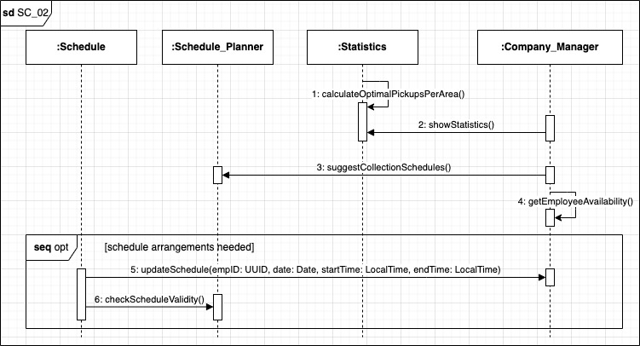
SC_03: Schedule and Plan
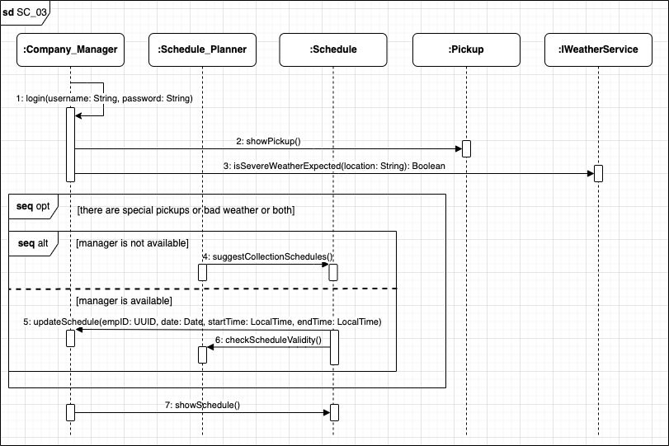

SC_04: Route Optimization
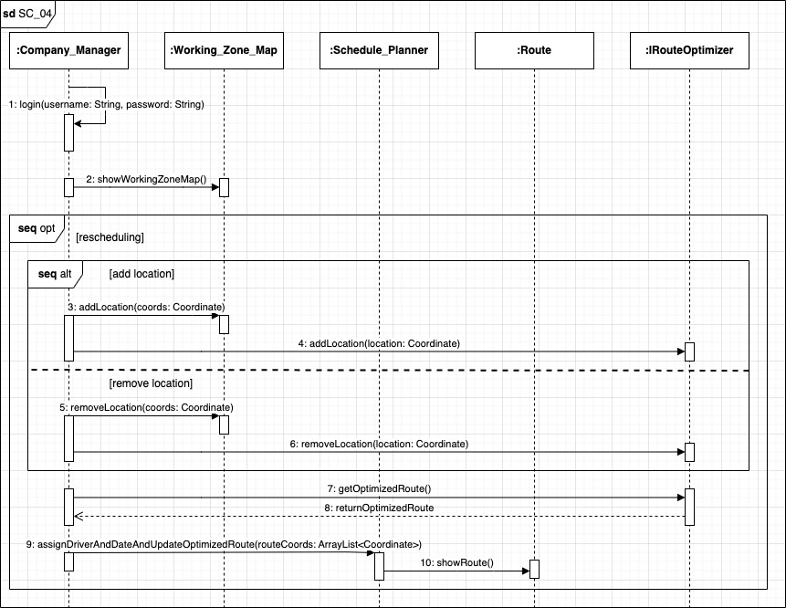

SC_05: Notification for Collection
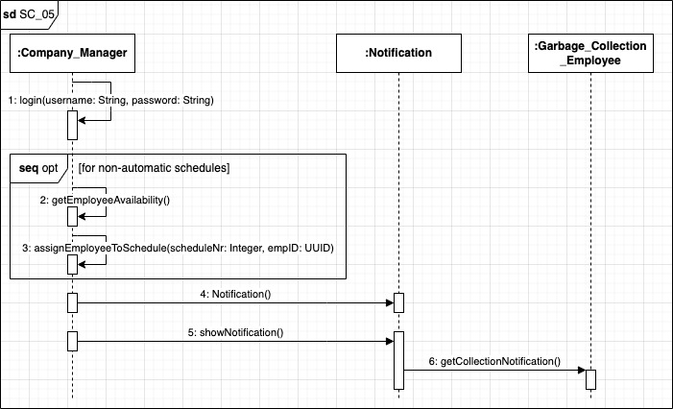

NOEL ZANI

SC_06: Vehicle Tracking

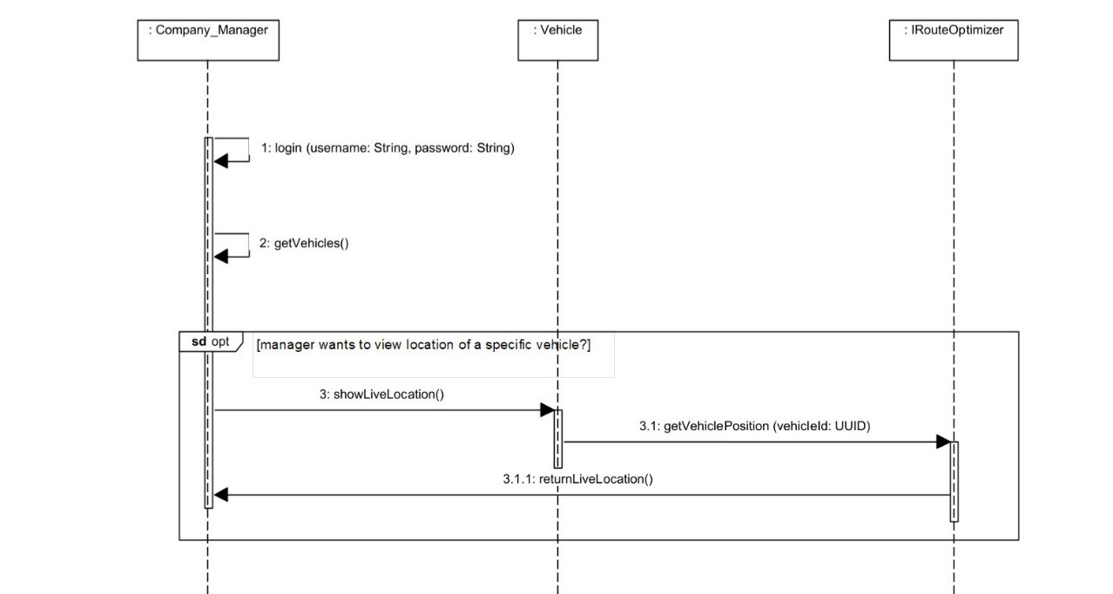

SC_07: Weather-Based Collection Adjustment

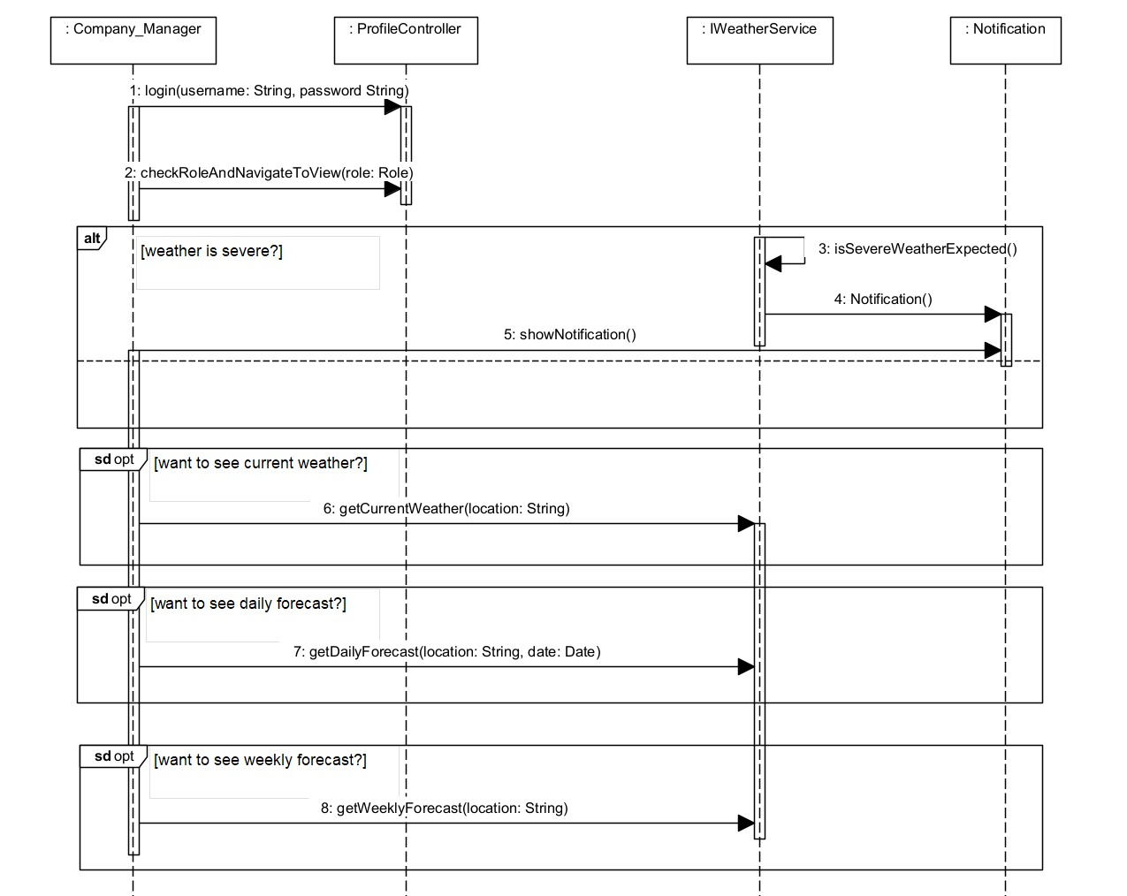

SC_08: Barcode for Traceability

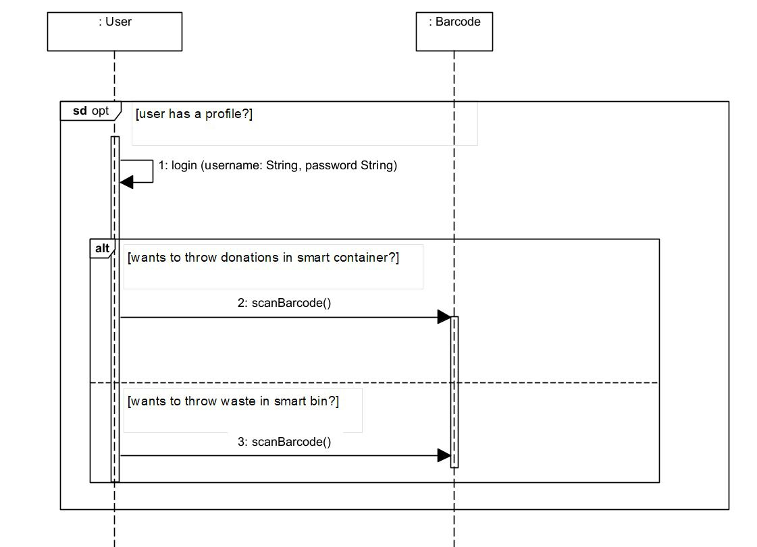

SC_09: Bin and Container Capacity Control
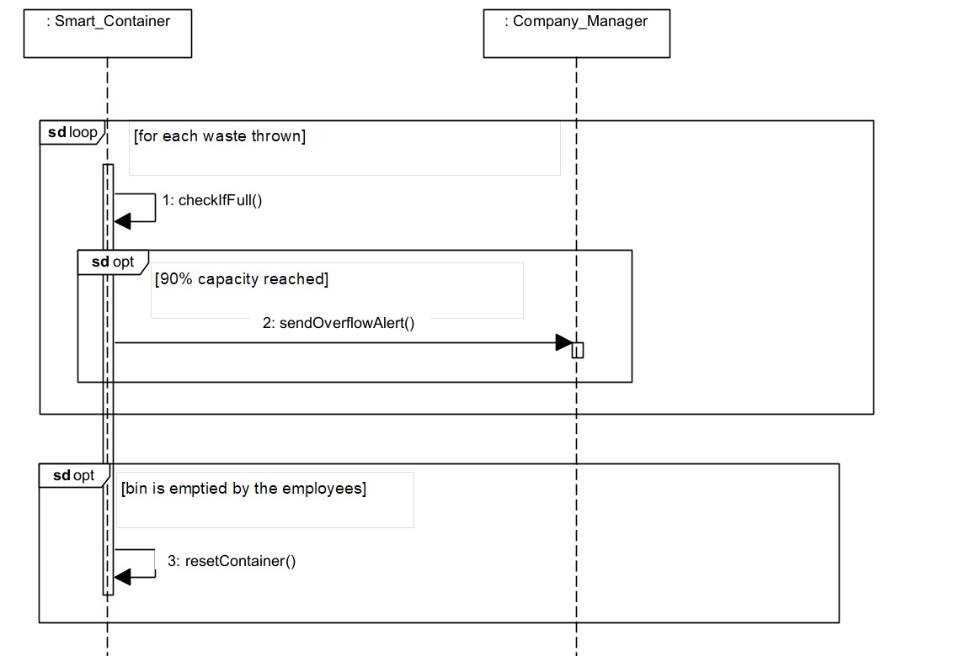
SC_10: Citizen Profile Management
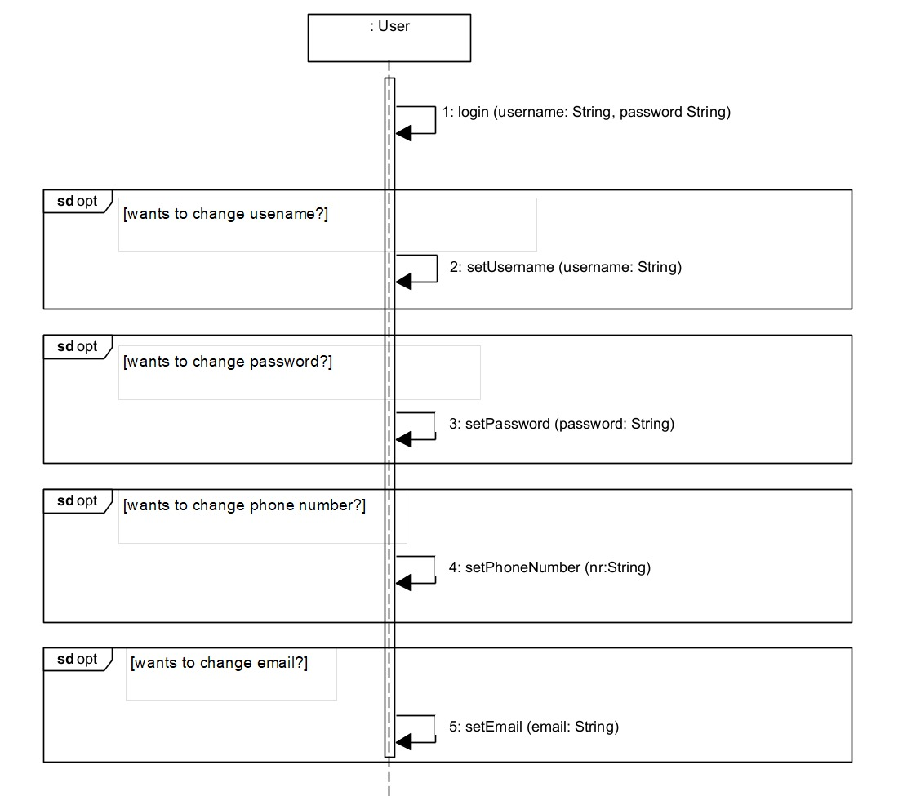

SIDRIT RRUSTEMI

SC_11: Smart Bin Categorization and Distribution
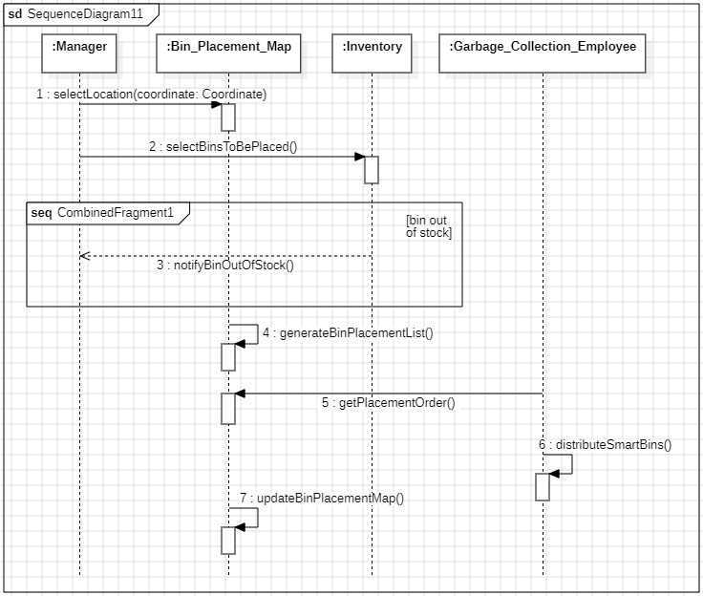
SC_12: Reward Points System
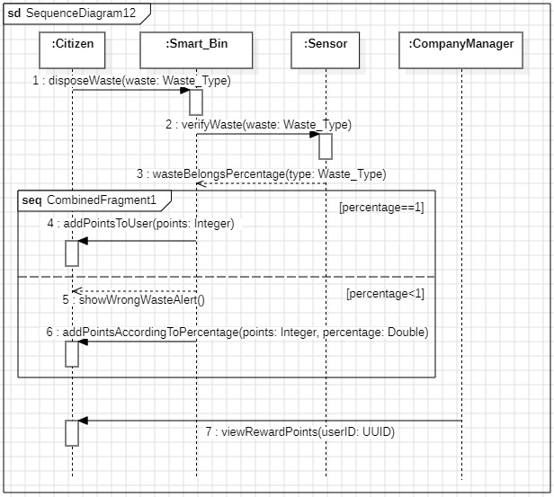

SC_13: Dynamic Pricing for Waste
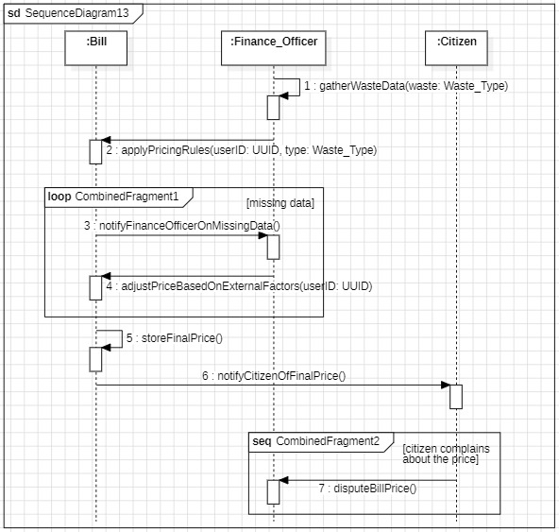
SC_14: Smart Bin Error Handling
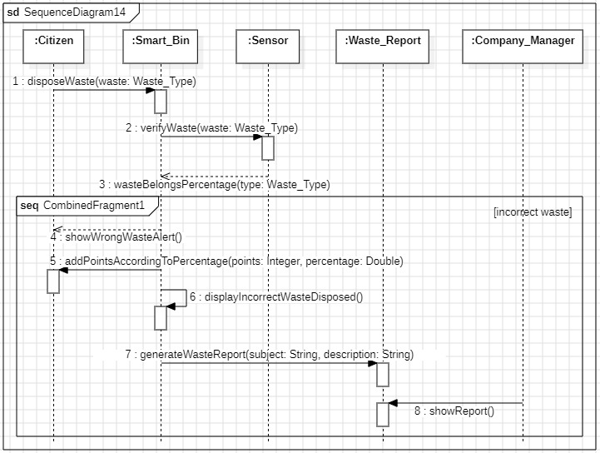

SC_15: Organization of Events
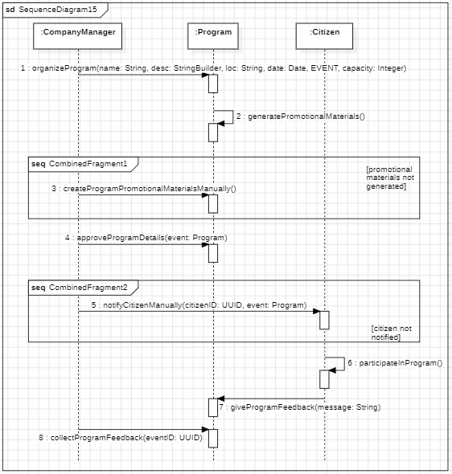

NIKOL DALIPI

SC_16: Educational Programs

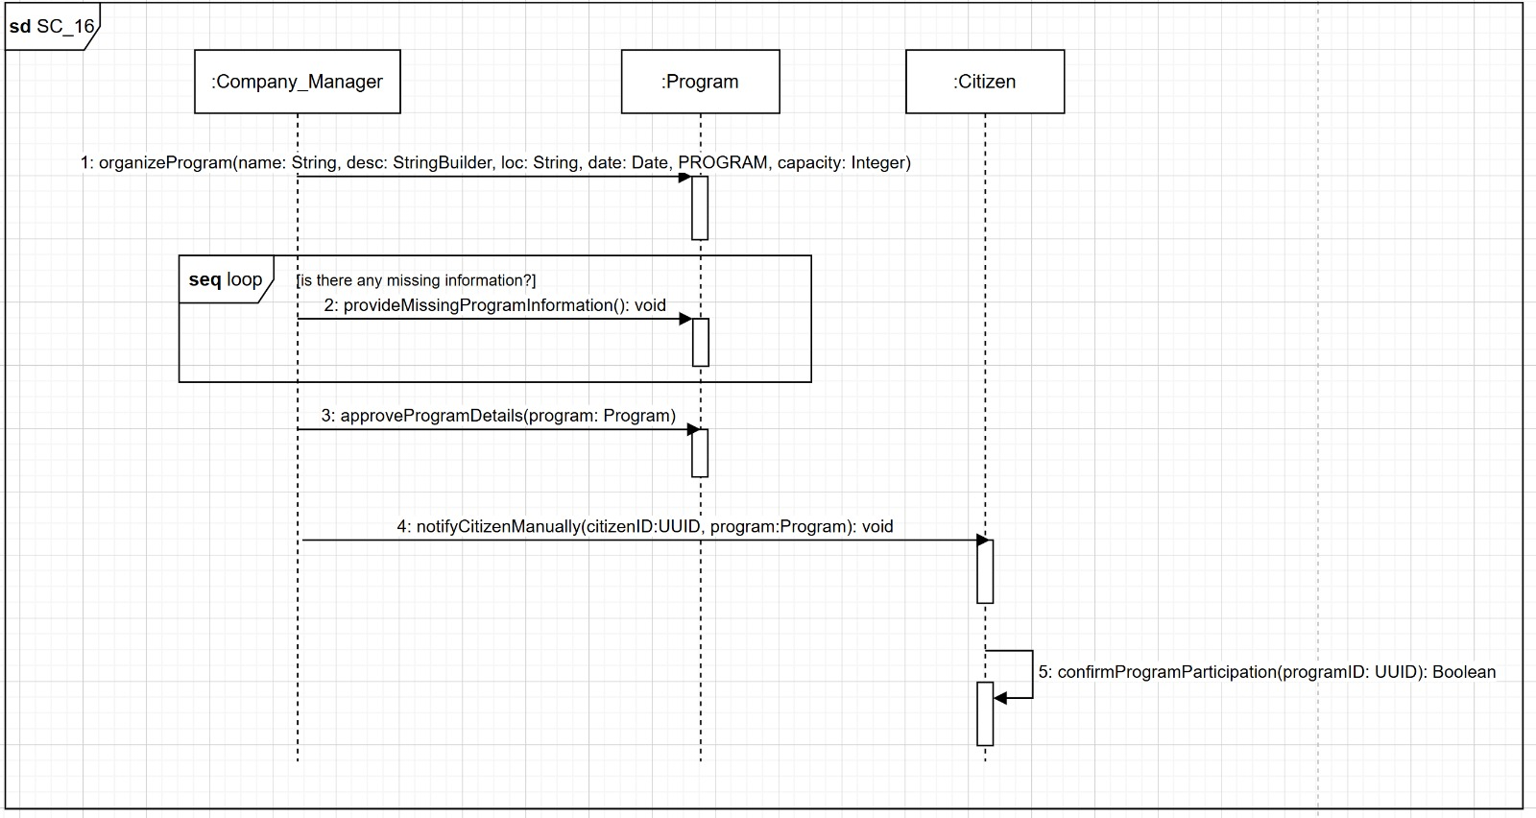

SC_17: Waste Further Processing and Verification

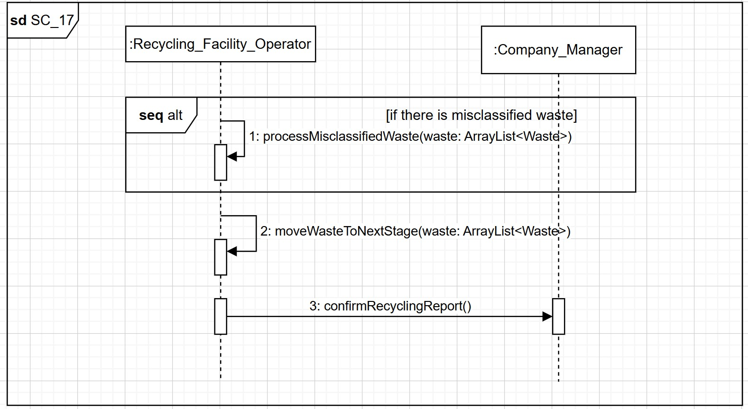
SC_18: Recycling Management
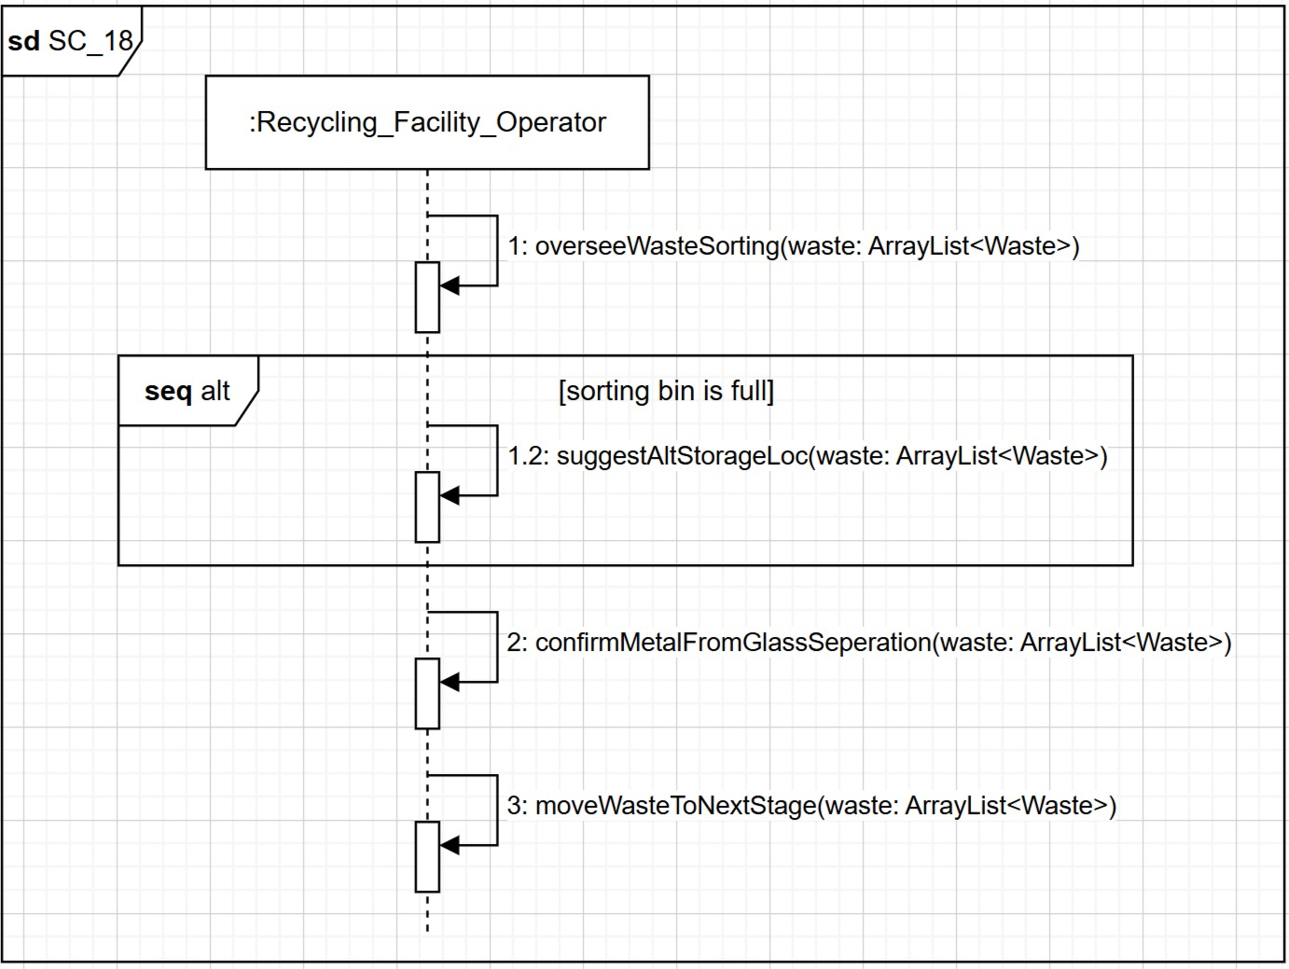

SC_19: Recycling Process Tracking
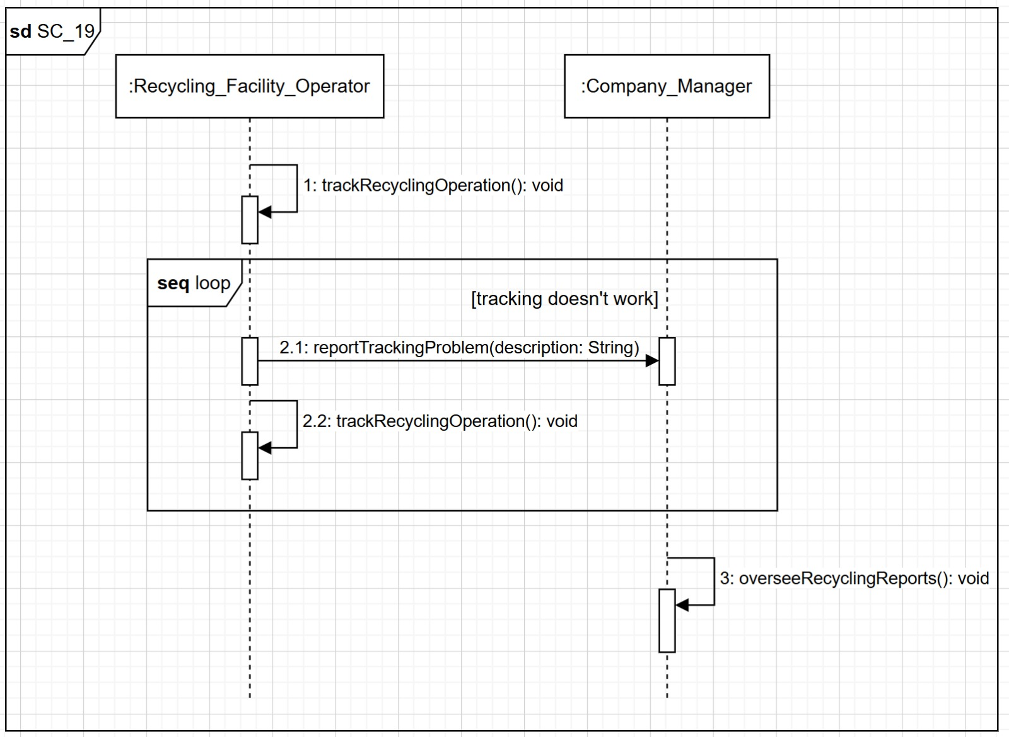

SC_20: Report & Feedback

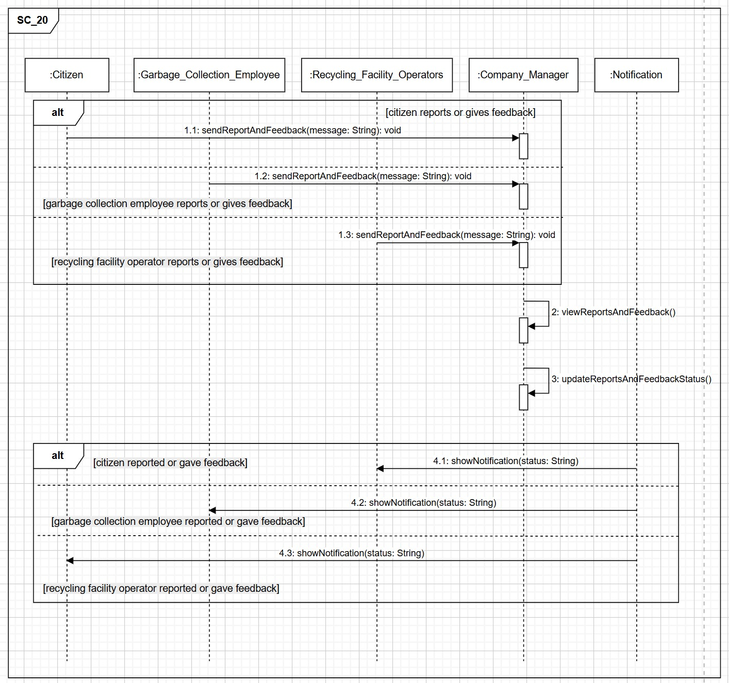

ALESIA DARDHA

SC_21: Informative Notifications

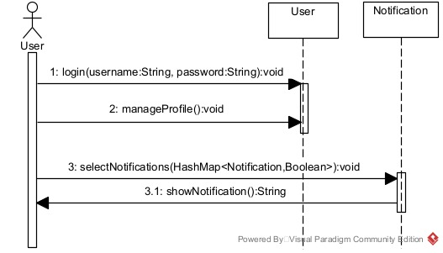

SC_22: Waste Classification Assistance

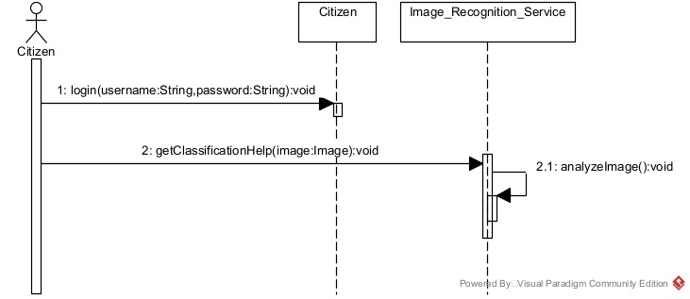

SC_23: Pickup Request

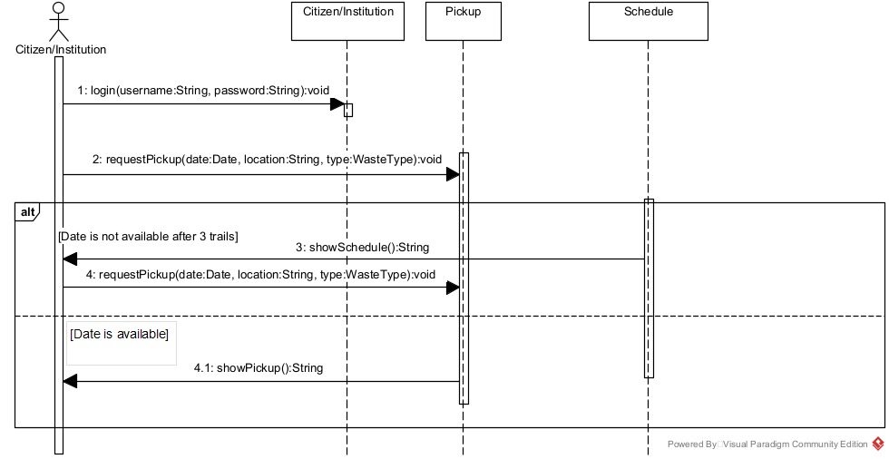

SC_24: Community Leaderboard & Incentives

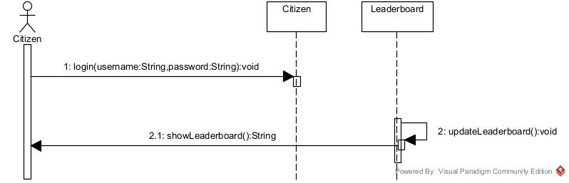

SC_25: Integration with Businesses

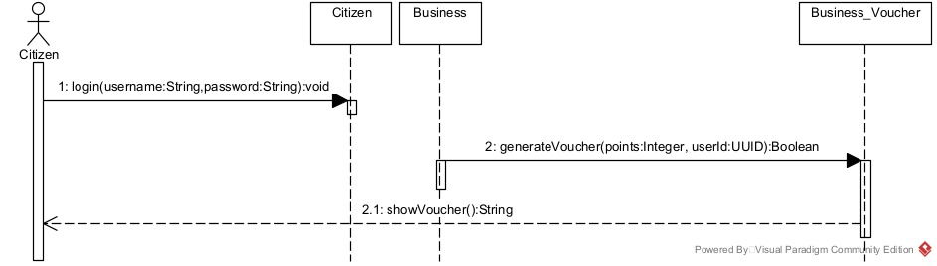

SUADA TEROLLI

SC_26: Integration with other Apps

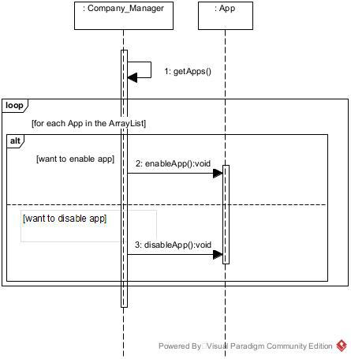

SC_27: Collaboration with Donation Agencies

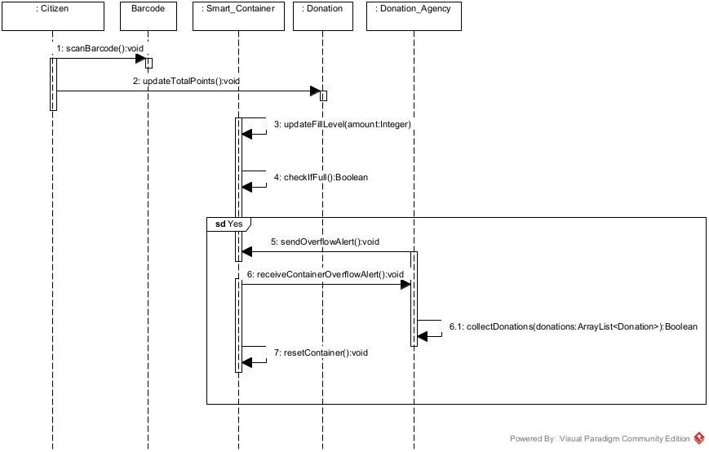

SC_28: Automated Billing

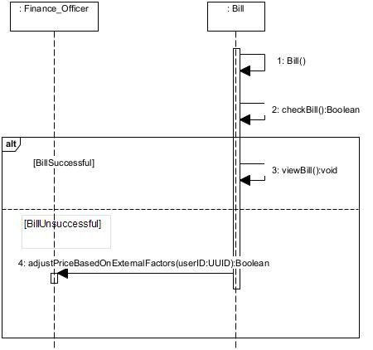

SC_29: Pay Bill

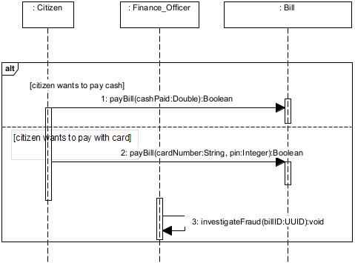

SC_30: Statistics of Waste Generation in Different Areas

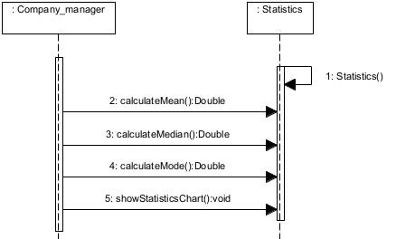

MIRSAD AMULI

SC_31: Fraud Detection & Prevention

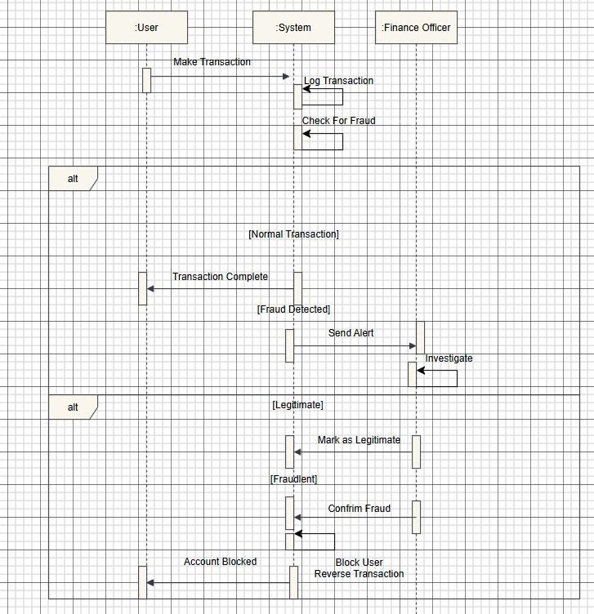

SC_32: Expense Tracking & Cost Analysis

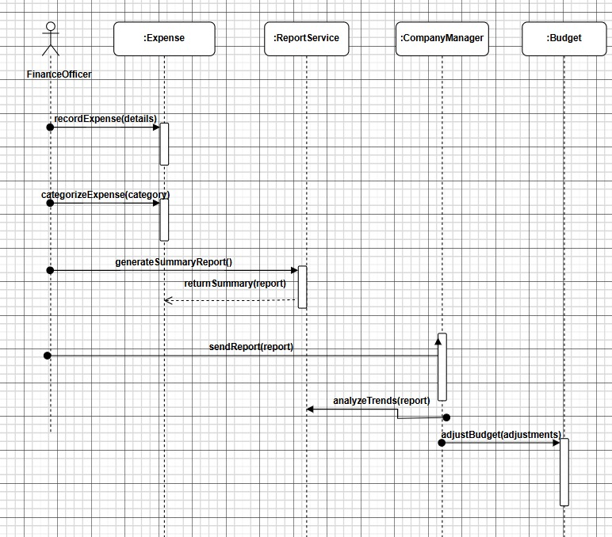

SC_33: Government Compliance & Tax Reporting

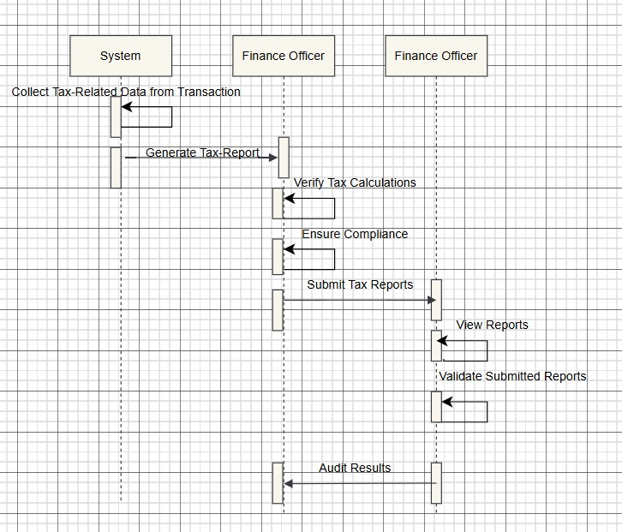
SC_34: Dispute Resolution & Refund Management

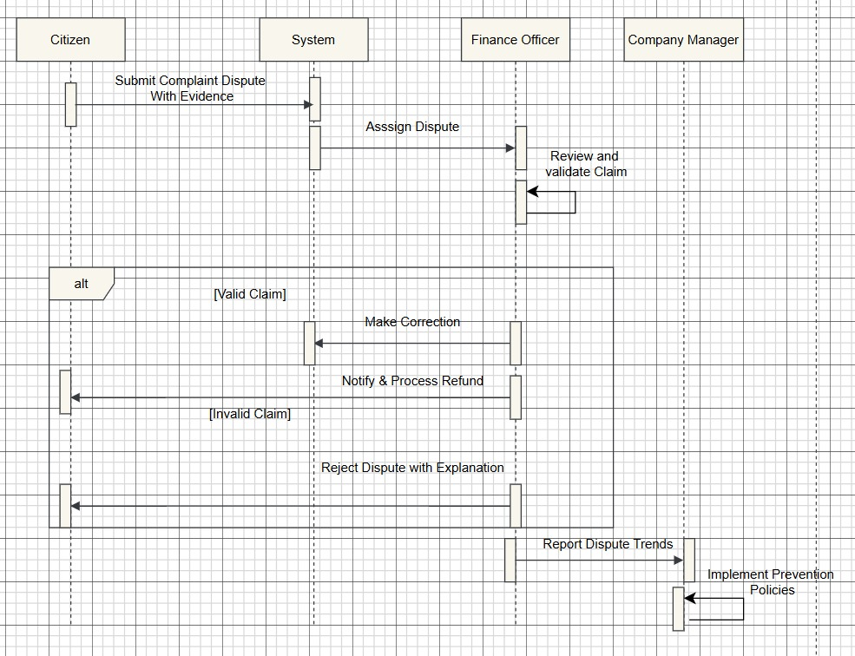

SC_35: Financial Forecasting & Budget Planning

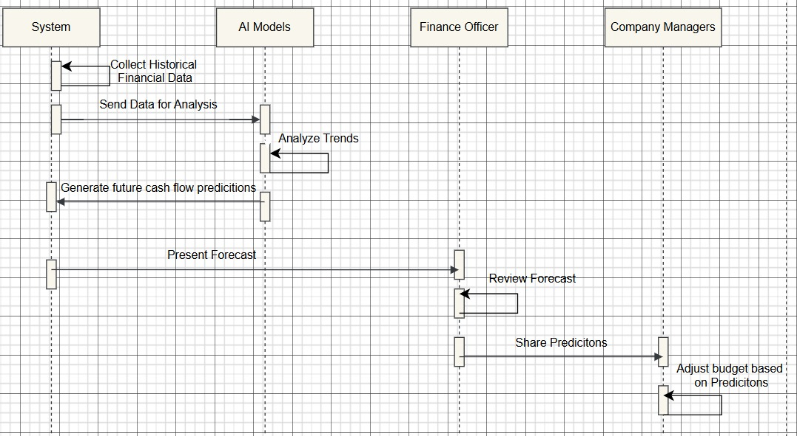

5.7 COLLABORATION DIAGRAM

VIOLA ZENELI

CC_01: Working Zone Map

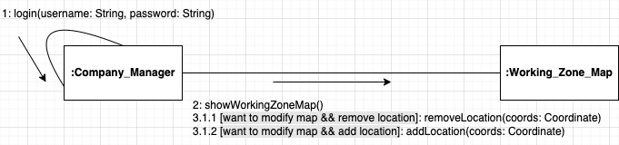

CC_02: Statistics-Based Schedule Optimization

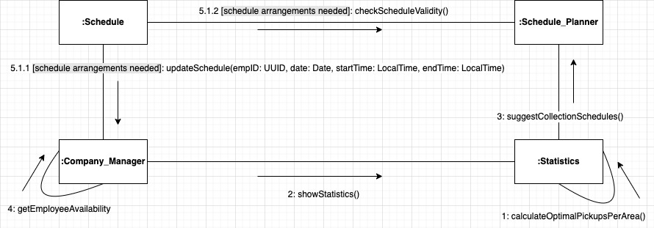

CC_03: Schedule and Plan

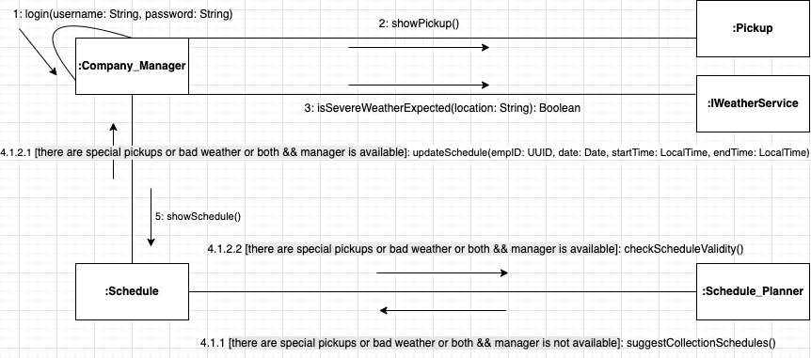

CC_04: Route Optimization

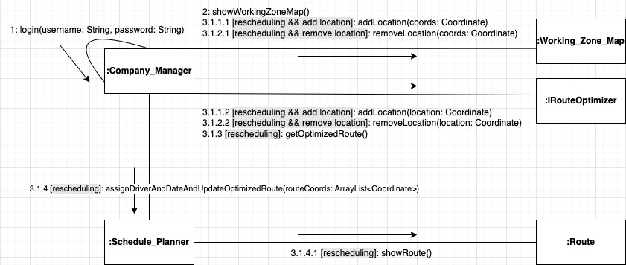

CC_05: Notification for Collection

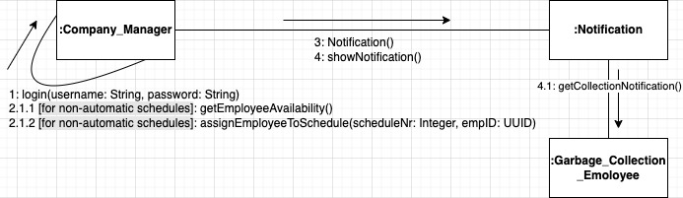

NOEL ZANI

CC_06: Vehicle Tracking

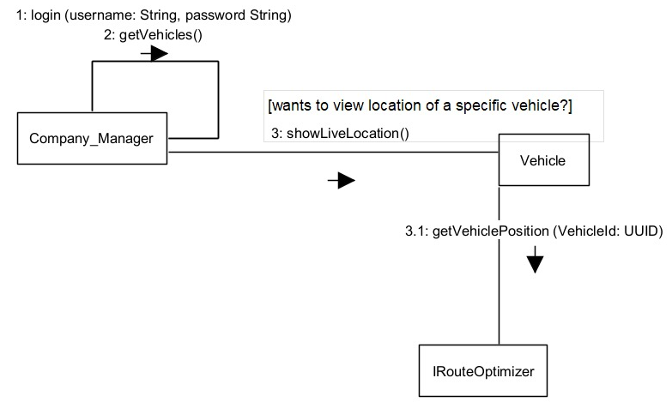

CC_07: Weather-Based Collection Adjustment

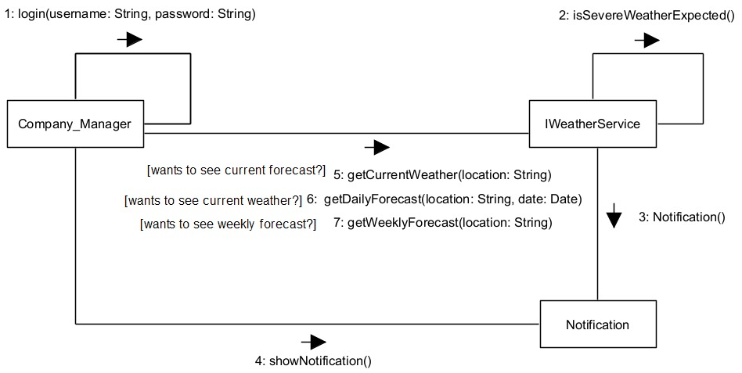

CC_08: Barcode for Traceability

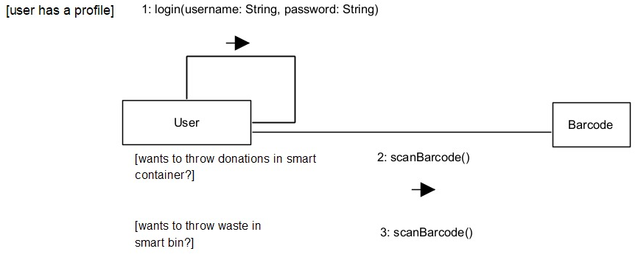

CC_09: Bin and Container Capacity Control

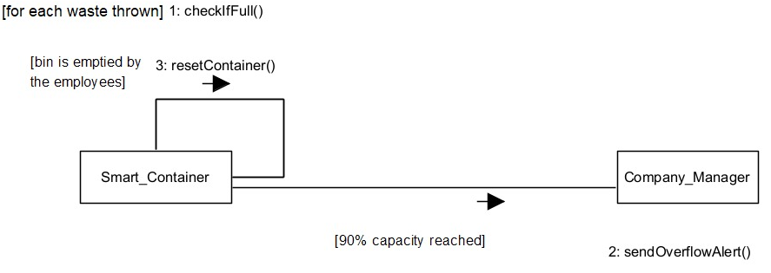

CC_10: Citizen Profile Management

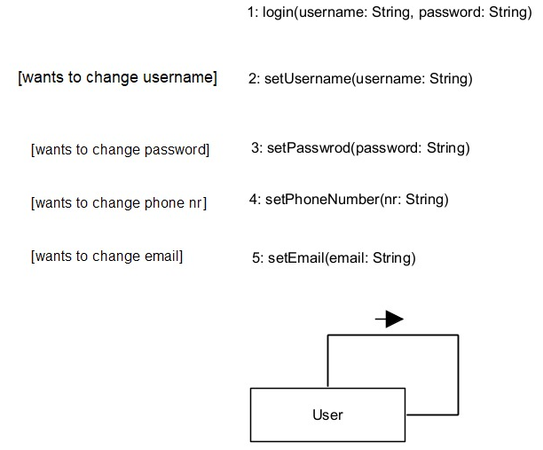

SIDRIT RRUSTEMI

CC_11: Smart Bin Categorization and Distribution

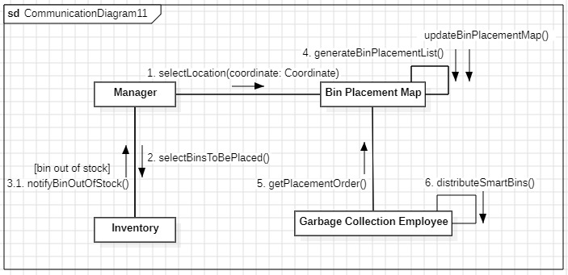

CC_12: Reward Points System

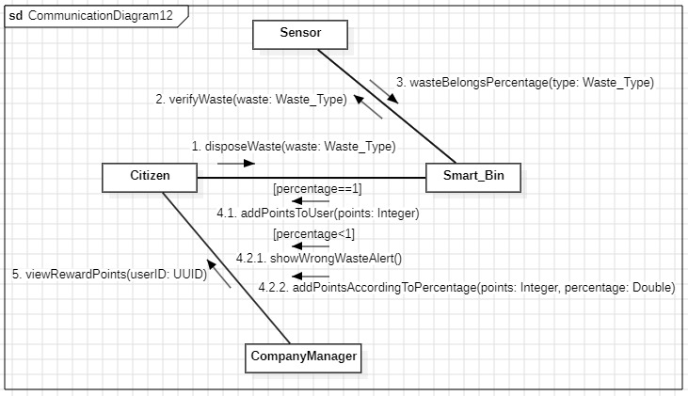

CC_13: Dynamic Pricing for Waste

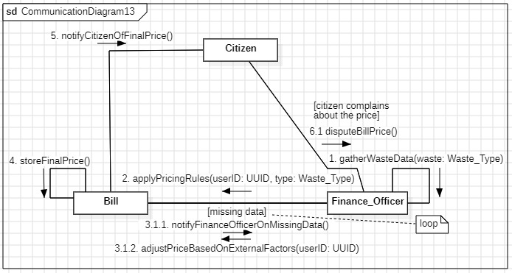
CC_14: Smart Bin Error Handling

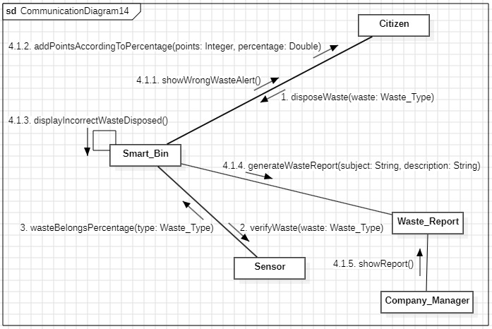

CC_15: Organization of Events

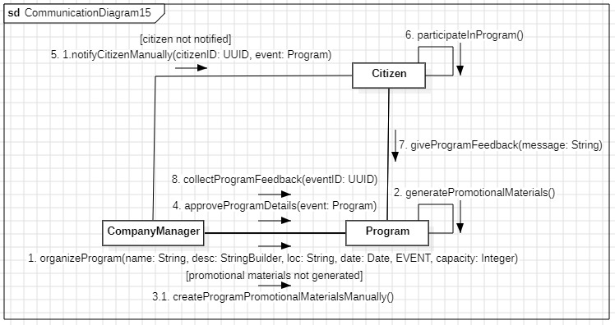
NIKOL DALIPI

CC_16: Educational Programs
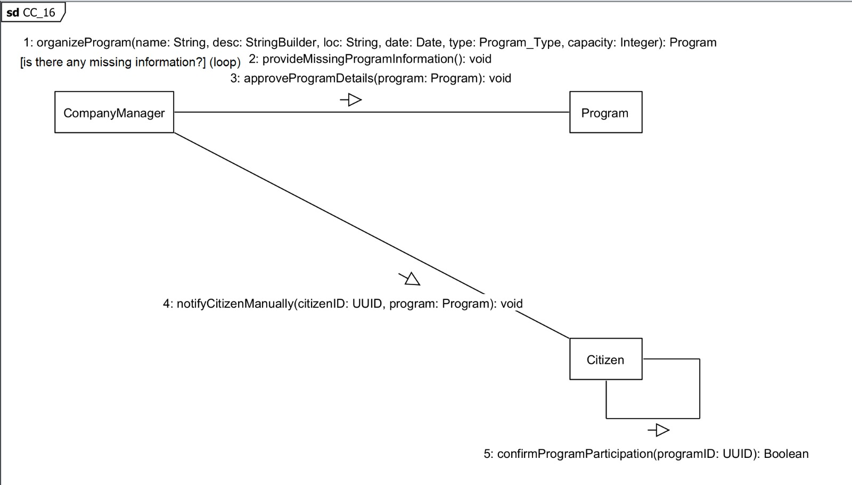

CC_17: Waste Further Processing and Verification
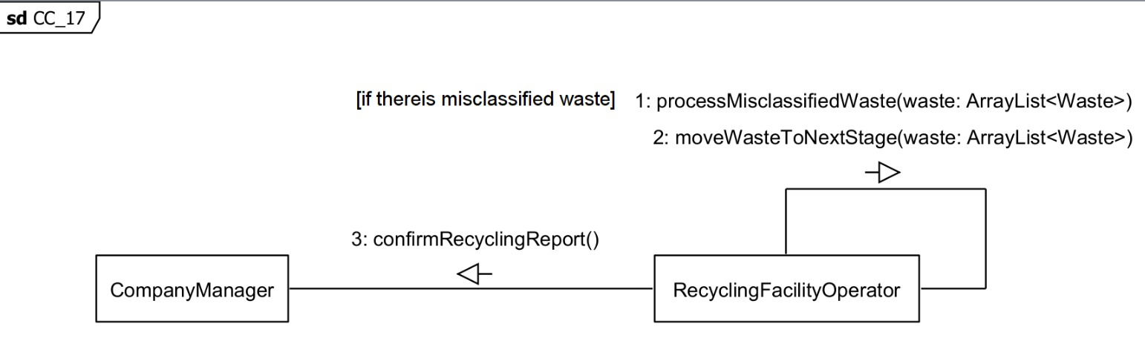

CC_18: Recycling Management
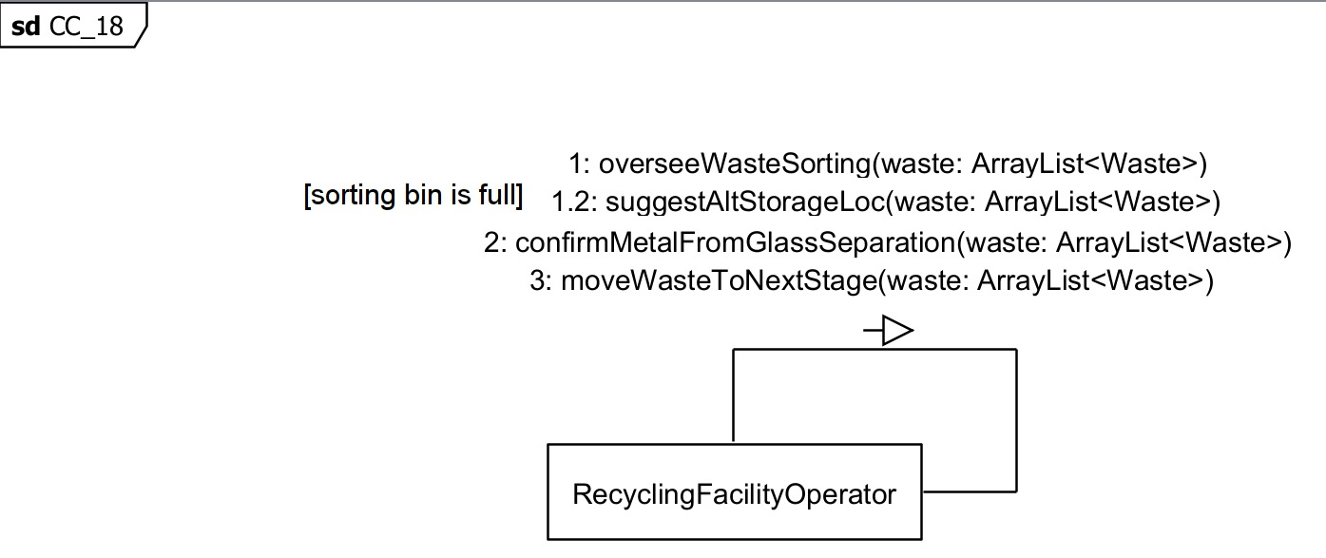

CC_19: Recycling Process Tracking

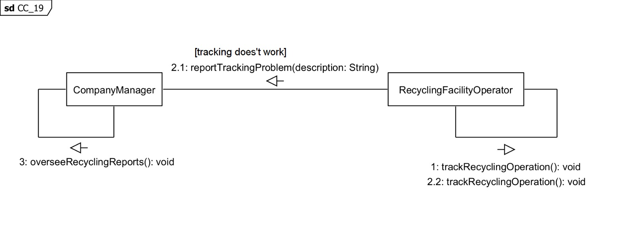

CC_20: Report & Feedback

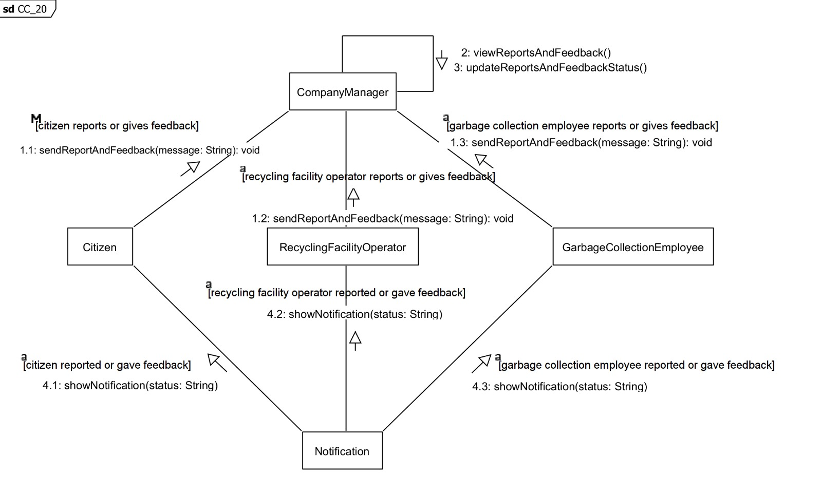

ALESIA DARDHA

CC_21: Informative Notifications

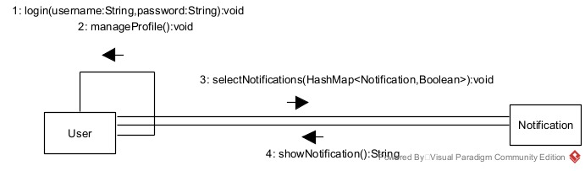

CC_22: Waste Classification Assistance

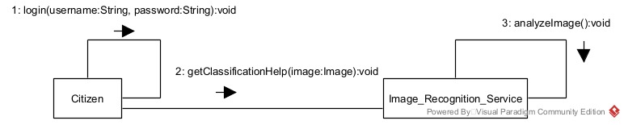

CC_23: Pickup Request

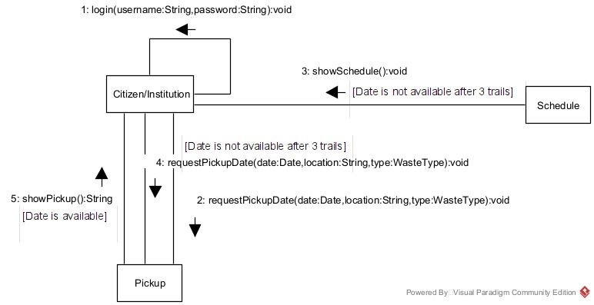

CC_24: Community Leaderboard & Incentives

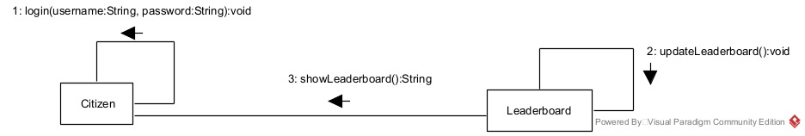

CC_25: Integration with Businesses

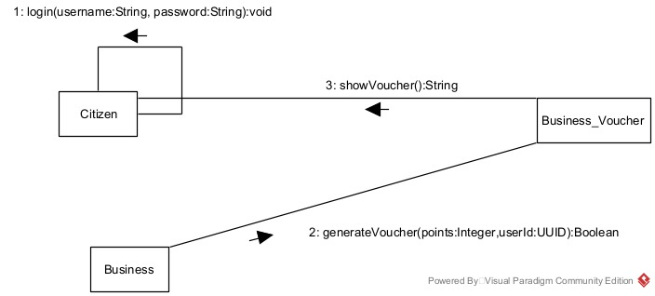

SUADA TEROLLI

CC_26: Integration with other Apps

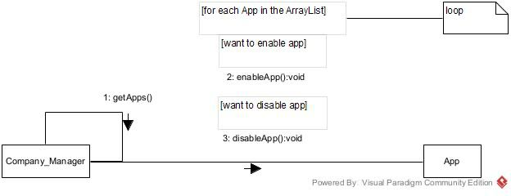

CC_27: Collaboration with Donation Agencies

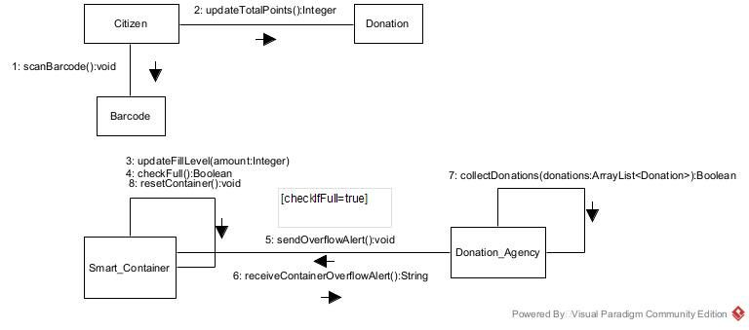

CC_28: Automated Billing

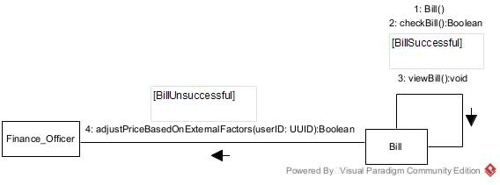

CC_29: Pay Bill

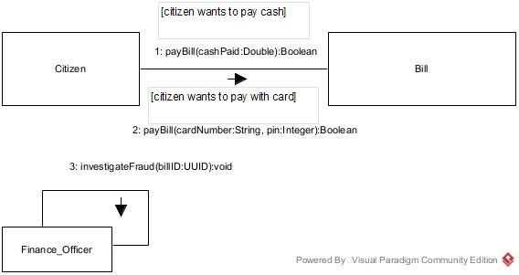

CC_30: Statistics of Waste Generation in Different Areas

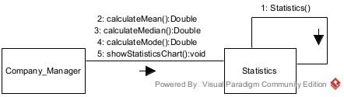

MIRSAD AMULI

CC_31: Fraud Detection & Prevention

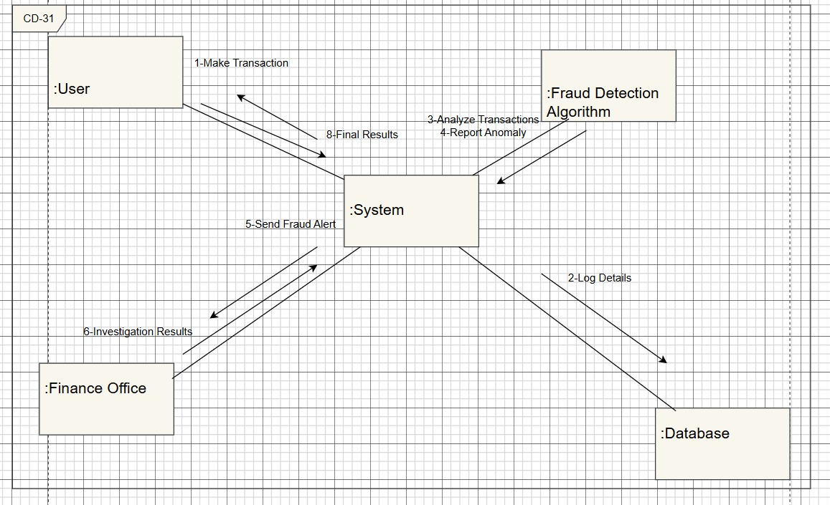

CC_32: Expense Tracking & Cost Analysis

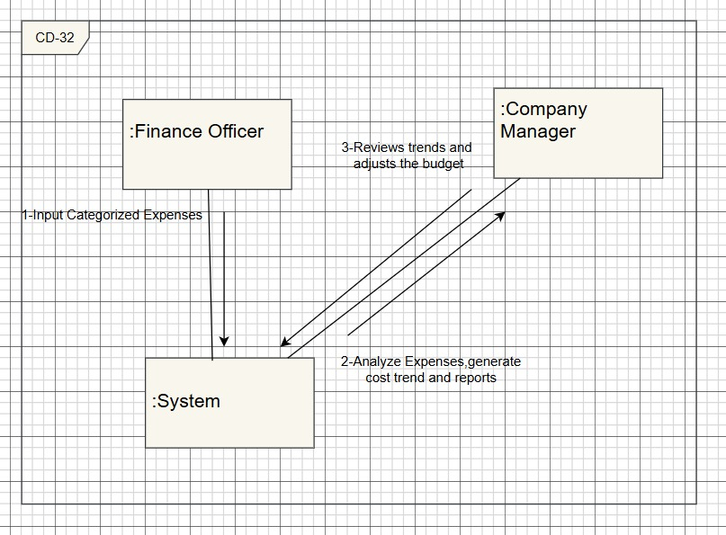

CC_33: Government Compliance & Tax Reporting

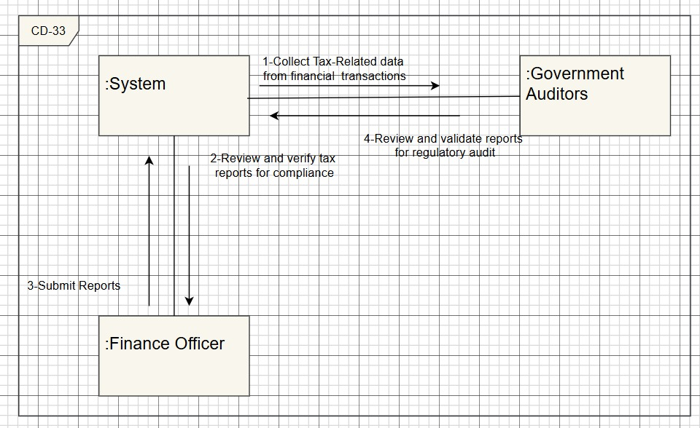

CC_34: Dispute Resolution & Refund Management

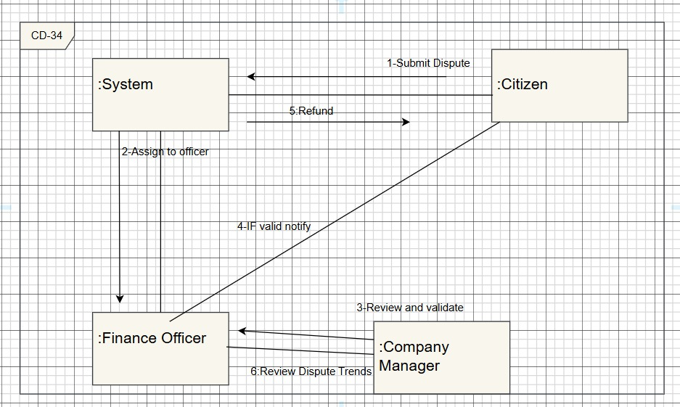

CC_35: Financial Forecasting & Budget Planning

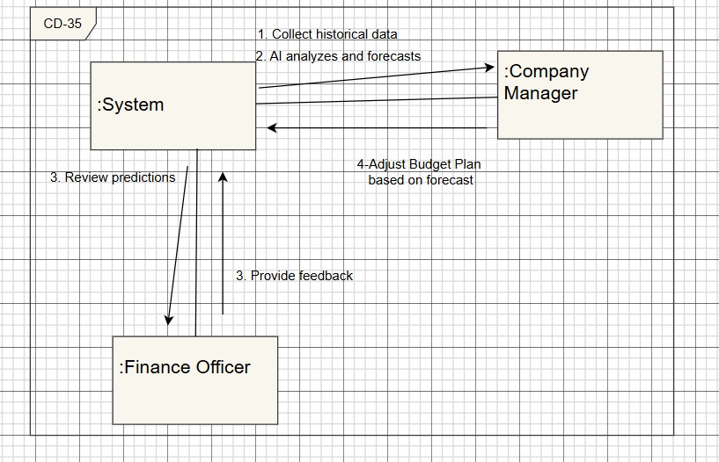

6. DESIGN PATTERNS

Work Division:
- Alesia & Suada found and justified 5 design patterns (theoretical part)
- Viola, Sidrit, Nikol and Noel made the class diagrams as named below.

- SINGLETON PATTERN – NOEL ZANI
The Singleton Pattern ensures that only one instance of a particular class exists throughout the application and provides a global point of access to that instance.
Where: Centralized access to key components like the Route Optimizer
Justification:
You only want one instance of certain critical services throughout the application:
- Only one instance of the Route Optimizer
Example:
Only one module in the system should be in charge of:
- Getting bin pickup data
- Analyzing traffic/weather
- Calculating routes
If two different components were calculating routes separately, it could lead to conflicting assignments, duplicate work, or confusion for garbage collection employees.
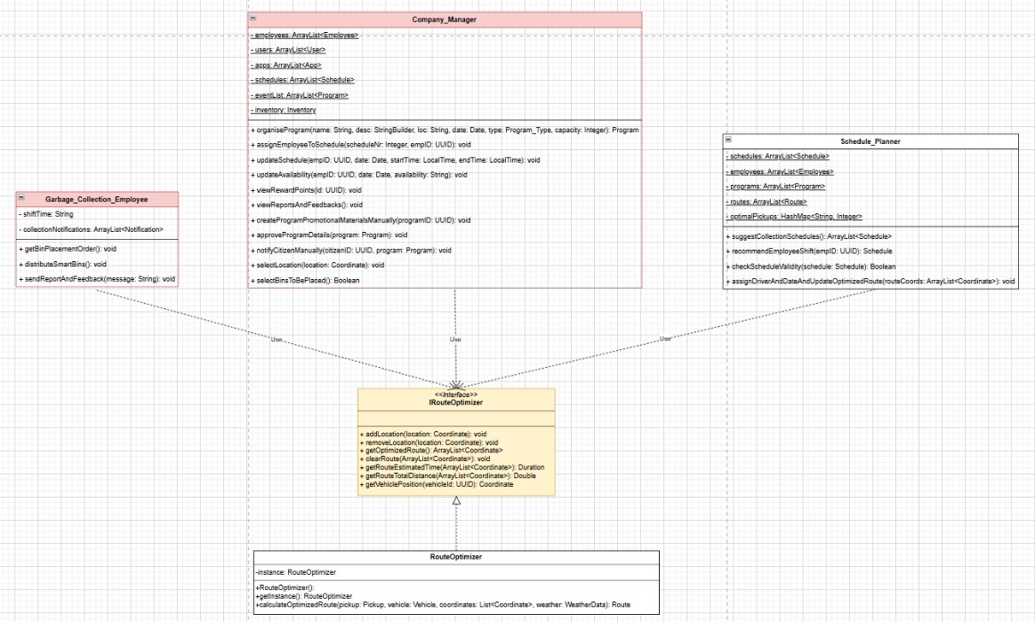

- OBSERVER PATTERN - NIKOL DALIPI
Where: Notification system for citizens and employees (e.g., collection updates, weather alerts, event participation, bin errors).
Justification:
The Observer Pattern is used when multiple users (observers) need to be updated when something changes in the system (subject). For example:
- When collection schedules change due to weather (FR_07), garbage collection employees are notified.
- Citizens receive alerts when they dispose of waste incorrectly (FR_14).
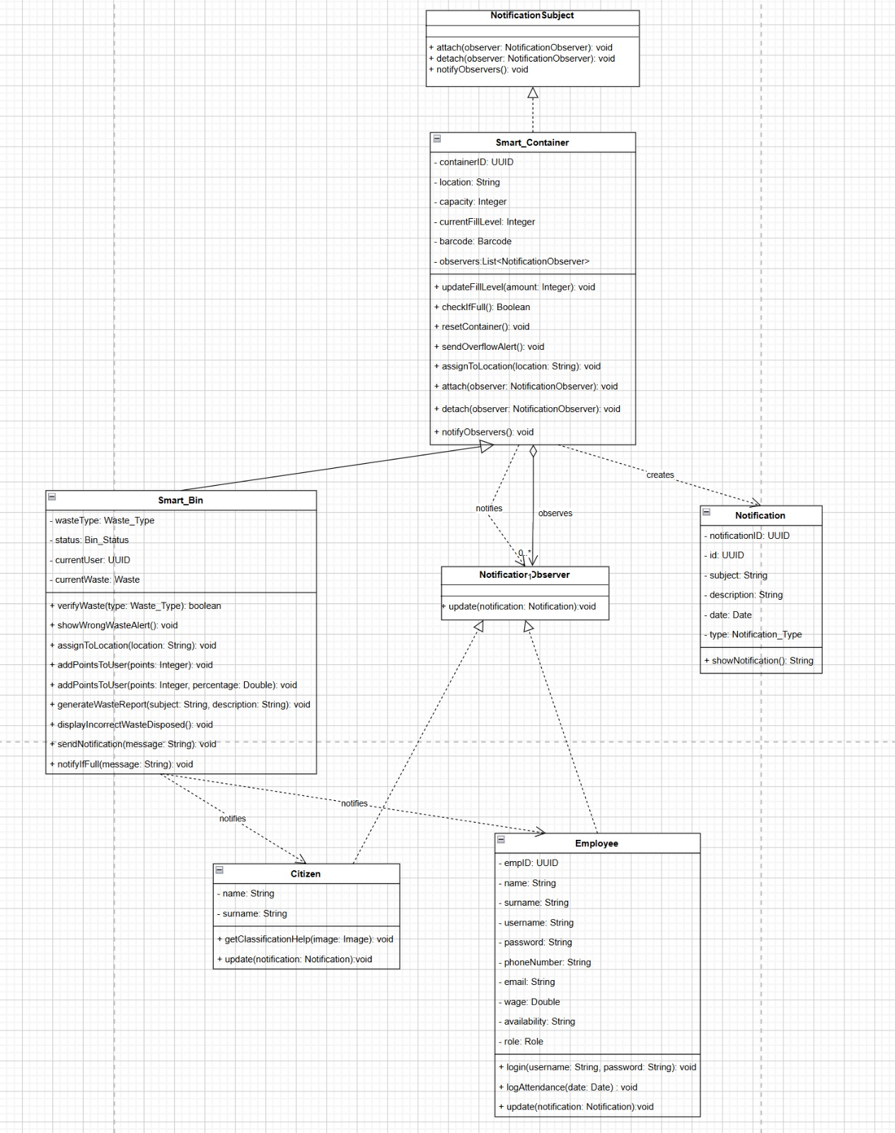

- FACTORY PATTERN - SIDRIT RRUSTEMI
Where: Creation of Educational Programs and Community Events (e.g., Earth Day Campaigns, School Awareness Programs)
Justification:
Different types of events need to be created dynamically based on manager input, but they all share a common structure: name, date, location, etc. The Factory Method Pattern allows the system to define a common interface or abstract class, while delegating the instantiation of specific event types to dedicated factories. This promotes flexibility and scalability by centralizing creation logic, ensuring that all events are created with valid defaults and appropriate data, and easily allowing the system to support new types of events in the future without modifying existing code.
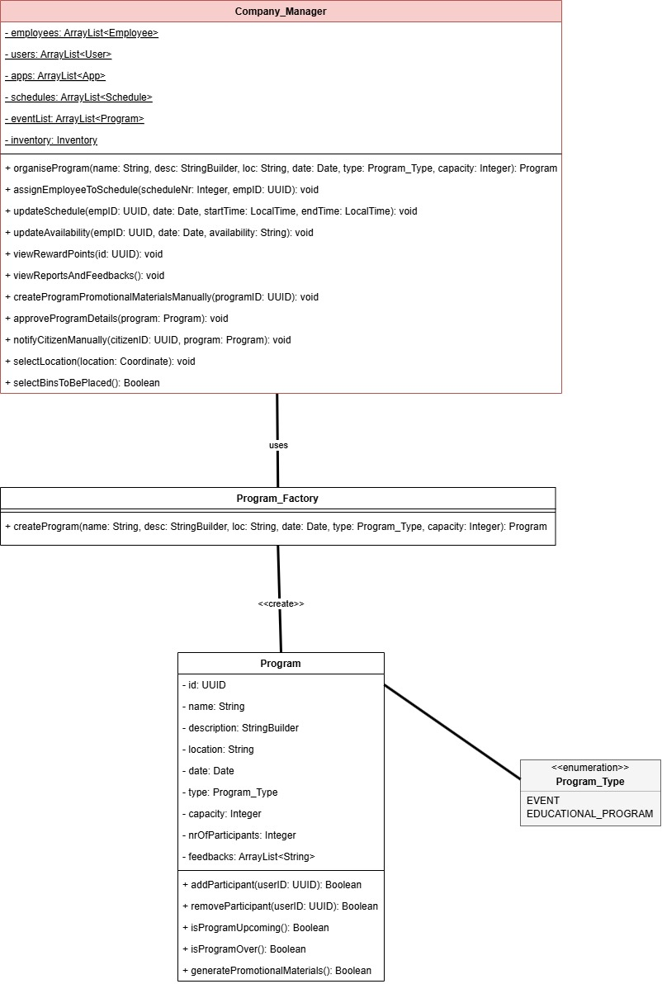
- DECORATOR PATTERN - VIOLA ZENELI

Where: User notifications
Justification:
You allow notifications to be customized per user preferences (FR_21).
- A base notification might just show a schedule update.
- A decorated notification might include rewards, event reminders. Also, users can select the notifications they want to receive.
The Decorator Pattern allows these extensions without modifying the core notification logic.
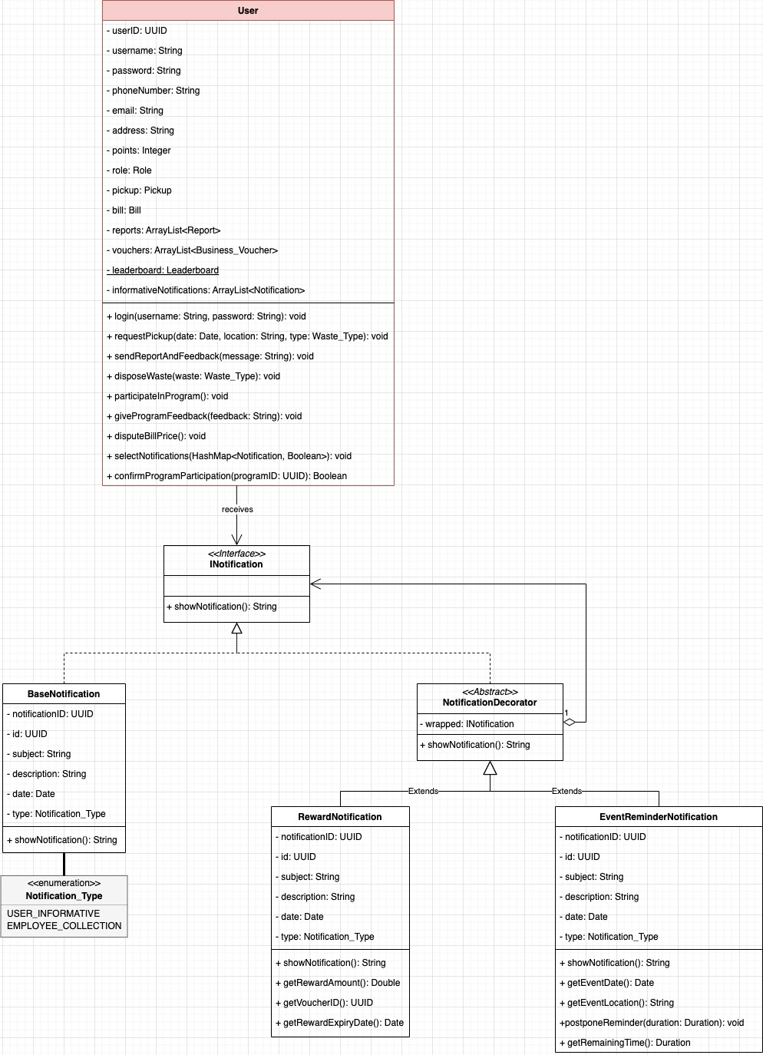

7. APPENDIX

Click here to visit our website: GreenBin Albania
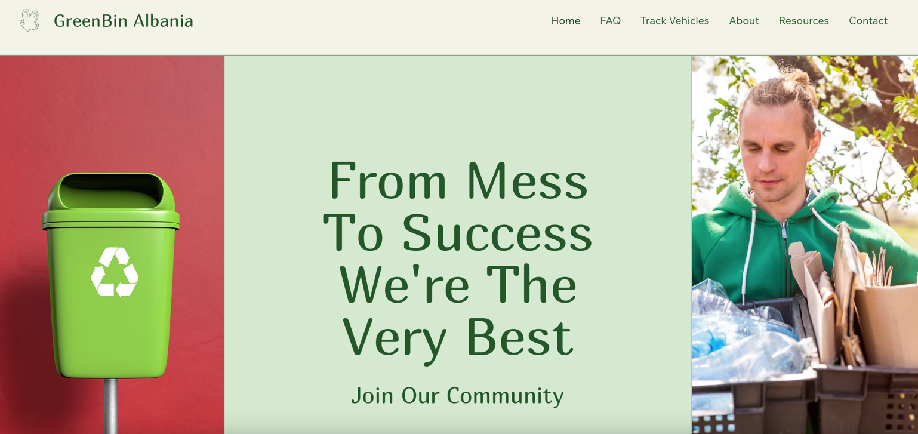

Our Location:

Rr. Naim Frasheri, Lgj. 21 Dhjetori, Tirana, Albania

