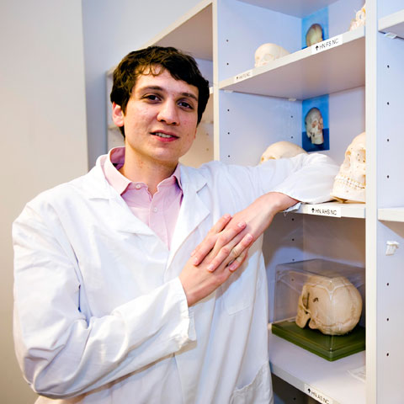

Tom

male

from Germany

20 years old

student

Tom has high temperature and very bad cough.

He wants to find out what is likely to be his

condition. He heard about e-health at work and

decided to register and search for his symptoms.

E-health gives back articles from healthfinder,

MedlinePlus and Bing. The article from

MedlinePlus say that those symptoms are likely

to correspond to flu. The article from Bing is on

fresher's flu.



Sara

female

from the UK

27 years old

accountant

Sara has cancer. She goes on e-health to look for

motivating articles so she adjusts the sentiment

score to high. She chooses users and reads other

users' stories on how they managed with the condition

and led a normal life. She found the articles that she read

very inspiring so she decided to share it and create a new

category to save it for another time.