KREUTZER 42 STUDIES
The secret of joy in work is contained in one word--excellence.
To know how to do something well is to enjoy it. ~Pearl S. Buck

Rodolphe Kreutzer (1776-1831) wrote a set of etudes that have become a MUST in every violinist's repertoire.
In 1817 he wrote the "42 Studies" (42 Etudes ou Caprices pour le Violon).
Rodolphe Kreutzer was born in Versailles, France on November 16, 1766. He was a violinist with a natural talent for the instrument and he composed his first violin concerto when he was only twelve. Rodolphe became professor of violin at the Paris Conservatory in 1796.
Kreutzer is also remembered for the famous Beethoven's Kreutzer Sonata, dedicated to him by Beethoven in 1806. Rodolphe Kreutzer died June 6, 1831 in Geneva switzerland, where he had gone to improve his health. Rodolphe Kreutzer left us this wonderful set of 42 etudes, that belong in every violin students music library.
Four Editions are available:
G. Schirmer  edited and revised by Edmund Singer | International Music Company  - Galamian
Carl Fischer | Edition Peters  numbers etudes differently


Tomaso Bear has invited a bakers dozen of his friends
to come to Sheila's Corner and play the 42 Kreutzer Etudes.
I. Adagio Sostenuto I have not played this one. It was never taught to me or even suggested I play it. I am sure it has many good features.
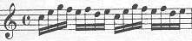
II. Allegro Moderato This is perhaps the most commercially famous of the etudes. A comedian named Jack Benny, who actually played the violin and owned a Stradivari used to come on stage and begin to play this etude. Parts of this etude can also be found in other beginner violin books. There are (depending on the edition you own many bowings to go with this etude. The International has 66 possible practice bowings and the Schirmer has 25. Number 19 (dotted 16th, 32nd, dotted 16th, 32nd, done at the tip is best known as the Kreutzer. The different editions have different versions of fingerings. I find the Schirmer uses most 1st to 3rd and the International has more 2nd and 4th position. of course any violinist will edited it to suit his/her own fingerings. Andrew from the bboard suggests trying this on the string and off.
Using a metronome and increasing the tempo is a fun way to approach the etude. perhaps starting at 120=quarter note and advancing in increments to 200.
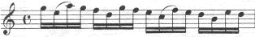
III. Allegro Moderato This can be practiced using the same bowings as are suggested for the II. etude.
Possible metronome settings might be to start at 88 to the 8th note and move upwards to 180. The downward shifting found in measures 12,13,14,15, are invaluable...and are a very good teaching aid. for students who need to learn proper dowward shifting technic.
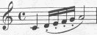
IV. Allegro This may be marked allegro, but slow practice in the beginning is needed to be sure the notes are detached and even.
A metronome marking suggestion might be to begin 69 to a quarter note and move 69-72-76-80-84-88 to the quarter note.
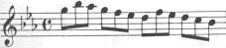V. Allegro Moderato The Schirmer edition suggests 16 possible bowings to practice in their edition. The International does not.
A suggested metronome beat might be to begin at 66 to the quarter note and advance to 108-112. The three flats in this etude are stumbling blocks to some students for intonation. There also are many accidentals.
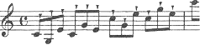
VI. Moderato a sempre martellato martele! hard work to keep the sound even. Firm storkes, near the tip of the bow. Up bows are harder to keep the even sound. I know some who can play a few lines of this etude nicely but cannot keep the stroke going for the entire etude. The word segue means to continue in the same manner of bowing style.
Metronome markings might start at 60 to the quarter note and progress to 80.
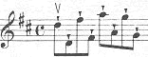
VII. Allegro Assai more marcato, martele bowing. This time starting on an up bow and jumping a few strings. Use the tip of the bow and stop with pressure.
A suggested metronome setting would be to start at 66 to the quarter notes and move up in increments,69-72-76-80-84-88-92-96-100. The International edition has a page of bowing suggestions to use for effective practice.
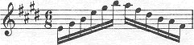
VIII. Allegro non troppo Have good string level awareness when playing this etude. Create musical phrases within it and look for patterns. Schirmer has a sete of extra bowings. International edition has a set of extra bowings and extra rhythms. Andrew from teh bboard suggests varying on string, off string. Upbow and downbow staccato.
Suggested metronome settings are: 104 to the 8th notes and then move up slowly 104-108-112-116-120-126.
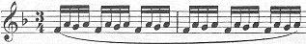
IX. Allegro moderato Play the notes evenly, use the metronome to practice. There are extensions in this one.
Suggested metronome settings are: start with 80 to the quarter note then move slowly 80-84-88-92-96-100-104-108
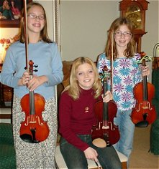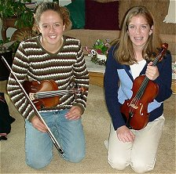
We all love to practice our Kreutzer Etudes.
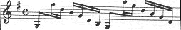
X. Allegro watch your intonation on this one. It is a fun one to play.
Begin with a metronome setting of 100 to the 8th note and move in increments up to 160...or the quarter note on 80..if you can. Be sure to restez in the upper positions when called for.
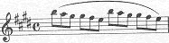
XI.Andante This is an excellent etude to practice shifting(correctly). Use light fingers and know where you are going. be sure to take your thumb with you as you shift. Do not cheat and play this in incorrect positions. Use the positions that are marked in the music. Andrew from the bboard suggests stopping before every shift and practicing the guiding note before the next passage.
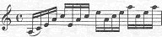
XII. Allegro moderato This is an enjoyable etude. The arpeggio work is a must for everyone. Try to know what key you are playing each one in. At the least know if you are playing a minor one or a major one. You will have to read an octave up on some of the arpeggios. Roll long with this one and enjoy it.
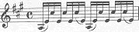
XIII. Moderato Keep your fingers down when you play this etude. Also try playing it as chords and know what chord you are playing. Practice it in chords a few times. You can be aggressive with this one. Andrew from the bboard suggests practicing in a chair with elbow on a low table. This will exercise the minimization of too much arm movements and easy wrist movements.
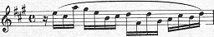
XIV. Moderato I find this one easy in places and difficult in others. Some of the higher notes are a bit hard to hear in your head. It is a mine field of accidentals. Your little finger will get a workout.
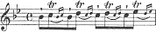
XV. Allegro non troppo (molto moderato) It is time to trill! The Kreutzer Etudes have a great deal of trill work. The International edition has 11 different practice drills printed out. Four are suggested in the Schirmer edition.
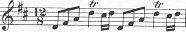
XVI. Moderato This one follows with more trill exercises. Be sure you know the key you are in and if the trills are half step or whole step trills. Try to do all the different ones in groups of 6-7-8-9.
XVII.Maestoso (Moderato)=
XVIII. Moderato - martele
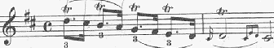
XIX. Moderato Trills, trills, and more trills. Also there are different rhythms included to use to practice this etude
XX. Allegro
XXI. Moderato e sempre marcato
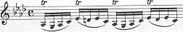
XXII. Moderato More trills and ornamments.The rhythm is not effectted by the ornament. Four flats, four sharps, lots of accidentals.
XXIII. Adagio (quasi Cadenza)Kreutzer No. 23 is chock full of difficulties. I think of it as the “Chopin” etude because of the many unmeasured runs that need to sound clean, yet almost improvised. My tricks:
1. Any time you have a nonmetrical figure with a “weird” number of notes in it, divide it up mentally and visually into metrical groupings. For example, the run in the first measure has 31 notes. My suggestion is to start by bracketing the C, B=, and A as a triplet, then all the other notes into groups of four. That’s only one possibility: you may prefer a different grouping. You’re not going to accent these groups, but it does give you a way to visualize the run and to practice it with the metronome.
2. Plan a fingering that goes with your groupings. If at all possible, change strings on the “beat” (first note of a bracketed group.) Try to shift on half steps instead of the traditional 1st to 3rd to 5th position fingerings. And put your shifts if possible on a “beat” or strong place rhythmically (such as the third note of a four-note grouping.) So for that first measure I would suggest shifting from 1 to 1 on the low A to B=, then stay in 2nd position until shifting 2 to 2 on the high A to B=. Finally, shift down to first position on the C (fourth-to-last note.)
3. Focus on your string changes in the right elbow. It’s tempting to slow down at every string change unless you think about the elbow almost leading your bow to the new string. Exception: Alternating back and forth between adjacent strings (measures 15-18) should be initiated by the wrist.
4. The fingers of the left hand should move energetically, but hit the strings very lightly. This will match up with the very light bow pressure you’ll have to use in order to fit all those notes in one bow. Obviously, you need to use every centimeter of available bowhair.
5. The printing of your edition may be questionable – is the run slurred in with the fermata note? No need to make it any harder than it already is! But I don’t think you should be splitting the bowing within the runs, except maybe measures 33, 39, and 40. You could also change bows in the middle of measures 2, 4, 10, 22, 24, 26, and possibly 34-36 (depending on what you did in measure 33.) Just make those bow changes smooth!
6. After you’ve made the runs sparkling clean, then consider how you could make them musical with rubato and/or dynamic change (either will be subtle, given the difficulties of saving bow!)
7. Measures 27-30 are an exercise in making dynamic changes while saving bow. The large crescendos and diminuendos can involve some change of bow speed; the “hairpins” are about bow weight. Practice first with perfectly even bow division and weight, then make the adjustments as needed.
No. 23 notes provided by Professor Reed Smith
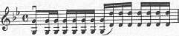
XXIV. Allegro Octaves. We all have to play them and they are very important in hand frame and position work and harmonics and need I say more. International edition has a 24a. and a 24b. Wow- two etudes for the price of one. Andrew from the bboard suggests 24b - Single notes only, linked by slurs for intonation
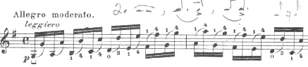
XXV. Allegro moderato More octaves.. Begin down bow sometimes and try beginning upbow some times. Create different rhythms.
XXVI. Moderato
XXVII. Moderato
XXVIII. Grave
XXIX. Moderato, molto legato
XXX. Moderato
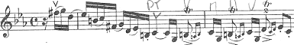XXXI. Vivace
Begin with a metronome setting of 60 to the quarter note
XXXII. Andante
XXXIII.Andante Andrew from the bboard suggests fingering both notes of the thirds/double stops, but only playing one of them during the whole etude. Then switch to the other note the second time.
XXXIV. ModeratoAndrew from the bboard suggests fingering both notes of the thirds/double stops, but only playing one of them during the whole etude. Then switch to the other note the second

