Evaluation and Ablation
Can topic-agnostic structural sequences detect fake news without words?
Results section draft - WELFake, held-out test set (n = 1,000)

1. Experimental Setup
All models are evaluated on a balanced subset of WELFake (10,000 articles: 5,000 fake, 5,000 real), split 80/10/10 with stratification into 8,000 train / 1,000 validation / 1,000 test examples. The split is fixed (seed 404) and identical across every model and baseline, so all reported numbers are directly comparable and every significance test is paired on the same test items.
Structural representation. Each article (title + body) is parsed with spaCy and reduced to three parallel token sequences with all lexical content removed: POS tags (syntax), DEP labels (grammatical relations), and SHAPE tokens (surface form: word-shape and punctuation). Sequences are truncated to 160 tokens.
Model. A BiLSTM with one embedding table per active channel (dim 48), concatenated and mean-pooled over the real tokens, then a linear classifier (hidden 64, dropout 0.3, Adam, lr 1e-3, 6 epochs, early stopping on validation F1). Seven channel combinations are trained, from each channel alone to all three together.
Baselines. (i) majority class; (ii) a length-only logistic regression on token count, to test whether structural signal is merely article length; and (iii) a lexical TF-IDF (1-2 grams, 50k features) + logistic regression on the raw words - the content-based reference the structural models must match.
Metrics. Accuracy, macro precision/recall/F1, positive-class F1, and ROC-AUC on the test set. Pairwise differences are assessed with McNemar's exact test (alpha = 0.05).

2. Main Results
Table 1. Test-set performance, sorted by macro-F1. The right column is the McNemar two-sided exact p-value against the best model (pos_dep_shape); n.s. = not significant, * = significant at alpha = 0.05.
Model | Accuracy | Macro-F1 | ROC-AUC | McNemar vs best
pos_dep_shape (POS+DEP+SHAPE) | 0.945 | 0.945 | 0.990 | ref (reference)
pos_shape (POS+SHAPE) | 0.941 | 0.941 | 0.984 | 0.63 (n.s.)
lexical TF-IDF + LR | 0.941 | 0.941 | 0.989 | 0.76 (n.s.)
dep_shape (DEP+SHAPE) | 0.930 | 0.930 | 0.978 | 0.086 (n.s.)
shape (SHAPE only) | 0.914 | 0.914 | 0.965 | 0.0004 *
pos_dep (POS+DEP) | 0.890 | 0.890 | 0.959 | <0.001 *
pos (POS only) | 0.849 | 0.849 | 0.932 | <0.001 *
dep (DEP only) | 0.811 | 0.811 | 0.904 | <0.001 *
length-only baseline | 0.557 | 0.542 | 0.553 | <0.001 *
majority-class baseline | 0.500 | 0.333 | - | <0.001 *

3. Findings

3.1 Structure-only is competitive with lexical content
The best structural model reaches 0.945 macro-F1 (AUC 0.990), marginally above the lexical TF-IDF model that sees every word (0.941, AUC 0.989). McNemar finds no significant difference between them (p = 0.76). A classifier with all lexical content stripped away is therefore statistically indistinguishable from a strong content-based model on this data - the central hypothesis of the project. This is the headline result: structural sequences alone carry enough signal to match word-based detection.

3.2 Channel importance: surface form > syntax > dependencies
As standalone channels the ordering is unambiguous: SHAPE (0.914) >> POS (0.849) > DEP (0.811). All three single-channel models differ significantly from one another, including POS vs DEP (p = 0.004). Surface form (word-shape and punctuation patterns) is by far the most predictive single structural channel, followed by part-of-speech syntax, with raw dependency relations the weakest on their own.

3.3 Two channels saturate; the third is redundant
Adding a syntactic channel on top of SHAPE produces a real, significant gain, but adding the second syntactic channel does not. SHAPE+POS significantly beats SHAPE alone (p = 0.001), yet the full SHAPE+POS+DEP model is statistically tied with SHAPE+POS (p = 0.63). The channels are thus complementary up to two channels and redundant beyond that: surface form is the backbone, one syntactic channel adds genuine information, and the remaining channel is largely subsumed.
Table 2. Marginal contribution of each channel added to SHAPE.
Channel set | Macro-F1 | Delta vs SHAPE | Significance
SHAPE | 0.914 | - | baseline channel
SHAPE + POS | 0.941 | +0.027 | significant gain (p=0.001)
SHAPE + DEP | 0.930 | +0.016 | not significant (p=0.105)
SHAPE + POS + DEP | 0.945 | +0.031 | no gain over SHAPE+POS (p=0.63)

The two syntactic channels are also complementary with each other: POS+DEP (0.890) clearly exceeds either POS (0.849) or DEP (0.811) alone. They simply add little once surface form is already present.

3.4 Surface form is not a length artifact
Because SHAPE is the strongest channel, a natural worry is that it merely encodes article length or formatting volume. The length-only baseline collapses to 0.54 macro-F1 (AUC 0.55) - barely above chance - and is significantly worse than every structural model (p < 0.001). Surface-form structure carries real predictive signal beyond document length.

4. Significance Analysis
McNemar's test groups the models into a clear top tier. Four models - pos_dep_shape, pos_shape, dep_shape, and the lexical baseline - are mutually non-significant (all pairwise p > 0.05) and should be reported as a statistical tie rather than ranked. Below them, SHAPE alone is significantly weaker than the top combinations, and every single-channel and trivial baseline is significantly worse than the top tier. The practical takeaway: SHAPE plus one syntactic channel already reaches the performance ceiling observed here, and matches the lexical model.

5. Figures
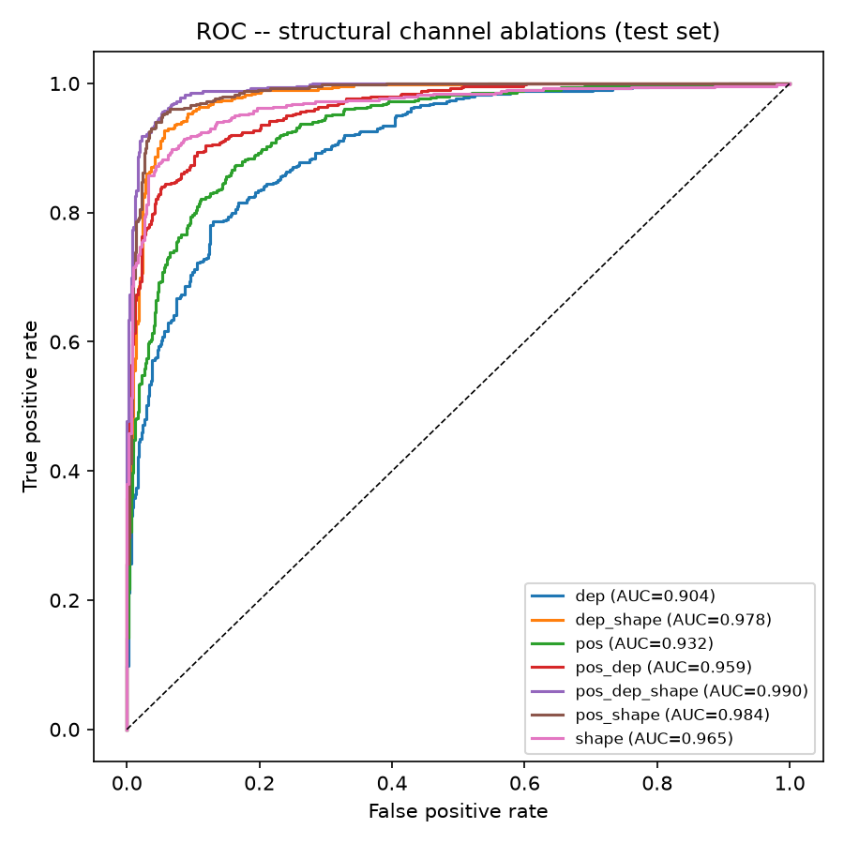
Figure 1. ROC curves for all structural channel combinations on the test set. Separation widens steadily as channels are added, with the top combinations near-overlapping.
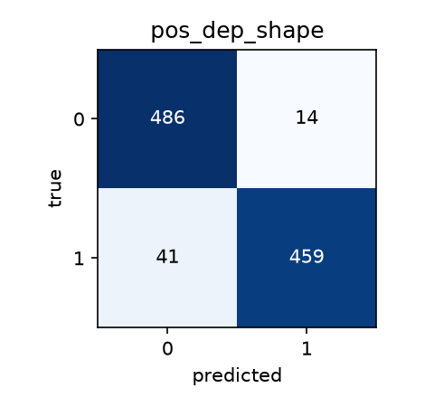
Figure 2. Confusion matrix for the best model (pos_dep_shape) on the 1,000-article test set; errors are roughly balanced across the two classes.

6. Limitations and Planned Next Steps
The results above are encouraging, but the team has identified a few limitations to keep in mind, along with the follow-up work we plan to take on as a group if time allows.
Single training seed. The headline numbers in Table 1 come from a single training seed (404). A second independent seed (seed 0) has now been run as a robustness check (Table 3): the best model (pos_dep_shape) stays clearly on top and the surface-form-dominant pattern holds, but the middle of the ranking does shift between seeds - for example pos_shape and dep_shape swap places, and pos and dep become essentially tied. This is expected from single runs and is exactly why a full five-seed mean +/- std sweep is still planned before the ranking is treated as final.
Single dataset. The topic-agnostic goal is not yet demonstrated across domains, since all evaluation so far is within WELFake - meaning the model could be picking up WELFake-specific style or source conventions. The group has flagged a cross-dataset test (train on WELFake, evaluate on a second corpus such as ISOT or LIAR, re-using our existing vocabularies) as the most valuable remaining experiment, and will decide together whether to include it now or note it as future work.
Surface-form interpretation. SHAPE is our strongest channel and, importantly, is not just a length artifact - but it may partly reflect dataset-level formatting habits (capitalization, punctuation, numerals). The same cross-dataset test would let us check whether this signal carries over to other sources.
Table 3. Robustness check - macro-F1 from a second independent training seed (seed 0) shown next to the seed-404 results from Table 1, plus seed-0 ROC-AUC. A full five-seed mean +/- std sweep is still planned.
Model | Macro-F1 (seed 404) | Macro-F1 (seed 0) | ROC-AUC (seed 0)
pos_dep_shape | 0.945 | 0.967 | 0.994
pos_shape | 0.941 | 0.925 | 0.976
dep_shape | 0.930 | 0.948 | 0.990
shape | 0.914 | 0.913 | 0.968
pos_dep | 0.890 | 0.875 | 0.952
pos | 0.849 | 0.825 | 0.904
dep | 0.811 | 0.825 | 0.918

