S1. Under NCOA — the mover policy (Mail / Drop) is clearly one decision with two options. Is there a third real-world option like "flag for client review" or "case-by-case" that should be in the radio group, or is it strictly Mail vs Drop?

(to me this could be on a counts report supplied by TS for a client to review and decide)
Movers
- Mail to Movers? (Out_MoveFootnote: 0, 91, 92, A)
- Drop movers? (Out_MoveFootnote: 1, 2, 3, 5, 14, 19, 66 — undeliverable)
Deceased (checkbox)
- Mail to Deceased?
- Drop Deceased?

S2. Under Deduplication → "Deduplication method" — is exactly one method picked per job, or can multiple apply (checkboxes)? E.g., can a job be both Individual AND Household dedup, or always just one?
Select ONE:
Individual (Full Name + Address) OR referred to as 1 per person
Household (Last Name + Address) OR referred to as 1 per household
Residential (Address Only) OR referred to as 1per address

S3. Presort section is empty in the source doc. David asked me to put placeholder fields. What does Tech Services actually need captured for presort on a work order? My guess was: permit/indicia holder, mailing class, presort level, entry point, drop ship plan. Is that the right list, or missing/extra items?

This is a screenshot of midnight – of the info that TS needs to do a presort:
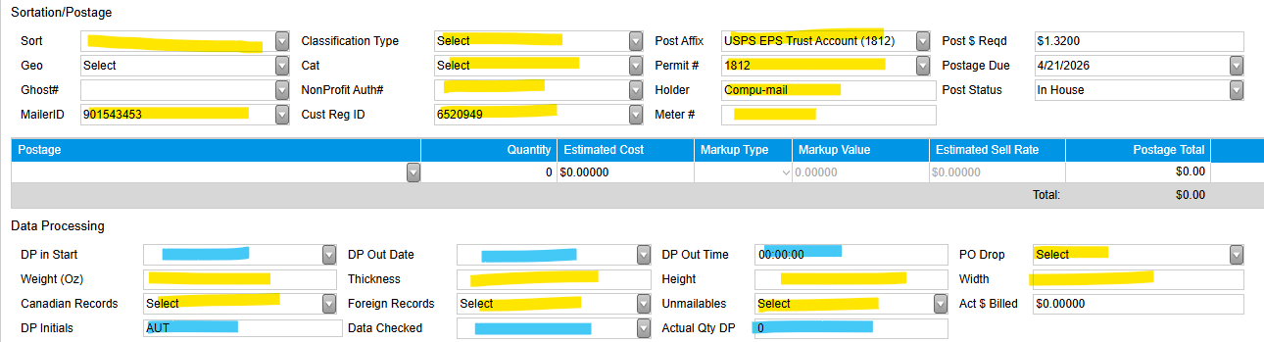

S4. Envelope-only fields — are any of the TS fields only relevant for envelope jobs? Prepress has one (Indicia) that auto-disables for non-envelope components. Does TS have the equivalent?

I am not sure – let TS answer – as there are scenarios where it can very.

S5. Required fields for TS — David picked "Data file locations" and "Input record count." Anything else Sally considers non-negotiable to fill in before a job can move forward?
Talk to Jason on these

S6. "Client review required" appears twice-ish (once as its own checkbox under NCOA, once implied by the meeting-required concept under Print). Are these two different things, or is one redundant?

I only see this occurring once – review NCOA counts.
Yes potentially a 2nd round of counts could be done after the client makes their choice on what to mail & not mail; therefore another review of final counts could be submitted so they can verify we did what they asked for correctly.

S7. The Deceased "Drop or mail?" sub-decision — is Drop the usual default, or Mail, or genuinely case-by-case with no default?

See response to S1 above

